**CleanTech: Transforming Waste Management with Transfer Learning**

**📌 Project Overview**

CleanTech is an AI-powered waste classification web application developed using **Transfer Learning** with **VGG16**. It helps users differentiate between waste types such as **biodegradable, recyclable, and trash** by uploading images through a simple Flask-based web interface.

**🚀 Features**

* 🌍 Web-based Image Upload
* ⚡ Real-time Waste Classification
* 🧠 VGG16 Pre-trained Model using Transfer Learning
* 📊 Training accuracy ~98.9%, Validation accuracy ~100%
* 🎨 Responsive Frontend using HTML/CSS

**🗂️ Project Structure**

CleanTech_Project/

├── app.py # Main Flask backend

├── model_training.py # Model training using VGG16

├── data_preparation.py # Dataset preprocessing logic

├── static/

│ └── uploads/ # Uploaded image storage

├── templates/ # HTML files

│ ├── index.html

│ ├── result.html

│ ├── blog.html

│ ├── blog-single.html

│ └── portfolio-details.html

├── .gitignore

└── README.md

**🧠 Model Training (VGG16)**

* Input size: 224x224 RGB
* Base model: VGG16 (without top layers)
* Fine-tuned with custom Dense layers
* Loss function: Categorical Cross entropy
* Optimizer: Adam
* Accuracy: 98.94%

**🔁 How It Works**

1. User visits the homepage
2. Uploads a waste image
3. Image is processed and classified
4. Predicted class (e.g., Recyclable) is shown on result page

**💻 Setup Instructions**

1. Clone the repo:
2. git clone https://github.com/ShaikMahammadHaneef/CleanTech_Transforming_Waste_Management.git
3. Navigate to project:
4. cd CleanTech_Transforming_Waste_Management
5. Setup virtual environment:
6. python -m venv venv
7. venv\Scripts\activate # On Windows
8. Install dependencies:
9. pip install -r requirements.txt
10. Run the app:
11. python app.py

**📸 Demo Screenshot**

* Home page

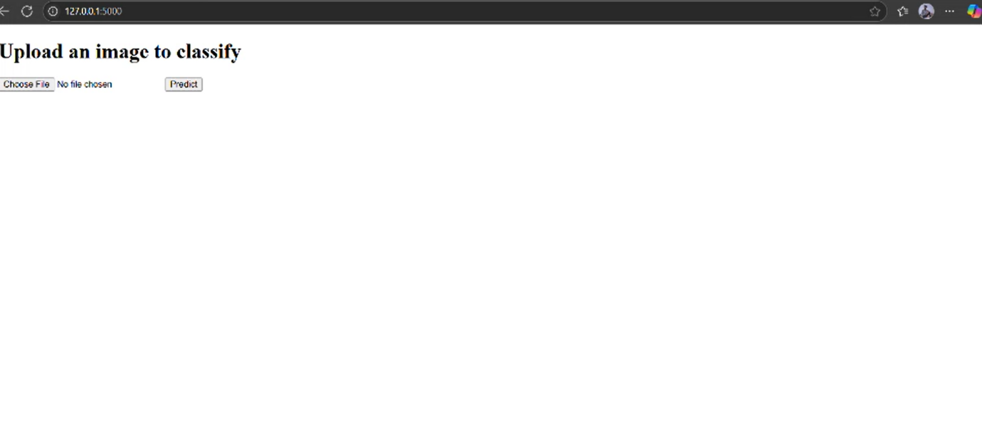

* Output

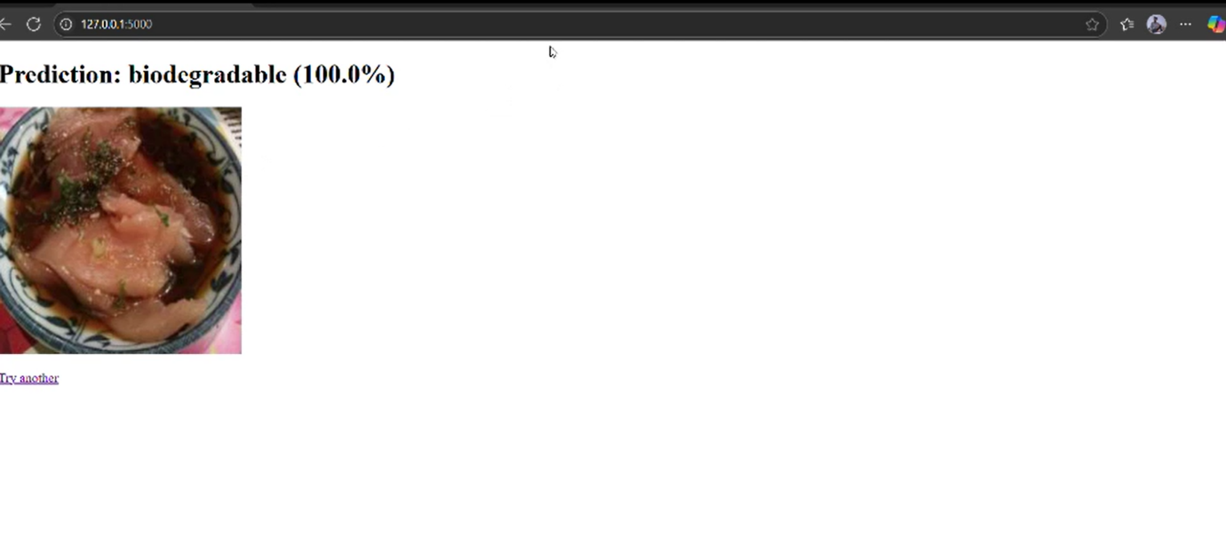

**📂 Dataset**

* Custom waste classification dataset from Kaggle
* 80 % data for model training and 20% for testing
* Organized into folders for Biodegradable, Recyclable, and Trash

**✍️ Author**

* Shaik Mahammad Haneef
* GitHub: [@ShaikMahammadHaneef](https://github.com/ShaikMahammadHaneef)
* Git link : <https://github.com/ShaikMahammadHaneef/CleanTech_Transforming_Waste_Management.git>

**📄 License**

This project is licensed for academic use only.