TITLE
ExpenseWise – Personal Expense Management System

OBJECTIVE
The objective of this project is to develop a backend-based Personal Expense Management System using Spring Boot and MongoDB. The system helps users manage income, expenses, categories, and budgets through secure REST APIs. It enables users to add, view, update, and delete expense records while ensuring proper data management and storage.

TOOLS USED
Tool / Technology | Purpose
Java 17 | Core programming language
Spring Boot 3.2.5 | Backend application development
Spring Security 6.x | Authentication and authorization
Spring Data MongoDB 3.x | Database operations
MongoDB 7.x | NoSQL database
Maven 3.9 | Dependency and build management
JWT (JJWT 0.11.5) | Secure user authentication
Postman | API testing
VS Code | Development environment
MongoDB Compass | Database management and monitoring

OUTPUTS

User Registration

A new user is successfully registered using the registration API. User details are stored securely in the MongoDB database.
POST /api/auth/register - User Registered (201 Created)
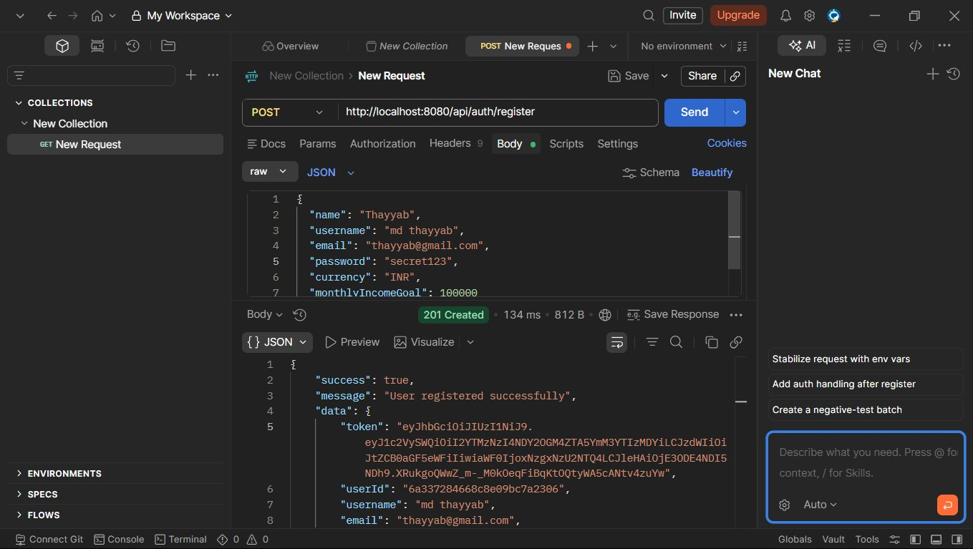

2. User Login
The login API authenticates the user and generates a JWT token for accessing protected endpoints.
POST /api/auth/login - Login Successful
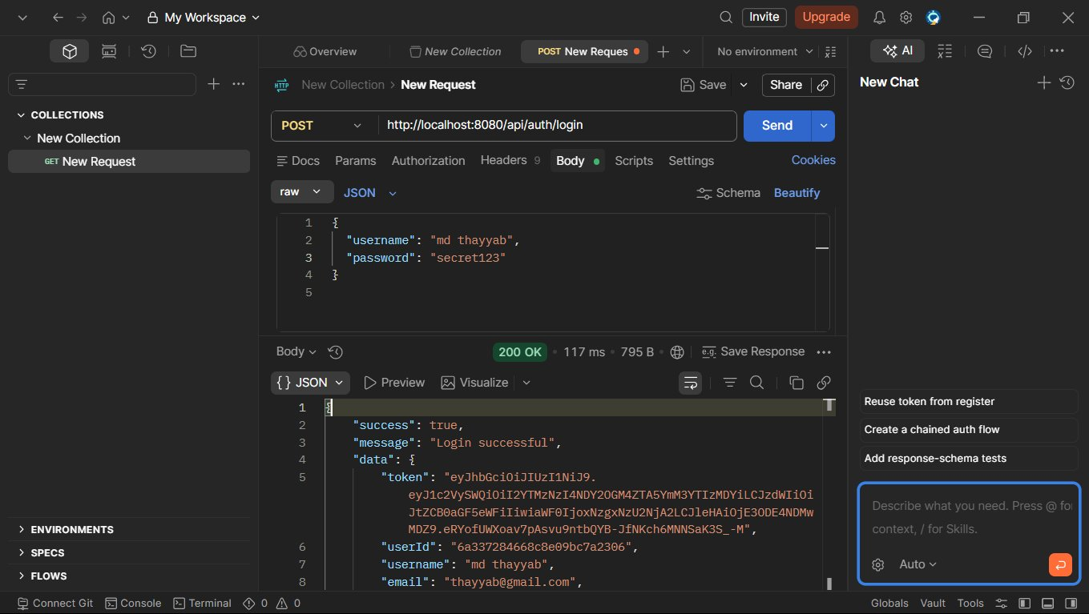

3. Categories Retrieval

The system fetches all available categories associated with the logged-in user.
GET /api/categories - Categories Fetched
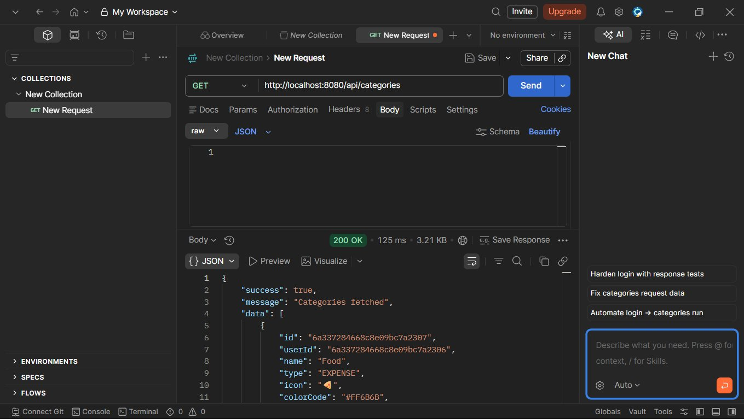

4. Category Filtering
Expense categories are filtered and displayed based on the selected category type.
ET /api/categories/type/EXPENSE - Categories by Type
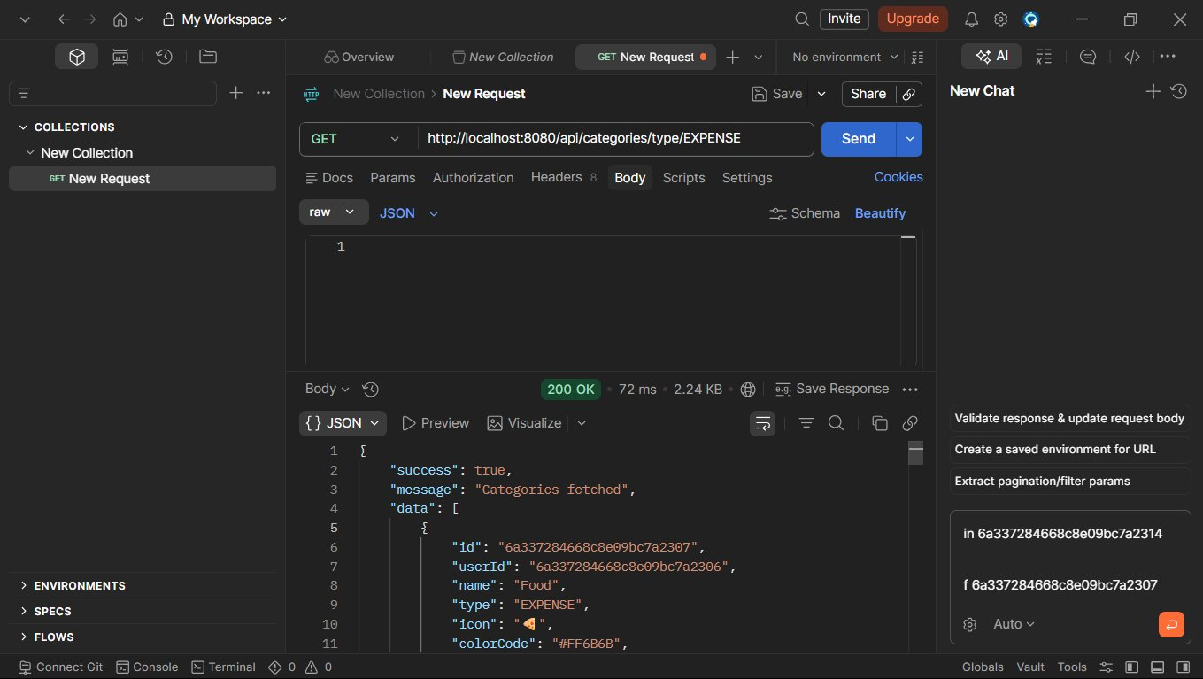

5. Expense Creation
Users can add new expense records with details such as title, amount, category, and payment mode.
POST /api/expenses - Expense Added
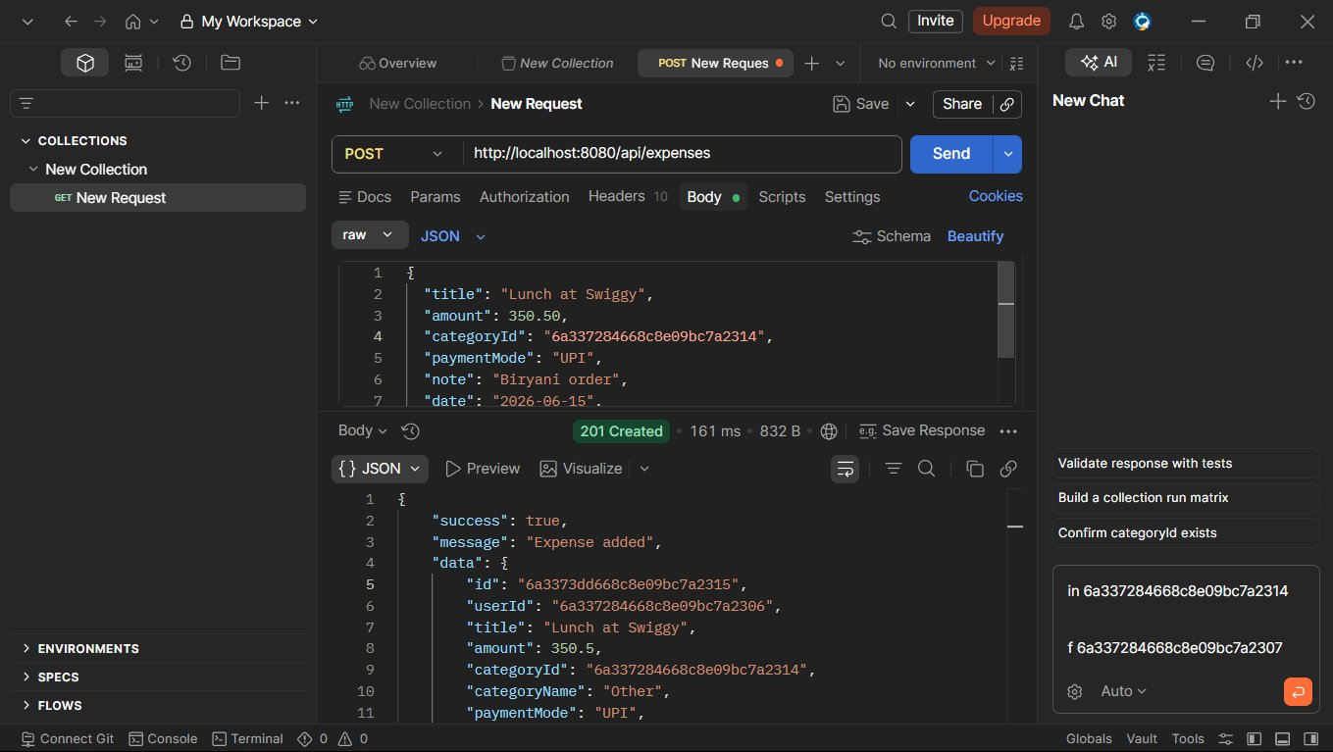

6. Expense Search
The search functionality allows users to find expenses using specific keywords.
GET /api/expenses/search?keyword=swiggy - Search Results
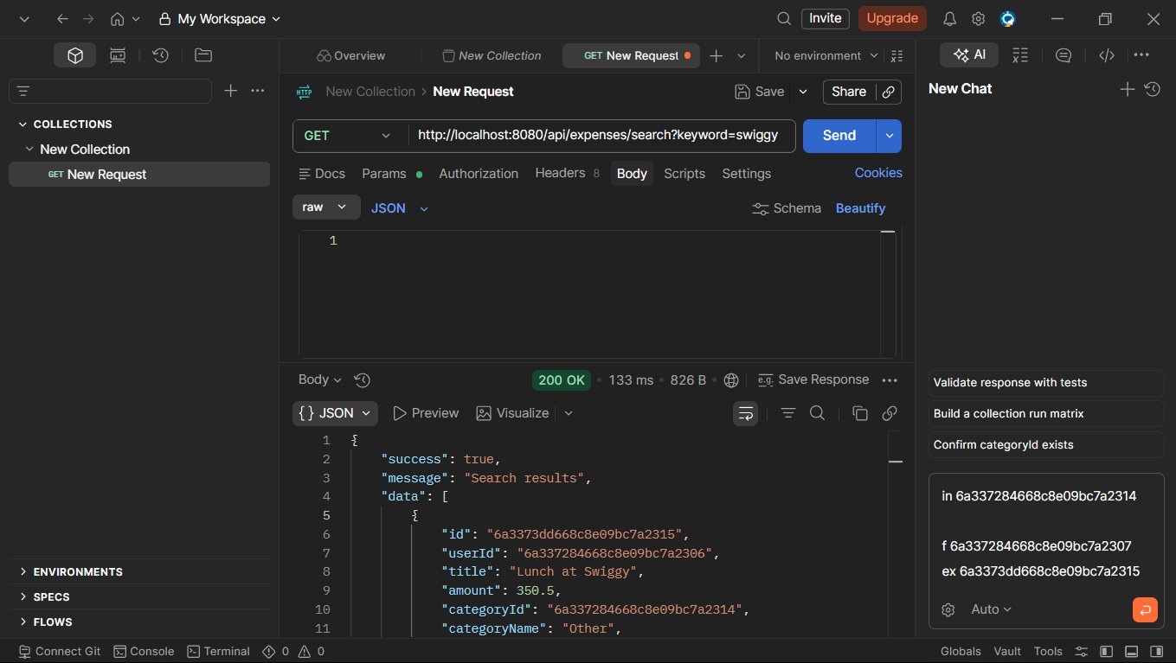

7. Expense Filtering
Expenses can be filtered based on month and year for better financial tracking.
GET /api/expenses/filter?month=6&year=... - Filtered by Month/Year
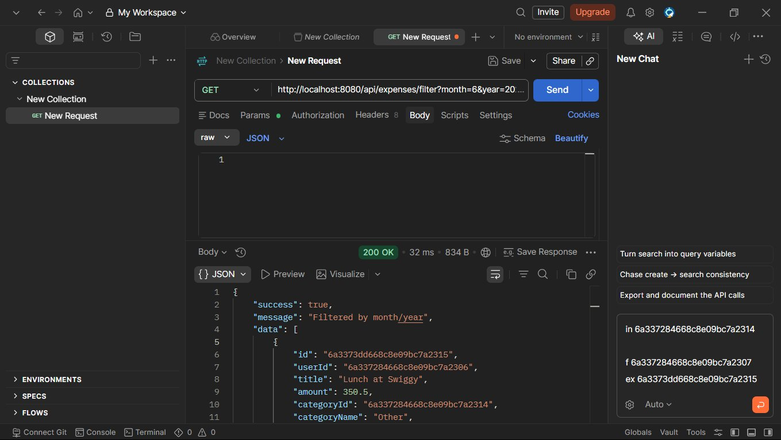

8. Income Creation
Users can add income records, which are stored separately from expenses.
POST /api/incomes - Income Added
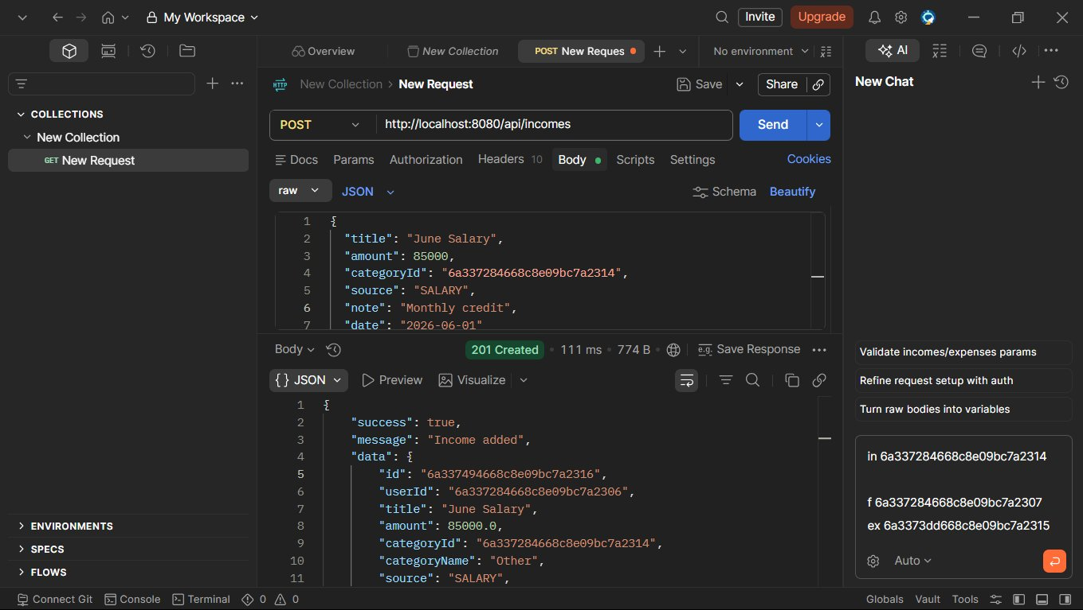

9. Budget Creation
Monthly budgets can be created for specific categories to monitor spending limits.
POST /api/budgets - Budget Set
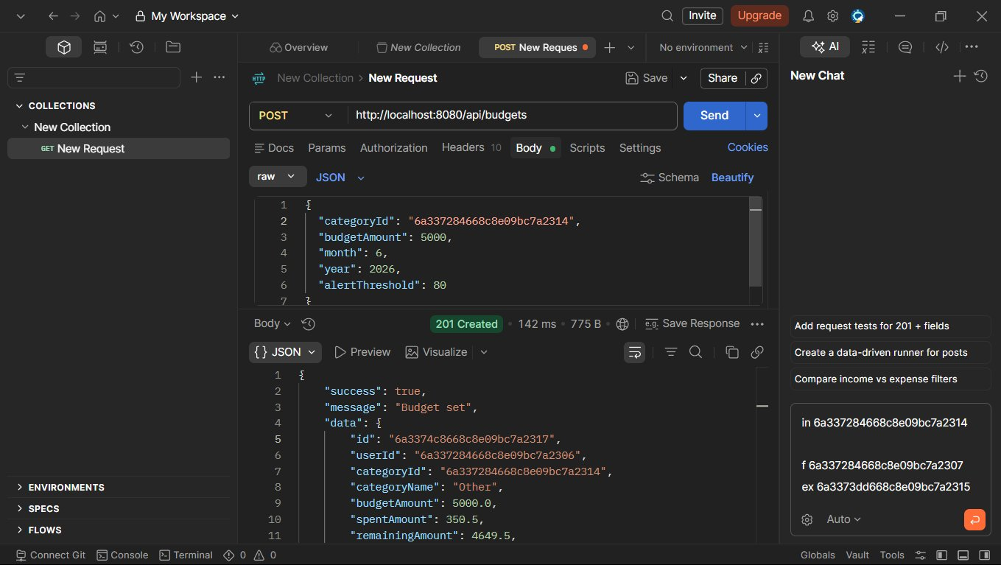

10. Additional Expense Entry
Additional expenses can be recorded and automatically reflected in budget calculations.
POST /api/expenses - Expense Added
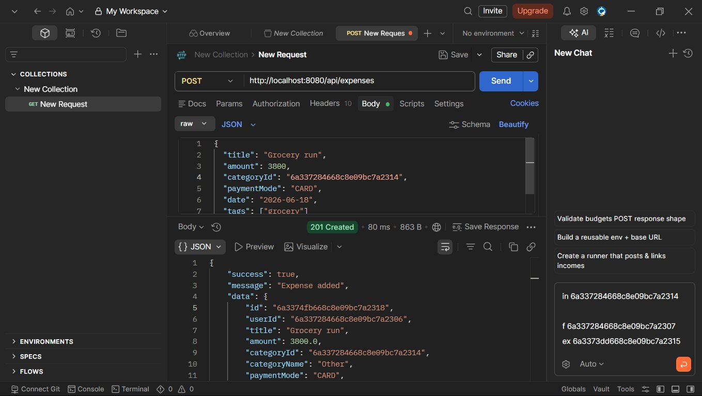

11. Monthly Summary Report
The system generates a monthly report showing total income, expenses, savings, and budget status.
GET /api/reports/summary?month=6&year=... - Monthly Summary
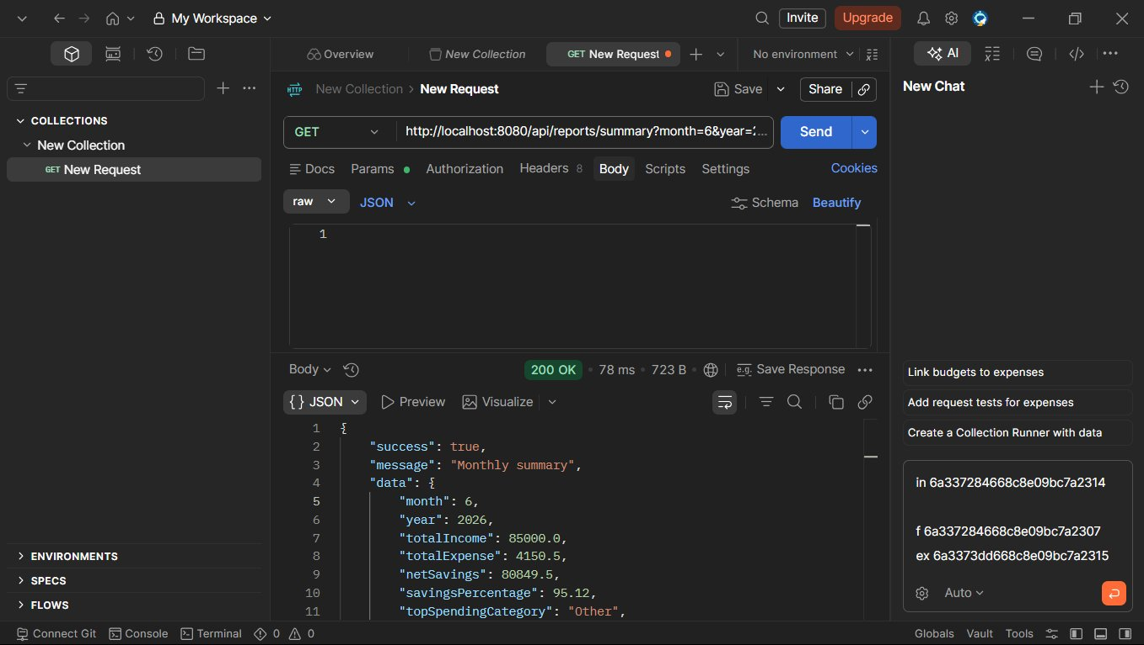

12. Income vs Expense Report
A comparison report displays total income and expenses for a selected period.
GET /api/reports/income-vs-expense?month=... - Income vs Expense
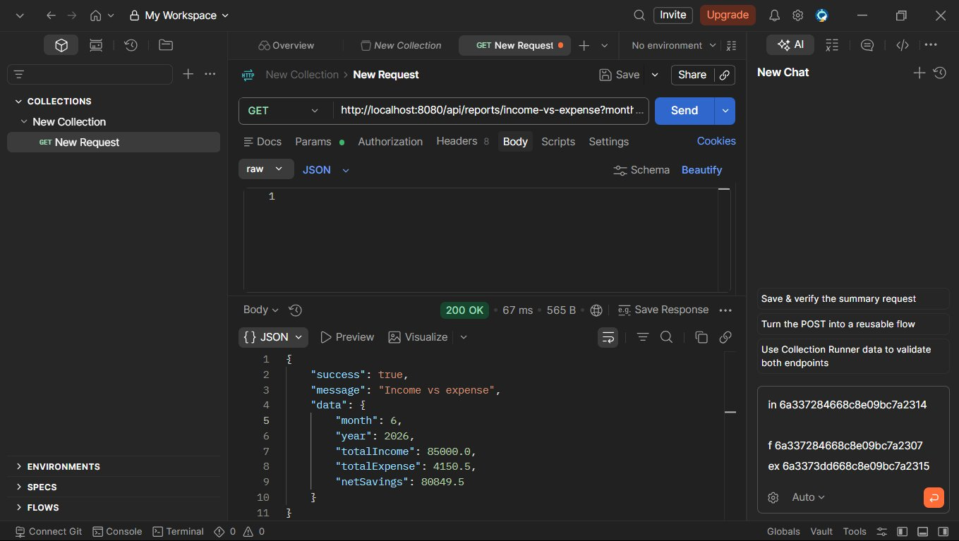

13. Top Expenses Report
The report identifies the highest spending transactions recorded during the month.
GET /api/reports/top-expenses?month=6&y... - Top Expenses
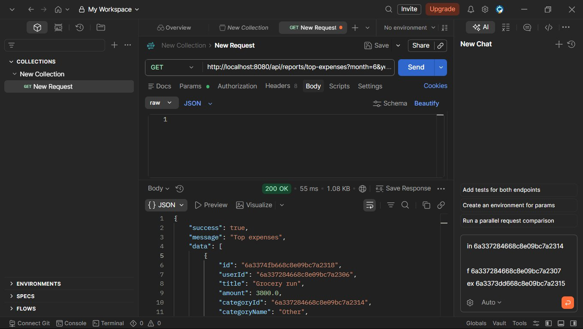

14. Profile Update
Users can update profile information such as name, preferred currency, and monthly income goal.
PUT /api/auth/profile - Profile Updated
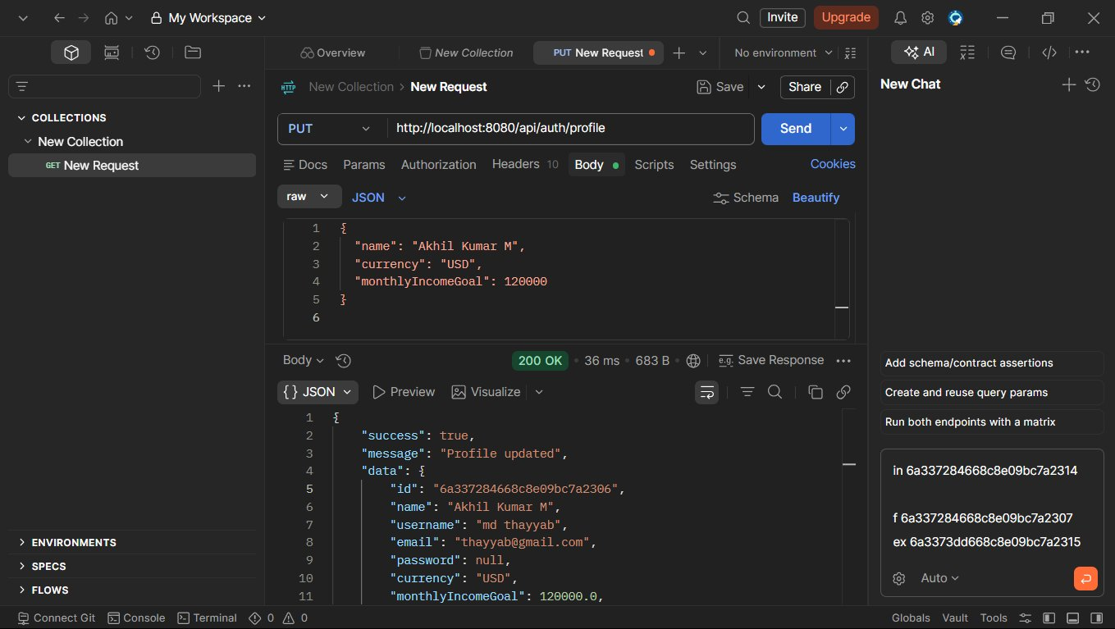

15. MongoDB Collections
The database contains separate collections for Users, Categories, Expenses, Incomes, and Budgets, ensuring organized data storage and management.
A. Collection: budgets (1 document)
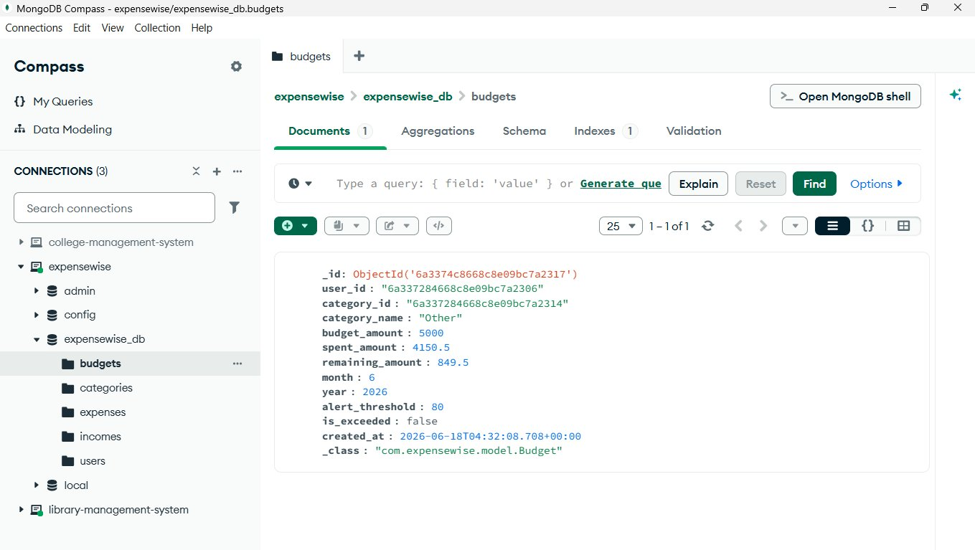
B. Collection: categories (42 documents)
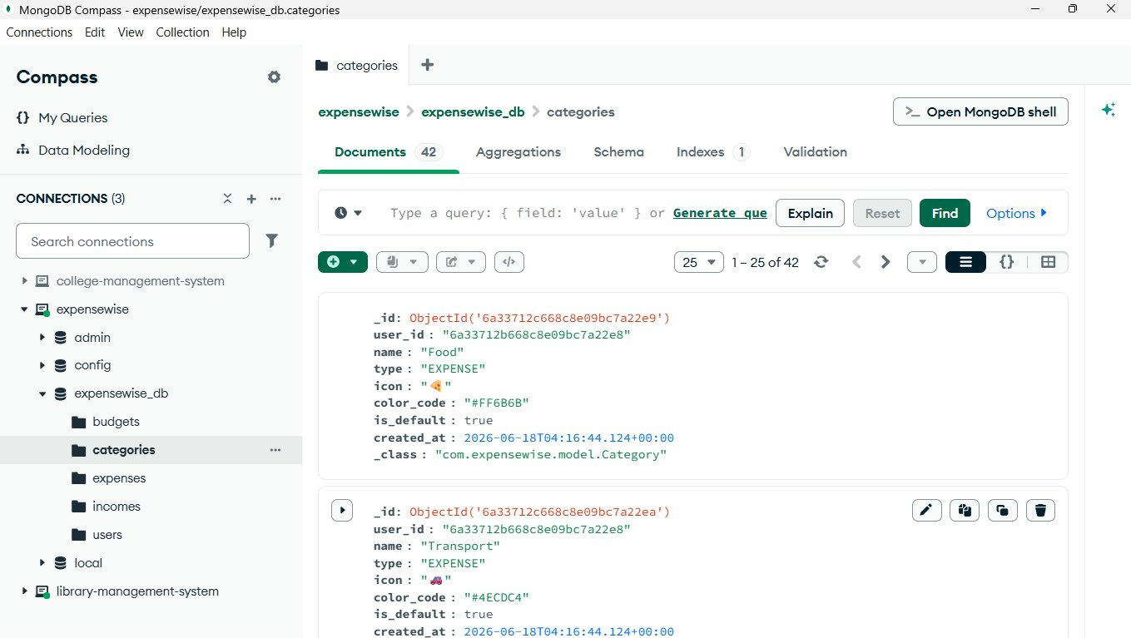
C. Collection: expenses (2 documents)
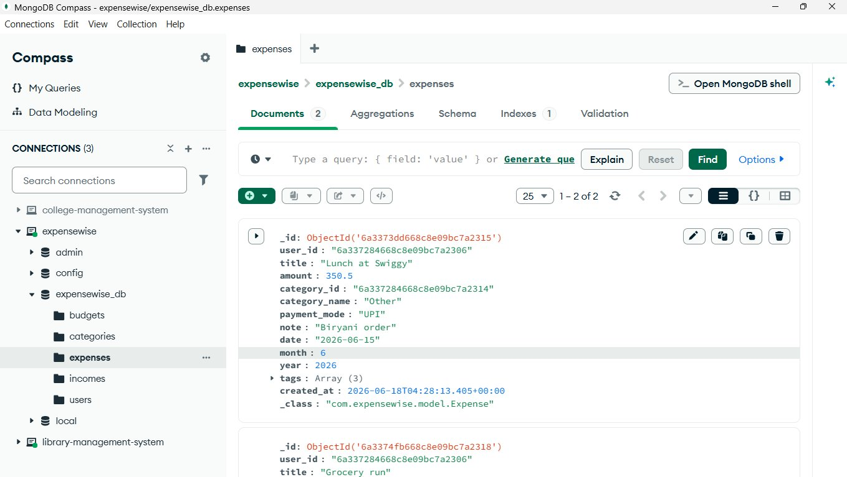
D. Collection: incomes (1 document)
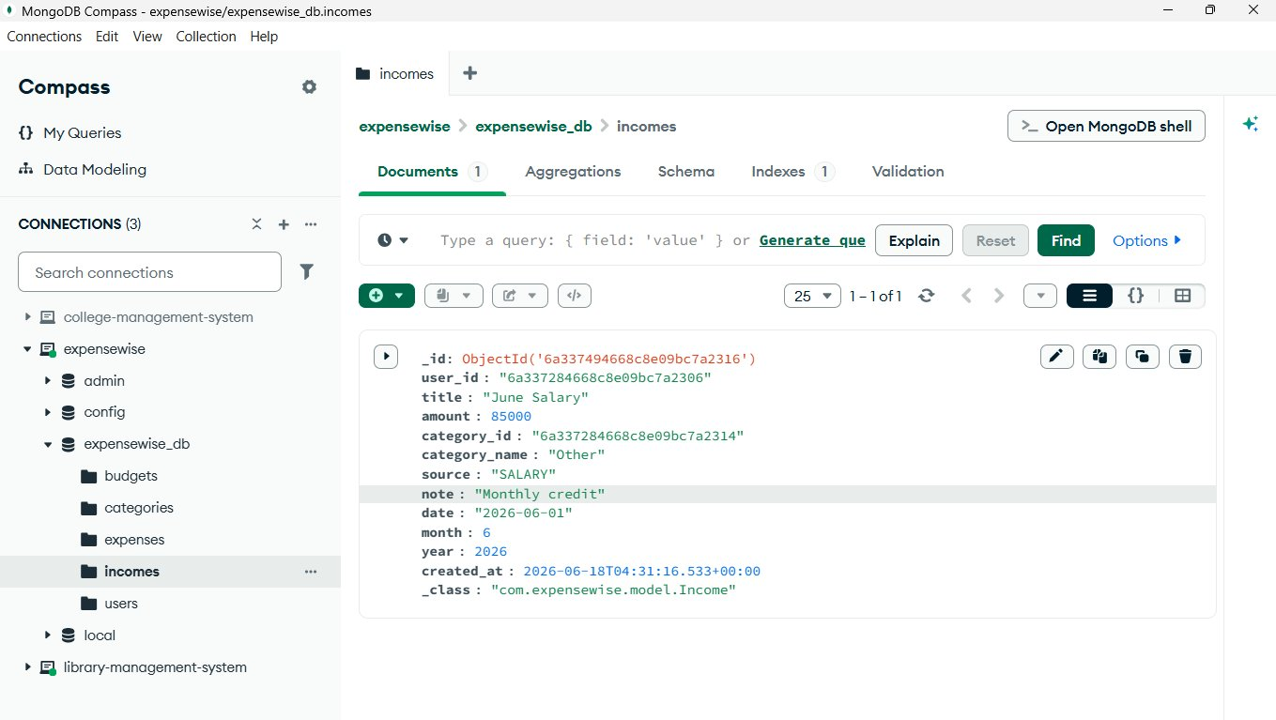
E. Collection: users (3 documents)
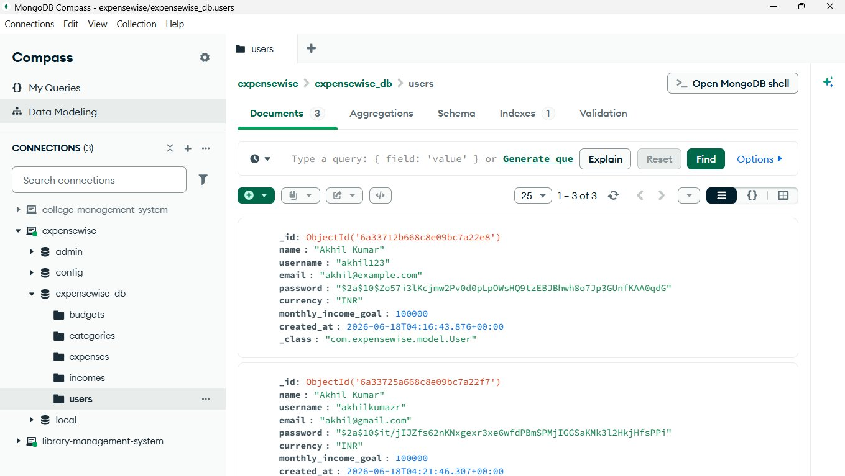

SUMMARY
ExpenseWise is a REST API-based backend application developed using Spring Boot and MongoDB. The system enables users to manage financial records through features such as authentication, expense tracking, income management, category management, budget planning, and financial reporting. The project demonstrates the implementation of secure APIs, database integration, and backend architecture using modern development practices.

CONCLUSION
The ExpenseWise Personal Expense Management System successfully provides a secure and efficient solution for managing personal finances. The project demonstrates practical knowledge of Spring Boot, MongoDB, REST API development, JWT authentication, and CRUD operations. It offers a structured approach to financial management while serving as a valuable learning experience in backend application development.

