Day-6
Task 1:
Wap to display a simple lambda exp to display “welcome”
@FunctionalInterface
interface name{
public void display();
}
public class Lambda3 {
public static void main(String[] args) {
name n=()-> System.out.println("welcome");
n.display();
}
}

Task 2:
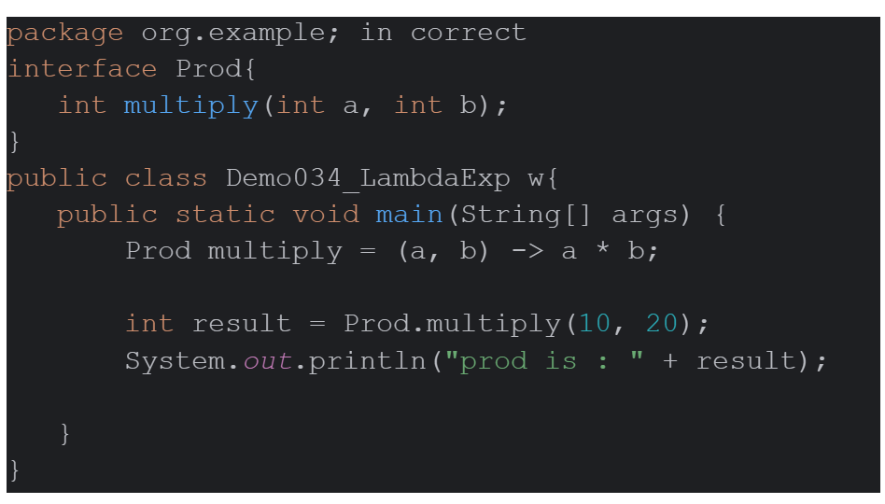
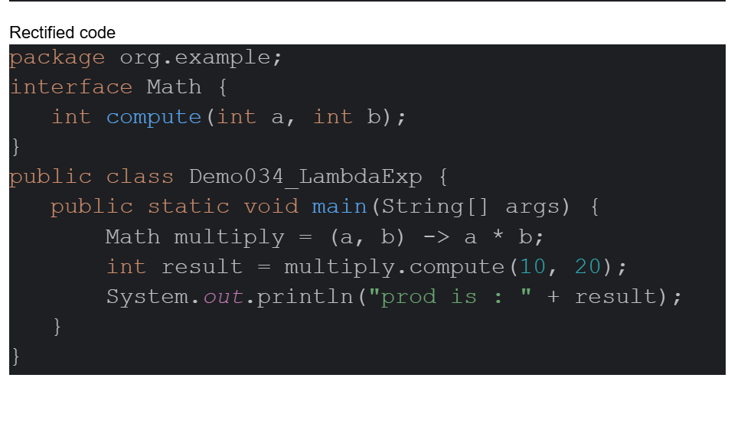
Tasks 3:

Wap to create a calc using lambda exp
interface Math{
int compute(int a,int b);
}
public class Lamda4 {
public static void main(String[] args) {
Math add = (a, b) -> a + b;
Math mul = (a, b) -> a * b;
Math div = (a, b) -> a / b;
Math sub = (a, b) -> a - b;
System.out.println("addition:" +add.compute(10,20));
System.out.println("multiplication:" +mul.compute(10,20));
System.out.println("division:" +div.compute(10,20));
System.out.println("substract:" +sub.compute(10,20));
}
}

Task 4:

You need to create an interface
-> With one abstract method (SAM) and 1 normal method
→ can you create 2 normal methods ?
→ can i have a method with abstract keyword

1. Interface with one abstract method (SAM) and one normal method
In Java, an interface cannot have a normal (concrete) method unless it is declared as default or static.

@FunctionalInterface
interface Demo {
// One abstract method (SAM)
void display();
// Default method
default void show() {
System.out.println("Default Method");
}
}
public class Lambda5 {
public static void main(String[] args) {
Demo d = () -> System.out.println("Abstract Method");
d.display();
d.show();
}
}

Can you create 2 normal methods?
Yes. You can have any number of default and static methods in a functional interface.

@FunctionalInterface
interface Demo6 {
void display(); // Only abstract method
default void show() {
System.out.println("Default Method 1");
}
default void print() {
System.out.println("Default Method 2");
} }
public class Lambda6{
public static void main(String[] args) {
Demo6 d1=()-> System.out.println(" 1 Abstract method");
d1.display();
d1.show();
d1.print();
}
}

Can I have a method with the abstract keyword?
Yes. It is valid, but not required because interface methods are implicitly abstract (unless they are default, static, or private).
Task-5
What is this code snippet doing..
Can i have a zero parameter lambda exp or not?
Yes we can have
@FunctionalInterface
interface OParameter{
void display();
}
public class Zeroparameterized {
public static void main(String[] args) {
OParameter obj = ()
-> System.out.println(
"This is a zero-parameter lambda expression!");
obj.display();
}
}

Task 6:

Wap to create an array list
Use lambda exp in foreach
Check if the num is even or odd

import java.util.ArrayList;
public class ArraylistLambda {
public static void main(String[] args){
ArrayList<Integer> list = new ArrayList<>();
list.add(10);
list.add(25);
list.add(30);
System.out.println("All elements in array:");
list.forEach(n -> System.out.println(n));
System.out.println("Even elements:");
list.forEach(n -> {
if (n % 2 == 0)
System.out.println(n);
});
}
}

Task-7
What is Junit5
JUnit 5 is the latest major version of the JUnit testing framework for Java. It is used to write, organize, and execute unit tests more effectively than earlier versions.
Task-8

List down the annotations of Junit 5
@Test Marks a method as a test method.
@BeforeEach Executes before each test method.
@AfterEach Executes after each test method.
@BeforeAll Executes once before all test methods (must be static unless using a per-class lifecycle).
@AfterAll Executes once after all test methods (must be static unless using a per-class lifecycle).
@Disabled Disables (skips) a test or test class.
@DisplayName Provides a custom name for a test or test class.
@Nested Creates nested test classes for better organization.
@Tag Assigns tags to tests for grouping and filtering.
@RepeatedTest Repeats a test a specified number of times.
@ParameterizedTest Runs the same test with different input values.
@ValueSource Supplies literal values to a parameterized test.
@CsvSource Supplies comma-separated values to a parameterized test.
@MethodSource Uses a method to provide arguments for a parameterized test.
@NullSource Supplies a null value to a parameterized test.
@EmptySource Supplies an empty value (such as an empty string or collection).
@NullAndEmptySource Supplies both null and empty values.

Task-9
Difference between Junit 5 and Junit4
JUnit 4 JUnit 5
Released in 2006 Released in 2017
Uses @Before Uses @BeforeEach
Uses @After Uses @AfterEach
Uses @BeforeClass Uses @BeforeAll
Uses @AfterClass Uses @AfterAll
Test annotation: @Test Test annotation: @Test (from org.junit.jupiter.api.Test)
Limited support for parameterized tests Better support with @ParameterizedTest
No support for nested tests Supports @Nested
No @DisplayName Supports @DisplayName
Uses org.junit package Uses org.junit.jupiter.api package
No modular architecture Modular architecture: Platform, Jupiter, Vintage
Limited extension support Powerful extension model with @ExtendWith

Taks-10
What is junit Test Suite?
A JUnit Test Suite is a collection of multiple test classes that are executed together in a single run. It helps organize and run related test cases at once.

Task 11:
What is Junit Vintage?
JUnit Vintage is a JUnit 5 module that allows you to run JUnit 3 and JUnit 4 test cases on the JUnit 5 Platform.
It provides backward compatibility, so existing JUnit 3 and JUnit 4 tests do not need to be rewritten immediately when migrating to JUnit 5.
Purpose
- Runs JUnit 3 test cases.
- Runs JUnit 4 test cases.
- Helps migrate old projects to JUnit 5 without changing existing tests.
Task-12
What are mock objects
Mock Objects are dummy objects that simulate the behavior of real objects during testing. They are mainly used in unit testing to test a class without depending on external resources such as databases, web services, or APIs.
Task-13
Write about Mockito?
Mockito is an open-source Java mocking framework used with JUnit to create mock objects for unit testing. It helps test a class by replacing its real dependencies (such as databases, APIs, or services) with mock objects.
Task-14
Define Functional Interface a java 8 feature
A Functional Interface is an interface that contains exactly one abstract method (SAM - Single Abstract Method). It was introduced in Java 8 to support Lambda Expressions and Method References
Task-15
What are default and static methods in interfaces?
1. Default Method
A default method is a method in an interface that has a body (implementation). It was introduced in Java 8 and is declared using the default keyword.
2. Static Method
A static method in an interface belongs to the interface itself, not to the implementing class. It is called using the interface name.

Task-17
What is Optional class in Java 8?
The Optional class is a container object introduced in Java 8. It is used to represent a value that may or may not be present, helping to avoid NullPointerException.

Task 19:
What is the double colon :: operator ?
The double colon (::) operator is called the Method Reference Operator in Java 8. It provides a shorter and cleaner way to refer to an existing method instead of writing a lambda expression.
Task 20:
What is method Reference in java 8?
A Method Reference is a feature introduced in Java 8 that allows you to refer to an existing method or constructor using the :: (double colon) operator. It is a shorter and cleaner alternative to a lambda expression.
Task 21:
There are different types of method reference

· Types:
o Static methods (Math::max)
o Instance methods (String::toLowerCase)
o Constructors (ArrayList::new)
Wap to use the above types of methods and show the use of each type

import java.util.ArrayList;
import java.util.function.BinaryOperator;
import java.util.function.Function;
import java.util.function.Supplier;
public class MethodReference {
// Static method
public static int maximum(int a, int b) {
return (a > b) ? a : b;
}
public static void main(String[] args) {
// 1. Static Method Reference
BinaryOperator<Integer> max = MethodReference::maximum;
System.out.println("Maximum = " + max.apply(10, 20));
// 2. Instance Method Reference
Function<String, String> lower = String::toLowerCase;
System.out.println("Lower Case = " + lower.apply("HELLO JAVA"));
// 3. Constructor Method Reference
Supplier<ArrayList<String>> list = ArrayList::new;
ArrayList<String> names = list.get();
names.add("Java");
names.add("Python");
System.out.println("List = " + names);
}
}

Task 22:

Java 8 one more feature is date and time api

Modern date and time
localDate(date) ,
localTime(time),
localDateTime(both)
ZoneDateTime(timezone)

Don't use legacy..
Java.util.Date;
java.util.Calender;

import java.time.LocalDate;
import java.time.LocalTime;
import java.time.LocalDateTime;
import java.time.ZonedDateTime;
public class DateTimeAPI {
public static void main(String[] args) {
// LocalDate
LocalDate date = LocalDate.now();
System.out.println("Current Date : " + date);
// LocalTime
LocalTime time = LocalTime.now();
System.out.println("Current Time : " + time);
// LocalDateTime
LocalDateTime dateTime = LocalDateTime.now();
System.out.println("Current Date and Time : " + dateTime);
// ZonedDateTime
ZonedDateTime zoneDateTime = ZonedDateTime.now();
System.out.println("Current Date, Time and Time Zone : " + zoneDateTime);
}
}

