SOFTWARE ENGINEERING
ACADEMIC YEAR
(2023-2024)
DEPARTMENT OF COMPUTER SCINCE AND ENGINEERING
QIS COLLEGE OF ENGINEERING &TECHNOLOGY 
CASE STUDY
“Netflix’s Recommendation System”
PRESENTERD BY:-
22491A05O5
22491A05O6
22491A05O8
22491A05O9
22491A05P0
22491A05P1
22491A05P2
22491A05P3
22491A05P4
22491A05P5
Creating a recommendation system like Netflix's involves several key components and software models. Here are some of the essential ones
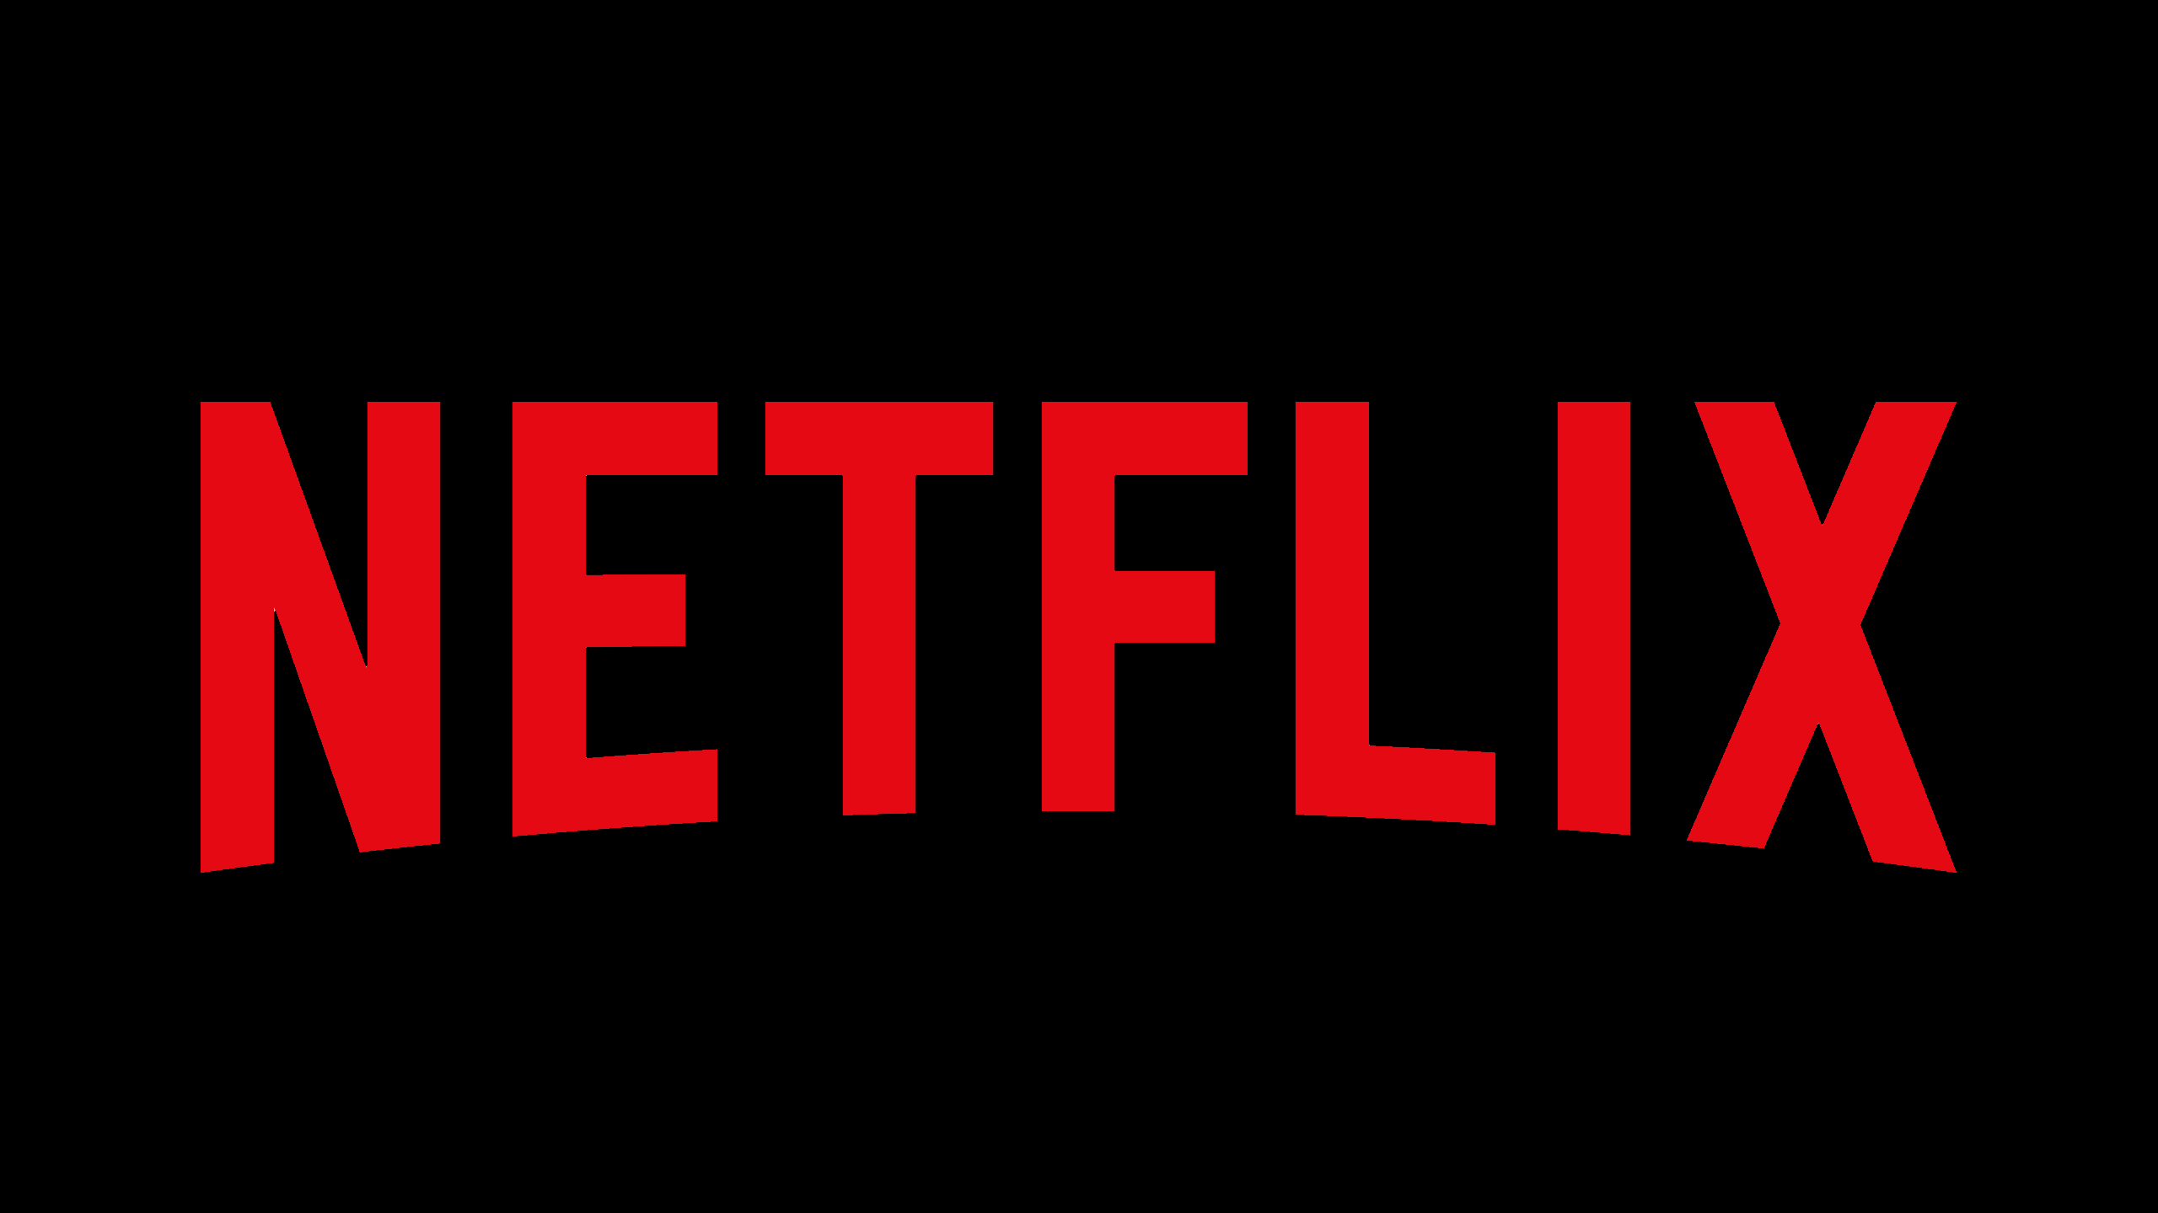:

Collaborative Filtering: This model analyzes user behavior and preferences to make recommendations. It looks at patterns of user interactions with items (movies, in Netflix's case) and identifies similarities between users or items

Content-Based Filtering: This model recommends items based on their attributes and the user's preferences. For Netflix, this might involve analyzing the content of movies (genre, actors, director, plot keywords) and recommending similar content to what a user has previously watched and enjoyed.

Hybrid Models: Combining collaborative filtering and content-based filtering can often yield better results than either approach alone. Hybrid models leverage both user behavior and item attributes to make recommendations.

Machine Learning Algorithms: Various machine learning algorithms can be used within recommendation systems, including matrix factorization techniques like Singular Value Decomposition (SVD) and Alternating Least Squares (ALS), as well as deep learning approaches such as neural networks.

Natural Language Processing (NLP): NLP techniques can be useful for analyzing textual data associated with items (e.g., movie descriptions, user reviews) to extract features that can enhance recommendation quality.

Scalable Infrastructure: Building a recommendation system for a platform like Netflix requires a scalable infrastructure to handle large volumes of data and user requests efficiently. This might involve technologies like distributed computing frameworks (e.g., Apache Spark) and cloud services (e.g., AWS, Google Cloud Platform).

Evaluation Metrics: It's crucial to have software models for evaluating the performance of the recommendation system, such as precision, recall, and mean average precision, to ensure that the recommendations are effective and relevant to users.

As for potential business models, since you're interested in building a recommendation system similar to Netflix's, you might consider the following:

Subscription-based Model: Offer a subscription service where users pay a monthly fee to access your platform and receive personalized recommendations for movies, TV shows, or other types of content.
Freemium Model: Provide basic recommendation services for free, but offer premium features or ad-free experiences as part of a paid subscription tier.

Content Monetization: In addition to providing recommendations, you could also monetize your platform by licensing or producing original content and offering it to users through subscriptions or pay-per-view models.

Data Monetization: Collecting user data and insights from their interactions with the recommendation system can be valuable for targeted advertising or selling anonymized data to third parties.

Partnerships and Affiliations: Partner with content providers, streaming services, or e-commerce platforms to earn commissions on sales generated through your recommendations.

Each of these business models has its own advantages and challenges, so it's essential to consider factors such as your target audience, competitive landscape, and revenue potential when deciding which model to pursue.

Netflix likely employs a combination of software models to build and maintain its application. Here are some of the use:
The most strongly recommended rows go to the top. The most strongly recommended titles start on the left of each row and go right -- unless you have selected Arabic or Hebrew as your language in our systems, in which case these will go right to left.

Netflix is a widely loved streaming service, and it owes much of its popularity to its personalized content suggestions. Here is how it works in simple terms:

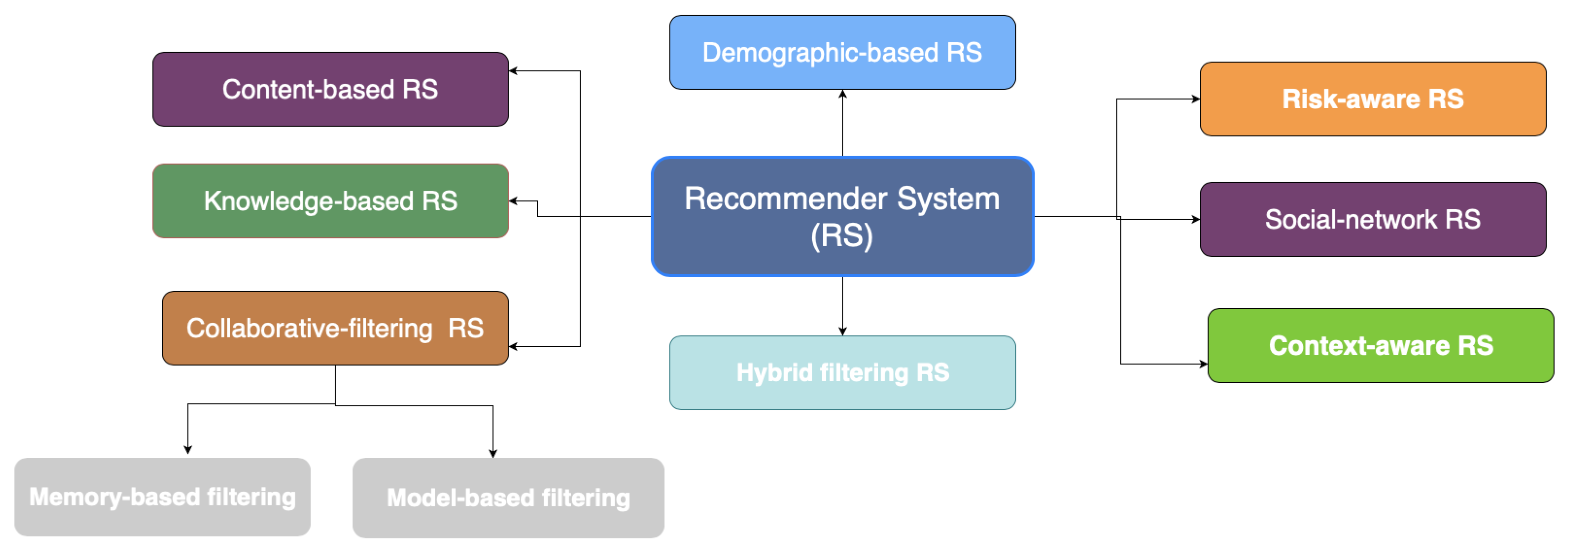
Agile Methodology: Agile is commonly used in software development for its iterative approach, allowing teams to respond to changes quickly. Netflix likely follows agile principles to continuously deliver updates and improvements to its application. Within Netflix's development teams, Agile principles likely guide their approach to software development. This means they work in iterative cycles, breaking down projects into smaller tasks or user stories that can be completed within short timeframes called sprints. At the end of each sprint, there's a potentially shippable product increment, allowing for frequent releases and rapid feedback from users.

DevOps: DevOps is a set of practices that combine software development (Dev) and IT operations (Ops). Netflix likely utilizes DevOps practices to automate and streamline the deployment pipeline, ensuring faster delivery of features and updates to its application.Netflix's DevOps culture emphasizes collaboration between development and operations teams, aiming to automate processes and remove barriers to deployment. Continuous integration (CI) ensures that code changes are regularly merged into a shared repository and tested automatically, while continuous deployment (CD) automates the release process, allowing updates to be pushed to production swiftly and safely.

Microservices Architecture: Netflix is known for its microservices architecture, where the application is broken down into small, loosely coupled services that can be developed, deployed, and scaled independently. This architecture enables Netflix to maintain flexibility, scalability, and resilience in its application.
Netflix's application likely comprises numerous microservices, each responsible for a specific function or feature. These services are independently deployable, allowing teams to work on them autonomously. This architecture enables scalability and fault isolation, as well as facilitating rapid innovation and experimentation.

Continuous Integration/Continuous Deployment (CI/CD): CI/CD practices involve automating the process of integrating code changes into a shared repository (CI) and then automatically deploying those changes to production environments (CD). Netflix likely employs CI/CD pipelines to ensure rapid and reliable delivery of updates to its application.

Chaos Engineering: Netflix is famous for its Chaos Monkey tool, which intentionally introduces failures into its production systems to test resilience. Chaos engineering is a practice that helps organizations identify weaknesses in their systems and build more resilient architectures. Netflix likely continues to employ chaos engineering principles to ensure the reliability of its application.
Netflix pioneered the practice of chaos engineering, which involves deliberately introducing failures into a system to test its resilience. Tools like Chaos Monkey randomly terminate instances in Netflix's production environment, helping to uncover weaknesses and improve the overall system's robustness. This approach ensures that Netflix's application can withstand unexpected failures and maintain high availability.

Data-Driven Development: Netflix heavily relies on data to drive decision-making, including content recommendations, user interface design, and performance optimization. Data-driven development involves collecting and analyzing user data to inform development efforts and improve the user experience.
These are just some of the software models and methodologies that Netflix may utilize in developing and maintaining its application. The specific approach may vary based on the team, project, and requirements at any given time.
Netflix leverages vast amounts of user data to inform nearly every aspect of its application, from content recommendations to interface design. Data analysis helps Netflix understand user behavior, preferences, and satisfaction levels, allowing them to tailor the user experience and optimize performance continually. This data-driven approach ensures that Netflix can deliver personalized and engaging content to its users, ultimately driving customer retention and satisfaction.
Certainly! Let's delve deeper into each of these software models and methodologies as they might be applied within the context of Netflix's application development:
By employing these software models and methodologies, Netflix can maintain a fast-paced development cycle, deliver high-quality software, and continuously innovate to meet the evolving needs of its users.
THANK YOU.
PRESENTED TO:-
D.DIWIJA MADAM………

