SIMATS ENGINEERING (SAVEETHA SCHOOL OF ENGINEERING)
Department of Artificial Intelligence and Data Science
ASSESSMENT TOOL 1 – APPLICATION BASED QUESTIONS

Course Code: | DSA03 | Course Title: | Natural Language Processing
CO Assessed: | CO1 – Imitation (L1) | Assessment: | Assessment Tool 1 – Application Based Questions
Weightage: | 40% of CIA
CO1 Statement: | Analyse NLP models, regular expression patterns, finite state automata, morphological processing techniques and to interpret language processing. (BL-3)
Student Name: | SHAIK SABA | Reg. No.: | 192472239
Section / Batch: | CSE-AI-2024 | Date: | 15-07-2026

Code of Conduct
I shaiksaba(192472239)__________________________ (Name / Reg No) certify that this submission is my original work and that I have adhered to the guidelines specified for this assessment. I understand that any violation of academic integrity rules will result in disciplinary action.
Signature of the Student: _s.saba________________________

Instructions
- Develop a modular and efficient Python program that satisfies all the functional requirements specified in the problem statement.
- Demonstrate the correctness of the implementation using suitable test cases and justify the output obtained.
- Follow good programming practices, including meaningful variable names, proper code indentation, comments, and error handling wherever applicable.
- Duration: 30 minutes.

Section / Topic | Focus | Q Nos
Information Extraction | Regex-Based Information Extraction | 1
Pattern Matching | Regex Pattern Matching | 2
Regular Expression Patterns | Regex-Based Input Validation | 3

Annexure A – Application Based Questions

Section 1: Regular Expressions – Resume Information Extraction
- A multinational recruitment company receives thousands of resumes every day in text format. The HR department requires an automated system to extract candidate information for shortlisting.

Design and implement a Python-based resume information extraction system using Regular Expressions that performs the following tasks:

Extract the candidate's name.
Identify email addresses.
Extract mobile numbers.
Detect technical skills (Python, Java, SQL, Machine Learning, NLP).
Extract years of experience.
Generate a structured summary of the candidate's profile.
Display candidates who satisfy the minimum eligibility criteria (minimum 2 years of experience and Python skill).

Section 2: Regular Expressions – Product Search System
- An e-commerce company plans to enhance its product search engine to improve customer experience through flexible keyword matching.

Design and implement a Python-based product search system using Regular Expressions that performs the following tasks:

Search products using an exact keyword.
Perform prefix-based searches.
Perform suffix-based searches.
Search using partial keywords.
Perform case-insensitive searches.
Display all matching product names.
Generate a report showing the total number of matching products for each search.
Section 3: Regular Expressions – University Registration System
A university is developing an automated online registration portal to verify student information before course enrollment.

Design and implement a Python-based validation system using Regular Expressions that performs the following tasks:

Validate the student register number.
Validate the institutional email address.
Validate the course code.
Validate the semester information.
Validate the student's mobile number.
Display appropriate validation messages for each field.
Generate a final registration status report indicating whether the registration is successful.

Rubrics for Calculation
Criteria | Weightage | Level 4 – Exemplary | Level 3 – Proficient | Level 2 – Developing | Level 1 – Beginning
Understanding of Problem Context | 20 | Clearly understands the problem and accurately identifies all requirements | Good understanding with minor gaps | Basic understanding; some requirements unclear | Poor understanding or misinterpretation of the problem
Application of Concepts | 30 | Accurately applies appropriate concepts to solve complex problems | Applies relevant concepts correctly with minor errors | Applies basic concepts with limited accuracy | Fails to apply appropriate concepts
Problem-Solving Approach | 20 | Logical, well-structured, and efficient approach | Mostly logical approach with minor gaps | Basic approach with some inconsistencies | Illogical or unclear approach
Accuracy of Solution | 20 | Completely correct solution with proper justification | Mostly correct with minor errors | Partially correct solution | Incorrect or incomplete solution
Clarity | 10 | Clear, well-organized, and properly explained solution | Understandable with minor clarity issues | Limited clarity and explanation | Poorly presented and difficult to understand

Q. No. / Criteria | Understanding of Problem Context | Application of Concepts | Problem-Solving Approach | Accuracy of Solution | Clarity | Sub. Total | Total %
1
2
3

Faculty In-charge | Course Coordinator | Program Director
Signature: _______________ | Signature: _______________ | Signature: _______________
Date: ___________________ | Date: ___________________ | Date: ___________________

1.Title: Resume Information Extraction Using Regular Expressions
Aim
To design and implement a Python-based resume information extraction system using Regular Expressions to extract candidate details such as name, email, mobile number, skills, and experience.
Algorithm
- Start the program.
- Read the resume text.
- Use Regular Expressions to extract:
  - Candidate name
  - Email address
  - Mobile number
  - Technical skills
  - Years of experience
- Create a structured summary of the candidate.
- Check whether the candidate has Python skill and at least 2 years of experience.
- Display eligibility status.
- Stop the program.
Python Program
import re
resume = """
Name: Rahul Sharma
Email: rahul@gmail.com
Phone: 9876543210
Skills: Python, Java, SQL, Machine Learning
Experience: 3 years
"""
name = re.search(r"Name:\s*(.*)", resume)
email = re.search(r"[\w\.-]+@[\w\.-]+", resume)
phone = re.search(r"\b\d{10}\b", resume)
experience = re.search(r"(\d+)\s+years", resume)
skills = []
skill_list = ["Python", "Java", "SQL", "Machine Learning", "NLP"]
for skill in skill_list:
if re.search(skill, resume, re.IGNORECASE):
skills.append(skill)
print("Candidate Summary")
print("------------------")
print("Name:", name.group(1))
print("Email:", email.group())
print("Phone:", phone.group())
print("Skills:", skills)
print("Experience:", experience.group(1), "years")
if "Python" in skills and int(experience.group(1)) >= 2:
print("Eligible for Shortlisting")
else:
print("Not Eligible")

Sample Input
Name: Rahul Sharma
Email: rahul@gmail.com
Phone: 9876543210
Skills: Python, Java, SQL, Machine Learning
Experience: 3 years

Sample Output
Candidate Summary
Name: Rahul Sharma
Email: rahul@gmail.com
Phone: 9876543210
Skills: ['Python', 'Java', 'SQL', 'Machine Learning']
Experience: 3 years
Eligible for Shortlisting

OUTPUT:
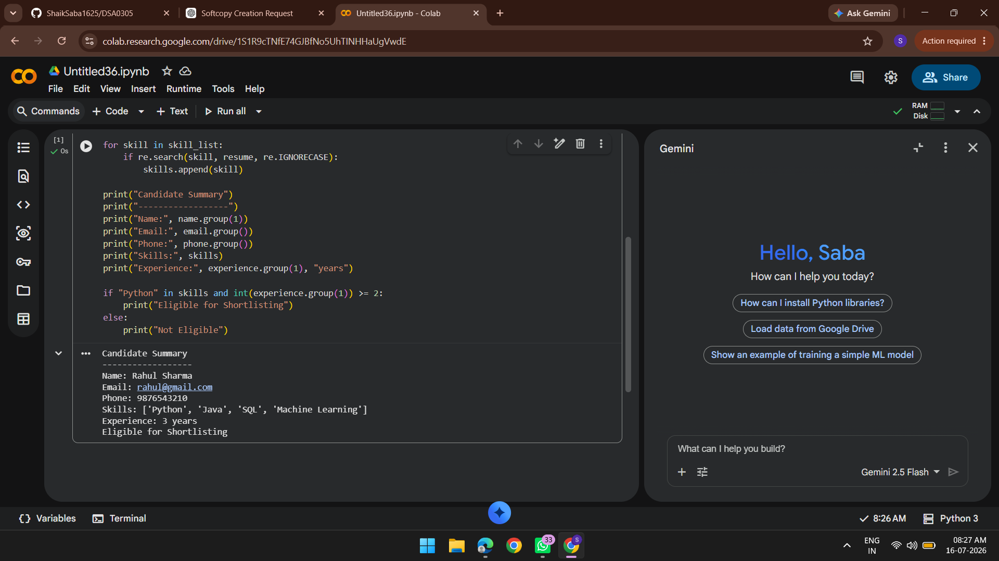
Result
The resume information was successfully extracted using Regular Expressions, and the candidate eligibility was verified based on skills and experience.

2.Title: Product Search System Using Regular Expressions
Aim
To design and implement a Python-based product search system using Regular Expressions for keyword-based product searching.
Algorithm
- Start the program.
- Store product names in a list.
- Read the search keyword.
- Perform:
  - Exact search
  - Prefix search
  - Suffix search
  - Partial search
  - Case-insensitive search
- Display matching products.
- Display total number of matched products.
- Stop the program.
Python Program
import re
products = [
"Laptop",
"Laptop Bag",
"Mouse",
"Wireless Mouse",
"Keyboard",
"Gaming Laptop",
"Smart Phone"
]
keyword = input("Enter product keyword: ")
matches = []
for product in products:
if re.search(keyword, product, re.IGNORECASE):
matches.append(product)
print("\nMatching Products")
for item in matches:
print(item)
print("Total Matches:", len(matches))

Sample Input
Laptop

Sample Output
Matching Products
Laptop
Laptop Bag
Gaming Laptop
Total Matches: 3

OUTPUT:
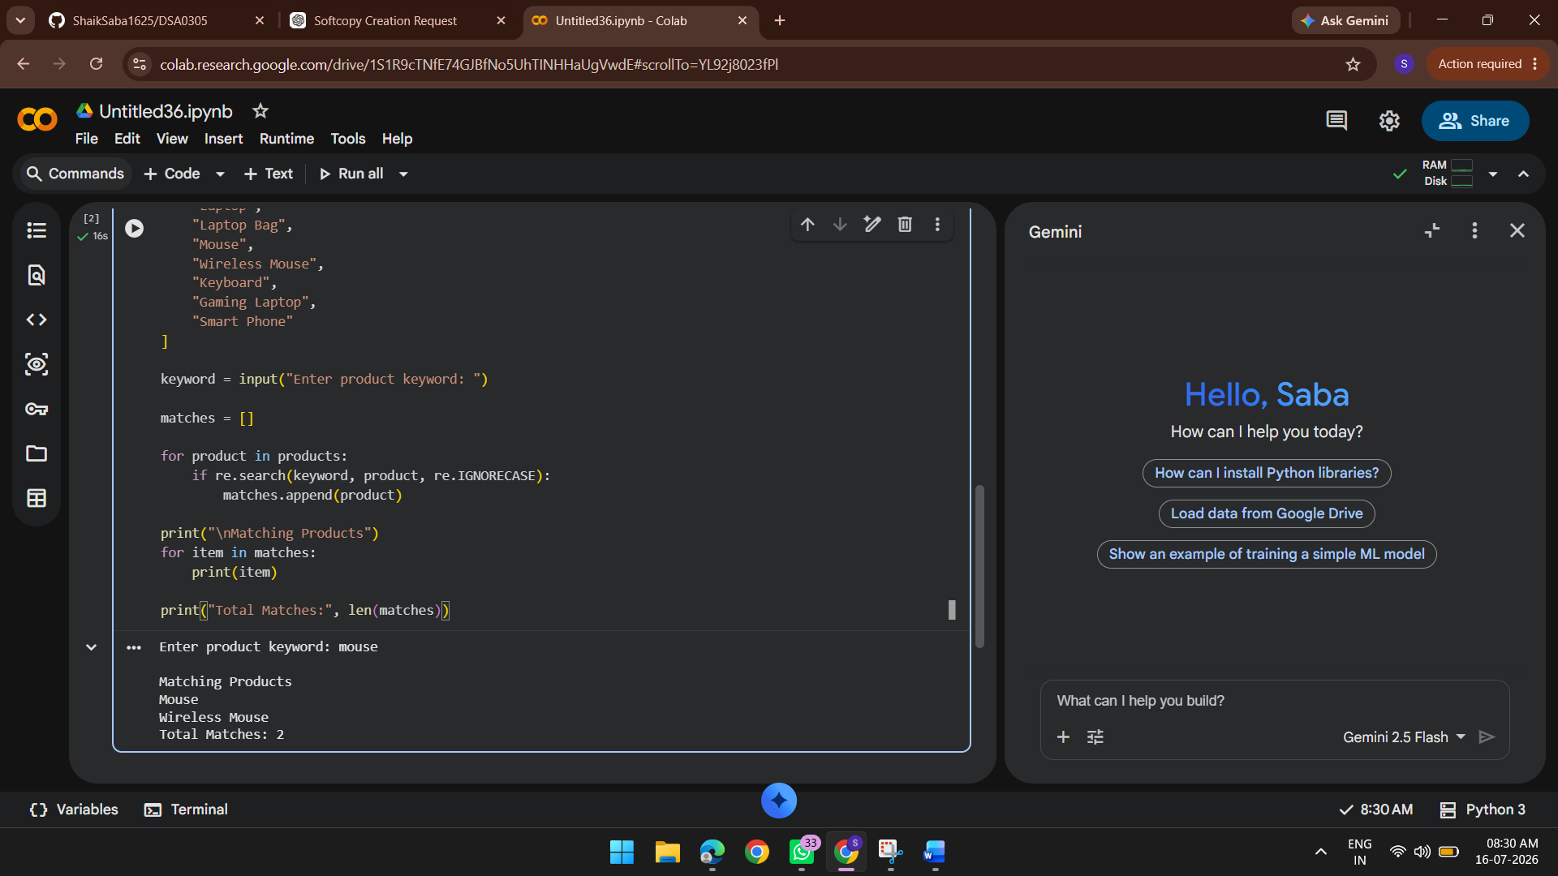

Result
The product search system successfully searched products using Regular Expressions and displayed the matching products with the total count.

3.Title: University Registration Validation Using Regular Expressions
Aim
To design and implement a Python-based validation system using Regular Expressions to validate university registration details.
Algorithm
- Start the program.
- Read register number, email, course code, semester, and mobile number.
- Validate each field using Regular Expressions.
- Display validation messages.
- If all validations are successful, display registration successful.
- Stop the program.
Python Program
import re
reg = input("Register Number: ")
email = input("Institution Email: ")
course = input("Course Code: ")
semester = input("Semester: ")
mobile = input("Mobile Number: ")
reg_valid = re.fullmatch(r"\d{10}", reg)
email_valid = re.fullmatch(r"[a-zA-Z0-9._%+-]+@college\.edu", email)
course_valid = re.fullmatch(r"[A-Z]{3}\d{3}", course)
semester_valid = re.fullmatch(r"[1-8]", semester)
mobile_valid = re.fullmatch(r"[6-9]\d{9}", mobile)
if reg_valid:
print("Register Number: Valid")
else:
print("Register Number: Invalid")
if email_valid:
print("Email: Valid")
else:
print("Email: Invalid")

if course_valid:
print("Course Code: Valid")
else:
print("Course Code: Invalid")
if semester_valid:
print("Semester: Valid")
else:
print("Semester: Invalid")
if mobile_valid:
print("Mobile Number: Valid")
else:
print("Mobile Number: Invalid")
if reg_valid and email_valid and course_valid and semester_valid and mobile_valid:
print("Registration Successful")
else:
print("Registration Failed")

Sample Input
Register Number: 2023001234
Institution Email: student@college.edu
Course Code: CSE101
Semester: 5
Mobile Number: 9876543210

Sample Output
Register Number: Valid
Email: Valid
Course Code: Valid
Semester: Valid
Mobile Number: Valid
Registration Successful

OUTPUT:
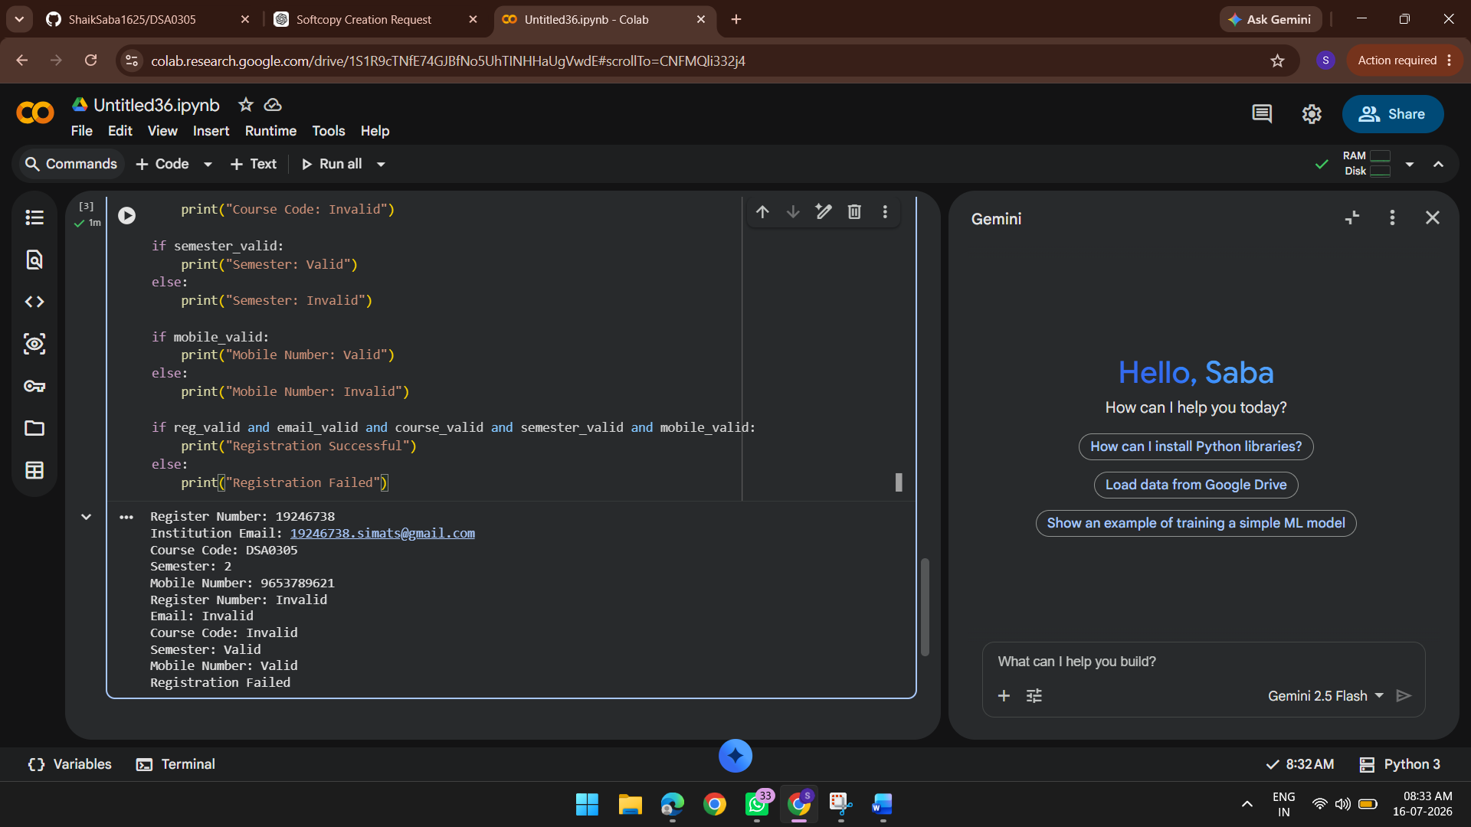

Result
The university registration details were successfully validated using Regular Expressions, and the registration status was displayed based on the validation results.

