PRACTICAL -1&2 PROGRAMMS:
Code 1:
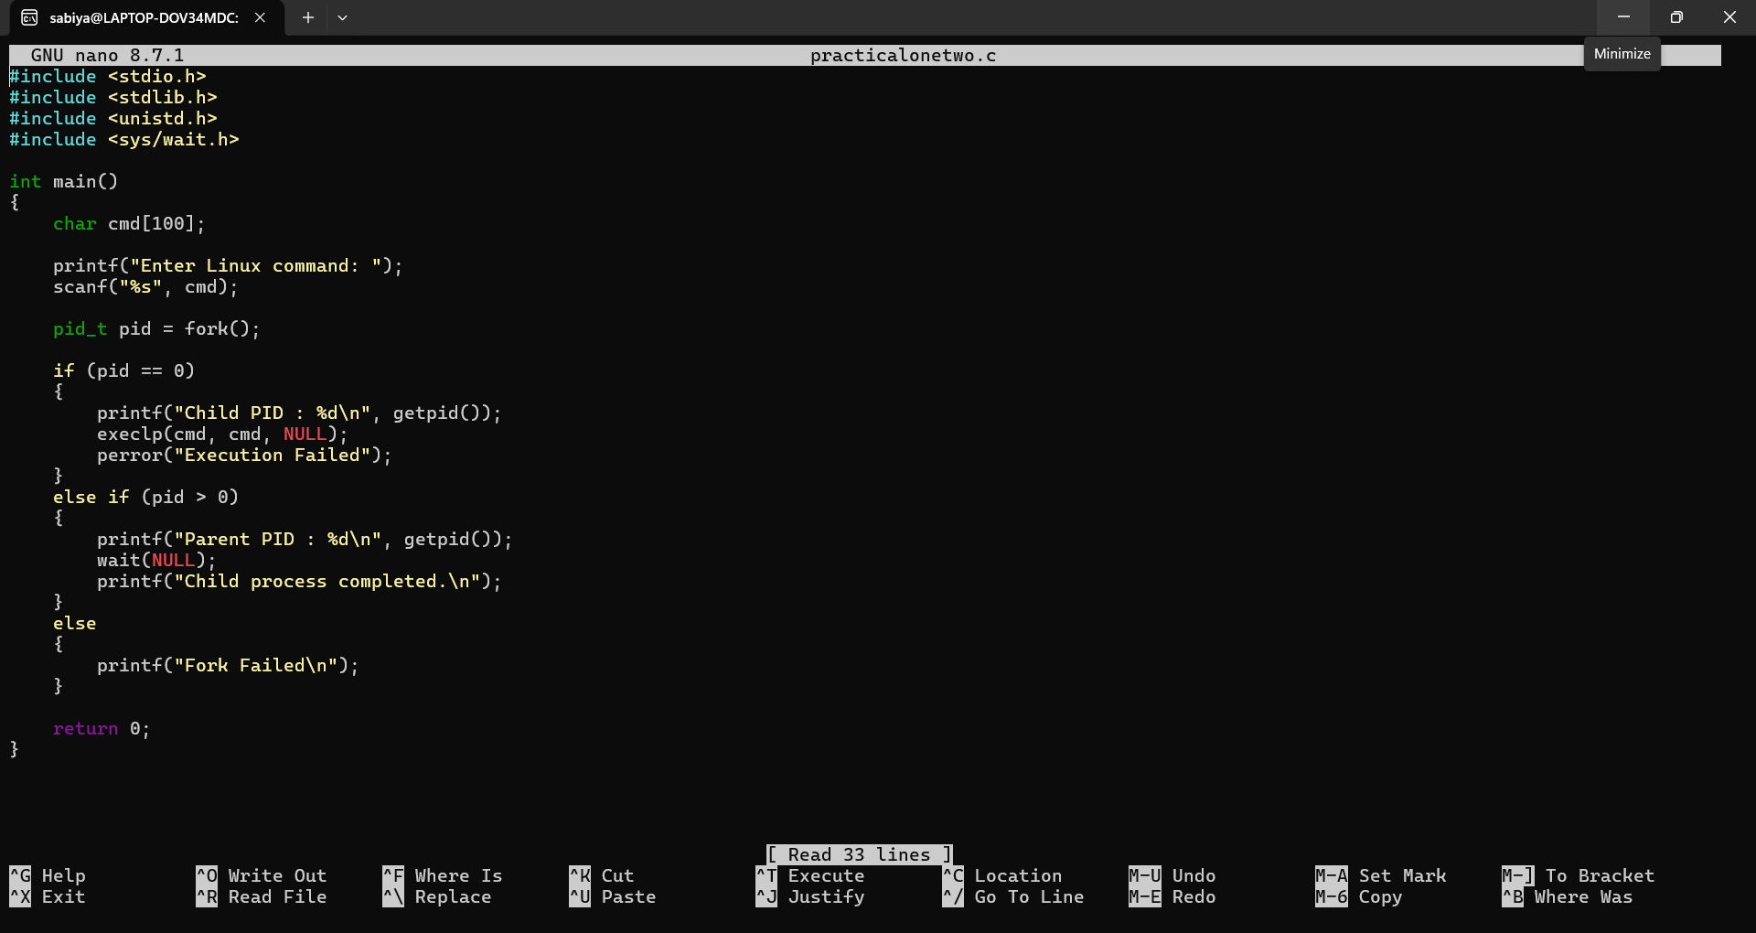

OUTPUT SCREENSHOT:
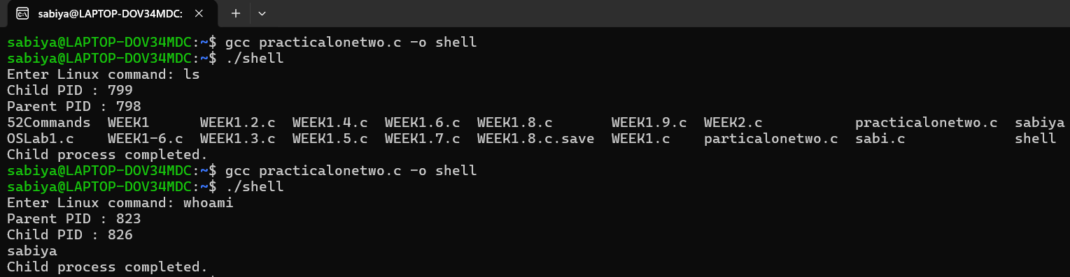

2. copying the contents from one file to another file

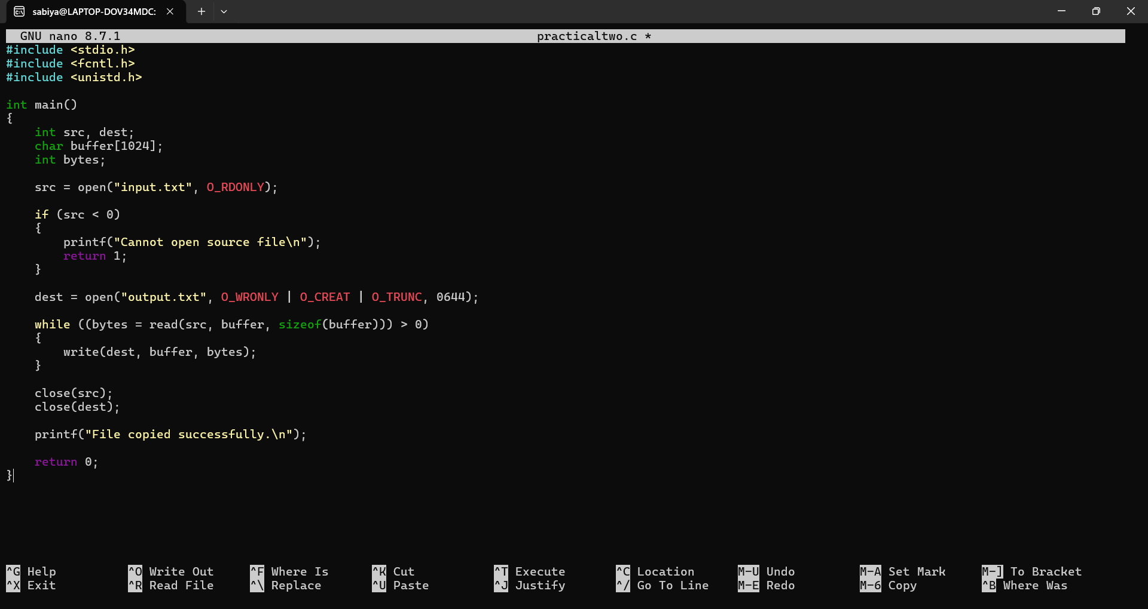

OUTPUT SCREENSHOT:
