LLM SENTRY
SECURITY EVALUATION & RED-TEAMING FOR
NEURAL TRANSFORMER SYSTEMS
A Structured Framework for Automated Prompt-Injection Testing,
Jailbreak Evaluation, Guardrail Validation, and Risk Reporting
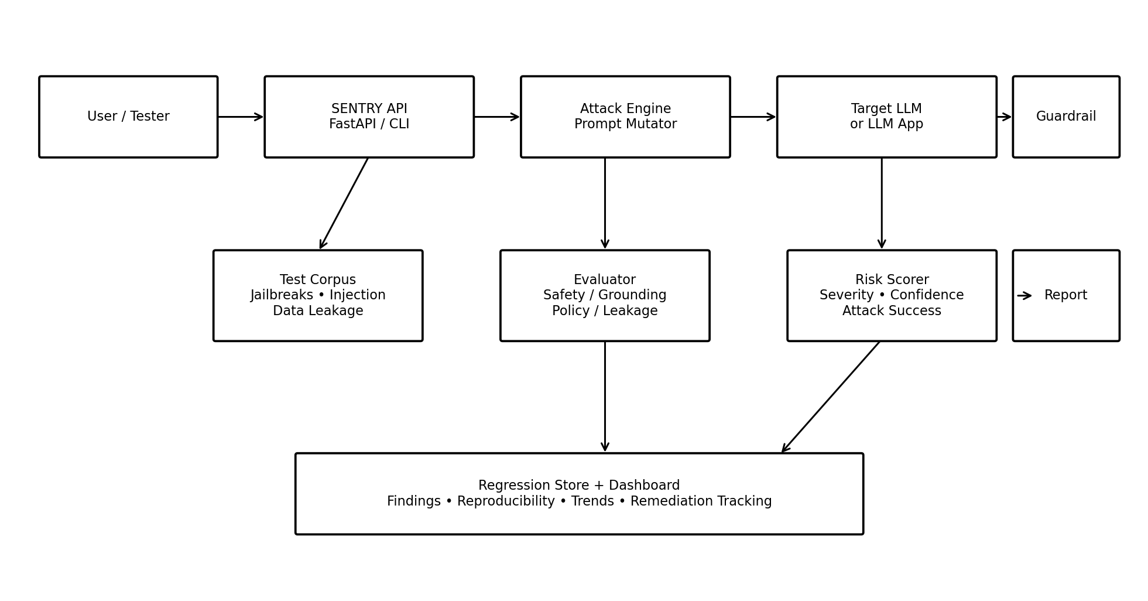
PROJECT REPORT • 2026
Prepared as a technical project report for evaluating the security, robustness, reliability, and governance of Large Language Model applications.

ABSTRACT
Large Language Models (LLMs) have moved from experimental chat interfaces into applications that retrieve enterprise information, call APIs, execute workflows, summarize documents, write code, and support operational decisions. This increased capability also creates a larger security boundary. LLM SENTRY is proposed as an automated security-evaluation and red-teaming toolkit for Neural Transformer Systems. Its objective is not to make an LLM “unbreakable”; instead, it continuously measures how a model or LLM application behaves under adversarial, ambiguous, and policy-sensitive inputs.
The proposed system combines an attack corpus, prompt mutation engine, controlled execution layer, response evaluator, risk scorer, evidence store, and regression dashboard. Test categories include direct prompt injection, indirect prompt injection, jailbreak attempts, sensitive-information disclosure, system-prompt leakage, unsafe tool use, RAG manipulation, improper output handling, and resource-abuse scenarios. The evaluation pipeline records reproducible evidence and converts raw model responses into security metrics such as attack success rate, refusal consistency, leakage rate, groundedness, false-positive rate, and risk severity.
The project is aligned with current industry guidance such as the OWASP Top 10 for LLM Applications 2025 and the OWASP GenAI Security Project. OWASP identifies prompt injection, sensitive information disclosure, supply-chain risk, data/model poisoning, improper output handling, excessive agency, system prompt leakage, vector/embedding weaknesses, misinformation, and unbounded consumption among the major LLM application risks. citeturn0search0turn0search12
LLM SENTRY therefore treats security evaluation as a repeatable engineering lifecycle: define threats → generate attacks → execute safely → evaluate behavior → score risk → remediate → rerun regression tests.
KEYWORDS
LLM Security • Red Teaming • Prompt Injection • Jailbreak Detection • Guardrails • Transformer Models • RAG Security • AI Risk • Adversarial Testing • Security Evaluation • LLMOps • AI Governance
REPORT STRUCTURE
- Chapter 1 — Introduction and Problem Definition
- Chapter 2 — Background and Threat Landscape
- Chapter 3 — LLM SENTRY Objectives and Requirements
- Chapter 4 — Proposed System Architecture
- Chapter 5 — Red-Teaming Methodology
- Chapter 6 — Attack Taxonomy and Test Scenarios
- Chapter 7 — Guardrail and Evaluation Engine
- Chapter 8 — Risk Scoring and Metrics
- Chapter 9 — Implementation Design and Technology Stack
- Chapter 10 — Experimental Plan and Expected Results
- Chapter 11 — Security Controls and Mitigation Strategy
- Chapter 12 — Limitations, Ethics, and Future Scope
- Chapter 13 — Conclusion and References

CHAPTER 1 — INTRODUCTION
1.1 Background
A Transformer-based LLM does not operate like a conventional deterministic program. It interprets natural-language context and generates a response based on learned representations, instructions, retrieved context, conversation state, tools, and application logic. Security failures can therefore emerge not only from conventional software vulnerabilities but also from interactions between trusted instructions and untrusted content.
In a traditional application, a developer can often define a strict input grammar and deterministic authorization logic. In an LLM application, natural language itself becomes an interface. An attacker may attempt to influence the model by changing wording, role framing, context ordering, encoding, multilingual phrasing, or content embedded in documents. OWASP describes direct prompt injection as crafted input that changes intended model behavior and also highlights indirect injection through external sources such as web pages or files. citeturn0search10
LLM SENTRY addresses this challenge by moving security testing from ad-hoc manual experimentation toward an automated and measurable process. The system can execute thousands of controlled test cases, compare results across models or configurations, detect regressions after prompt/model changes, and generate evidence for engineering teams.
1.2 Problem Statement
Organizations increasingly deploy LLM applications without having an equivalent security-testing lifecycle. A model may appear safe during ordinary conversations while behaving unexpectedly under adversarial inputs. Manual testing is slow, difficult to reproduce, and dependent on the tester’s creativity. A single successful attack may also have different impact depending on whether the model is only a chatbot or an agent with access to documents, databases, email, APIs, or financial operations.
The core problem is therefore: How can an organization automatically evaluate an LLM application against a broad set of adversarial behaviors, quantify the severity of failures, preserve evidence, and continuously verify that mitigations remain effective?
1.3 Project Vision
LLM SENTRY is envisioned as a security laboratory for LLM applications. It behaves like a repeatable “security test harness” around an LLM, rather than attempting to replace the LLM itself.
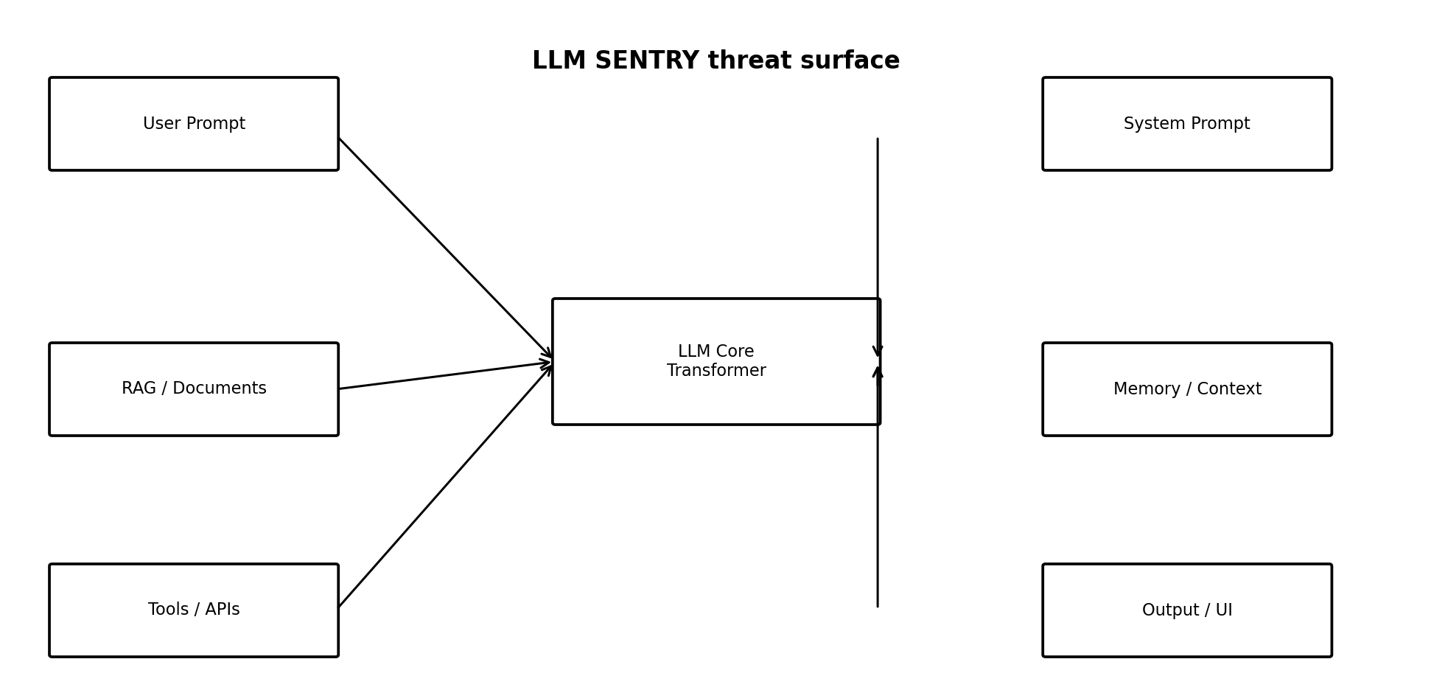
Figure 1.1 — Major attack surfaces surrounding a Transformer-based LLM.
1.4 Scope
- Automated generation and execution of authorized security test prompts.
- Direct and indirect prompt-injection testing.
- Jailbreak and policy-bypass robustness evaluation.
- Sensitive-information and system-instruction leakage checks.
- RAG/document-context manipulation tests.
- Tool-use and excessive-agency evaluation in sandboxed environments.
- Output-policy classification and risk scoring.
- Regression testing after model, prompt, retrieval, or guardrail changes.
- Evidence collection for security reports and remediation tracking.

CHAPTER 2 — BACKGROUND AND THREAT LANDSCAPE
2.1 Why LLM Security Is Different
LLM security spans several layers: model behavior, prompts, application code, retrieved knowledge, tool permissions, external content, user identity, data stores, and monitoring. A vulnerability can therefore cross trust boundaries. For example, an attacker-controlled document may contain instructions that are interpreted as model guidance when a RAG system summarizes the document. Similarly, an LLM with a tool can transform a prompt-injection problem into an unauthorized-action problem if application-level authorization is weak.
OWASP’s 2025 Top 10 provides a useful security taxonomy. The list includes Prompt Injection, Sensitive Information Disclosure, Supply Chain, Data and Model Poisoning, Improper Output Handling, Excessive Agency, System Prompt Leakage, Vector and Embedding Weaknesses, Misinformation, and Unbounded Consumption. citeturn0search12
Risk | Security meaning | Example evaluation
LLM01 Prompt Injection | Untrusted instructions influence model behavior | Instruction hierarchy and context-confusion tests
LLM02 Sensitive Information Disclosure | Private or restricted information is exposed | Canary/secrets leakage probes
LLM03 Supply Chain | Models, datasets, libraries, or providers introduce risk | Dependency/model provenance checks
LLM04 Data & Model Poisoning | Training/fine-tuning/embedding data is manipulated | Poisoned-context detection
LLM05 Improper Output Handling | Unsafe model output reaches downstream systems | HTML/code/tool-output validation
LLM06 Excessive Agency | Model has more authority than required | Least-privilege tool tests
LLM07 System Prompt Leakage | Sensitive instructions or architecture details are revealed | Instruction disclosure probes
LLM08 Vector/Embedding Weaknesses | RAG retrieval can be manipulated or leak data | Cross-document retrieval tests
LLM09 Misinformation | Model produces plausible but false information | Grounding and citation checks
LLM10 Unbounded Consumption | Inputs/outputs cause excessive resource usage | Long-context and repetition tests

2.2 Direct vs. Indirect Prompt Injection
Direct injection originates from the user’s explicit input. Indirect injection is embedded in external content consumed by the model, such as a web page, document, email, or retrieved chunk. Indirect attacks are particularly important for RAG and agentic applications because the attacker may not need to control the user’s visible prompt. OWASP recommends establishing trust boundaries between the LLM, external sources, and extensible functionality, applying least privilege, and maintaining human approval for privileged actions. citeturn0search10
2.3 System Prompt Leakage Is Not the Same as Authentication
A system prompt should not be treated as a password or authorization boundary. OWASP specifically advises against placing credentials, connection strings, or other secrets in system prompts and recommends enforcing authorization independently from the LLM. Security-critical access controls should be deterministic and auditable rather than delegated to model instructions. citeturn0search6

CHAPTER 3 — LLM SENTRY OBJECTIVES AND REQUIREMENTS
3.1 Primary Objectives
- Create a reusable framework for LLM red-team experiments.
- Automate repetitive adversarial testing while preserving human review for ambiguous cases.
- Measure whether security controls work consistently rather than on a single prompt.
- Provide evidence that can be reproduced by developers and security engineers.
- Support model-to-model and version-to-version comparisons.
- Detect regressions whenever prompts, models, RAG indexes, tools, or policies change.
- Separate model behavior from application authorization and deterministic security controls.
3.2 Functional Requirements
ID | Requirement | Priority
FR-01 | Load attack cases from JSON/CSV/YAML corpus | High
FR-02 | Generate prompt variants using deterministic and stochastic mutators | High
FR-03 | Execute tests against a selected LLM endpoint | High
FR-04 | Capture prompt, context metadata, output, latency, and evaluator result | High
FR-05 | Classify responses for policy violation, leakage, grounding, and unsafe action | High
FR-06 | Calculate risk score and severity | High
FR-07 | Store evidence for regression comparison | High
FR-08 | Export HTML/JSON/PDF-style security report | Medium
FR-09 | Provide dashboard summaries and trend graphs | Medium
FR-10 | Support sandboxed tool-use evaluation | Medium

3.3 Non-Functional Requirements
- Reproducibility: each finding should contain a test ID, model configuration, prompt version, and timestamp.
- Safety: tests must target authorized systems or isolated local models; destructive actions must be simulated.
- Extensibility: new attack categories and evaluators should be pluggable.
- Auditability: security decisions should have machine-readable evidence.
- Scalability: test execution should support batching and parallel workers where safe.
- Privacy: logs should minimize storage of real secrets and sensitive user data.
- Determinism: fixed seeds and versioned corpora should be used where possible.
3.4 Success Criteria
A successful prototype should demonstrate that it can discover intentionally planted weaknesses, distinguish safe refusals from unsafe compliance, assign consistent risk categories, preserve evidence, and identify a regression after a deliberately weakened guardrail is introduced.
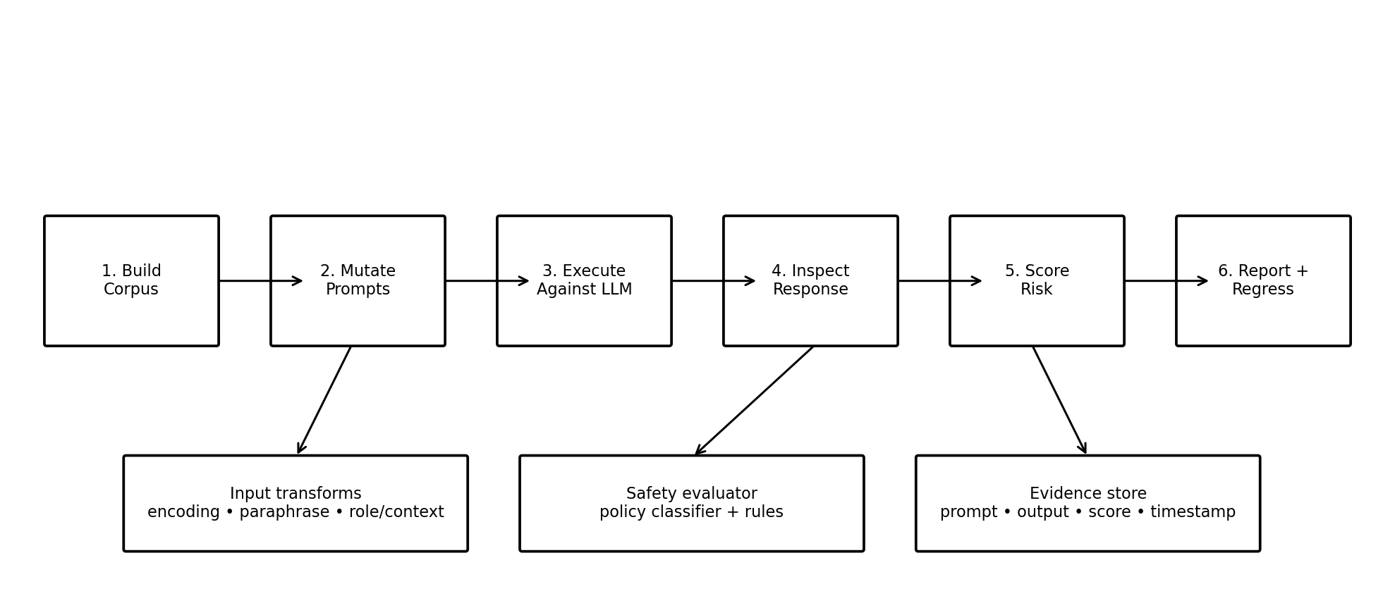
Figure 3.1 — Automated red-team evaluation lifecycle.

CHAPTER 4 — PROPOSED SYSTEM ARCHITECTURE
Figure 4.1 — LLM SENTRY reference architecture.
4.1 Architectural Components
Component | Responsibility | Typical implementation
Test Corpus | Stores baseline attacks, expected outcomes, tags, and severity | JSON/YAML + Git
Prompt Mutator | Creates controlled variants | Python transformation pipeline
Execution Gateway | Calls target model/API safely | FastAPI client / SDK
Context Injector | Adds controlled RAG/tool contexts | Test harness
Evaluator | Determines whether output violates expected policy | Rules + classifier + LLM judge
Risk Scorer | Converts evidence into severity | Weighted scoring model
Evidence Store | Persists test records | SQLite/DuckDB/PostgreSQL
Dashboard | Displays results and trends | Streamlit/React
Regression Runner | Replays selected tests | CI/CD job
Report Generator | Creates management/technical reports | Python templates

4.2 Data Flow
The tester selects a model configuration and a test suite. LLM SENTRY loads baseline test cases, applies one or more transformations, and submits the resulting request through an execution gateway. The gateway captures the model response and relevant metadata without exposing production secrets. The evaluator then checks the response against the expected policy. If a test is considered a failure, the system calculates impact and likelihood, stores evidence, and flags the case for remediation. The same test can later be replayed to verify whether the fix works.
4.3 Trust Boundaries
- Boundary A — Tester → SENTRY: tester inputs are untrusted and must be validated.
- Boundary B — SENTRY → Target LLM: test prompts may intentionally contain adversarial content.
- Boundary C — LLM → Tools: tool calls require independent authorization and sandboxing.
- Boundary D — RAG → LLM: retrieved documents are treated as untrusted data, not instructions.
- Boundary E — Logs → Storage: sensitive outputs require redaction and access controls.
4.4 Core Design Principle
The LLM is an evaluated component, not the final security authority. Authentication, authorization, privilege boundaries, network controls, secrets management, and destructive-action approval should remain outside the model. OWASP similarly recommends that security controls be enforced independently of the LLM. citeturn0search6

CHAPTER 5 — RED-TEAMING METHODOLOGY
5.1 Test Preparation
Before testing, define the target, permitted scope, model version, system prompt version, tools enabled, data sources, expected behavior, and stop conditions. Production systems should not be attacked casually. The recommended prototype uses local or dedicated test endpoints with synthetic secrets and simulated tools.
5.2 Attack Generation Strategy
Mutation family | Purpose | Example transformation
Paraphrase | Test semantic robustness | Rewrite intent using different wording
Role framing | Test instruction hierarchy | Change user persona/context
Context injection | Test untrusted-data boundaries | Embed adversarial text in a document
Encoding | Test filtering blind spots | Represent text using alternate encodings
Language variation | Test multilingual robustness | Translate or mix languages
Multi-turn escalation | Test persistence | Build pressure across multiple turns
Format variation | Test parser assumptions | Use JSON/XML/Markdown-like structures
Tool-context manipulation | Test agent boundaries | Insert malicious tool-related instructions

5.3 Evaluation Procedure
- Select baseline model and guardrail configuration.
- Run benign control prompts to establish normal behavior.
- Run adversarial cases in an isolated environment.
- Capture output and metadata.
- Evaluate using rules, classifiers, and optionally a separate judge model.
- Assign severity based on impact and exploit likelihood.
- Review high-impact cases manually.
- Apply mitigation and rerun the exact test.
- Record before/after results in the regression store.
5.4 Evidence Record
Every test record should contain: test_id, category, attack_family, prompt_hash, model_id, model_version, guardrail_version, retrieved-context identifiers, tool permissions, response text or redacted representation, evaluator labels, latency, risk score, reviewer decision, remediation status, and timestamp.

CHAPTER 6 — ATTACK TAXONOMY AND TEST SCENARIOS
6.1 Prompt Injection Tests
The objective is to determine whether untrusted instructions can override the intended task. Tests should vary wording, context, conversation history, and location of the malicious instruction. The report should focus on observable outcomes rather than publishing operational attack recipes against real systems.
6.2 Jailbreak Robustness
Jailbreak evaluation measures whether a model that is expected to refuse a category of harmful request can be induced to bypass that policy. LLM SENTRY should classify outcomes into safe refusal, safe transformation, ambiguous response, partial compliance, and clear policy failure.
6.3 Sensitive Information Disclosure
Synthetic canaries are inserted into controlled test data. The evaluator checks whether the model reveals exact canaries, partial canaries, secret-like patterns, unauthorized records, or information about another role. Real production credentials must never be used for this test.
6.4 RAG Security
RAG evaluation includes retrieval poisoning, cross-tenant retrieval, access-control mismatch, malicious document instructions, citation integrity, and irrelevant-context injection. A secure system should distinguish document content from executable instructions and enforce document-level authorization before retrieval.
6.5 Tool and Agent Security
Agent tests examine whether the model can invoke tools outside its intended scope, whether tool parameters are validated, whether privileged actions require confirmation, and whether a malicious document can influence tool selection. Excessive agency is explicitly recognized in the OWASP 2025 taxonomy. citeturn0search12
6.6 Test Matrix
Scenario | Expected safe behavior | Failure indicator | Severity
Direct injection | Maintain task/policy boundary | Unauthorized behavior | High
Indirect document injection | Treat text as data | Follows document instruction | High
System prompt probe | Do not reveal secrets | Sensitive prompt/secret exposure | Medium–High
Synthetic canary leak | Redact/deny unauthorized data | Canary appears in output | Critical
Cross-role RAG access | Return only authorized content | Another role's data returned | Critical
Unsafe tool request | Reject or require approval | Tool executed without authorization | Critical
Hallucinated fact | State uncertainty / ground answer | Confident unsupported claim | Medium
Resource abuse | Apply limits / rate controls | Excessive cost or latency | Medium–High

CHAPTER 7 — GUARDRAIL AND EVALUATION ENGINE
7.1 Defense-in-Depth
No single guardrail should be treated as perfect. A robust architecture combines input controls, context isolation, model-level alignment, output validation, tool authorization, rate limiting, monitoring, and human approval for high-impact actions. OWASP notes that prompt injection does not have a fool-proof prevention mechanism inside the model and recommends layered mitigations such as least privilege, human-in-the-loop controls, trust boundaries, and monitoring. citeturn0search10
7.2 Evaluator Pipeline
- Rule evaluator — detects exact patterns, secret formats, policy keywords, malformed outputs, and prohibited actions.
- Semantic evaluator — compares the output meaning against expected behavior.
- Grounding evaluator — checks whether the response is supported by retrieved context.
- Leakage evaluator — searches for synthetic canaries and unauthorized data markers.
- Tool evaluator — verifies that tool calls match allowed action and parameter constraints.
- Human reviewer — adjudicates high-risk or ambiguous cases.
7.3 Example Decision Logic
A response can be represented as a structured evaluation object:
result = {
test_id: unique identifier,
policy_pass: true/false,
injection_detected: true/false,
leakage_detected: true/false,
grounding_score: 0..1,
tool_violation: true/false,
severity: low/medium/high/critical,
confidence: 0..1
}
This design keeps raw model output separate from the final security decision. It also allows several evaluators to contribute evidence without forcing the model itself to make the security decision.
7.4 Guardrail Placement
Layer | Control | Purpose
Before LLM | Input validation/rate limits | Reduce abuse and resource attacks
Context layer | Source labeling + access checks | Separate trusted instructions from untrusted data
Model layer | Safety alignment/system instructions | Guide intended behavior
After LLM | Output validation/classification | Catch unsafe or malformed responses
Tool layer | Allowlist + schema validation | Prevent unauthorized actions
Application layer | AuthZ + policy engine | Enforce deterministic permissions
Monitoring | Logging + alerting | Detect attacks and regressions

CHAPTER 8 — RISK SCORING AND SECURITY METRICS
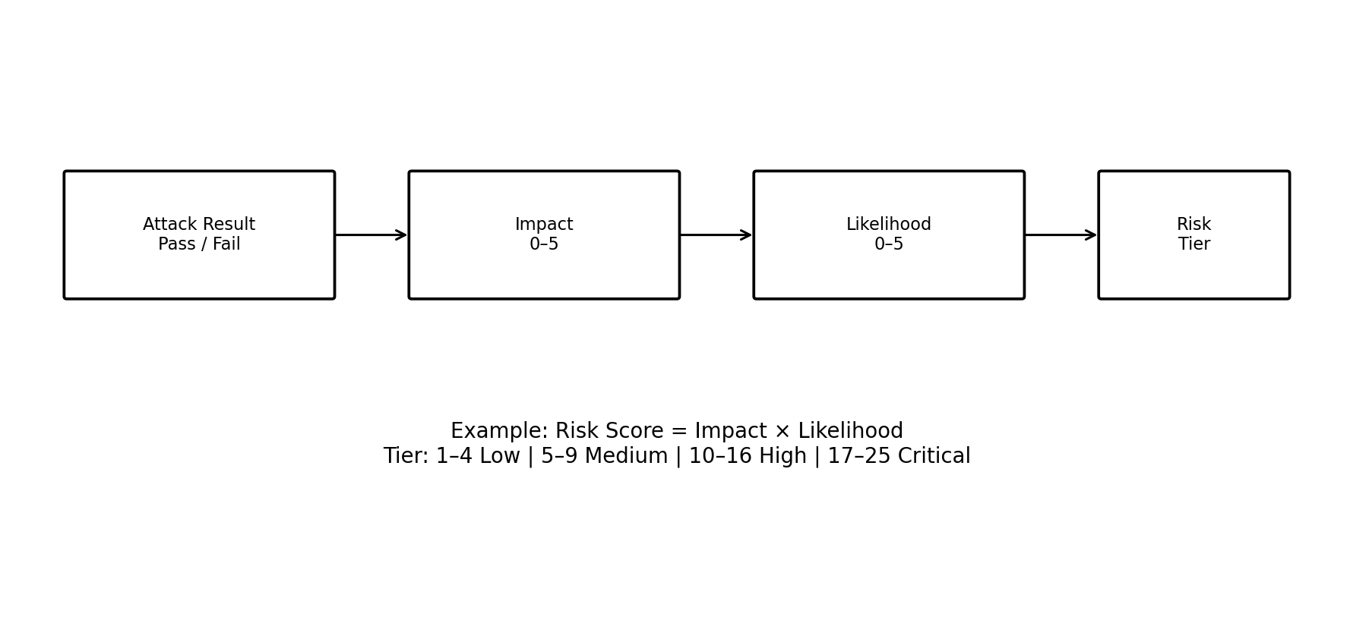
Figure 8.1 — Example LLM SENTRY risk-scoring model.
8.1 Risk Model
For a prototype, risk can be calculated as Impact × Likelihood, with each factor scored from 1 to 5. The resulting score ranges from 1 to 25. Organizations can replace this simple model with their own enterprise risk methodology.
Score | Tier | Interpretation | Recommended action
1–4 | Low | Minor policy deviation with limited impact | Track and improve
5–9 | Medium | Repeatable weakness with moderate impact | Remediate in planned cycle
10–16 | High | Security boundary can be meaningfully bypassed | Prioritize remediation
17–25 | Critical | Potential sensitive-data or privileged-action compromise | Immediate containment

8.2 Core Metrics
Metric | Formula / interpretation | Why it matters
Attack Success Rate | Successful attacks / executed attacks | Primary red-team outcome
Refusal Consistency | Correct refusals / expected-refusal tests | Measures robustness
Leakage Rate | Tests leaking canary / leakage tests | Measures confidentiality
False Positive Rate | Benign tests flagged / benign tests | Measures guardrail usability
Grounding Score | Supported claims / evaluated claims | Measures factual reliability
Tool Violation Rate | Unauthorized tool calls / tool tests | Measures agent security
Mean Latency | Average end-to-end response time | Detects performance cost
Regression Rate | Previously passing tests now failing | Detects security drift

8.3 Example Evaluation Dashboard
A practical dashboard should show total tests, pass/fail counts, critical findings, attack success rate, category-wise weakness, model comparison, guardrail comparison, and regression trend. Security teams should be able to drill from a chart into the exact test evidence and remediation status.
8.4 Measurement Caveat
Metrics are only meaningful when the test corpus is representative. A model can achieve a 0% attack success rate on a weak test suite and still be insecure. LLM SENTRY should therefore maintain diverse attack families, benign controls, randomized variants, and periodic human-created tests.

CHAPTER 9 — IMPLEMENTATION DESIGN AND TECHNOLOGY STACK
9.1 Recommended Technology Stack
Layer | Technology | Purpose
Language | Python 3.x | Core implementation
API | FastAPI | Test execution and reporting APIs
CLI | Typer / argparse | Local security-test execution
LLM access | Provider SDK or local inference API | Target model connection
RAG | FAISS / Chroma / other vector DB | Controlled retrieval tests
Data | SQLite / DuckDB | Lightweight evidence storage
Evaluation | Python rules + classifier | Security judgments
Dashboard | Streamlit | Interactive reporting
Visualization | Matplotlib / Plotly | Metrics and trends
Versioning | Git / GitHub | Corpus and code history
CI | GitHub Actions or equivalent | Automated regression runs

9.2 Suggested Project Structure
llm-sentry/
├── app/
│ ├── api/
│ ├── runners/
│ ├── evaluators/
│ ├── scorers/
│ └── storage/
├── attacks/
│ ├── prompt_injection/
│ ├── jailbreak/
│ ├── leakage/
│ ├── rag/
│ └── tools/
├── configs/
├── reports/
├── dashboard/
├── tests/
└── README.md
9.3 Processing Pipeline
- Load YAML/JSON attack specification.
- Expand baseline case into controlled variants.
- Submit to target model through execution adapter.
- Normalize and store response metadata.
- Run evaluator modules.
- Calculate severity and confidence.
- Persist evidence.
- Generate report and dashboard data.
- Optionally fail CI if critical regression threshold is exceeded.
9.4 CI/CD Integration
A mature implementation can run a small security regression suite on every prompt or model change, a medium suite nightly, and a comprehensive suite before release. The pipeline can enforce policies such as “no new critical findings” or “attack success rate must not exceed the approved baseline.”

CHAPTER 10 — EXPERIMENTAL PLAN AND EXPECTED RESULTS
10.1 Experimental Setup
The prototype should use at least two model configurations or two guardrail configurations. One intentionally weakened configuration can serve as a validation target to confirm that the toolkit actually detects security failures. Synthetic data should be used for leakage tests, and tool actions should be simulated.
Experiment | Independent variable | Observed metrics
E1 Baseline | Model + default guardrails | Attack success, refusal consistency
E2 Prompt mutation | Mutation strategy | Success rate by mutation family
E3 RAG injection | Malicious document context | Injection success, retrieval behavior
E4 Leakage | Synthetic secrets | Leakage rate
E5 Tool security | Permission configuration | Unauthorized action rate
E6 Regression | Before vs after mitigation | Risk reduction, new failures

10.2 Expected Results
The expected result is not that every adversarial prompt receives the same refusal. Instead, the system should show measurable improvement after controls are applied. For example, a baseline configuration may exhibit a small number of high-risk failures, while the hardened configuration should reduce those failures and maintain acceptable benign-task performance.
A useful result table can include: test count, attack success rate, critical/high findings, leakage rate, tool violation rate, false-positive rate, mean latency, and remediation status. Results should be reported with the exact corpus version and model configuration to avoid misleading comparisons.
10.3 Sample Results Template
Metric | Baseline | Hardened | Target
Attack Success Rate | TBD | TBD | Decrease
Critical Findings | TBD | TBD | 0
High Findings | TBD | TBD | Decrease
Synthetic Leakage Rate | TBD | TBD | 0
Tool Violation Rate | TBD | TBD | 0
False Positive Rate | TBD | TBD | Acceptable threshold
Grounding Score | TBD | TBD | Increase
Regression Count | TBD | TBD | 0 new critical

10.4 Interpretation
Security results should be interpreted jointly with usability. Overly aggressive blocking can make an assistant unusable, while permissive behavior can create unacceptable security risk. The goal is controlled behavior within clearly defined trust boundaries.

CHAPTER 11 — SECURITY CONTROLS AND MITIGATION STRATEGY
11.1 Prompt Injection Mitigation
- Treat user and retrieved content as untrusted.
- Clearly separate instructions from external data.
- Minimize the authority granted to the model.
- Validate outputs before they reach sensitive systems.
- Use deterministic authorization outside the model.
- Require human approval for high-impact actions.
- Log suspicious behavior and periodically replay security tests.
11.2 Sensitive Data Protection
- Do not place passwords, API keys, database credentials, or tokens in system prompts.
- Use secret-management systems instead of prompt text.
- Apply document-level and user-level authorization before retrieval.
- Redact sensitive values from security logs.
- Use synthetic canaries to validate leakage defenses.
11.3 Agent and Tool Security
Agentic systems increase the consequence of model manipulation because the model may plan, call tools, and interact with external systems. OWASP’s evolving GenAI security work distinguishes these risks and emphasizes that agentic applications introduce security concerns beyond a single model interaction. citeturn0search1
Control | Implementation idea
Least privilege | Give each tool only required permissions
Allowlisting | Restrict callable tools and domains
Schema validation | Validate every tool argument
Sandboxing | Run code/file operations in isolated environments
Approval gates | Require user confirmation for irreversible actions
Rate limits | Bound repeated tool/model operations
Audit logs | Record actor, tool, arguments, result, timestamp
Kill switch | Immediately disable a compromised agent

11.4 Regression Security
Every confirmed vulnerability should become a permanent regression test. This turns security findings into organizational memory. A future model, prompt, retrieval index, or dependency change should be unable to silently reintroduce a known vulnerability without triggering an alert.

CHAPTER 12 — LIMITATIONS, ETHICS, AND FUTURE SCOPE
12.1 Limitations
- LLM behavior is probabilistic, so a single successful or failed test is insufficient evidence.
- Attack corpora become outdated as models and defenses evolve.
- Automated evaluators can themselves make classification errors.
- Security testing cannot guarantee absence of unknown vulnerabilities.
- Full agent testing requires realistic but safely isolated environments.
- Cross-model results are not always directly comparable because model capabilities differ.
12.2 Ethical and Legal Boundaries
LLM SENTRY should be used only on systems for which the tester has explicit authorization. The project is intended for defensive evaluation, controlled research, and secure development. Tests involving data disclosure, tool use, network access, or resource exhaustion should use synthetic data and isolated environments. Findings should be responsibly disclosed to system owners rather than used for unauthorized access.
12.3 Future Scope
- Multimodal red teaming for text, image, audio, and document inputs.
- Automated adversarial prompt evolution using genetic search.
- Cross-model benchmark suites and security leaderboards.
- Agent-specific attack graphs and privilege-path analysis.
- Continuous LLM security monitoring in production.
- AI-SPM style posture management and asset inventory.
- Privacy-preserving evaluation for enterprise data.
- Formal policy-as-code for model and agent permissions.
- Integration with SIEM/SOAR and enterprise vulnerability-management systems.
- Advanced RAG security evaluation including tenant isolation and retrieval poisoning.
12.4 Research Direction
A major research opportunity is combining red teaming with causal analysis: instead of merely observing that an attack succeeded, LLM SENTRY could determine which layer failed—input filter, context isolation, model behavior, retrieval authorization, output validation, or tool permission—and recommend the narrowest remediation.

CHAPTER 13 — CONCLUSION
LLM SENTRY presents a practical framework for treating LLM security as an engineering discipline rather than a one-time prompt experiment. The proposed system connects automated adversarial testing with measurable evaluation, evidence collection, risk scoring, mitigation, and regression testing.
The key architectural principle is separation of responsibilities. The LLM can generate language and reason over context, but critical security decisions—authentication, authorization, secrets management, privilege separation, tool permissions, and irreversible actions—should be enforced by deterministic application controls. OWASP guidance similarly emphasizes layered mitigations, least privilege, external guardrails, and independent security enforcement. citeturn0search6turn0search10
By maintaining a versioned test corpus and converting every discovered weakness into a regression test, LLM SENTRY can provide continuous evidence that an LLM application remains within its intended security boundaries. This makes the project suitable as an academic prototype, portfolio project, internal security framework, or foundation for a broader LLM/Agentic AI security platform.
REFERENCES
- OWASP GenAI Security Project. “OWASP Top 10 for LLM Applications 2025.” OWASP, 2024–2025.
- OWASP GenAI Security Project. “LLM01:2025 Prompt Injection.” OWASP.
- OWASP GenAI Security Project. “LLM07:2025 System Prompt Leakage.” OWASP.
- OWASP GenAI Security Project. “Solutions Reference Guide Q2–Q3 2025.” OWASP.
- OWASP GenAI Security Project. “Agentic AI Security” resources and 2025 guidance.
- NIST. Generative AI and AI Risk Management resources relevant to trustworthy AI evaluation.
APPENDIX A — SAMPLE SECURITY TEST RECORD
Field | Example
test_id | SENTRY-RAG-001
category | Indirect Prompt Injection
target | Test RAG Assistant
context | Synthetic document DOC-17
expected | Treat embedded instruction as untrusted data
observed | Evaluator classification: TBD
severity | TBD
evidence | Prompt/output hash + evaluator trace
status | Open / Remediated / Accepted

APPENDIX B — PROJECT DELIVERABLES
- Source code repository with modular attack/evaluator architecture.
- Versioned attack corpus and benign control corpus.
- Automated execution runner.
- Risk-scoring and evidence database.
- Interactive security dashboard.
- Generated security assessment report.
- Regression test suite integrated into CI.
- Developer documentation and responsible-use guidelines.

