**Code (Android App for HAR)**

* Results

Every Activity has a type and will be detected by this terminology: -

1. IN_VEHICLE (If the device is in moving Vehicle)
2. ON_BICYCLE
3. ON_FOOT
4. STILL
5. TILTING
6. UNKNOWN (This is shown when users activity is not detected / recognised)
7. WALKING (This is sub type of ON_FOOT)
8. RUNNING (This is sub type of ON_FOOT)
9. INVALID (used for parsing errors)

A number ranging from 0 – 100 is shown which is the accuracy / confidence level.

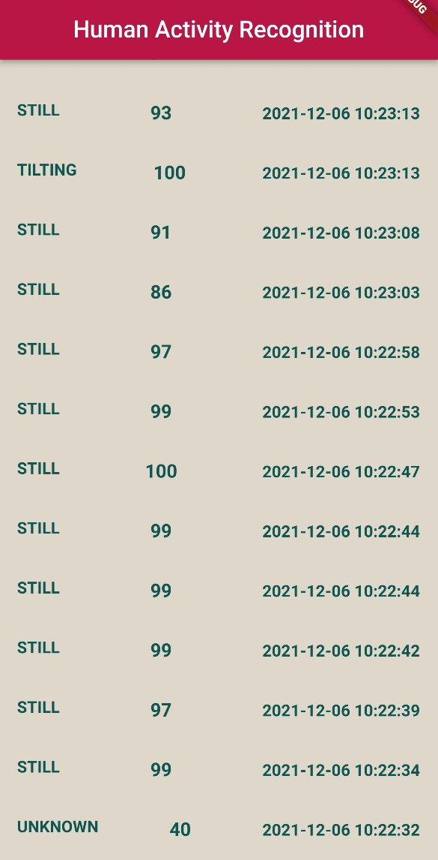



Double Click the VLC Media Icon to play the video

**Code (TensorFlow for HAR with LSTM)**

* Results

1. The Bar Graph represents a chart between Number of Users & Activity type.

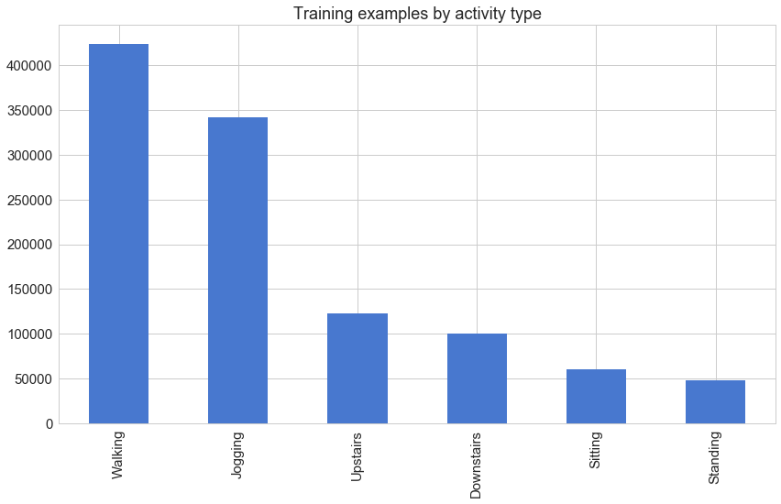

1. The Line graph represents Activity and axis (Based on accelerometer): - Standing, Walking, Sitting, Jogging.

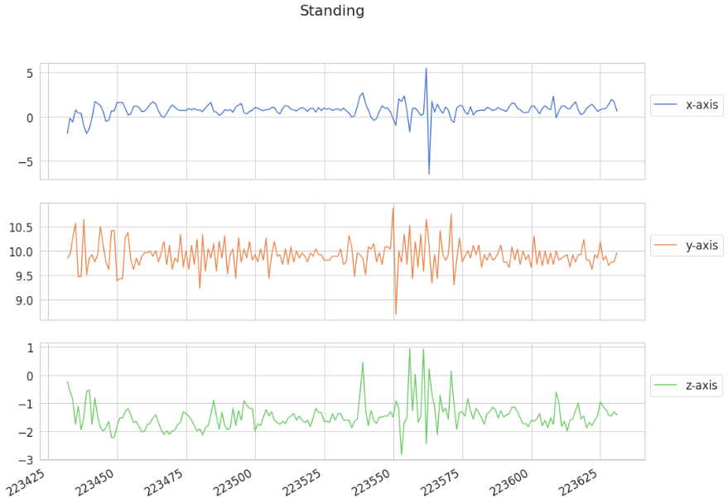

1. Model contains 2 LSTM Layers stacked on each other and then the data is trained up to 50 epochs and hence we observe the test accuracy increase from 0.77 to 0.94 and loss decreasing from 1.27 to 0.25

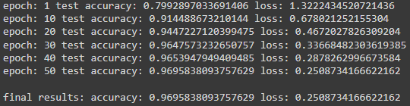

1. At last, we plot the graph between Training Accuracy and Loss and also Test Accuracy and loss and observe the deviations. Our model seems to learn well with accuracy reaching above 97% and loss hovering at around 0.2.

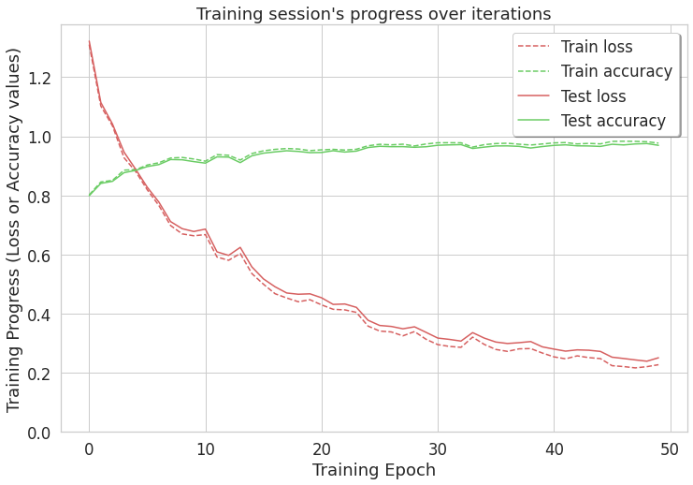

1. A confusion matrix is made between activities predicted and true.

