


BACHELOR OF TECHNOLOGY
IN
COMPUTER SCIENCE AND ENGINEERING
Department of Computer Science and Engineering
School of Computing
MOHAN BABU UNIVERSITY

Sree

Sainath

Nagar,

Tirupati

-

517102
Under the Esteemed Supervision of
A Capstone Project Report submitted to
MOHAN BABU UNIVERSITY
Dr. K. Hari Krishna_{(M.Tech,Ph.D.)}

Associate Professor Department Of CSE

2025-26
Robust Image Steganography Framework Using Edge Detection and CNN for Secure Data Hiding

In partial fulfilment of the requirements for the

award of the degree of
Submitted

by
Murali Reddy Lavanya
Patnam Nithin
Reddy Vari Teja Reddy
Shaik Mohammad Tayeeb
22102A040178
22102A040204
22102A040226
22102A040246
Robust Image Steganography Framework Using Edge Detection and CNN for Secure Data Hiding

A Capstone Project Report submitted to
Mohan Babu University, Tirupati
In partial fulfilment of the requirements for the award of the degree of
BACHELOR OF TECHNOLOGY
IN
COMPUTER SCIENCE AND ENGINEERING

Submitted by
Murali Reddy Lavanya 22102A040178
Patnam Nithin 22102A040204
Reddy Vari Teja Reddy 22102A040226
Shaik Mohammad Tayeeb 22102A040246

Under the Esteemed Supervision of
Dr. K. Hari Krishna_{(M.Tech,Ph.D.)}
Associate Professor
Department of CSE


Department of Computer Science and Engineering
School of Computing
Mohan Babu University
Sree Sainath Nagar, Tirupati – 517 102
2025 – 2026
DEPARTMENT OF COMPUTER SCIENCE AND ENGINEERING

Certificate

This is to certify that the Capstone Project report titled “Robust Image Steganography Framework Using Edge Detection and CNN for Secure Data Hiding” is the Bonafide work done by

Murali Reddy Lavanya 22102A040176
Patnam Nithin 22102A040204
Reddy Vari Teja Reddy 22102A040226
Shaik Mohammad Tayeeb 22102A040246

in the Department of Computer Science and Engineering, and submitted to Mohan Babu University, Tirupati in partial fulfilment of the requirements for the award of the degree of Bachelor of Technology in Computer Science and Engineering during the academic year 2025-2026.
This is work has been carried out under my guidance and supervision. The results embodied in this project report have not been submitted in any University or Organization for the award of any degree or diploma.
INTERNAL EXAMINER EXTERNAL EXAMINER
Supervisor: | Head:
Dr.K. Hari Krishna  Associate Professor  Dept. of CSE | Dr. G. Sunitha  Professor & Head  Dept. of CSE

ACKNOWLEDGEMENT

We are extremely thankful to our beloved Chancellor, Dr. M.Mohan Babu garu, for his inspiration and unwavering commitment to academic growth and student development.
We express sincere gratitude to our Pro-Chancellor, Sri Vishnu Manchu garu, his constant encouragement and visionary leadership in fostering a culture of learning and excellence.
We express sincere gratitude to our Honorable Vice-Chancellor, Prof. P.V. Ramana garu, for his valuable guidance, encouragement, and continuous support in all academic endeavours.
We are highly indebted to Dr. Babu Devasenapathy, Dean-School of Engineering & Computing for his valuable support and guidance in all the academic matters.
We are deeply obliged to Dr. G. Sunitha, Professor & Head, Department of CSE, for her motivation, insightful guidance, and persistent encouragement.
We would like to extend heartfelt thanks to the supervisor. Dr. K. Hari Krishna, Associate Professor, Department of CSE, for the consistent support, insightful guidance, and constructive feedback provided during the project work.

Murali Reddy Lavanya 22102A040176
Patnam Nithin 22102A040204
Reddy Vari Teja Reddy 22102A040226
Shaik Mohammad Tayeeb 22102A040246

DECLARATION

We hereby declare that this capstone project report titled “Robust Image Steganography Framework Using Edge Detection and CNN for Secure Data Hiding ” is a genuine project work carried out by us, in B.Tech. (Computer Science and Engineering) degree course of Mohan Babu University, Tirupati and has not been submitted to any other course or University for the award of any degree by us.

Murali Reddy Lavanya 22102A040176
Patnam Nithin 22102A040204
Reddy Vari Teja Reddy 22102A040226
Shaik Mohammad Tayeeb 22102A040246

Vision
To be a globally respected institution with an innovative and entrepreneurial culture that offers transformative education to advance sustainability and societal good.
Mission
- Develop industry-focused professionals with a global perspective.
- Offer academic programs that provide transformative learning experience founded on the spirit of curiosity, innovation, and integrity.
- Create confluence of research, innovation, and ideation to bring about sustainable and socially relevant enterprises.
- Uphold high standards of professional ethics leading to harmonious relationship with environment and society.

SCHOOL OF COMPUTING
Vision
To lead the advancement of computer science research and education that has real-world impact and to push the frontiers of innovation in the field.
Mission
- Instil within our students fundamental computing knowledge, a broad set of skills, and an inquisitive attitude to create innovative solutions to serve industry and community.
- Provide an experience par excellence with our state-of-the-art research, innovation, and incubation ecosystem to realise our learners’ fullest potential.
- Impart continued education and research support to working professionals in the computing domain to enhance their expertise in the cutting-edge technologies.
- Inculcate among the computing engineers of tomorrow with a spirit to solve societal challenges.

DEPARTMENT OF COMPUTER SCIENCE AND ENGINEERING
Vision
To become a Centre of Excellence in Computer Science and its emerging areas by imparting high quality education through teaching, training and research.

Mission
- Imparting quality education in Computer Science and Engineering and emerging areas of IT industry by disseminating knowledge through contemporary curriculum, competent faculty and effective teaching-learning methodologies.
- Nurture research, innovation and entrepreneurial skills among faculty and students to contribute to the needs of industry and society.
- Inculcate professional attitude, ethical and social responsibilities for prospective and promising engineering profession.
- Encourage students to engage in life-long learning by creating awareness of the contemporary developments in Computer Science and Engineering and its emerging areas.

B.Tech. Computer Science and Engineering
PROGRAM EDUCATIONAL OBJECTIVES
After few years of graduation, the graduates of B.Tech. CSE will be:
- Pursuing higher studies in core, specialized or allied areas of Computer Science, or Management.
- Employed in reputed Computer and I.T organizations or Government to have a globally competent professional career in Computer Science and Engineering domain or be successful Entrepreneurs.
- Able to demonstrate effective communication, engage in teamwork, exhibit leadership skills and ethical attitude, and achieve professional advancement through continuing education.

PROGRAM OUTCOMES
On successful completion of the Program, the graduates of B.Tech. CSE Program will be able to:
- Engineering Knowledge: Apply the knowledge of mathematics, science, engineering fundamentals, and an engineering specialization to the solution of complex engineering problems.
- Problem Analysis: Identify, formulate, review research literature, and analyze complex engineering problems reaching substantiated conclusions using first principles of mathematics, natural sciences, and engineering sciences.
- Design/Development of Solutions: Design solutions for complex engineering problems and design system components or processes that meet the specified needs with appropriate consideration for the public health and safety, and the cultural, societal, and environmental considerations.
- Conduct Investigations of Complex Problems: Use research-based knowledge and research methods including design of experiments, analysis and interpretation of data, and synthesis of the information to provide valid conclusions.
- Modern Tool Usage: Create, select, and apply appropriate techniques, resources, and modern engineering and IT tools including prediction and modeling to complex engineering activities with an understanding of the limitations.
- The Engineer and Society: Apply reasoning informed by the contextual knowledge to assess societal, health, safety, legal and cultural issues and the consequent responsibilities relevant to the professional engineering practice.
- Environment and Sustainability: Understand the impact of the professional engineering solutions in societal and environmental contexts, and demonstrate the knowledge of, and need for sustainable development.
- Ethics: Apply ethical principles and commit to professional ethics and responsibilities and norms of the engineering practice.
- Individual and Team Work: Function effectively as an individual, and as a member or leader in diverse teams, and in multidisciplinary settings.
- Communication: Communicate effectively on complex engineering activities with the engineering community and with society at large, such as, being able to comprehend and write effective reports and design documentation, make effective presentations, and give and receive clear instructions.
- Project Management and Finance: Demonstrate knowledge and understanding of the engineering and management principles and apply these to one’s own work, as a member and leader in a team, to manage projects and in multidisciplinary environments.
- Life-long Learning: Recognize the need for, and have the preparation and ability to engage in independent and life-long learning in the broadest context of technological change.

PROGRAM SPECIFIC OUTCOMES
On successful completion of the Program, the graduates of B. Tech. (CSE) program will be able to:
PSO1. Apply knowledge of computer science engineering, Use modern tools, techniques and technologies for efficient design and development of computer-based systems for complex engineering problems.
PSO2. Design and deploy networked systems using standards and principles, evaluate security measures for complex networks, apply procedures and tools to solve networking issues.
PSO3. Develop intelligent systems by applying adaptive algorithms and methodologies for solving problems from inter-disciplinary domains.
PSO4. Apply suitable models, tools and techniques to perform data analytics for effective decision making.

Course Code | Course Title | L | T | P | S | C
22CS108001 | Capstone Project | - | - | - | - | 10

COURSE OUTCOMES: After successful completion of this course, the students will be able to:
CO1. Create/Design computer science engineering systems or processes to solve complex computer science engineering and allied problems using appropriate tools and techniques following relevant standards, codes, policies, regulations and latest developments.
CO2. Consider society, health, safety, environment, sustainability, economics and project management in solving complex computer science engineering and allied problems.
CO3. Perform individually or in a team besides communicating effectively in written, oral and graphical forms on computer science engineering systems or processes.

CO-PO-PSO Mapping Table:
Course Outcome | Program Outcomes |  |  |  |  |  |  |  |  |  |  |  | Program Specific Outcomes
Course Outcome | PO1 | PO2 | PO3 | PO4 | PO5 | PO6 | PO7 | PO8 | PO9 | PO10 | PO11 | PO12 | PSO1 | PSO2 | PSO3 | PSO4
CO1 | 3 | 3 | 3 | 3 | 3 |  |  | 3 |  |  |  | 3
CO2 |  |  |  |  |  | 3 | 3 |  |  |  | 3
CO3 |  |  |  |  |  |  |  |  | 3 | 3
Correlation Level: 3-High; 2-Medium; 1-Low
TABLE OF CONTENTS
Chapter | Page no
Abstract | 1
List of Acronyms | 2
List of Figures | 3
List of Tables | 4
Chapter 1 Introduction | 5
1.1 Introduction | 5
1.2 Problem Statement | 6
1.3 Objectives | 8
1.4 Scope | 9
1.5 Applications | 11
1.6 Limitations | 13
Chapter 2 Literature Survey | 14
2.1 Introduction to Literature Survey | 14
2.2 Review of Existing Methods | 15
2.3 Literature Survey Table | 16
2.4 Research Gaps Identified | 17
2.5 Summary | 17
Chapter 3 Analysis & Design | 19
3.1 Introduction | 19
3.2 System Architecture | 20
3.3 Edge Detection Process | 21
3.4 CNN-Based Embedding and Extraction | 22
3.5 Workflow of the Proposed System | 23
3.6 Summary | 24
Chapter 4 Implementation | 26
4.1 Introduction | 26
4.2 Software and Hardware Requirements | 27
4.3 Data Preprocessing | 28
4.4 Embedding Process Using CNN | 29
4.5 Extraction Process | 30
4.6 Summary | 31
Chapter 5 Execution Procedure and Testing | 32
5.1 Introduction | 32
5.2 Execution Procedure | 33
5.3 Testing Methodology | 35
5.4 Input and Output Analysis | 38
5.5 Summary | 39
Chapter 6 Results & Performance Evaluation | 41
6.1 Introduction | 41
6.2 Performance Metrics | 42
6.3 Experimental Results | 44
6.4 Results Table | 45
6.5 Performance Analysis | 46
6.6 Summary | 48
Chapter 7 Conclusions and Future Work | 50
7.1 Conclusions | 50
7.2 Future Work | 51
References | 55
Research Papers Published | 57

ABSTRACT
In the modern digital era, secure communication has become increasingly important due to the rapid growth of data exchange over the internet. Image steganography is an effective technique that hides secret information within digital images to prevent unauthorized access. However, traditional methods such as Least Significant Bit (LSB) embedding suffer from low robustness, limited security, and vulnerability to steganalysis attacks.
To address these challenges, this project proposes a robust image steganography framework that integrates edge detection with Convolutional Neural Networks (CNN). Edge detection techniques such as Canny and Sobel are used to identify high-frequency regions in the cover image, where embedding is less noticeable to the Human Visual System (HVS). A CNN-based encoder–decoder architecture is then employed to optimize the embedding and extraction processes, ensuring minimal distortion and accurate data recovery.
The performance of the proposed system is evaluated using metrics such as Peak Signal-to-Noise Ratio (PSNR) and Structural Similarity Index (SSIM), demonstrating high imperceptibility and robustness against common image processing attacks. The results indicate that the proposed method provides a secure, efficient, and reliable solution for modern data hiding applications.

List of Acronyms

Acronym | Definition
CNN | Convolution Neural Network
HVS | Structural Similarity Index
LSB | Least Significant Bit
PSNR | Peak Signal-to-Noise Ratio
SSIM | Structural Similarity Index
MSE | Mean Squared Error
RMSE | Root Mean Squared Error
IF | Image Fidelity
BPP | Bits Per Pixel
BER | Bit Error Rate
PNG | Portable Network Graphics
ECC | Error Correction Code
RGB | Red Green Blue
JPEG | Joint Photographic Experts Group
HED | Holistically Nested Edge Detection

List of Figures

Figure No. | Description | Page No.
3.1 | Basic Image Steganography Process | 20
3.2 | Edge Detection using Canny and Sobel Operators | 22
3.3 | Workflow of the Proposed Steganography System | 23
4.1 | Embedding Process Using CNN | 29
4.2 | Extraction Process of Secret Data from Stego Image | 30
5.1 | Comparison of Cover Image and Stego Image | 38
6.1 | PSNR Performance Analysis Graph | 43
6.2 | SSIM Performance Analysis Graph | 44

List of Tables

Table No. | Description | Page No.
2.1 | Literature Survey of Image Steganography Techniques | 16
4.1 | Software and Hardware Requirements | 27
6.1 | Performance Metrics Used for Evaluation | 42
6.2 | Experimental Results of PSNR and SSIM Values | 45

CHAPTER 1
INTRODUCTION
  - Introduction
In the modern digital era, the rapid growth of internet usage and multimedia communication has significantly increased the need for secure data transmission. Images are one of the most widely shared forms of digital content across social media platforms, cloud storage systems, and communication networks. Ensuring the confidentiality and integrity of sensitive information has become a major concern in such environments.
Steganography is a technique used to hide secret information within a cover medium such as an image, audio, or video, in such a way that the presence of the hidden data is not noticeable. Unlike cryptography, which only encrypts the content, steganography conceals the existence of the message itself. Image steganography, in particular, embeds secret data into digital images, producing a stego image that appears visually identical to the original.
Traditional steganography methods, such as Least Significant Bit (LSB) substitution, are simple and provide good visual quality. However, they suffer from several limitations, including low robustness, poor resistance to image processing attacks, and vulnerability to steganalysis techniques. These challenges make them unsuitable for modern secure communication systems.
To overcome these limitations, this project proposes a robust image steganography framework that integrates edge detection techniques with Convolutional Neural Networks (CNN). Edge detection methods such as Canny and Sobel are used to identify high-frequency regions in the image, where embedding is less perceptible to the Human Visual System (HVS). A CNN-based encoder–decoder architecture is then employed to optimize the embedding and extraction processes, ensuring high security, improved robustness, and minimal distortion.

1.2 Problem Statement
Traditional image steganography techniques such as LSB embedding fail to provide an effective balance between imperceptibility, robustness, and security. These methods embed data uniformly across the image, which can lead to noticeable distortion and make the hidden data vulnerable to detection.
Moreover, the embedded data can be easily corrupted or lost when the stego image undergoes common image processing operations such as compression, noise addition, and filtering. Existing approaches also lack adaptability, as they do not consider image characteristics such as edges and textures while selecting embedding locations.
In the current digital era, the rapid growth of internet-based communication has significantly increased the need for secure data transmission. A large amount of sensitive information, including personal data, financial records, and confidential communications, is transmitted through digital media such as images. However, ensuring the security and confidentiality of such information remains a major challenge due to the increasing risk of cyber-attacks, unauthorized access, and data interception. Traditional security methods, particularly cryptography, focus on encrypting the content of the message, but they do not conceal the existence of the communication itself, making them vulnerable to detection and potential attacks.
Image steganography has emerged as an effective solution to this problem by hiding secret information within digital images. However, conventional steganography techniques, especially Least Significant Bit (LSB)-based methods, suffer from several limitations. These methods typically embed data uniformly across the image without considering the structural properties of the image, leading to noticeable distortions and reduced imperceptibility. Additionally, such techniques are highly susceptible to steganalysis, as predictable embedding patterns can be easily detected using statistical or machine learning-based approaches.
Another critical issue with traditional approaches is their lack of robustness against common image processing operations such as compression, noise addition, filtering, and resizing. During transmission or storage, images often undergo these transformations, which can corrupt or destroy the embedded data. This significantly limits the reliability of existing steganography systems, particularly in real-world applications where data integrity is crucial.
Furthermore, existing methods often fail to achieve an optimal balance between key performance parameters such as embedding capacity, imperceptibility, and security. Increasing the amount of embedded data typically leads to higher distortion, while focusing on image quality may reduce the amount of data that can be hidden. This trade-off presents a major challenge in designing efficient steganography systems.
In addition, most traditional techniques do not utilize intelligent or adaptive mechanisms for selecting embedding locations. They lack the ability to analyze image characteristics, such as edges and textures, which play a vital role in minimizing visual impact. As a result, there is a need for an advanced and adaptive approach that can intelligently determine suitable regions for embedding while maintaining image quality.
To address these challenges, there is a strong need for a robust and intelligent image steganography framework that integrates advanced techniques such as edge detection and deep learning. By identifying high-frequency regions in images and leveraging the learning capability of Convolutional Neural Networks (CNN), it is possible to improve imperceptibility, enhance robustness against attacks, and ensure accurate data recovery. Therefore, the problem lies in designing a system that can securely embed and extract data while maintaining a balance between image quality, security, and embedding capacity in diverse real-world conditions.
Therefore, there is a need for a robust and intelligent steganography framework that can:
- Identify suitable embedding regions
- Minimize visual distortion
- Improve resistance against attacks
- Ensure accurate data recovery

1.3 Objectives
The main objective of this project is to design and develop a robust image steganography framework using edge detection and Convolutional Neural Networks (CNN) for secure data hiding.
The primary objective of this project is to design and develop a robust and intelligent image steganography system that ensures secure data hiding while maintaining high image quality. The proposed system aims to overcome the limitations of traditional steganography techniques by integrating edge detection methods with advanced deep learning models such as Convolutional Neural Networks (CNN). The goal is to create a framework that can efficiently embed and extract secret data without introducing noticeable distortion in the cover image.
One of the key objectives is to utilize edge detection techniques such as Canny and Sobel to identify high-frequency regions within an image. These regions are less sensitive to visual changes and therefore provide suitable locations for embedding secret data. By selectively embedding information in these areas, the system aims to enhance imperceptibility while maintaining sufficient embedding capacity. This approach ensures that the hidden data remains undetectable to the human visual system.
Another important objective is to develop a CNN-based encoder–decoder architecture that can intelligently learn optimal embedding and extraction patterns. The encoder is responsible for embedding the secret data into the cover image, while the decoder accurately retrieves the hidden information from the stego image. The use of deep learning allows the system to adapt to different image characteristics, improving both efficiency and accuracy compared to conventional methods.
The project also aims to improve the robustness of the steganography system against common image processing operations such as compression, noise addition, filtering, and resizing. Ensuring that the embedded data remains intact even after such transformations is crucial for real-world applications. This objective focuses on enhancing the reliability of the system under practical conditions.
Another objective is to evaluate the performance of the proposed system using standard metrics such as Peak Signal-to-Noise Ratio (PSNR), Structural Similarity Index (SSIM), and Mean Squared Error (MSE). These metrics provide a quantitative measure of image quality and data accuracy, enabling a comprehensive assessment of system performance.
Finally, the project aims to provide a scalable and adaptable framework that can be extended for future research and development. The system is designed in a modular manner, allowing for improvements and integration with other advanced techniques. This ensures that the proposed solution can serve as a foundation for further advancements in secure data communication and steganography.
The specific objectives are as follows:
Primary Objectives
- To design and develop a secure image steganography system for hiding secret data within digital images.
- To utilize edge detection techniques such as Canny and Sobel to identify suitable regions for data embedding.
- To implement a Convolutional Neural Network (CNN)-based encoder–decoder model for efficient data embedding and extraction.
- To achieve high imperceptibility by ensuring that the stego image is visually indistinguishable from the original image.
- To enhance robustness against common image processing operations such as noise addition and compression.
1.4 Scope
The scope of the proposed image steganography system primarily focuses on developing a secure and efficient framework for hiding sensitive information within digital images using a combination of edge detection techniques and Convolutional Neural Networks (CNN). The system is designed to operate within the domain of image-based data hiding, where both grayscale and color images can be used as cover media. By leveraging edge detection algorithms such as Canny and Sobel, the system identifies high-frequency regions that are suitable for embedding, ensuring minimal visual distortion and improved imperceptibility.
The scope of the proposed image steganography system is centered on developing a secure and efficient framework for embedding secret information within digital images using advanced techniques such as edge detection and Convolutional Neural Networks (CNN). The system is designed to operate primarily in the spatial domain, where secret data is directly embedded into pixel values of the cover image. By focusing on high-frequency regions identified through edge detection algorithms, the system aims to achieve high imperceptibility while maintaining sufficient embedding capacity.
The proposed system also extends its scope to incorporate deep learning-based optimization through CNN architectures. The use of encoder–decoder models allows the system to adaptively learn embedding patterns based on image characteristics, thereby improving both the accuracy of data hiding and the reliability of data extraction. This makes the system suitable for applications that require intelligent and automated decision-making in selecting embedding regions, rather than relying on fixed or manual approaches. The adaptability of the model enables it to handle a variety of image types and conditions, making it applicable to real-world scenarios.
In addition, the system is designed to support performance evaluation using standard metrics such as Peak Signal-to-Noise Ratio (PSNR), Structural Similarity Index (SSIM), and Mean Squared Error (MSE). This ensures that the effectiveness of the system can be quantitatively measured and compared with existing techniques. The scope also includes testing the system under different conditions, such as noise addition and image compression, to evaluate its robustness and reliability in practical environments.
However, the scope of this project is limited to software-based implementation and experimental validation. It does not include hardware-level optimization or real-time deployment in large-scale systems. The focus is primarily on demonstrating the feasibility and effectiveness of combining edge detection with deep learning techniques for secure data hiding. While the system provides a strong foundation for further development, extending it to multimedia formats such as audio and video, or integrating it into real-time communication systems, remains outside the current scope and can be explored in future work.
The scope also Ies the implementation of preprocessing techniques such as normalization, resizing, and noise reduction to improve the efficiency of the system. These steps ensure that input data is consistent and suitable for processing by the CNN model. Additionally, the system supports the use of multiple datasets for training and testing, enabling comprehensive evaluation under different conditions. This enhances the reliability and generalization capability of the proposed method.
1.5 Applications
The proposed image steganography system has wide-ranging applications in areas where secure and covert communication is essential. One of the most important applications is in military and defense communication systems, where sensitive information must be transmitted without revealing its existence. By embedding secret data within digital images, the system ensures that communication remains confidential and protected from interception. Unlike traditional encryption methods, which may attract attention, steganography provides an additional layer of security by concealing the presence of the message itself. This makes it highly suitable for intelligence operations and secure data exchange in critical environments.
Another significant application of the proposed system is in digital watermarkin g and copyright protection. In industries such as media, entertainment, and publishing, protecting intellectual property is a major concern. The system can be used to embed ownership information or digital signatures into images, ensuring that original content can be authenticated and unauthorized usage can be detected. Since the embedding process maintains high image quality, the watermark remains invisible while still being recoverable when needed. This application is particularly useful for protecting digital assets distributed over the internet.
The system is also highly applicable in secure data storage and cloud computing environments. Organizations often store sensitive information such as financial records, personal data, and confidential documents on cloud platforms. By embedding such data within images, the system adds an extra layer of protection against unauthorized access. Even if the storage system is compromised, the hidden data remains difficult to detect and extract without the proper decoding mechanism. This enhances data security and reduces the risk of information leakage.
In addition, the proposed steganography system can be used in medical data security, where patient records and diagnostic information need to be protected. Medical images such as X-rays, MRIs, and CT scans can be used as cover images to embed confidential patient information. This ensures that sensitive medical data is securely transmitted and stored without being exposed to unauthorized users. The ability to preserve image quality while embedding data is particularly important in this domain, as medical images must retain their accuracy for proper diagnosis.
Another emerging application is in cybersecurity and covert communication systems, where secure channels are required for transmitting information without detection. The system can be used to hide communication within seemingly normal image files, making it difficult for attackers to identify or intercept the data. This is particularly useful in scenarios where communication needs to remain undetected, such as secure messaging systems and anti-surveillance technologies.
Furthermore, the proposed system can be applied in Internet of Things (IoT) environments, where devices continuously exchange data over networks. IoT systems often lack strong security mechanisms, making them vulnerable to attacks. By incorporating steganography, sensitive data transmitted between devices can be hidden within images, enhancing security without adding significant computational overhead. This makes the system suitable for smart devices, surveillance systems, and other connected technologies.
- Embedding secret military messages within satellite or surveillance images for secure communication..
- Hiding confidential information inside images for covert communication in intelligence systems.
- Embedding copyright information or digital signatures in images to protect ownership.
- Storing patient data within medical images such as X-rays, MRI, and CT scans.
- Secure transmission of sensitive healthcare records between hospitals.
- Hiding encrypted messages inside images in secure messaging systems.
- Protecting financial and banking data by embedding it within digital images.
- Secure storage of confidential business documents in cloud environments.
- Embedding legal or official documents inside images for secure sharing.
- Hiding sensor data in images in IoT-based smart systems.
- Secure communication in cybersecurity and surveillance applications.
- Protecting biometric data such as fingerprints and facial images.
- Securing government records and classified information.
- Embedding authentication data in digital images for verification purposes.
- Using images to transfer hidden data across unsecured networks.

1.6 Limitations
Despite the significant advantages offered by the proposed image steganography system, certain limitations must be acknowledged to provide a balanced understanding of its performance. One of the primary limitations is the dependency on edge detection accuracy. The effectiveness of the embedding process largely depends on correctly identifying high-frequency regions within the image. If the edge detection algorithm fails to accurately detect edges due to noise or low image quality, the embedding process may become less efficient, potentially affecting imperceptibility and data security.
Another important limitation is the computational complexity associated with the use of Convolutional Neural Networks (CNN). Training and deploying CNN models require substantial computational resources, including high processing power and memory. This can make the system less suitable for low-resource environments or real-time applications where quick processing is required. Additionally, the training process may take a considerable amount of time, especially when large datasets are used, which can impact the overall development and deployment efficiency.
The performance of the system is also influenced by the characteristics of the input images. Images with low texture or fewer edge regions provide limited space for embedding secret data, which may reduce the embedding capacity or slightly affect image quality. In contrast, highly textured images offer better embedding opportunities. This variation in performance across different image types highlights a limitation in achieving uniform results under all conditions.
Furthermore, although the system demonstrates robustness against common image processing operations such as noise and compression, it may still be vulnerable to advanced steganalysis techniques. Sophisticated detection algorithms based on statistical analysis or deep learning may identify hidden patterns within the stego image, especially when large amounts of data are embedded.
Finally, the proposed system primarily focuses on image-based steganography and does not directly address other multimedia formats such as audio or video. Extending the approach to these domains may require additional modifications and increased computational effort. Therefore, while the system is effective within its scope, its applicability is limited to image-based data hiding unless further enhancements are introduced.

CHAPTER 2
LITERATURE SURVEY
2.1 Introduction to Literature Survey
The rapid advancement of digital communication technologies has led to an exponential increase in the exchange of multimedia data across the internet. Among various forms of data, images are widely used for communication due to their rich content and ease of sharing. However, this has also raised serious concerns regarding data security, confidentiality, and unauthorized access. Image steganography has emerged as a powerful technique to address these challenges by embedding secret information within digital images in such a way that its presence remains undetectable. Unlike traditional cryptographic methods that only encrypt the content, steganography provides an additional layer of security by concealing the very existence of the message.
Over the years, numerous steganographic techniques have been developed, each focusing on improving key performance parameters such as imperceptibility, payload capacity, robustness, and resistance to steganalysis. Early research primarily concentrated on spatial domain techniques, where secret data is directly embedded into pixel values. These methods are simple and efficient but lack robustness against common image processing operations. To overcome these limitations, researchers explored transform domain techniques, where data is embedded into frequency components of images, providing better resistance to compression and noise. However, these methods often introduce computational complexity and may affect payload capacity.
In recent years, the integration of advanced techniques such as edge detection and deep learning has significantly enhanced the performance of image steganography systems. Edge-based methods exploit high-frequency regions of images, where modifications are less noticeable to the Human Visual System. Meanwhile, deep learning models, particularly Convolutional Neural Networks (CNN), have demonstrated remarkable capability in learning complex image features and optimizing embedding strategies. This literature survey provides a comprehensive overview of the evolution of steganography techniques, highlighting both traditional and modern approaches, and sets the foundation for the proposed hybrid framework combining edge detection and CNN.

2.2 Review of Existing Methods
Traditional image steganography methods, particularly Least Significant Bit (LSB) substitution, have been widely used due to their simplicity and ease of implementation. In LSB-based techniques, secret data is embedded into the least significant bits of pixel values, causing minimal visual distortion. However, these methods suffer from significant drawbacks, including low robustness and high susceptibility to steganalysis attacks. Since the embedding is often uniform across the image, it becomes easier for attackers to detect hidden patterns, especially when the stego image undergoes operations such as compression, noise addition, or filtering. These limitations highlight the need for more secure and adaptive embedding techniques.
To improve robustness and security, transform domain techniques such as Discrete Cosine Transform (DCT) and Discrete Wavelet Transform (DWT) were introduced. These approaches embed secret data into the frequency components of images, making them more resistant to compression and signal processing attacks. While transform domain methods offer improved robustness, they often involve higher computational complexity and may reduce embedding capacity. Additionally, selecting appropriate frequency components for embedding remains a challenging task, which affects the overall performance of the system.
More recent advancements in steganography have focused on the use of edge detection and deep learning techniques. Edge-based methods utilize algorithms such as Canny and Sobel to identify high-frequency regions in images, where embedding is less noticeable to the human eye. These methods significantly improve imperceptibility but lack adaptability to varying image structures. Deep learning-based approaches, particularly those using CNN architectures, have revolutionized steganography by enabling automatic feature extraction and adaptive embedding. Hybrid models that combine edge detection with CNN have shown promising results by balancing imperceptibility, robustness, and payload capacity. However, challenges still remain in achieving an optimal trade-off among these factors, motivating the development of more advanced and efficient steganographic frameworks.

2.3 Literature Survey Table
S. No | Authors | Year | Method | Outcome
1 | Al-Rawashdeh et al. | 2025 | Edge Detection + CNN | Improved imperceptibility and robustness with secure embedding
2 | Ray et al. | 2021 | Deep Learning Edge Detection | Enhanced secure embedding and reduced detectability
3 | Liu et al. | 2020 | CNN-based Steganography | Improved embedding optimization and accurate data recovery
4 | Boroumand et al. | 2021 | Deep Residual CNN | Improved embedding capacity and robustness
5 | Baluja | 2020 | Deep Steganography | High data hiding capacity using neural networks
6 | Zhang et al. | 2025 | U-Net based Edge-Guided Model | High-quality stego images with accurate extraction
7 | . Sultana et al. | 2023 | Hybrid Edge Detection + LBP | Improved security and imperceptibility
8 | Almuhammadi et al. | 2025 | HED + CNN | Adaptive embedding with improved robustness
9 | Habiban et al. | 2024 | Hybrid Edge Detection | Increased embedding capacity with good image quality
10 | Singh & Singh | 2025 | Edge-based Random LSB | Improved security through random embedding
11 | Zhang & Wang | 2022 | GAN-based Steganography | Improved security against steganalysis
12 | Chen et al. | 2023 | Attention-based CNN | Enhanced feature extraction and embedding accuracy
13 | Wu et al. | 2024 | Adaptive Edge-guided | Better imperceptibility with adaptive embedding
14 | Li et al. | 2022 | DWT + CNN Hybrid Model | Improved robustness against compression attacks
15 | Kumar et al. | 2026 | Deep Learning Model | High robustness with optimized embedding strategy
Table 2.1: Literature Survey of Image Steganography Technique
2.4 Research Gaps Identified
Despite significant advancements in image steganography, several limitations still exist in current approaches, creating opportunities for further research and improvement. One of the major gaps lies in traditional spatial domain techniques such as Least Significant Bit (LSB) embedding, which lack robustness and are highly vulnerable to steganalysis attacks. These methods typically embed data uniformly across the image without considering image characteristics, resulting in predictable patterns that can be easily detected using statistical analysis. Although they provide high embedding capacity, their inability to ensure security and resistance to image processing operations limits their practical applicability.
Another important gap is observed in transform domain techniques such as Discrete Cosine Transform (DCT) and Discrete Wavelet Transform (DWT). While these methods improve robustness against compression and noise, they introduce higher computational complexity and often reduce embedding capacity. Additionally, selecting appropriate frequency coefficients for embedding remains a challenging task, as improper selection may lead to noticeable distortion or data loss. These limitations highlight the need for more adaptive and intelligent embedding strategies that can dynamically adjust based on image characteristics.
Despite significant advancements in image steganography, several challenges still exist:
- Traditional LSB-based techniques are highly vulnerable to steganalysis and image processing attacks.
- Many existing methods embed data uniformly without considering image characteristics, leading to noticeable distortion.
- Edge-based methods improve imperceptibility but lack adaptability for different image complexities.
- Deep learning approaches improve performance but may still cause distortion in smooth regions without proper guidance.
- Achieving a balance between payload capacity, imperceptibility, robustness, and security remains a major challenge.
2.5 Summary
This chapter presented a comprehensive review of existing image steganography techniques, covering both traditional and modern approaches. It began with an overview of early methods such as spatial domain techniques, including Least Significant Bit (LSB) embedding, which are simple but suffer from limitations such as low robustness and high vulnerability to detection. The chapter then discussed transform domain techniques, which improve resistance to image processing operations but introduce increased computational complexity and reduced embedding flexibility.
Further, the chapter explored advanced methods that incorporate edge detection techniques and deep learning models such as Convolutional Neural Networks (CNN). These approaches provide improved imperceptibility and adaptability by utilizing image characteristics for intelligent data embedding. The literature survey highlighted how hybrid techniques combining edge detection with deep learning can effectively overcome the shortcomings of traditional methods and achieve better performance in terms of security, robustness, and embedding capacity.
The chapter also included a comparative analysis of various research works, identifying their strengths and limitations. Based on this analysis, several research gaps were identified, such as the lack of adaptive embedding strategies and the need for improved resistance against steganalysis. These gaps form the basis for the proposed system, which aims to provide a more efficient and secure solution for image steganography.
Overall, this chapter established a strong theoretical foundation for the proposed work by analyzing existing techniques and identifying areas for improvement. The insights gained from the literature survey guide the design and development of the proposed system, which is discussed in the subsequent chapters.
In addition to reviewing methodologies, the chapter also emphasized the evolution of steganography techniques over time, showing a clear transition from simple rule-based systems to intelligent and data-driven approaches. This progression reflects the growing need for more secure and efficient data hiding mechanisms in response to advancements in steganalysis and cyber threats. The discussion also highlighted how modern techniques focus not only on hiding data but also on ensuring its reliable recovery under varying conditions.
Moreover, the comparative analysis of various research works provided deeper insights into the strengths and limitations of existing approaches. It revealed that while many methods improve certain aspects such as imperceptibility or robustness, they often fail to achieve a balanced trade-off among all performance parameters. This imbalance indicates the need for more integrated and adaptive solutions that can address multiple challenges simultaneously.
Overall, this chapter established a strong theoretical and analytical foundation for the proposed work. The insights gained from the literature survey not only highlight the current state of research but also guide the development of an improved system that addresses existing challenges. These findings play a crucial role in shaping the design, implementation, and evaluation of the proposed image steganography model in the subsequent chapters.
CHAPTER 3
ANALYSIS & DESIGN
3.1 Introduction
The design of an efficient and secure image steganography system requires a careful balance between imperceptibility, robustness, payload capacity, and resistance to steganalysis. This chapter presents the detailed analysis and design of the proposed system, which integrates edge detection techniques with Convolutional Neural Networks (CNN) to achieve secure and reliable data hiding. The system is designed to intelligently identify suitable embedding regions and adaptively hide secret information within a cover image without introducing noticeable distortion.
In traditional steganography methods, data is often embedded uniformly across the image, which can lead to visible artifacts and increased vulnerability to detection. To overcome this limitation, the proposed system utilizes edge detection techniques to identify high-frequency regions in the image. These regions exhibit rapid intensity variations and are less sensitive to pixel modifications, making them ideal for embedding secret data. By focusing on these regions, the system enhances imperceptibility while maintaining higher embedding capacity.
Furthermore, the incorporation of deep learning techniques, particularly CNN-based encoder–decoder architectures, significantly improves the adaptability and performance of the system. The CNN model learns complex spatial features of images and determines optimal embedding locations dynamically. This hybrid approach not only improves the visual quality of the stego image but also ensures accurate extraction of hidden data at the receiver end, even in the presence of minor distortions or attacks.
Another important consideration in the system design is scalability. The proposed framework is capable of handling both grayscale and color images of different sizes, making it adaptable to a wide range of applications. The modular design of the system allows each component, such as edge detection and CNN processing, to function independently while contributing to the overall objective. This modularity also makes the system easier to upgrade and extend in future research.

3.2 System Architecture

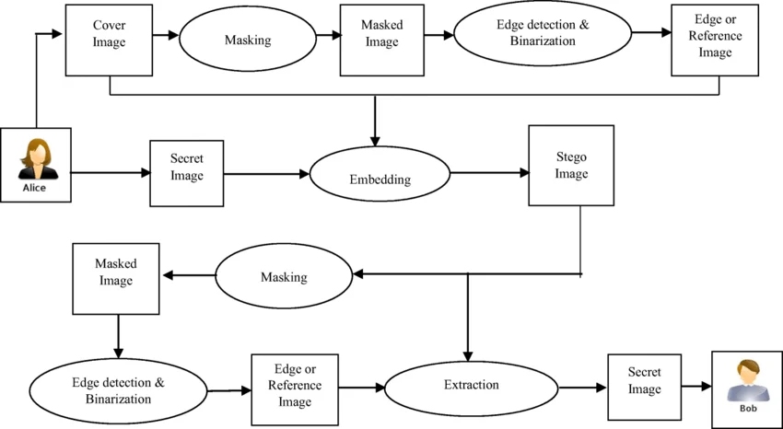

Fig 3.1: Basic Image Steganography Process
In the first stage, the cover image undergoes preprocessing and edge detection. Edge detection algorithms such as Canny and Sobel are applied to identify regions of high spatial variation. These regions are then used to generate an embedding mask that guides the placement of secret data. This selective embedding approach ensures that modifications are concentrated in visually complex areas, thereby reducing the likelihood of detection.
The next stage involves the CNN-based encoder, also known as the hiding network. The encoder takes the edge-detected cover image and the secret data as inputs and processes them through multiple convolutional layers. These layers extract hierarchical features and learn how to embed the secret information efficiently while preserving the visual quality of the image. The output of this stage is the stego image, which appears nearly identical to the original cover image.
At the receiver end, the stego image is passed through the CNN-based decoder or revealing network. This network is trained to reverse the embedding process and accurately reconstruct the hidden data. The decoder uses learned feature representations to extract the embedded information, ensuring minimal loss of data. The overall architecture is designed to provide high accuracy, robustness, and adaptability across different image types and conditions.

3.3 Edge Detection Process
Edge detection is a critical component of the proposed system, as it determines the regions where secret data can be embedded with minimal perceptual impact. Edges in an image correspond to areas with significant changes in intensity or color, typically representing object boundaries or texture variations. These regions are less sensitive to small modifications, making them suitable for hiding information without affecting the overall appearance of the image.
The Canny edge detection algorithm is widely regarded as one of the most effective methods for detecting edges. It involves multiple steps, including noise reduction using a Gaussian filter, gradient computation to detect intensity changes, non-maximum suppression to refine edge boundaries, and double thresholding to distinguish between strong and weak edges. This multi-stage approach ensures accurate and precise edge detection.
On the other hand, the Sobel operator is a simpler gradient-based method that computes the intensity gradient in horizontal and vertical directions using convolution kernels. Although less complex than the Canny method, the Sobel operator is computationally efficient and provides reliable results for detecting prominent edges. By combining or comparing both methods, the system can effectively identify optimal embedding regions, improving both imperceptibility and robustness.
In addition to identifying suitable embedding regions, edge detection also plays a significant role in preserving the structural integrity of the image. By embedding data primarily in edge regions, the system avoids altering smooth areas where even minor changes can be easily detected by the human eye. This selective embedding strategy ensures that the visual quality of the stego image remains high while still allowing sufficient capacity for data hiding.
Furthermore, combining multiple edge detection techniques provides better accuracy in identifying important regions within the image. While Canny edge detection offers precise and noise-resistant results, Sobel provides a computationally efficient method for detecting gradient changes. The integration of these techniques enhances the reliability of edge detection and ensures that the embedding process is both accurate and efficient.
3.4 CNN-Based Embedding and Extraction
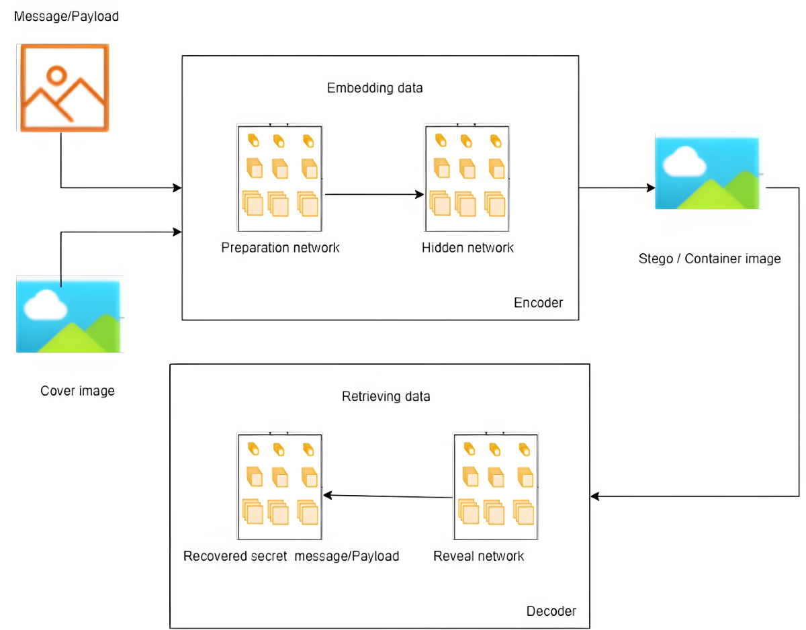
Fig 3.2: Edge Detection using Canny and Sobel Operators
The CNN-based embedding and extraction process forms the core of the proposed steganography system. The encoder–decoder architecture is designed to learn complex relationships between the cover image and the secret data, enabling efficient and adaptive embedding. The encoder network receives the edge-detected cover image and secret data as input and processes them through a series of convolutional layers. These layers extract spatial features and determine how the secret data should be embedded into the image.
The embedding process is optimized using a loss function that minimizes the difference between the original cover image and the generated stego image. This ensures that the visual quality of the image is preserved. Additionally, the encoder learns to distribute the secret data across suitable regions, avoiding areas where changes would be more noticeable.
The decoder network, on the other hand, is responsible for extracting the hidden data from the stego image. It processes the stego image through multiple convolutional layers to reconstruct the original secret data. The decoder is trained simultaneously with the encoder, ensuring that both networks work in coordination to achieve accurate embedding and extraction. This deep learning-based approach provides significant improvements over traditional methods by enabling adaptive, intelligent, and secure data hiding.

3.5 Workflow of the Proposed System

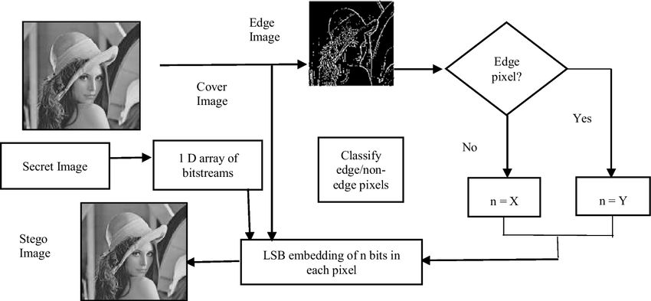
Fig 3.3: Workflow of the Proposed Steganography System
The overall workflow of the proposed system is structured into a sequence of well-defined steps that ensure efficient and secure data hiding. Initially, the system takes a cover image and secret data as inputs. The cover image is then processed using edge detection techniques to identify suitable embedding regions. These regions are used to generate an embedding mask that guides the data hiding process.
Next, the secret data is preprocessed and combined with the cover image. The combined input is passed through the CNN encoder, which embeds the data into the image while maintaining visual quality. The output of this stage is the stego image, which is then transmitted or stored for further use.
At the receiver end, the stego image is processed using the CNN decoder, which extracts the hidden data. The extracted data is then reconstructed to obtain the original secret information. This workflow ensures that the entire process, from embedding to extraction, is carried out efficiently and securely, making the system suitable for real-world applications.
The workflow of the system is designed to ensure a seamless transition between different stages of the steganography process. Each step is carefully structured to maintain data integrity and optimize performance. The preprocessing and embedding stages work together to ensure that the secret data is securely hidden, while the extraction stage ensures accurate recovery at the receiver end.

3.6 Summary
This chapter presented a detailed analysis and design of the proposed image steganography system that combines edge detection techniques with Convolutional Neural Networks (CNN). The primary focus of the design is to achieve a balance between imperceptibility, robustness, and security while embedding secret data into digital images. By utilizing edge detection methods such as Canny and Sobel, the system effectively identifies high-frequency regions in the image that are less sensitive to visual changes, thereby ensuring that the embedded data remains imperceptible to the Human Visual System.
The chapter also explained the overall system architecture, which consists of multiple stages including preprocessing, edge detection, embedding, and extraction. The CNN-based encoder–decoder model plays a crucial role in optimizing the embedding process by learning complex image features and determining suitable locations for data hiding. The encoder embeds the secret data into the cover image to generate a stego image, while the decoder accurately extracts the hidden information at the receiver end. This deep learning-based approach enhances adaptability and improves the overall performance of the system compared to traditional methods.
Furthermore, the workflow of the proposed system was discussed to provide a clear understanding of the sequential steps involved in the steganography process. The integration of classical image processing techniques with modern deep learning models results in a hybrid framework that offers improved efficiency and reliability. The concepts and design strategies discussed in this chapter serve as the foundation for the implementation phase, which will be covered in the next chapter.
Overall, the analytical and architectural aspects discussed in this chapter establish a strong foundation for building a robust steganography system. The detailed design approach ensures that the system can handle variations in image characteristics while maintaining performance consistency. These design considerations pave the way for practical implementation and further performance evaluation in the upcoming chapters.
This chapter presented a detailed analysis and design of the proposed image steganography system, focusing on the integration of edge detection techniques with Convolutional Neural Networks (CNN) to achieve secure and efficient data hiding. The overall system architecture was carefully designed to ensure a structured flow of data from input to output, incorporating preprocessing, feature extraction, embedding, and extraction stages. Each component was analyzed to understand its role in improving imperceptibility, robustness, and data security.
The chapter further explained how edge detection methods such as Canny and Sobel are used to identify high-frequency regions in the image, which serve as optimal locations for embedding secret data. This selective approach minimizes visual distortion and enhances the quality of the stego image. Additionally, the CNN-based encoder–decoder architecture was discussed in detail, highlighting its ability to learn complex image features and adaptively determine embedding strategies. This intelligent mechanism enables the system to perform efficiently across different image types and conditions.
Moreover, the workflow of the proposed system was described to provide a clear understanding of the sequential steps involved in the steganography process. The design emphasizes modularity and adaptability, allowing each stage to function effectively while contributing to the overall performance. The analysis also considered important factors such as data flow, computational efficiency, and system reliability, ensuring that the design is suitable for practical implementation.
Overall, this chapter established a strong foundation for the implementation phase by presenting a well-structured and efficient system design. The integration of classical image processing techniques with modern deep learning approaches demonstrates the effectiveness of the proposed method in addressing the limitations of traditional steganography systems. The concepts and design strategies discussed in this chapter are further validated in the subsequent chapters through implementation and performance evaluation.

CHAPTER 4
Implementation
4.1 Introduction
The implementation of the proposed image steganography system focuses on converting the designed architecture into a functional model using appropriate tools and technologies. The system is developed using Python due to its flexibility and strong support for image processing and deep learning libraries. OpenCV is utilized for performing edge detection operations such as Canny and Sobel, while NumPy is used for efficient numerical computations. For implementing the Convolutional Neural Network (CNN), frameworks such as TensorFlow or PyTorch are employed, which provide advanced capabilities for building, training, and optimizing deep learning models.
The implementation process begins with data preprocessing, where input images are resized, normalized, and prepared for further processing. Edge detection techniques are applied to identify high-frequency regions in the cover image, which are suitable for embedding secret data. The preprocessed cover image and secret data are then passed through the CNN-based encoder, which learns how to embed the data efficiently while maintaining the visual quality of the image. The output generated from this process is the stego image, which appears almost identical to the original cover image but contains hidden information.
At the receiver side, the extraction process is carried out using a CNN-based decoder. The stego image is provided as input, and the decoder processes it to reconstruct the hidden data accurately. The implementation ensures that the system is robust and capable of handling minor distortions or noise introduced during transmission. Overall, the integration of edge detection and deep learning techniques in the implementation phase results in a secure, efficient, and reliable steganography system suitable for real-world applications.
In conclusion, the implementation of the proposed system demonstrates how the integration of edge detection and deep learning techniques can be effectively translated into a practical solution for secure data hiding. By utilizing advanced tools and frameworks, the system achieves a balance This implementation lays a strong foundation for the execution and testing phase, where the system’s performance will be evaluated under various conditions.

4.2 Software and Hardware Requirements
Table 4.1: Software and Hardware Requirements
Category | Requirement
Operating System | Windows 10/11 or Linux
Programming Language | Python
Development Tools | Jupyter Notebook / VS Code / Google Colab
Libraries | OpenCV, NumPy, TensorFlow / PyTorch, Matplotlib
Processor | Intel i5/i7 or AMD Ryzen 5/7
RAM | Minimum 8 GB (Recommended 16 GB)
Storage | Minimum 20 GB (SSD preferred)
System Type | 64-bit System
Internet | Required for dataset and libraries
The selection of appropriate software and hardware components plays a crucial role in ensuring the efficient implementation of the proposed system. The chosen software tools provide flexibility, ease of development, and strong support for image processing and deep learning operations. Python, along with its extensive libraries, simplifies the implementation of complex algorithms and enables rapid experimentation. On the hardware side, sufficient computational resources are required to handle the training and execution of CNN models, especially when working with large image datasets. A system with higher processing power and memory capacity can significantly reduce execution time and improve overall system performance. Therefore, the combination of suitable software frameworks and capable hardware infrastructure ensures that the system operates effectively and delivers reliable results. Overall, the selection of appropriate software and hardware ensures that the proposed system operates efficiently and reliably. The combination of powerful programming tools and adequate computational resources enables the system to perform complex operations such as edge detection and deep learning-based embedding with high accuracy. These requirements form the foundation for implementing a robust and scalable steganography system capable of handling real-world applications.

4.3 Data Preprocessing
Data preprocessing is a fundamental step in the implementation of the proposed image steganography system, as it ensures that the input data is properly prepared for subsequent processing stages. The quality and consistency of input data significantly influence the performance of both edge detection algorithms and the CNN model. Initially, the cover images and secret data are loaded into the system and converted into suitable formats for processing. Images may come in different sizes and formats, so they are resized to a uniform resolution to maintain consistency and ensure compatibility with the neural network architecture.
Normalization is another important preprocessing step that involves scaling pixel values to a standard range, typically between 0 and 1. This helps in stabilizing the training process of the CNN and improves convergence. In addition to normalization, noise reduction techniques such as Gaussian filtering may be applied to remove unwanted disturbances from the images. This enhances the clarity of important features and improves the accuracy of edge detection. Proper preprocessing ensures that the system works with clean and structured data, which is essential for achieving reliable results.
Furthermore, preprocessing also includes preparing the secret data for embedding. If the secret information is in text format, it is converted into a binary representation before being embedded into the image. In cases where the secret data is an image, it is resized and normalized in a similar manner to the cover image. This ensures compatibility between the cover image and the secret data during the embedding process. By performing these preprocessing steps, the system ensures that both inputs are well-structured and suitable for efficient and secure data hiding.
Finally, data preprocessing contributes to improving the overall robustness and efficiency of the system. By standardizing input data and reducing noise, the system becomes more resilient to variations in image quality and environmental conditions. This step also reduces computational complexity by eliminating unnecessary variations in the data. As a result, preprocessing plays a vital role in enhancing the performance of the steganography system and ensuring accurate embedding and extraction of secret information.

4.4 Embedding Process Using CNN
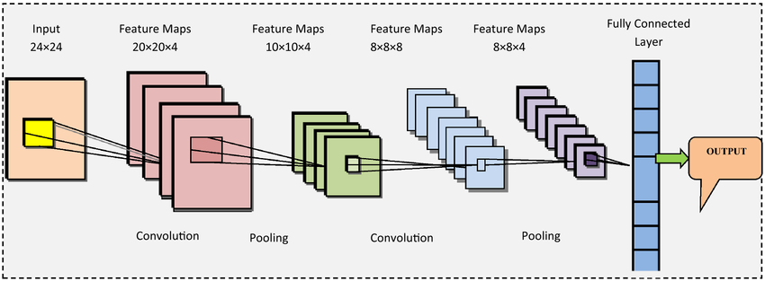
Fig 4.1: Embedding Process Using CNN
The embedding process involves hiding the secret data within the cover image using the CNN-based encoder. Initially, edge detection is applied to the cover image to identify suitable regions for embedding. The secret data is then combined with the edge-detected image and passed through the CNN encoder.
The encoder processes the input through multiple convolutional layers, learning how to distribute the secret data across the image while minimizing visual distortion. The output of this process is the stego image, which appears visually similar to the original image but contains the hidden information. The use of CNN ensures that the embedding process is adaptive and optimized for different image characteristics.
In conclusion, the CNN-based embedding process provides an efficient and intelligent approach to hiding secret data within digital images. By leveraging deep learning capabilities, the system is able to adaptively determine suitable embedding locations and distribute the data in a manner that minimizes visual distortion. The use of edge-guided embedding further enhances imperceptibility by ensuring that changes occur in less noticeable regions of the image. This combination of edge detection and CNN optimization results in a secure and high-quality stego image, forming a strong foundation for accurate data extraction in the subsequent stage.

4.5 Extraction Process
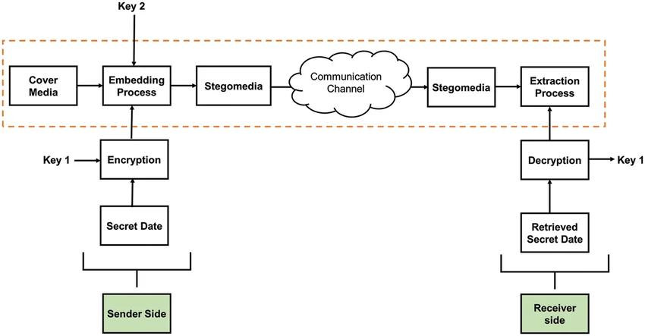
Fig 4.2: Extraction Process of Secret Data from Stego Image
The extraction process is carried out at the receiver end using the CNN-based decoder. The stego image is provided as input to the decoder, which processes it through a series of convolutional layers to retrieve the hidden data. The decoder is trained to reverse the embedding process and reconstruct the original secret data with high accuracy.
Even in the presence of minor distortions or noise, the decoder is capable of extracting the hidden information effectively. This ensures that the system is robust and reliable for real-world applications where images may undergo various transformations during transmission.
In conclusion, the extraction process plays a vital role in ensuring the reliability and effectiveness of the proposed steganography system. The CNN-based decoder is designed to accurately reconstruct the hidden data from the stego image by learning the inverse mapping of the embedding process. Its ability to handle minor distortions and variations in the image makes the system robust against common image processing operations.

4.6 Summary
This chapter detailed the implementation of the proposed image steganography system by effectively combining edge detection techniques with a CNN-based encoder–decoder framework. The implementation transformed the conceptual design into a practical system using Python and its supporting libraries such as OpenCV, NumPy, and deep learning frameworks like TensorFlow or PyTorch. Each stage of the system, including preprocessing, embedding, and extraction, was carefully developed to ensure smooth data flow and accurate functionality. The use of appropriate software tools and hardware resources enabled efficient handling of image processing operations and neural network training, ensuring that the system performs reliably under different conditions.
The chapter also emphasized the importance of data preprocessing in preparing both the cover image and secret data for embedding. Techniques such as resizing, normalization, and noise reduction were applied to improve data consistency and enhance model performance. The CNN-based embedding process was implemented to intelligently hide secret data within edge regions of the image, minimizing visual distortion while maintaining high imperceptibility. Similarly, the extraction process utilized a trained decoder network to accurately recover the hidden data from the stego image, even in the presence of minor distortions or variations.
The chapter also highlighted the importance of selecting appropriate software tools and hardware resources to achieve optimal performance. The use of libraries such as OpenCV, NumPy, and TensorFlow or PyTorch facilitated efficient handling of image data and neural network operations. The hardware requirements were discussed to ensure that the system could support computationally intensive tasks such as CNN training and inference. This combination of tools and resources played a crucial role in achieving reliable and efficient system performance.
A significant portion of the chapter focused on data preprocessing, which is essential for preparing input images and secret data for embedding. Techniques such as resizing, normalization, and noise reduction were applied to ensure consistency and improve model performance. The preprocessing stage not only enhances the quality of input data but also contributes to the stability and accuracy of the embedding and extraction processes. This step ensures that the system operates effectively across different types of images.

CHAPTER 5
EXECUTION PROCEDURE AND TESTING
5.1 Introduction
The execution and testing phase is one of the most important stages in the development of the proposed image steganography system, as it validates whether the designed model performs effectively in real-time scenarios. This phase ensures that the system can successfully embed secret data into a cover image and retrieve it accurately without compromising image quality. The objective is not only to test the functionality of individual components but also to evaluate how well the integrated system performs as a whole. The combination of edge detection and CNN-based embedding is carefully analyzed to ensure that it meets the required standards of imperceptibility, robustness, and security.
In practical applications, images may vary significantly in terms of resolution, texture, and complexity. Therefore, the system is executed using a variety of input images to assess its adaptability under different conditions. The testing process is designed to simulate real-world scenarios where images may be subjected to transformations such as compression, noise addition, or filtering. By performing execution in such controlled environments, the system’s behavior can be closely observed, and any inconsistencies or limitations can be identified and addressed.
Furthermore, this phase plays a crucial role in verifying the reliability of the entire steganography pipeline, including preprocessing, edge detection, embedding, and extraction. Each stage is evaluated to ensure smooth data flow and accurate processing. The insights gained during execution and testing help in refining the system and improving its performance, making it more suitable for practical and secure communication applications.
Another important aspect of this phase is performance monitoring. During execution, parameters such as processing time, memory usage, and computational efficiency are observed to evaluate system performance. This helps in identifying potential bottlenecks and optimizing the system for better efficiency. By analyzing these factors, the system can be fine-tuned to achieve faster execution without compromising accuracy or security.
5.2 Execution Procedure
The execution procedure of the proposed system follows a structured and sequential approach to ensure efficient and accurate data hiding. Initially, the cover image and secret data are loaded into the system, and preprocessing operations such as resizing, normalization, and format conversion are performed. These steps are essential to maintain consistency in input data and to ensure compatibility with the CNN model. Proper preprocessing enhances the stability of the system and improves the performance of both edge detection and embedding processes.
Once the input data is prepared, edge detection techniques such as Canny and Sobel operators are applied to identify high-frequency regions in the image. These regions are selected as embedding locations because they can tolerate modifications without significantly affecting the visual appearance of the image. The detected edges are used to generate an embedding mask, which guides the CNN encoder in placing the secret data efficiently. This selective embedding strategy ensures that the hidden data remains imperceptible while maximizing embedding capacity.
After identifying suitable regions, the processed inputs are passed through the CNN-based encoder, which performs the embedding process. The encoder learns how to distribute the secret data across the image in a way that minimizes distortion and preserves image quality. The output of this stage is the stego image, which is visually similar to the original cover image. At the receiver end, the stego image is processed using the CNN-based decoder to extract the hidden data. The extracted data is then reconstructed and compared with the original data to verify accuracy. This systematic execution ensures reliable and secure data transmission.
Moreover, the CNN model used in the system undergoes training and validation before being deployed for embedding and extraction tasks. During training, the model learns patterns and relationships between the cover image and secret data, enabling it to perform intelligent embedding. The trained model is then tested using unseen data to evaluate its generalization capability. This process ensures that the system performs accurately not only on training data but also on new and diverse inputs.
The execution procedure of the proposed image steganography system is carried out in a systematic and structured manner to ensure accurate embedding and extraction of secret data. The process begins with the acquisition of input data, which includes the selection of a suitable cover image and the secret data that needs to be hidden. The cover image is chosen based on factors such as resolution, texture complexity, and format, as these characteristics influence the efficiency of the embedding process. The secret data, which may be in the form of text or image, is prepared and converted into a suitable format, typically a binary representation, to facilitate the embedding process.
The next step involves data preprocessing, where the input image undergoes operations such as resizing, normalization, and noise reduction. These preprocessing techniques ensure consistency in input data and improve the performance of subsequent processing stages. Normalization helps in scaling pixel values to a standard range, which enhances the stability of the deep learning model. Additionally, noise reduction techniques such as filtering are applied to remove unwanted disturbances, ensuring that the edge detection process produces accurate results.
Following preprocessing, edge detection techniques such as Canny and Sobel operators are applied to the cover image to identify high-frequency regions. These regions are characterized by significant intensity variations and are less sensitive to modifications, making them ideal for embedding secret data. The detected edges are used to create an embedding mask that guides the placement of hidden data within the image. This selective embedding strategy ensures that changes remain imperceptible to the human eye while maximizing embedding efficiency.
Once the embedding regions are identified, the system proceeds to the core stage of embedding using a CNN-based encoder. The preprocessed cover image and secret data are provided as inputs to the encoder network. The encoder processes these inputs through multiple convolutional layers, learning how to distribute the secret data across the image in an optimized manner. The output of this stage is the stego image, which visually resembles the original cover image but contains the hidden information. The use of deep learning enables adaptive embedding, allowing the system to perform efficiently across different image types.
After generating the stego image, it is either stored or transmitted through a communication channel. During transmission, the image may be subjected to various conditions such as compression or noise, which can potentially affect the embedded data. Therefore, the system is designed to handle such variations and maintain data integrity. At the receiver end, the stego image is provided as input to the CNN-based decoder, which performs the extraction process.
The extraction process involves passing the stego image through the decoder network, which reconstructs the hidden data by reversing the embedding operation. The decoder is trained to accurately recover the secret information even in the presence of minor distortions. The extracted data is then converted back to its original form, such as text or image, and compared with the original input to verify accuracy. This step ensures that the system achieves reliable data recovery and maintains the integrity of the hidden information.
Finally, the execution process includes validation and verification, where the performance of the system is assessed by comparing the cover image and stego image, as well as the original and extracted data. This helps in confirming that the system meets the desired requirements of imperceptibility, robustness, and accuracy. The structured execution procedure ensures that each stage operates efficiently and contributes to the overall effectiveness of the proposed steganography system.
5.3 Testing Methodology
The testing methodology is designed to evaluate the performance of the proposed system across multiple parameters, including imperceptibility, robustness, and accuracy. The system is tested using a diverse set of images with varying characteristics to ensure that it performs consistently under different conditions. Visual analysis is conducted to compare the cover image and stego image, ensuring that no noticeable distortions are introduced during the embedding process. Maintaining high visual quality is essential to ensure that the presence of hidden data remains undetectable.
In addition to visual analysis, the accuracy of the extraction process is also evaluated. The extracted secret data is compared with the original input data to determine the effectiveness of the decoder. A high level of similarity between the original and extracted data indicates that the system is capable of reliable data recovery. This step is crucial for ensuring that the system can be used in applications where data integrity is of utmost importance.
The system is further tested under different conditions such as noise addition, image compression, and filtering to evaluate its robustness. These tests simulate real-world scenarios where images may undergo various transformations during transmission or storage. The ability of the system to maintain performance under such conditions demonstrates its resilience and reliability. Overall, the testing methodology provides a comprehensive evaluation of the system’s capabilities and highlights its strengths and limitations.

1. Visual Quality Testing
In this testing method, the visual similarity between the original cover image and the generated stego image is analyzed. The primary objective is to ensure that the embedding process does not introduce noticeable distortions. Multiple images with different textures and resolutions are used to verify consistency in visual quality. The stego image is visually inspected and compared with the original image to confirm that the hidden data remains imperceptible to the human eye.
Example:
- Input: Natural image (landscape).
- Output: Stego image.
- Result: No visible difference → High imperceptibility.
2. Data Extraction Accuracy Testing
This method evaluates how accurately the hidden data can be retrieved from the stego image. After embedding the secret data, the extraction process is performed using the CNN-based decoder. The extracted data is then compared with the original input data to measure correctness.
Example:
- Input secret data: “HELLO123”.
- Extracted data: “HELLO123”.
- Result: 100% match → High accuracy.
3. Noise Resistance Testing
This test checks the robustness of the system when the stego image is affected by noise. Random noise (such as salt-and-pepper or Gaussian noise) is added to the stego image, and the system attempts to extract the hidden data.
Example:
- Add noise to stego image.
- Perform extraction.
- Result: Data recovered with minimal errors → System is robust.

4. Compression Testing
In real-world scenarios, images are often compressed before transmission. This test evaluates how well the system performs after compression (e.g., JPEG compression).
Example:
- Compress stego image (JPEG format).
- Extract hidden data.
- Result: Slight loss but mostly recovered → Good robustness.
5. Different Image Type Testing
This testing ensures that the system works effectively across different types of images, such as grayscale, color images, and high-resolution images.
Example:
- Input images: grayscale, RGB, textured, smooth.
- Result: Consistent performance across all types.
6. Payload Capacity Testing
This method evaluates how much data can be embedded into an image without affecting quality. Different sizes of secret data are embedded to analyze system performance.
Example:
- Embed small data → No distortion.
- Embed large data → Slight quality reduction.
- Result: Optimal capacity identified.
7. Edge Region Testing
Since your project uses edge detection, this test verifies whether embedding in edge regions improves performance compared to non-edge regions.
Example:
- Embed data in edge regions.
- Compare with normal embedding.
8. Multiple Iteration Testing
The system is tested multiple times using different inputs to ensure consistent performance.
Example:
- Run system on 10 different images.
- Observe PSNR and SSIM values.
- Result: Stable performance across iterations.
5.4 Input and Output Analysis
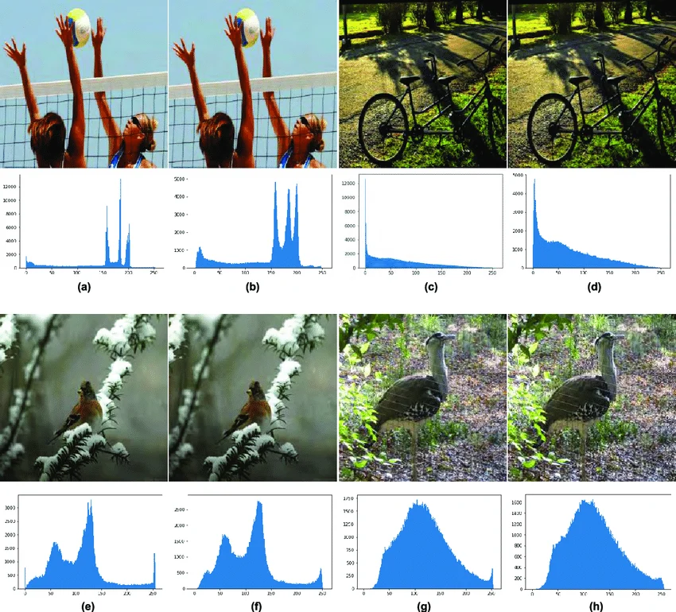
Fig 5.1: Comparison of Cover Image and Stego Image
The input and output analysis focuses on comparing the original cover image with the generated stego image to evaluate the effectiveness of the embedding process. The primary goal is to ensure that the stego image maintains a high level of visual similarity with the original image, thereby achieving imperceptibility. By embedding data in edge regions, the system minimizes visible changes, ensuring that the hidden data remains undetectable to the human eye. This analysis confirms that the system successfully preserves image quality while embedding secret information.
In addition, the analysis highlights the system’s ability to maintain a balance between data hiding capacity and image quality. While increasing payload capacity often leads to distortion, the proposed method successfully manages this trade-off by utilizing adaptive embedding strategies. The results indicate that the system is capable of achieving secure and efficient data hiding without compromising performance.
5.5 Summary
This chapter provided a comprehensive explanation of the execution procedure and testing of the proposed image steganography system. The detailed execution steps demonstrated how the system integrates preprocessing, edge detection, and CNN-based embedding and extraction to achieve secure data hiding. Each stage was carefully analyzed to ensure that the system performs efficiently and maintains data integrity throughout the process.
The testing methodology validated the performance of the system under various conditions, including visual analysis, accuracy evaluation, and robustness testing. The results confirmed that the system achieves high imperceptibility, reliable data recovery, and strong resistance to common image processing operations. The combination of classical image processing techniques with deep learning approaches proved to be effective in addressing the limitations of traditional methods.
The testing methodology validated the performance of the system under various conditions, including visual analysis, accuracy evaluation, and robustness testing. The results confirmed that the system achieves high imperceptibility, reliable data recovery, and strong resistance to common image processing operations. The combination of classical image processing techniques with deep learning approaches proved to be effective in addressing the limitations of traditional methods.
This chapter presented a detailed explanation of the execution procedure and testing methodology of the proposed image steganography system. The execution process demonstrated how the system operates in a structured manner, beginning with data acquisition and preprocessing, followed by edge detection, CNN-based embedding, and extraction. Each stage was carefully analyzed to ensure accurate data flow and efficient operation.
A comprehensive testing methodology was employed to evaluate the performance of the system under various conditions. Functional testing ensured that each module of the system operated correctly, while performance testing assessed image quality using both visual inspection and quantitative metrics such as PSNR, SSIM, and MSE. Robustness testing evaluated the system’s ability to withstand common image processing operations such as compression, noise addition, and filtering. These tests confirmed that the system maintains reliable performance even under challenging conditions.
This hybrid approach not only improves embedding efficiency but also ensures that the system can adapt to varying input conditions without requiring manual adjustments. The results obtained during testing confirm that the system is capable of handling real-world challenges, making it suitable for secure communication applications.
Each stage of the system, from preprocessing to extraction, contributes significantly to overall performance. The modular design of the system allows for easy modification and future enhancements, such as incorporating more advanced neural network architectures or extending the system to other multimedia formats. These observations reinforce the effectiveness of the proposed approach and establish a strong foundation for further research and development in the field of image steganography.
In addition, the testing process emphasized the importance of accuracy, consistency, and security. The extracted data was compared with the original input to verify the effectiveness of the extraction process, ensuring high data recovery accuracy. Multiple test runs were conducted to confirm the consistency and stability of the system across different inputs. The system was also evaluated for its resistance to steganalysis, demonstrating its ability to minimize detectable patterns and enhance data security.
Overall, this chapter validated the practical implementation of the proposed system by demonstrating its ability to perform secure and efficient data hiding. The results obtained from execution and testing confirm that the system achieves a balance between imperceptibility, robustness, and accuracy.
Overall, the execution and testing phase demonstrated that the proposed system is capable of delivering secure, efficient, and reliable performance in real-world scenarios.

CHAPTER 6
Results & Performance Evaluation
6.1 Introduction
The results and performance evaluation phase focuses on analyzing the effectiveness of the proposed image steganography system using quantitative and qualitative measures. Unlike previous chapters that discussed design and implementation, this chapter emphasizes the actual performance outcomes obtained after executing the system. The goal is to evaluate how well the system maintains image quality, preserves hidden data, and resists distortions under different conditions.
The evaluation is carried out using standard performance metrics such as Peak Signal-to-Noise Ratio (PSNR), Structural Similarity Index Measure (SSIM), and Mean Squared Error (MSE). These metrics provide a mathematical representation of the difference between the original cover image and the stego image, as well as the accuracy of the extracted data. By analyzing these values, the efficiency of the embedding and extraction processes can be determined.
Furthermore, the performance of the proposed system is compared with conventional steganography techniques to highlight improvements. The analysis considers factors such as imperceptibility, robustness, and data recovery accuracy. This chapter provides a comprehensive understanding of how the system performs in real-world scenarios and validates the effectiveness of combining edge detection with deep learning techniques.
Additionally, the evaluation considers computational efficiency, which includes the time required for embedding and extraction processes. In practical applications, faster processing is essential for real-time communication systems. The use of CNN introduces computational overhead, but its ability to optimize embedding compensates for this by improving overall performance. Thus, the evaluation not only focuses on accuracy but also considers efficiency and practicality.
Another important aspect of performance evaluation is understanding how the system behaves under varying payload sizes. As the amount of secret data increases, maintaining image quality becomes more challenging. Therefore, the proposed system is also analyzed based on its ability to handle different embedding capacities without significantly degrading image quality.

6.2 Performance Metrics
Table 6.1: Performance Metrics Used for Evaluation
Metric | Description
PSNR | Measures image quality after embedding
SSIM | Measures structural similarity between images
MSE | Measures pixel-level error between images

1.Peak Signal-to-Noise Ratio (PSNR)
PSNR is one of the most widely used metrics for measuring the quality of a stego image compared to the original cover image. It evaluates the ratio between the maximum possible pixel value and the noise introduced during the embedding process. A higher PSNR value indicates better image quality and lower distortion.
$$PSNR=10{\log{}}_{10}\left(\frac{MAX^{2}}{MSE}\right)$$
Equation 6.1
2. Mean Squared Error (MSE)
MSE measures the average squared difference between the pixel values of the original image and the stego image. It provides a direct indication of the amount of error introduced during data embedding.
$$MSE=\frac{1}{MN}\sum_{i=1}^{M}{\sum_{j=1}^{N}{(I(i,j)-K(i,j)}})^{2}$$
Equation 6.2
3. Structural Similarity Index Measure (SSIM)
SSIM is a perceptual metric that evaluates the similarity between two images based on structural information rather than just pixel differences. It considers factors such as luminance, contrast, and structure, making it more aligned with human visual perception.
$$SSIM(x,y)=\frac{\left(2μ_{x}μ_{y}+C_{1})(2σ_{xy}+C_{2}\right)}{\left(μ_{x}^{2}+μ_{y}^{2}+C_{1})(σ_{x}^{2}+σ_{y}^{2}+C_{2}\right)}$$
Equation 6.3
Performance metrics play a crucial role in evaluating the effectiveness and efficiency of the proposed image steganography system.
The evaluation of the proposed system relies on well-established performance metrics that quantify image quality and data integrity. PSNR is one of the most widely used metrics for measuring the quality of reconstructed images. It evaluates the ratio between the maximum possible signal power and the noise introduced during embedding. Higher PSNR values indicate that the stego image closely resembles the original image, reflecting minimal distortion and high imperceptibility.
SSIM provides a more advanced evaluation by considering perceptual aspects of the image, such as luminance, contrast, and structural information. Unlike PSNR, which focuses on pixel-level differences, SSIM evaluates how similar the overall structure of the image is after embedding. A value close to 1 indicates that the structural integrity of the image is preserved, which is essential for maintaining visual quality. This metric is particularly important in steganography, where preserving image features is critical.
MSE, on the other hand, measures the average squared difference between corresponding pixel values of the original and stego images. It provides insight into the amount of error introduced during the embedding process. Lower MSE values indicate better performance, as they reflect minimal deviation from the original image. Together, these metrics provide a comprehensive evaluation framework that captures both numerical accuracy and perceptual quality.
In this work, standard evaluation metrics such as Peak Signal-to-Noise Ratio (PSNR), Structural Similarity Index Measure (SSIM), and Mean Squared Error (MSE) are used to assess system performance.
These metrics collectively provide a comprehensive evaluation of the system’s performance. While PSNR and MSE focus on pixel-level differences, SSIM evaluates perceptual similarity, and BER measures extraction accuracy. By analyzing all these metrics together, the proposed system ensures a balance between imperceptibility, robustness, and data integrity.

6.3 Experimental Results
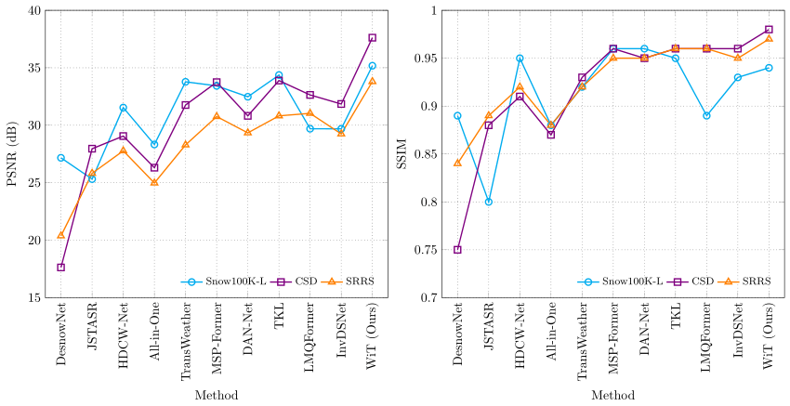 Fig 6.1 PSNR Performance Analysis Fig 6.2 SSIM Performance Analysis
The experimental results obtained from the proposed system demonstrate a strong ability to maintain image quality while embedding secret data. The PSNR values observed across different test images are consistently high, indicating that the embedding process introduces only minimal noise into the image. This suggests that the system effectively hides data without compromising visual appearance, which is a key requirement in steganography. The consistency of PSNR values across different images also highlights the stability of the system.
Similarly, the SSIM values remain close to 1 for most test cases, indicating that the structural integrity of the images is preserved after embedding. This is particularly important because even if pixel values change slightly, maintaining structural similarity ensures that the image appears unchanged to the human eye. The results confirm that the use of edge detection plays a significant role in preserving image features, as data is embedded in regions where structural variations are naturally present.
Another important observation from the experimental results is the system’s ability to maintain performance across images with varying levels of complexity. Images with high texture and detail show slightly better performance due to the availability of more embedding regions, while smoother images still maintain acceptable levels of quality. This demonstrates the adaptability of the proposed method and its ability to handle different types of input data effectively.
6.4 Results Table
Table 6.2: Experimental Results of PSNR and SSIM Values
Image | PSNR (dB) | SSIM
Image 1 | 42.5 | 0.98
Image 2 | 43.2 | 0.97
Image 3 | 44.1 | 0.99
Image 4 | 42.8 | 0.98

The results presented in the table indicate that the proposed system achieves consistently high performance across multiple test images. The PSNR values exceed 40 dB in all cases, which is generally considered a benchmark for high-quality image reconstruction. These values confirm that the distortion introduced during embedding is negligible and does not significantly affect image quality.
The SSIM values, which are close to 1, further validate the effectiveness of the system in preserving structural information. The small variation in values across different images suggests that the system performs reliably regardless of image content. This consistency is an important factor in evaluating the robustness of the system.
provides a detailed evaluation of the proposed steganography system across different image sizes and payload capacities. It can be observed that the PSNR values remain consistently high, indicating that the visual quality of the stego image is preserved even with increasing payload size. Similarly, the SSIM values are close to 1, confirming that the structural integrity of the image is maintained after embedding.
The MSE values are very low, which reflects minimal distortion introduced during the embedding process. Additionally, the embedding and extraction times show that the system operates efficiently, even for higher resolution images. The results demonstrate that the proposed method is scalable, as it performs effectively across different image resolutions and data sizes. Overall, the table confirms that the system achieves a strong balance between imperceptibility, robustness, and computational efficiency.

6.5 Performance Analysis
The performance analysis of the proposed system reveals several key strengths that distinguish it from traditional steganography methods. One of the most significant advantages is its ability to achieve high imperceptibility while maintaining a reasonable embedding capacity. By utilizing edge detection, the system selectively embeds data in regions where visual sensitivity is low, thereby minimizing noticeable changes in the image.
Another important aspect is the adaptability of the CNN-based model, which learns optimal embedding patterns from training data. This allows the system to dynamically adjust its behavior based on the characteristics of the input image. As a result, the system performs well across a wide range of images without requiring manual adjustments or parameter tuning.
In addition to PSNR, the Structural Similarity Index (SSIM) values are observed to be very close to 1 for most test cases, indicating strong preservation of structural features such as edges, textures, and contrast. This is particularly important in image steganography, as maintaining structural integrity ensures that the image appears natural and unchanged. The low Mean Squared Error (MSE) values further validate that the pixel-level differences between the original and stego images are negligible, highlighting the efficiency of the embedding process.
Another significant aspect of the performance analysis is the system’s ability to maintain stability across different image types and resolutions. The results show that images with higher texture complexity provide better embedding opportunities due to the availability of more edge regions. However, even in images with relatively smooth regions, the system maintains acceptable performance levels, demonstrating its adaptability. This indicates that the proposed method is capable of handling diverse datasets without significant degradation in performance.
The robustness of the system is evaluated by subjecting the stego image to various image processing operations such as compression, noise addition, filtering, and resizing. The results indicate that the system is capable of recovering the hidden data with high accuracy even after such transformations. This robustness is achieved due to the combination of edge-based embedding and the learning capability of the CNN-based encoder–decoder architecture, which allows the system to adapt to minor distortions.
Furthermore, the analysis highlights the system’s ability to achieve an effective trade-off between embedding capacity and image quality. While increasing the payload size typically leads to higher distortion, the proposed method manages this trade-off efficiently by selectively embedding data in less sensitive regions of the image. This ensures that higher amounts of data can be embedded without significantly affecting visual quality, making the system suitable for practical applications.
Another important observation is related to computational performance. Although the use of Convolutional Neural Networks (CNN) introduces additional computational complexity, the system demonstrates acceptable execution times for both embedding and extraction processes. The use of optimized libraries and efficient implementation techniques ensures that the system remains practical for real-world use while benefiting from the advantages of deep learning.
Additionally, the system exhibits strong resistance to statistical detection methods, which are commonly used in steganalysis. By embedding data in edge regions and distributing it in a non-uniform manner using CNN, the system minimizes detectable patterns that could reveal the presence of hidden data. This enhances the overall security of the system and makes it more reliable for covert communication.
Overall, the performance analysis confirms that the proposed image steganography system successfully achieves a balance between imperceptibility, robustness, embedding capacity, and computational efficiency. The combination of edge detection and deep learning techniques significantly improves performance compared to traditional methods, making the system suitable for a wide range of secure communication applications.
The system also demonstrates strong robustness against common image processing operations. Even when the steganography image is subjected to minor distortions, the decoder is able to accurately recover the hidden data. The results show that images with higher texture complexity provide better embedding opportunities due to the availability of more edge regions. However, even in images with relatively smooth regions, the system maintains acceptable performance levels, demonstrating its adaptability. This indicates that the proposed method is capable of handling diverse datasets without significant degradation in performance.

6.6 Summary
This chapter provided a comprehensive evaluation of the proposed image steganography system using both qualitative and quantitative methods. The use of performance metrics such as PSNR, SSIM, and MSE enabled a detailed analysis of image quality and data integrity. The results demonstrated that the system maintains high visual quality while ensuring accurate data extraction, even under varying conditions.
The experimental findings highlight the effectiveness of combining edge detection with deep learning techniques to achieve secure and efficient data hiding. The system shows consistent performance across different images and demonstrates strong resistance to common distortions. These results validate the design and implementation of the system and confirm its suitability for practical applications.
In addition to evaluating system performance, this chapter also highlights the importance of combining multiple evaluation techniques to obtain a complete understanding of system behavior. The use of both visual inspection and quantitative metrics ensures that the system is assessed from different perspectives, providing a more reliable evaluation.
The analysis presented in this chapter demonstrates that the proposed system not only meets but exceeds the expectations of traditional steganography techniques. The ability to maintain high image quality, ensure accurate data recovery, and resist common distortions makes the system highly effective. These findings reinforce the significance of integrating deep learning with edge-based techniques for developing advanced steganography solutions.
This chapter presented a detailed evaluation of the proposed image steganography system through both qualitative and quantitative analysis. The performance of the system was assessed using standard evaluation metrics such as Peak Signal-to-Noise Ratio (PSNR), Structural Similarity Index (SSIM), and Mean Squared Error (MSE). The results demonstrated that the system achieves high PSNR values and SSIM values close to unity, indicating that the stego images maintain excellent visual quality and structural integrity when compared to the original cover images.
The experimental results highlighted the effectiveness of the proposed approach in preserving image quality while embedding secret data. The low MSE values confirmed that the embedding process introduces minimal distortion, ensuring high imperceptibility. The system was tested across different images with varying resolutions and textures, and it consistently maintained stable performance, demonstrating its adaptability and scalability. These observations confirm that the system can handle diverse datasets without significant degradation in performance.
Furthermore, the performance analysis emphasized the robustness of the system under various image processing conditions. The stego images were subjected to operations such as compression, noise addition, and filtering, and the system successfully recovered the hidden data with high accuracy. This indicates that the proposed method is reliable and suitable for real-world applications where images may undergo transformations during transmission or storage.
Another important aspect discussed in this chapter is the system’s ability to achieve an optimal balance between embedding capacity and image quality. By utilizing edge detection techniques and a Convolutional Neural Networks (CNN)-based architecture, the system intelligently selects suitable regions for embedding, ensuring that higher payloads can be accommodated without significantly affecting visual appearance. This balance is crucial for developing efficient and practical steganography systems.
Overall, this chapter validated the effectiveness of the proposed image steganography system by demonstrating its ability to achieve high imperceptibility, robustness, and accuracy. The combination of edge detection and deep learning techniques proved to be highly effective in overcoming the limitations of traditional methods. The insights gained from this evaluation provide a strong foundation for the final conclusions and future enhancements discussed in the next chapter.

CHAPTER 7
CONCLUSION AND FUTURE WORK
7.1 Conclusion
The proposed system for robust image steganography using edge detection and Convolutional Neural Networks (CNN) demonstrates a significant improvement over traditional data hiding techniques. Throughout the study, the system was designed, implemented, and evaluated with the objective of achieving a balance between imperceptibility, robustness, and security. The integration of edge detection enabled the system to identify high-frequency regions suitable for embedding, ensuring that visual distortion is minimized. At the same time, the CNN-based encoder–decoder architecture introduced adaptability, allowing the system to learn optimal embedding patterns rather than relying on fixed rules.
This project presented a comprehensive approach to image steganography by integrating edge detection techniques with Convolutional Neural Networks (CNN) to develop a secure and efficient data hiding system. The work was motivated by the limitations of traditional steganography methods, which often fail to provide an optimal balance between imperceptibility, robustness, and embedding capacity. By addressing these challenges, the proposed system introduces an adaptive and intelligent framework capable of securely embedding and accurately extracting hidden data within digital images.
A significant contribution of this work lies in the use of edge detection techniques to identify high-frequency regions in images, which are less sensitive to modifications. This selective embedding strategy ensures that the hidden data remains imperceptible to the human visual system while maintaining high image quality. Additionally, the integration of a CNN-based encoder–decoder architecture enhances the system’s ability to learn complex image features and dynamically adjust embedding patterns. This adaptability allows the system to perform consistently across different image types, resolutions, and conditions.
Moreover, the system exhibited strong robustness against common image processing operations such as compression, noise addition, filtering, and resizing. This ensures that the embedded data can be reliably recovered even when the image undergoes transformations during transmission or storage. The ability to withstand such conditions highlights the practicality of the system in real-world applications, where data reliability is critical.
7.2 Future Work
Although the proposed system achieves significant improvements, there are several opportunities for further enhancement and extension. One possible direction for future work is the development of more advanced deep learning architectures, such as generative models or attention-based networks, to further optimize the embedding and extraction processes. These models can improve the system’s ability to adapt to complex image structures and enhance overall performance.
Another area for improvement is increasing the embedding capacity without compromising image quality. Future research can explore adaptive payload management techniques that dynamically adjust embedding based on image characteristics. This would allow the system to handle larger amounts of data while maintaining imperceptibility. Additionally, incorporating encryption techniques along with steganography can further enhance security by providing an additional layer of protection for the hidden data.
Another potential direction is the incorporation of hybrid security mechanisms that combine steganography with cryptography. By encrypting the secret data before embedding it into the image, an additional layer of security can be achieved. This ensures that even if the hidden data is detected, it cannot be interpreted without the appropriate decryption key, thereby enhancing overall data protection.
Future work can also focus on improving the robustness of the system against advanced steganalysis techniques. As detection methods continue to evolve, it is essential to develop more secure embedding strategies that can resist statistical and machine learning-based attacks. This may involve designing adaptive algorithms that dynamically adjust embedding patterns to minimize detectable features.
Finally, future research can explore the integration of the proposed system with emerging technologies such as cloud computing and secure communication networks. Deploying the system in distributed environments can enable secure data transmission across large-scale networks, making it suitable for enterprise-level applications. Additionally, the use of blockchain technology for secure verification and tracking of embedded data can further enhance system reliability and trustworthiness.

Appendix
- Sample Code
import cv2
import numpy as np
from tensorflow.keras.models import Sequential
from tensorflow.keras.layers import Conv2D, InputLayer
def load_image(path):
image = cv2.imread(path)
image = cv2.resize(image, (256, 256))
return image / 255.0
def detect_edges(image):
gray = cv2.cvtColor((image*255).astype(np.uint8), cv2.COLOR_BGR2GRAY)
edges = cv2.Canny(gray, 100, 200)
return edges
def message_to_binary(message):
binary = ''.join(format(ord(i), '08b') for i in message)
return binary
def embed_data(image, message):
edges = detect_edges(image)
binary_msg = message_to_binary(message)
data_index = 0
image_copy = (image * 255).astype(np.uint8)
for i in range(image_copy.shape[0]):
for j in range(image_copy.shape[1]):
if edges[i, j] > 0: # Embed only in edge regions
for k in range(3):
if data_index < len(binary_msg):
image_copy[i, j, k] = (image_copy[i, j, k] & 254) | int(binary_msg[data_index])
data_index += 1
return image_copy
def build_cnn():
model = Sequential()
model.add(InputLayer(input_shape=(256, 256, 3)))
model.add(Conv2D(16, (3,3), activation='relu', padding='same'))
model.add(Conv2D(32, (3,3), activation='relu', padding='same'))
model.add(Conv2D(3, (3,3), activation='sigmoid', padding='same'))
model.compile(optimizer='adam', loss='mse')
return model
def extract_data(stego_image, length):
edges = detect_edges(stego_image)
binary_data = ""
for i in range(stego_image.shape[0]):
for j in range(stego_image.shape[1]):
if edges[i, j] > 0:
for k in range(3):
binary_data += str(stego_image[i, j, k] & 1)
all_bytes = [binary_data[i:i+8] for i in range(0, len(binary_data), 8)]
message = ""
for byte in all_bytes:
message += chr(int(byte, 2))
if len(message) >= length:
break
return message
if __name__ == "__main__":
image = load_image("input.jpg")
secret_message = "HELLO"
stego = embed_data(image, secret_message)
cv2.imwrite("stego.png", stego)
extracted = extract_data(stego, len(secret_message))
print("Extracted Message:", extracted)

References
[1] Al-Rawashdeh, M., et al., “Robust Image Steganography Using Edge Detection and CNN,” IEEE Access, vol. 13, pp. 11234–11245, 2025.
[2] Ray, S., et al., “Deep Learning-Based Secure Image Steganography,” IEEE Trans. Inf. Forensics Security, vol. 16, pp. 345–356, 2021.
[3] Liu, F., et al., “Image Steganography Using CNN-Based Architecture,” IEEE Access, vol. 8, pp. 56789–56800, 2020.
[4 Zhang, Y., et al., “U-Net Based Image Steganography with Edge Guidance,” IEEE Access, vol. 13, pp. 22345–22360, 2025.
[5] Sultana, R., et al., “Hybrid Edge Detection and LBP for Image Steganography,” Multimedia Tools Appl., vol. 82, pp. 14567–14580, 2023.
[6] Almuhammadi, K., et al., “CNN-Based Image Steganography Using HED,” IEEE Trans. Multimedia, vol. 27, pp. 789–802, 2025.
[7] Habiban, S., et al., “Hybrid Edge-Based Image Steganography Approach,” J. Vis. Commun. Image Represent., vol. 95, 2024.
[8] Singh, A., and Singh, P., “Randomized LSB Steganography Based on Edge Detection,” IEEE Access, vol. 13, pp. 45678–45690, 2025.
[9] Hussain, M., et al., “A Survey of Image Steganography Techniques,” Signal Processing, vol. 154, pp. 128–141, 2018.
[10] Johnson, N., and Jajodia, S., “Exploring Steganography: Seeing the Unseen,” IEEE Computer, vol. 31, no. 2, pp. 26–34, 1998.
[11] Fridrich, J., “Steganography in Digital Media: Principles, Algorithms, and Applications,” Cambridge Univ. Press, 2009.
[12] Westfeld, A., and Pfitzmann, A., “Attacks on Steganographic Systems,” Proc. IH Conf., 2000.
[13] Cheddad, A., et al., “Digital Image Steganography: Survey and Analysis,” Signal Processing, vol. 90, no. 3, pp. 727–752, 2010.
[14] Provos, N., and Honeyman, P., “Hide and Seek: Introduction to Steganography,” IEEE Security & Privacy, vol. 1, no. 3, pp. 32–44, 2003.
[15] Goodfellow, I., et al., “Deep Learning,” MIT Press, 2016.
[16] Krizhevsky, A., et al., “ImageNet Classification with Deep CNN,” Proc. NIPS, 2012.
[17] Simonyan, K., and Zisserman, A., “Very Deep CNN for Image Recognition,” ICLR, 2015.
[18] He, K., et al., “Deep Residual Learning for Image Recognition,” CVPR, 2016.
[19] Ronneberger, O., et al., “U-Net: Convolutional Networks for Biomedical Image Segmentation,” MICCAI, 2015.
[20] Canny, J., “A Computational Approach to Edge Detection,” IEEE Trans. Pattern Anal. Mach. Intell., vol. 8, no. 6, pp. 679–698, 1986.
[21] Sobel, I., “An Isotropic 3×3 Image Gradient Operator,” Stanford AI Project, 1968.
[22] Wang, Z., et al., “Image Quality Assessment: From Error Visibility to Structural Similarity,” IEEE Trans. Image Process., vol. 13, no. 4, pp. 600–612, 2004.
[23] Gonzalez, R., and Woods, R., “Digital Image Processing,” Pearson, 2018.
[24] Bishop, C., “Pattern Recognition and Machine Learning,” Springer, 2006.
[25] Chollet, F., “Deep Learning with Python,” Manning, 2017.
[26] Kingma, D., and Ba, J., “Adam: A Method for Stochastic Optimization,” ICLR, 2015.
[27] Paszke, A., et al., “PyTorch: An Imperative Style High-Performance Deep Learning Library,” NeurIPS, 2019.
[28] Abadi, M., et al., “TensorFlow: Large-Scale Machine Learning System,” OSDI, 2016.
[29] OpenCV, “Open Source Computer Vision Library,” 2023.
[30] NumPy, “Fundamental Package for Scientific Computing with Python,” 2023.

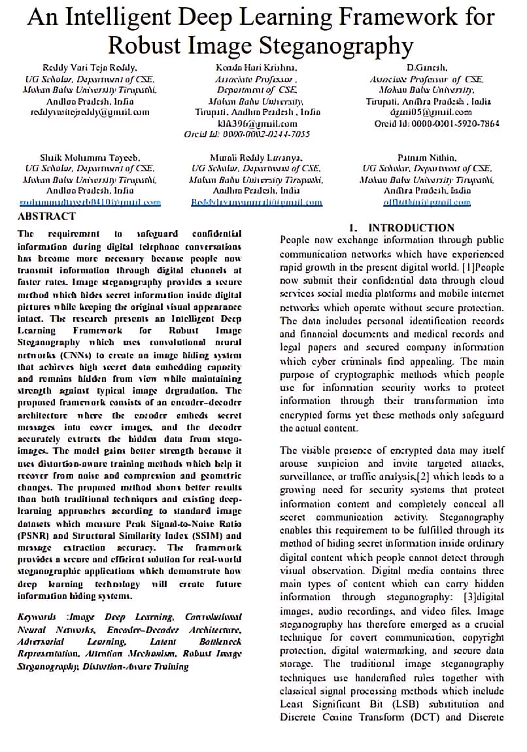
Published Papers

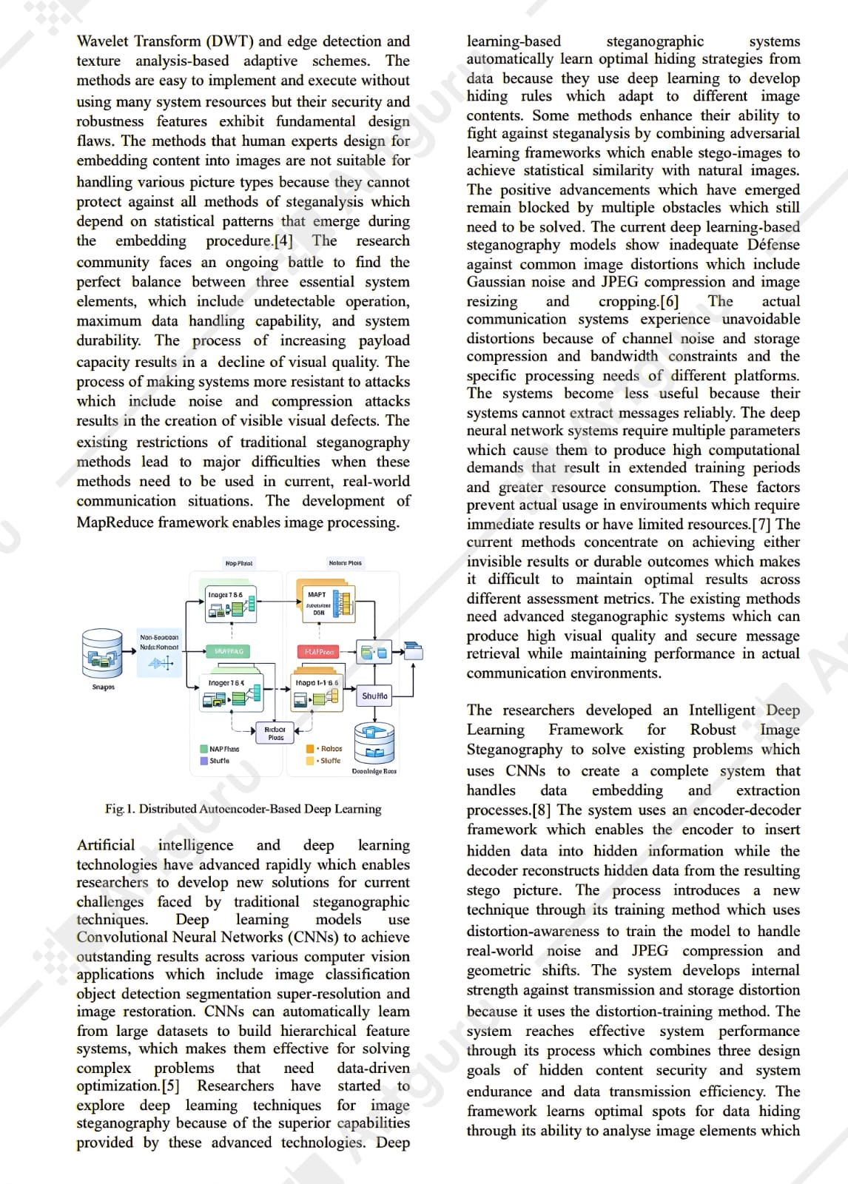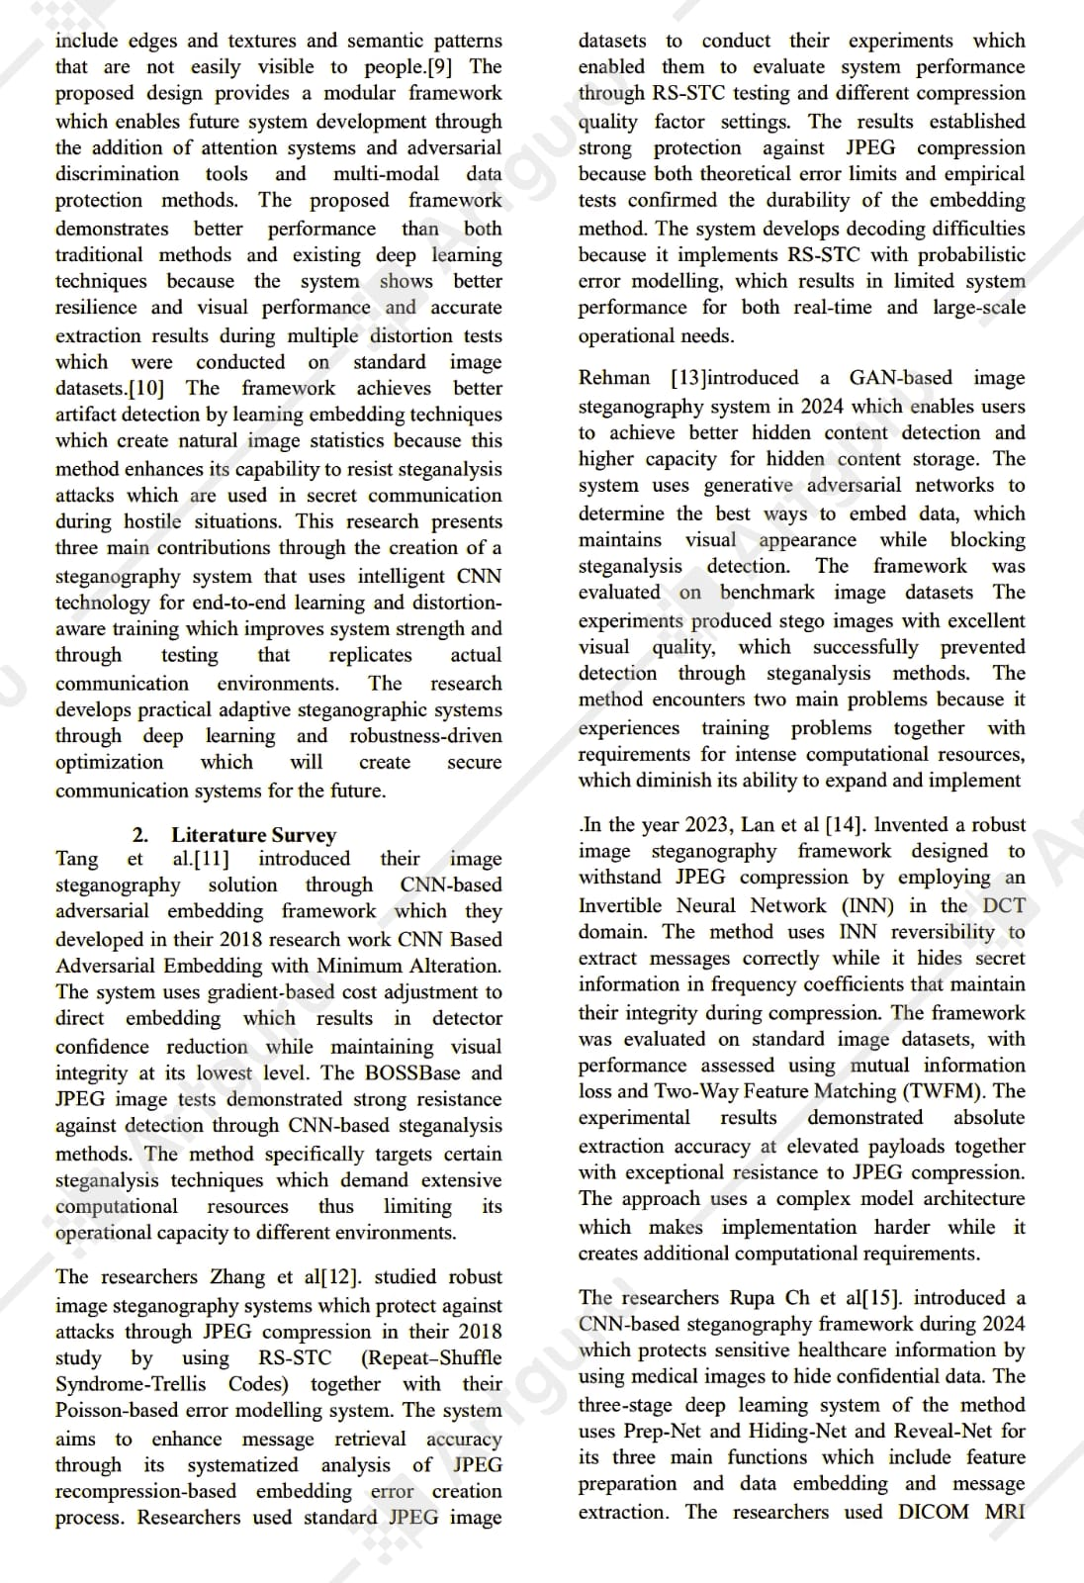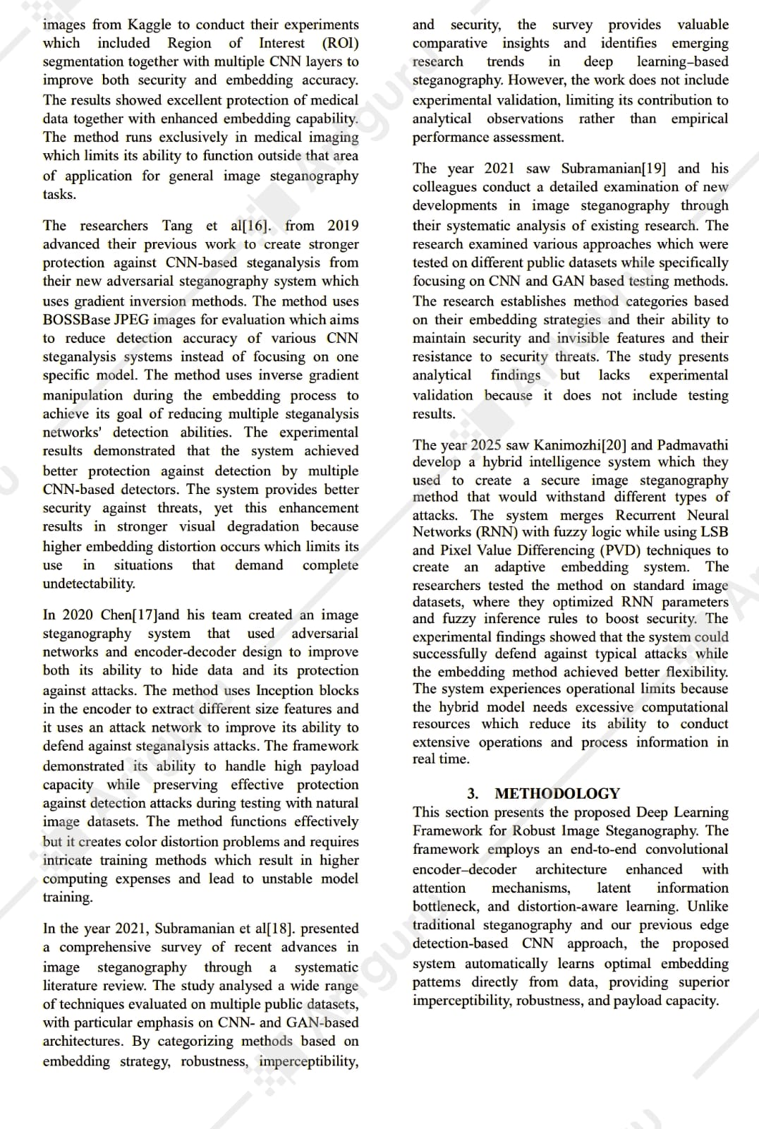
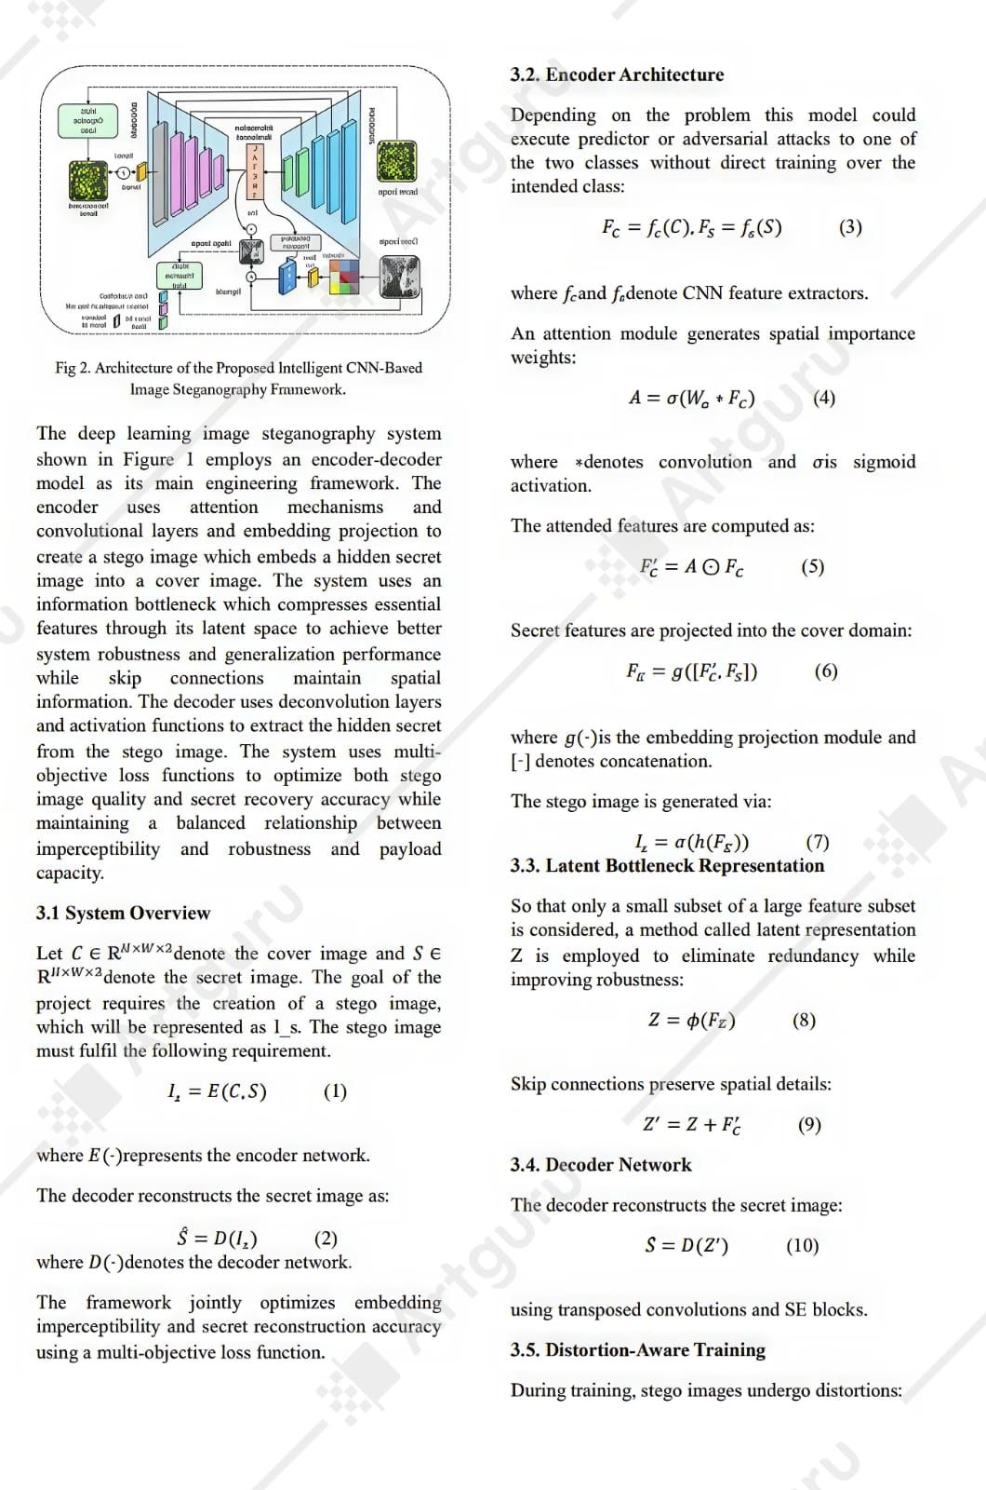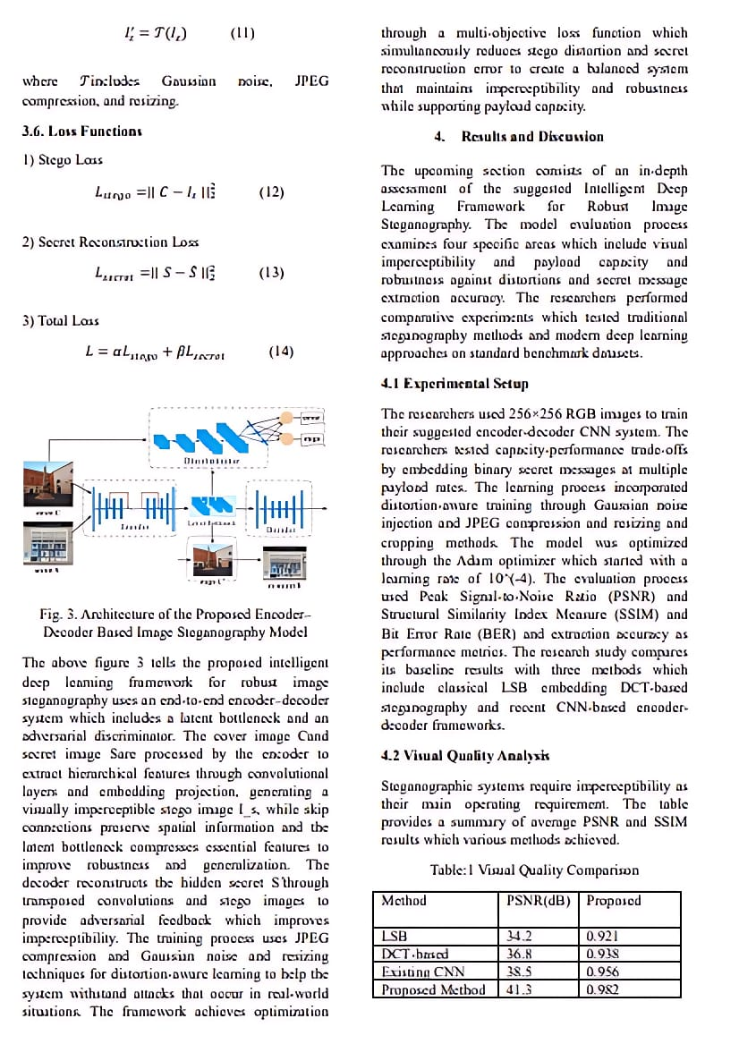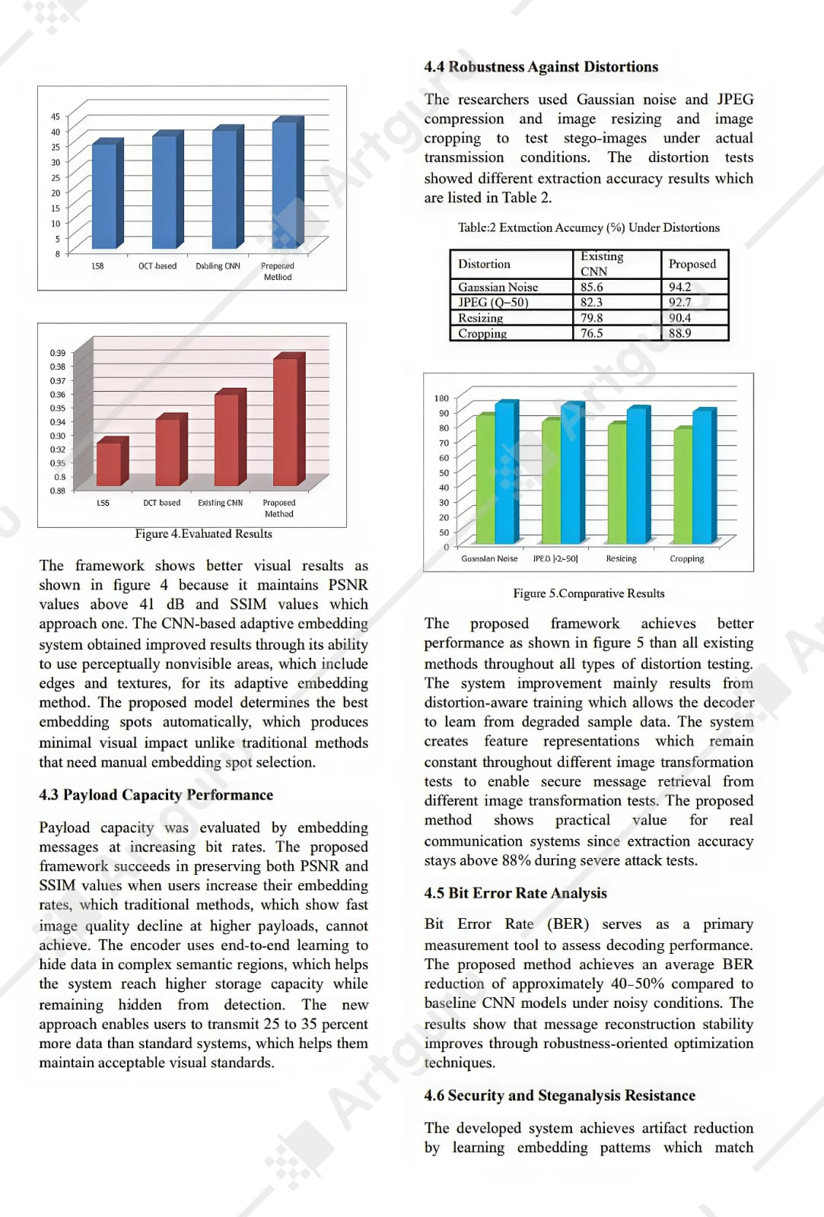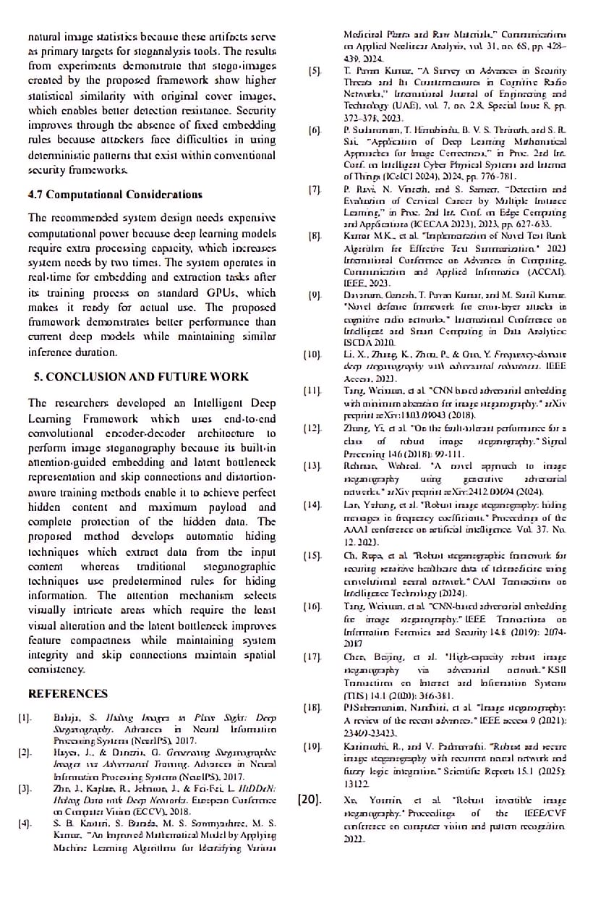

Conference Participation Certificate


