**ETHICAL HACKING**

**EXPERIMENT 9 – VULNERABILITY ANALYSIS USING NIKTO**

**BURAN.S**

**192124214**

**1.OPEN TERMINAL AND TYPE nikto -h** [**www.zoho.com**](http://www.zoho.com) **-Tuning x COMMAMD**

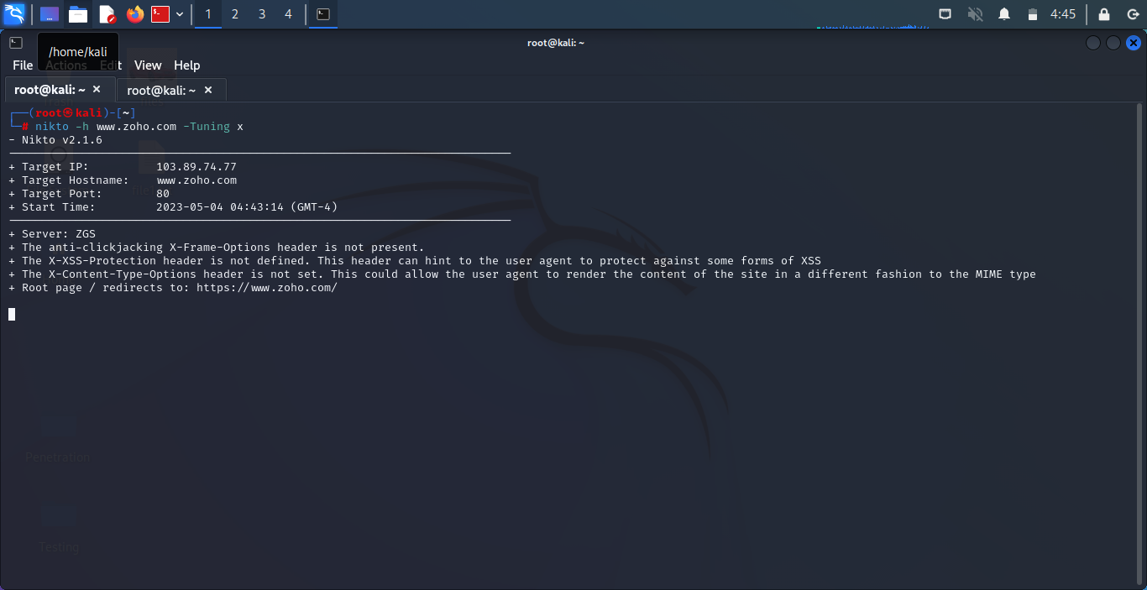

**2.NIKTO STARTS WEB SCANNING WITH ALL TUNING OPTIONS ENABLED**

**3.TYPE nikto -h** [**www.certifiedhacker.com**](http://www.certifiedhacker.com) **-Cgidirs all**

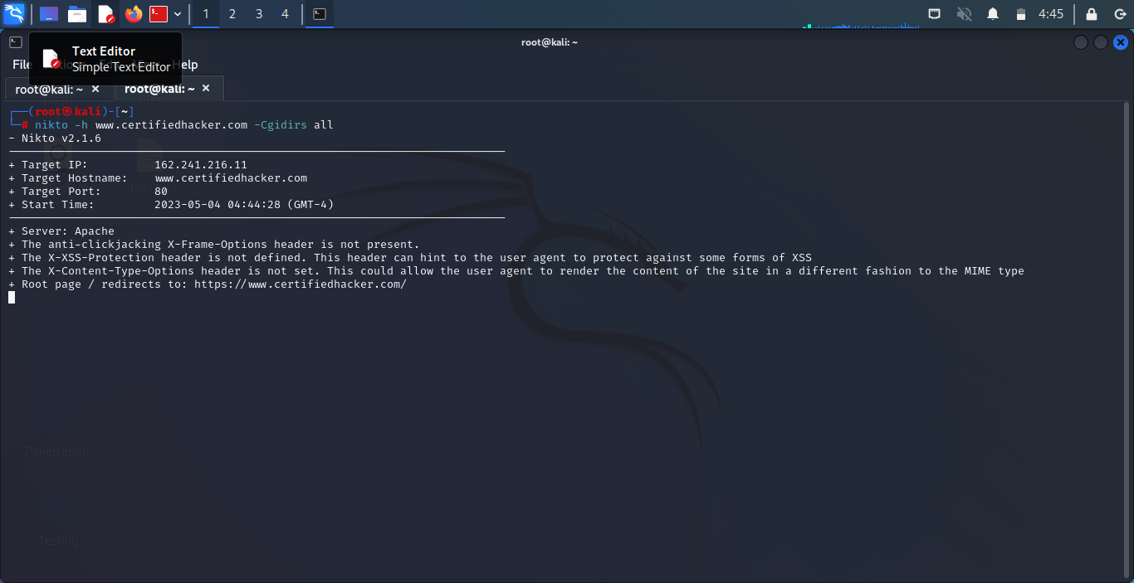

**4.Nikto will scan web server as it looks vulnerable CGI directories. It scans webserver and list of directories.**