WEEK 2 INTERNSHIP PROJECT
Exploratory Data Analysis and Visualization
of the Titanic Passenger Dataset
Virtual Data Science with Python
Submitted by: Shaikh
Week 2 Task

1. Introduction
Exploratory Data Analysis (EDA) is an important step in data science because it helps us understand the structure, quality, distribution and relationships present in a dataset before advanced analysis or machine learning. In this project, the Titanic passenger dataset is analyzed using Python. The analysis focuses on passenger survival and its relationship with variables such as gender, passenger class, age, fare and embarkation location.
The project follows the Week 2 internship requirements by using Pandas for data handling, Matplotlib and Seaborn for visualization, descriptive statistics for numerical understanding, and interpretation of patterns found in the data. The standard Seaborn Titanic dataset contains 891 passenger records and 15 columns. citeturn0search0turn0search4

2. Objectives
- Load and understand a public Titanic dataset.
- Inspect rows, columns, data types and missing values.
- Calculate descriptive statistics and survival statistics.
- Perform data cleaning and transformations.
- Create multiple visualizations using Matplotlib and Seaborn.
- Study survival patterns by gender and passenger class.
- Analyze age and fare distributions.
- Examine relationships and correlations among numerical variables.
- Interpret visualizations and summarize important findings.

3. Dataset Description
The Titanic dataset contains information about passengers on the RMS Titanic. Each row represents a passenger. Important columns include survival status, passenger class, gender, age, family-related counts, fare and embarkation point. The standard Seaborn version contains 891 rows and 15 columns. citeturn0search0turn0search2
Column | Meaning | Type
survived | 0 = did not survive, 1 = survived | Integer
pclass | Passenger class | Integer
sex | Passenger gender | Categorical
age | Passenger age | Numeric
sibsp | Siblings/spouses aboard | Integer
parch | Parents/children aboard | Integer
fare | Passenger fare | Numeric
embarked | Port code | Categorical
class | Class label | Categorical
who | Man, woman or child | Categorical
deck | Deck information | Categorical
alive | Survival label | Categorical
alone | Travelled alone | Boolean

4. Tools and Technologies
Python is used as the programming language. Pandas is used for loading, cleaning and analyzing tabular data. Matplotlib provides general plotting functionality, while Seaborn provides statistical and categorical visualizations. NumPy is included for numerical operations.

5. Importing Libraries
import pandas as pd
import numpy as np
import matplotlib.pyplot as plt
import seaborn as sns
sns.set_theme(style="whitegrid")

6. Loading the Dataset
import seaborn as sns
df = sns.load_dataset("titanic")
print(df.shape)
print(df.head())

Seaborn provides load_dataset() for loading its example datasets, including the Titanic dataset. citeturn0search2

7. Initial Dataset Analysis
The dataset contains 891 rows and 15 columns. There are 342 passengers marked as survived and 549 marked as not survived. Therefore, the overall survival rate is approximately 38.4%.
print(df.shape)
print(df.head())
print(df.info())
print(df.describe(include="all").T)

8. Missing Value Analysis
Missing values were checked before analysis. The standard Titanic dataset has 177 missing age values, 2 missing embarkation values and 688 missing deck values. Age is handled using the median for age-based analysis, and missing embarkation values are filled with the mode. The deck field is not used as a primary feature because a large proportion of its values are missing.
print(df.isnull().sum())
df["age_filled"] = df["age"].fillna(df["age"].median())
df["embarked_filled"] = df["embarked"].fillna(df["embarked"].mode()[0])

9. Data Transformation
Three useful transformations are performed. Missing age values are replaced with the median age, missing embarkation values are replaced with the most frequent category, and a readable survival_status column is created for charts.
df["age_filled"] = df["age"].fillna(df["age"].median())
df["embarked_filled"] = df["embarked"].fillna(df["embarked"].mode()[0])
df["survival_status"] = df["survived"].map({0:"Not Survived",1:"Survived"})

10. Descriptive Statistics
Statistic | Value
Total passengers | 891
Survived | 342
Not survived | 549
Overall survival rate | 38.4%
Male passengers | 577
Female passengers | 314
Mean age | 29.70 years
Median age | 28.00 years
Mean fare | 32.20
Median fare | 14.45

11. Visualization 1: Survival Distribution
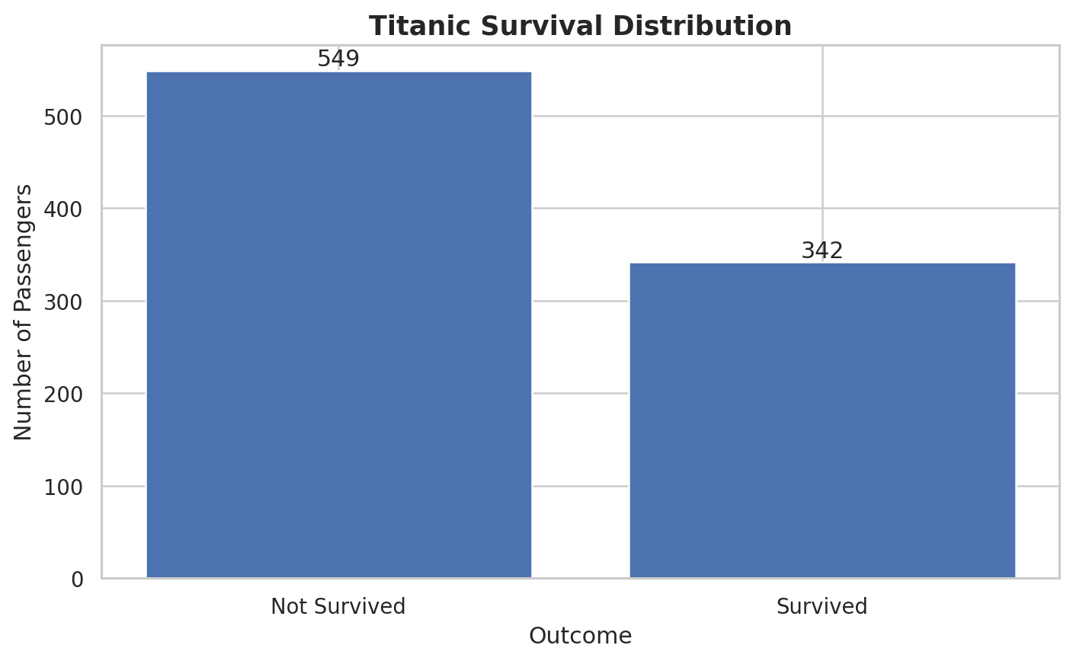
Figure 1: Distribution of survived and non-survived passengers.
Out of 891 passengers, 342 survived and 549 did not survive. The survival rate is approximately 38.4%, so non-survival was the majority outcome in the dataset.

12. Visualization 2: Passenger Distribution by Gender
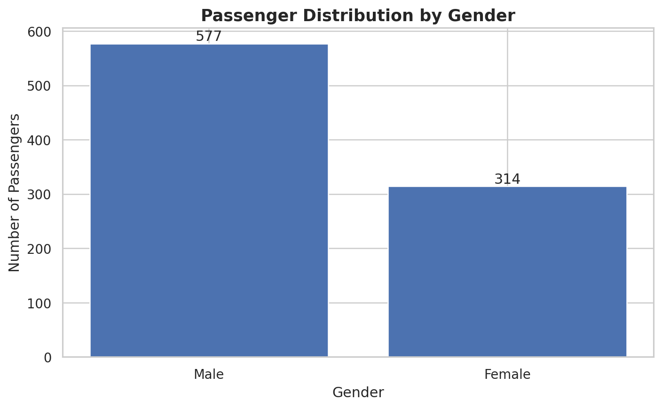
Figure 2: Passenger distribution by gender.
There are 577 male passengers and 314 female passengers. Male passengers therefore form the larger group in the dataset.

13. Visualization 3: Survival by Gender
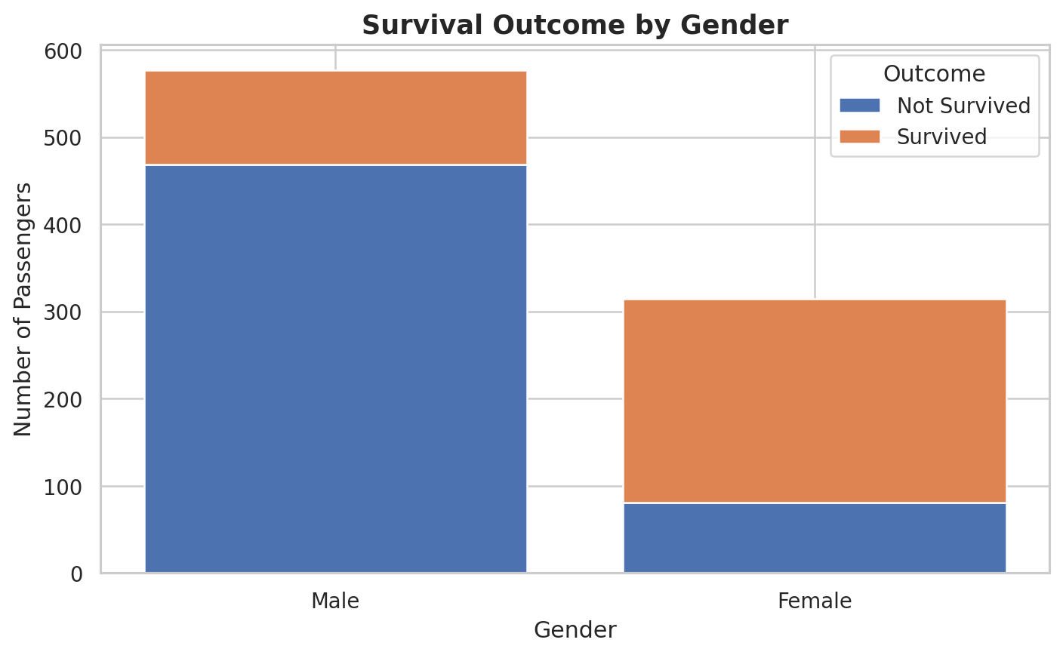
Figure 3: Survival outcome by gender.
Approximately 233 of 314 female passengers survived, while 109 of 577 male passengers survived. The survival rates are about 74.2% for females and 18.9% for males, showing a strong observed association between gender and survival.

14. Visualization 4: Passenger Class Distribution
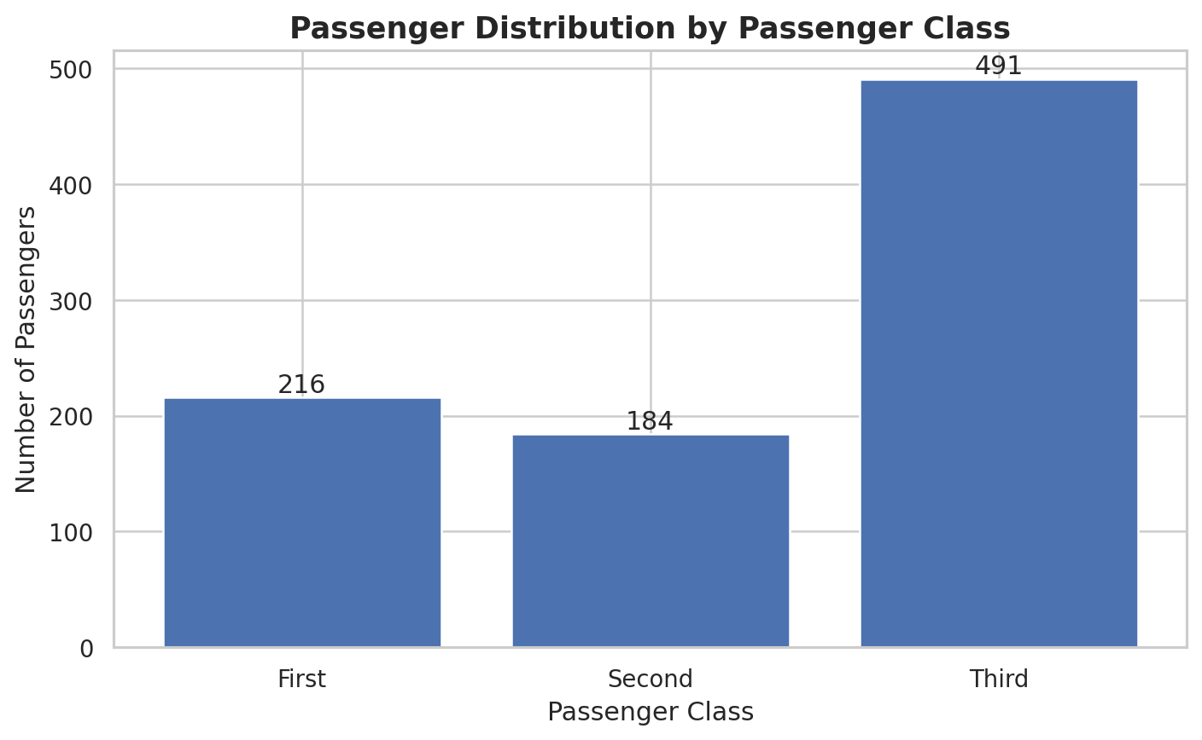
Figure 4: Passenger distribution across passenger classes.
Third class contains 491 passengers, first class 216 and second class 184. The class sizes are unequal, so raw survivor counts should be interpreted together with survival rates.

15. Visualization 5: Survival by Passenger Class
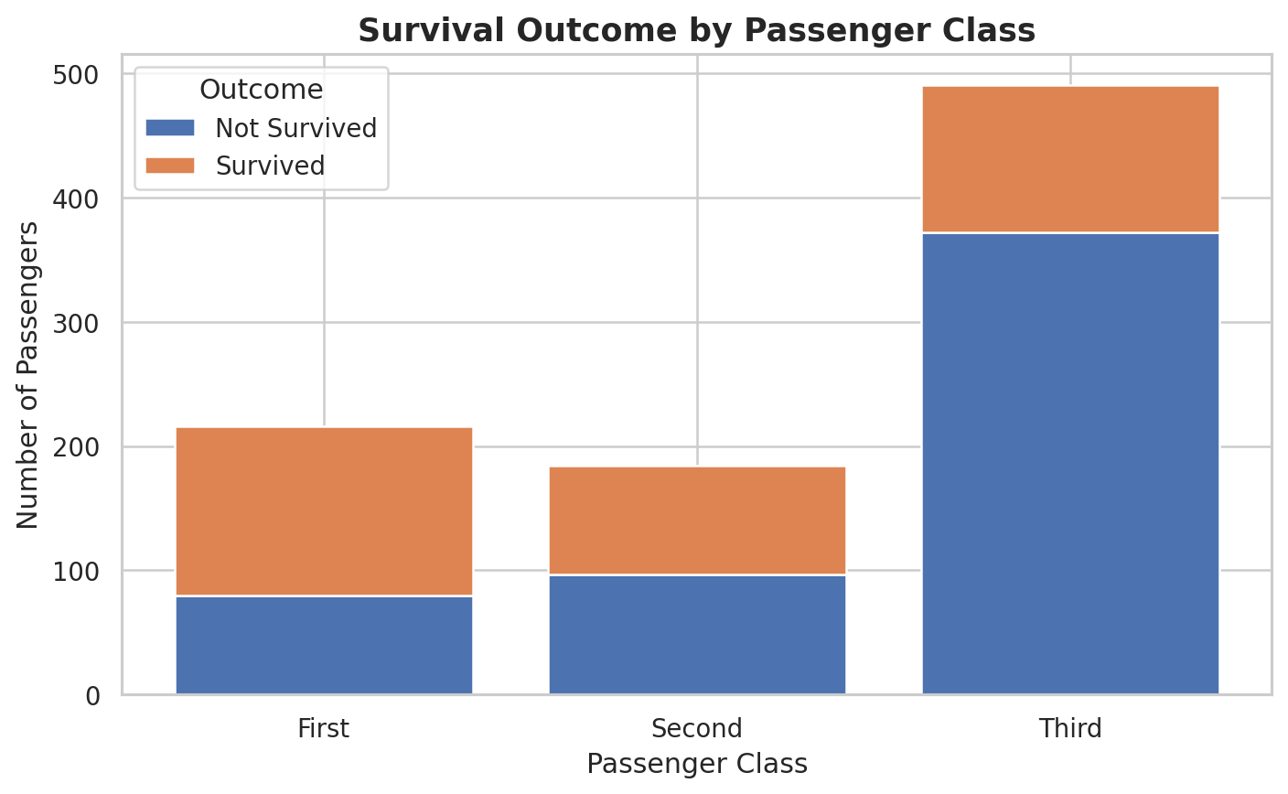
Figure 5: Survival outcome by passenger class.
First class had 136 survivors, second class had 87 and third class had 119. Comparing percentages is more informative because the class groups have different sizes.

16. Visualization 6: Survival Rate by Gender
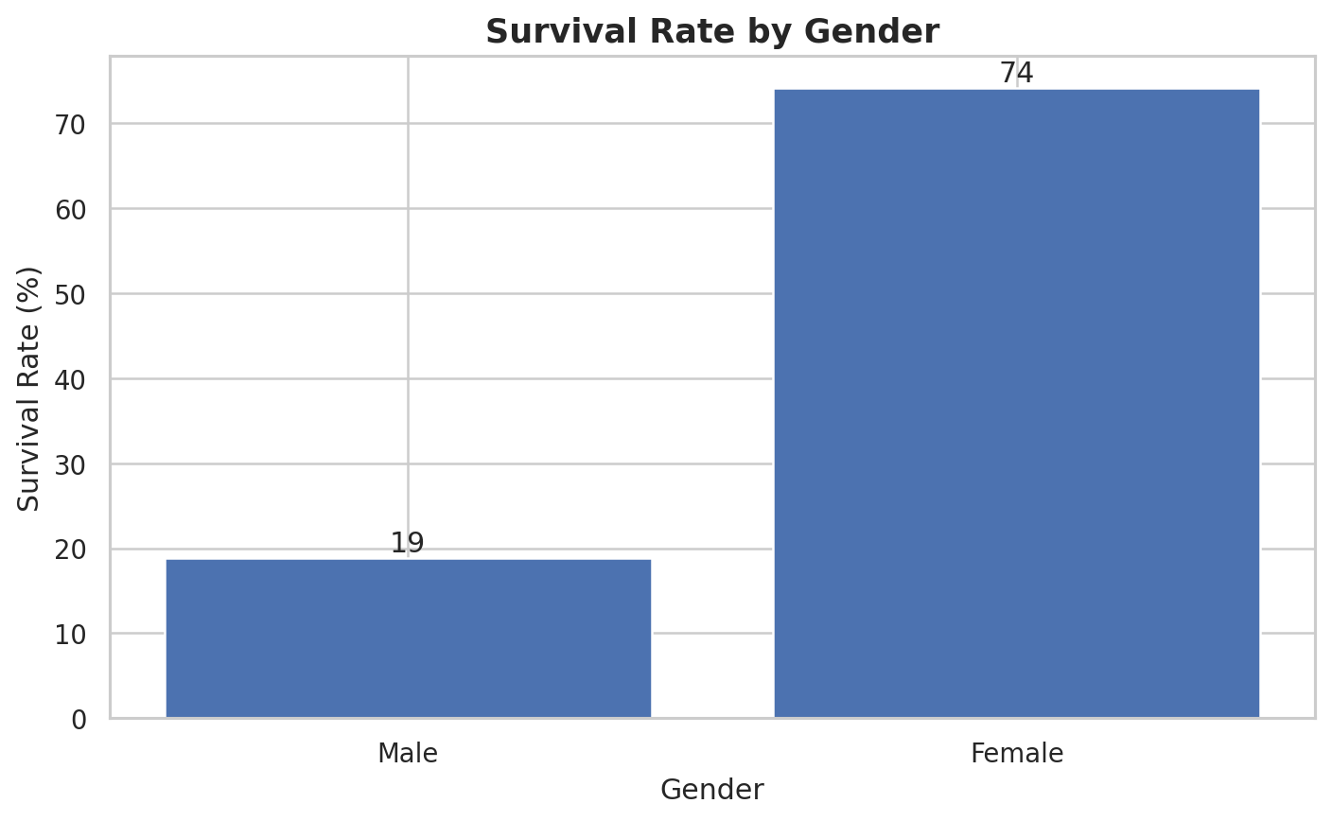
Figure 6: Percentage survival rate by gender.
Female survival is approximately 74.2%, compared with approximately 18.9% for males. This is one of the strongest patterns identified during the EDA.

17. Visualization 7: Survival Rate by Passenger Class
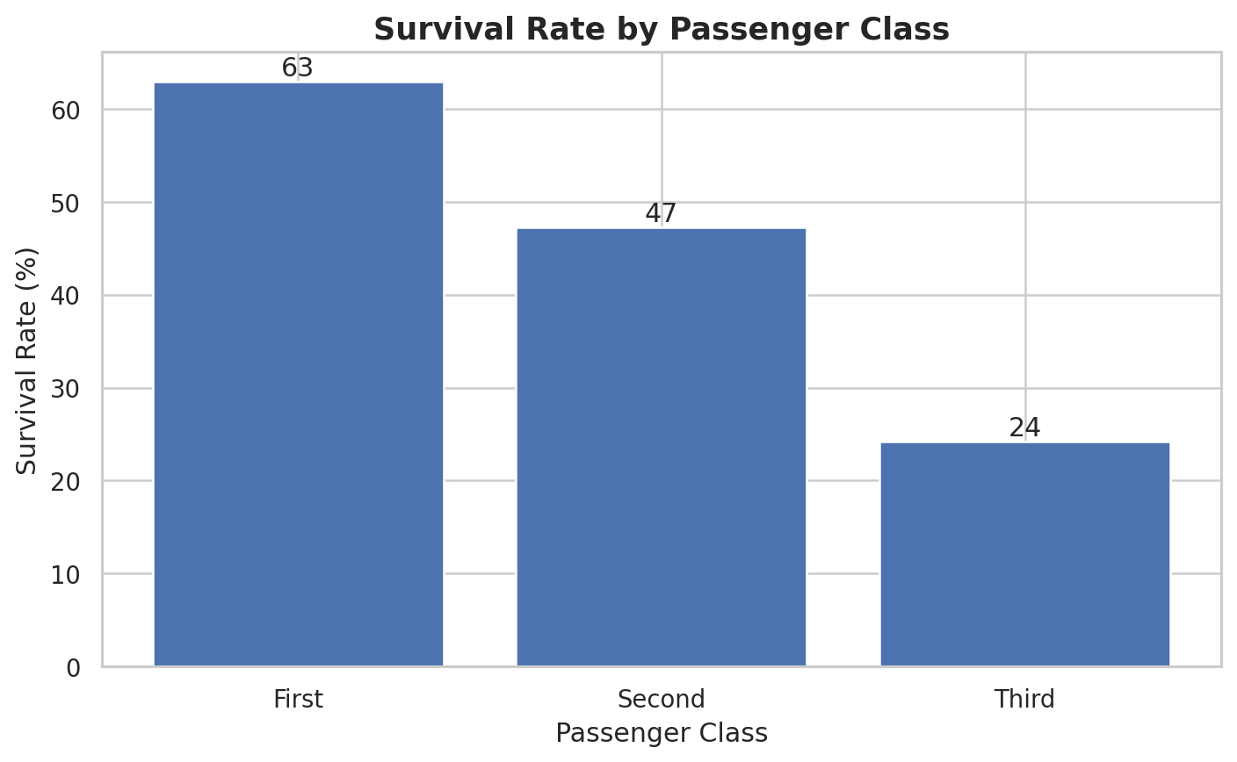
Figure 7: Percentage survival rate by passenger class.
First class has the highest survival rate at about 63.0%, followed by second class at about 47.3% and third class at about 24.2%. Passenger class was therefore strongly associated with survival.

18. Visualization 8: Embarkation Distribution
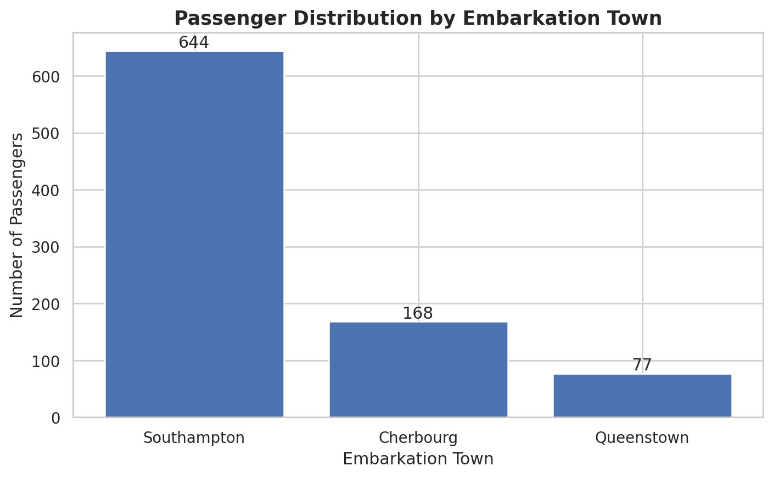
Figure 8: Passenger distribution by embarkation town.
Most passengers embarked at Southampton (644), followed by Cherbourg (168) and Queenstown (77). Two embarkation values are missing in the original dataset.

19. Visualization 9: Correlation Analysis
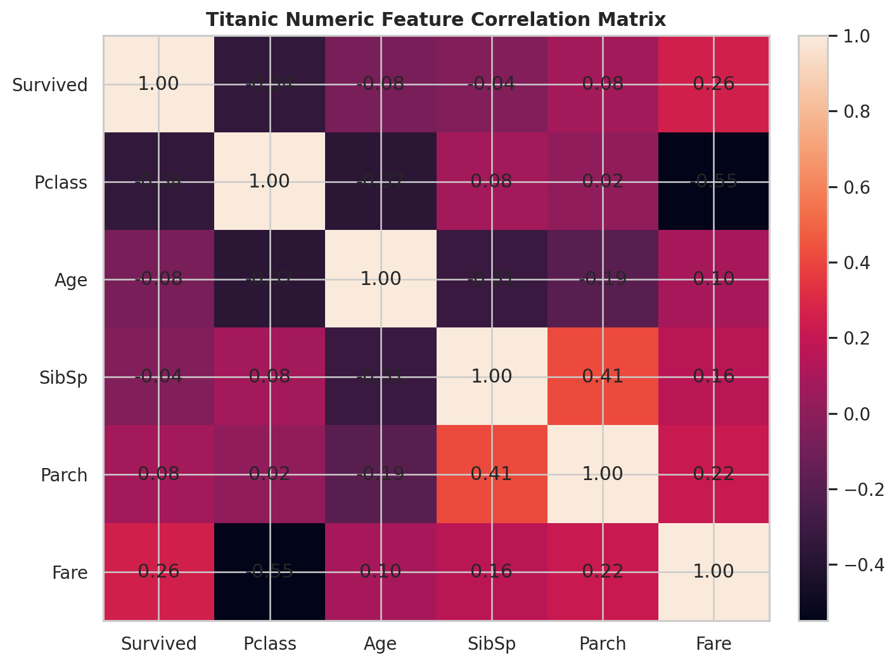
Figure 9: Numeric feature correlation matrix.
Correlation describes the strength and direction of a linear relationship between numerical variables. Survival has a negative relationship with the numeric pclass code and a positive relationship with fare. These are associations and should not be interpreted as proof of causation.

20. Key Findings
- The dataset contains 891 passengers and 15 variables.
- Only about 38.4% of passengers survived.
- Female passengers had a much higher survival rate than male passengers.
- First-class passengers had the highest survival rate, while third-class passengers had the lowest.
- Third class had the largest passenger count, so raw counts alone can be misleading.
- The mean age was about 29.7 years and the median age was 28 years.
- The mean fare was about 32.20 while the median was about 14.45, showing an uneven fare distribution.
- Age, embarked and deck contain missing information and require suitable handling.
- Correlation analysis helps identify relationships among survival, class, age, family variables and fare.

21. Interpretation and Discussion
The EDA indicates that survival was not evenly distributed across passenger groups. Gender and passenger class show particularly strong differences. Female passengers had a much higher survival rate than male passengers, while first-class passengers had a higher survival rate than lower classes. The analysis shows associations in the observed data; it does not prove that one variable directly caused survival.
The fare distribution is also uneven. A smaller number of passengers paid high fares while many passengers paid lower fares, which is why the mean fare is higher than the median. Missing-value analysis also demonstrates why data preparation is necessary before visualization or statistical analysis.

22. Main EDA Code
# Basic information
print(df.shape)
print(df.head())
print(df.info())
# Missing values
print(df.isnull().sum())
# Descriptive statistics
print(df.describe(include="all").T)
# Survival rate by gender
print(df.groupby("sex")["survived"].mean())
# Survival rate by class
print(df.groupby("class", observed=False)["survived"].mean())
# Correlation
numeric_cols = ["survived","pclass","age","sibsp","parch","fare"]
print(df[numeric_cols].corr())

23. Conclusion
This Week 2 project successfully performed exploratory data analysis and visualization on the Titanic passenger dataset. Pandas was used for data inspection, missing-value analysis, transformations and group-based calculations. Matplotlib and Seaborn were used to create clear visualizations. The analysis identified important survival patterns related to gender and passenger class, examined passenger and fare distributions, and explored numerical correlations. The project demonstrates how EDA can convert raw data into meaningful insights before further statistical or machine-learning work.

24. Future Scope
- Build a machine-learning model to predict passenger survival.
- Compare different classification algorithms.
- Perform feature engineering using family size, title and ticket information.
- Study interactions between gender, age and passenger class.
- Create an interactive dashboard using Streamlit or Power BI.

25. References
1. Seaborn Titanic dataset repository: https://github.com/mwaskom/seaborn-data/blob/master/titanic.csv
2. Seaborn load_dataset documentation: https://seaborn.pydata.org/archive/0.12/generated/seaborn.load_dataset.html
3. Seaborn categorical visualization documentation: https://seaborn.pydata.org/tutorial/categorical.html

