This is the complete, comprehensive Technical Specification and Architecture Document for your internal operations portal. This document maps out every single detail we discussed—combining your desaturated dark theme, the premium Clash Display + Inter typography system, dynamic multi-tab spreadsheet routing, and the unified team-wide global ticket repository.

1. UI Design & Design System
The system uses a high-contrast, desaturated dark theme designed to minimize eye strain over long operational shifts.

Color Palette Tokens
Token Name | Hex / RGBA Code | Operational Placement
--bg | #0a0a0a | Global canvas baseline background
--bg2 | #111111 | Secondary structures (Sticky footer, dense cards)
--text | #f0ede6 | High-contrast off-white for data readouts & headings
--muted | rgba(240, 237, 230, 0.45) | Secondary descriptions, subtext, and inactive labels
--card-bg | #111111 | Individual tracking columns & input field baselines
--card-border | rgba(255, 255, 255, 0.07) | Ultra-thin dividers separating columns and list rows
--card-hover | rgba(255, 255, 255, 0.03) | Subtle interactive highlight background
--line | rgba(255, 255, 255, 0.08) | Hard layout division lines (Header/Footer boundaries)

Typography Blueprint
- Display Font: Clash Display (Weights: 600, 700) -> Used for high-priority numbers, section headings, and dashboard telemetry counters.
- UI Body Font: Inter (Weights: 300, 400, 500, 600) -> Used for raw data inputs (User IDs), dropdown selectors, form buttons, and system text.

CSS Font Hierarchy Rules
CSS
.page-title {
font-family: 'Clash Display', sans-serif;
font-weight: 700;
font-size: clamp(2rem, 5vw, 3.5rem);
letter-spacing: -0.03em;
}
.section-header {
font-family: 'Clash Display', sans-serif;
font-weight: 600;
font-size: 1.15rem;
text-transform: lowercase; /* Optional minimalist aesthetic */
}
.column-label {
font-family: 'Inter', sans-serif;
font-weight: 600;
font-size: 0.72rem;
text-transform: uppercase;
letter-spacing: 0.08em;
}
.live-counter {
font-family: 'Clash Display', sans-serif;
font-weight: 600;
font-size: 1.6rem;
}

2. Core Operational Workflow
The application operates as a single-screen hub split into two distinct execution tracking panels.
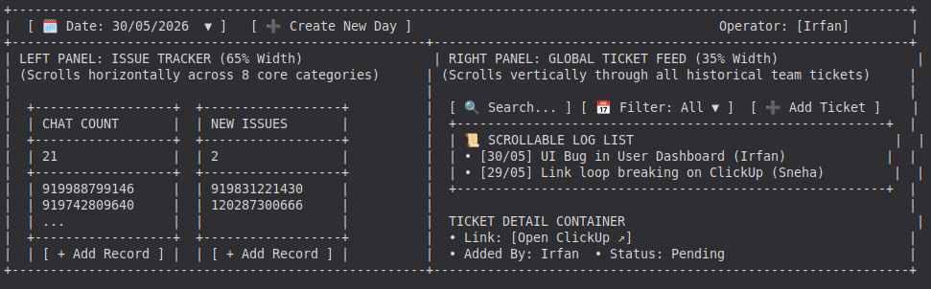

1. Step-by-Step System Flow
- Authentication Gate: The user visits the application. They select their name from a verified drop-down list (Irfan, Priyal, Jeffin, Sneha, Payal) and enter the uniform password: Link&Bug.
- Session Variable Locking: The app initializes a secure frontend state keeping that specific user’s target mapping active.
- Workspace Bootup:
  - The app reads the global current date (30/05/2026).
  - The Left Panel fetches and builds the 8 columns matching the active user's specific sheet tab inside the Links and Bugs ATM sheet.
  - The Right Panel pulls down the uniform team ticket history database.
- Daily Record Entry: The operator selects a column header, types or bulk-pastes user IDs directly into the bottom bar, and presses Enter. The front-end list grows dynamically, and the running tally updates instantly on screen.
- Automated Matrix Synthesis: The application backend fires an API callback, runs an Array.length totalizer function on the fresh array, and passes that value directly into the corresponding intersection block (Irfan rows 49–56 × Current Date column) on the shared Customer Support Master Sheet.
- Ticket Generation: Clicking + Ticket triggers an overlay modal capturing data to feed into the persistent global workspace registry without resetting or clearing any active work on the left-hand tracking tables.

3. Frontend Architecture (Next.js)
The layout is built with standard CSS Flexbox rules to completely prevent page scrollbars, maintaining a fixed viewport canvas where data lists handle their own scroll properties independently.

Application Folder Tree
├── app/
│ ├── layout.jsx # Font loads, metadata, and root styles
│ ├── page.jsx # Authentication gate (Login layout)
│ └── dashboard/
│ └── page.jsx # Dual-panel interactive application dashboard
├── components/
│ ├── AddTicketModal.jsx # Interactive overlay for capturing new ClickUp issues
│ ├── ColumnCard.jsx # Reusable instance for data-input categories
│ └── TicketDetail.jsx # Displays rich metadata when a single ticket item is clicked

Client-Side State Schemas
JavaScript
// Dynamic session tracking
const [currentUser, setCurrentUser] = useState("Irfan");
const [selectedDate, setSelectedDate] = useState("30/05/2026");

// Left panel issue mapping state
const [dailyLogs, setDailyLogs] = useState({
chatCountUpdated: ["919988799146", "919742809640"],
newIssuesChecked: ["919831221430"],
checkedFilters: [],
callsAnswered: [],
callsUnanswered: [],
issuesResolved: [],
tagsAssigned: [],
aiCount: []
});

// Right panel global feed tracking states
const [allTickets, setAllTickets] = useState([]); // Array of objects
const [searchQuery, setSearchQuery] = useState("");
const [ticketDateFilter, setTicketDateFilter] = useState("All");
const [activeTicketSelection, setActiveTicketSelection] = useState(null);

4. Backend & API Database Routing
The application utilizes API endpoints (/api/records and /api/tickets) using Google Sheets as a relational datastore engine accessed via a Google Workspace Service Account.

Data Matrix Mappings
┌──▶ Target Tab: [CurrentUser Variable] (e.g., "Irfan")
│ Writes raw multi-column arrays for local day review.│
[ Web Frontend Payloads ] ├──▶ Target File: Customer Support Master Sheet
│ 1. Matches Row Block: [CurrentUser] (Rows 49–56)
│ 2. Matches Column Header: [SelectedDate]
│ 3. Issues direct cell update with final array length counts.
│
└──▶ Target Tab: "Ticket Tracker" (Common to all users)
Appends persistent structured logs to uniform repository.

1. Individual Record Tabs Structure (Links and Bugs ATM sheet)
Every individual row holds historical entry items stamped by date across custom columns, allowing Option B layout query execution:
[ Date ] [ Category_Key ] [ User_ID ]

2. Universal Global Ticket Schema (Ticket Tracker Tab)
Every entry row in this uniform document registers structural objects:
[ Date ] [ Created_By ] [ Ticket_Title ] [ ClickUp_URL ] [ Optional_Status ]

5. Component Functional Specifications

Top-Left Management Bar
- Date Picker Selector: Toggling a historical date sets the UI layout state into Read-Only Mode. This alters column background styling, freezes cell entry inputs, and swaps active state tracking lists with historical lines returned from the database engine.
- "Create New Day" Action Trigger: Checks if a table data array matches the current date string inside the user tab. If not found, it runs an entry initialization routine creating an empty working cache for all 8 metrics.

Global Ticket Panel Integration
- Front-End Memory Filtering: To achieve hyper-fast searching, text inputs and date filtering drop-downs execute directly over the downloaded memory matrix using local mutations (.filter()) instead of launching repeated backend database queries.
- Automated Title Derivation: When pasting a long ClickUp link into the link input box, the form uses JavaScript regex to parse and pull the specific ClickUp task ID (e.g., 86d35x3m4) to pre-populate or tag the title block if the user leaves it empty.

