Guidelines for Data Visualization and Analysis Project

About the Project:

In this project, you will be working with a dataset from the Superstore, aiming to answer 30 scenario-based questions through data visualisation and analysis. Your objective is to select the best chart for each question, explain your choice. This project will showcase your proficiency in data visualisation, critical thinking, and effective communication.

Skills Required:

- Proficiency in data visualisation concepts and techniques.
- Familiarity with Tableau or a similar data visualisation tool.
- Strong analytical and problem-solving skills.
- Ability to choose appropriate charts based on data characteristics and question requirements.
- Clear and concise communication skills.

Deliverables:

- A Google document containing solutions to the scenario based questions including the screenshot of relevant chart picked for each scenario, presented in a concise and well-structured format. Make sure to provide explanations that highlight your problem-solving skills.

Rubrics for Assessment:

Question Responses:
- Accuracy and completeness of answers for all 30 questions.
- Clear and concise explanations that address the question's context.
Chart Selection and Explanation:
- Thoughtful rationale for choosing specific chart types.
- Justification based on data characteristics, context, and communication goals.
Creative Enhancements:
- Effective use of creative elements to enhance visualisation quality.
- Enhancements that contribute to better understanding or engagement.

Note:
- Duplicate this document and proceed to write your solutions.
- For each scenario and question, provide a justification for the choice of chart type. Explain why it is the best option to visualise the data effectively.
- Attach screenshots of the charts you have created in Tableau for each scenario and question using the Superstore dataset. Label them clearly to match the corresponding questions in the Google Document.
- Submit the duplicated google doc file after completion.

Use these guidelines to structure your data visualisation and analysis project. Remember to maintain consistency in your responses, explanations, and visualisation styles. This project will not only demonstrate your skills but also your ability to effectively communicate complex information through visualisations. Good luck!

Problem Statement: Choose the Best chart for any 30 scenario based questions from Superstore Dataset.

Imagine you are a data enthusiast aiming to excel in data visualisation and analysis. In this task, you have been given any 30 scenario-based questions derived from the Superstore dataset, and your objective is to provide insightful answers using appropriate charts. For each question, you need to select a chart that best represents the data, explain why you chose that specific chart, and then proceed to build the chosen chart using Tableau.

Your responses should be succinct, organised, and illustrative of your problem-solving capabilities.

Dataset Link:
https://community.tableau.com/s/question/0D54T00000CWeX8SAL/sample-superstore-sales-excelxls

Please keep in mind:
- Answer Completion: Ensure that you furnish answers for all any 30 questions and build charts for them.
- Encouraged Creativity: Don't hesitate to employ visuals, creative elements, or any other innovative approaches to enhance the quality of your responses.

By completing this task effectively, you'll not only demonstrate your proficiency in data visualisation and analysis but also showcase your ability to effectively communicate complex concepts through both text and charts.

Good luck!

Questions:

- Which product categories have the highest total sales in the "Superstore" dataset?
Ans: The Technology category has the highest sales in the given dataset.
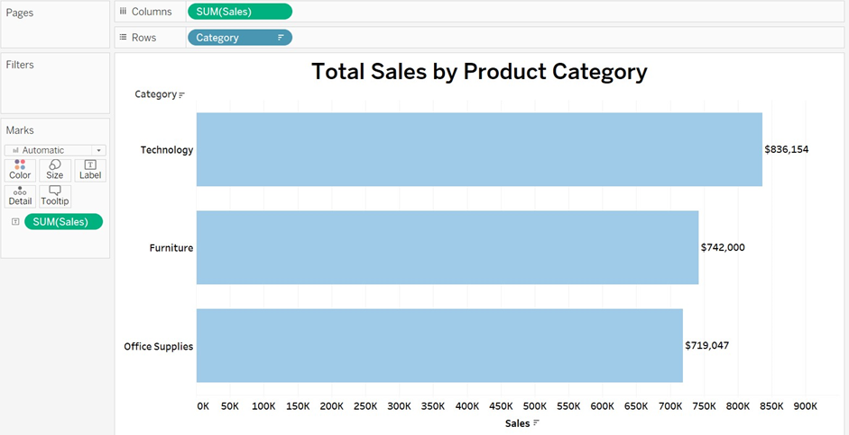
Explanation: I have used a horizontal bar chart to show the total sales by category because horizontal charts make it easier to read longer names without any confusion. In horizontal charts, it is also easy to show the rank of the categories based on a given function, such as technology followed by furniture and then office supplies.

- How do the monthly sales amounts change over the course of a year?
Ans: In the months of March, September, and November, the growth of sales is significantly higher than in other months, while from April to August, the sales remain relatively constant. Overall, there is an increase in sales throughout the year.
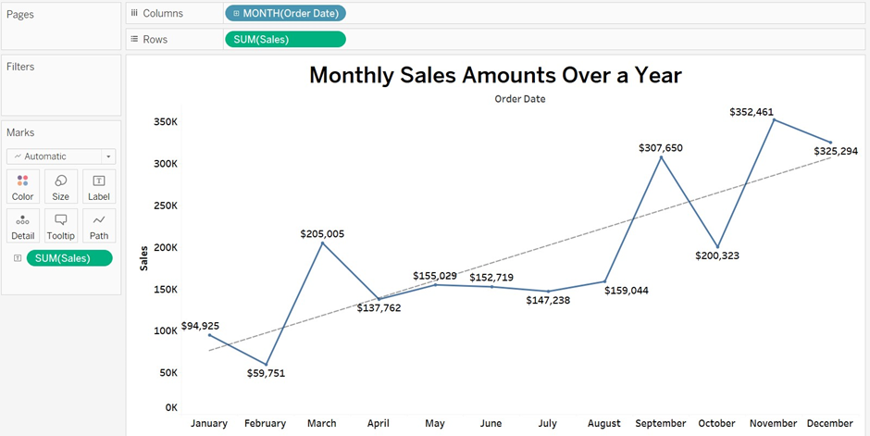
Explanation: I have used a line graph because it shows the trend over time. The line graph highlights fluctuations in the data, which is beneficial for analyzing supermarket performance.

- How is the total sales amount distributed among different product categories?
Ans: 36.4% of sales are in the Technology category, 32.3% of sales are in the Furniture category, and the remaining 31.3% of sales are in the Office Supplies category.
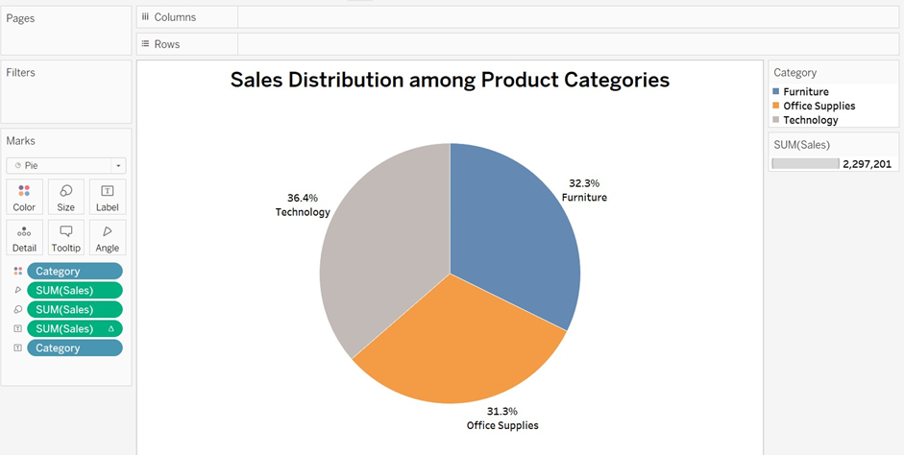
Explanation: I have used a pie chart because it effectively shows the distribution of sales among different product categories. Each slice of the pie chart provides an immediate understanding of the distribution of each product category.

- Can we analyze the sales performance of individual customers over time?
Ans: Yes, we can analyze the sales performance of individual customers as visualize below.
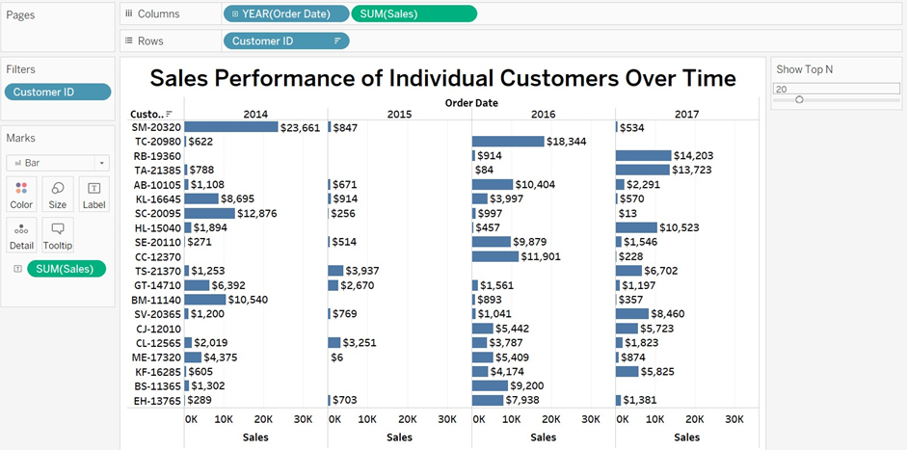
Explanation: I have used a horizontal bar chart to analyze the sales performance of customers over time. The horizontal chart provides a quick understanding of each customer's performance, displaying their sales for each year. The horizontal layout is suitable for showcasing the large label names associated with the customers.

- How do sales vary based on different days of the week and product categories?
Ans: Sales variation by days of the week and product categories is visualize as,
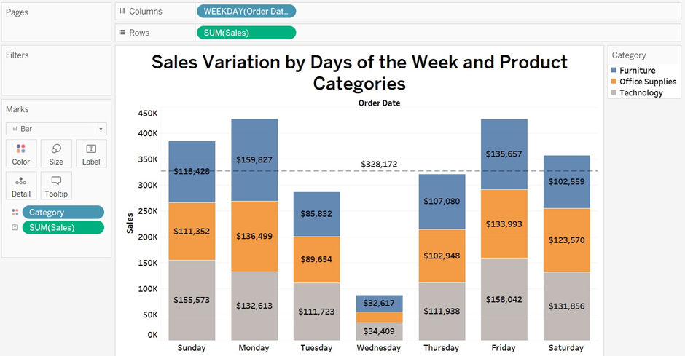
Explanation: A stacked bar chart is used to represent the combination of different categories in a single chart. In this chart, we can observe the sales for each day of the week, ranging from Sunday to Saturday, with each color representing a different category. The visualization provided by the stacked chart is ideal for presenting multiple categories simultaneously in a single chart.

- Can we visualise the sales growth of different product categories over time?
Ans: Yes, sales growth of different product categories over time is visualize as,
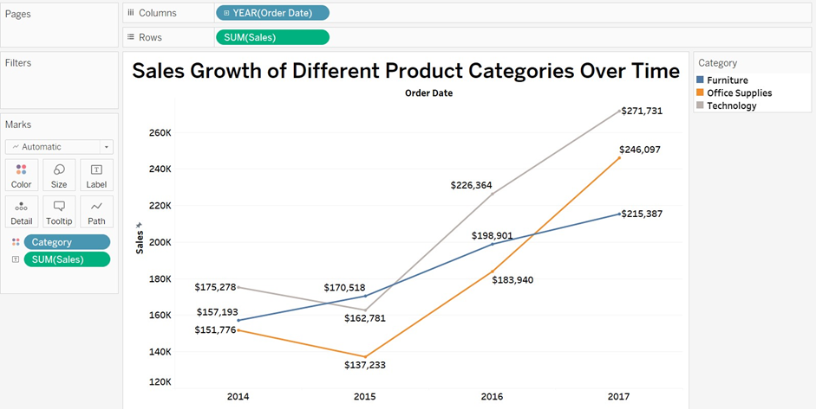
Explanation: A line chart is the best choice for visualizing growth trends or rates of change over time. In this chart, we can see the growth of different categories represented by different colors, allowing for quick visualization of sales growth from 2014 to 2017. The line chart is an optimal solution for showing the trends of different categories. In this graph, Furniture shows constant growth without any declines, whereas Office Supplies and Technology experienced a decline in sales in the year 2015. Following this decline, both Office Supplies and Technology showed a growth in sales at a higher rate than Furniture. Technology had the highest sales in 2017.

- How does the sales distribution vary across different regions in the "Superstore" dataset?
Ans: The sales in the West region are higher, followed by the East region, then the Central region, and finally the South region. This visualization is as follows:
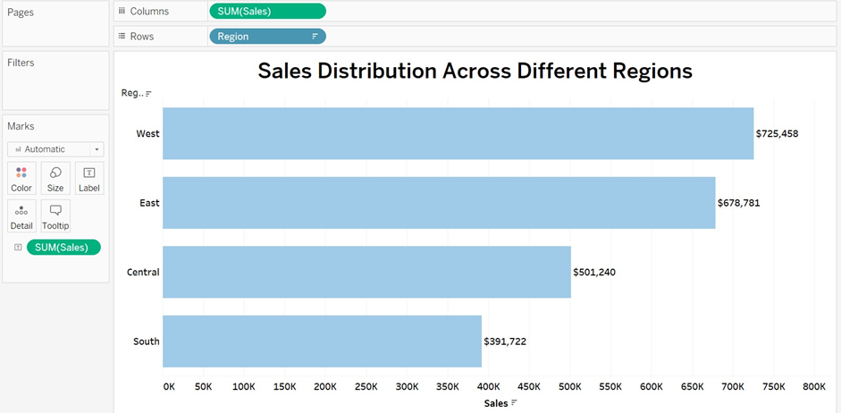
Explanation: A horizontal bar chart is used to display the sales distribution, showcasing the highest sales in the West region and the lowest sales in the South region. This graph is highly efficient and makes it easy to understand the sales distribution across different regions.

- Can we visualise the composition of profits across various subcategories within different customer segments?
Ans: Yes, the visualization of Profits across subcategories within different customer segments are follows as:
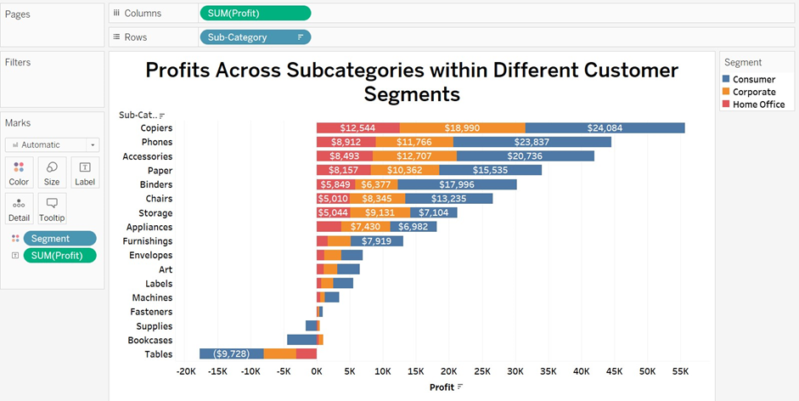
Explanation: The horizontal stacked bar chart is used to display different segments with profit represented as positive values and loss as negative values. A horizontal bar chart is chosen due to the long sub-categories. This stacked bar chart is ideal for visualizing different customer segments along with their corresponding profits or losses. In this chart, it is evident that the Copier segment is highly profitable, while Tables are associated with significant losses.

- What is the percentage contribution of each region to the overall sales?
Ans: The West region contributes 31.6%, Central contributes 21.8%, East contributes 29.5%, and South contributes 17.1% to overall sales. This visualization is represented as:
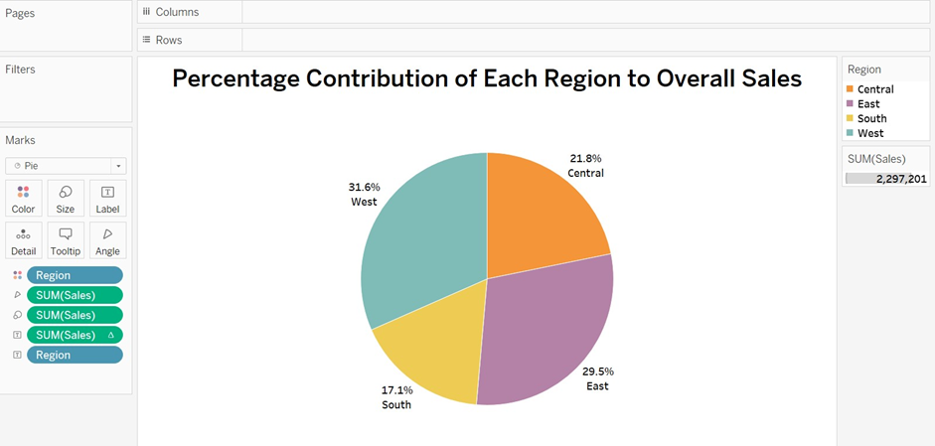
Explanation: A pie chart is used to show the distribution of percentage contribution of each region to overall sales. Here every single slice represents a different region with the percentage contribution to overall sales.

- Can we visualise the profit margins associated with different shipping modes and customer segments?
Ans: Yes, profit margins with different shipping models and customer segments are visualized as follows: 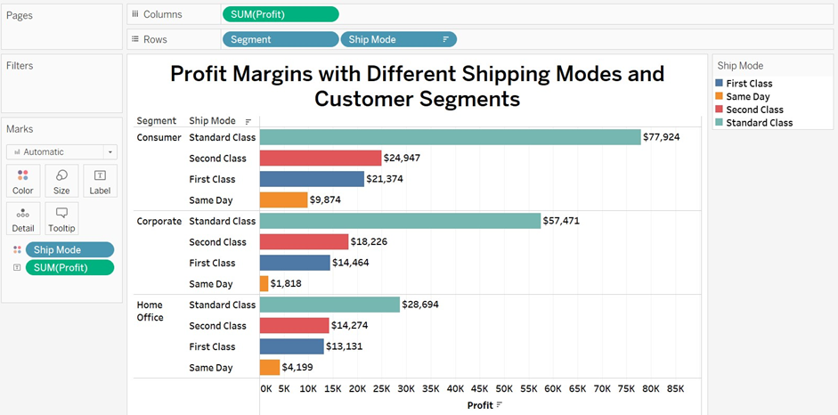
Explanation: A grouped horizontal bar chart is effectively used to display profit margins across different shipping modes and customer segments. In this chart, each segment is grouped by its shipping modes, with each shipping mode represented by a different color for easy visualization. The chart shows that the standard class has the highest profit margin in every segment.

- How long does it take to process orders for different product categories?
Ans: To determine the processing time, we will calculate the average, and its visualization is provided as follows:
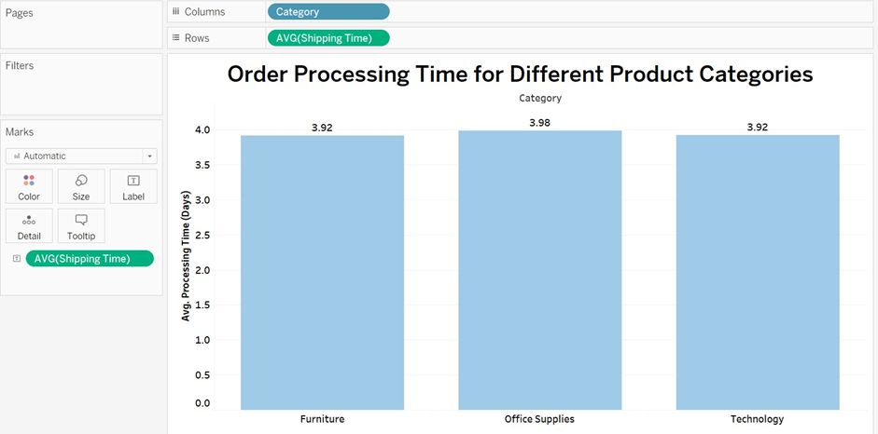
In this vertical bar chart, the categories and average processing times in days are displayed. Each bar represents the average shipping time for a category. The visualization shows that the Furniture and Technology categories both take 3.92 days, while Office Supplies take 3.98 days. Therefore, we can conclude that there is a lower scope for improvement in Office Supplies.

- How do discounts affect overall profit?
Ans: The visualization showing how discounts affect overall profit is provided as follows:
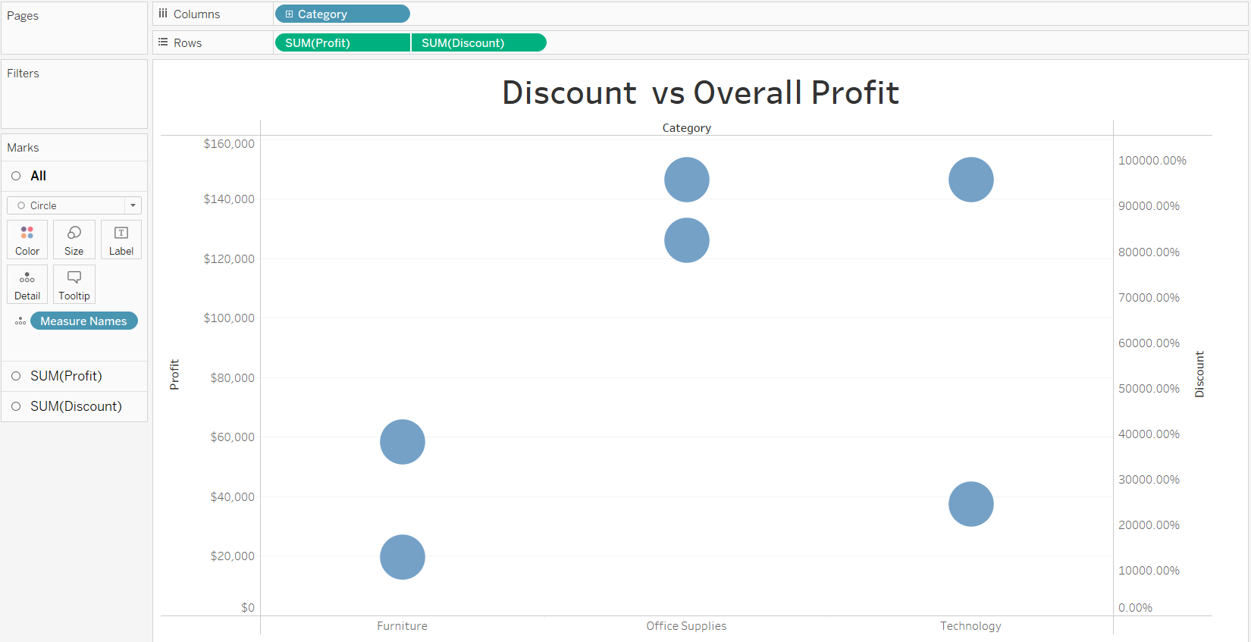
Explanation: A dual-axis scatter plot is best suited for illustrating the relationship between discount and profit. In this plot, we can observe that in the Furniture category, the discount does not significantly affect profit. In the Office Supplies category, there is a slight difference in profit due to discounts. However, in the Technology category, discounts have a substantial impact on profit.

- Can we visualise the relationship between product sales and profitability for different product categories?
Ans: Yes, the visualization for sales and profitability for different product categories is represented as follows:
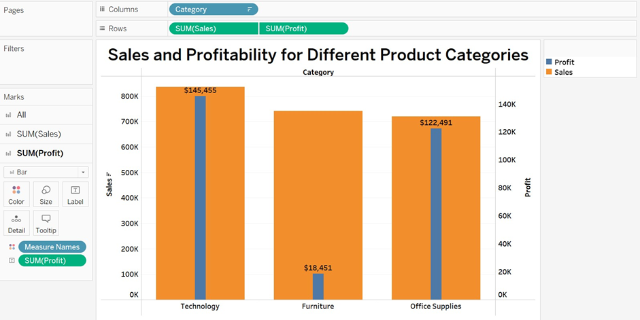
Explanation: This dual-axis bar chart is perfectly suited for displaying sales and profitability across different categories because it allows two metrics to be shown in a single chart. From the visualization, we can see that the sales and profit of Technology and Office Supplies have a balanced relationship for the sample-superstore dataset. However, for Furniture, while sales are high, the profit generated from Furniture is much lower than the sales.

- What is the distribution of order quantities for products in the dataset?
Ans: The visualization representing the distribution of order quantities for products is as follows:
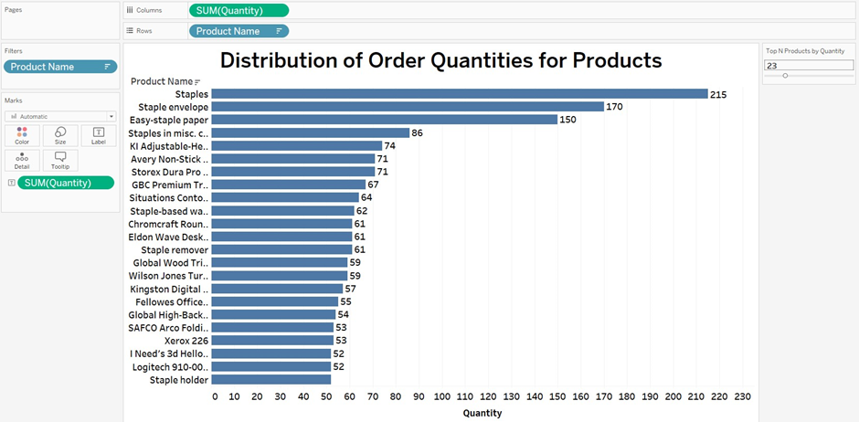
Explanation: In this horizontal bar chart, we can easily observe the distribution of order quantities for products. The horizontal layout makes it straightforward to identify the products with higher and lower distribution at a glance, by simply visualizing the top and bottom products.

- How do the profit distributions vary across different product categories?
Ans: The visualization representing the profit distribution across different product categories is as follows:
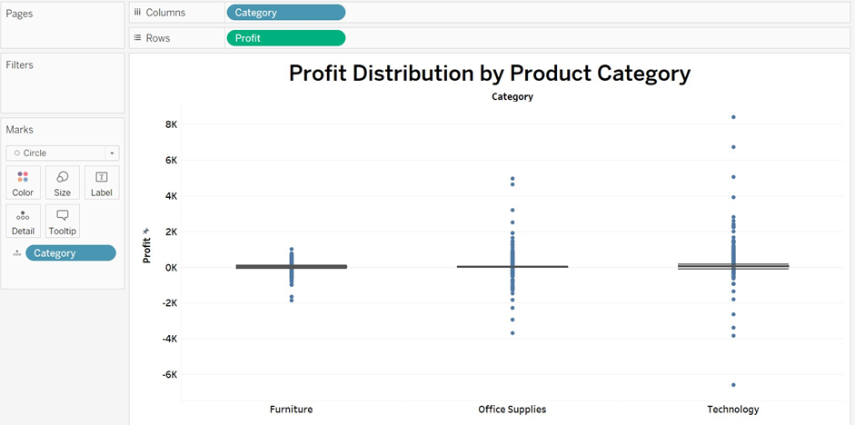
Explanation: A box and whisker plot is the best choice to visualize the profit distribution by product category. This visualization shows the median, which provides a measure of central tendency for skewed distributions. Additionally, it displays the interquartile range (IQR), highlighting the middle 50% of the data. In the Technology plot, we can observe significant outliers indicating great profit, while in the Office Supplies plot, there is profit but also some losses. In the Furniture plot, the outliers below the profit line indicate higher losses.

- Can we compare the shipping time distributions for different shipping modes?
Ans: Yes, the visualization is represented as:
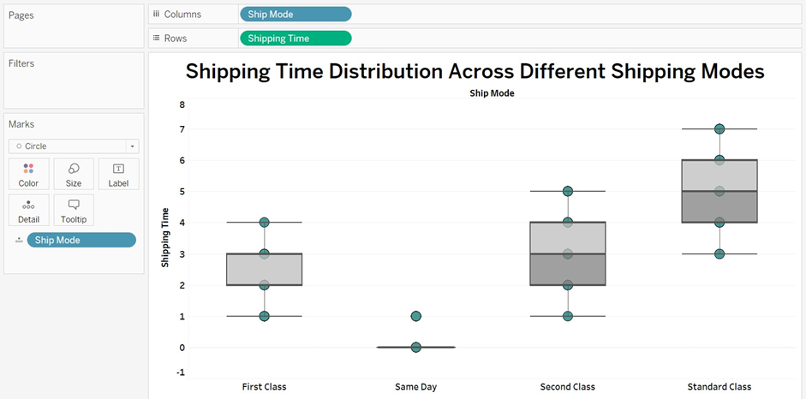
Explanation: A box and whisker plot is used to visualize the shipping time for different shipping modes. In the First Class mode, there are outliers that indicate quick shipping times, while other outliers show consistent shipping times. At same time mode, shipments are delivered on the same day, representing the fastest shipping. In the Second Class mode, the interquartile range (IQR) is broader, and the median is also higher than in First Class, indicating slower delivery times. For Standard Class, both the IQR and median are broader and higher, respectively, suggesting the slowest shipping option.

- What is the monthly trend in the number of orders shipped?
Ans: The shipping trend from January to December is visualized as follows:
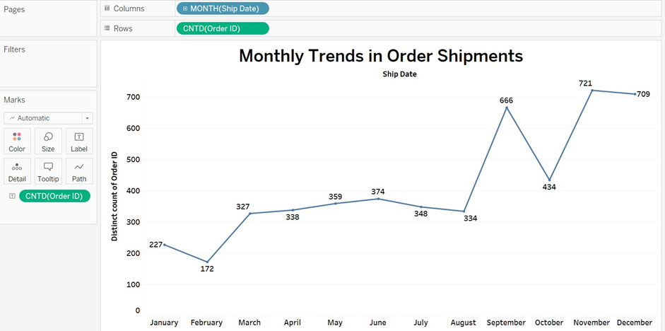
Explanation: A line graph is highly suited for visualizing trends over time. In this line chart, it displays the monthly trend in order shipments, highlighting that September, November, and December are the months with the highest shipment volumes.

- How do different customer segments perform in terms of sales and discount rates?
Ans: The visualization for Sales vs Discounts across customer segment is:
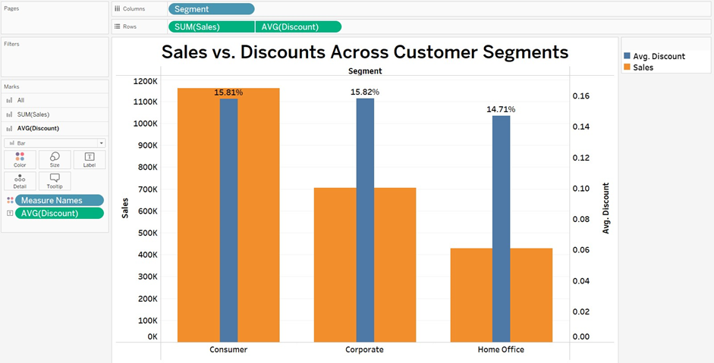
Explanation: The dual-axis bar chart is used to display two metrics in a single chart. In this graph, one axis represents sales while the other shows the average discount for customer segments. In the Consumer segment, there appears to be a balance between sales and discounts. In the Corporate segment, sales are slightly lower than discounts. However, in the Home Office segment, discounts are given more than the actual sales.

- What are the sales and profit trends across different product subcategories and regions in the Superstore dataset?
Ans: Sales and profit trends by product subcategory across regions are visualized as:
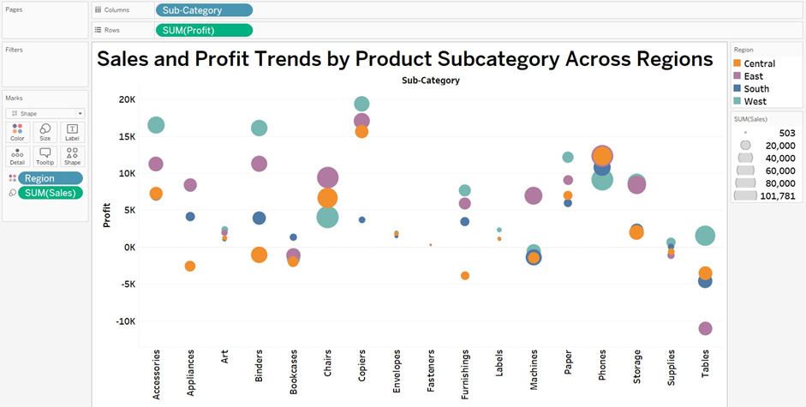
Explanation: A scatter plot is best suited for displaying the sales and profit trend by product subcategory across regions. In this plot, the four colors of bubbles represent the four regions: Central, East, South, and West. The size of each bubble indicates the sales volume across the region. The main conclusion drawn from this visualization is that tables are loss-making, especially in the East region, while copiers are highly profitable despite having low sales volume.

- What is the average delivery duration for different regions and ship modes?
Ans: The delivery modes in order of quickest to slowest are Same Day (quick delivery), First Class, Second Class, and Standard Class (slowest delivery). This visualization can be represented as follows:
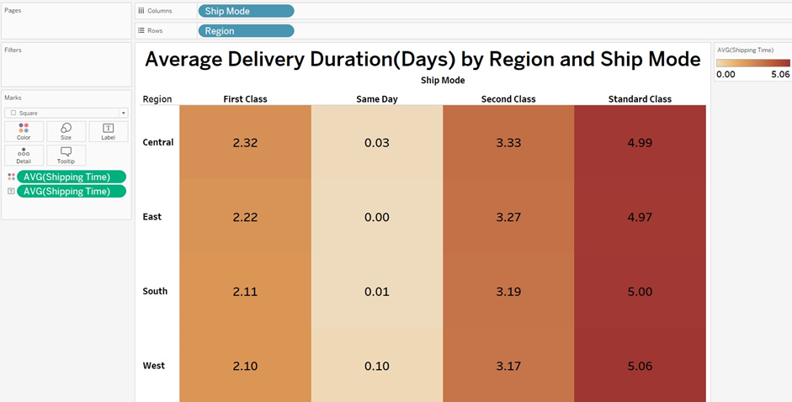
Explanation: The highlight table chart is best suited for quickly visualizing the average duration for different regions. Light colors indicate lower values, while dark colors indicate higher values.

- How has the average order quantity changed over the years for various product categories?
Ans: The visualization is as follows:
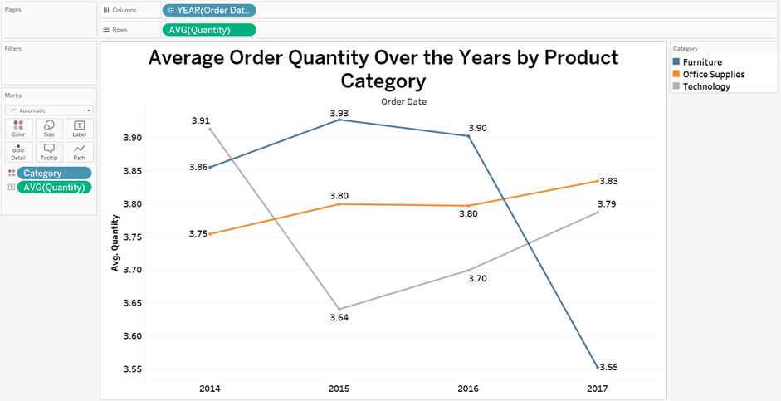
Explanation: In this line chart, we can observe the average order quantity over the years by product category, representing the trend over time. The trend for Furniture shows a slight incline in 2015, followed by a slight decline in 2016, and a more decline in 2017, indicating a decrease in order quantity after 2016. For the Office Supplies category, the order quantity remains relatively stable from 2014 to 2017, with slight variations. In the Technology category, orders were high in 2014 but declined in 2015, followed by a slight recovery thereafter.

- Can we visualise the correlation between discount rates and order quantities for different customer segments?
Ans: Yes, the visualization is represented as:
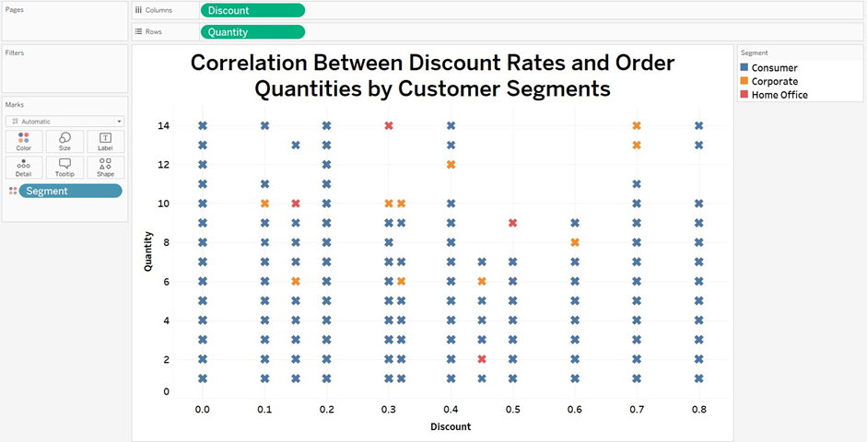
Explanation: A scatter plot is best suited for visualizing the correlation between discount rates and order quantities by customer segment. In this plot, each scatter point with a different color represents the correlation between quantity and discount rates.

- What is the proportion of orders returned in each region within the Superstore dataset?
Ans: To show this visualization we used pie chart as follows:
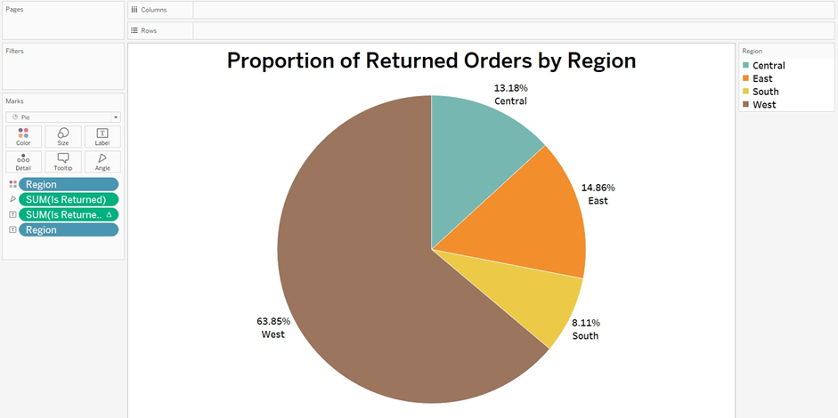
Explanation: A pie chart is optimally used to show the distribution or proportion of any category. In this visualization, the pie chart is best suited for representing the return rates across different regions. The West region shows the highest return rate at 63.85%, followed by the East region at 14.86%, the Central region at 13.18%, and the South region at 8.11%. The chart suggests that the South region has the lowest proportion of returned orders.

- Can you compare the profit of different products for different subcategories?
Ans: Yes, the visualization is given as:
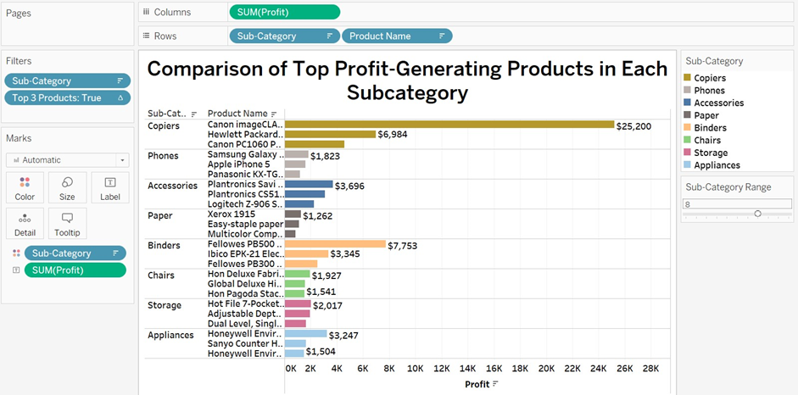
Explanation: A horizontal grouped bar chart is my preferred choice for comparing the top profit-generating products in each subcategory. Each subcategory is grouped by product name, and each product name is represented using a bar chart. The highest profit-generating product is positioned at the top of each group, while the lowest profit-generating product is positioned at the bottom.

- Which shipping mode is the most commonly used in the Sample Superstore dataset?
Ans: Standard shipping mode is most commonly used in sample superstore dataset. The visualization is given as:
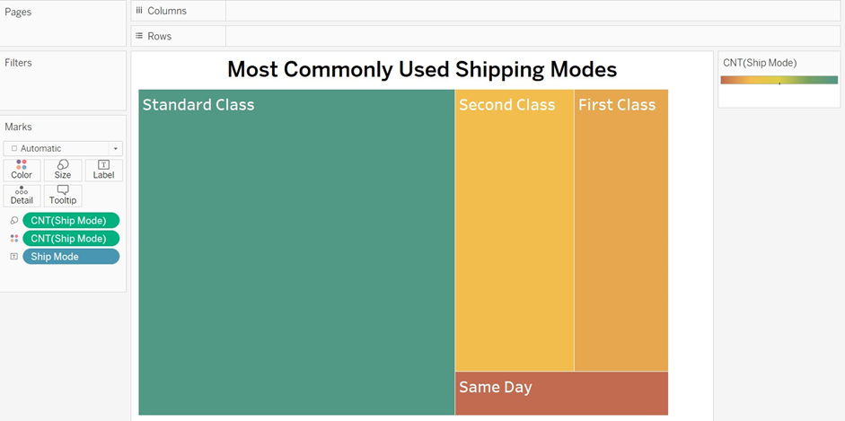
Explanation: A treemap is an effective solution for visualizing the most common shipping modes. In this visualization, it is clear that the Standard Class is the most common shipping mode, followed by Second Class which is preferred less than Standard Class. First Class is used less frequently than Second Class, and Same Day shipping mode is the least common shipping mode in the sample superstore dataset.

- How does the sales performance of different regions evolve throughout the quarters of a year?
Ans: The visualization is as follows:
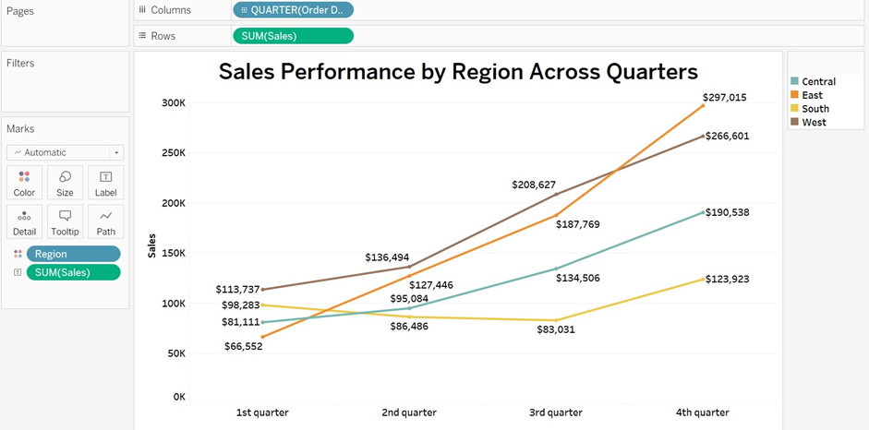
Explanation: A line graph is the optimal and best choice for representing sales performance by region across quarters. Each different color represents a different region with respect to sales and quarter to order date. This graph can be easily understood by visualizing the inclination and declination of the lines, indicating the trends in sales over time across different regions.

- What is the distribution of order priorities across different product categories?
Ans: The distribution visualization is given as:
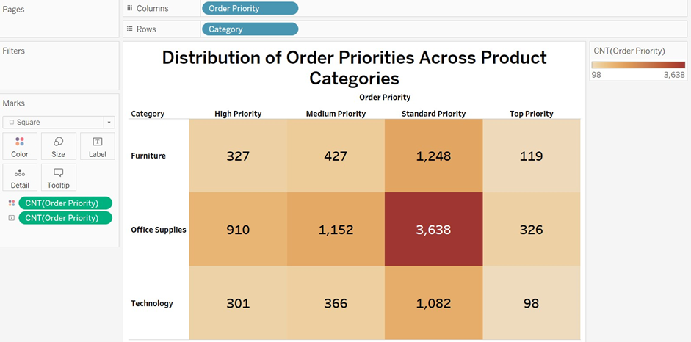
Explanation: The highlight table provides a clear view of the distribution of order priorities across product categories. In this context, First Class is categorized as High priority, Second Class as medium priority, Standard Class as standard priority, and Same Day as top priority. Interestingly, the top priority shipping mode is the least demanded, whereas the standard priority is highly sought after, especially in office supplies.

- What is the relationship between discounts and sales?
Ans: The relationship visualization is as follows:
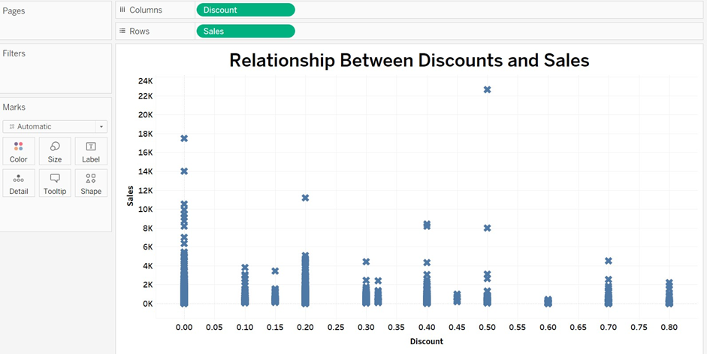
Explanation: A scatter plot is a good choice for displaying the relationship between discount and sales. Each scatter point represents the density and distribution of data points. The conclusion drawn from the plot is that there are higher sales for the lowest discount values, and lower sales for the highest discount values.

- How does the average order value differ between repeat customers and new customers?
Ans: The visualization is as follows:
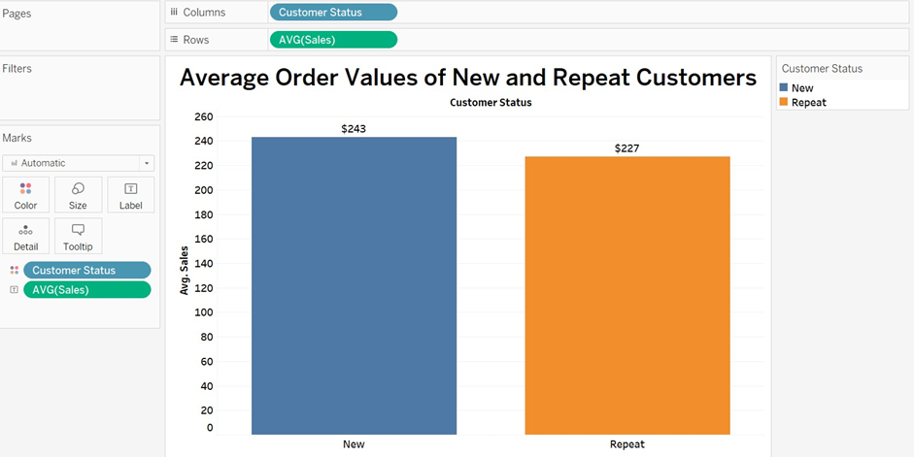
Explanation: The vertical bar chart is ideally used to show the average order values of new and repeat customers. For new customers, the average order value is $243, while for repeat customers, it is $227. This indicates that new customers are highly incentivized to repeat their purchases.

- What is the geographical distribution of returns and its impact on overall profitability?
Ans: Geographical distribution is shown as:
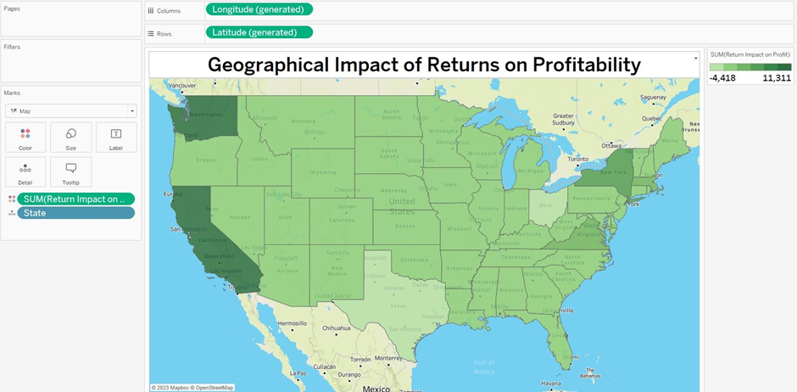
Explanation: A map chart is the ideal solution for visualizing the geographical impacts of returns on profitability. Darker colors on the map indicate a higher impact of returns on profit, while lighter colors indicate a lower impact. This chart is easy to understand, as it allows for a quick visual assessment of the locations or regions with varying impacts on profitability due to returns.

