|  |  |  |  |  |  |  |  |  |  |  |
| --- | --- | --- | --- | --- | --- | --- | --- | --- | --- | --- |
| **Software Design Specification**  TalentMatch - Applicant Tracking System  (ATS)  21F-ATS  Version: 1.0   |  |  | | --- | --- | | Project Code |  | | Supervisor | Sir Rizwan Ali Abro  __________ | | Co-Supervisor | NA | | Project Team | Vishaka Pahuja  Mohammad Yaqoob | | Submission Date | Feb-2025 | |

Document History

|  |  |  |
| --- | --- | --- |
| **Name of Person** | **Date** | **Description of change** |
| Vishaka Pahuja | 27/12/2024 | Document Created |
| Mohammad Yaqoob | 31012/2024 | Added Non-functional requirements |
| Vishaka Pahuja | 4/1/2024 | Added Case Diagrams (HR & Candidate) |
| Mohammad Yaqoob | 09/01/2025 | Added ER-Diagram |
| Vishaka Pahuja | 15/01/2025 | Added Sequence Diagrams |
| Mohammad Yaqoob | 18/01/2025 | Added Architecture Design |
| Vishaka Pahuja | 24/01/2025 | Added Database Diagram |
| Mohammad Yaqoob | 29/01/2025 | Added Class Diagram |
| Vishaka Pahuja | 5/02/2025 | Added Interface Design |
| Mohammad Yaqoob | 15/02/2025 | Added Test Cases |

**TABLE OF CONTENTS**

Document History 2

1. Introduction 4

1.1 Purpose of Document 4

1.2 Intended Audience 4

2. Overall System Description 5

2.1 Project Background 5

2.2 Project Objectives 5

3.Entity Relationship Diagram (ER-Diagram) 6

4. USE CASE DIAGRAMS 7

4.1 USE CASE DIAGRAM (For HR) 7

4.2 USE CASE DIAGRAM (For Candidate) 8

5. Sequence Diagrams 9

5.1 User Login 9

5.2 Job Posting 10

5.3 Job Application 11

5.4 Resume Parsing & AI Analysis 12

5.5 Interview Scheduling 13

6. Architecture Design 14

7. Database Diagram 15

8. Class Diagram 16

9. Interface Design 17

10. Test Cases 18

# Introduction

## 1.1 Purpose of Document

The purpose of this document is to provide the Software Design Specifications (SDS) for the AI-based Applicant Tracking System (ATS). It outlines the overall architectural design of the system, detailing how various components interact with each other, the data flow, and the key functional modules within the system. This document serves as a guideline for developers, stakeholders, and quality assurance teams to ensure that the ATS is developed in alignment with the defined requirements and follows best practices in software design.

## 1.2 Intended Audience

This intended audience for this document includes HR professionals, recruiters, developers, and quality assurance teams. It serves to ensure the system’s design meets the needs of HR departments, streamlines recruitment, improves decision-making, and provides an intuitive user experience.

# 2. Overall System Description

## 2.1 Project Background

Recruitment is a crucial yet time-consuming process, often relying on manual resume screening and interview scheduling, leading to delays, bias, and inefficiencies. Organizations struggle to manage large application volumes, resulting in increased costs and missed opportunities.

The **AI-Based Applicant Tracking System (ATS)** addresses these challenges by automating resume screening, candidate evaluation, and ranking using AI and machine learning. This ensures faster, unbiased, and more efficient hiring, reducing HR workload while improving selection accuracy.

## 2.2 Project Objectives

The AI-Based Applicant Tracking System (ATS) automates the hiring process, enhancing resume screening, candidate evaluation, and interview scheduling for a faster, unbiased, and efficient recruitment workflow.

Key objectives include:

* **Automate Resume Screening**
* **Enhance Candidate Evaluation**
* **Streamline Interview Scheduling**
* **Reduce Hiring Bias**
* **Boost HR Productivity**

This system aims to reduce hiring time, improve candidate quality, and optimize recruitment efficiency.

# 

# 3.Entity Relationship Diagram (ER-Diagram)

This **Entity-Relationship Diagram (ERD)** represents a job application system that connects HR with job seekers.

* **HR** creates job postings with details like title, location, skills, and qualifications.
* **Users** (job seekers) register, browse job listings, and submit applications.
* **Applications** store candidate details, resumes, and job references, linking each application to a specific job and user.

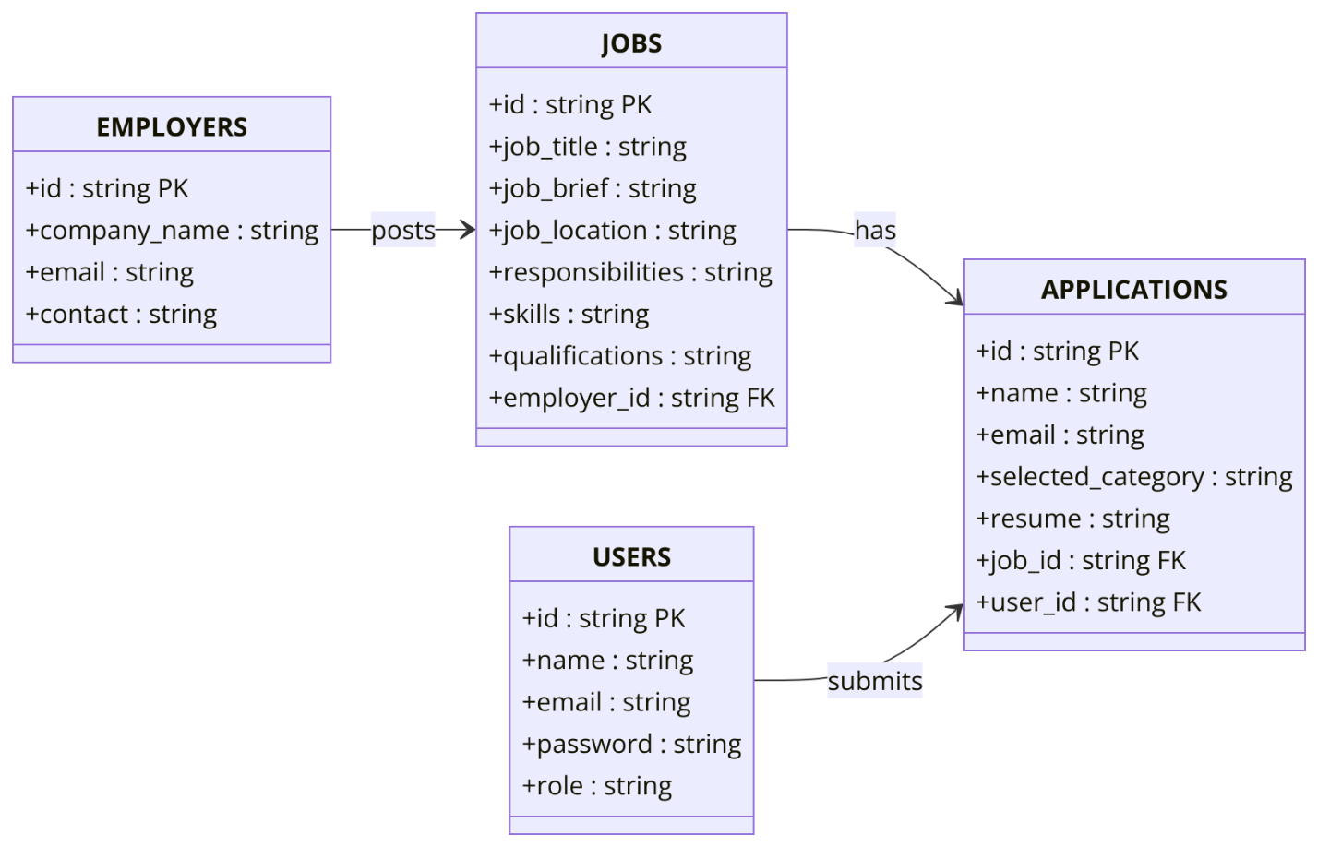

**Figure 1 : Entity Relationship Diagram of** **ATS**

# 4. USE CASE DIAGRAMS

A **Use Case Diagram** visually represents the interactions between users (actors) and a system, depicting different functionalities (use cases) the system provides.

## 4.1 USE CASE DIAGRAM (For HR)

The HR use case diagram depicts the interactions between HR professionals and the AI-based Applicant Tracking System (ATS). It outlines key tasks such as reviewing candidate applications, shortlisting candidates, scheduling interviews, managing test assessments, and making final hiring decisions. The diagram provides a clear overview of how HR users interact with the system to streamline the recruitment process and improve decision-making efficiency.

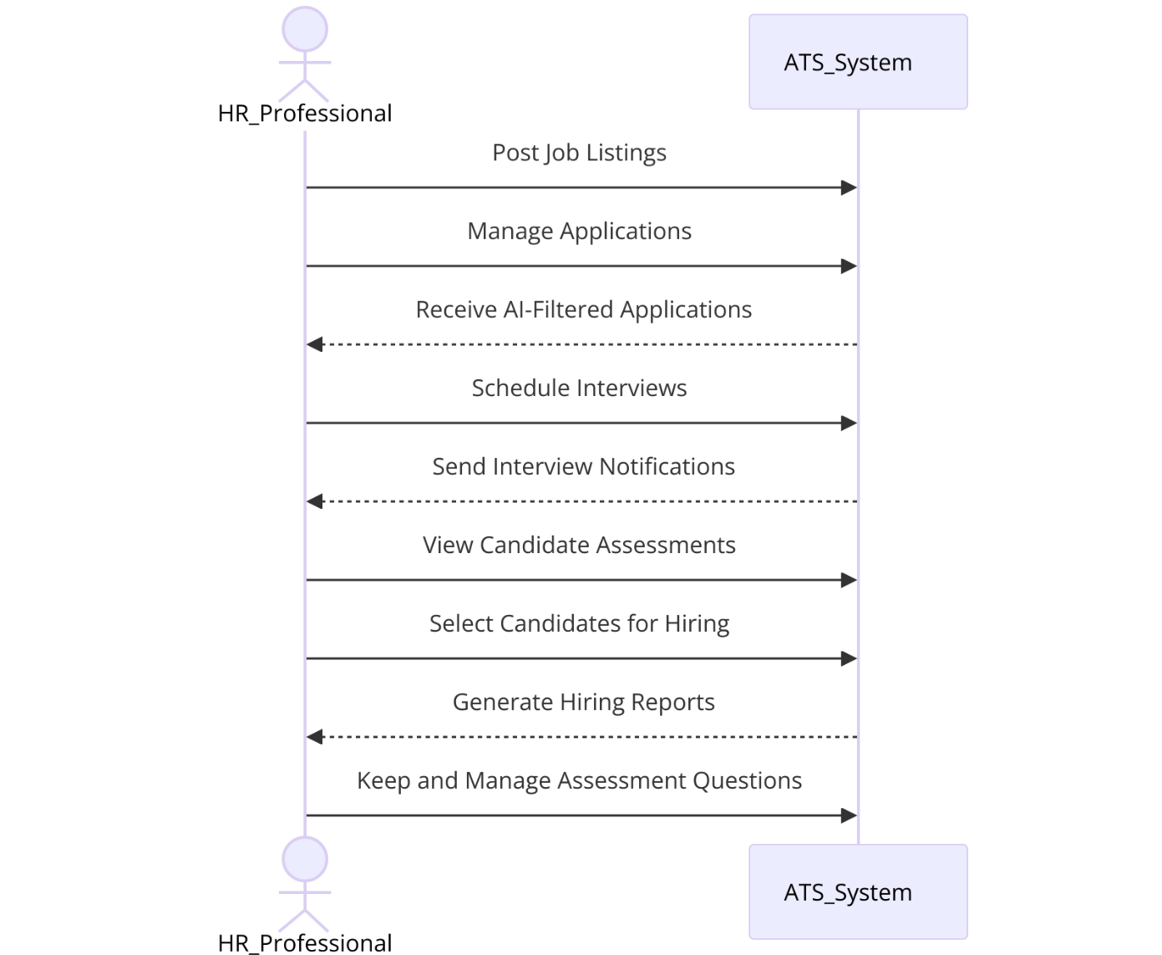

**Figure 2 : Use Case Diagram of HR**

## 4.2 USE CASE DIAGRAM (For Candidate)

The candidate use case diagram illustrates the interactions between candidates and the AI-based Applicant Tracking System (ATS). It highlights key actions such as applying for jobs, uploading resumes, taking assessments, and receiving application status updates. This diagram showcases how candidates engage with the system throughout the hiring process, providing a clear overview of their experience from application submission to receiving feedback

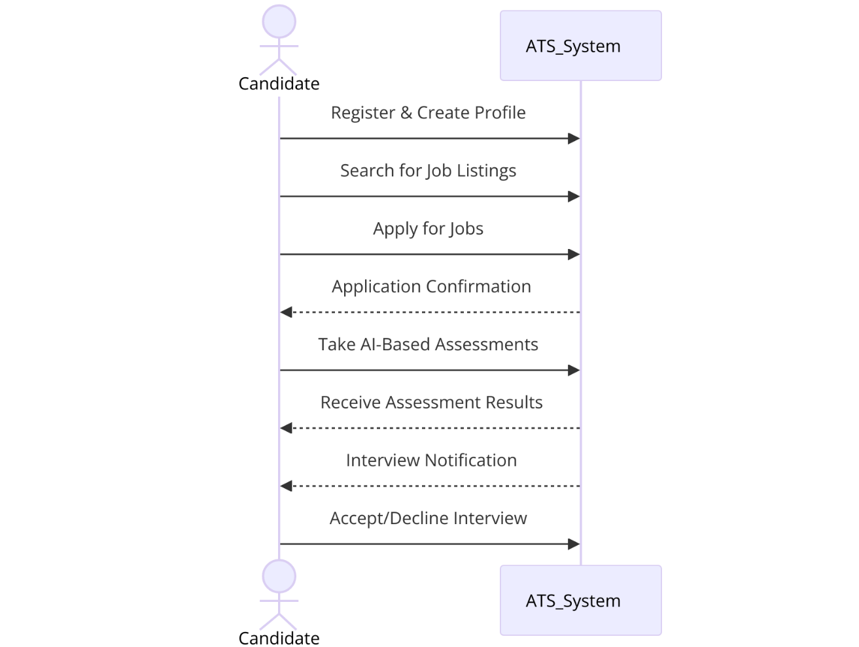

.

**Figure 3 : Use Case Diagram of Candidate**

# 5. Sequence Diagrams

The Sequence Diagrams are used to illustrate the interactions between objects in a specific use case, in sequential order. For our ATS project, the Sequence Diagram depicts how various components interact throughout the candidate evaluation process. The interactions include User Login, Job Posting, Job Application , Resume Parsing & AI Analysis and Interview Scheduling. These diagrams help visualize the step-by-step flow of data and actions.

## 5.1 User Login

This diagram illustrates the user authentication process in the ATS. The user enters their credentials, which are verified against the database. The system then returns either a successful login or a failure message.

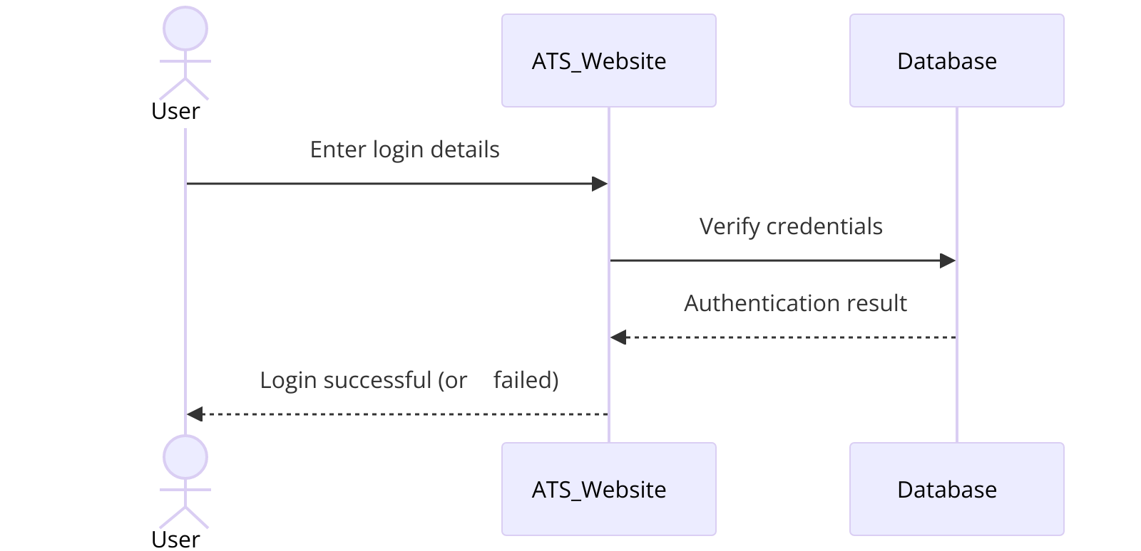

**Figure 4: User login**

## 5.2 Job Posting

This diagram shows how an HR manager posts a job on the ATS. The HR user enters job details, which are stored in the database. The system then confirms that the job posting is successful.

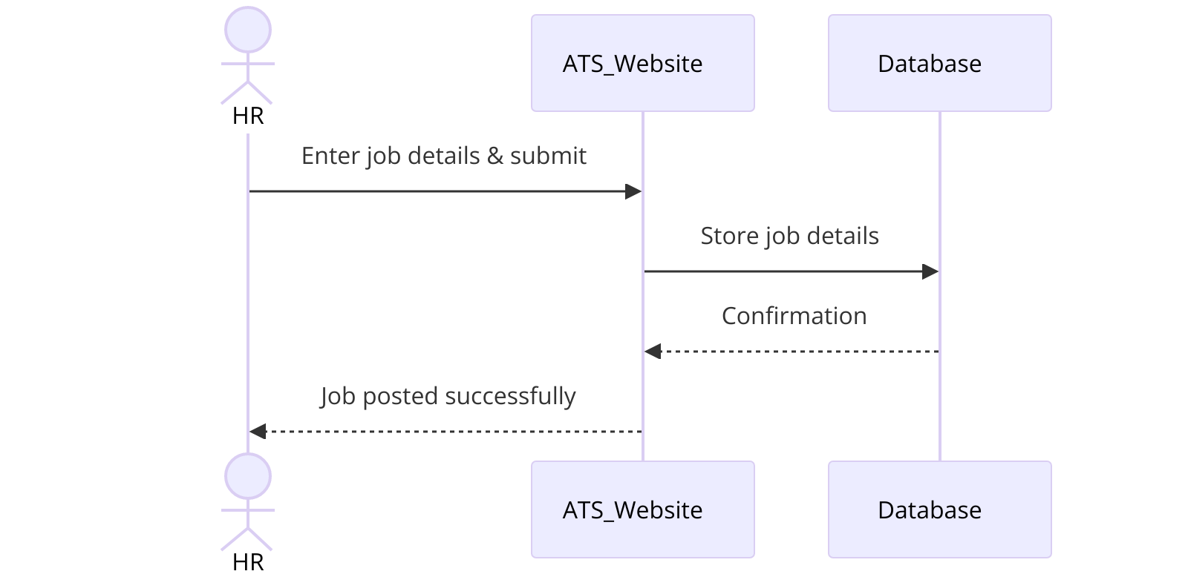

**Figure 5: Job Posting**

## 5.3 Job Application

This sequence diagram represents how an **applicant applies for a job**. The user selects a job and submits an application. The system stores the application data and confirms the submission.

**Figure 6: Job Application**

## 5.4 Resume Parsing & AI Analysis

After an applicant uploads a resume, the system processes it using a resume parser. The extracted skills are analyzed by an AI engine, which ranks the candidate and stores the results. The applicant receives a confirmation message.

**Figure 7: Resume Parsing & AI Analysis**

## 5.5 Interview Scheduling

This diagram depicts how an HR manager schedules an interview. The system sets the interview date, updates the database, and notifies the applicant. The applicant can confirm availability, and the status is updated accordingly.

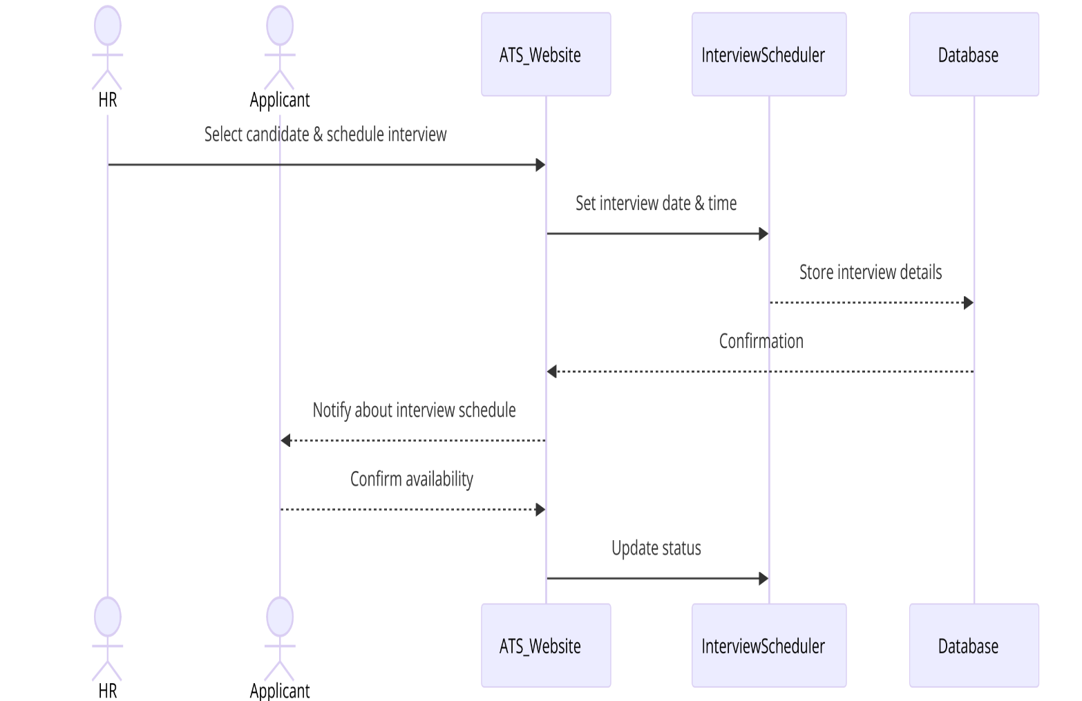

**Figure 8: Interview Scheduling**

# 6. Architecture Design

This Automated Recruitment System architecture enables seamless job matching and candidate assessment. The User Interface interacts with the Core Backend via an API Gateway with authentication. A Questions Database stores assessment tests, while Database Services handle user data, job applications, and AI-driven job matching using an NLP Model. Monitoring, Logging, and File Storage ensure system efficiency, and a Notification Service keeps users updated. The system is hosted on a scalable infrastructure for reliability and security.

**Figure 9: Architecture Design**

# 7. Database Diagram

The **Database Schema Diagram** for the **AI-Based ATS** outlines key entities and relationships. HR create Job Postings, while Applicants submit Applications. AI Evaluation ranks candidates, Assessments store test results, and Interviews manage scheduling.

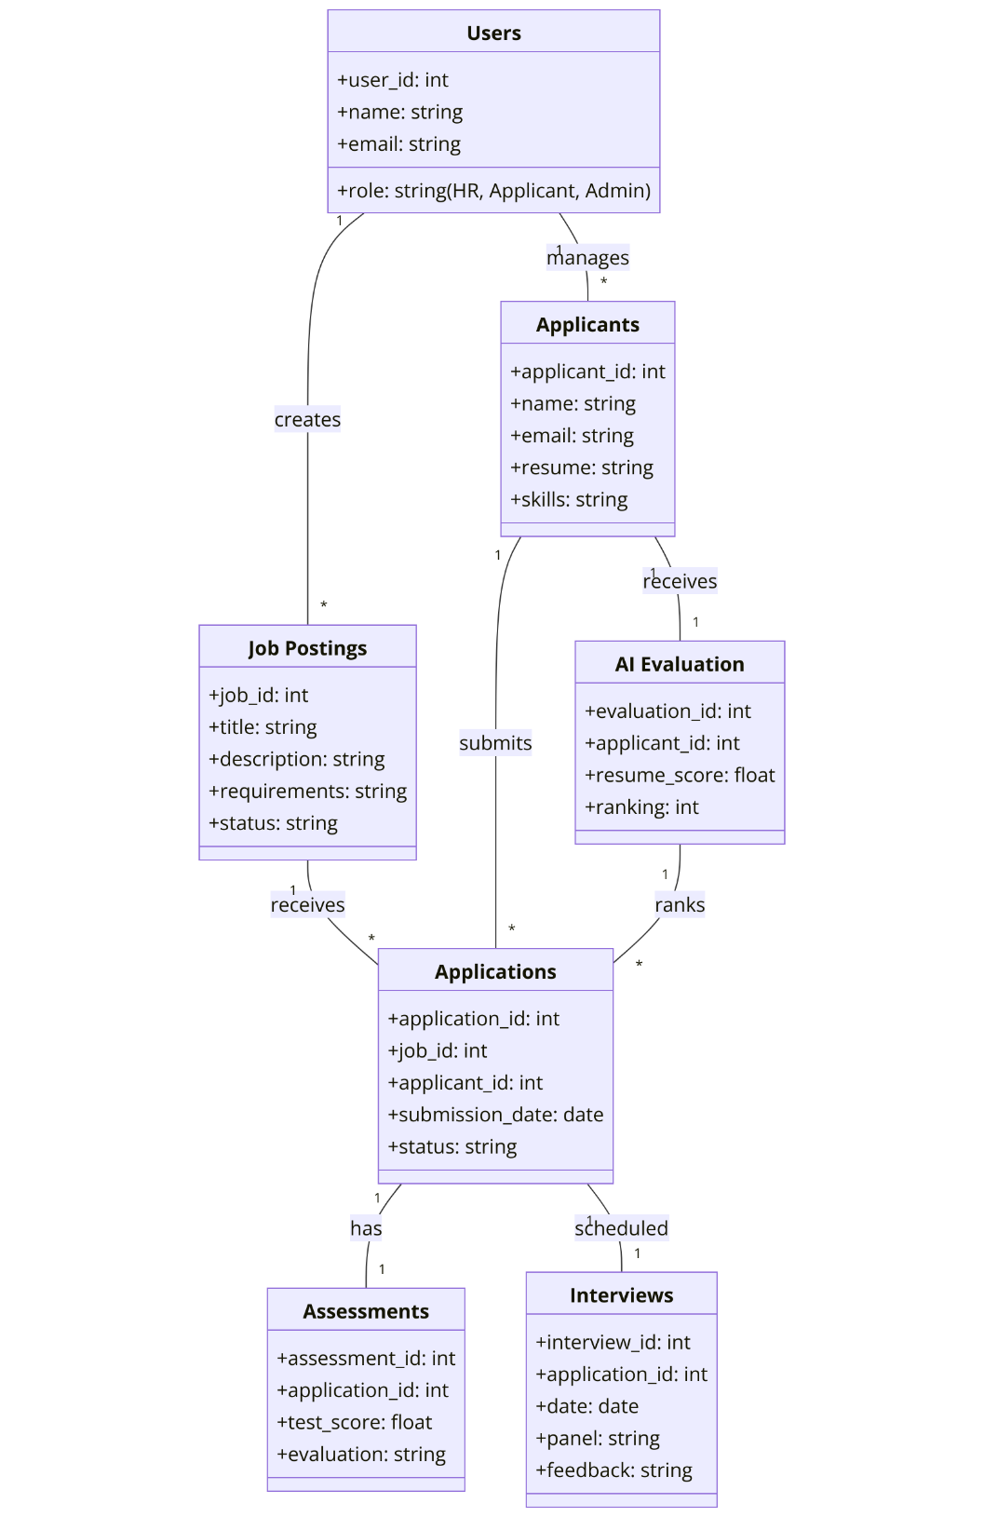

**Figure 10: Database Diagram**

# 8. Class Diagram

This class diagram represents a job application system with four main entities: Employer, Job, User, and Application.

**Figure 11: Class Diagram**

# 9. Interface Design

Sign Up Page

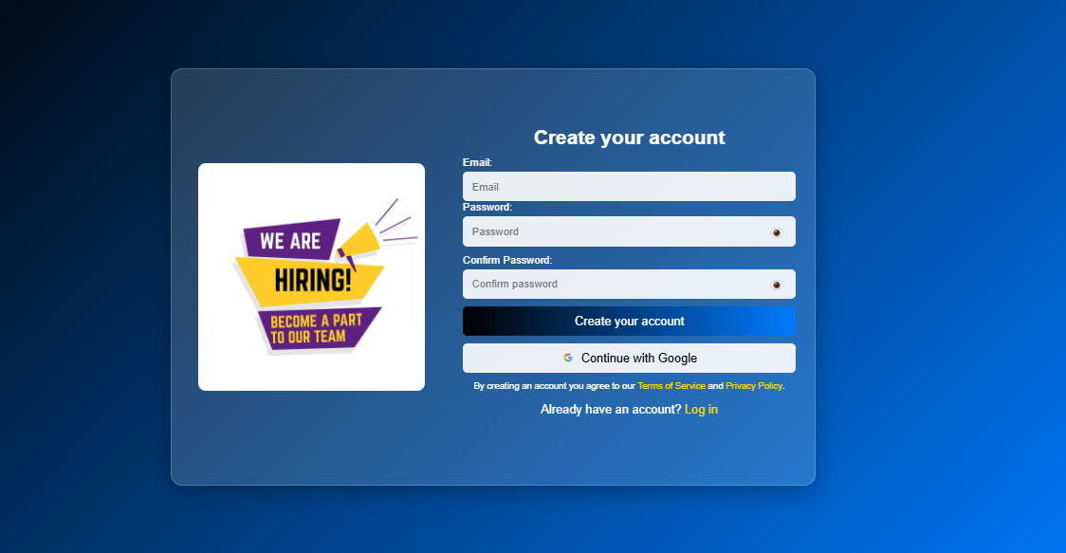

**FOR CANDIDATE**

**Home Page**

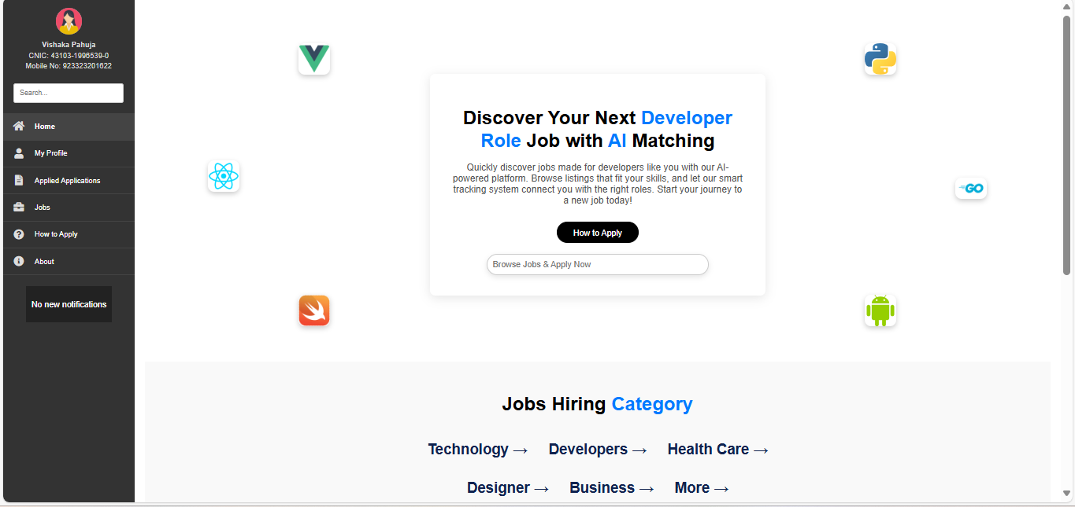

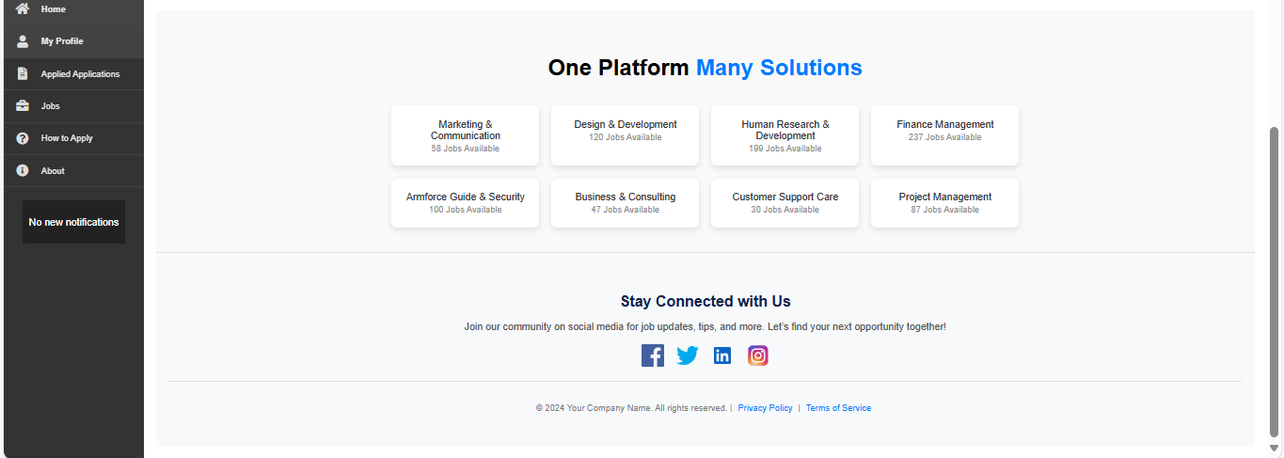

**Jobs Page**

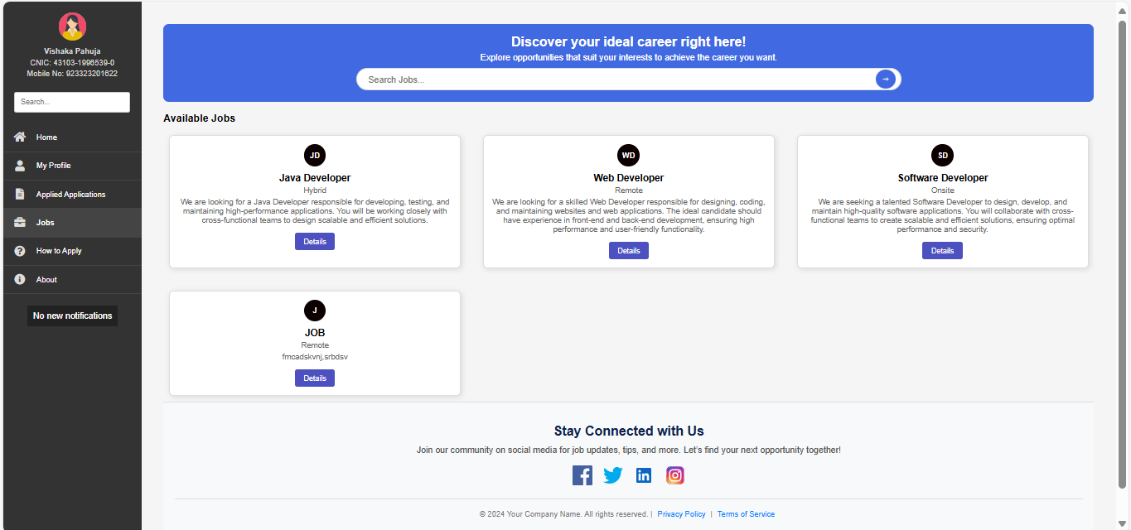

**FOR HR**

**Job Details Page**

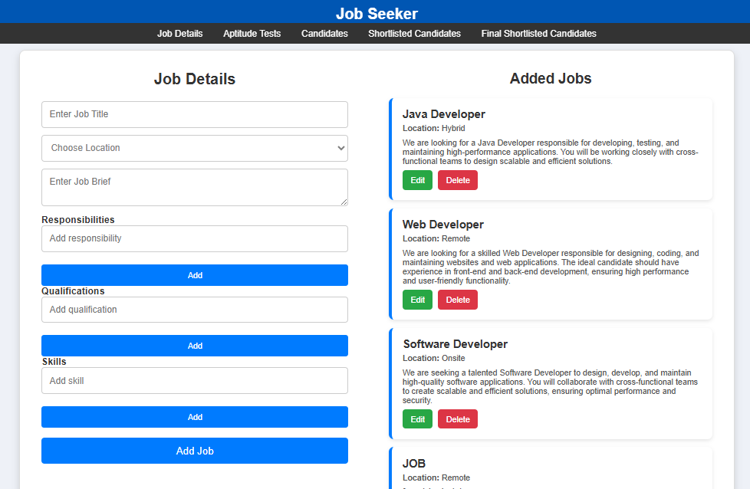

# 10. Test Cases

In this section of document, some of the test cases have been written.

|  |  |  |
| --- | --- | --- |
| **TC-01 Valid User Login** | | |
| **Test case Id** | | **TC-01** |
| **Test Scenario:** Verify user login with valid credentials. | | |
| **Pre-condition** | | User must be registered in the system. |
| **Steps #** | **Test Steps** | |
| **1.** | Go to the login screen | |
| **2.** | Enter valid email/username | |
| **3.** | Enter valid password | |
| **4.** | Click the Login button | |
| **Test data:** | | |
| * **Username:** hr_manager@example.com * **Password:** Hr@1234 | | |
| **Expected outcome:** | | User is successfully logged into the system and redirected to the dashboard. |
| **Actual results:** | | TBD |
| **TC-02 Invalid User Login** | | |
| **Test case Id** | | **TC-02** |
| **Test Scenario: Verify user login with invalid credentials.** | | |
| **Pre-condition** | | User must be registered in the system. |
| **Steps #** | **Test Steps** | |
| **1.** | Go to the login screen | |
| **2.** | Enter invalid email/username | |
| **3.** | Enter invalid Password | |
| **4.** | Click the Login button | |
| **Test data:** | | |
| * **Username:** wrong_user@example.com * **Password:** Wrong@123 | | |
| **Expected outcome:** | | User is not logged in.  The system should display an error message:  "Invalid credentials, please try again." |
| **Actual results:** | | TBD |
| **TC-03 JOB POSTING** | | |
| **Test case Id** | | **TC-03** |
| **Test Scenario:** Verify that an HR manager can successfully post a job. | | |
| **Pre-condition** | | HR must be logged into the system. |
| **Steps #** | **Test Steps** | |
| **1.** | Navigate to the Job Posting section | |
| **2.** | Enter job details (title, description, skills, qualifications) | |
| **3.** | Click the Post Job button | |
| **Test data:** | | |
| * **Job Title:** Software Engineer * **Skills:** Python, Django, SQL | | |
| **Expected outcome:** | | Job is successfully posted, and confirmation is displayed. |
| **Actual results:** | | TBD |
| TC-04 Job Application Submission | | |
| **Test case Id** | | **TC-04** |
| **Test Scenario:** Verify that a candidate can successfully apply for a job. | | |
| **Pre-condition** | | Candidate must be logged into the system. |
| **Steps #** | **Test Steps** | |
| **1.** | Navigate to the Job Listings section | |
| **2.** | Select a job | |
| **3.** | Upload resume | |
| **4.** | Submit application | |
| **Test data:** | | |
| * **Job Title:** Software Engineer * **Resume:** resume.pdf | | |
| **Expected outcome:** | | Application is submitted successfully, and a confirmation message is displayed |
| **Actual result:** | | TBD |
|  | |  |
| **TC-05 Resume Parsing & AI Analysis** | | |
| **Test case Id** | | **TC-05** |
| **Test Scenario:** Verify that the system correctly parses the resume and ranks the candidate. | | |
| **Pre-condition** | | Candidate must have uploaded a resume. |
| **Steps #** | **Test Steps** | |
| **1.** | Upload resume | |
| **2.** | System processes the document using AI-based parsing | |
| **3.** | Candidate profile is updated with extracted data | |
| **Test data:** | | |
| **Resume File:** resume.pdf | | |
| **Expected outcome:** | | System extracts relevant data and ranks the candidate accordingly. |
| **Actual results** | | TBD |
| **TC-06 Interview Scheduling** | | |
| **Test case Id** | | **TC-06** |
| **Test Scenario:** Verify that an HR manager can schedule an interview. | | |
| **Pre-condition** | | Candidate must have passed initial screening. |
| **Steps #** | **Test Steps** | |
| **1.** | HR navigates to the Interview Scheduling section | |
| **2.** | Selects a candidate and assigns interview date/time | |
| **3.** | Clicks the Schedule Interview button | |
| **Test data:** | | |
| * **Candidate Name:** Vishaka Pahuja * **Interview Date:** 10th Feb 2025 | | |
| **Expected outcome:** | | Interview is scheduled, and confirmation is sent to the candidate. |
| **Actual results** | | TBD |
|  | |  |
| **TC-07 Notification System** | | |
| **Test case Id** | | **TC-07** |
| **Test Scenario:** Verify that candidates receive notifications for job updates. | | |
| **Pre-condition** | | Candidate must have applied for a job. |
| **Steps #** | **Test Steps** | |
| **1.** | HR updates the job application status | |
| **2.** | System generates a notification | |
| **3.** | Candidate receives an email/app notification | |
| **Test data:** | | |
| * **Job Title:** Software Engineer * **Notification Type:** Application Status Update | | |
| **Expected outcome:** | | Candidate receives notification successfully. |
| **Actual results** | | TBD |
| **TC-08 Candidate Profile Update** | | |
| **Test case Id** | | **TC-08** |
| **Test Scenario:** Verify that a candidate can update their profile information**.** | | |
| **Pre-condition** | | Candidate must be logged into the system |
| **Steps #** | **Test Steps** | |
| **1.** | Navigate to Profile Settings | |
| **2.** | Edit profile details (name, email, resume, etc.) | |
| **3.** | Click the Save button | |
| **Test data:** | | |
| * **Name:** Vishaka Pahuja * **Email:** vishaka@gmail.com * **Resume:** updated_resume.pdf | | |
| **Expected outcome:** | | Profile is updated successfully. |
| **Actual results** | | TBD |