5.1  Levi's | 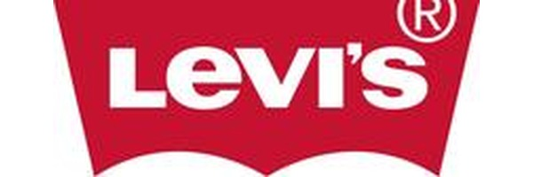

HIGH RISK MOST FAKED 501 jeans, trucker jackets
TOP 3 TELLS: Big E vs small e red tab era • Button stamp must match care label • RN# 52468Labels & Tags

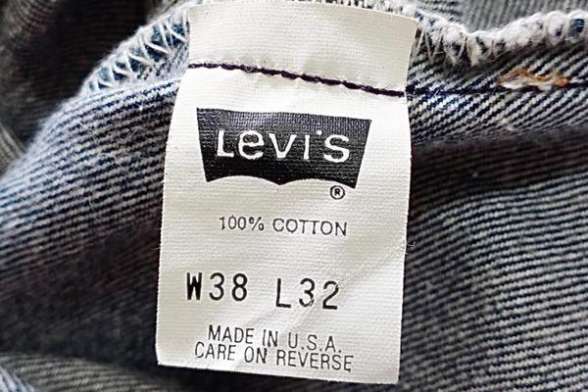  NECK / IDENTITY TAG | 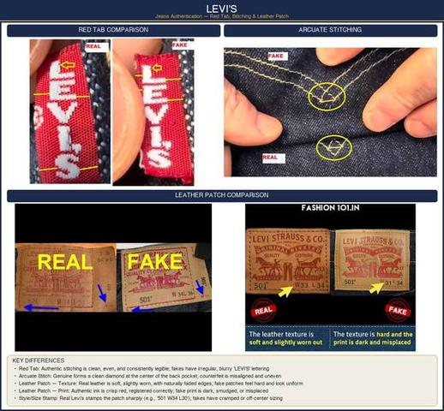  AUTHENTIC vs FAKE

BUTTON VERIFICATION
• Top button back is stamped with a factory code (e.g., '555') plus the style number.
• Button should feel heavy and solid — counterfeits use lightweight, hollow buttons.
• On vintage 501s, buttons are copper-toned with raised text. Modern 501s may use silver-toned.
FABRIC QUALITY
✓ Heavyweight, durable denim (12–14 oz) with distinctive aging pattern ✗ Thin, lightweight denim (8–10 oz) that feels flimsy
✓ Selvedge line visible on cuff when rolled (vintage/LVC/MIJ lines) ✗ No selvedge, rough-cut edges on cuff
STITCHING & ARCUATE
Levi's products feature consistently straight, even stitching throughout. The signature arcuate stitching on back pockets must be symmetrical and clean. On 501s, count the belt loops — genuine always has 5 loops.
✓ Arcuate stitching is symmetric, with even depth and consistent thread ✗ Asymmetric arcs, uneven depth, loose or different colored thread
KNOWN PRODUCTION COUNTRIES
USA (vintage/LVC), Mexico, Bangladesh, Sri Lanka, Turkey, Pakistan, Cambodia, Lesotho. If a tag reads 'Made in China,' it is not necessarily fake — Levi's has produced there — but verify other markers carefully.

PRO TIP
On vintage Levi's (pre-1983), the arcuate was hand-stitched, so slight variations are expected and actually prove authenticity. Machine-perfect arcuates on 'vintage' jeans are a giveaway.

5.2  Dickies | 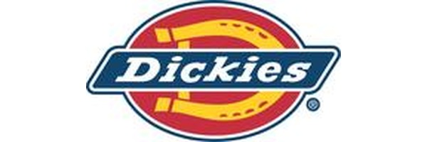

MEDIUM RISK MOST FAKED 874 work pants, eisenhower jackets
TOP 3 TELLS: Triple-stitched seams on 874 • YKK/Talon zippers only • Heavy 8.5-10 oz twill fabric

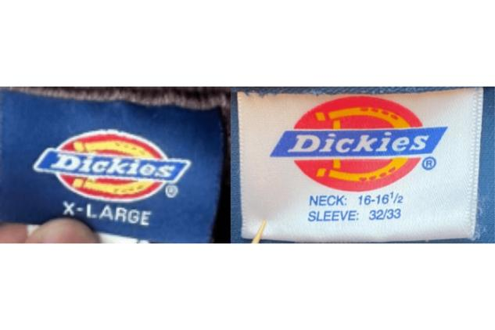  NECK / IDENTITY TAG | 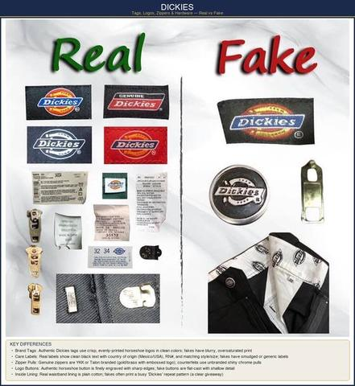  AUTHENTIC vs FAKE

LABELS & TAGS
Authentic Dickies labels feature the brand name in a bold, curvilinear script with distinctive thick-and-thin strokes. The horseshoe logo should have clean, crisp edges.
• Style Number: Always printed on the care label — cross-reference with Dickies product catalog online.
• Label Attachment: Woven into the garment at the waistband (pants) or collar (shirts). Never a stick-on or loosely attached label.
LOGOS & EMBROIDERY
✓ Consistent, detailed, clear stitching with no fraying ✗ Loose threads, gaps in stitching, uneven character weight
BUTTONS & ZIPPERS
• High-quality metal buttons engraved with 'Dickies' branding on work pants.
• YKK or Talon zippers on authentic garments — no generic unmarked zippers.
✓ Substantial, weighted hardware with clean engravings ✗ Lightweight, flimsy buttons with shallow or absent text
FABRIC & STITCHING
• Dickies workwear fabric is characteristically thick (8.5–10 oz twill), durable, and resilient — designed for heavy use.
• Stitching is strong, even, and reinforced at stress points (pocket corners, belt loops, crotch seams).
• Triple-stitched seams on 874 Original Fit — doubles won't hold up to comparison.

PRO TIP
The Dickies 874 is the most commonly counterfeited style. Compare the fabric weight by hand — a real 874 feels noticeably heavier than a fake.

5.3  Burberry | 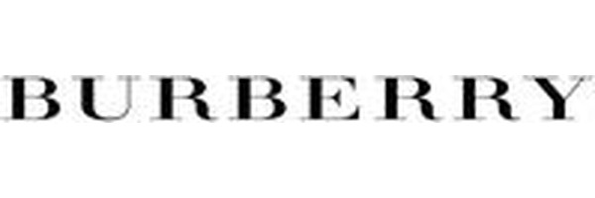

HIGH RISK MOST FAKED Trench coats, scarves, check pattern items
TOP 3 TELLS: 2018 logo change (serif→sans-serif) • Check pattern alignment at seams • Horn buttons on classic trenches

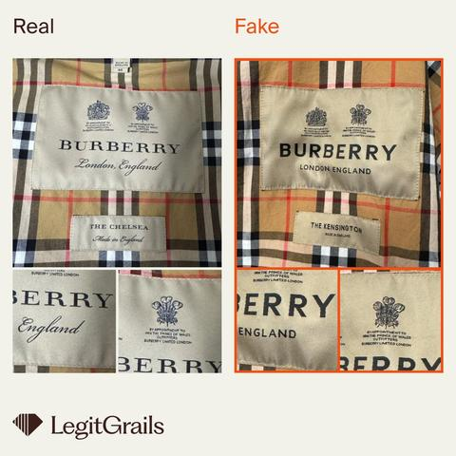  NECK / IDENTITY TAG | 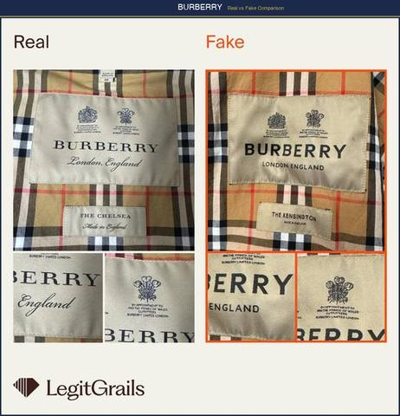  AUTHENTIC vs FAKE

LABELS & TAGS
• Line Identification: Pre-2018: 'Burberry London,' 'Burberry Brit,' 'Burberry Prorsum' (separate lines). Post-2018: unified under 'Burberry' only. If a 'new-looking' item says 'Burberry London,' it's suspect.
• Font Evolution: In 2018, Burberry changed its logo font from serif to sans-serif and dropped the equestrian knight. Know which era you're inspecting.
• Authenticity Label: Newer items have a white label with black text reading 'Burberry' and a style/serial number underneath. The font is crisp, never blurry.
THE ICONIC CHECK PATTERN
✓ Crisp, clean lines with no bleeding or blurring ✗ Blurred stripes from low-quality cashmere fuzz
✓ Black/white lines are thin and narrow ✗ Lines are too thick and large
✓ Sharp color transitions at pattern boundaries ✗ Colors bleeding into adjacent sections
✓ Pattern aligns perfectly across seams and pockets ✗ Pattern misaligned at seam joinings
BUTTONS & HARDWARE
✓ Properly proportioned, engraved with 'Burberry' in consistent font ✗ Too small, too boxy, or missing engravings
• On trench coats: D-rings, buckles, and button toggles should all be metal with an antique brass finish.
• Horn buttons on classic trenches — they have natural variation and feel warm, not cold like plastic.
STITCHING & CONSTRUCTION
Genuine stitching on label patches appears slightly wider, yet thinner in thread than counterfeits. Interior stitching is fine, even, and consistent throughout.
• Trench Coat Check: Genuine trenches have a check-lined throat latch, storm shield, and gun flap. Missing structural elements = counterfeit.
🚩 RED FLAG: The Nova check pattern is the most counterfeited element. Always verify line thickness, color accuracy, and pattern alignment at seams.

5.4  The North Face | 

HIGH RISK MOST FAKED Nuptse jackets, puffer vests, fleece
TOP 3 TELLS: Hologram tag shifts when tilted (2015+) • RN# 61661 on care label • YKK zippers exclusively

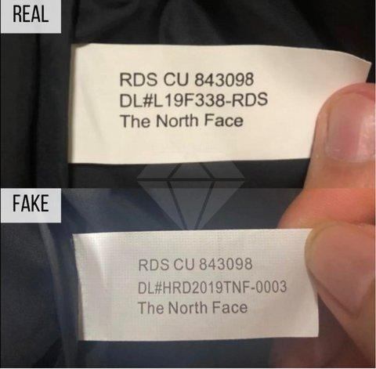  NECK / IDENTITY TAG | 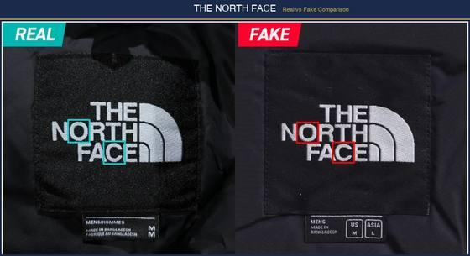  AUTHENTIC vs FAKE

LOGO — THE HALF DOME
✓ Perfectly aligned, symmetrical half-dome; bold font; thick thread ✗ Misaligned shape; thinner font; thin, poor-quality thread
• The half-dome lines should be evenly spaced and never touching the outer border. Under magnification, thread density is consistent.
• On Nuptse jackets, the logo is embroidered on the left chest. Centered logos are a red flag.
HOLOGRAM TAG
• CRITICAL: Authentic TNF items from 2015+ have a holographic sticker on the interior tag. Tilt it — it should shift between the half-dome logo and text. Fakes either omit this or use a flat, non-shifting sticker.
ZIPPER
✓ YKK zippers exclusively; noticeably thicker; bold, wide text on metal pull ✗ Non-YKK brand; thinner zipper; faint, narrow text on pull
'700' FILL POWER TEXT
The '700' text on Nuptse sleeves uses thicker thread with bolder, clearer lettering on authentic products. The fill power number should be embroidered, not printed.
PRODUCT CODE TAG
✓ Larger white tag; larger, bold black text; includes style name, size, RN#61661 ✗ Smaller tag; smaller, thin, grayish text; rougher material; wrong or missing RN
• RN Number: Authentic North Face items carry RN# 61661. This should appear on the care label.
INTERIOR CONSTRUCTION
• Down jackets should have uniform baffle (section) puffiness. Uneven fill distribution or flat sections indicate poor-quality fill.
• Seam tape on waterproof jackets should be continuous with no gaps or peeling edges.

PRO TIP
For Nuptse jackets: squeeze a baffle — authentic 700-fill goose down bounces back within 2-3 seconds. Low-quality polyester fill recovers slowly or stays flat.

5.5  Nike | 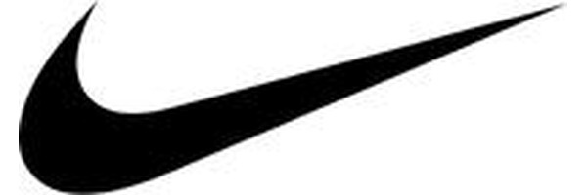

HIGH RISK MOST FAKED Air Jordan, Dunk, Air Force 1, football shirts
TOP 3 TELLS: Style code format: 6+3 chars (e.g. CW2288-111) • Swoosh taper test at endpoints • Interior excess material behind crest

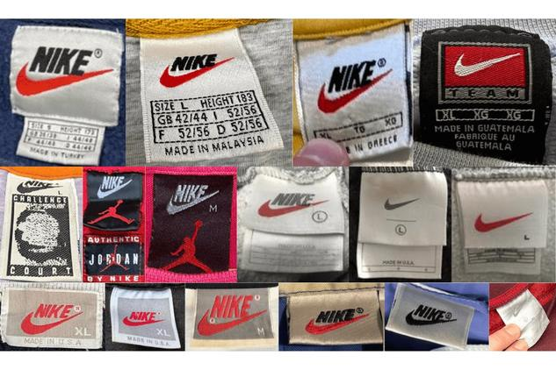  NECK / IDENTITY TAG | 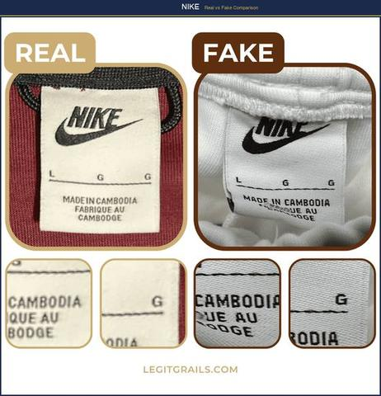  AUTHENTIC vs FAKE

LOGO (SWOOSH)
The iconic Swoosh has been a brand staple since 1971. Examine both endpoints — the trailing point should taper cleanly to a sharp tip. On genuine products, the Swoosh is smooth, proportional, and consistent.
✓ Smooth curve with clean taper at both ends; uniform thickness along body ✗ Chunky or angular curve; blunt endpoints; uneven thickness
NECK TAGS & WASH TAGS
✓ Short, thin attachment strings ✗ Longer, thicker strings
✓ Short, dense, even wash tag stitching ✗ Longer, less dense stitches
• Tag Font: Nike uses a specific sans-serif font on all care labels. The text is sharp and evenly spaced. Blurry or inconsistent font = fake.
BARCODE & STYLE CODE VERIFICATION
• Format: Nike style codes follow the pattern: 6 characters + hyphen + 3 characters (e.g., CW2288-111). The code on the box MUST match the code on the shoe/garment tag.
• Google the style code — it should return the exact product in the correct colorway from official Nike and retail sites.
• Scan the barcode — it should match the style code and size shown on the label.
INTERIOR CONSTRUCTION
• Turn the garment inside out — excess material behind logos or crests is a classic counterfeit indicator.
• Interior seams should be clean and finished, not rough or with excess trailing threads.
FOOTWEAR SPECIFICS
• Insole: Nike logo should be cleanly printed or embossed — never a sticker or transfer.
• Midsole foam: Press with your thumb — genuine Nike React/ZoomX bounces back immediately; fakes feel stiff or mushy.
• Outsole: Tread pattern must match the exact pattern from Nike's official product images for that model.

PRO TIP
For Nike football/soccer shirts, check behind the crest for excess material and sloppy interior finishing — one of the most reliable tells.

5.6  Polo Ralph Lauren | 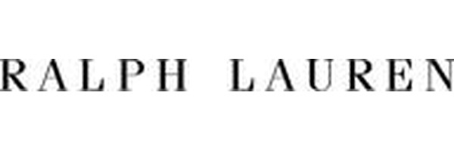

HIGH RISK MOST FAKED Polo shirts, Oxford shirts, caps
TOP 3 TELLS: Separate size tab beside collar label • Back hem longer than front • RN# 41381

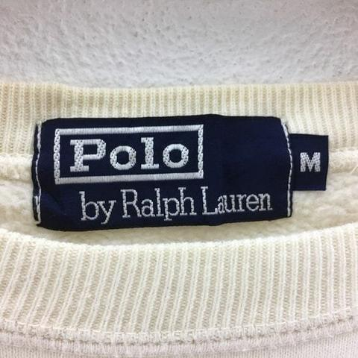  NECK / IDENTITY TAG | 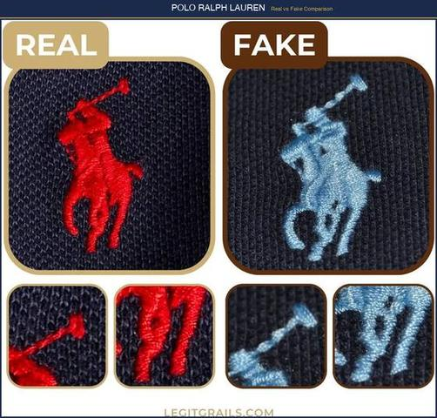  AUTHENTIC vs FAKE

LOGO (POLO PLAYER) — KEY AUTHENTICATION POINTS
✓ Visible horse tail, straight right-back leg, rectangular mallet, clear rider's leg ✗ Circular mallet, indistinct tail and leg, poor stitching precision
• Under 10x magnification: count the individual stitches in the horse's legs — authentic logos use 15-20 stitches per leg with consistent thread tension.
• The rider's arm holding the mallet should be clearly separated from the body — fakes often have the arm merged into the torso.
BUTTONS
✓ Durable, polished, cross-stitched with matching thread ✗ Lower quality, different stitching, mismatched thread color
• Engraving: On premium lines (Purple Label, RRL), buttons are engraved with 'Ralph Lauren' or 'Polo Ralph Lauren'. On standard Polo, buttons are plain but high-quality mother-of-pearl or plastic.
COLLAR LABEL
• Must have main collar label with logo PLUS a separate small size tab extending to the right.
• No separate size label = likely counterfeit.
• Font should be legible with no misspellings. Even subtle spacing changes indicate a fake.
HEM CHECK
• Authentic: Back hemline is slightly longer than front hemline (curved shirt tail).
• Counterfeit: Equal hemlines, or front hem longer than back.
CARE LABEL
• Located near bottom of shirt; must contain trademark ® symbol and neat, evenly spaced text.
• Should include RN# 41381 (Polo Ralph Lauren's registered number).
• Country of Origin: Authentic: Sri Lanka, Vietnam, China, India, Indonesia, Philippines, Cambodia. If it says 'Made in Korea' on a modern piece, verify carefully.
STITCHING
Turn inside out — genuine Ralph Lauren has one thin, even line of stitching along the bottom. Jagged, uneven, or absent stitching = counterfeit. On Oxford shirts, the collar should have 8-10 stitches per inch.

5.7  Adidas | 

HIGH RISK MOST FAKED Yeezy, Ultraboost, Superstar, tracksuits
TOP 3 TELLS: Product code search returns exact product • Boost pellets are irregular (organic) • Both shoes have different serials but same style code

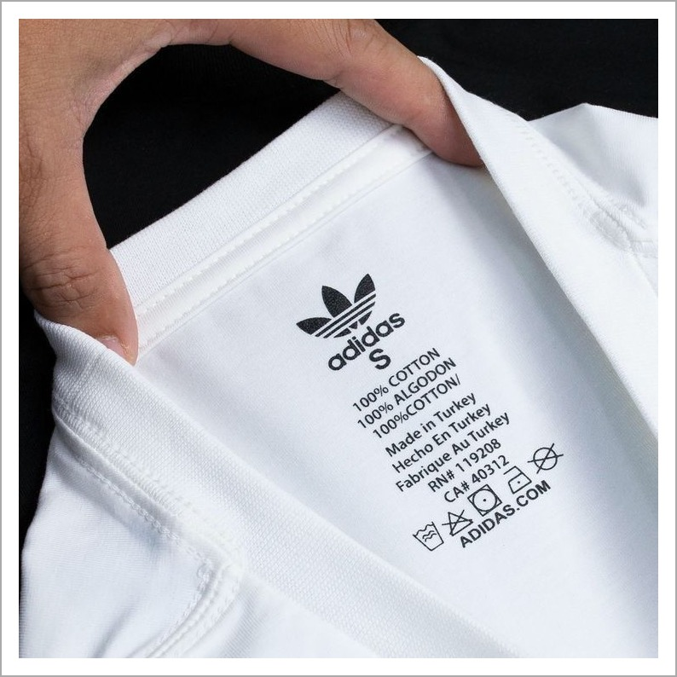  NECK / IDENTITY TAG | 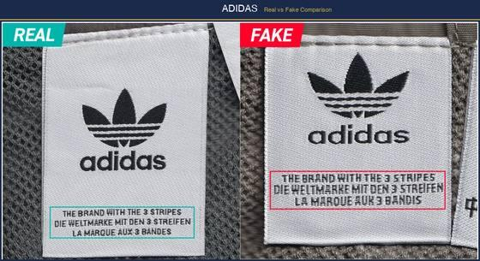  AUTHENTIC vs FAKE

LOGO — THREE VARIANTS
• Performance (3 Stripes): Three parallel bars of equal width and spacing on shoes and sportswear.
• Originals (Trefoil): Three-leaf clover shape — leaves must be perfectly symmetric with uniform thickness.
• Badge of Sport (Mountain): Three ascending stripes — the stripes must be equal width and evenly spaced.
✓ Wordmark touches bottom of stripes; consistent kerning between letters ✗ Trailing stitches between letters; typeface too thin; stripes wonky
PRODUCT CODE VERIFICATION
Every authentic Adidas product has a unique product code (e.g., DP2644) on the care label. Search this code online — genuine codes return matching product images from retailers.
• Code Format: Typically 6 characters (letters + numbers) on apparel. On footwear, the style code is on the tongue label AND the box — they must match.
BOOST TECHNOLOGY (FOOTWEAR)
✓ Boost pellets are irregularly shaped (organic, varied sizes) — feels soft and bouncy ✗ Pellets are uniform/machined-looking — feels stiff, not responsive
SERIAL NUMBERS
• Interior tongue label has a unique serial number. No two pairs should share the same serial.
• Check: both shoes in a pair should have DIFFERENT serial numbers but the SAME style code.

PRO TIP
Always Google the Adidas product code. If it returns no results or results for a different product, it's likely counterfeit. This is the single fastest check for Adidas.

5.8  Lacoste | 

HIGH RISK MOST FAKED L.12.12 polo shirts, fragrances
TOP 3 TELLS: Crocodile has ~1,400 stitches • Mother of pearl buttons (cool to touch) • European numeric sizing (2-9) always present

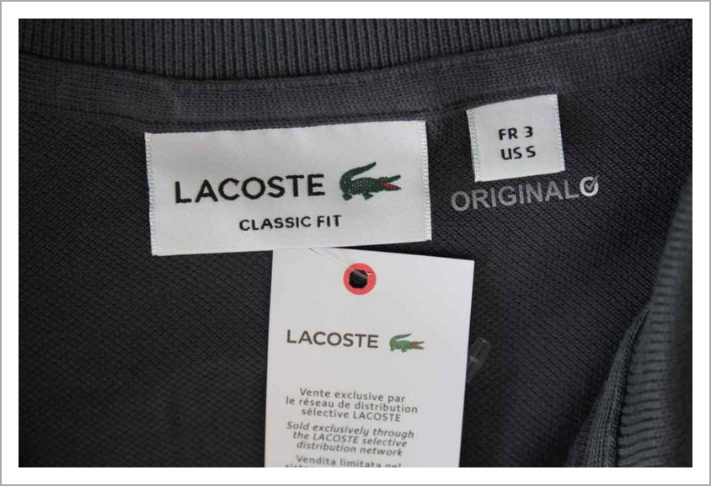  NECK / IDENTITY TAG | 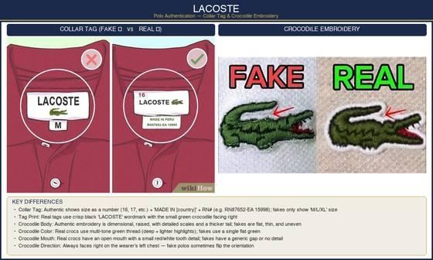  AUTHENTIC vs FAKE

THE CROCODILE LOGO — DETAILED INSPECTION
• Authentic crocodile has approximately 1,400 stitches — it should be dense and detailed under magnification.
• Must have: visible open mouth with red interior, distinct eye, 4 legs with claws, textured tail curving upward.
• The crocodile faces RIGHT on all products. If it faces left, it's a counterfeit (exception: some vintage 1930s-40s pieces).
✓ Dense, detailed embroidery with 1,400+ stitches; vivid green body, red mouth ✗ Sparse stitching (under 800 stitches); dull colors; missing mouth detail
SIZING
✓ Numerical European sizing (2-9) with red number above croc logo ✗ Only S/M/L sizing with no European number
Modern Lacoste may include US sizes alongside European, but European numbers are always present.
BUTTONS
• Material: Made from mother of pearl (not plastic) — should feel cool to the touch initially, then warm up from body heat. Plastic stays at room temperature.
• Threading: Two holes with thread passing vertically (up-down, NOT side-to-side).
• Placement: One button at top of collar, one partway down. On L.12.12 polos, exactly 2 buttons — never 3.
INTERIOR TAG
• Bottom inside of shirt; reads '100% cotton' in seven languages.
• Reverse side shows washing instructions. Older products reference 'Devanlay' (former distributor).
• RN Number: US-sold Lacoste carries RN# 115890. Missing or wrong RN = suspicious.
KNOWN PRODUCTION COUNTRIES
France, Peru, Morocco, Vietnam, Tunisia, Turkey, Italy, El Salvador, Thailand, Romania. If it says 'Made in China' on a standard polo, it's very likely counterfeit.
🚩 RED FLAG: Counterfeit tags may have washing instructions on the front instead of back, be roughly sewn with hanging threads, or have obstructed text.

5.9  Tommy Hilfiger | 

HIGH RISK MOST FAKED Polo shirts, hoodies, flag logo items
TOP 3 TELLS: Triangle stitch at back of neck on polos • Size spelled out (MEDIUM not M) • Buttons engraved with full name

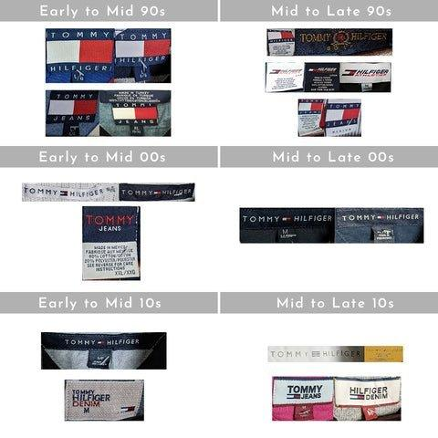  NECK / IDENTITY TAG | 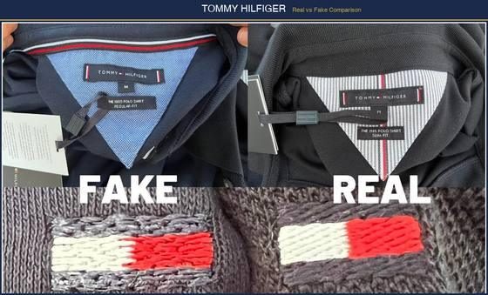  AUTHENTIC vs FAKE

COLLAR LABEL
• Neat, even stitching with three-dimensional feel to the red/white/blue logo.
• Original labels are larger with 'Tommy Hilfiger' text running horizontally. Fakes often run text vertically.
• Label should feel smooth — counterfeits have harsh edges and cheaply sewn letters.
• Polo Check: Authentic TH polos have a small triangle stitched at the back of the neck (same color thread as shirt). Counterfeits lack this.
THE FLAG LOGO
✓ White rectangle + red rectangle; navy stripes top and bottom; perfectly even edges ✗ Uneven stitching, jagged lines, disproportionate navy stripes
• Check spelling: 'Tommy' has 2 m's; 'Hilfiger' has only 1 l.
• The flag must be exactly rectangular — no rounded corners, no trapezoidal distortion.
SERIAL NUMBERS
• Authentic items have unique serial numbers on tags or packaging.
• Serial number on washing tag must correspond to garment's main serial number.
BUTTONS
✓ Engraved with 'Tommy Hilfiger' name (including on pants button backs) ✗ Plain buttons without any engravings
WASHING TAGS
✓ High-quality matte material; several tags; multi-language instructions; clear text ✗ Shiny, cheap material; only 2-3 tags; smudgeable ink
SIZE LABELING
✓ Size spelled out in letters (e.g., 'MEDIUM') below main label ✗ Only abbreviated (e.g., 'M') without full word

5.10  Patagonia | 

MEDIUM RISK MOST FAKED Better Sweater fleece, Nano Puff, Torrentshell
TOP 3 TELLS: RN# 51884 on all items • Wash label NEVER behind neck • YKK or Patagonia-branded zippers only

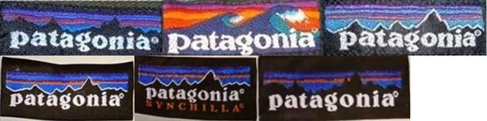  NECK / IDENTITY TAG | 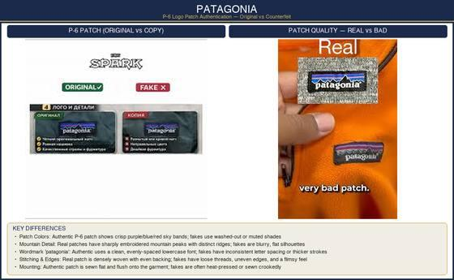  AUTHENTIC vs FAKE

LABELS & TAGS
• Front logo must be straight — piping should not overlap any letters.
• Font of 'Patagonia' should be clean and properly spaced.
• CRITICAL: The wash label on genuine Patagonia is NEVER behind the neck label — it is always at the bottom/side of the garment.
• RN Number: All authentic Patagonia carries RN# 51884. Missing or incorrect = counterfeit.
STYLE CODE VERIFICATION
• Every Patagonia item has a 5-digit style number (e.g., 84674) on the interior label.
• Cross-reference on Patagonia's Worn Wear or official site — it should return the exact product.
LOGOS & EMBROIDERY
• Authentic Patagonia jackets always have embroidery somewhere on the product — usually the mountain/sky logo on left chest.
• The Fitz Roy mountain range in the logo should have distinct peaks with a gradient sky behind it.
🚩 RED FLAG: If a Patagonia jacket has NO embroidery at all, it is fake.
ZIPPERS
Genuine Patagonia uses either YKK-brand zippers or Patagonia's own proprietary zippers. No other zipper brands should appear.
✓ YKK or Patagonia-branded pulls; smooth operation; substantial feel ✗ Unbranded or 'YRR' zippers; sticky or catching operation
FABRIC & CONSTRUCTION
• High-performance, sustainable materials with consistent weight and texture.
• On fleece: the pile should be even and dense, not thin or patchy. Better Sweater fleece has a distinctive knit-face exterior.
• On shells: DWR coating causes water to bead and roll off. Test with a drop of water — it should bead, not soak in.

PRO TIP
Patagonia offers free repairs and has an 'Ironclad Guarantee.' If a seller refuses to let you contact Patagonia for verification, that's a major red flag.

5.11  Canada Goose | 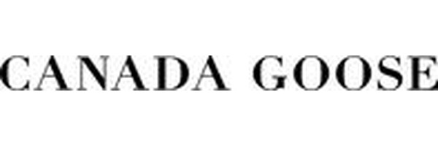

HIGH RISK MOST FAKED Expedition parka, Chilliwack bomber, Langford
TOP 3 TELLS: Arctic badge maple leaf has 11 points • Hologram polar bear shifts when tilted • QR code links to canadagoose.com/verify

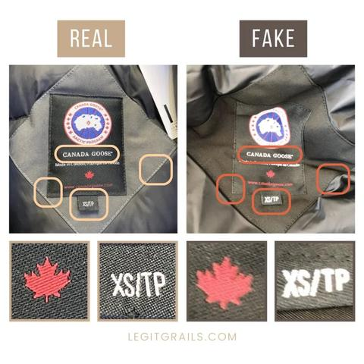  NECK / IDENTITY TAG | 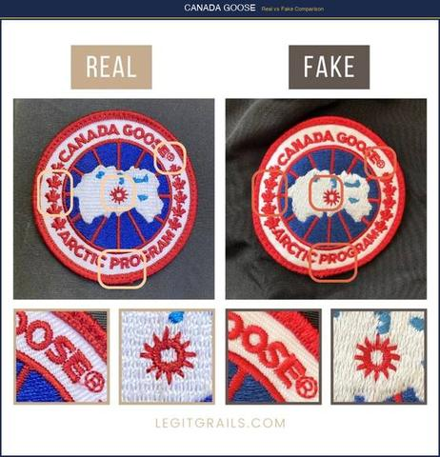  AUTHENTIC vs FAKE

ARCTIC PROGRAM BADGE — CRITICAL INSPECTION
✓ Thinner symbols; evenly spaced lettering; precise embroidery ✗ Thicker, larger inscriptions and leaf symbols; uneven embroidery
• The maple leaf must have exactly 11 points with clean, sharp tips.
• Letters in 'CANADA GOOSE' and 'ARCTIC PROGRAM' must be evenly spaced along the arc — never touching each other.
• The 'island' in the center should have a distinct shape with the North Pole marker.
• Color Check: Background is white; text and borders are navy blue; leaves are red. Any color deviation = fake.
HOLOGRAM & SECURITY FEATURES
• Hologram: Post-2017 jackets have a holographic label near the inside pocket. Tilt to see a polar bear shift between two positions. Flat or non-shifting hologram = counterfeit.
• QR Code: Modern CG items have a scannable QR code linking to canadagoose.com/verify. Scan it — it should return product details.
BUTTONS & ZIPPER PULLS
✓ Dark grey, matte finish, deeply engraved lettering ✗ Shinier, lighter (silver-toned), shallow engravings
✓ Proportional zipper pulls with bold, embossed lettering ✗ Oversized pulls with pale, engraved (not embossed) lettering
FUR RUFF (COYOTE FUR)
✓ Very fluffy, high-density coyote fur with rich, varied coloring ✗ Thinner, uniform-color fur lacking fullness (often raccoon or faux)
DOWN FILL
• Genuine CG uses Hutterite white goose down (625-800 fill power). Squeeze a baffle — it should spring back within 1-2 seconds.
✓ Uniform puffiness across all baffles; lightweight but warm ✗ Uneven fill; some sections flat; heavier than expected
INTERIOR LABELS
• Content Label: Must state '625 fill power' or higher, along with exact material composition percentages.
🚩 RED FLAG: Air bubbles under the badge indicate a non-genuine stitching job. Run your fingers over the badge — it should lay perfectly flat.

5.12  True Religion | 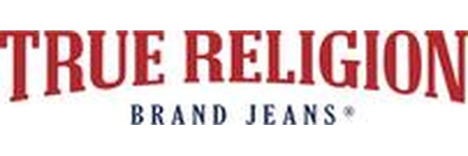

HIGH RISK MOST FAKED Super T jeans, horseshoe logo items
TOP 3 TELLS: 3-label system (main + security + manufacturing) • Security label has white micro-thread • Horseshoe stitching must be symmetrical

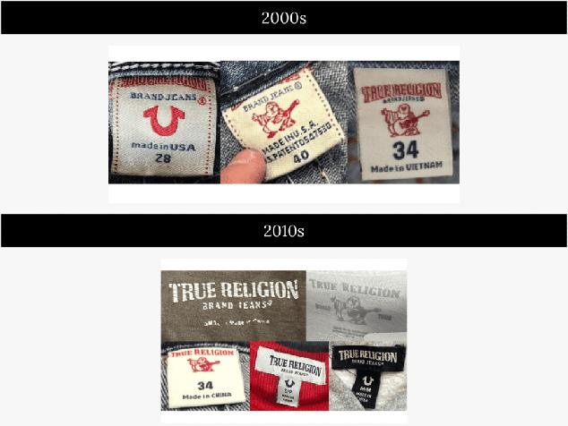  NECK / IDENTITY TAG | 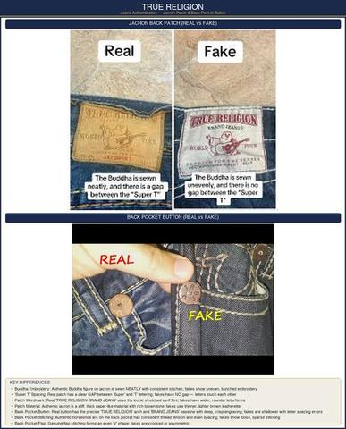  AUTHENTIC vs FAKE

INNER LABELS (3-LABEL SYSTEM)
• Label 1 — Main Label: Standard brand label with True Religion horseshoe logo and branding.
• Label 2 — Security Label: Located underneath main label; features horseshoe logo with white plastic micro-thread along the bottom. Reverse has a unique PRINTED (not embroidered) number.
• Label 3 — Manufacturing Label: Third label detailing style codes, cut codes, and manufacturing information.
HORSESHOE LOGO STITCHING
✓ Horseshoe shape is smooth and symmetrical; thread is thick and evenly applied ✗ Horseshoe is lumpy or asymmetric; thread is thin or uneven
BACK POCKET DESIGN
• True Religion back pockets have distinctive 'Super T' stitching with thick, colorful thread.
• Stitch pattern must be symmetrical across both pockets — check alignment by folding jeans in half.
HARDWARE
• Buttons and rivets should be stamped with 'True Religion Brand Jeans' and/or horseshoe logo.
✓ Heavy, solid metal hardware with clear stamping ✗ Lightweight, generic hardware with faint or absent stamping

PRO TIP
Cross-reference the style names/numbers on the third label with any swing-tags or paperwork. They must match exactly.

5.13  Stussy | 

MEDIUM RISK MOST FAKED Logo tees, hoodies, bucket hats
TOP 3 TELLS: Hand-drawn signature has natural flow • Thin dots on ü character • Curved 't' bottom-right leg

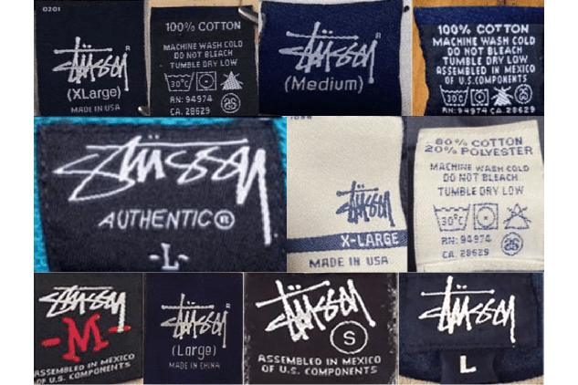  NECK / IDENTITY TAG | 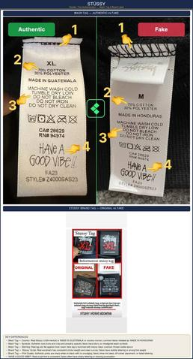  AUTHENTIC vs FAKE

LABELS & TAGS
✓ Letter 'ü' has thinner dots ✗ Dots in 'ü' are too thick
✓ Letter 't' is very curved on bottom-right leg ✗ 't' is not curved at the bottom
✓ 'Size' text has wider spacing ✗ 'Size' text is too narrow
THE SIGNATURE LOGO
✓ Longer line in 's' character; thinner dots in 'ü'; hand-drawn quality maintained ✗ 's' is too short; dots in 'ü' too thick; looks mechanically perfect
• Shawn Stussy's original handwritten signature should have a natural, flowing feel — if it looks too clean or computer-generated, it's suspect.
FABRIC & CARE LABELS
✓ Smaller '100% COTTON' text with correct font ✗ '100% COTTON' too large with different font
INTERIOR STITCHING
✓ Subtle black top stitches; bigger '70% COTTON' text ✗ Exposed, large stitching at top; '70% COTTON' too small
✓ Standard weight 'HAVE A GOOD VIBE!!' text ✗ 'HAVE A GOOD VIBE!!' text too thick
NECK LABEL CONSTRUCTION
• Woven label with clean edges — never heat-transferred or printed.
• Modern pieces include a small fabric loop at back collar for hanging.

5.14  Victoria's Secret | 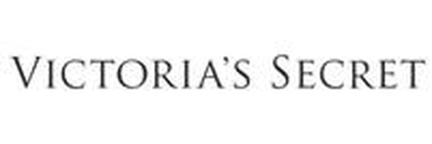

MEDIUM RISK MOST FAKED Bras, pajama sets, body mists
TOP 3 TELLS: Woven size label in left gore • Stitching parallel to label sides • Spare buttons included with PJ sets

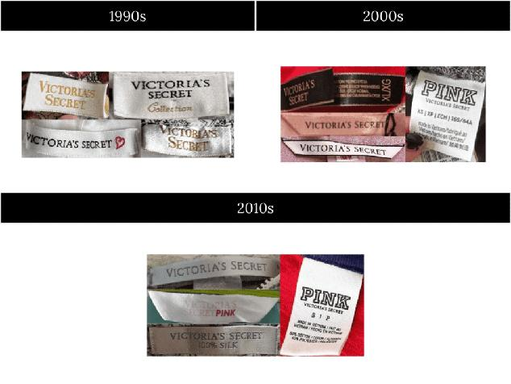  NECK / IDENTITY TAG | 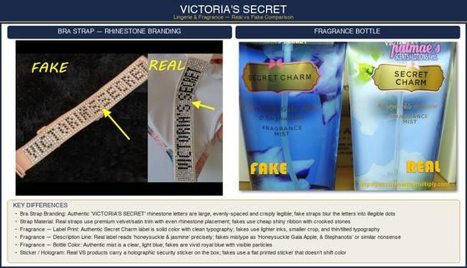  AUTHENTIC vs FAKE

LABELS & TAGS
✓ Perfect, symmetrical fill; stitching parallel to sides ✗ Incomplete fill; stitching not parallel to label sides
LOGOS & EMBROIDERY
• Consistent, intricate stitching with high-quality thread.
• Logo details should be sharp and clearly defined. The script font has specific thin and thick strokes.
BRA-SPECIFIC CHECKS
• Size label sewn into the left side gore (center front between cups). Must be woven, never printed.
• Hook-and-eye closures should have smooth, polished metal with no rough edges.
✓ Molded cups with uniform padding and smooth transition ✗ Lumpy or uneven padding; visible wrinkles in cup fabric
BUTTONS & HARDWARE
• Some genuine buttons may not have engravings, but quality is always superb.
• Original pyjama sets include spare buttons.
FABRIC & STITCHING
✓ High-quality materials; stitching regular and nearly invisible on tag surface ✗ Inferior fabric; visible, irregular stitching on tag surface

5.15  Lululemon | 

HIGH RISK MOST FAKED Align leggings, Define jacket, Scuba hoodie
TOP 3 TELLS: RN# 106259 on all items • No plastic film over size dots • Hangtag never attached to rip tag

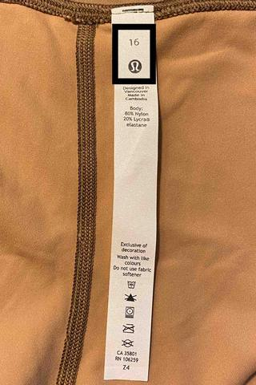  NECK / IDENTITY TAG | 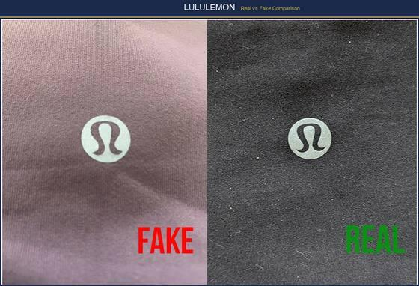  AUTHENTIC vs FAKE

LOGO — THE 'OMEGA' SYMBOL
✓ Slightly rounded at top with tapered edges; reflective logos actually reflect light ✗ Clunky, squashed, untapered edges; non-reflective logos
• The symbol (stylized 'A' for Athletica) should have smooth, clean lines with no jagged edges when viewed under magnification.
RIP TAG
• Always on the left side near the seam — never placed elsewhere.
• Uses correct spelling, capitalization, and consistent font. QR code must scan.
• Common Error: Counterfeits spell it 'Lululemon athleticá' instead of 'lululemon athletica' (lowercase 'l', no accent). The brand name is ALWAYS lowercase.
• RN Number: All authentic Lululemon carries RN# 106259. Missing or wrong RN = counterfeit.
CARDBOARD HANGTAG
• CRITICAL: Authentic Lululemon NEVER attaches the cardboard hangtag to the rip tag. It is inserted into a seam to avoid snag marks on the fabric.
SIZE DOTS
• CRITICAL: Lululemon NEVER puts a plastic film over size dots. Film present = fake.
• Size dot is found in a hidden pocket (left hip pocket on leggings, inside hem pocket on bras). No size dot in the expected location = suspicious.
FABRIC QUALITY
✓ Luon/Nulu/Everlux fabric — buttery soft, opaque, 4-way stretch, moisture-wicking ✗ Thin, see-through when stretched, limited stretch, pills quickly
✓ Clean machine stitching matching fabric color; flatlock seams ✗ Hand-sewn look or coming apart; visible seam ridges
• Pattern-matching at seams should be seamless — misaligned stripes/patterns = fake.

PRO TIP
The 'squat test' — authentic Lululemon leggings remain fully opaque when you bend over. If you can see skin through the fabric, they're counterfeit or heavily worn.

5.16  Moncler | 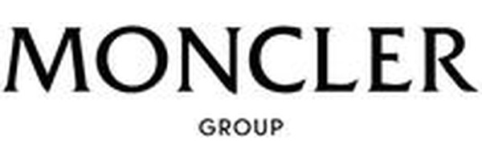

HIGH RISK MOST FAKED Maya jacket, puffer vests, Himalaya parka
TOP 3 TELLS: Certilogo QR verification (2014+) • N in MONCLER aligns with rooster peak • No circular size stickers on tags

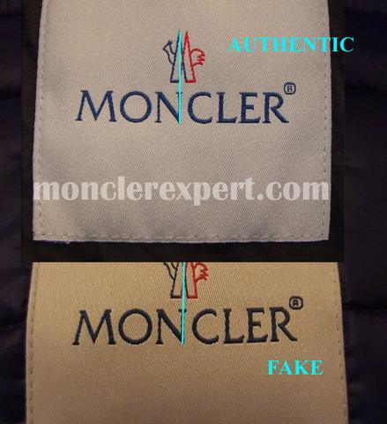  NECK / IDENTITY TAG | 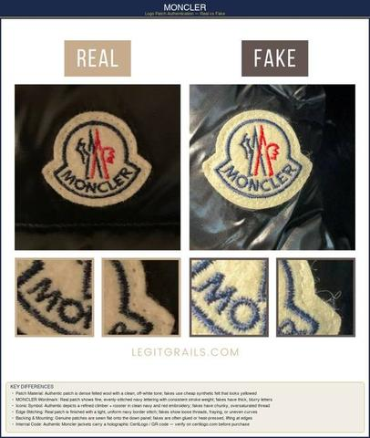  AUTHENTIC vs FAKE

LABELS & TAGS
• Examine the DIST tag (introduced winter 2017-18) — counterfeits now replicate this.
• Certilogo: Every Moncler item from 2014+ has a Certilogo authentication code. Download the Certilogo app and scan the QR code — it should confirm the item. Multiple failed verifications on the same code = counterfeit copies.
🚩 RED FLAG: If you see a circular sticker with a size number on the tag, it's likely fake. Genuine Moncler does not use size stickers.
LOGO (ROOSTER EMBLEM)
• Smoothly cut with symmetrical embroidery within the black border.
• Letters evenly spaced, neatly embroidered along a perfect arc — never touching each other.
• The 'M' has a slight taper; the ends of the 'C' barely curl in or don't at all.
• Alignment Check: Right side of 'N' in 'MONCLER' should align with the left peak of the rooster emblem. Misalignment = counterfeit.
• The rooster's tail feathers should have 3-4 distinct feather lines — fakes often simplify to 1-2.
CARTOON TAG
• Interior Cartoon: Many Moncler jackets have a small comic strip label inside showing the jacket's features. The printing should be sharp and multi-colored, not blurry or single-tone.
ZIPPERS
✓ Lampo or YKK zippers with clean, polished appearance ✗ Excessively scratched, worn, or cheap sheen; non-Lampo/YKK brand
DOWN QUALITY
✓ Premium white goose down; uniform puffiness; incredibly lightweight for its warmth ✗ Lumpy fill; uneven baffles; heavier than expected for a down jacket

5.17  Juicy Couture | 

MEDIUM RISK MOST FAKED Velour tracksuits, logo tees
TOP 3 TELLS: Metal J zipper pull (not plastic) • Era-specific tag differences • Dense plush velour with visible nap

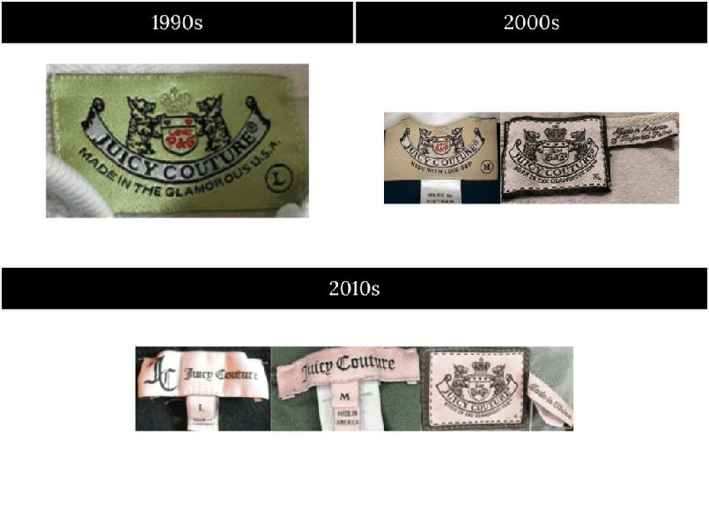
AUTHENTIC vs FAKE

TAG IDENTIFICATION BY ERA
• Pre-2006: Vintage tags with 'Juicy Couture' in cursive script. Labels are woven, not printed.
• 2006–2011 (Peak Era): Updated tags with 'JUICY COUTURE' in all-caps on some lines. 'J' zipper pulls on tracksuits are metal, not plastic.
• Modern/Y2K Revival: Contemporary tags styled after Y2K aesthetics. Distinguish genuine modern tags from counterfeits imitating vintage.
TRACKSUIT SPECIFICS
• Authentic velour tracksuits have a thick, plush velour with visible nap direction.
✓ Dense, soft velour that springs back when pressed ✗ Thin, flat velour that feels more like regular cotton
• 'JUICY' across the back should be rhinestone, embroidered, or printed depending on the style — verify against known authentic images for the exact style.
HARDWARE
✓ 'J' zipper pull in heavy metal with clean casting ✗ Lightweight 'J' pull with visible seam lines or rough edges

PRO TIP
Study tag examples from each era before authentication. Juicy Couture tags vary significantly across production periods — an authentic 2005 tag looks very different from a 2010 tag.

5.18  Fruit of the Loom | 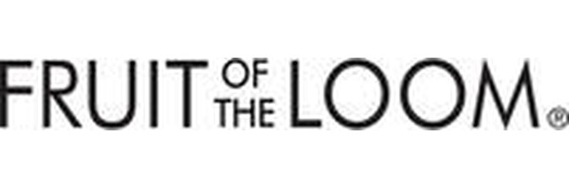

LOW RISK MOST FAKED Basic tees, underwear
TOP 3 TELLS: Woven labels only (not heat-transferred) • Distinct individual fruits in logo • 5.0 oz HD Cotton weight

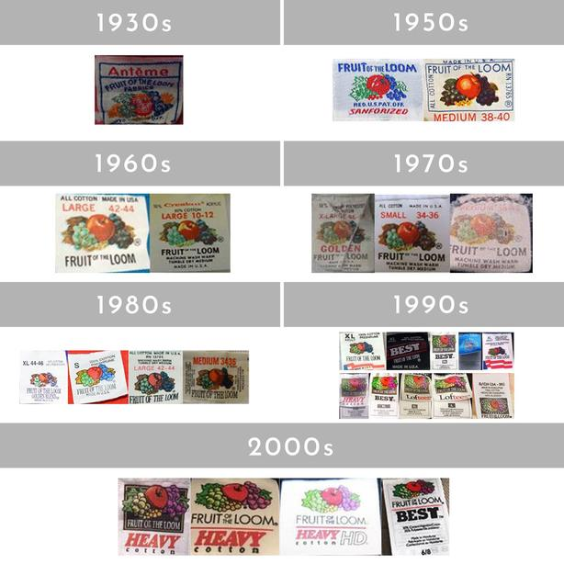
AUTHENTIC vs FAKE

LABELS & TAGS
• Detailed and well-printed with country of manufacture and care instructions.
• The fruit logo should be crisp with distinct individual fruits visible (apple, grapes, currants, green leaves).
✓ Woven or high-quality printed label with sharp fruit logo detail ✗ Blurry logo, indistinct fruits, heat-transferred cheap label
FABRIC WEIGHT
• FOTL 'HD Cotton' tees should weigh approximately 5.0 oz/yd². The fabric is soft yet substantial.
✓ Even, consistent dye with no mottling or thin spots ✗ Uneven dye, visible thin areas when held to light
🚩 RED FLAG: Printed labels (heat-transferred rather than woven/stitched) are a counterfeit indicator for this brand.

5.19  Almost Famous | 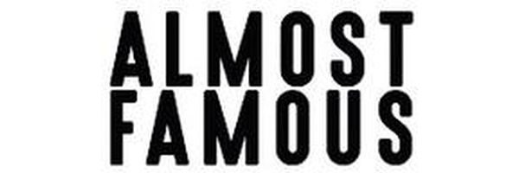

LOW RISK MOST FAKED Juniors tops, dresses
TOP 3 TELLS: Clear printed labels • Consistent logo stitching • Quality hardware for price point

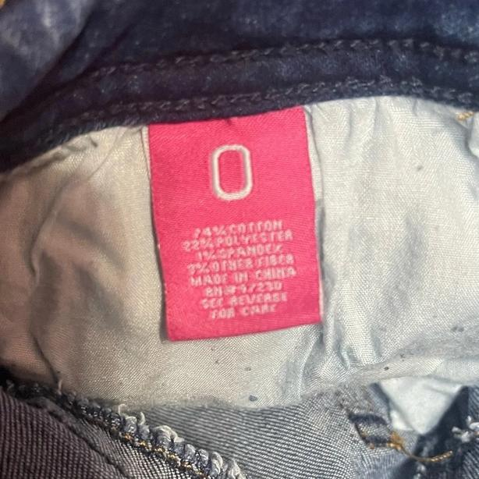
AUTHENTIC vs FAKE

LABELS & TAGS
• Clear, well-printed labels with country of manufacture and care instructions.
• The brand targets juniors/young women — sizing should reflect this demographic.
CONSTRUCTION
• Consistent logo stitching with no fraying.
• High-quality buttons, zippers, and hardware for the price point.
• Even, strong stitching throughout with consistent fabric quality.

5.20  Miss Me | 

MEDIUM RISK MOST FAKED Embellished jeans, shorts
TOP 3 TELLS: Rhinestones firmly set and uniform • Branded rivets and buttons • Symmetrical back pocket design

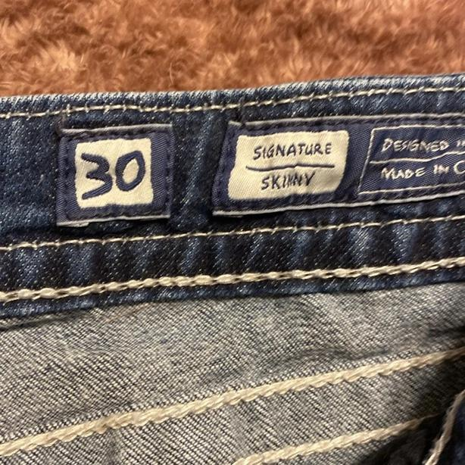
AUTHENTIC vs FAKE

LABELS & TAGS
• Clear, well-printed labels with country of manufacture and care instructions.
• Main label has the 'Miss Me' script with a distinctive wing/angel motif.
SIGNATURE BACK POCKETS
• Miss Me is known for elaborate back pocket designs with rhinestones, studs, and decorative stitching.
✓ Rhinestones are firmly set, uniform size, and sparkle consistently ✗ Loose stones, inconsistent sizes, dull or cloudy rhinestones
HARDWARE
• High-quality buttons, often engraved with 'Miss Me' branding.
• Rivets should be firmly set and stamped with the brand name.
DENIM QUALITY
• High-quality denim with even, strong stitching including decorative stitch patterns.
✓ Medium-weight denim (10-12 oz) with good stretch recovery ✗ Thin, stiff denim with poor stretch or excessive sagging

5.21  Mixit | 

LOW RISK MOST FAKED Jewelry, accessories
TOP 3 TELLS: JCPenney reference on care labels • Consistent construction quality • Securely stitched labels

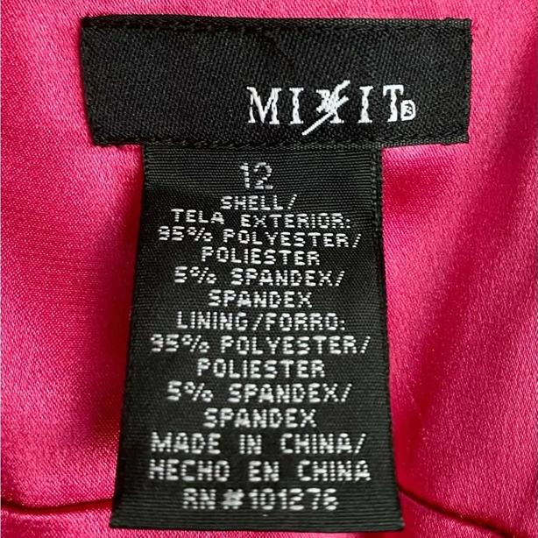
AUTHENTIC vs FAKE

LABELS & TAGS
• Clear, well-printed labels with country of manufacture and care instructions.
• Mixit is a JCPenney private label — authentic items should reference JCPenney on care/content labels.
CONSTRUCTION QUALITY
• Consistent logo stitching.
• High-quality materials on buttons and zippers for a private-label brand.
• Even, strong stitching with consistent fabric quality throughout.

5.22  Coach | 

HIGH RISK MOST FAKED Crossbody bags, wallets, tote bags
TOP 3 TELLS: Creed patch text stamped INTO leather • 6-7 stitches per cm on handles • YKK zippers with Coach-engraved pull

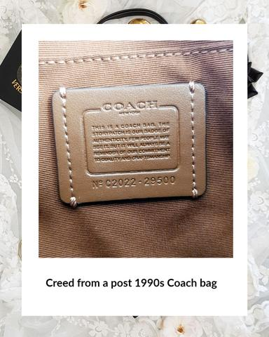  NECK / IDENTITY TAG | 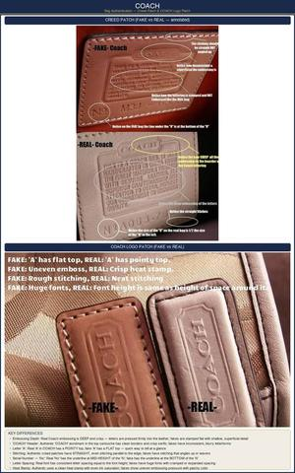  AUTHENTIC vs FAKE

CREED PATCH
✓ Text is stamped/embossed INTO the leather (you can feel the indentation) ✗ Text is printed ON TOP — feels flat, no depth
• Font should be thick and round, not thin and generic.
• The creed patch tells the product's story: 'This is a Coach bag' followed by material and origin details.
SERIAL NUMBER
• Format: Stamped on the creed patch or on a separate leather tab. Format is typically 'No. XXXX-XXXXX' where the first group is a style/factory code and the second is the body style code.
• Verification: The first two letters indicate the factory location. Known factory codes include: AA, AB, AC, AD, AE, AF, AH, AI, AK, etc.
• Search the body style code (last 4-5 digits) online — it should return the exact bag model.
STITCHING
✓ 6-7 stitches per centimeter on handles and seams; uniform throughout ✗ Uneven spacing, loose threads, double-stitched corners
HARDWARE
✓ Solid brass/nickel with clean 'Coach' engravings; substantial weight; no tarnish ✗ Lightweight, hollow metal that tarnishes quickly; sloppy engravings
• Turnlock closures should have 'Coach' engraved on the front — fakes often omit this.
LINING & ZIPPER
• Authentic linings have a consistent, repeating 'C' pattern with no misalignment at seams.
• Zippers are YKK-branded and operate smoothly. The zipper pull should have 'Coach' engraved.
LEATHER QUALITY
✓ Rich, natural leather scent; supple with visible grain; develops patina over time ✗ Chemical/plastic smell; stiff or overly uniform surface; no natural aging

PRO TIP
Coach offers a free authentication service at any Coach retail store. If you can visit one, staff can verify the item's authenticity using their internal database.

5.23  Stone Island | 

HIGH RISK MOST FAKED Overshirts, cargo pants, soft shell jackets
TOP 3 TELLS: Triangular button holes (not round) • Certilogo L has a kink/curve • Muted badge colors (not vibrant)

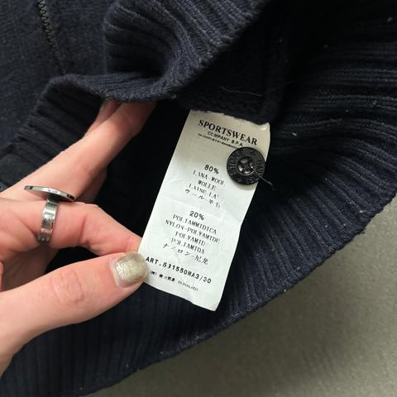  NECK / IDENTITY TAG | 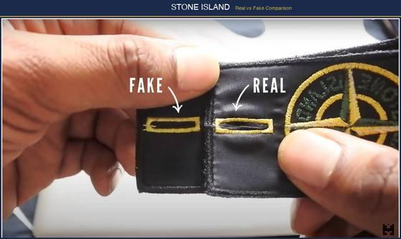  AUTHENTIC vs FAKE

CERTILOGO QR CODE
• CRITICAL: Scan the QR code on the garment label. The 'L' in 'CERTILOGO' should have a kink/curve. A completely straight 'L' will scan as counterfeit.
• Every authentic Stone Island item has a unique Certilogo code. Download the Certilogo app and verify. The code should return '1/1 authentic' — if it says it's been scanned many times before, it's a copy of a real code.
🚩 RED FLAG: Counterfeits sometimes copy real Certilogo codes. Once a code is overused across many items, the system flags it. Always check the scan count.
BUTTONS — THE TRIANGLE TEST
✓ Four TRIANGULAR holes for stitching; small indent on back behind 'Island' text ✗ Four ROUNDED holes; no indent on back
• Button Back: Authentic buttons have 'STONE ISLAND' embossed on the back with a small dot/indent below the text. No indent = fake.
BADGE / COMPASS PATCH
✓ Pale, muted greens and yellows; clean embroidery on compass needles ✗ Overly vibrant, saturated colors; sloppy compass needle stitching
• Badge Attachment: The badge is attached with two buttons on the LEFT upper arm. Both buttons must pass the triangle-hole test.
• Ghost Project: Badges are entirely monochromatic, matching garment color.
• Shadow Project: Badges are always all-black.
WASH LABELS
✓ Vintage: papery, crisp texture. Modern: silky, smooth polyamide ✗ Wrong material texture for the product era
ART NUMBER
• The Art Number (product code) on the label should match Stone Island's catalog. Google it — it should return the exact item.

5.24  Carhartt / Carhartt WIP | 

MEDIUM RISK MOST FAKED Detroit jacket, beanies, WIP hoodies
TOP 3 TELLS: Mainline vs WIP tag distinction • 12 oz duck canvas weight (stiff when new) • Triple-stitched main seams

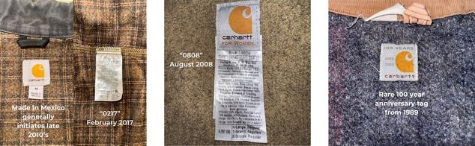  NECK / IDENTITY TAG | 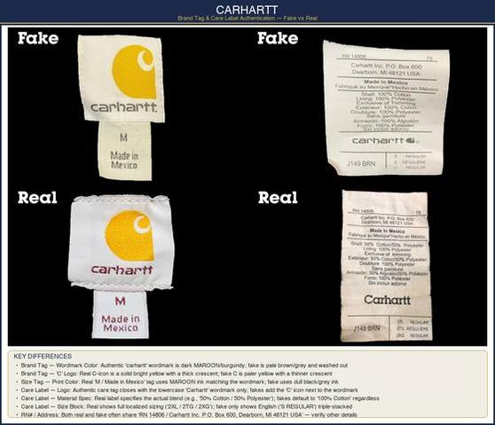  AUTHENTIC vs FAKE

TWO BRANDS — KNOW THE DIFFERENCE
• Carhartt (USA): Workwear line. Heavier fabrics, looser fits, tags say 'Carhartt, Inc.' Made in USA, Mexico, or Central America.
• Carhartt WIP (Europe): Fashion/streetwear line. Slimmer cuts, different tag design. Made in Europe, Turkey, or Tunisia. Tags say 'Carhartt Work In Progress.'
🚩 RED FLAG: Mixing up Carhartt and Carhartt WIP tags is a common counterfeiter mistake — e.g., WIP styling with a mainline Carhartt tag.
MAIN LABEL
• Securely stitched with high-quality woven material that does not fray or peel.
✓ Correct font, letter spacing matching official standards; 'C' logo is clean ✗ Slightly off spacing, wrong font weights, or spelling errors; 'C' logo is blobby
LABEL ATTACHMENT
✓ Sewn firmly at all four corners with reinforced stitching ✗ Attached loosely or only at top; peeling or curling at edges
STITCHING & BARTACK
• Clean, even stitching throughout with no loose threads.
• Bartack reinforcement at stress points (pocket corners, belt loops) must be tight and uniform.
✓ Triple-stitched main seams; heavy-duty bartacks at stress points ✗ Single stitching; flimsy or absent bartacks
MATERIAL WEIGHT
✓ Substantial, heavy duck canvas (12 oz) or denim with characteristic stiffness ✗ Lighter, thinner fabric lacking the weight of genuine Carhartt

PRO TIP
Carhartt mainline duck canvas is notoriously stiff when new — it takes weeks of wear to break in. If a 'new' Carhartt jacket feels soft and supple, the fabric weight is wrong.

5.25  Champion | 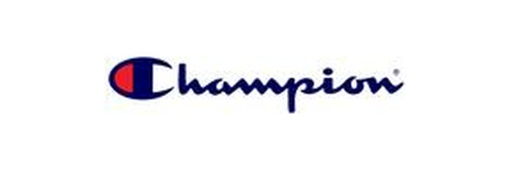

MEDIUM RISK MOST FAKED Reverse Weave hoodies, logo tees
TOP 3 TELLS: C patch always on LEFT sleeve • Reverse Weave side panels (horizontal grain) • Era-matched tags (pre-1990 vs modern)

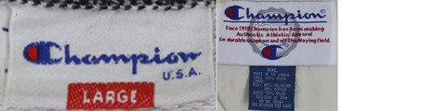  NECK / IDENTITY TAG | 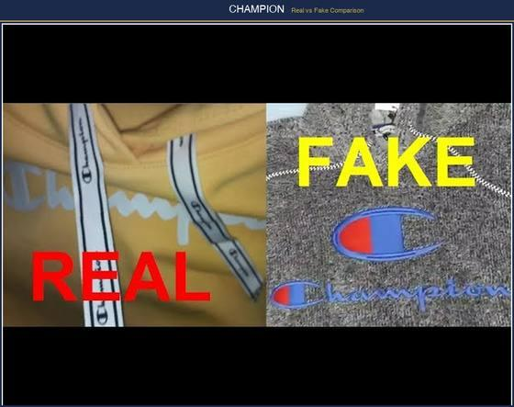  AUTHENTIC vs FAKE

C LOGO ON SLEEVE
✓ Left sleeve cuff, perfectly centered, dense clean-bordered stitching ✗ Off-center, thin uneven embroidery
• Placement: The 'C' patch is ALWAYS on the left sleeve. If it's on the right sleeve, it's a counterfeit. It should be positioned on the cuff area, centered between the seam edges.
NECK TAG
✓ Crisp clear lettering; sturdy woven fabric tag material ✗ Blurry printing, spelling errors, flimsy tag material
REVERSE WEAVE CONSTRUCTION
• Authentic: Horizontal grain fabric panels on the sides prevent vertical shrinkage. Run your hand across the side panels — the grain runs horizontally, perpendicular to the rest of the garment.
• Counterfeit: Feels thin and lacks the side-panel construction entirely — fabric grain runs the same direction throughout.
FLATLOCK STITCHING
✓ Flatlock stitching (lays flat); reinforced double stitching on shoulders, cuffs, hems ✗ Single or uneven stitching that unravels
ERA-APPROPRIATE TAGS
• Pre-1990s: Tags say 'Champion Products Inc.' with 'Made in USA.'
• 1990s–2000s: Transition to 'Champion USA' then 'Champion Authentic.'
• Modern: Tags say 'Champion' with specific sub-line (Reverse Weave, Powerblend, etc.).
🚩 RED FLAG: 'Made in USA' on a post-2000s style tag is a red flag. Pre-1990s pieces should say 'Champion Products Inc.' — mismatched era details = fake.

5.26  Calvin Klein | 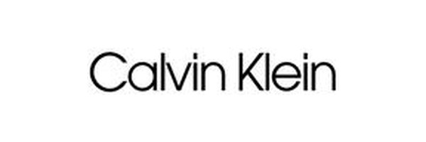

HIGH RISK MOST FAKED Underwear, jeans, fragrances
TOP 3 TELLS: Raised waistband lettering (feel with fingers) • Sub-brand tag must match product line • White band along waistband top edge

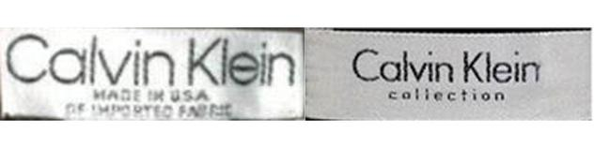  NECK / IDENTITY TAG | 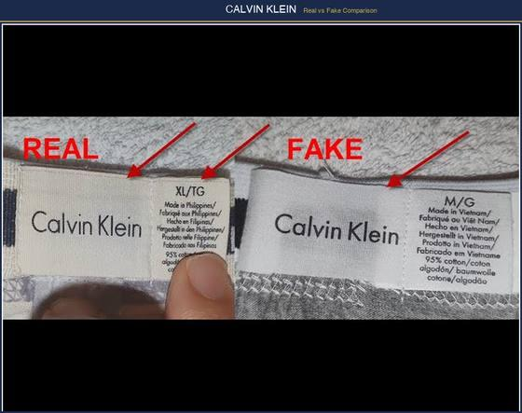  AUTHENTIC vs FAKE

WAISTBAND (UNDERWEAR)
✓ Thin white band along top edge; properly colored logo embroidery; tight, even stitching ✗ Missing white band; wrong embroidery color; loose stitching
LOGO TEXTURE
✓ Raised lettering you can feel with fingertips on waistband ✗ Flat, printed lettering with no depth
SUB-BRAND IDENTIFICATION
• Calvin Klein (mainline): Premium line with 'Calvin Klein' in serif font.
• CK Calvin Klein: Mid-range. Logo uses 'ck' in lowercase with specific spacing.
• Calvin Klein Jeans: Casual line. Tags clearly say 'Calvin Klein Jeans.'
• Counterfeits often mix up the sub-brand tags — e.g., a CK Jeans product with a mainline Calvin Klein tag.
PRODUCT CODES
• Real CK items have product codes on inner labels. The format varies by product category but is always present.
✓ Verifiable product code matching CK catalog ✗ Non-verifiable or fabricated codes
PACKAGING
✓ Consistent branding, correct UPC codes, clean printing; underwear comes in branded box/packaging ✗ Slightly off colors or blurry text on packaging; loose or unpackaged

5.27  Under Armour | 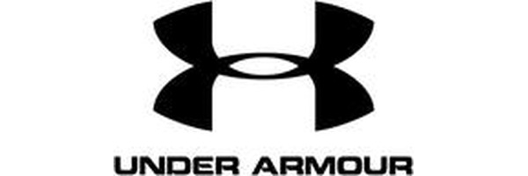

MEDIUM RISK MOST FAKED HeatGear shirts, HOVR shoes, backpacks
TOP 3 TELLS: Symmetrical interlocking U and A • HeatGear/ColdGear/Storm tech labels correct • Barcode verifiable on UA website

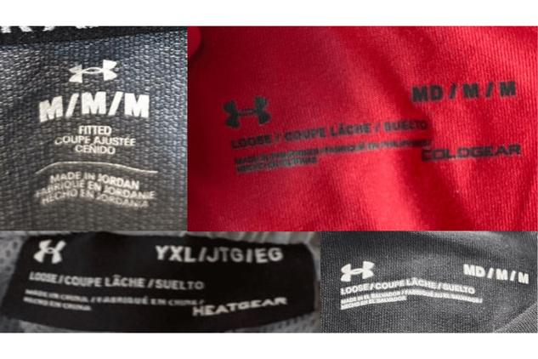  NECK / IDENTITY TAG | 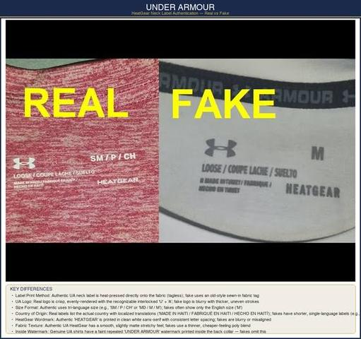  AUTHENTIC vs FAKE

UA LOGO
✓ Crisp, perfectly symmetrical, sharply defined interlocking U and A ✗ Slightly uneven or blurry; letters don't align cleanly
• The 'U' and 'A' overlap at a specific angle — the crossbar of the 'A' should intersect the right leg of the 'U' at a consistent point.
INTERNAL LABEL
• Must have manufacturing country, size, model number, and scannable barcode.
• Cross-check barcode/model number on Under Armour's website.
🚩 RED FLAG: Fakes often omit the product code, color designation, or barcode entirely.
TECHNOLOGY LABELS
✓ HeatGear/ColdGear/Storm labels with correct proprietary font matching UA branding ✗ Misspelled technology names or incorrect fonts
• HeatGear: Lightweight, breathable fabric designed for hot conditions. Should feel thin but strong.
• ColdGear: Dual-layer fabric with soft interior. Should feel noticeably warmer than regular synthetics.
MATERIALS & STITCHING
✓ High-grade mesh, quality synthetic fabrics, even consistent stitching ✗ Plasticky, stiff, or overly lightweight fabric; uneven stitching
FOOTWEAR
✓ Clear model name, size, barcode, color code on tongue/box — all matching ✗ Missing fields or mismatched information between shoe and box

5.28  New Balance | 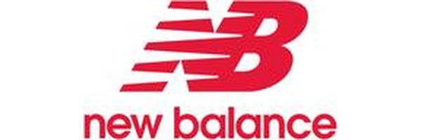

HIGH RISK MOST FAKED 990, 550, 2002R, 574 sneakers
TOP 3 TELLS: Made in USA/UK on premium lines (990, 991, etc.) • 'new balance' on sole has a space between words • N logo has consistent width throughout

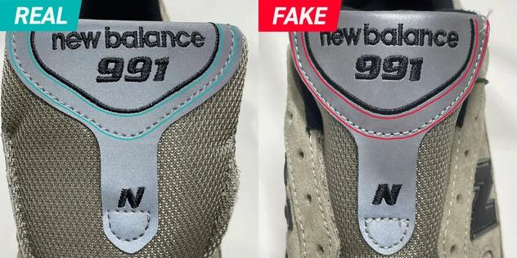  NECK / IDENTITY TAG | 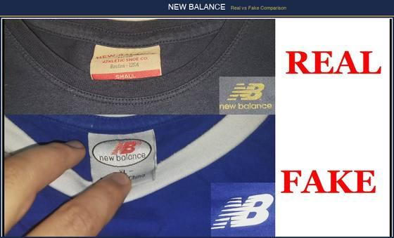  AUTHENTIC vs FAKE

N LOGO
✓ Sharp, well-defined edges; clean dual stitch lines tracing perimeter ✗ Poorly stitched N with irregular width or rounded edges
• The 'N' should have consistent width throughout — no thick spots or thin spots. Stitching should be tight with no fabric showing between the threads.
TONGUE LABEL
✓ Serial numbers match retail box; thinner, fully painted characters; QR code links to NB product page ✗ Mismatched serials; thicker characters; scratched 'B' in 'Balance'
• Made in USA/UK: Premium NB lines (990, 991, 992, 993, 1300, 1500, etc.) are made in USA or UK. The tongue label should say 'Made in USA' or 'Made in England.' If a 990 says 'Made in China/Vietnam,' it's counterfeit.
SOLE TEXT
✓ Deep, clear engraving of 'new balance' (two words, WITH a space) ✗ 'newbalance' (no space) or misspelled 'non-making sole' instead of 'non-marking sole'
MODEL NUMBER VERIFICATION
• Format: NB model numbers follow a pattern: letters + numbers (e.g., M990GL5 = Men's 990 version 5 in Grey). The prefix indicates gender (M=Men, W=Women, K=Kids).
• Google the full model number — it should return the exact shoe in the exact colorway.
MATERIAL QUALITY
✓ Real suede with nap direction; quality mesh; sturdy rubber outsole ✗ Synthetic faux-suede — too soft, shiny, or plastic-like

PRO TIP
For Made in USA/UK models: look inside the shoe at the insole. Genuine pairs have a full-length insole with NB branding. Fakes often have a thin, glued-in insole that peels up.

5.29  Guess | 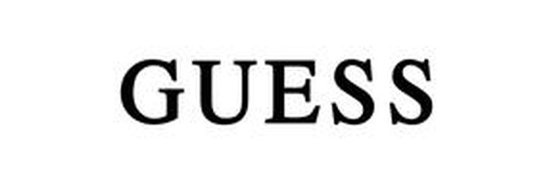

MEDIUM RISK MOST FAKED Handbags, logo tees, watches
TOP 3 TELLS: Triangle logo with centered ? • Grey swing tag with rounded corners • Silver embossing on packaging

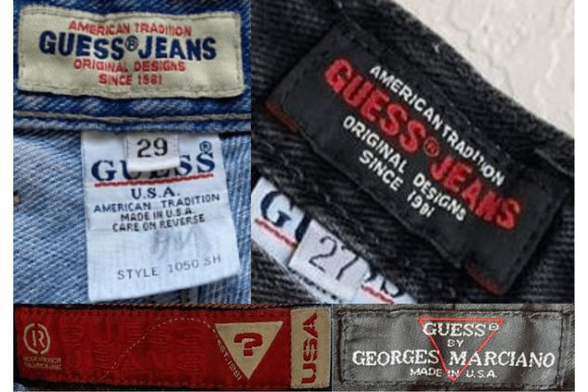  NECK / IDENTITY TAG | 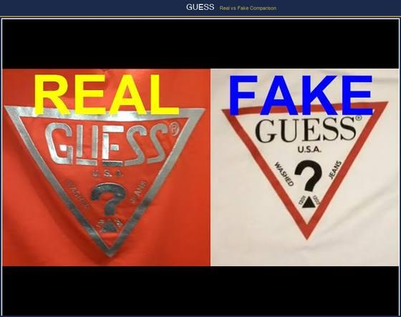  AUTHENTIC vs FAKE

TRIANGLE LOGO
✓ Clean, precise edges; evenly spaced text; matching font on interior and exterior ✗ Uneven edges; inconsistent text spacing; mismatched fonts
• The inverted triangle should have perfectly straight sides and a sharp point. The '?' should be centered within the triangle.
SWING TAG
• Authentic: Grey patterned tag with rounded corners, silver embossing reading 'Guess' or 'Guess by Marciano'. Back has model number, barcode, and price.
• Counterfeit: Missing back information, wrong corner shape, or incorrect embossing.
HARDWARE
✓ Solid metal, high-quality finish, clean precise engravings ✗ Hollow, lightweight metal that tarnishes, flakes, or chips
PACKAGING
✓ White or red box embossed only with 'GUESS by Marciano' ✗ Different-colored boxes, wrong fonts, or boxes with a question mark logo
STITCHING
✓ Evenly spaced, neatly finished throughout ✗ Uneven stitch lengths, loose threads at stress points

5.30  Columbia Sportswear | 

MEDIUM RISK MOST FAKED Puffer jackets, fleece, rain shells
TOP 3 TELLS: YKK zippers exclusively • CSC factory ID on interior label • Gem logo has rounded corners

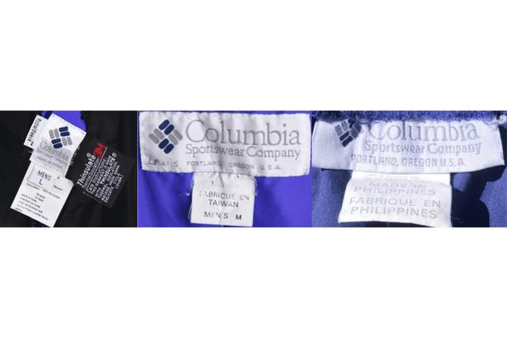  NECK / IDENTITY TAG | 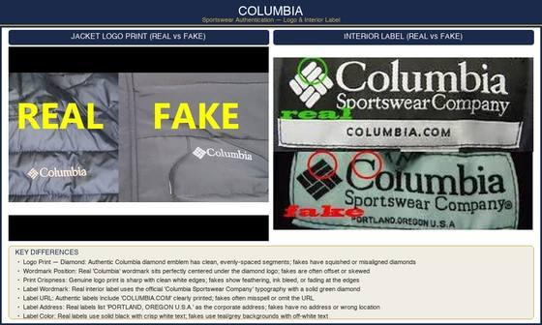  AUTHENTIC vs FAKE

LOGO SHAPE
✓ Columbia 'gem' logo has ROUNDED/radius corners; 'C' has flag-like serifs ✗ Square corners on gem logo; incorrect 'C' serif style
ZIPPERS
• CRITICAL: Authentic Columbia uses YKK zippers exclusively. If you see 'YRR' or any other brand on the zipper pull, it is fake.
FACTORY ID
• Every authentic garment has a CSC factory ID (2-5 digits) on the interior label.
• This supply-chain identifier is typically absent or fabricated on counterfeits.
OMNI-TECH / OMNI-HEAT LABELS
✓ Correct proprietary font matching Columbia's official branding ✗ Wrong font or spacing on technology labels
• Omni-Heat: Items with Omni-Heat should have visible silver dots on the jacket lining — these are reflective thermal dots that trap body heat.
EMBROIDERY QUALITY
✓ Well-defined, tightly stitched logo with no fading ✗ Fuzzy edges or uneven thread density

5.31  Converse | 

MEDIUM RISK MOST FAKED Chuck Taylor All Star, Chuck 70
TOP 3 TELLS: All Star patch on INNER ankle only • Waffle sole pattern with specific elements • 10 oz canvas on Chuck 70

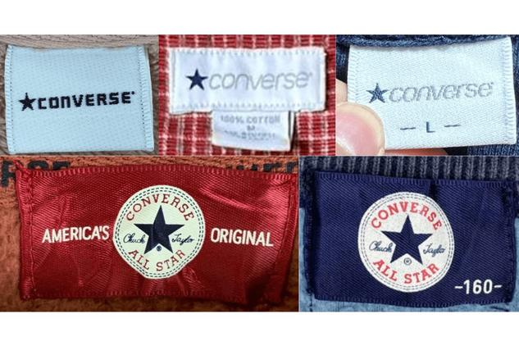  NECK / IDENTITY TAG | 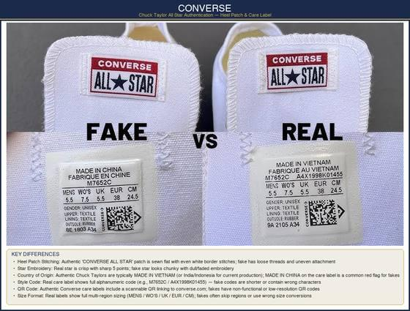  AUTHENTIC vs FAKE

ALL STAR PATCH PLACEMENT
• CRITICAL: On high-tops, the round logo patch goes on the INNER ankle — never the outer side. Patch on the outside = definitively fake.
• The star inside the circle should have five even, sharp-pointed arms. Rounded or uneven star = fake.
TOE CAP
✓ Solid gum rubber, straight, parallel to bottom laces, bends without cracking ✗ Oversized toe cap with excess glue visible around edges
• Toe Cap Height: On Chuck Taylor 70s, the toe cap is taller than on standard Chucks. On standard Chucks, it should measure approximately 1.5 inches from sole to top edge.
SOLE PATTERN
• Authentic: Specific waffle pattern combining diamond shapes, diagonal lines, crisscross patterns, and horizontal lines. The 'ALL STAR' text is molded into the sole heel area.
• Counterfeit: Simplified or distorted pattern. Missing or poorly formed 'ALL STAR' text.
TONGUE LABEL
• Inside of tongue has: country of manufacture, model number, size, material composition, QR code, and unique serial number.
• Chuck 70 tongue labels include 'Chuck 70' text and have a longer, padded tongue vs. standard Chuck Taylor.
EYELET QUALITY
✓ Metal eyelets firmly set, evenly spaced, with no rough edges; laces thread smoothly ✗ Uneven spacing, rough edges, loose eyelets that spin when touched
OVERALL CONSTRUCTION
✓ Clean, evenly applied glue; substantial canvas (Chuck 70 uses 10 oz canvas); firmly set eyelets ✗ Excess visible glue; thin papery canvas; uneven eyelet spacing
🚩 RED FLAG: Fakes either omit the serial number or print it poorly/illegibly.

5.32  Gucci | 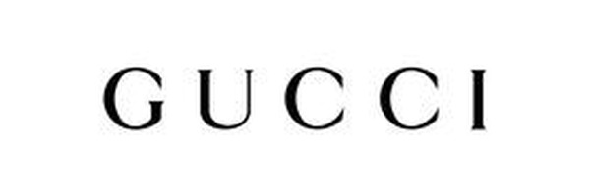

HIGH RISK MOST FAKED GG bags, Ace sneakers, belts, wallets
TOP 3 TELLS: Serial heat-stamped (not printed) in serif font • GG pattern aligns at seams • Subtle gold hardware (never flashy/shiny)

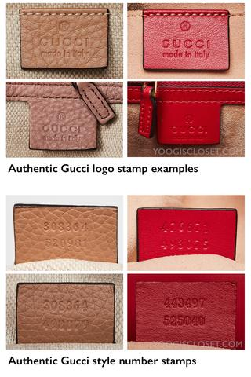  NECK / IDENTITY TAG | 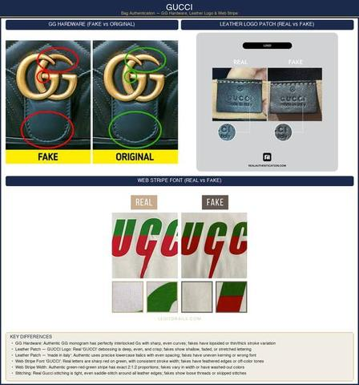  AUTHENTIC vs FAKE

SERIAL NUMBER TAG
• Format: Two rows of digits heat-stamped into a leather interior patch. Pre-2016: 10-13 digits. Post-2016 with new creative director: typically 10 digits.
• Font: Typewriter-style serif font. Characters are thin and evenly spaced.
✓ Numbers heat-stamped with subtle, clean impression that you can feel ✗ Numbers too deeply engraved, wrong spacing, or modern sans-serif font
HEAT STAMP
• 'GUCCI' in all-caps with a registered trademark ® symbol.
• Below: 'Made in Italy' — always in English, always lowercase 'in'.
✓ Clean, subtle stamp with consistent depth; 'Made in Italy' is smaller than 'GUCCI' ✗ Too bold, unevenly pressed, or missing ® symbol; same-size text
GG PATTERN — SUPREME CANVAS
• The interlocking Gs must be perfectly round and symmetrical.
• One G faces right-side-up, the other is inverted. They interlock at the exact center.
• The GG pattern should align at seams — if the pattern breaks abruptly at a seam, it's likely fake.
✓ Gs are perfectly round with uniform line thickness ✗ Gs are slightly oval, flattened, or have varying thickness
HARDWARE
✓ Solid metal with subtle gold tone (not shiny/flashy); smooth finish; 'GUCCI' engraved on clasps/buckles ✗ Overly shiny/gold-plated, visible mold seams, lightweight feel, missing engravings
STITCHING
✓ Uniform, tight stitching; same-color thread matching leather; 8-10 stitches per inch ✗ Uneven stitch lengths, fraying, gaps, or wrong thread color
DUST BAG & BOX
• Dust Bag: Soft, cream/off-white flannel with 'GUCCI' in dark brown or black print. Modern dust bags are pale cream; vintage may be darker.
• Box: Sturdy dark brown box with gold 'GUCCI' lettering. Interior tissue paper is branded.
🚩 RED FLAG: Counterfeits show slightly flattened or asymmetric G curves — always check under magnification.

5.33  Puma | 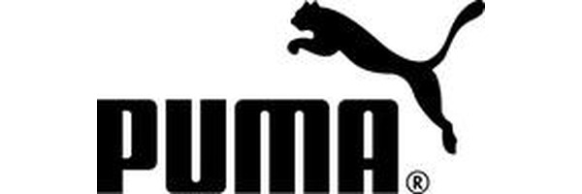

MEDIUM RISK MOST FAKED Suede Classic, RS-X, Speedcat
TOP 3 TELLS: Formstrip is laser-embossed (feel ridges) • Cat direction mirrors on left/right shoe • Serial verifiable via Google search

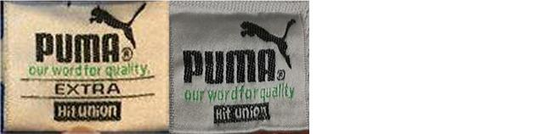  NECK / IDENTITY TAG | 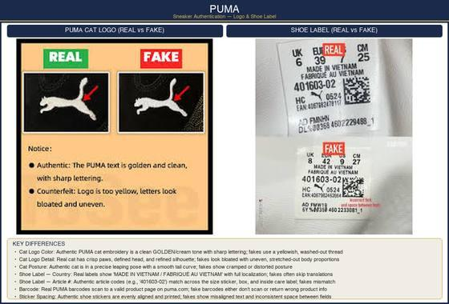  AUTHENTIC vs FAKE

FORMSTRIP LOGO
• CRITICAL: The formstrip (leaping cat silhouette) is laser-embossed on authentic pairs — you can feel distinct ridges with a fingernail. Fakes are flat-printed or blurry.
• The cat should be leaping to the RIGHT on the left shoe, and to the LEFT on the right shoe (mirrored). Same-direction cats on both shoes = counterfeit.
TONGUE LABEL
• Contains style ID, size, country of manufacture, and a unique serial/QR code.
• Google the serial — it should return the exact model. Non-verifiable codes = fake.
SOLE LOGO
✓ Precisely centered PUMA wordmark on outsole; leaping cat logo on heel ✗ Misaligned, poorly bonded, or missing logos
OUTSOLE PATTERN
✓ Intricate tread patterns with solid rubber construction ✗ Simplified patterns, thinner rubber, inconsistent tread depth
STITCHING & CONSTRUCTION
✓ Tight, even, no loose threads; clean glue application ✗ Uneven, sloppy stitching with visible excess glue residue
SUEDE QUALITY (FOR SUEDE CLASSIC)
✓ Genuine suede with visible nap; rich, saturated color ✗ Faux suede that's too smooth; washed-out or inconsistent color

5.34  Versace | 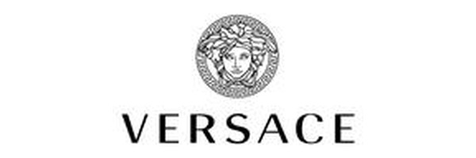

HIGH RISK MOST FAKED Medusa logo items, silk shirts, bags
TOP 3 TELLS: Medusa has human hair (pre-curse) • Greek key border with right angles • NFC tag verification (post-2020)

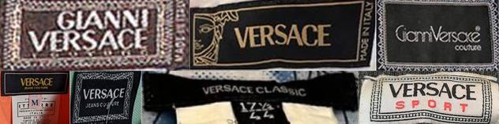  NECK / IDENTITY TAG | 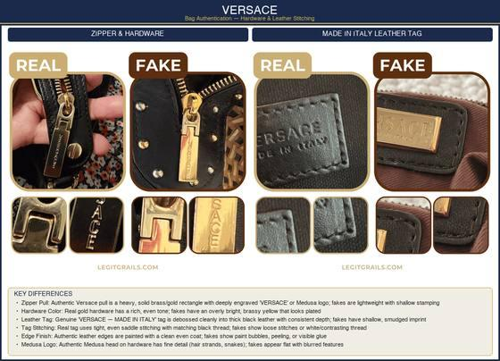  AUTHENTIC vs FAKE

MEDUSA HEAD — THE DEFINING MARK
• Key Detail: Depicts Medusa BEFORE her curse — she has human hair (not snakes), encircled by a Greek key (meander) pattern.
✓ Correct facial proportions; detailed Greek key border with clean right angles ✗ Distorted face; simplified or missing Greek key border; rounded angles
• Under magnification: Medusa's features should be finely detailed — lips, nose, and eyes are distinct. Hair flows in defined waves.
HARDWARE
✓ Heavy, seamless metal with designs etched (not stamped) into surface ✗ Visible mold seams, lightweight feel, stamped/printed designs
• Hardware should be consistently gold-toned (Versace's signature). Silver hardware is rare and only on specific collections.
LABELS
• Always state 'Made in Italy.' Font is a clean sans-serif specific to Versace.
• Sub-Lines: 'VERSACE' (mainline), 'VERSACE COLLECTION' (diffusion, now discontinued), 'VERSUS VERSACE' (younger line). Each has distinct labeling.
🚩 RED FLAG: Fakes use incorrect fonts or list other countries of manufacture. If it says 'Made in China,' it's counterfeit.
NFC AUTHENTICATION
• Modern Items: Versace now includes NFC tags on product labels (post-2020). Tap with your phone to verify authenticity via Versace's official system.
FABRIC
✓ Smooth, luxurious texture with consistent weave; Medusa print has sharp detail ✗ Coarse feel, weave irregularities, blurry or bleeding prints

5.35  Fila | 

MEDIUM RISK MOST FAKED Disruptor sneakers, logo tees
TOP 3 TELLS: F has rounded edges, doesn't touch border • Logo on tongue, outer, AND insole • Evenly punched toe cap holes

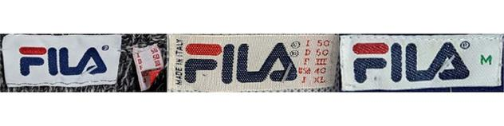  NECK / IDENTITY TAG | 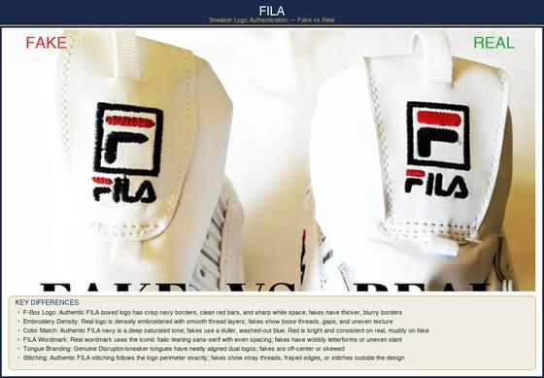  AUTHENTIC vs FAKE

F-BOX LOGO
• CRITICAL: The 'F' has rounded edges that do NOT touch the square border. If edges are sharp or touch the box frame, it is fake.
• The 'F' should be navy blue on a red background (or inverted on some products). Colors should be vivid, never washed out.
LOGO PLACEMENT
• Must appear on the outer side near laces, tongue, AND insole on footwear. Fakes often omit one location or misalign.
TOE CAP HOLES
✓ Evenly spaced and consistently punched ✗ Uneven hole spacing or rough edges
LABELS
✓ Securely stitched with style ID, product number, and care instructions ✗ Glued-on labels with spelling errors or missing data
MATERIAL
✓ High-quality, substantial leather/synthetic with clean edges ✗ Thin, flimsy, or plasticky feel

5.36  Reebok | 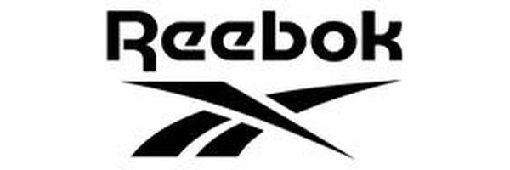

MEDIUM RISK MOST FAKED Classic Leather, Club C, Instapump Fury
TOP 3 TELLS: Tongue code matches box sticker exactly • Era-correct logo (Vector vs Delta) • Union Jack flag on box label

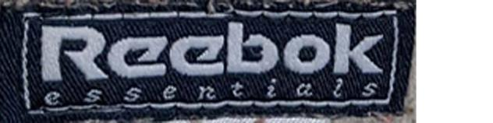  NECK / IDENTITY TAG | 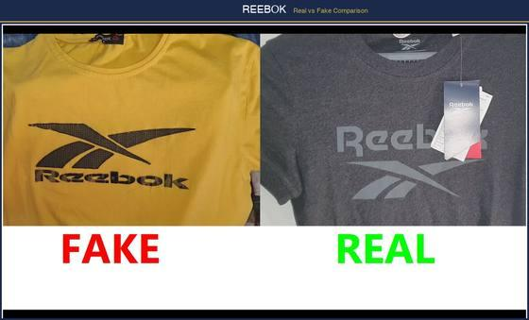  AUTHENTIC vs FAKE

TONGUE LABEL CODE
• Format: One letter followed by five numbers (e.g., J98765). Must match the code on the box sticker exactly. Mismatch = fake.
LOGO — KNOW THE ERA
• Vector Logo (classic): The side-stripe 'V' shape. Used on retro/Classic Leather styles.
• Delta Logo (modern): Triangle shape introduced in 2014 for fitness lines.
• The logo used must match the product era. A Delta logo on a 'vintage' style = inconsistent.
LOGO STITCHING
✓ Stitched with precision in correct brand colors ✗ Glued-on logos or mismatched thread colors
BOX LABEL
✓ Union Jack flag logo; white sticker with size, style number in distinctive Reebok font ✗ Blurry printing, incorrect flag colors, or missing data
SOLE PATTERN
• Must exactly match the pattern of the same model sold by official retailers.
🚩 RED FLAG: Fakes simplify or alter tread designs — always compare against official product images.

5.37  Wrangler | 

LOW RISK MOST FAKED Cowboy Cut jeans, western shirts
TOP 3 TELLS: W stitch on back pockets centered and even • Real leather patch (firm, grainy) • Rivets stamped with Wrangler text

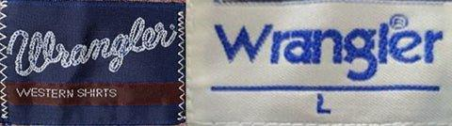  NECK / IDENTITY TAG | 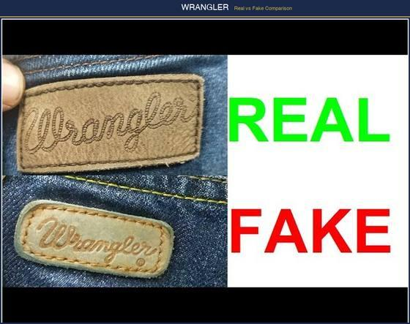  AUTHENTIC vs FAKE

BACK POCKET 'W' STITCH
✓ Even, consistent depth, centered W-shaped stitching on each pocket ✗ Shallow, wobbly, or off-center W stitching
• The W should be symmetrical — fold the pocket mentally in half and both sides should mirror.
LEATHER PATCH
✓ Real brown leather — firm, grainy texture; 'Wrangler' text is embossed/debossed ✗ Synthetic material that feels plasticky or wrong color; text is printed
RIVETS
✓ Stamped with 'Wrangler' text; heavy and robust copper-toned metal ✗ Blank rivets or lightweight, flimsy metal
LABELS
• Feature the Wrangler 'W' emblem in a specific vintage typeface.
✓ Correct font with sharp printing; style number present ✗ Incorrect font or poor print quality; missing style details
STITCHING
✓ Consistent stitch length in even rows; bar-tacking at stress points ✗ Irregular spacing, loose threads, uneven tension

5.38  Gap | 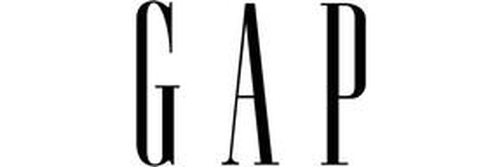

LOW RISK MOST FAKED Logo hoodies, jeans, basics
TOP 3 TELLS: Spire font with specific spacing • Unique style ID on interior label • Complete multi-language care labels

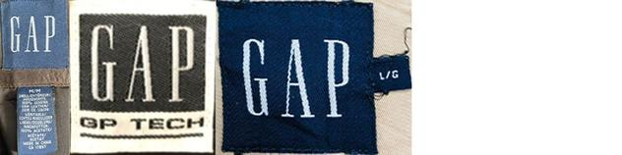  NECK / IDENTITY TAG | 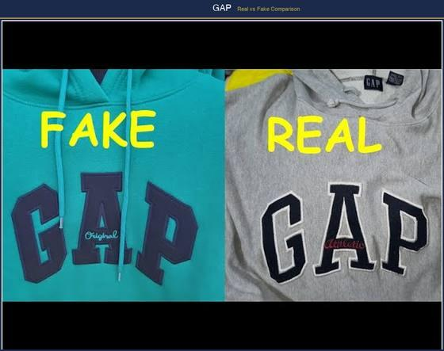  AUTHENTIC vs FAKE

LOGO FONT
• The GAP wordmark uses Spire (a custom typeface). Letters are bold and compact with specific spacing.
✓ Correctly spaced, sharp letterforms with no edge lifting ✗ Letters too large, incorrectly spaced, or with peeling edges
INTERIOR LABELS
✓ Sturdy material with clear text; country of origin and unique style ID ✗ Thin labels with blurry text or missing style codes
CARE LABELS
✓ Legible font with complete washing instructions; no spelling errors ✗ Misprints, incomplete instructions, or spelling mistakes
FABRIC & STITCHING
✓ Substantial thickness with vibrant, consistent coloring; precise stitching ✗ Thinner fabric with inconsistent dye; irregular stitch lengths or fraying

5.39  H&M | 

LOW RISK MOST FAKED Basics, Divided line, Conscious line
TOP 3 TELLS: Always stitched label (never glued) • Sub-brand designation correct • 10-digit product code verifiable

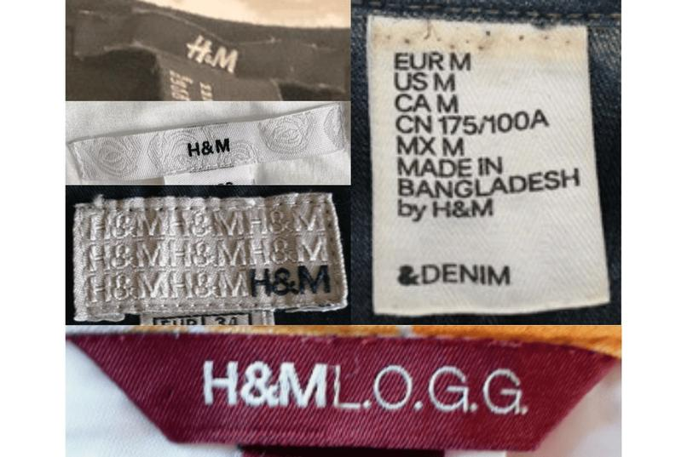
AUTHENTIC vs FAKE

MAIN LABEL
• Attachment: Always securely stitched (never glued) with clear, legible brand logo.
• Check for correct sub-brand designation (Divided, L.O.G.G., Conscious, etc.).
✓ Firmly stitched label with sharp printing ✗ Loose or glued label with blurry text
CARE LABEL
✓ Neatly sewn into interior seam; washing symbols with sharp, error-free multi-language text ✗ Blurry printing, spelling mistakes, or poorly sewn into garment
PRODUCT CODE
• Found on the care label; format is typically a 10-digit number. Can be verified against H&M's catalog.
FABRIC & STITCHING
✓ Vibrant colors with no fading; even, secure stitching; no loose threads ✗ Immediate pilling, flimsy feel, uneven tension, visible glue

5.40  Zara | 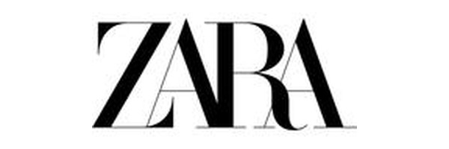

LOW RISK MOST FAKED Blazers, dresses, logo tees
TOP 3 TELLS: Custom Helvetica Neue Bold kerning • 9-12 digit code on BOTH price tag and care label • Plastic fastener attachment (not safety pins)

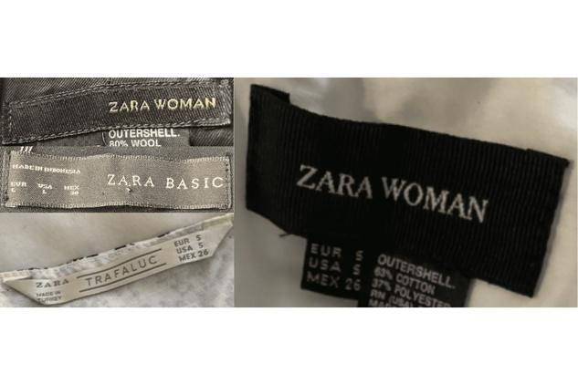  NECK / IDENTITY TAG | 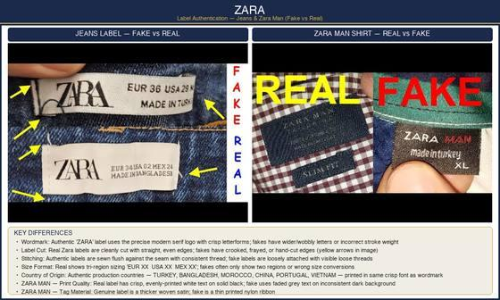  AUTHENTIC vs FAKE

LABEL LOGO
• Font: Custom Helvetica Neue Bold with precise kerning — no extra space between 'Z' and 'A', equal tracking across all letters.
✓ Correct kerning, sharp letterforms ✗ Widened gap after 'Z', distorted 'R' leg, or fuzzy printing
PRODUCT CODE
• Format: 9-12 digit code (e.g., 5643/002/400) appears on BOTH price tag and care label. The code format includes style/color/size.
• Cross-check on Zara's website/app — it should return the exact item.
🚩 RED FLAG: Non-matching or unverifiable codes across tags = counterfeit.
CARE TAGS
✓ Stitched on inside seam; washing instructions in multiple languages; neatly sewn ✗ Poorly sewn, incomplete instructions, or loose threads
PRICE TAG ATTACHMENT
✓ Attached with plastic fastener; shows product code, size, price, and barcode ✗ Attached with safety pins or string; missing data fields
FABRIC QUALITY
✓ Soft yet structured; even stitching; no loose threads ✗ Thin, overly stiff, or cheap-feeling fabric

5.41  Gymshark | 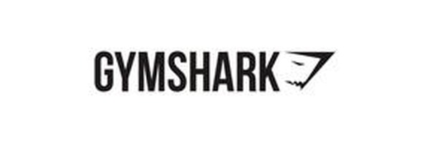

MEDIUM RISK MOST FAKED Vital seamless leggings, Apollo / Arrival tops, sports bras
TOP 3 TELLS: Heat-pressed logo with crisp edges • Correct flatlock seam pattern • Wash-label QR resolves on gymshark.com

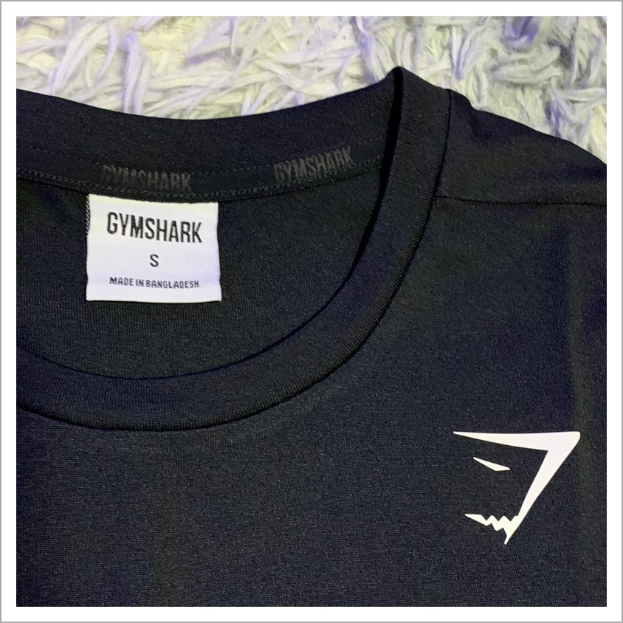  NECK / IDENTITY TAG | 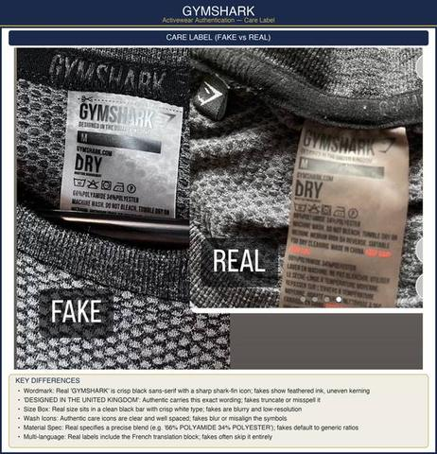  AUTHENTIC vs FAKE

LOGO & BRANDING
✓ Heat-pressed or embroidered logo with crisp, sharp edges and clean lines ✗ Blurry, fuzzy, or peeling logo with rough, lifting edges
• Logo Placement: The Gymshark shark-fin logo sits consistently — small left-chest or centered on the waistband. Counterfeits misplace, oversize, or skew it.
• Wordmark: The shark-fin mark is geometrically precise; fakes distort the fin angle or proportions.
LABELS & TAGS
• Neck / Waist Label: Authentic pieces use a soft printed or woven label with a consistent font; fakes use cheap, scratchy labels or the wrong typeface.
• Wash-Care Label QR: Genuine wash labels carry a QR code that resolves to gymshark.com — fakes have a non-working or absent QR.
• Size Markings: Real size dots/markings are clean, evenly printed, and correctly placed.
FABRIC & CONSTRUCTION
✓ Seamless knit construction with the correct flatlock seam pattern; four-way stretch with good recovery ✗ Bulky seams, incorrect seam placement, poor stretch recovery
✓ Leggings fabric is thick, opaque, and squat-proof ✗ Thin, see-through fabric that pills quickly
• Stitching: Even, tight stitching throughout with no loose threads.
HARDWARE & DETAILS
• Drawcords & Tips: Hoodie and jogger drawcord tips are branded or uniformly finished; fakes use bare or mismatched tips.

PRO TIP
Gymshark sells direct-to-consumer almost exclusively. Deep discounts from third-party marketplaces are a major red flag — verify pricing against gymshark.com.

5.42  Ed Hardy | 

HIGH RISK MOST FAKED Trucker hats, graphic tees, hoodies
TOP 3 TELLS: Christian Audigier signature placement • Dense, even rhinestone setting • Holographic authenticity sticker

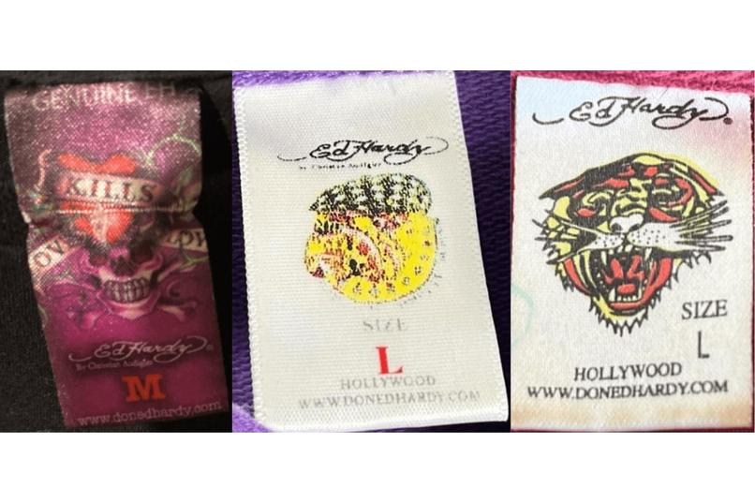
AUTHENTIC vs FAKE

GRAPHICS & PRINT
✓ Dense, vivid, high-resolution print with sharp detail in the tattoo artwork ✗ Faded, pixelated, or low-detail print with muddy colors
• Christian Audigier Signature: Authentic pieces carry the Christian Audigier signature in the correct placement and font; fakes misspell, misplace, or omit it.
• Artwork Registration: Multi-color prints are perfectly registered with aligned layers; fakes show color bleed and misalignment.
RHINESTONES & EMBELLISHMENTS
✓ Rhinestones are evenly set, uniform, and secure with no glue residue ✗ Crooked, uneven, or missing stones with visible glue
• Foil & Glitter: Metallic foil accents are crisp and durable; fakes flake or look dull.
LABELS & AUTHENTICITY MARKERS
• Neck Label: Genuine Ed Hardy neck labels are detailed, with the Ed Hardy logo woven rather than printed.
• Holographic Sticker: Authentic items carry a holographic authenticity sticker or hangtag — verify the hologram shifts when tilted.
• Hangtags: Real hangtags are thick, multi-layered, and consistently branded.
STITCHING & CONSTRUCTION
✓ Even stitching, quality fabric weight, and clean hems ✗ Loose threads, thin fabric, and uneven hems

PRO TIP
Ed Hardy is heavily counterfeited from its 2000s peak. Cross-check the trademark and seller reputation — legitimate modern Ed Hardy is licensed product.

5.43  Bape (A Bathing Ape) | 

HIGH RISK MOST FAKED Shark hoodies, ABC camo, Bapesta sneakers
TOP 3 TELLS: Ape-head face symmetry • Camo color accuracy • Clean gull-wing zipper stitching

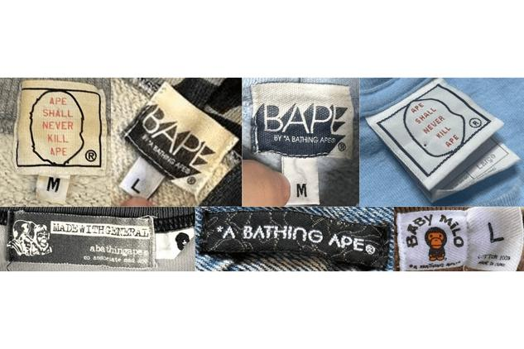  NECK / IDENTITY TAG | 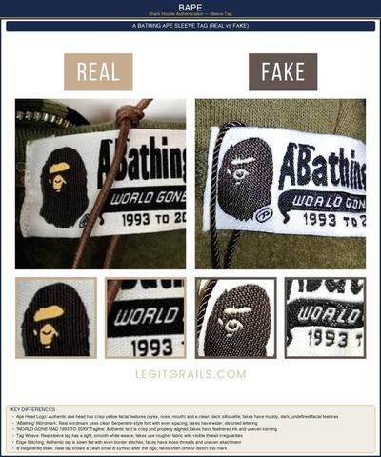  AUTHENTIC vs FAKE

APE-HEAD LOGO
✓ Ape-head face is symmetrical with correct proportions and clean facial detail ✗ Asymmetric face, wrong ear/jaw shape, sloppy detail
• Logo Embroidery: Authentic ape-head embroidery is dense and clean on the reverse; fakes show loose, sparse stitching.
CAMO PATTERN
✓ ABC camo colors are accurate, correctly scaled, and crisply printed ✗ Wrong color tones, blurry edges, incorrect camo scale
• Hidden Details: The hidden "APE" wordmark and star within the camo are present and correctly formed; camo aligns logically across panels.
SHARK HOODIE DETAILS
• Zipper: The gull-wing zipper stitching is clean and symmetric, the zipper is branded (often YKK), and the teeth align perfectly when zipped over the face.
✓ Hood holds its structure and the M-65 style zipper extends fully over the hood ✗ Misshapen hood, zipper too short, crooked face print
LABELS & TAGS
• Neck Label: Authentic Bape labels use the correct font and reference "NOWHERE CO., LTD" / "BAPE".
• Hangtags & Packaging: Real Bape ships with the camo-pattern hangtag and tissue paper — verify print quality.
BAPESTA SNEAKERS
✓ Bapesta star and patent leather are cleanly applied with a crisp sole stamp ✗ Sloppy star edges, dull patent leather, weak sole stamping

PRO TIP
Bape is one of the most faked streetwear brands. Authenticate through StockX/GOAT or BAPE’s own tags — a price far below retail is a red flag.

5.44  Hollister | 

MEDIUM RISK MOST FAKED Logo hoodies, graphic tees, jeans
TOP 3 TELLS: Burgundy seagull embroidery • A&F parent-company reference on neck tag • RN# 79854

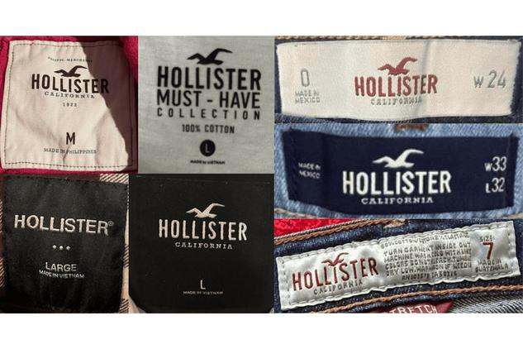  NECK / IDENTITY TAG | 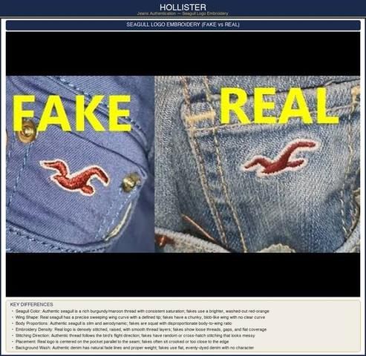  AUTHENTIC vs FAKE

LOGO & EMBROIDERY
✓ Burgundy seagull embroidery is dense, clean, and correctly colored ✗ Wrong shade, loose or sparse embroidery, crooked seagull
• Wordmark: The "Hollister" / "HCO" script uses the correct font with consistent kerning; fakes use wrong fonts or spacing.
LABELS & TAGS
• Neck Tag: Authentic tags reference parent company Abercrombie & Fitch; fakes omit or misspell this.
• RN Number: Genuine Hollister carries RN# 79854 — a wrong or missing RN indicates a fake.
• Care Label: Correct fabric content and care icons, cleanly printed.
FABRIC & CONSTRUCTION
✓ Soft, consistent fabric weight with even dye; even stitching and properly finished hems ✗ Thin, scratchy fabric with uneven color; loose threads and puckered seams
HARDWARE
• Buttons & Rivets: On denim, buttons and rivets are branded "Hollister" and feel solid; fakes use blank or lightweight hardware.

PRO TIP
Hollister is a mid-tier brand, so counterfeits are usually crude. The true-burgundy seagull color and the A&F reference catch most fakes quickly.

5.45  Diesel | 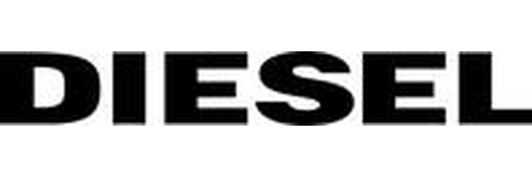

HIGH RISK MOST FAKED Denim jeans, denim jackets
TOP 3 TELLS: Jacron patch detail & thickness • 'Scan for Authenticity' QR tag • Correct style-code format

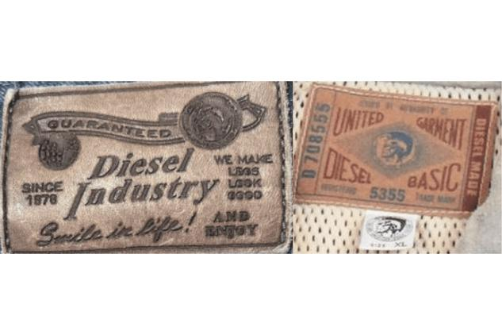  NECK / IDENTITY TAG | 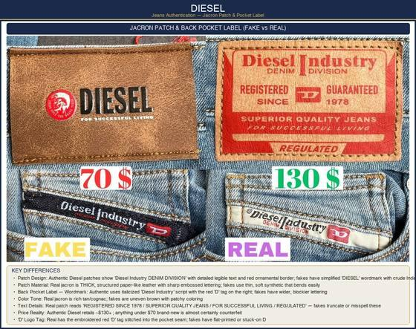  AUTHENTIC vs FAKE

JACRON PATCH
✓ Thick, structured paper-like leather jacron with sharp embossed lettering reading "Diesel Industry DENIM DIVISION" ✗ Thin, soft synthetic patch with a simplified or crude wordmark
• Patch Text: Authentic patches read "REGISTERED SINCE 1978 / SUPERIOR QUALITY JEANS / FOR SUCCESSFUL LIVING" — fakes truncate or misspell this.
• Patch Color: Real jacron is a rich, even tan/cognac; fakes are patchy or uneven brown.
AUTHENTICITY TAG & QR
• Scan-for-Authenticity Tag: Authentic jeans carry a "SCAN FOR AUTHENTICITY" tag with a working QR code that resolves to diesel.com.
✓ QR code scans and verifies the item; the circular "DIESEL — ONLY THE BRAVE" border is sharp ✗ Non-scanning QR with a blurry or broken border
STYLE CODE & LABELS
• Style Code Format: Diesel style codes use a precise model-name format (e.g., "LARKEE-BEEX"); fakes misspell or use generic names.
• Size Format: Real size tabs show an "01 W## - L##" format with a leading zero.
HARDWARE & STITCHING
✓ Fine red selvedge stitch at the waistband; crisp parallel double-stitching on belt loops; solid branded hardware ✗ No red stitch detail; uneven or single-stitched loops; lightweight blank hardware

PRO TIP
Authentic Diesel jeans retail around $130+. Brand-new Diesel priced under $70 is almost certainly counterfeit.

5.46  Lee | 

MEDIUM RISK MOST FAKED Vintage denim jackets and jeans
TOP 3 TELLS: Deeply embossed leather patch • ® mark placement • Clean, even bartack stitching

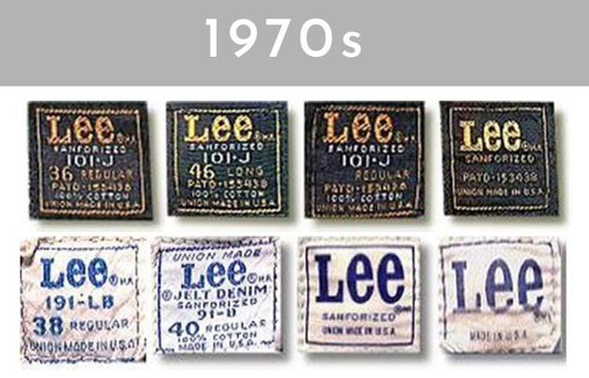  NECK / IDENTITY TAG | 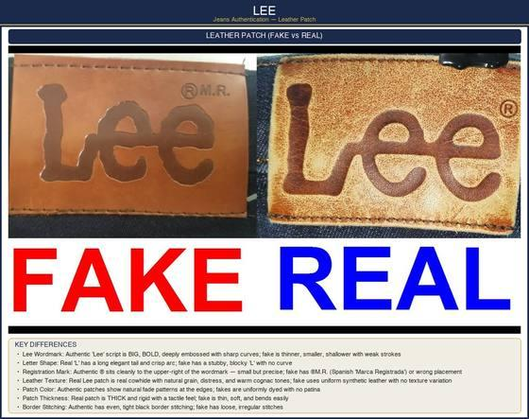  AUTHENTIC vs FAKE

LEATHER PATCH
✓ "Lee" script is big, bold, and deeply embossed with sharp curves; the "L" has a long, elegant tail ✗ Thin, shallow, stubby lettering; a blocky "L" with no curve
• Registration Mark: The authentic ® sits cleanly to the upper-right of the wordmark; fakes use "®M.R." or the wrong placement.
✓ Real cowhide patch with natural grain, distress, and warm cognac tones ✗ Uniform synthetic leather with no texture variation
STITCHING & CONSTRUCTION
✓ Even, tight bartack stitching at belt loops and pocket corners; neat overlock seams on sturdy cotton-drill pocket bags ✗ Frayed threads, bartack failures, loose corners, thin pocket fabric with raw edges
• Waistband: Consistent topstitching with no skipped stitches.
LABELS & TAGS
• Neck / Care Label: Correct Lee logo font with an era-appropriate label style on vintage pieces.
• Union Made / Sanforized: Vintage Lee labels reference "UNION MADE" and "Sanforized" — verify era consistency.
HARDWARE
• Buttons & Zippers: Branded "Lee" buttons; vintage pieces use period-correct zipper brands (Conmar, Talon, Crown).

PRO TIP
For vintage Lee, the leather-patch embossing depth and the long "L" tail are the fastest tells — reproductions consistently fail the deep-emboss test.

5.47  Barbour | 

HIGH RISK MOST FAKED Wax jackets (Bedale, Beaufort, Border)
TOP 3 TELLS: Three royal warrants on neck label • Correct style-code format • 'NAME' write-in field on care label

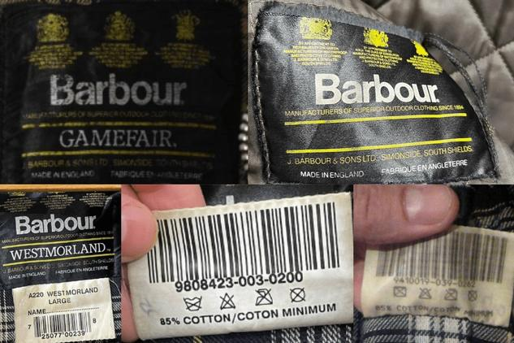  NECK / IDENTITY TAG | 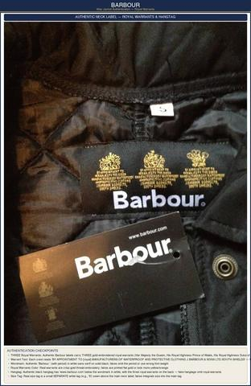  AUTHENTIC vs FAKE

NECK LABEL & ROYAL WARRANTS
✓ THREE gold-embroidered royal warrants on the neck label in crisp thread embroidery ✗ One, two, or fictional warrants; flat printed or yellowish warrants
• Wordmark: Authentic "Barbour." includes the period in white sans-serif on solid black; fakes omit the period or use the wrong weight.
• Size Tag: The real size tag is a small, SEPARATE white tag sewn above the main label; fakes integrate it into the main tag.
CARE LABEL & STYLE CODE
• Style Code Format: Codes follow a "MWX####XX##" format — prefix + 4 digits + color code + year. A wrong prefix (MWX/LWX/MQU/LQU/MCA) indicates a fake.
• Style Name: The specific model is listed in CAPS (BEDALE, BEAUFORT, BORDER, SAPPER).
• NAME Field: Authentic care labels have a "NAME ____" write-in line — a long-standing Barbour signature that fakes often omit.
• Serial Number: A unique 7-digit serial; fakes repeat the same number across multiple items.
WAX COTTON & CONSTRUCTION
✓ Heavy, evenly waxed cotton with the distinctive Barbour smell; tartan lining correctly aligned; tight reinforced stitching ✗ Light or unevenly waxed fabric; wrong or blurry tartan; loose stitching
HARDWARE
✓ Solid branded studs and zip pulls (often branded YKK/Barbour) with a genuine corduroy collar ✗ Lightweight blank hardware and the wrong collar material

PRO TIP
The three royal warrants plus the "NAME" write-in field together are nearly impossible for fakes to get fully right — always check both.

5.48  Coogi | 

HIGH RISK MOST FAKED Vintage 3D multi-color knit sweaters
TOP 3 TELLS: 'COOGI' spelling — not 'CUGGI' • Multi-color woven wordmark • Dense 3D knit construction

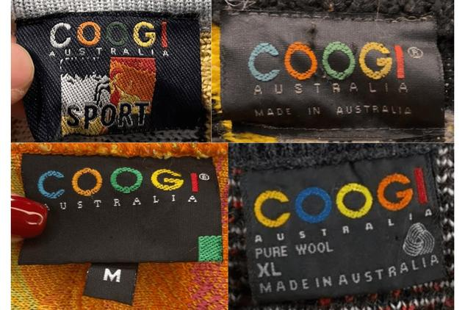  NECK / IDENTITY TAG | 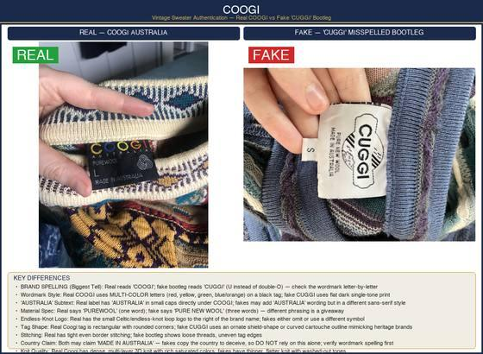  AUTHENTIC vs FAKE

BRAND SPELLING (BIGGEST TELL)
✓ Wordmark reads "COOGI" with a double-O ✗ Bootleg reads "CUGGI" (a U instead of the double-O) — check letter by letter
• Wordmark Style: Real COOGI uses multi-color woven letters on a black tag; fakes use flat, single-tone print.
• "AUSTRALIA" Subtext: The authentic label has "AUSTRALIA" in small caps under COOGI in the correct style.
LABEL & TAGS
• Material Spec: The real label says "PUREWOOL" (one word); fakes say "PURE NEW WOOL" (three words).
• Endless-Knot Logo: Authentic labels have the small Celtic endless-knot loop to the right of the brand name.
• Tag Shape: A real Coogi tag is rectangular with rounded corners; fakes use ornate shield or cartouche shapes.
KNIT CONSTRUCTION
✓ Dense, multi-layer 3D knit with rich, saturated colors; tight, even border stitching on the tag ✗ Thinner, flatter knit with washed-out tones; loose threads and uneven tag edges
• Country Claim: Both real and fake pieces may claim "MADE IN AUSTRALIA" — never rely on this alone; verify the wordmark spelling first.

PRO TIP
The single fastest authentication is the spelling: COOGI vs CUGGI. Many bootlegs depend entirely on the buyer not reading the wordmark closely.

5.49  Michael Kors | 

HIGH RISK MOST FAKED Signature-print handbags, totes, wristlets, wallets
TOP 3 TELLS: Even, refined logo lettering • Cleanly engraved zipper-pull hardware • Crisp, correctly-scaled MK monogram print

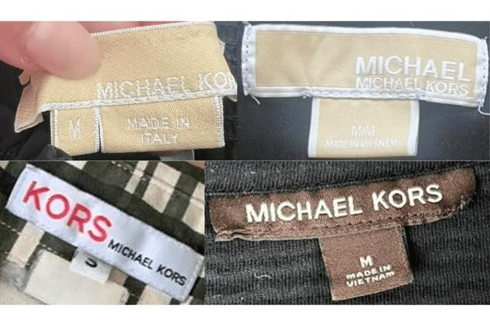  NECK / IDENTITY TAG | 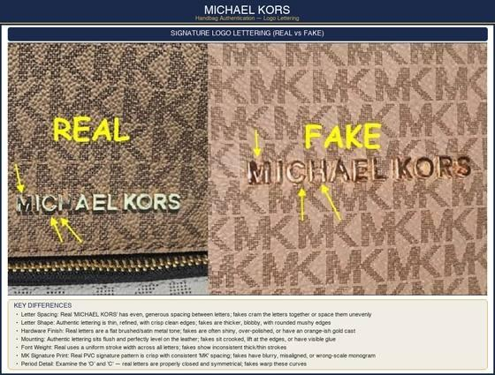  AUTHENTIC vs FAKE

LOGO & LETTERING
✓ "MICHAEL KORS" lettering is thin, refined, and evenly spaced with crisp edges ✗ Thick, blobby letters crammed together or unevenly spaced
• Hardware Finish: Real letters have a flat brushed/satin tone; fakes are shiny, over-polished, or have an orange-gold cast.
• Mounting: Authentic lettering sits flush and level on the leather; fakes lift at the edges or sit crooked.
• MK Monogram Print: Genuine signature PVC has crisp, consistent "MK" spacing and scale; fakes are blurry or wrong-scale.
HARDWARE
✓ Solid, weighty hardware with even plating and cleanly engraved zipper pulls ✗ Lightweight, hollow-feeling hardware with shallow or printed engraving
• Hardware Consistency: All hardware matches in tone; fakes mix gold shades piece to piece.
• Zippers: Quality branded zippers (often YKK) that operate smoothly.
LABELS & SERIAL
• Interior Label: Authentic bags have a clean leather or fabric brand label with the correct font; fakes use wrong fonts or crooked placement.
• Care Card: Genuine bags include a care card — verify any style or serial number format.
STITCHING & MATERIAL
✓ Even, tight stitching; leather or PVC with consistent grain and finish ✗ Loose threads, uneven stitch density, plasticky or off-grain material

PRO TIP
MK is heavily faked because it is accessible luxury. The logo lettering quality — even spacing and flush mounting — catches the majority of counterfeits.

5.50  Louis Vuitton | 

HIGH RISK MOST FAKED Monogram & Damier bags, pochettes, wallets
TOP 3 TELLS: Thin, crisp heat stamp with tight double-T • Date-code factory letters match 'made in' country • Even, correctly-toned stitching

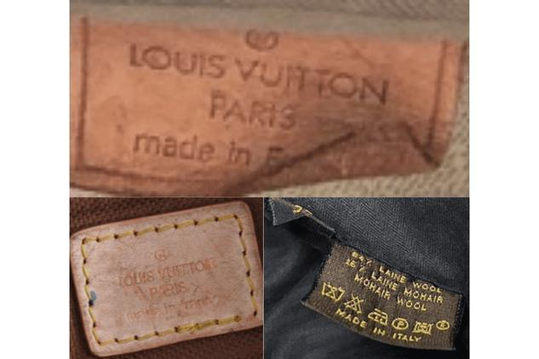  NECK / IDENTITY TAG | 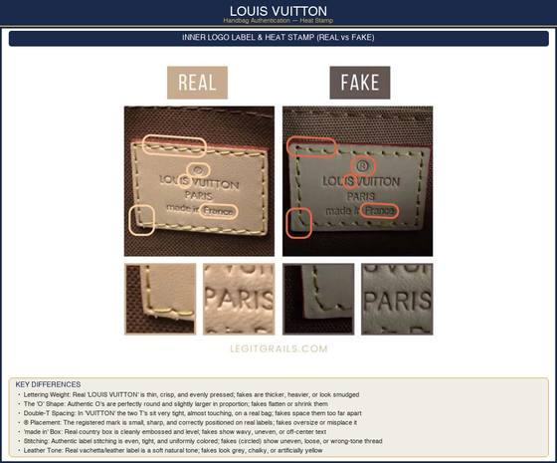  AUTHENTIC vs FAKE

HEAT STAMP
✓ The "LOUIS VUITTON" heat stamp is thin, crisp, and evenly pressed with round "O"s; the two T’s in VUITTON sit very tight ✗ Thick, heavy, or smudged lettering with flat "O"s and T’s spaced too far apart
• Registered Mark: The ® mark is small, sharp, and correctly positioned; fakes oversize or misplace it.
• "made in" Box: Cleanly embossed and level; fakes show wavy or off-center text.
DATE CODE
• Format Logic: A date code is 2 letters (factory) + 4 digits (date) — the factory letters MUST match the "made in" country found elsewhere on the bag.
✓ Crisply heat-stamped with sharp, evenly-pressed characters ✗ Faint, fat, or unevenly inked characters
CANVAS & MATERIAL
✓ Monogram/Damier canvas is correctly scaled and symmetrically placed; vachetta leather is a soft, natural tone ✗ Wrong-scale or off-center pattern; grey, chalky, or artificially yellow leather
• Pattern Placement: On authentic bags the monogram is centered and mirrored across symmetrical panels.
HARDWARE & STITCHING
✓ Heavy gold-toned hardware (often engraved "Louis Vuitton"); even stitching in the signature mustard-yellow thread on Monogram ✗ Lightweight hardware; uneven, loose, or wrong-color thread

PRO TIP
A date code alone NEVER proves authenticity — many fakes copy valid formats. Always verify it alongside the heat stamp, hardware, and canvas.

5.51  Kate Spade | 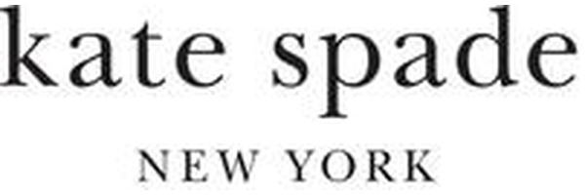

MEDIUM RISK MOST FAKED Saffiano-leather handbags, totes, wallets
TOP 3 TELLS: Logo 'N' lines up under the 't' in 'kate' • Fabric label stitched directly on (won't peel) • Credo-patch serial matches retail tag

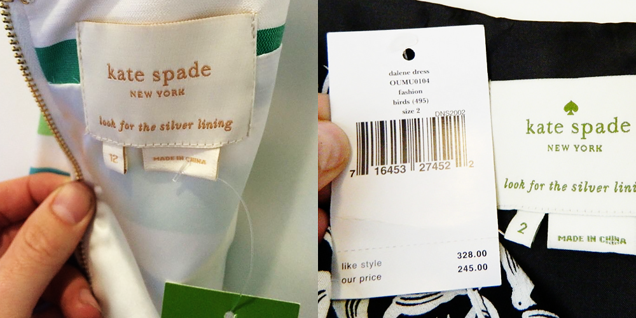
AUTHENTIC vs FAKE

LOGO & LETTERING
✓ Lowercase "kate spade" on line 1 and "NEW YORK" on line 2 in matching font and size; the "N" lines up under the "t" in "kate" ✗ Uneven spacing, blurry print, and the "N" and "t" misaligned
• Embossing: Authentic lettering is sharp with clean, consistent embossing depth; fakes are fuzzy with a crooked baseline.
LABELS & TAGS
• Interior Label: The fabric label is stitched DIRECTLY onto the bag and will not peel; fakes are glued on or sewn over an original label.
• Country-of-Origin Tag: All bags made after 1996 have a COO tag in the interior seam pocket, made in an approved country (USA, Italy, China, Taiwan, Dominican Republic, Indonesia, Vietnam, Rwanda, Philippines).
• Serial / Credo Patch: The serial on the leather credo patch matches the number on the green retail tag.
HARDWARE
✓ Gold or silver tone, all matching, heavy and solid, and never tarnishing; small round or flat feet at the four base corners ✗ Mismatched tones, a lightweight or hollow feel, and oversized or pointy feet
MATERIAL & STITCHING
✓ Saffiano leather with a firm crosshatch texture and cleanly painted edges; tight, even stitching ✗ Plasticky or overly glossy "leather", raw or sloppy edge paint, and loose, irregular stitches

PRO TIP
The logo alignment test (the "N" under the "t") plus the directly-stitched, non-peeling label catch most Kate Spade fakes in seconds.

5.52  Bebe | 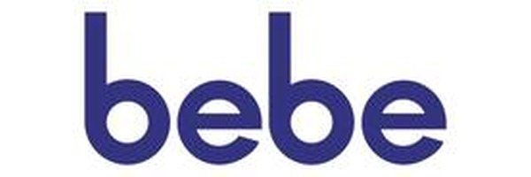

MEDIUM RISK MOST FAKED Rhinestone logo tops, tanks, dresses
TOP 3 TELLS: Black woven brand label (not white/grey thread) • Care tag on the right inside seam • Rhinestones evenly set with no glue residue

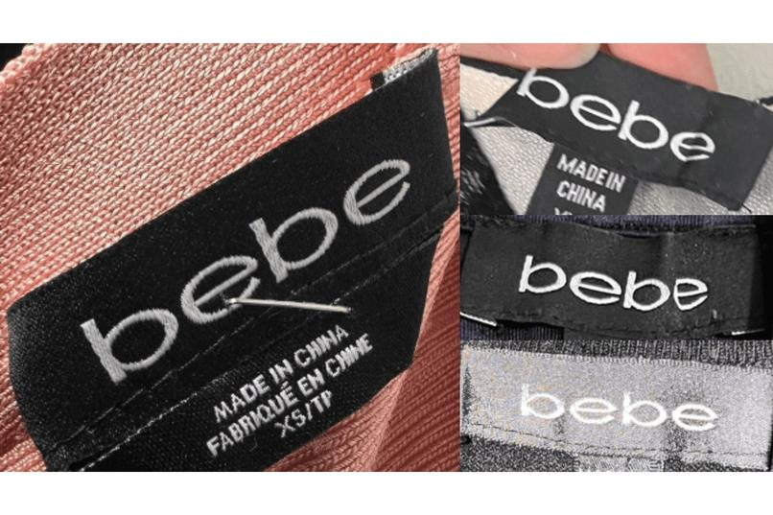
AUTHENTIC vs FAKE

BRAND LABEL
✓ The label is BLACK with a clean, crisply woven "bebe" wordmark ✗ A white label sewn with grey thread; a blurry or poorly woven logo
• Logo Accuracy: The correct lowercase "bebe" wordmark with nothing missing or distorted; fakes use wrong fonts or off-shape lettering.
CARE INSTRUCTIONS
• Placement: All bebe shirts have the care tag on the RIGHT INSIDE of the garment — fakes place it elsewhere or include spelling errors.
RHINESTONE LOGO
✓ Rhinestones are evenly set, secure, and uniform in size and sparkle with no glue residue; the logo is centered ✗ Visible glue around the stones, mismatched cheap stones, and a crooked or off-center logo
CONSTRUCTION & FABRIC
✓ Straight, clean stitching with high stitch density and even seams; weighted, fine fabric with true color ✗ Loose, low-density stitching, crooked seams, and thin fabric that fades, bleeds, pulls, or rips

PRO TIP
Vintage bebe used white labels, but modern authentic bebe uses BLACK labels — pair the label-color check with the care-tag placement to confirm.

