ADIDAS | HIGH RISK  NO. 5.7

MOST FAKED Yeezy, Ultraboost, Superstar, tracksuits, Sambas
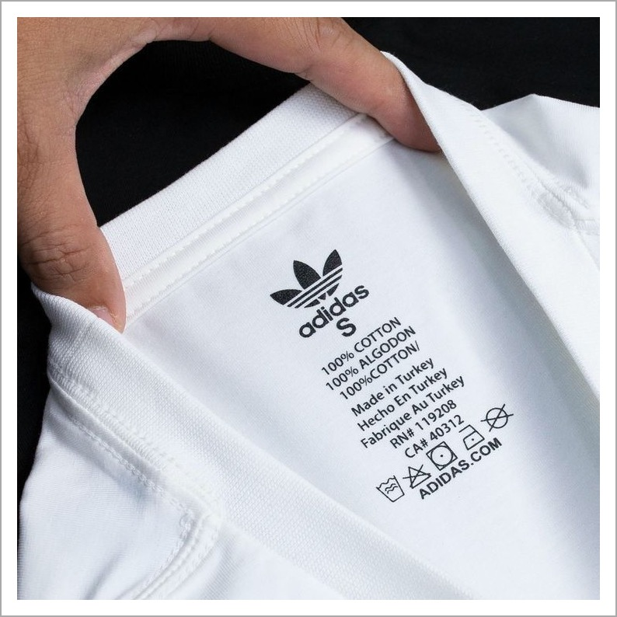
AUTHENTIC NECK / IDENTITY TAG
THE THREE THINGS TO CHECK
01 | The product code should resolve to the exact product.  Every authentic Adidas item has a unique 6-character code (e.g. DP2644) printed on the care label. Search it on Google — if it returns no results, the wrong product, or duplicate listings, it is counterfeit.
02 | Boost pellets are irregular and organic.  Genuine Boost foam has pellets of varying size and shape. Counterfeits use uniformly sized pellets that look molded and machined.
03 | Each shoe has a unique serial; the style code matches.  Authentic pairs share the same style code but have different serial numbers. If the style codes don't match between left and right, it's counterfeit.
PRO TIP Always Google the product code on the care label. A wrong or missing result is the single fastest counterfeit check for any Adidas item.

LACOSTE | HIGH RISK  NO. 5.8

MOST FAKED L.12.12 polo shirts, fragrances, footwear
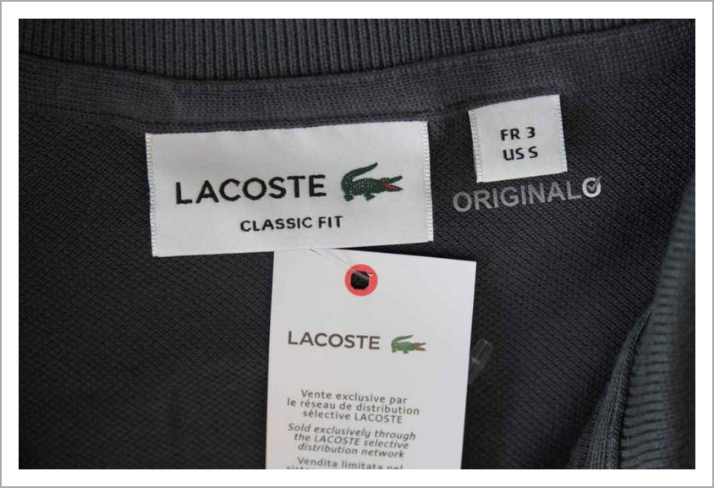
AUTHENTIC NECK / IDENTITY TAG
THE THREE THINGS TO CHECK
01 | The crocodile is embroidered with ~1,400 stitches.  Authentic crocodile is dense, detailed, faces right, with a visible red mouth, distinct eye, four legs and textured scales. Counterfeits are sparse, flat or face the wrong direction.
02 | Buttons are mother-of-pearl — cool to the touch.  Real Lacoste polos use mother-of-pearl buttons with a slight weight and iridescence. Plastic buttons feel warm and lightweight.
03 | European numeric sizing (2–9) is always present.  Authentic tags show a red European number (2–9) above the crocodile, with US RN# 115890 on the care label. Letter-only sizing or a missing RN = counterfeit.
PRO TIP Touch the buttons. Mother-of-pearl feels cool and slightly weighted; plastic feels room-temperature — this is the fastest tactile check on a Lacoste polo.

