Adidas
What is the authentic Adidas?
This one-pager covers the fastest checks to verify a genuine Adidas item — neck tag, logo detailing, materials and the single tell that catches most counterfeits.

RISK  HIGH | Counterfeit Risk Profile  Most faked items: Yeezy, Ultraboost, Superstar, tracksuits, Sambas  Where to look first: The product code printed on the care label — Googling it is the single fastest counterfeit check.

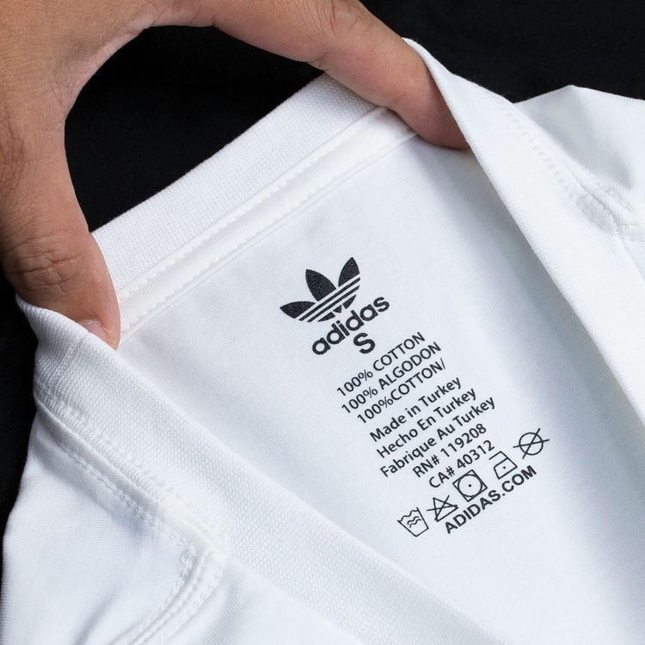  AUTHENTIC NECK / IDENTITY TAG | Authentic vs Fake  ✓ Authentic  • Trefoil/3-stripe wordmark touches the bottom of the stripes; clean, sharp print  • Unique 6-character product code (e.g. DP2644) on the care label, resolves to the exact item on Google  • Boost foam pellets are irregular and organic — varying in size and shape  • Even stitching at 8–10 stitches per inch; premium fabric weight  ✗ Fake  • Stripes detached from wordmark; uneven letter spacing; blurred ink  • Code missing, repeats across items, or Google returns wrong/no product  • Boost pellets look uniform, molded, or machined — never organic  • Loose threads, thin or stiff fabric, uneven/skipped stitches

PRO TIP
Always Google the product code on the care label first. A wrong or missing result is the single fastest counterfeit check for any Adidas item.

Lacoste
What is the authentic Lacoste?
This one-pager covers the fastest checks to verify a genuine Lacoste item — neck tag, logo detailing, materials and the single tell that catches most counterfeits.

RISK  HIGH | Counterfeit Risk Profile  Most faked items: L.12.12 polo shirts, fragrances, footwear  Where to look first: The crocodile embroidery and the buttons — both reveal counterfeits within seconds.

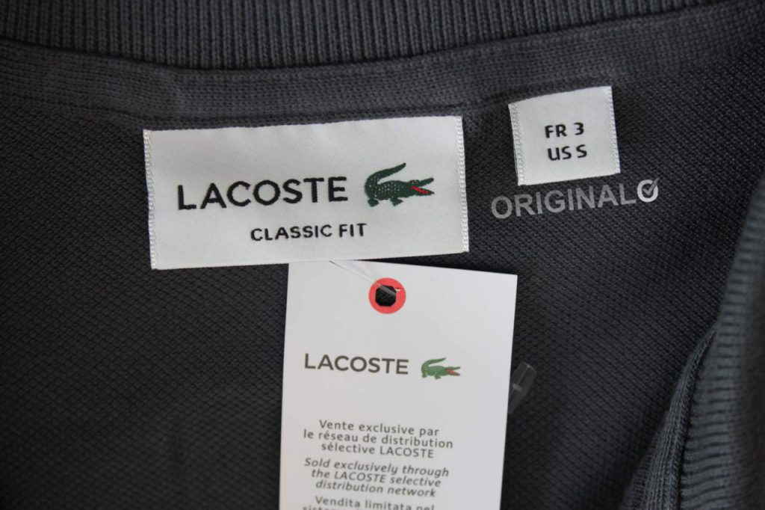  AUTHENTIC NECK / IDENTITY TAG | Authentic vs Fake  ✓ Authentic  • Crocodile faces RIGHT, with a visible red open mouth, distinct eye, four legs with claws  • Roughly 1,400 stitches in the crocodile embroidery — dense, detailed, three-dimensional  • Mother-of-pearl buttons — cool to the touch with a slight iridescence and weight  • European numeric size (2–9) in red above the crocodile; US RN# 115890 on the care label  ✗ Fake  • Crocodile faces left, has missing eye/claws, or sparse flat embroidery  • Wrong shade of green; mouth missing or closed; legs deformed  • Plastic buttons that feel warm and weightless; glossy/cheap finish  • Letter sizing only (S/M/L); missing or wrong RN number; spelling errors on tag

PRO TIP
Touch the buttons. Mother-of-pearl feels cool and slightly weighted; plastic feels room-temperature — this tactile check catches most fake Lacoste polos instantly.

