NO. 5.7 • HIGH RISK
ADIDAS
— — —
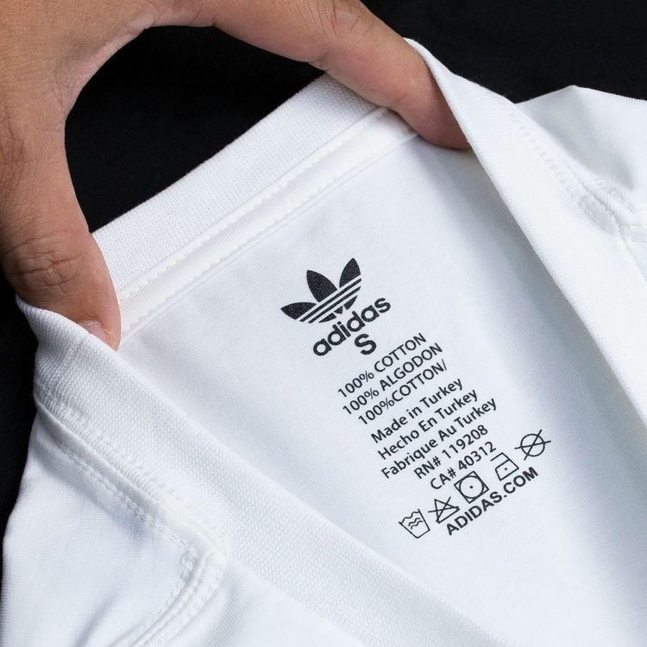
Authentic Neck / Identity Tag
01 The product code on the care label is unique to that exact item — a Google search should resolve to the same product.
02 Boost pellets in authentic shoes are irregular and organic; uniform pellets indicate a counterfeit.
03 Each shoe has a unique serial number but identical style codes — mismatched style codes between left and right reveal a fake.
— — —
Always Google the product code on the care label. A wrong or missing result is the single fastest counterfeit check for Adidas.

NO. 5.8 • HIGH RISK
LACOSTE
— — —
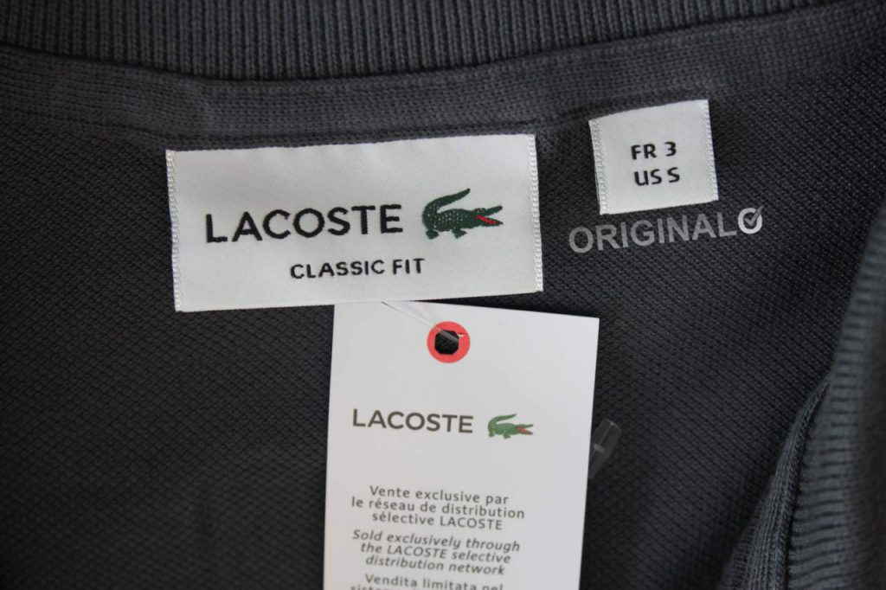
Authentic Neck / Identity Tag
01 The crocodile is embroidered with roughly 1,400 stitches; it faces right, with a red mouth, distinct eye and four legs with claws.
02 Buttons are mother-of-pearl — they feel cool to the touch and have a slight iridescence. Plastic feels warm and weightless.
03 European numeric sizing (2 to 9) is always present in red above the crocodile, alongside US RN# 115890 on the care label.
— — —
Touch the buttons. Mother-of-pearl feels cool and slightly weighted; plastic feels room-temperature — the fastest tactile check on a Lacoste polo.

