5.7
Adidas

COUNTERFEIT RISK  HIGH | MOST FAKED  Yeezy, Ultraboost, Superstar, tracksuits  TOP 3 TELLS  • Product code search returns exact product  • Boost pellets are irregular (organic)  • Both shoes: different serials but same style code

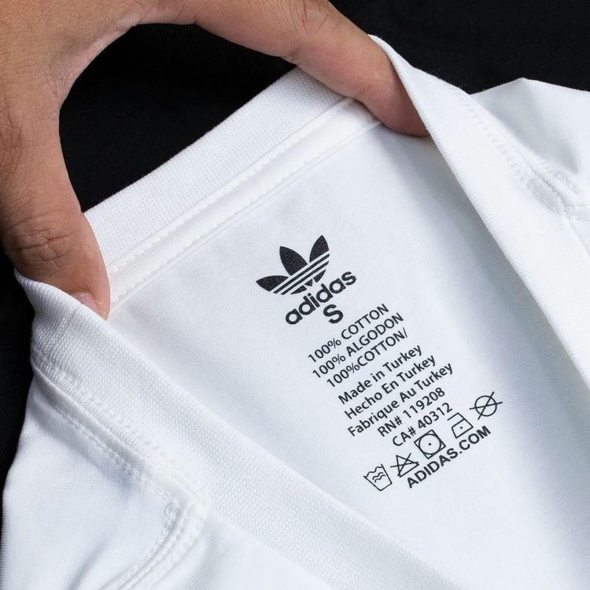  NECK / IDENTITY TAG | 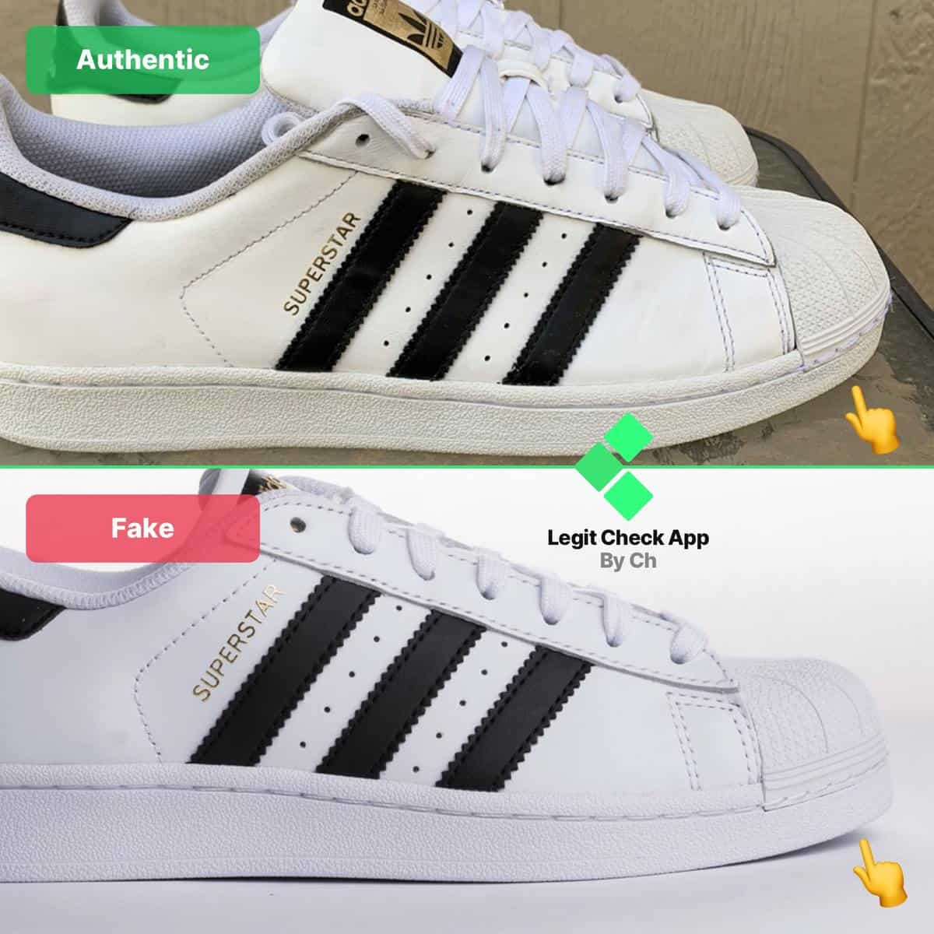  AUTHENTIC vs FAKE

LOGO — THREE VARIANTS  • Performance (3 Stripes): Three parallel bars of equal width.  • Originals (Trefoil): Three-leaf clover, perfectly symmetric.  • Badge of Sport: Three ascending stripes, equal width.  ✓ AUTHENTIC: Wordmark touches bottom of stripes; consistent kerning  ✗ FAKE: Trailing stitches between letters; typeface too thin | PRODUCT CODE VERIFICATION  Every authentic Adidas product has a unique product code (e.g., DP2644) on the care label. Search it online — genuine codes return matching products.  • Code Format: 6 chars on apparel. On footwear: tongue label AND box must match.

BOOST TECHNOLOGY (FOOTWEAR)  ✓ AUTHENTIC: Pellets are irregular (organic, varied sizes); soft & bouncy  ✗ FAKE: Uniform/machined pellets; feels stiff, not responsive | SERIAL NUMBERS  • Interior tongue label carries a unique serial per shoe.  • Both shoes: DIFFERENT serials but the SAME style code.

PRO TIP
Always Google the Adidas product code. No results or a different product = counterfeit. Single fastest check for any Adidas item.

5.8
Lacoste

COUNTERFEIT RISK  HIGH | MOST FAKED  L.12.12 polo shirts, fragrances  TOP 3 TELLS  • Crocodile has ~1,400 stitches  • Mother of pearl buttons (cool to touch)  • European numeric sizing (2–9) always present

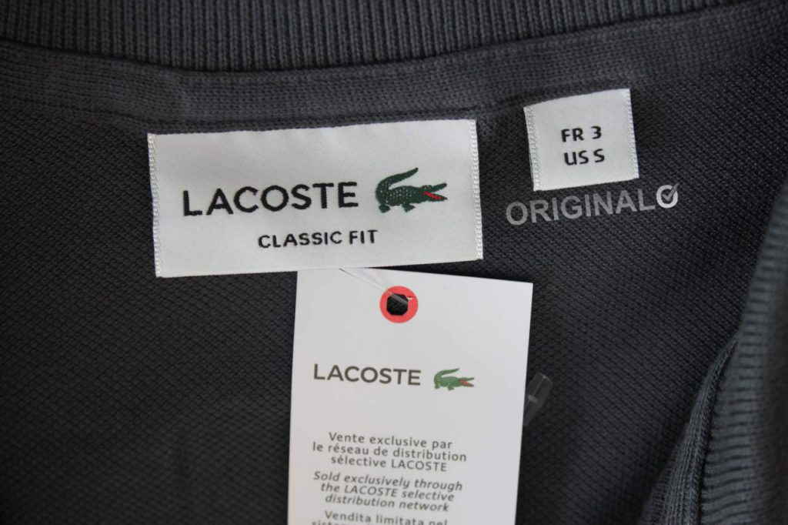  NECK / IDENTITY TAG | 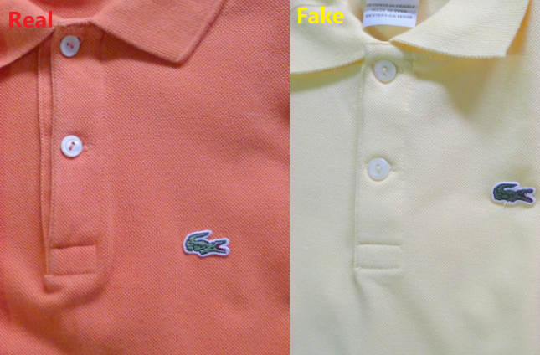  AUTHENTIC vs FAKE

THE CROCODILE — DETAILED INSPECTION  • ~1,400 stitches — dense and detailed under magnification.  • Open mouth with red interior, distinct eye, 4 legs with claws, textured tail.  • Faces RIGHT on all products (except some 1930s–40s vintage pieces).  ✓ AUTHENTIC: Dense embroidery 1,400+ stitches; vivid green body, red mouth  ✗ FAKE: Sparse stitching (<800); dull colors; missing mouth detail | SIZING & BUTTONS  ✓ AUTHENTIC: Numerical European sizing (2–9) in red above croc  ✗ FAKE: Only S/M/L sizing with no European number  • Buttons: Mother of pearl — cool to touch, warms from body heat. Plastic stays room-temp.  • L.12.12 polos: exactly 2 buttons — never 3.

INTERIOR TAG  • Reads '100% cotton' in seven languages on bottom inside.  • Older products reference 'Devanlay' (former distributor).  • RN #115890: Required on US-sold Lacoste; missing/wrong RN = suspicious. | PRODUCTION COUNTRIES  France, Peru, Morocco, Vietnam, Tunisia, Turkey, Italy, El Salvador, Thailand, Romania.  🚩 RED FLAG: 'Made in China' on a standard polo = very likely counterfeit.

PRO TIP
Touch the buttons. Mother-of-pearl feels cool and slightly weighted; plastic feels room-temperature — fastest tactile check on a Lacoste polo.

