5.7 ADIDAS | COUNTERFEIT RISK: HIGH

MOST FAKED: Yeezy, Ultraboost, Superstar, tracksuits, Sambas
TOP 3 TELLS: Product code search returns exact same product • Boost pellets are irregular & organic (never uniform) • Each shoe has a unique serial but matching style code
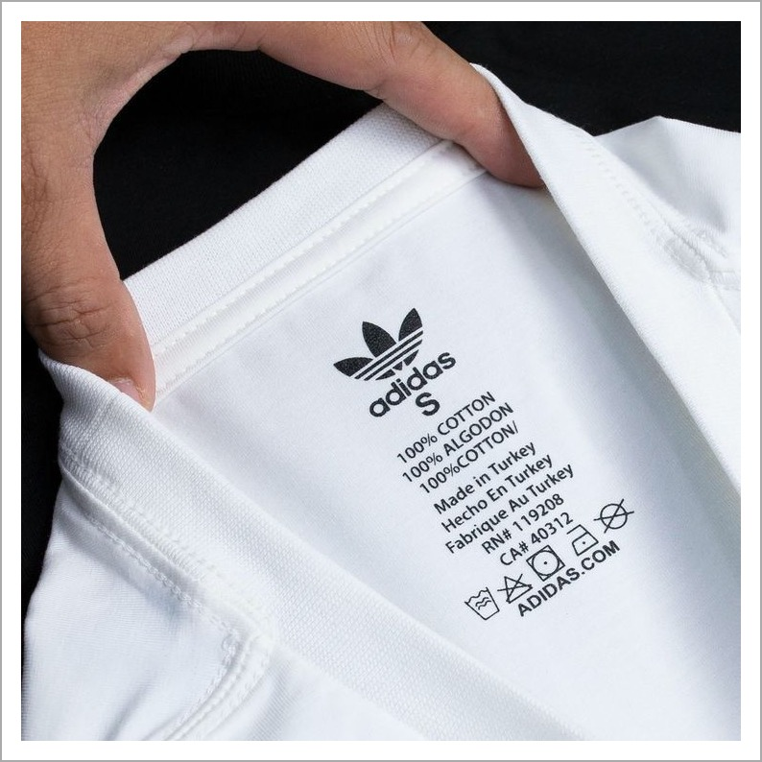  NECK / IDENTITY TAG | LOGO & BRANDING  ✓ Authentic: Wordmark touches the bottom of stripes; consistent kerning between letters; sharp, clean print  ✗ Fake: Stripes detached from wordmark; uneven letter spacing; blurred or smudged ink  PRODUCT CODE  ✓ Authentic: Unique 6-char code (e.g., DP2644) on care label; Googling it returns the exact product  ✗ Fake: Code missing, repeats across items, or returns wrong/no product on search  STITCHING & MATERIAL  ✓ Authentic: Even stitching ~8–10 per inch; premium fabric weight; clean interior seams  ✗ Fake: Loose threads; thin or stiff fabric; uneven or skipped stitches

💡 PRO TIP: Always Google the Adidas product code on the care label. If it returns no results or a different product, it's counterfeit — this is the single fastest check.

5.8 LACOSTE | COUNTERFEIT RISK: HIGH

MOST FAKED: L.12.12 polo shirts, fragrances, footwear
TOP 3 TELLS: Crocodile embroidered with ~1,400 stitches (dense, detailed) • Mother-of-pearl buttons — cool to the touch, never plastic • European numeric sizing (2–9) always present above the croc
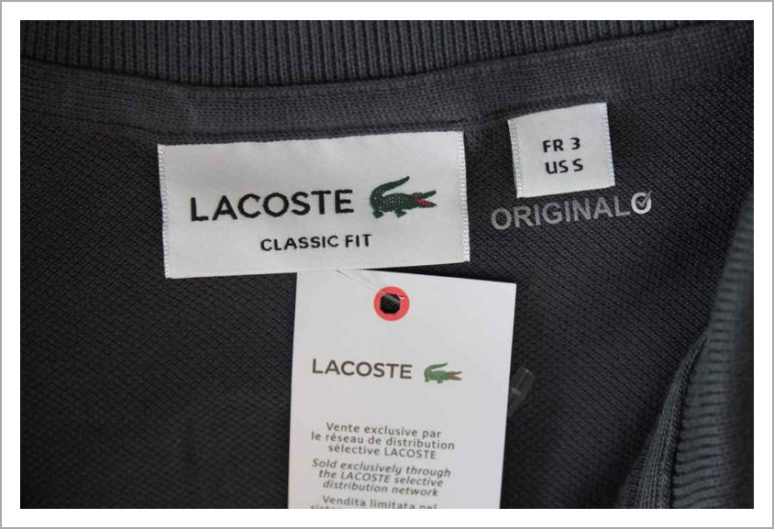  NECK / IDENTITY TAG | CROCODILE LOGO  ✓ Authentic: Faces RIGHT; visible open mouth with red interior; 4 legs with claws; dense embroidery  ✗ Fake: Faces left; missing eye or claws; flat or sparse stitching; wrong shade of green  SIZING & LABELS  ✓ Authentic: European numeric size (2–9) in red above crocodile; US RN# 115890 on care label  ✗ Fake: Letter sizing only (S/M/L); missing or wrong RN number; misspelled country of origin  BUTTONS & FABRIC  ✓ Authentic: Mother-of-pearl buttons (cool to touch, slight iridescence); soft petit piqué cotton  ✗ Fake: Plastic buttons that feel warm; stiff or glossy fabric; weak weave

💡 PRO TIP: Touch the buttons. Authentic Lacoste polos always use mother-of-pearl which feels cool and slightly weighted — plastic feels room-temperature and lightweight.

