5.7
Adidas

COUNTERFEIT RISK  HIGH | Most Faked  Yeezy, Ultraboost, Superstar, tracksuits  Top 3 Tells  • Product code search returns exact product  • Boost pellets are irregular (organic)  • Both shoes have different serials but same style code

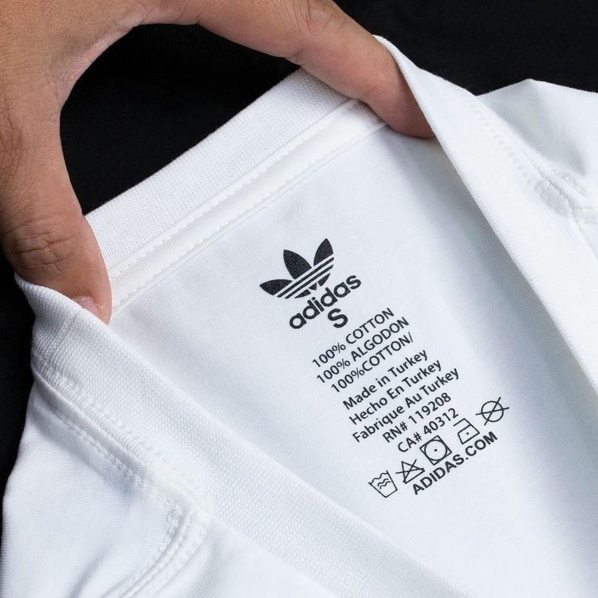  NECK / IDENTITY TAG | LOGO — THREE VARIANTS  • Performance (3 Stripes): Three parallel bars of equal width and spacing on shoes and sportswear.  • Originals (Trefoil): Three-leaf clover shape — leaves must be perfectly symmetric with uniform thickness.  • Badge of Sport (Mountain): Three ascending stripes — equal width and evenly spaced.  ✓ AUTHENTIC: Wordmark touches bottom of stripes; consistent kerning between letters  ✗ FAKE: Trailing stitches between letters; typeface too thin; stripes wonky

PRODUCT CODE VERIFICATION
Every authentic Adidas product has a unique product code (e.g., DP2644) on the care label. Search this code online — genuine codes return matching product images from retailers.
• Code Format: Typically 6 characters (letters + numbers) on apparel. On footwear, the style code is on the tongue label AND the box — they must match.

BOOST TECHNOLOGY (FOOTWEAR)  ✓ AUTHENTIC: Boost pellets are irregularly shaped (organic, varied sizes) — feels soft and bouncy  ✗ FAKE: Pellets are uniform/machined-looking — feels stiff, not responsive | SERIAL NUMBERS  • Interior tongue label has a unique serial number. No two pairs should share the same serial.  • Both shoes in a pair should have DIFFERENT serial numbers but the SAME style code.

PRO TIP
Always Google the Adidas product code. If it returns no results or results for a different product, it's likely counterfeit. This is the single fastest check for Adidas.

5.8
Lacoste

COUNTERFEIT RISK  HIGH | Most Faked  L.12.12 polo shirts, fragrances  Top 3 Tells  • Crocodile has ~1,400 stitches  • Mother of pearl buttons (cool to touch)  • European numeric sizing (2–9) always present

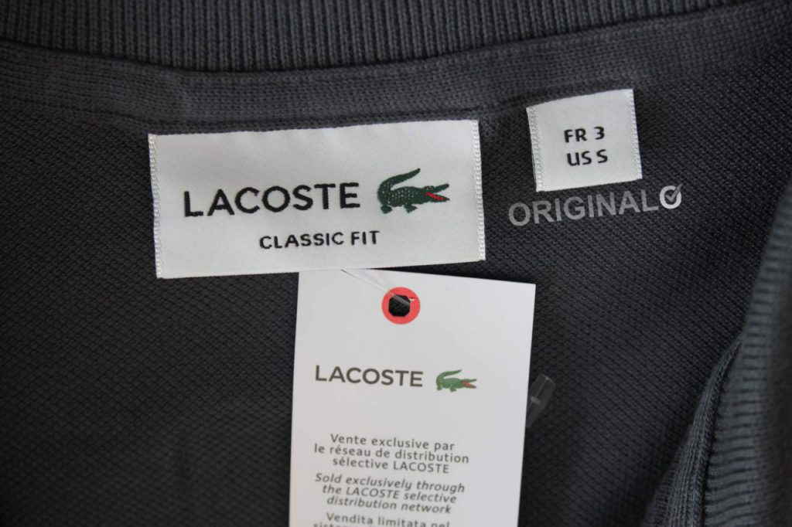  NECK / IDENTITY TAG | THE CROCODILE LOGO — DETAILED INSPECTION  • Authentic crocodile has approximately 1,400 stitches — dense and detailed under magnification.  • Must have: visible open mouth with red interior, distinct eye, 4 legs with claws, textured tail curving upward.  • The crocodile faces RIGHT on all products. If it faces left, it's a counterfeit (exception: some vintage 1930s–40s pieces).  ✓ AUTHENTIC: Dense, detailed embroidery with 1,400+ stitches; vivid green body, red mouth  ✗ FAKE: Sparse stitching (under 800 stitches); dull colors; missing mouth detail

SIZING  ✓ AUTHENTIC: Numerical European sizing (2–9) with red number above croc logo  ✗ FAKE: Only S/M/L sizing with no European number  Modern Lacoste may include US sizes alongside European, but European numbers are always present. | BUTTONS  • Material: Mother of pearl (not plastic) — feels cool to touch initially, then warms from body heat.  • Threading: Two holes with thread passing vertically (up-down, NOT side-to-side).  • Placement: On L.12.12 polos, exactly 2 buttons — never 3.

INTERIOR TAG  • Bottom inside of shirt; reads '100% cotton' in seven languages.  • Reverse side shows washing instructions. Older products reference 'Devanlay' (former distributor).  • RN Number: US-sold Lacoste carries RN# 115890. Missing or wrong RN = suspicious. | KNOWN PRODUCTION COUNTRIES  France, Peru, Morocco, Vietnam, Tunisia, Turkey, Italy, El Salvador, Thailand, Romania.  🚩 RED FLAG: 'Made in China' on a standard polo is very likely counterfeit.

