**Q)** **List all unique cities where customers are located.**

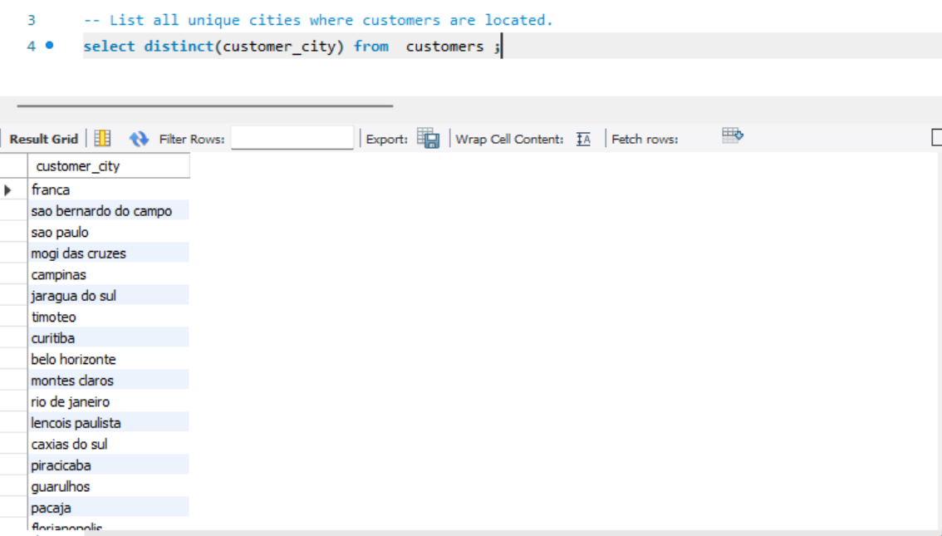

**Q)** **Count the number of orders placed in 2017.**

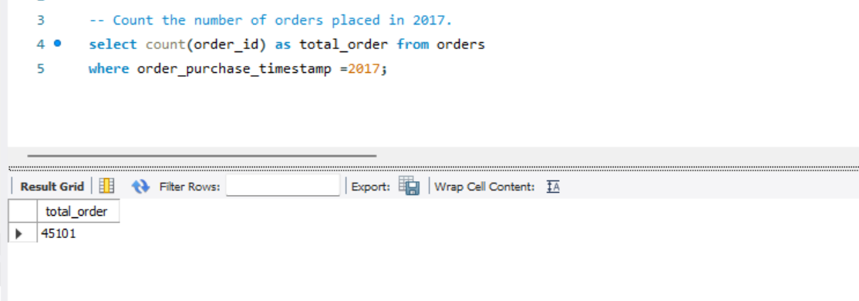

**Q)** **Find the total sales per category.**

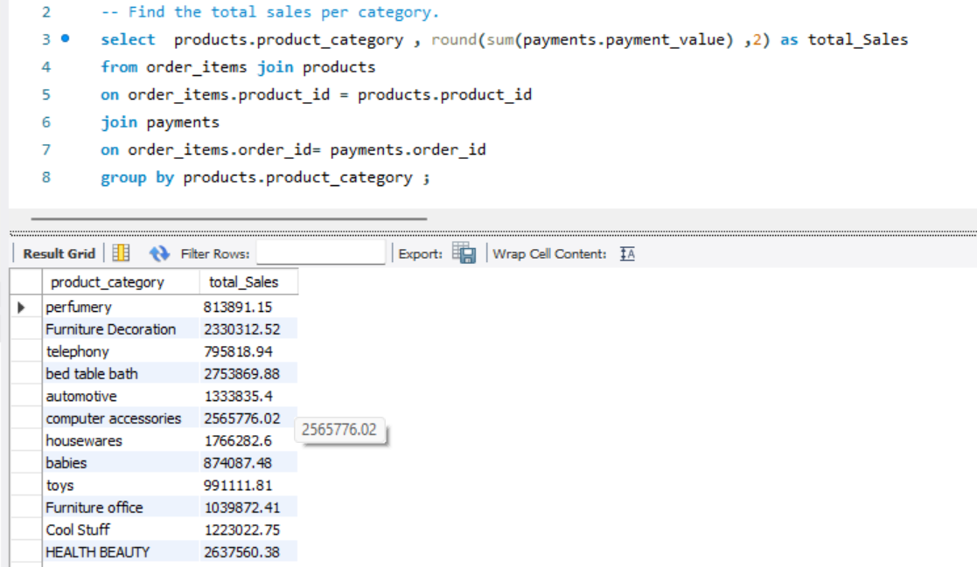

**Q)** **Calculate the percentage of orders that were paid in installments.**

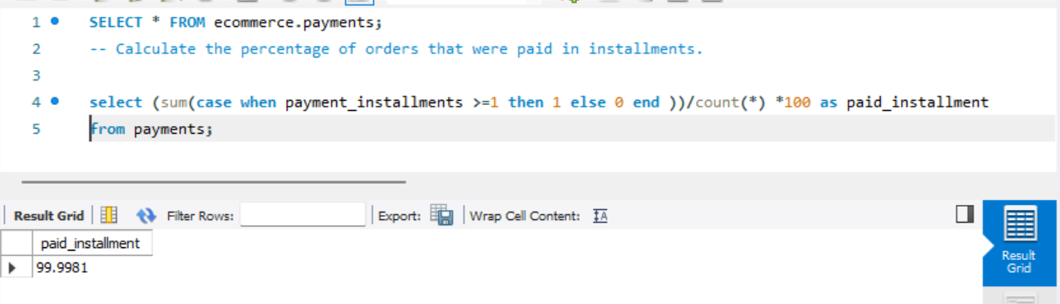

**Q)** **Count the number of customers from each state.**

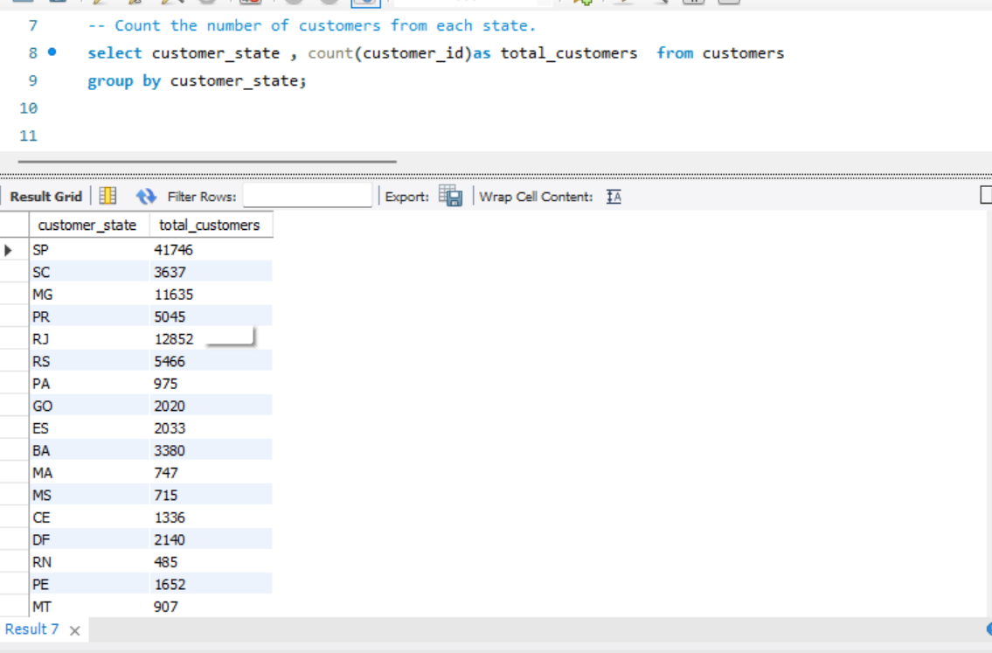

**Q)** **Calculate the number of orders per month in 2018.**

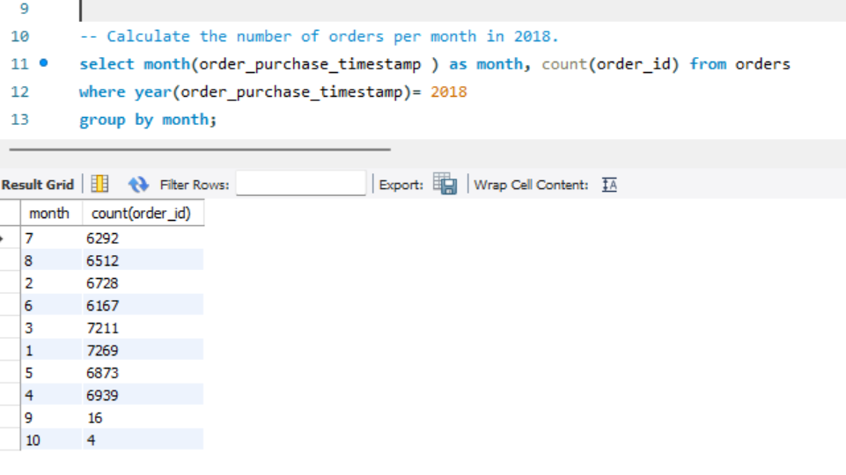

**Q)** **Find the average number of products per order, grouped by customer city.**

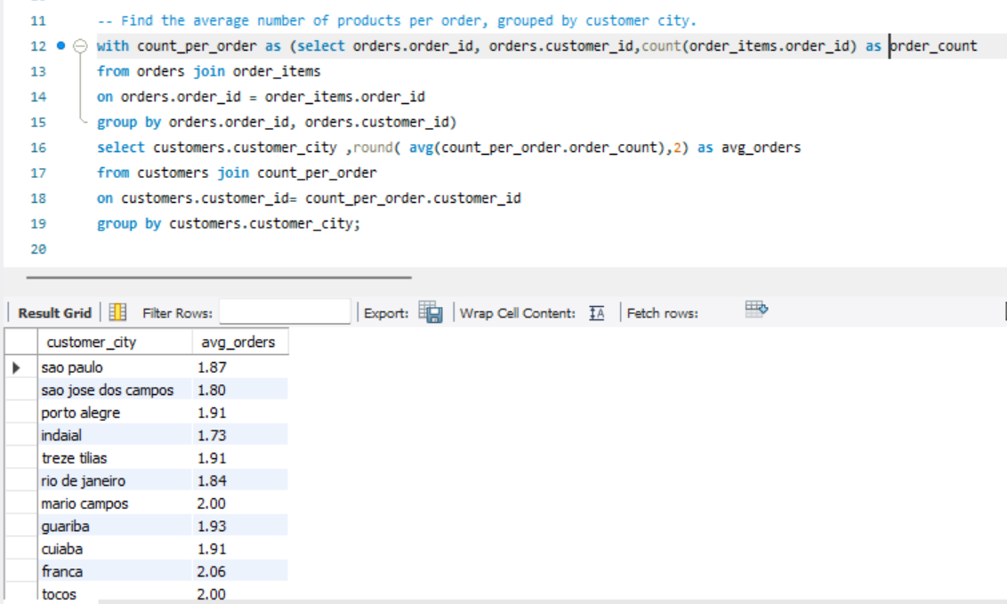

**Q)** **Calculate the percentage of total revenue contributed by each product category.**

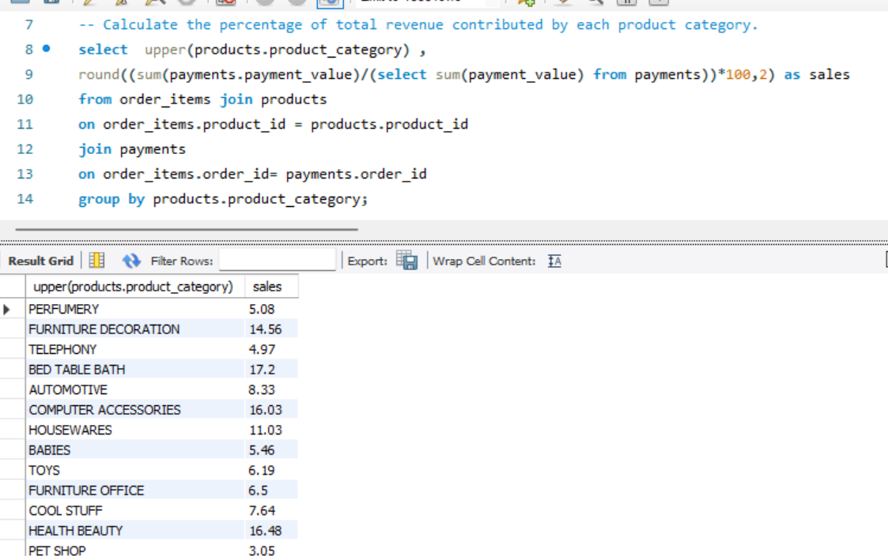

**Q)** **Identify the correlation between product price and the number of times a product has been purchased.**

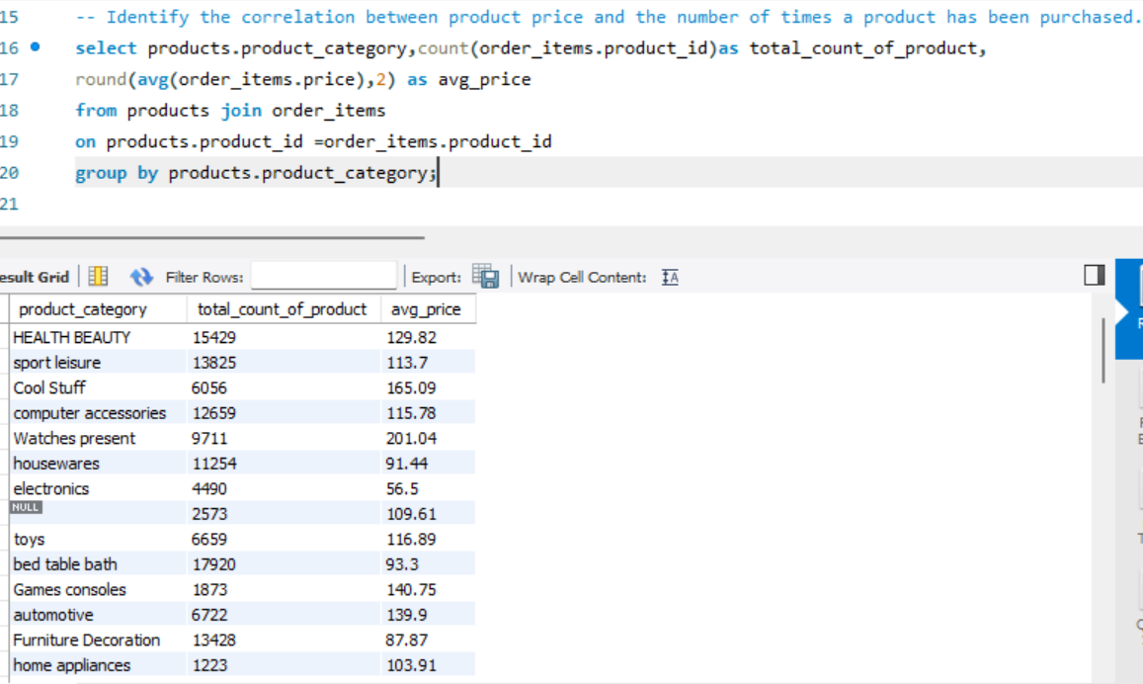

**Q)** **Calculate the total revenue generated by each seller, and rank them by revenue.**

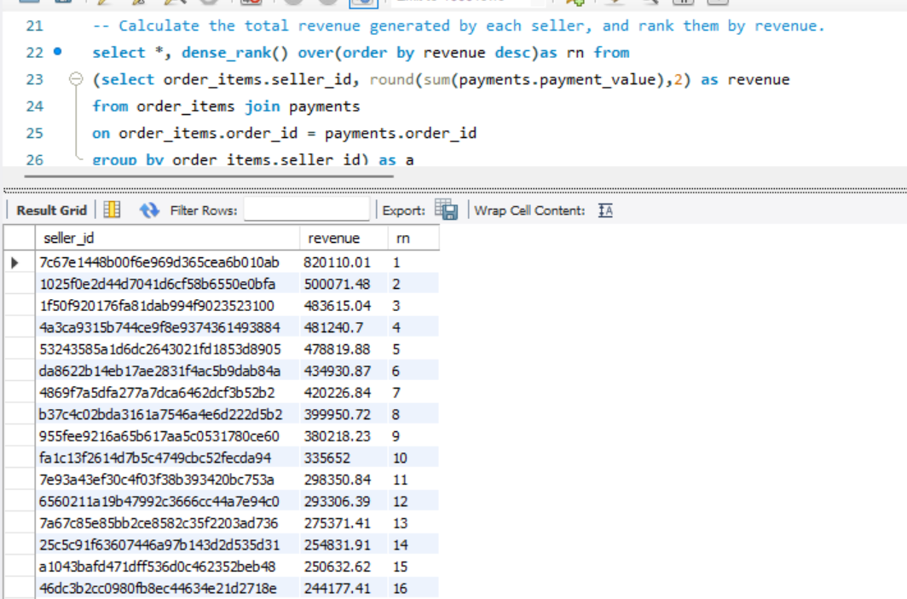

**Q)** **Calculate the moving average of order values for each customer over their order history.**

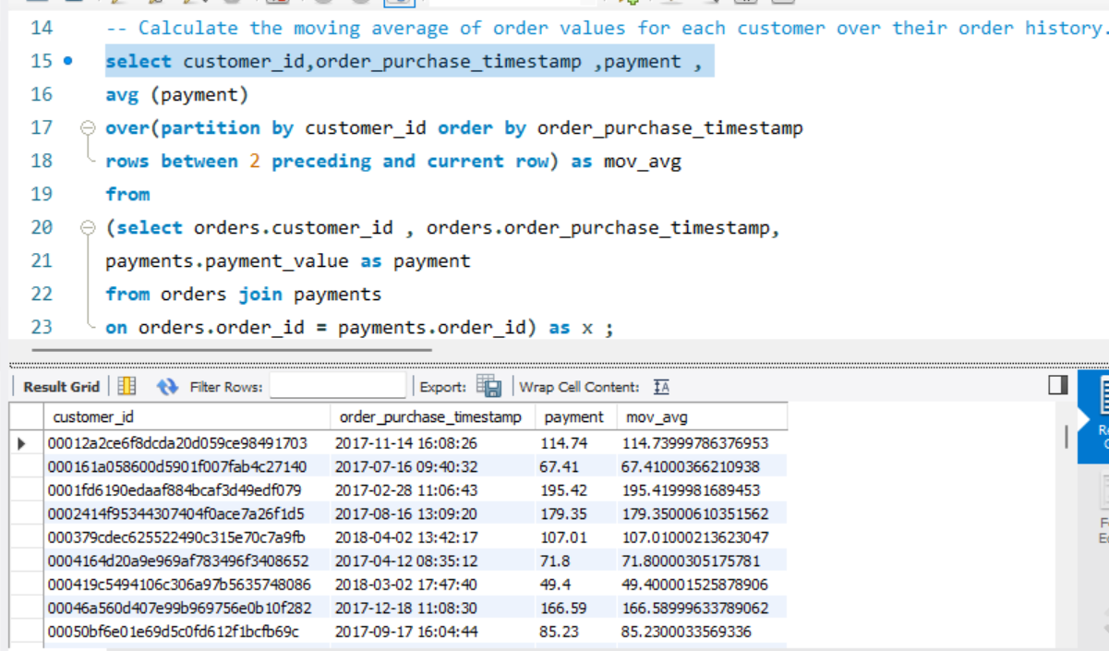

**Q)** **Calculate the cumulative sales per month for each year.**

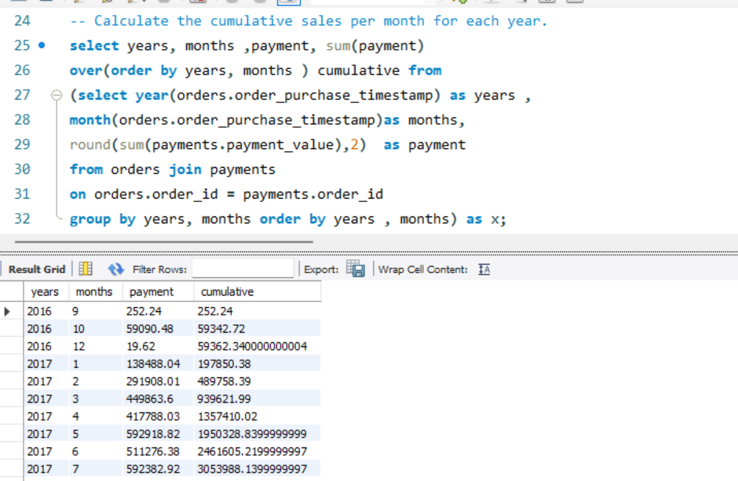

**Q)** **Calculate the year-over-year growth rate of total sales.**

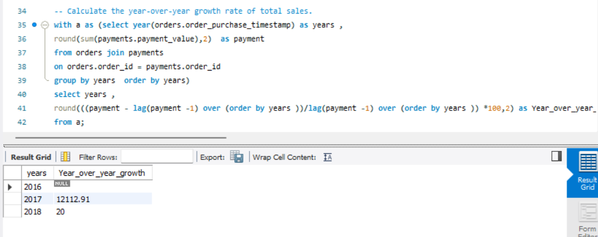

**Q)** **Identify the top 3 customers who spent the most money in each year.**

