**Q) Retrieve the total number of orders placed.**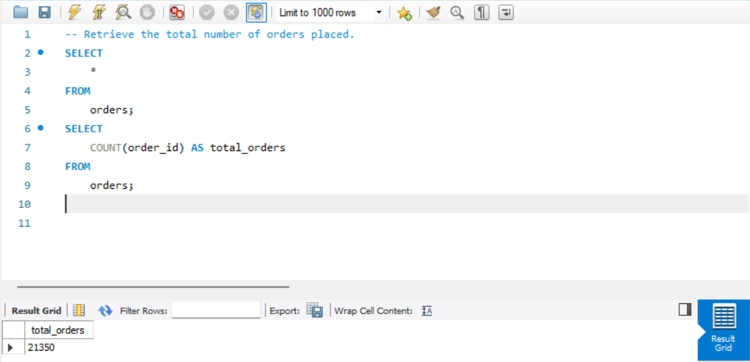

**Q) Calculate the total revenue generated from pizza sales.**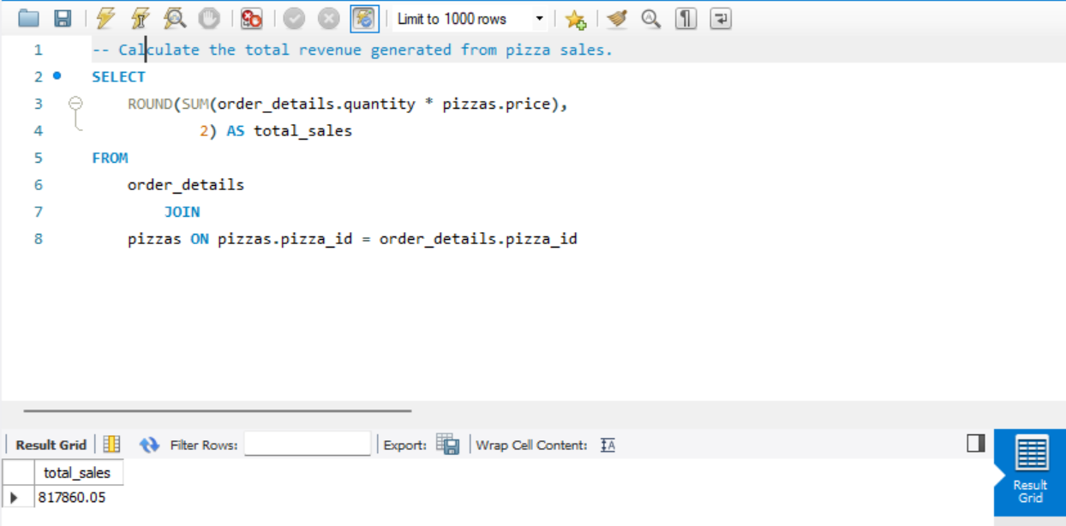

**Q)** **Identify the highest-priced pizza.**

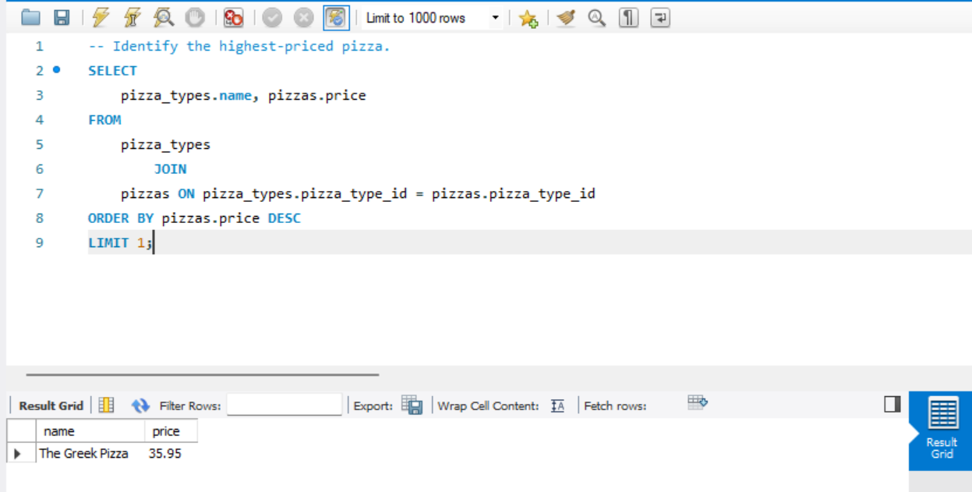

**Q)** **Identify the most common pizza size ordered.**

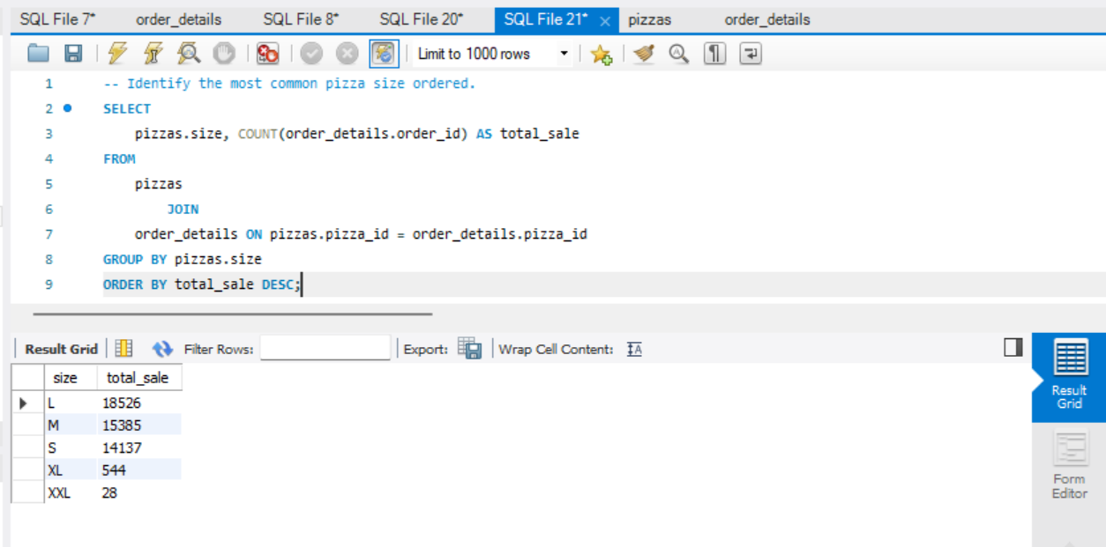

**Q)** **List the top 5 most ordered pizza types along with their quantities.**

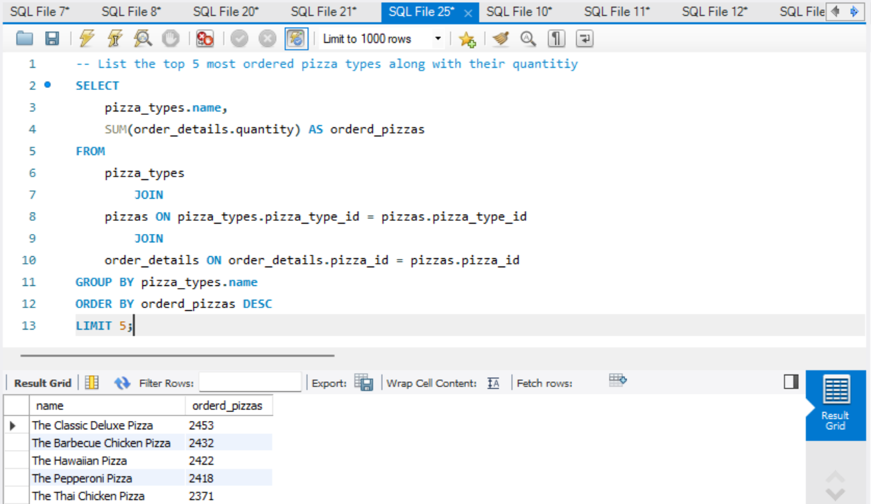

**Q) Join relevant tables to find the category-wise distribution of pizzas.**

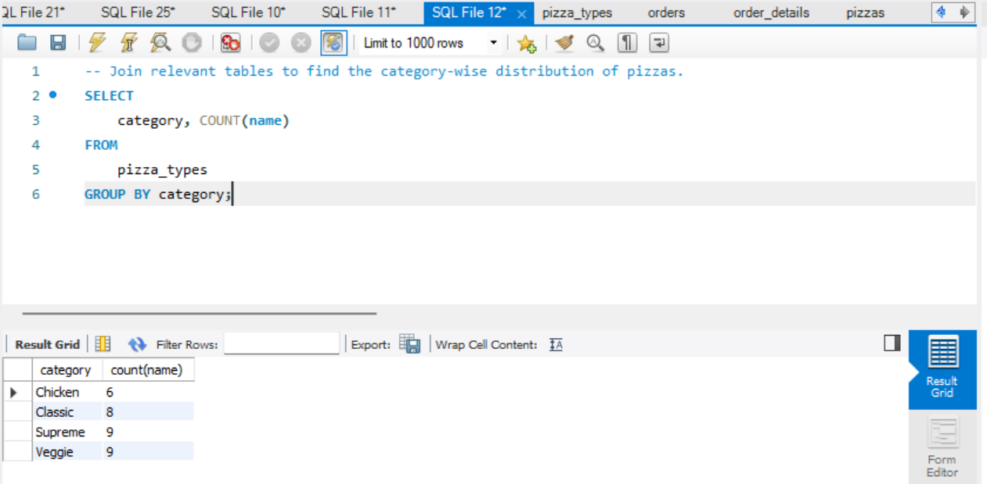

**Q)** **Determine the distribution of orders by hour of the day.**

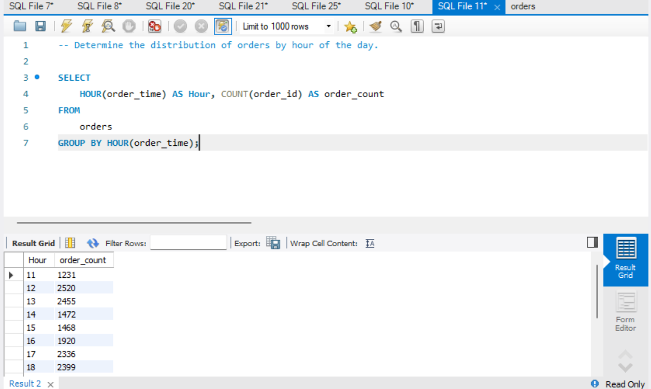

**Q)** **Determine the top 3 most ordered pizza types based on revenue.**

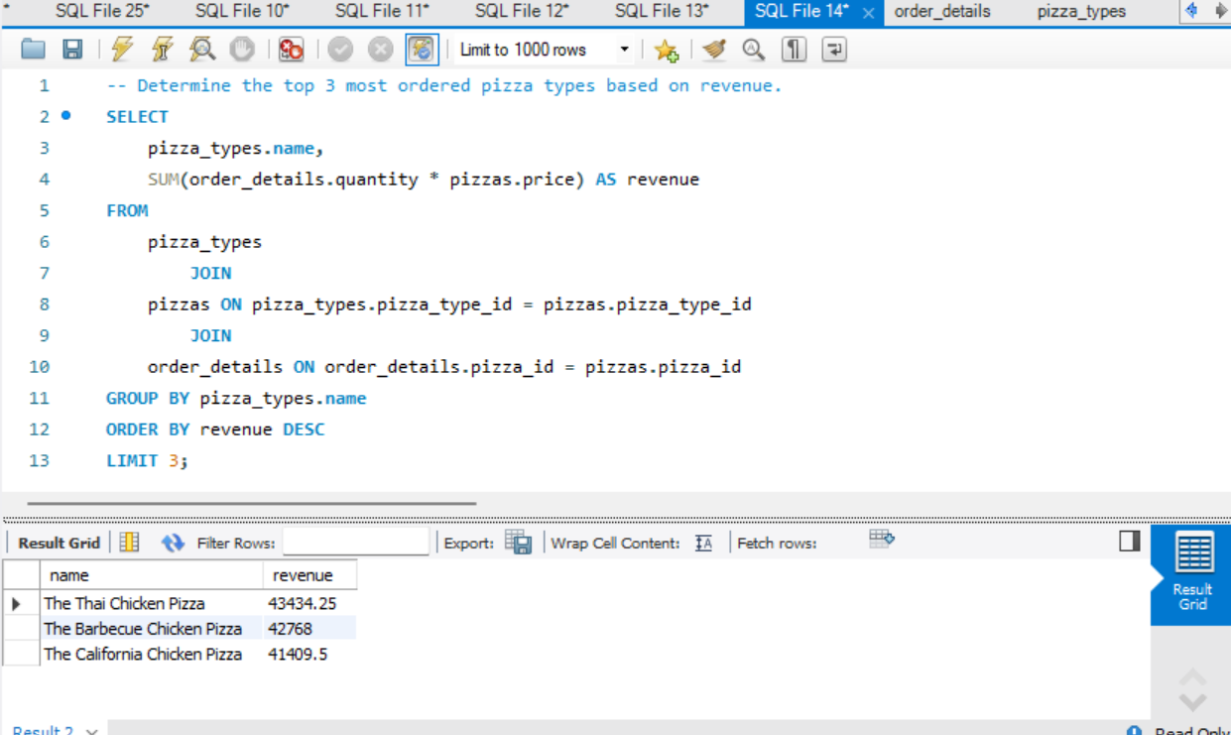

**Q) Calculate the percentage contribution of each pizza type to total revenue.**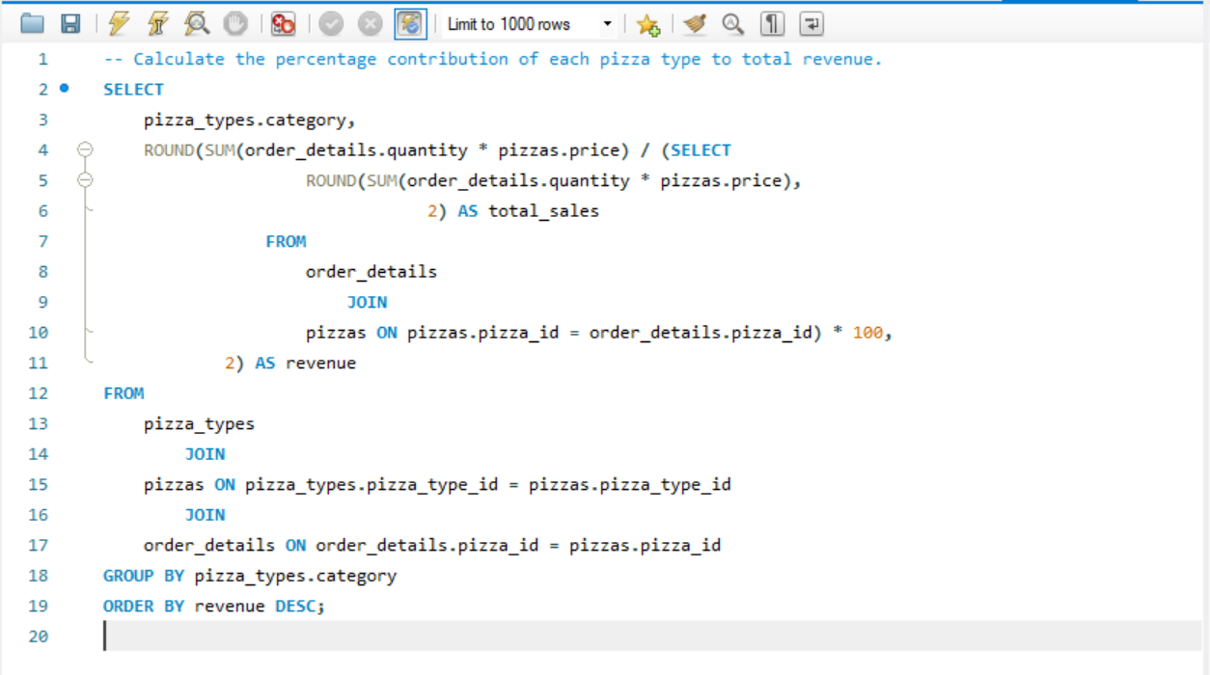

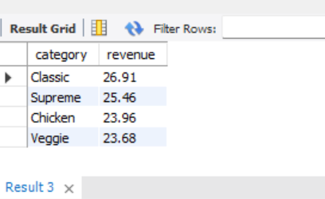

**Q)** **Group the orders by date and calculate the average number of pizzas ordered per day.**

