Software Project Management-3
Midterm Technical Report
Bull's Eye
Automated Archery Scoring System

Submitted By

Md. Shaikhul Islam
Roll: BSSE-1438
BSSE Session: 2021-2022

Supervised By

Toukir Ahammed
Lecturer
Institute of Information Technology
University of Dhaka

Submission Date: 02 August 2026

Table of Contents
1. Introduction 1
1.1 Purpose 1
1.2 Problem Statement 1
1.3 Objectives 1
1.4 Scope 1
1.5 Definitions, Acronyms, Abbreviations 2
1.6 Document Overview 2
2. Overall Description 3
2.1 Product Perspective 3
2.2 Product Functions (Summary) 4
2.3 User Classes and Characteristics 4
2.4 System Stakeholders 5
2.5 Operating Environment 5
2.6 Design and Implementation Constraints 5
2.7 Assumptions and Dependencies 5
3. System Features (Functional Requirements) 6
4. External Interface Requirements 9
4.1 User Interfaces 9
4.2 Hardware Interfaces 10
4.3 Software Interfaces 10
4.4 Communication Interfaces 10
5. Non-Functional Requirements 10
6. AI Engineering Design 12
6.1 Multi-Stage Computer Vision & AI Pipeline 12
6.2 Heuristic Rules Engine & Mathematical Scoring Formulations 12
7. System Models: 13
7.1 Use Case Diagram 14
7.1.2 Use Case Descriptions 15
UC-01: Manage Users 15
UC-02: Manage Tournaments 15
UC-03: Manage Sessions 15
UC-04: Register Archers 15
UC-05: Configure Cameras 15
UC-06: View Live Camera Preview 16
UC-07: Trigger AI Scoring 16
UC-08: View Override History 16
UC-09: View Real-Time Leaderboard 16
UC-10: View Own Scores & Report 16
UC-11: Receive Real-Time Notifications 17
UC-12: Monitor System Health 17
UC-13: Generate/Export Report 17
7.2 Data Flow Diagrams 18
7.2.1 Context Diagram 18
7.2.2 Activity Diagrams 19
7.2.3 Process Decomposition 20
7.3 Entity-Relationship Diagram 21
7.4 Sequence Diagrams 22
7.4.1 User Login 22
7.4.2 Live AI-Assisted Scoring (Core Flow) 23
7.4.3 Score Override (Low Confidence) 24
7.4.4 Camera Connect & Auto-Reconnect 25
7.4.5 Report Generation & Export 26
7.5 State Diagrams 27
7.5.1 Session Lifecycle 27
7.5.2 Camera Connection Lifecycle 28
7.5.3 Score Validation Lifecycle 29
8. Preliminary Test Plan 30
8.1 Testing Objectives 30
8.2 Features to be Tested 30
8.3 Automated Verification Suite 30
9. Endpoints 31
REST API Endpoint Summary 31
10. Project Timeline 33
10.1 Project Work Breakdown 33
11. Conclusion 34
12. References 34

List of Figures
Figure Title | Section/Reference | Page Number
Figure 1: System Tiers and Runtime Architecture | 2.1 | 7
Figure 2: Use Case Diagram | 7.1 | 22
Figure 3: Data Flow Diagram Level 0 (Context) | 7.2.1 | 26
Figure 4: Data Flow Diagram Level 1 (Major Processes) | 7.2.2 | 28
Figure 5: Entity-Relationship Diagram | 7.3 | 21
Figure 6: Sequence Diagram - User Login | 7.4.1 | 22
Figure 7: Sequence Diagram - AI Scoring Flow | 7.4.2 | 23
Figure 8: Sequence Diagram - Score Override | 7.4.3 | 24
Figure 9: Sequence Diagram - Camera Management | 7.4.4 | 25
Figure 10: Sequence Diagram - Reporting | 7.4.5 | 26
Figure 11: State Diagram - Session Lifecycle | 7.5.1 | 27
Figure 12: State Diagram - Camera Connection | 7.5.2 | 28
Figure 13: State Diagram - Score Validation | 7.5.3 | 29
Figure 14: Project Gantt Chart | 10.1 | 37

1. Introduction

1.1 Purpose
This document specifies the software requirements for the Automated Archery Scoring System — a full-stack application that combines a computer-vision based arrow-detection pipeline with a tournament-management web platform. It is intended for developers, testers, tournament organizers, and reviewers who need a single authoritative reference for what the system does, independent of how it is implemented.

1.2 Problem Statement
Traditional archery competition management relies heavily on manual observation, presenting critical issues:
- Human Error & Dispute Delays: Disagreements over "line cutters" frequently halt competitions for manual inspection.
- High Latency: Significant delays occur before scores are tallied and shared with spectators and coaches.
- High Hardware Cost: Existing electronic systems require specialized hardware costing thousands of dollars per lane.
- Environmental Degradation: Standard sensors fail under varying outdoor sunlight, camera angles, or worn target faces.

1.3 Objectives
The system aims to achieve the following technical objectives:
- Sub-2-Second Detection Latency: Detect target boundaries and identify arrow tips in under 2.0 seconds.
- World Archery (WA) Compliance: Implement precise mathematical scoring for Zones 1 to 10 and the X-ring.
- Multi-Method AI Engine: Maintain >95% accuracy using YOLOv8 fused with multi-spectral CV fallbacks.

1.4 Scope
- Tournament, session (round), and archer/lane registration management.
- Connecting physical cameras (USB / RTSP / HTTP) to lanes and streaming live previews.
- An AI/computer-vision pipeline that detects arrow impact points on a World Archery (WA) standard target face and computes a score (zone 0–10) with a confidence value.
- Manual validation/override of AI-detected scores with a full audit trail.
- Real-time leaderboard computation (Redis-cached) and broadcast to all connected clients over WebSocket.
- Report generation (PDF / CSV / JSON) for sessions and tournaments.
- Role-based access control (admin, scorer, spectator, archer).
- System health monitoring (database, cache, storage, thread pool) and audit logging.
- Out of scope: payment/billing, hardware driver development, mobile native apps (the web frontend is responsive but not a native app), and multi-tenant SaaS isolation (single deployment per venue/tournament is assumed).

1.5 Definitions, Acronyms, Abbreviations
Term | Meaning
SRS | Software Requirements Specification
WA | World Archery — governing body whose 10-ring target proportions are used for zone calculation
Session | A scoring round within a tournament (e.g., “Round 1 – Morning”)
Lane | A physical shooting position, associated with one camera and one archer per session
Zone | The scored ring on the target face, 0 (miss) to 10 (X-ring)
End | A set of arrows shot before scores are recorded/retrieved (terminology used in archery; mapped to round_number + arrow_number in the data model)
RBAC | Role-Based Access Control
JWT | JSON Web Token
DFD | Data Flow Diagram
ERD | Entity Relationship Diagram
TTL | Time To Live (cache expiry)
FR | Functional Requirement
NFR | Non-Functional Requirement

1.6 Document Overview
Section 2 provides a high-level description of the product, including perspective, functions, user classes, stakeholders, operating environment, and constraints. Section 3 details the functional requirements grouped by module. Section 4 describes external interface requirements (user, hardware, software, and communication). Section 5 covers non-functional requirements such as performance and security. Section 6 describes the AI engineering design, covering the multi-stage pipeline and mathematical scoring formulations. Section 7 presents the comprehensive system models, including Use Case, Data Flow, Entity-Relationship, Sequence, and State Diagrams. Section 8 provides the preliminary test plan. Section 9 lists the REST API endpoint summary, and Section 10 outlines the project work breakdown and timeline.

2. Overall Description

2.1 Product Perspective
The system is a self-contained client-server application with three runtime tiers:
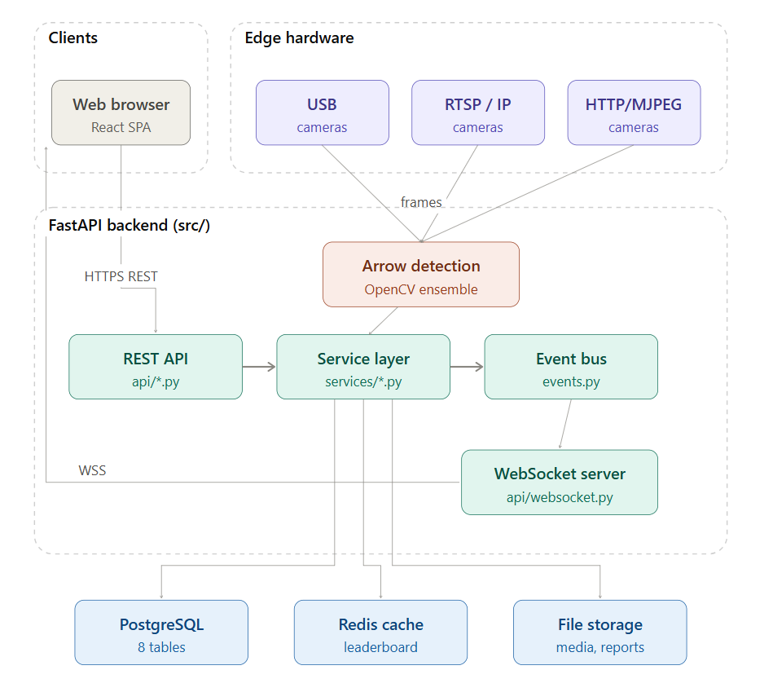
Figure 1: System Tiers and Runtime Architecture

The backend is the system of record; the frontend is a thin presentation layer with no independent business logic. Cameras are the only external hardware dependency.

2.2 Product Functions (Summary)
- User registration, authentication (JWT) and role-based authorization.
- Tournament creation and lifecycle management.
- Session (round) creation, lane configuration, and status transitions (active / paused / completed).
- Archer registration and lane assignment per session.
- Camera registration, connection/disconnection, lane assignment, and automatic reconnection.
- Live camera preview streaming to the frontend.
- AI-assisted arrow detection and zone/score computation from captured frames.
- Manual validation or override of AI-computed scores with audit trail.
- Real-time, cached leaderboard computation and ranking.
- Real-time event broadcast (score recorded, leaderboard updated, camera/session state changes) via WebSocket.
- Report generation and export (PDF, CSV, JSON) at session level.
- System health monitoring (DB, cache, storage, thread pool).
- Audit logging of significant state-changing actions.
- Storage quota monitoring and (planned) data retention/archival.

2.3 User Classes and Characteristics
The system implements four roles at the API/authorization layer (src/dependencies.py, require_role()), with admin implicitly satisfying any role check:
Role (implemented) | Conceptual Persona(s) | Description | Typical Access
admin | System Administrator + Tournament Administrator | Full system access: user management, tournament/session CRUD, camera configuration, all reports, system health | Everything
scorer | Scorer / Range Operator | Operates cameras during an active session, triggers AI scoring, confirms/overrides scores | Scoring endpoints, assigned cameras, session data
archer | Archer / Competitor | Views own scores, own annotated images, own leaderboard position and personal report | Read-only, scoped to own data
spectator | Public viewer | Read-only access to public leaderboard/session info | Read-only, public data

2.4 System Stakeholders
The following stakeholders are involved in the system:
- Archery Athletes / Competitors: Primary subjects who shoot arrows and rely on instant, fair scoring and immediate feedback.
- Event Scorers & Umpires: Field officials responsible for supervising sessions, reviewing low-confidence AI detections, and resolving disputes.
- Tournament Administrators: Event hosts who configure tournaments, setup sessions, assign lanes/cameras, and manage permissions.
- Spectators & Audience: Remote and stadium fans who view real-time leaderboards and shot placements.
- Software & AI Engineers: Maintainers responsible for model training, pipeline optimization, and system uptime.

2.5 Operating Environment
- Backend: Python 3.11+, FastAPI, runs behind Uvicorn; PostgreSQL 15+ for persistence; Redis for caching/pub-sub support; optional OpenCV (cv2) for computer vision the arrow-detection service degrades gracefully if OpenCV is not installed.
- Frontend: React 18 + TypeScript SPA built with Vite, served as static assets; targets modern desktop and tablet browsers (Chromium/Firefox/Safari).
- Deployment: Docker Compose (db, cache, api services) for local/venue deployment; Alembic manages schema migrations.
- Hardware: USB UVC cameras, RTSP IP cameras, or HTTP/MJPEG cameras, one per shooting lane.

2.6 Design and Implementation Constraints
- All business logic must live in the service layer; API routers must not access the ORM directly (layering constraint already enforced in the codebase).
- All configurable values (pool sizes, JWT TTL, rate limits, image processing parameters, WebSocket batching) must be sourced from Settings (src/config.py), not hard-coded.
- Score and audit records are immutable once written — corrections are recorded as overrides, not as deletions/updates of history.
- The event bus (src/events.py) is in-process, fire-and-forget; it is not a durable message queue. Consumers (leaderboard cache invalidation, WebSocket broadcast, audit log) must tolerate at-most-once delivery.

2.7 Assumptions and Dependencies
- A reasonably well-lit, stationary target face is assumed for the CV pipeline to achieve target confidence levels.
- Network connectivity between cameras and backend is assumed to be local (LAN), not over the public internet, to meet the <1s scoring latency target.
- Exactly one archer and one camera are bound to a lane within a given session at a time.

3. System Features (Functional Requirements)

Requirement ID | Module | Detailed Functional Requirement | Priority
FR-01 | User Management | The system shall provide secure user registration, login, logout, JWT-based authentication, refresh token management, decrypt password hashing, password reset functionality, email verification (optional), and Role-Based Access Control (RBAC). Supported roles shall include Admin, Scorer, Spectator, and Archer, with permissions enforced for every protected API and frontend route. | High
FR-02 | Tournament Management | The system shall allow authorized users (Admin and Scorer) to create, update, archive, restore, and delete tournament events. Each tournament shall include attributes such as tournament name, description, venue, organizer, start date, end date, competition category, status (Upcoming, Ongoing, Completed, Archived), and additional configuration settings. Tournament information shall be searchable and filterable. | High
FR-03 | Session & Round Management | The system shall allow administrators to create multiple shooting sessions and rounds within a tournament. Each session shall support configurable parameters including session name, shooting distance, target type, number of shooting lanes (default 6), arrows per end (default 6), number of ends, shooting order, scheduled start/end times, and session status. | High
FR-04 | Archer Registration & Lane Assignment | The system shall register archers into tournament sessions, assign each archer to a unique shooting lane, prevent duplicate lane assignments within the same session, support reassignment before competition begins, and maintain historical lane allocation records. Archer profiles shall include identification details, club/team affiliation, and competition category. | High
FR-05 | Camera Management & Stream Integration | The system shall support multiple camera sources including USB cameras, RTSP streams, IP cameras, and HTTP image feeds. Each camera shall be configurable with resolution, FPS, calibration parameters, lane association, and connection settings. The system shall continuously monitor camera health using heartbeat mechanisms and automatically reconnect when connection failures occur. | High
FR-06 | Image Acquisition | The system shall capture target images either manually, periodically, or automatically based on configurable triggers. Captured images shall be associated with the corresponding tournament, session, lane, archer, end, and arrow sequence. Images shall be timestamped, stored securely, and transmitted to the AI scoring engine with minimal latency. | High
FR-07 | AI Target & Arrow Detection | The system shall process captured images using a multi-stage computer vision pipeline to detect the target face, locate scoring rings, identify arrow shafts and arrow tips, determine arrow impact coordinates, and calculate confidence scores. The detection pipeline shall support rotated, partially occluded, and perspective-distorted target images while maintaining high detection accuracy. | High
FR-08 | World Archery (WA) Score Calculation | The system shall calculate arrow scores according to World Archery regulations by determining the radial distance of each detected arrow impact from the target center using normalized elliptical geometry. The scoring engine shall assign values from 0 to 10, detect X-ring hits, support configurable target dimensions, and calculate cumulative scores for ends, sets, sessions, and tournaments. | High
FR-09 | Manual Score Validation & Override | Authorized users (Admin and Scorer) shall be able to review AI-generated scores using annotated target images displaying detected arrows, scoring rings, impact coordinates, and confidence values. Users may approve, reject, or manually modify scores. Every manual adjustment shall require confirmation and be recorded with user identity, timestamp, previous value, updated value, and reason for modification. | High
FR-10 | Real-Time Score Broadcasting | The system shall publish score updates instantly through WebSocket connections whenever a score is generated or modified. Connected frontend clients shall automatically receive updates without page refresh. Real-time events shall include arrow scores, end completion, leaderboard updates, session status, and scoring notifications while ensuring low-latency synchronization across multiple clients. | High
FR-11 | Leaderboard & Ranking | The system shall continuously compute live rankings based on cumulative scores, X-counts, tie-breaking rules, and tournament-specific ranking policies. Frequently accessed leaderboard data shall be cached using Redis to reduce database load. Cache entries shall be automatically invalidated and regenerated whenever scores are added, updated, or removed. | Medium
FR-12 | Reporting & Analytics | The system shall generate official tournament reports including scorecards, leaderboard summaries, archer performance statistics, session results, scoring accuracy reports, and historical comparisons. Reports shall be exportable in PDF, CSV, and JSON formats. Statistical metrics shall include averages, highest score, X-count, hit distribution, and scoring trends. | Medium
FR-13 | Audit Logging & System Monitoring | The system shall record all critical administrative operations including user authentication, tournament modifications, score overrides, camera configuration changes, AI processing events, and system configuration updates in an immutable audit log. Each audit record shall include timestamp, user ID, action type, affected resource, previous value, updated value, IP address (if available), and operation status to support traceability and compliance. | Medium
FR-14 | Image Storage | The system shall securely store original captured images, processed images, and annotated images while maintaining references to tournament, session, lane, and archer information. | Medium
FR-15 | AI Processing Queue | The system shall process image scoring requests asynchronously using a task queue to support concurrent scoring from multiple shooting lanes. | Medium
FR-16 | Notifications | The system shall notify scorers when image processing fails, cameras disconnect, or manual validation is required. | Medium
FR-17 | System Configuration | Administrators shall configure scoring parameters, camera settings, target templates, WebSocket settings, AI thresholds, and tournament defaults through an administrative interface. | Medium

4. External Interface Requirements

4.1 User Interfaces
The frontend SPA (frontend/src/pages/) exposes the following primary screens:
Page | Purpose | Primary Roles
Login / Register | Authentication | All
Dashboard | System/tournament overview, health widgets | admin, scorer
Tournaments | Tournament CRUD, search/sort | admin
Sessions (within Tournament) | Session CRUD, status control, archer/lane setup | admin
Scoring | Live camera previews, [Calculate] trigger, score review/override | scorer
Cameras | Camera registration, connection status, lane assignment | admin
Reports | Score tables, charts, PDF/CSV/JSON export | admin, archer (own data)
Users | User account management | admin
Settings | System configuration views | admin
BatchTesting | CV pipeline test harness | admin/dev

4.2 Hardware Interfaces
- USB cameras: enumerated via OpenCV VideoCapture indices.
- RTSP cameras: connected via stream URL (rtsp://...).
- HTTP/MJPEG cameras: connected via stream URL (http://.../video).
All camera types present a uniform frame-capture interface to the arrow-detection service regardless of transport.

4.3 Software Interfaces
- REST API: 25+ JSON endpoints under /api
- WebSocket API: /api/ws/{session_id}, JSON event envelopes (event_type, timestamp, data).
- Database: PostgreSQL 15+ via SQLAlchemy ORM, schema-versioned with Alembic.
- Cache: Redis, used for leaderboard caching and pub/sub-style invalidation triggers.

4.4 Communication Interfaces
- HTTPS for all REST traffic in production; WSS for WebSocket in production.
- JWT Bearer token in Authorization header for both REST and WebSocket authentication.
- CORS restricted to configured origins (cors_origins setting).

5. Non-Functional Requirements

Requirement ID | Category | Requirement | Priority
NFR-01 | Performance | The system shall complete end-to-end scoring (image capture, AI detection, score calculation, and result display) within 1 second under normal operating conditions. | High
NFR-02 | Performance | The system shall support multiple concurrent camera streams (minimum 3) and provide real-time score updates through WebSockets without significant performance degradation. | High
NFR-03 | Performance | Leaderboard data shall be cached using Redis to improve response time and reduce unnecessary database queries. | Medium
NFR-04 | Security | The system shall provide secure authentication using JWT, store passwords using bcrypt hashing, and enforce Role-Based Access Control (RBAC) for all protected resources. | High
NFR-05 | Security | All client-server communication shall use secure protocols (HTTPS/WSS), apply CORS restrictions, and implement request rate limiting to prevent unauthorized access and abuse. | High
NFR-06 | Reliability | The system shall automatically recover from temporary failures by retrying database operations, reconnecting disconnected cameras, and maintaining WebSocket sessions during brief network interruptions. | High
NFR-07 | Availability | The application shall continue operating even if non-critical services (e.g., event handlers or optional AI modules) fail, while logging all errors for diagnosis. | Medium
NFR-08 | Scalability | The system shall efficiently support increasing numbers of cameras, users, and scoring requests using connection pooling, worker threads, and optimized event processing. | Medium
NFR-09 | Maintainabi-  lity | The backend shall follow a modular layered architecture, centralize configuration through environment variables, and manage database schema changes using version-controlled migrations. | High
NFR-10 | Usability | The user interface shall provide intuitive navigation, role-specific functionality, confidence-based score visualization, and confirmation prompts before destructive actions. | Medium
NFR-11 | Auditability | All administrative actions, authentication failures, and manual score overrides shall be recorded in immutable audit logs containing the user, timestamp, action, and reason for traceability. | High
NFR-12 | Compliance | Score records and audit logs shall remain immutable, with corrections recorded as separate override entries instead of modifying historical data. | High
NFR-13 | Compatibility | The system shall support modern web browsers and integrate with USB cameras, RTSP/IP cameras, and HTTP image sources across supported operating systems. | Medium

6. AI Engineering Design

6.1 Multi-Stage Computer Vision & AI Pipeline
The system utilizes a 5-stage hybrid processing pipeline combining computer vision heuristics and deep learning:
- Stage 1: Preprocessing: Includes dynamic rescaling, CLAHE contrast enhancement, and bilateral filter denoising.
- Stage 2: Target Detection: Localizes the target face using zone ellipses fitting, color bands masking, and HoughCircles fallback.
- Stage 3: Arrow Detection: Employs concurrent strategies including Puncture Hole Blackhat Morphology, Color Segmentation, Multi-Channel HoughLinesP, SIFT Keypoint Analysis, and YOLOv8 inference.
- Stage 4: Zone & Ellipse Scoring: Uses line-ellipse intersection algorithms and normalized radial distance calculations mapped to WA standards.
- Stage 5: Confidence Fusion: Calculates a composite confidence score to validate AI results or flag for manual review.

6.2 Heuristic Rules Engine & Mathematical Scoring Formulations
Color Threshold Specifications
- Yellow / Gold (Bullseye & 9-Ring): HSV: H ∈ [13, 45], S ∈ [70, 255], V ∈ [100, 255]; LAB: L ∈ [0, 255], A ∈ [0, 255], B > 143.
- Red (8 & 7 Rings): HSV Range 1: H ∈ [0, 14], S ∈ [90, 255], V ∈ [70, 255]; HSV Range 2: H ∈ [163, 180], S ∈ [90, 255], V ∈ [70, 255]; LAB: A > 140.
- Blue (6 & 5 Rings): HSV: H ∈ [85, 140], S ∈ [90, 255], V ∈ [60, 255].
- Black (4 & 3 Rings): HSV: H ∈ [0, 180], S ∈ [0, 255], V ∈ [15, 110].
- White (2 & 1 Rings): HSV: H ∈ [0, 180], S ∈ [0, 40], V ∈ [190, 255].

Mathematical Intersection Formula (Quadratic Substitution Method)
The system solves for entry intersection using the quadratic equation At² + Bt + C = 0, where A, B, and C are derived from the line segment components substituted into the canonical ellipse equation. Roots are solved to find the entry point (t) representing the shaft's intersection with the target plane.
WA Zone Radial Mapping
Normalized Distance (d_norm) | Scoring Zone
≤ 0.048 | Zone 10 (X-Ring)
≤ 0.096 | Zone 10 (Outer Gold)
≤ 0.192 | Zone 9 (Yellow)
≤ 0.288 / 0.384 | Zone 8 / 7 (Red)
≤ 0.480 / 0.576 | Zone 6 / 5 (Blue)
≤ 0.672 / 0.768 | Zone 4 / 3 (Black)
≤ 0.864 / 0.960 | Zone 2 / 1 (White)
> 0.960 | Zone 0 (Miss)

7. System Models:

7.1 Use Case Diagram
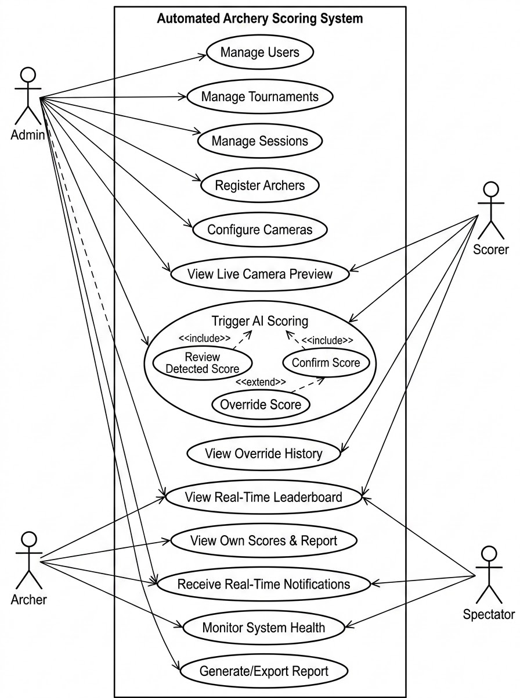
Figure 2: Use Case Diagram

7.1.2 Use Case Descriptions

UC-01: Manage Users
- Primary Actor: Admin.
- Description: Administrative control over user accounts and Role-Based Access Control (RBAC) levels.
- Flow: Admin creates or deactivates accounts, assigns roles, and updates profile information; system enforces uniqueness and hashes passwords.

UC-02: Manage Tournaments
- Primary Actor: Admin.
- Description: Creation and lifecycle management of high-level tournament events.
- Flow: Admin inputs tournament metadata (name, location, dates); system validates timing constraints and persists the tournament state.

UC-03: Manage Sessions
- Primary Actor: Admin.
- Description: Configuration of shooting rounds and control of session status (active, paused, completed).
- Flow: Admin initializes a round within a tournament; system manages state transitions and enforces session-specific scoring rules.

UC-04: Register Archers
- Primary Actor: Admin.
- Description: Assignment of archers to specific shooting lanes for a given session.
- Flow: Admin maps archer names to lane numbers; system validates that lanes are not double-assigned within the same session.

UC-05: Configure Cameras
- Primary Actor: Admin.
- Description: Registration and mapping of physical cameras (USB/RTSP/HTTP) to shooting lanes.
- Flow: Admin provides camera connection parameters; system establishes stream connectivity and initiates heartbeat monitoring.

UC-06: View Live Camera Preview
- Primary Actor: Admin, Scorer.
- Description: Monitoring of live streams from cameras assigned to lane targets.
- Flow: Scorer selects a lane; system streams frames from the backend directly to the browser UI dashboard.

UC-07: Trigger AI Scoring
- Primary Actor: Admin, Scorer.
- Description: Execution of the computer vision pipeline to detect arrow impacts and compute zone scores.
- Flow: Scorer triggers capture; system processes frames through target/arrow detection modules and returns a predicted score for review.

UC-08: View Override History
- Primary Actor: Admin, Scorer.
- Description: Auditing of manual score corrections and the rationale behind them.
- Flow: User filters audit logs by archer or lane; system displays original detected points vs. manually entered points and reasons.

UC-09: View Real-Time Leaderboard
- Primary Actor: Admin, Scorer, Archer, Spectator.
- Description: Accessing live standings and ranking updates powered by high-performance caching.
- Flow: User opens the leaderboard view; system serves current rankings from Redis and refreshes automatically as new scores are recorded.

UC-10: View Own Scores & Report
- Primary Actor: Archer.
- Description: Personal access for competitors to review their individual performance and download scorecards.
- Flow: Authenticated archer retrieves their session history; system scopes data to the specific user and provides export options.

UC-11: Receive Real-Time Notifications
- Primary Actor: Archer, Spectator.
- Description: Push updates for score submission, leaderboard changes, and session status shifts.
- Flow: System detects state changes; EventBus publishes messages to the WebSocket server which broadcasts updates to all active client connections.

UC-12: Monitor System Health
- Primary Actor: Admin.
- Description: Real-time observation of database pool saturation, storage usage, and service availability.
- Flow: Admin accesses health dashboard; system queries component metrics and displays utilization percentages and status indicators.

UC-13: Generate/Export Report
- Primary Actor: Admin.
- Description: Production of official session analytics and printable PDF scorecards for tournament archives.
- Flow: Admin selects session and format; ReportService aggregates data and streams the generated binary file back to the browser.

7.2 Data Flow Diagrams

7.2.1 Context Diagram
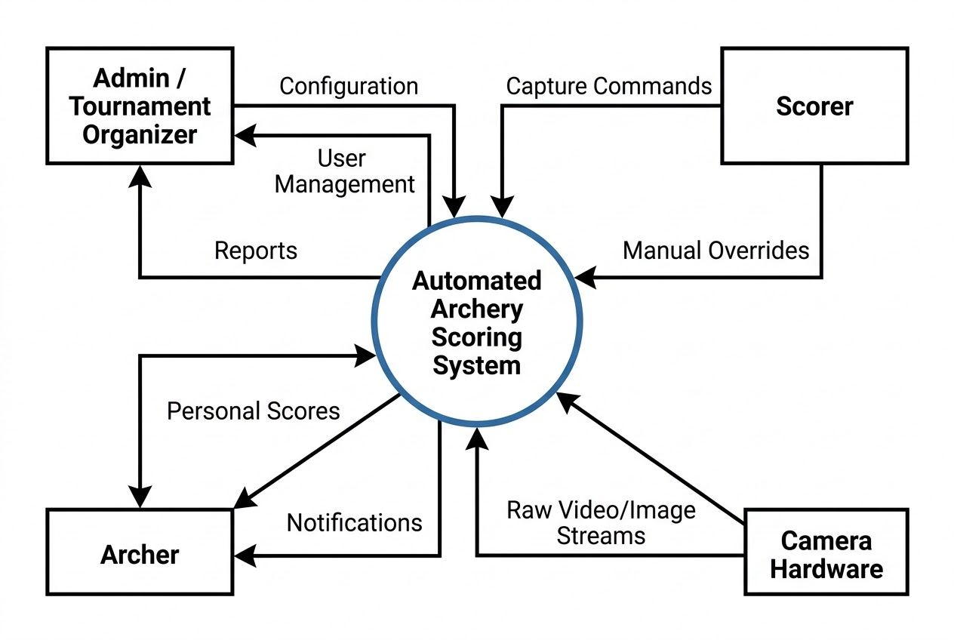
Figure 3: Data Flow Diagram Level 0

7.2.2 Activity Diagrams
Automated Scoring & Real-Time Broadcast Flow
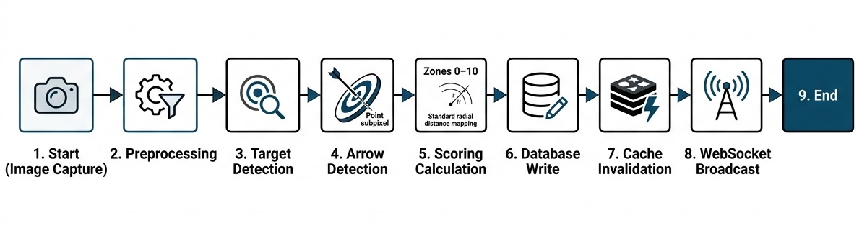
Tournament & Session Management Creation Workflow
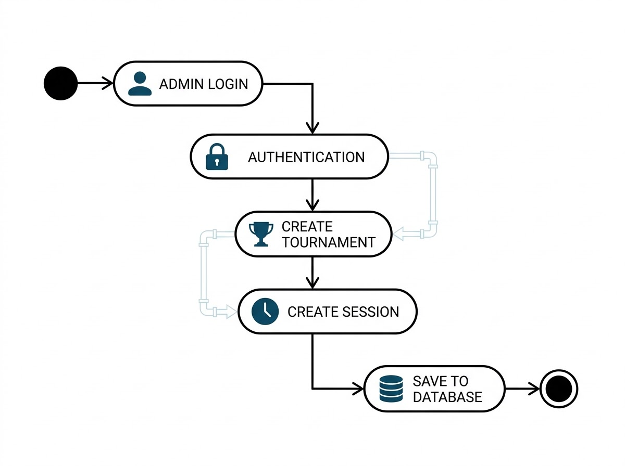

7.2.3 Process Decomposition

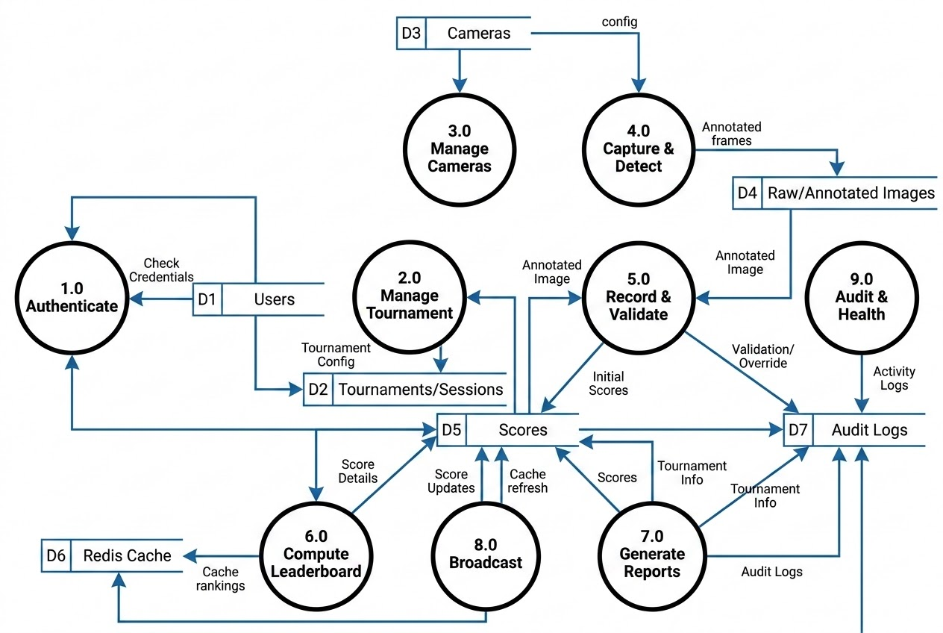
Figure 4: Data Flow Diagram Level 1

7.3 Entity-Relationship Diagram
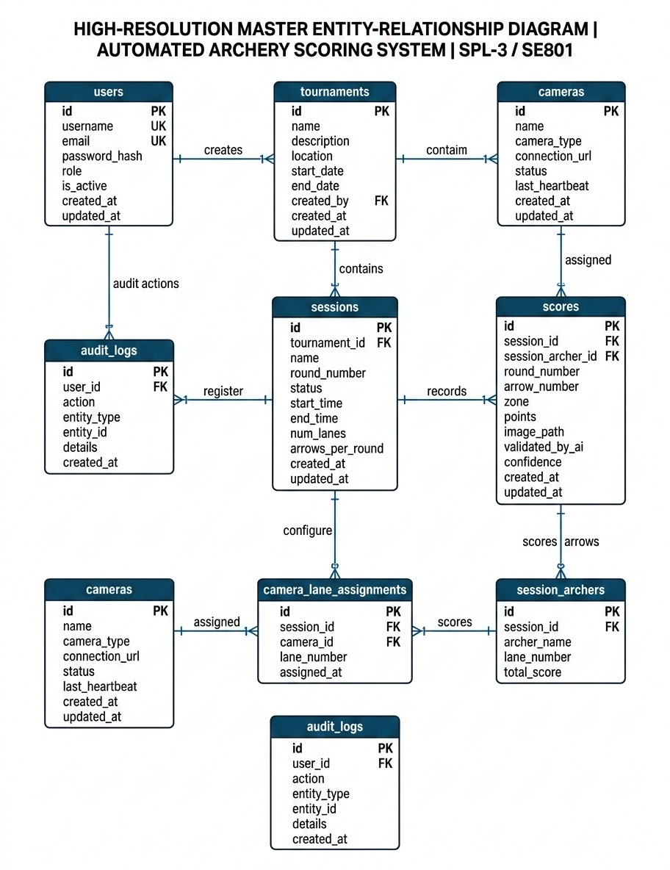
Figure 5: Entity-Relationship Diagram

7.4 Sequence Diagrams

7.4.1 User Login
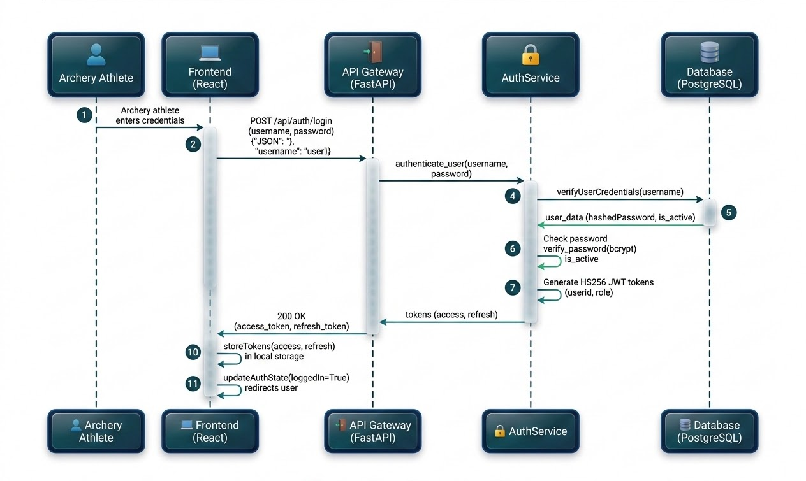
Figure 6: Sequence Diagram - User Login

7.4.2 Live AI-Assisted Scoring (Core Flow)
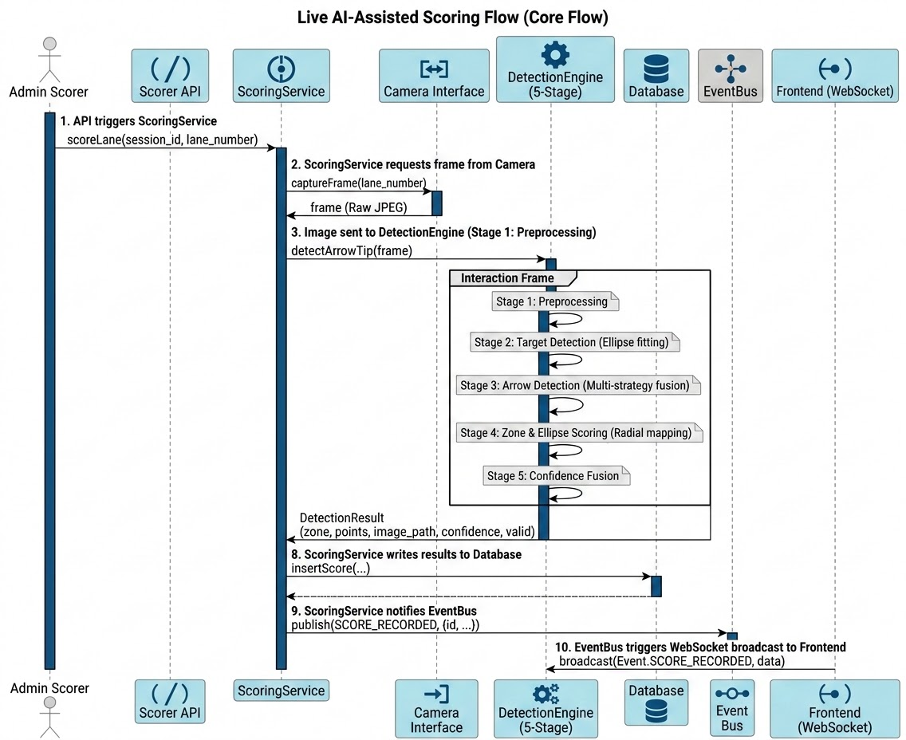
Figure 7: Sequence Diagram - AI Scoring Flow

7.4.3 Score Override (Low Confidence)
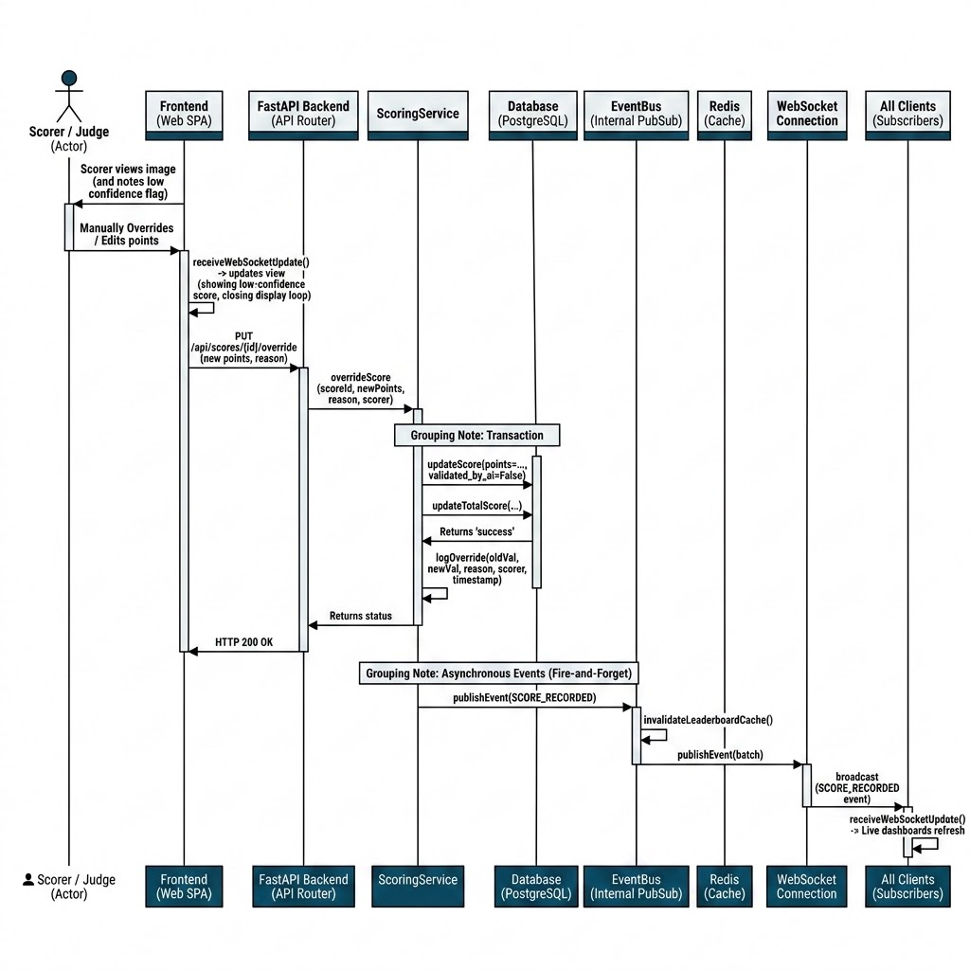
Figure 8: Sequence Diagram - Score Override

7.4.4 Camera Connect & Auto-Reconnect
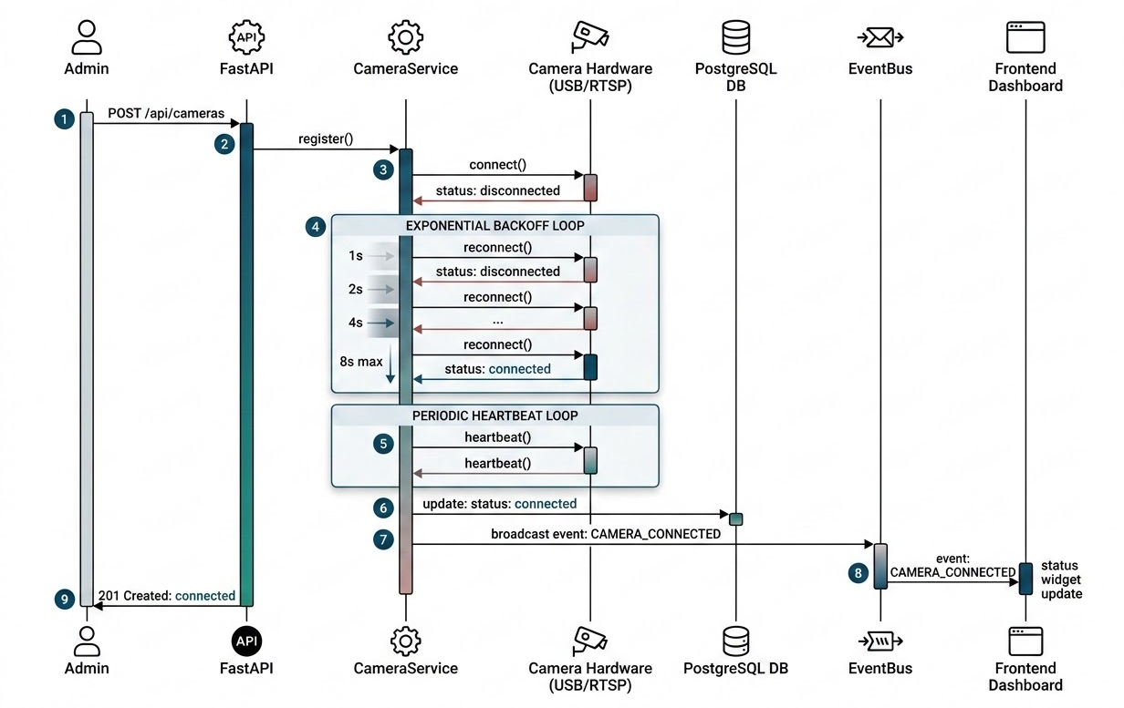
Figure 9: Sequence Diagram - Camera Management

7.4.5 Report Generation & Export
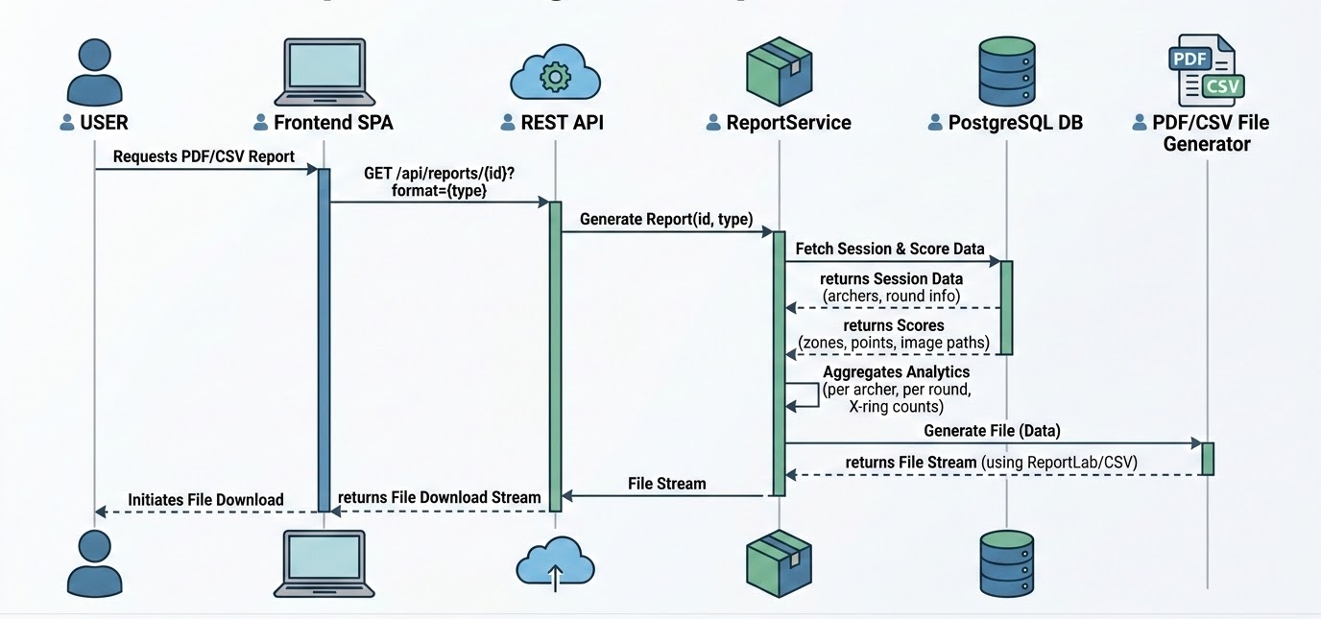
Figure 10: Sequence Diagram - Reporting

7.5 State Diagrams

7.5.1 Session Lifecycle
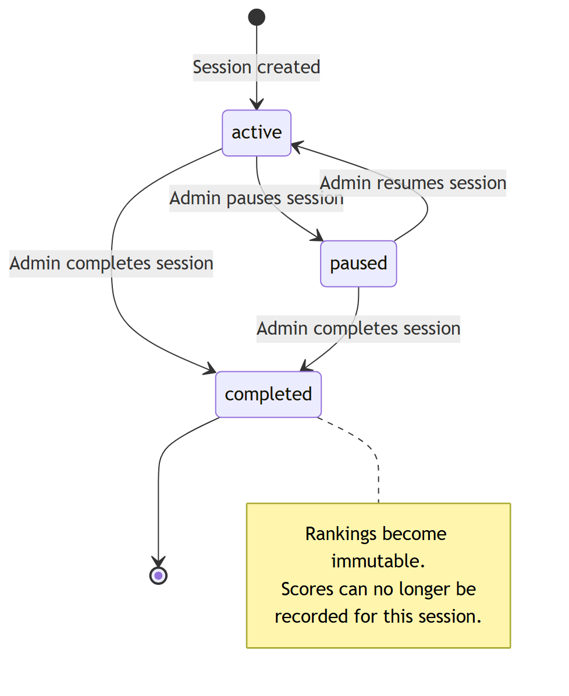
Figure 11: State Diagram - Session Lifecycle

7.5.2 Camera Connection Lifecycle
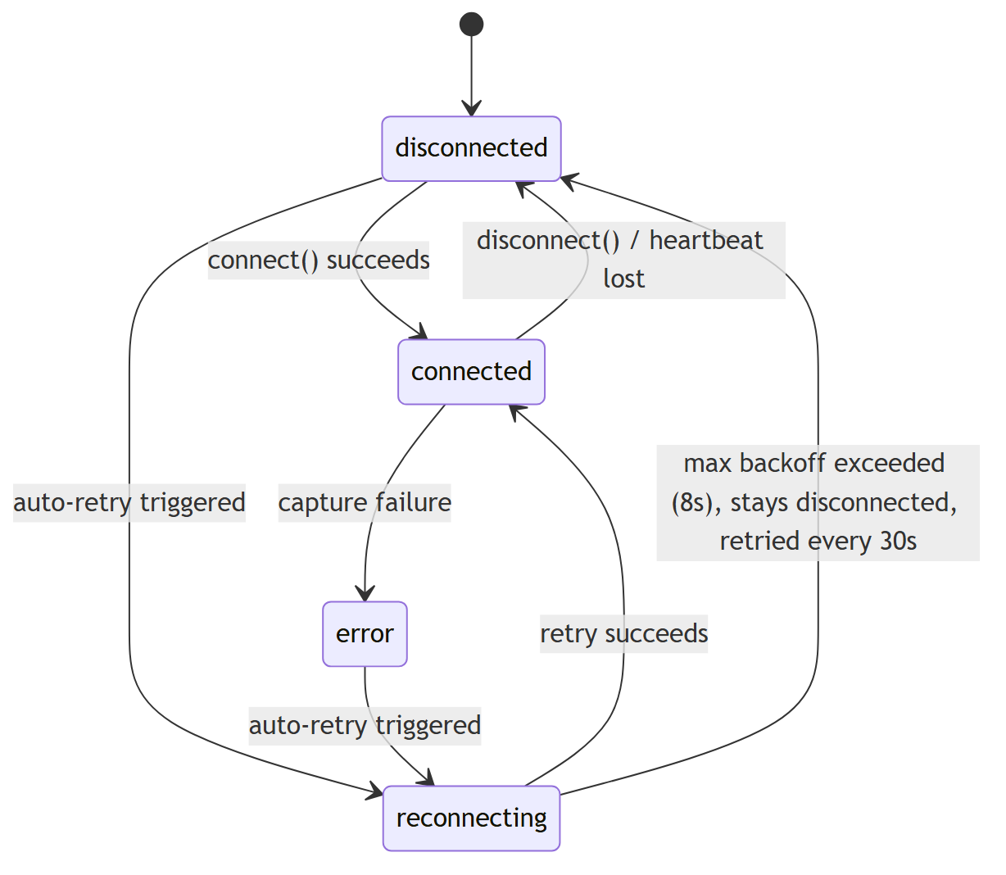
Figure 12: State Diagram - Camera Connection

7.5.3 Score Validation Lifecycle
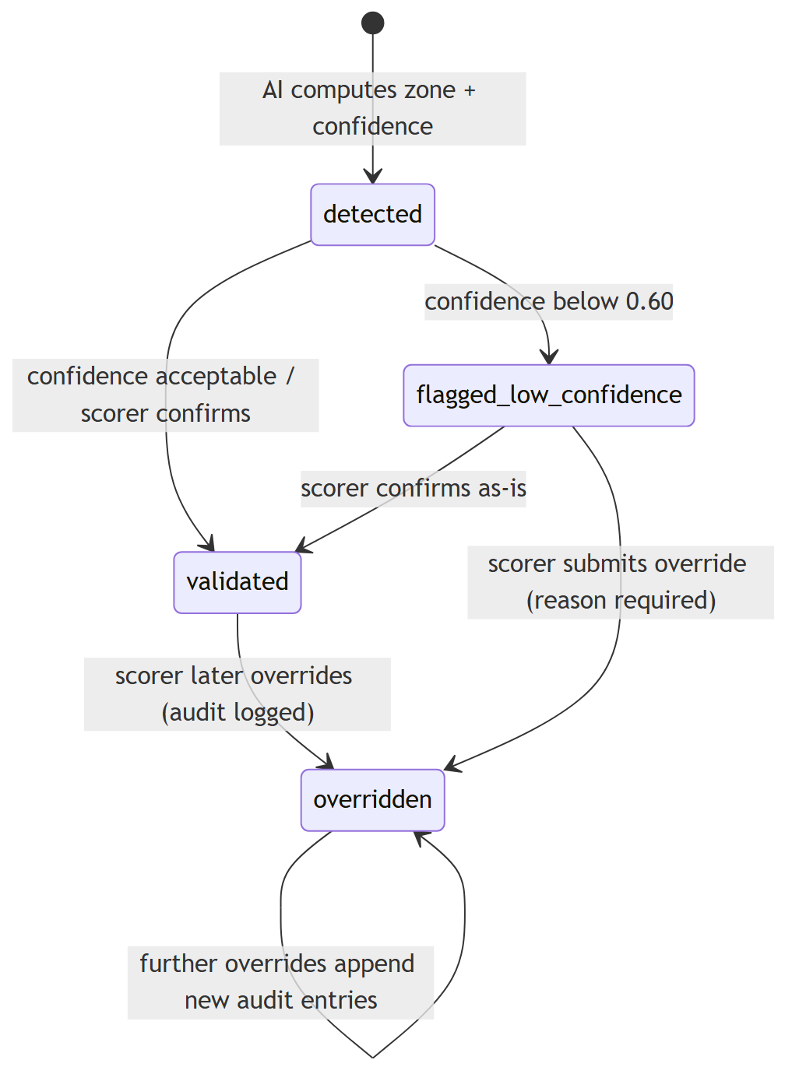
Figure 13: State Diagram - Score Validation

8. Preliminary Test Plan

8.1 Testing Objectives
The test plan ensures the reliability and accuracy of the automated scoring system through systematic verification.

8.2 Features to be Tested
Tested features include core backend REST endpoints, the AI/CV detection pipeline accuracy, and real-time frontend dashboard responsiveness.

8.3 Automated Verification Suite
The system includes a pytest verification suite with over 46 unit and integration tests, achieving comprehensive code coverage for the scoring engine.
Test Matrix Overview
Test Module | Sub-Features Tested | Count
Auth & Security | Registration, JWT Login, Permissions | 6
Tournament Workflow | Creation, Session Init, Archer Registration | 8
Score Engine & CV | Ellipse Detection, Subpixel Tip, WA Mapping | 12
Scoring DB & Retries | Transactional Writes, Backoff Loops | 6
Camera & Streams | Connect/Disconnect, Heartbeats | 5
Leaderboard & Redis | Sorting, Cache Writes/Invalidation | 5
Reports & Export | PDF/CSV Generation | 4

9. Endpoints

REST API Endpoint Summary
Domain Router | HTTP Method | Endpoint URI | Purpose / Functional Handler | Role Level
Authentication | POST | /api/auth/register | Register new user account (default spectator) | Public
Authentication | POST | /api/auth/login | Authenticate credentials & issue JWT token | Public
Authentication | POST | /api/auth/refresh | Refresh expired JWT token | Authenticated
Authentication | POST | /api/auth/reset-password | Reset user password credentials | Authenticated
Tournaments | GET | /api/tournaments | List all active/archived tournaments | Public
Tournaments | POST | /api/tournaments | Create new tournament container | Admin, Scorer
Tournaments | GET | /api/tournaments/{id} | Retrieve specific tournament metadata | Public
Tournaments | PUT | /api/tournaments/{id} | Update tournament parameters | Admin, Scorer
Sessions | GET | /api/tournaments/{id}/sessions | List shooting sessions in tournament | Public
Sessions | POST | /api/tournaments/{id}/sessions | Create new round/session (lanes=6) | Admin, Scorer
Sessions | GET | /api/sessions/{id} | Retrieve session status & details | Public
Sessions | PATCH | /api/sessions/{id} | Update status (active, paused, completed) | Admin, Scorer
Sessions | POST | /api/sessions/{id}/archers | Register archer & assign lane number | Admin, Scorer
Scores | POST | /api/sessions/{id}/scores | Record manual arrow score entry | Scorer
Scores | POST | /api/sessions/{id}/scores/upload | Upload image AI detect score shot | Scorer, System
Scores | GET | /api/sessions/{id}/scores | List all recorded scores for session | Public
Scores | GET | /api/scores/{id} | Retrieve single arrow score record | Public
Scores | POST | /api/scores/{id}/validate | Flag score AI validation status | Scorer
Scores | PUT | /api/scores/{id}/override | Admin/Scorer score override & audit log | Admin, Scorer
Cameras | GET | /api/sessions/{id}/cameras | List camera streams assigned to session | Admin, Scorer
Cameras | POST | /api/sessions/{id}/cameras/{cam_id}/connect | Connect physical USB/RTSP camera stream | Admin, Scorer
Cameras | POST | /api/sessions/{id}/cameras/{cam_id}/disconnect | Disconnect camera feed | Admin, Scorer
Cameras | POST | /api/cameras/{id}/reconnect | Auto-reconnect lost RTSP stream | System, Admin
Cameras | POST | /api/sessions/{id}/cameras/assign | Assign camera device to target lane | Admin, Scorer
Leaderboard | GET | /api/sessions/{id}/leaderboard | Retrieve live sorted leaderboard (Redis cached) | Public
Reports | GET | /api/sessions/{id}/report | Generate PDF scorecard or CSV export | Public
Health | GET | /api/health | Basic system health check | Public
Health | GET | /api/health/detailed | Subsystem status (DB, Redis, Storage) | Admin
Real-Time WS | WS | /ws/{session_id} | WebSocket pub/sub live score broadcast | Public

10. Project Timeline

10.1 Project Work Breakdown
The project follows an agile 13-week software design and implementation lifecycle:
- Phase 1 (Weeks 1-4): System Specifications, Requirements, Architecture Design, and DB Schema Design.
- Phase 2 (Weeks 5-11): Backend API (FastAPI), Computer Vision Engine, and Frontend Dashboard (React/Vite).
- Phase 3 (Weeks 10-12): AI Model Fine-tuning, WebSocket PubSub, and Redis Caching.
- Phase 4 (Week 12-13): Verification, Automated Testing, Containerization, and Midterm Submission.
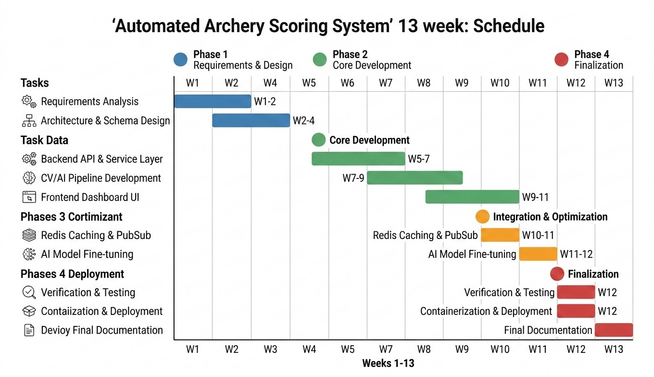
Figure 14: Project Gantt Chart

11. Conclusion
The Automated Archery Scoring System represents a significant technological advancement in sports officiating by integrating real-time computer vision with robust tournament management. By addressing the critical challenges of human error, high latency, and hardware costs, this system provides a scalable and reliable solution for modern archery competitions. The proposed architecture, combining a multi-stage AI pipeline with a responsive web-based platform, ensures precise scoring while maintaining system maintainability. Future work will focus on further optimizing detection accuracy under extreme environmental conditions and expanding hardware compatibility.

12. References
[1] S. Adam, N. A. Fitri, S. Bibi, and M. R. Sufandi, "Real-Time Arrow Detection and Scoring on Archery Targets Using YOLOv8 with Euclidean Distance-Based Zone Estimation," Journal of Applied Informatics and Computing (JAIC), vol. 9, no. 6, pp. 3669–3680, Dec. 2025.
[2] FastAPI, "FastAPI Documentation," 2026. [Online]. Available: https://fastapi.tiangolo.com/
[3] React, "React Documentation," 2026. [Online]. Available: https://react.dev/
[4] Vite, "Vite Documentation," 2026. [Online]. Available: https://vite.dev/
[5] OpenCV, "OpenCV Documentation," 2026. [Online]. Available: https://docs.opencv.org/

