Mutation Testing Report
Subject: Java Project (math and io packages)
Tools Used: JUnit, PIT (PITest), Mockito

Overview
Mutation testing is used to evaluate the effectiveness of unit tests. It works by injecting small faults (mutations) into the code and verifying whether the test suite detects them. A mutation is "killed" if a test fails because of it, and "survived" if it does not.

Initial State
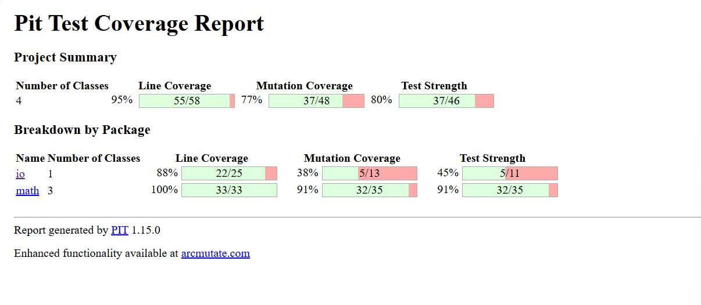

After taking some steps
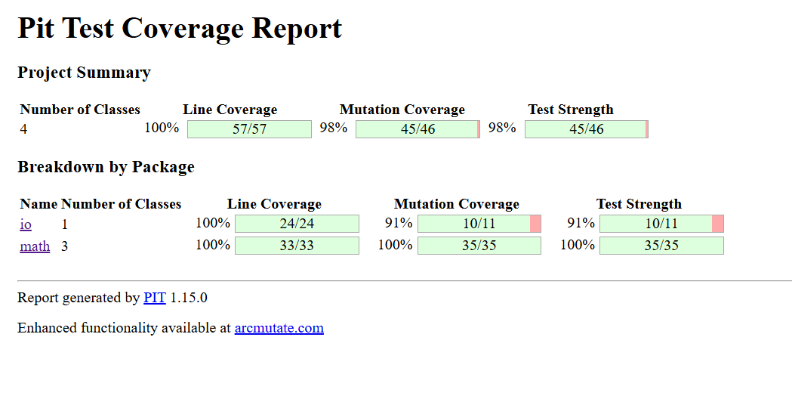

Mutation Testing Summary
Package | Class | Total Mutations | Survived | Killed
math | ArithmeticOperations | 13 | 0 | 13
math | ArrayOperations | 5 | 0 | 5
math | MyMath | 17 | 0 | 17
io | FileIO | 11 | 1 | 10

Detailed Report
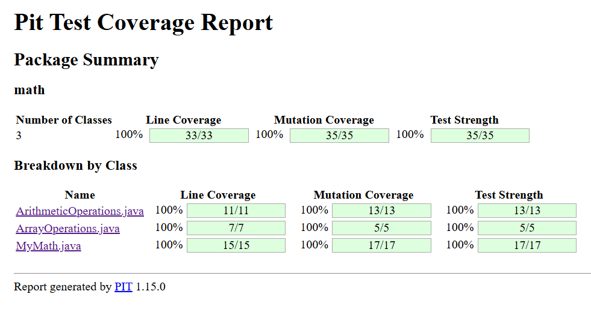
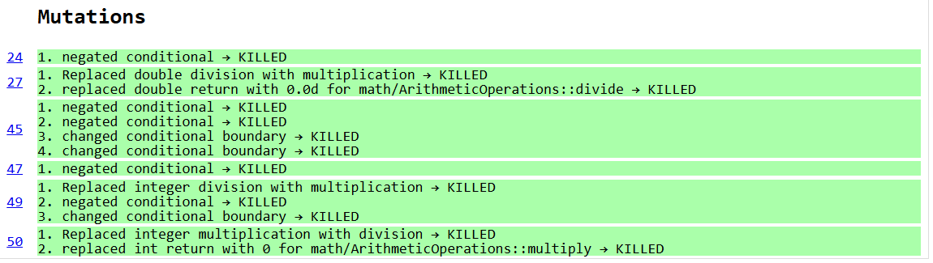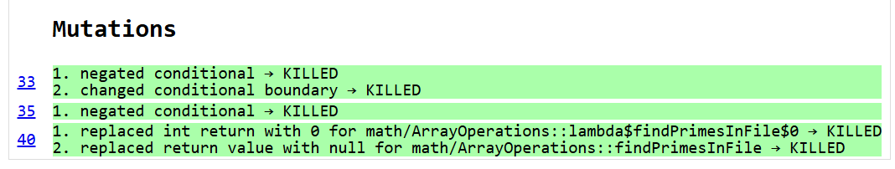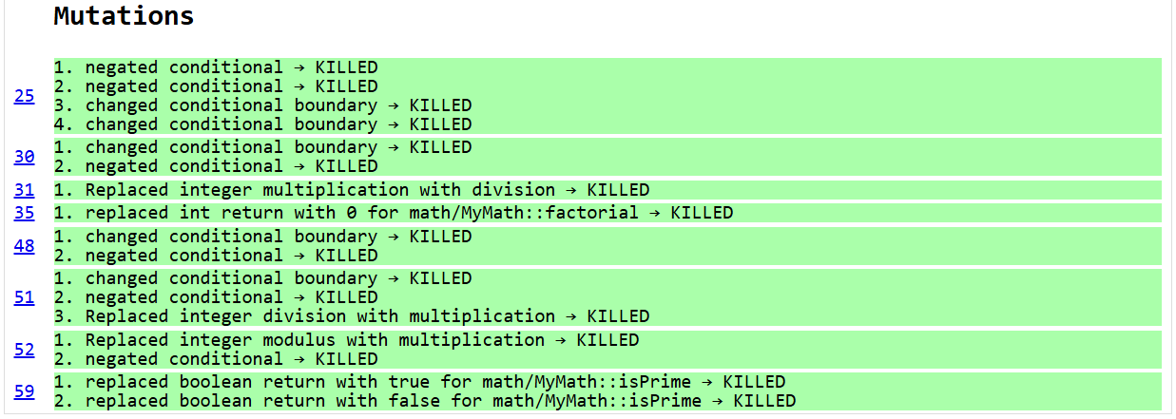

math.ArithmeticOperations
Mutation: x <= Integer.MAX_VALUE / y → x < Integer.MAX_VALUE / y
Reason: Missing boundary case.
Fix:
@org.junit.Test
public void testMultiplyAtBoundary() {
int x = Integer.MAX_VALUE / 2;
int y = 2;
assertEquals(x * y, new ArithmeticOperations().multiply(x, y));
}
Mutation: Integer overflow check
Fix:
@org.junit.Test(expected = IllegalArgumentException.class)
public void testMultiplyOverflowFromBoundaryCondition() {
new ArithmeticOperations().multiply(Integer.MAX_VALUE / 2 + 1, 2);
}

math.MyMath
Mutation: Boundary check n < 0 || n > 12
Fix:
@org.junit.Test
public void factorialOfZero() {
assertEquals(1, new MyMath().factorial(0));
}
@org.junit.Test
public void factorialOfTwelve() {
assertEquals(479001600, new MyMath().factorial(12));
}
Mutation: isPrime() loop condition change
Fix:
@org.junit.Test
public void isNotPrimeFour() {
assertFalse(new MyMath().isPrime(4));
}

io.FileIO
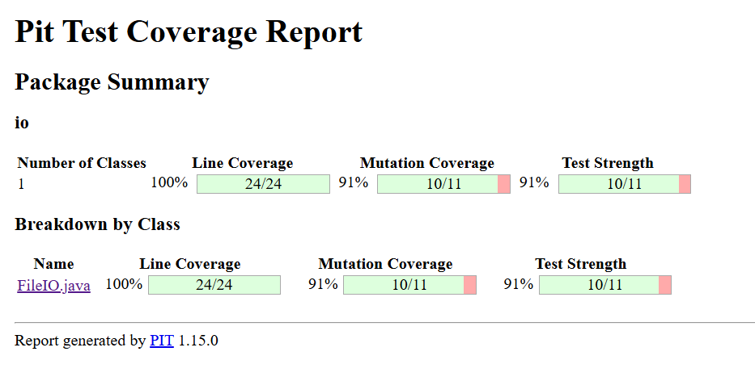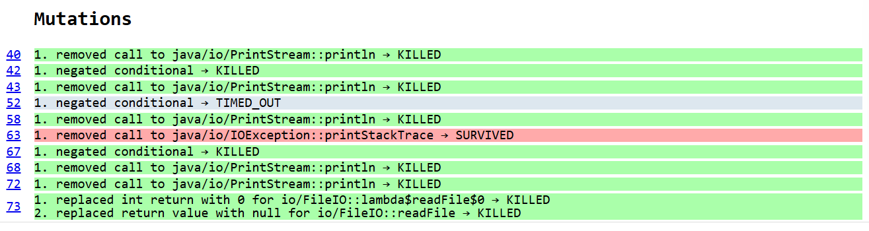
Mutation Fixes:
@Test
public void testReadFileWithSingleLine() throws Exception {
File tempFile = File.createTempFile("test", ".txt");
tempFile.deleteOnExit();
try (FileWriter writer = new FileWriter(tempFile)) {
writer.write("42\n");
}
FileIO fileIO = new FileIO();
int[] result = fileIO.readFile(tempFile.getAbsolutePath());
assertArrayEquals(new int[]{42}, result);
}
@Test
public void testReadFileLogsInputPath() throws Exception {
File tempFile = File.createTempFile("logtest", ".txt");
tempFile.deleteOnExit();
try (FileWriter writer = new FileWriter(tempFile)) {
writer.write("1\n");
}
FileIO fileIO = new FileIO();
fileIO.readFile(tempFile.getAbsolutePath());
assertTrue(systemOutRule.getLog().contains("==> readFile called with: " + tempFile.getAbsolutePath()));
}
@Test
public void testOnlyInvalidLinesPrintsEmptyMessage() throws Exception {
FileIO fileIO = new FileIO();
URL resourceUrl = getClass().getClassLoader().getResource("only_invalid.txt");
assertNotNull(resourceUrl);
String path = Paths.get(resourceUrl.toURI()).toString();
try {
fileIO.readFile(path);
fail("Expected IllegalArgumentException");
} catch (IllegalArgumentException e) {
assertEquals("Given file is empty", e.getMessage());
assertTrue(systemOutRule.getLog().contains("==> File was empty"));
}
}

In the test testReadFileLogsInputPath, the mutation on if (!file.exists()) is killed because the test creates a real file, so the condition evaluates to false and the method continues normally. When PIT negates this condition, it incorrectly assumes the file doesn't exist and throws an exception, causing the test to fail and killing the mutation. The mutations that remove System.out.println(...) calls are also killed because the tests rely on console logs—specifically, testReadFileLogsInputPath and testOnlyInvalidLinesPrintsEmptyMessage check that certain messages are printed, such as the input path and "File was empty". If those prints are removed, the systemOutRule assertions fail. In the test testOnlyInvalidLinesPrintsEmptyMessage, the code throws an IllegalArgumentException when no valid numbers are parsed, which also leads to the killing of mutations related to the file being empty. On the other hand, the conditional negation mutation on line 52 times out, likely due to an infinite loop or incorrect handling of file lines. Finally, in testReadFileWithSingleLine, the returned array is asserted to contain the parsed number, so any mutation (like returning null or replacing values) will cause the test to fail and kill the mutation.

Conclution
The mutation testing process successfully demonstrated the robustness and effectiveness of the unit tests written for the Java project’s math and io packages. Out of a total of 46 mutations, 45 were killed, showing that the current test suite is highly effective at detecting incorrect or altered logic. Specifically, all mutations in ArithmeticOperations, ArrayOperations, and MyMath classes were killed, indicating comprehensive test coverage and strong assertion validation for mathematical operations and boundary conditions.
In the FileIO class, 10 out of 11 mutations were killed. The remaining survived mutation (IOException.printStackTrace() removal) points to a lack of coverage for real I/O error scenarios—such as simulating unreadable or corrupted files—which could be addressed in future tests, possibly using mocking. Tests like testReadFileWithSingleLine, testReadFileLogsInputPath, and testOnlyInvalidLinesPrintsEmptyMessage were instrumental in validating file reading logic, logging, and input validation, thereby eliminating most mutations in the FileIO class.
Overall, the mutation testing outcome confirms that the test suite is well-structured and catches a wide range of faults, with only minimal improvement needed for handling exceptional I/O cases. This reinforces the reliability of the tested codebase and highlights mutation testing as a powerful technique for evaluating test adequacy.

