Lab No. 01:

Selective Coloring Using Brush Tool in Photoshop

Objective
To convert a color image into black & white and restore color in selected parts using the Brush Tool and Layer Mask in Adobe Photoshop.

Theory
Selective coloring is a photo editing technique in Photoshop where most of the image is converted into black & white, while a selected object remains in full color.
This is done using Adjustment Layers, Layer Masks, and Brush Tool. The Brush Tool is used to manually reveal or hide parts of the image by painting on the mask.
- Black color on mask = hides effect (shows color)
- White color on mask = shows effect (black & white)

Tools Used
- Adobe Photoshop
- Brush Tool (B)
- Quick Selection Tool
- Layer Mask
- Black & White Adjustment Layer

Procedure

Step 1: Open Image
- Open Adobe Photoshop.
- Import a color image.

Step 2: Selection of Object
- Select Quick Selection Tool (W).
- Carefully select the object you want to keep in color.

Step 3: Apply Layer Mask
- Go to Adjustments Panel.
- Add Black & White Adjustment Layer.
- Click on Layer Mask icon to apply mask.

Step 4: Apply Black & White Effect
- The whole image becomes black & white.
- Make sure mask is selected.

Step 5: Use Brush Tool
- Select Brush Tool (B).
- Set foreground color to Black.
- Zoom in for accuracy.
- Paint over the selected object to bring back original color.
If mistake happens:
- Use White color brush to fix it back.

Step 6: Final Adjustments
- Adjust brush size and hardness.
- Smooth edges for natural look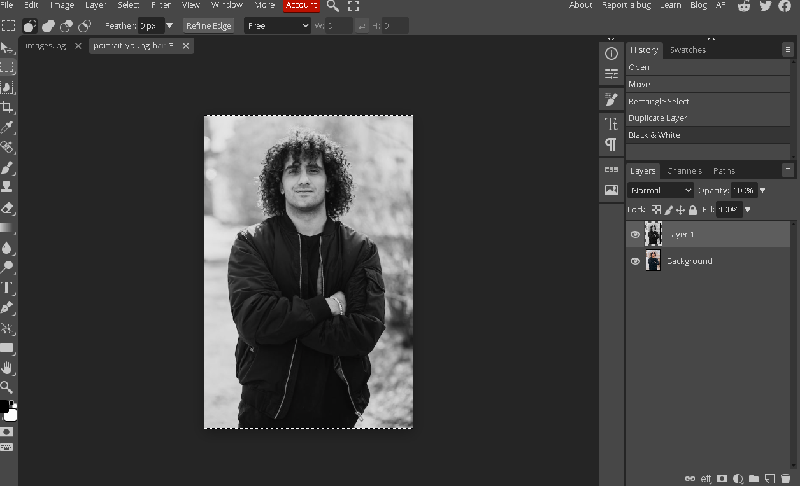
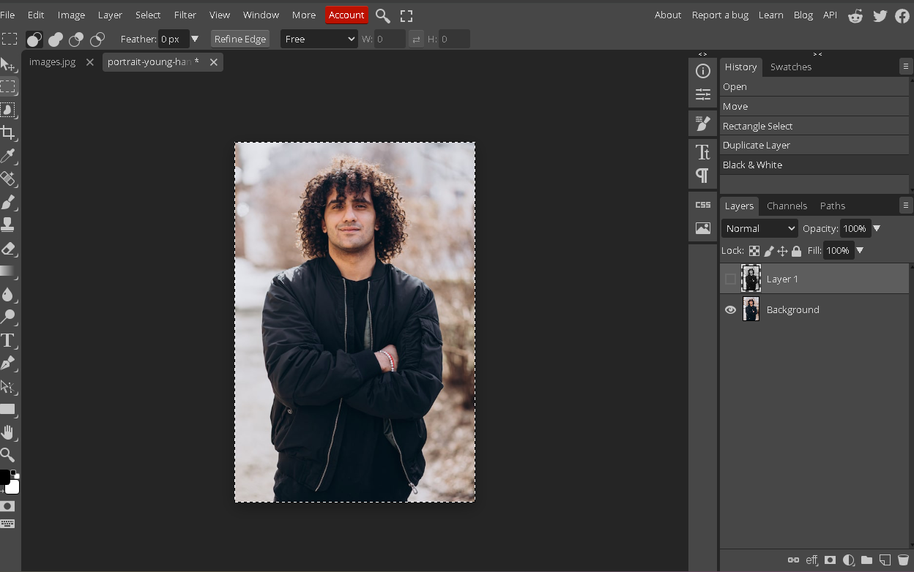

Result
The image is successfully converted into black & white while the selected object is restored in full color using the Brush Tool and Layer Mask technique.

Conclusion
In this lab, we learned how to create a selective coloring effect using Brush Tool and Layer Mask in Photoshop. This technique is widely used in professional photo editing for highlighting specific subjects.

