Lab No. 02:

Changing Object Color Using Hue/Saturation in Adobe Photoshop

Objective
To change the color of specific objects such as a shirt and car in an image using the Quick Selection Tool, Hue/Saturation Adjustment Layer, and Layer Mask in Adobe Photoshop.

Theory
Adobe Photoshop provides several techniques for changing the color of an object without affecting the rest of the image. In this lab, the object is first selected using the Quick Selection Tool. A Hue/Saturation Adjustment Layer is then used to change its color.
The Hue slider changes the actual color, while Saturation controls the intensity of the color and Lightness controls its brightness or darkness.
A Layer Mask is used to restrict the color adjustment to the selected object only.

Tools Used
- Adobe Photoshop
- Quick Selection Tool (W)
- Hue/Saturation Adjustment Layer
- Layer Mask
- Brush Tool (B) – for refining the mask

Procedure

Step 1: Open the Image
- Open Adobe Photoshop.
- Go to File → Open.
- Select and open an image containing a shirt or car.

Step 2: Select the Object
- Select the Quick Selection Tool (W).
- Drag the tool over the object you want to recolor.
- Continue adding areas until the complete object is selected.
- Use Alt while dragging to remove unwanted areas from the selection.
- Refine the selection edges if necessary.

Step 3: Create Hue/Saturation Adjustment Layer
- Go to the Adjustments Panel.
- Select Hue/Saturation.
- Photoshop will create a Hue/Saturation Adjustment Layer with a Layer Mask based on the selection.
- Make sure the Layer Mask is active.

Step 4: Change the Object Color
- Open the Properties Panel for Hue/Saturation.
- Move the Hue slider to change the object's color.
- Adjust the Saturation slider to increase or decrease color intensity.
- Adjust Lightness if the object needs to be lighter or darker.
- Enable Colorize if necessary, especially when changing the object to a completely different color.

Step 5: Refine the Mask
- Select the Brush Tool (B).
- Use a soft brush to refine the Layer Mask.
- Paint with black to hide the color effect from unwanted areas.
- Paint with white to reveal the color effect on the required areas.
- Carefully refine the edges of the object.

Step 6: Save the Image
- Go to File → Save As.
- Save the Photoshop file in PSD format to preserve the layers.
- Export the final image as JPG if required.

Lab Tasks

Task 1: Shirt Color Change
- Open a portrait image of a person wearing a shirt.
- Select the shirt using the Quick Selection Tool.
- Create a Hue/Saturation Adjustment Layer.
- Change the shirt color using the Hue slider.
- Adjust Saturation and Lightness for a realistic result.
- Use the Layer Mask and Brush Tool to refine the edges.
- Change the shirt to at least two different colors.
- Save the final image as Shirt_Color_Change.jpg.

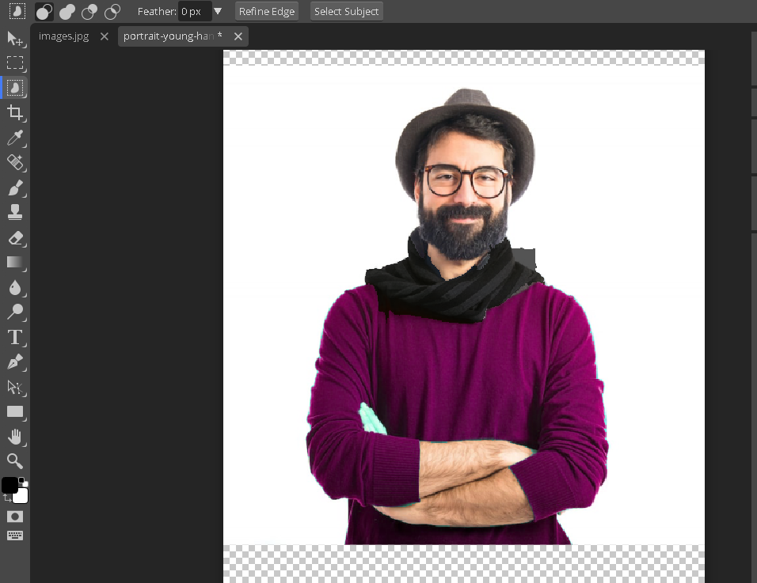

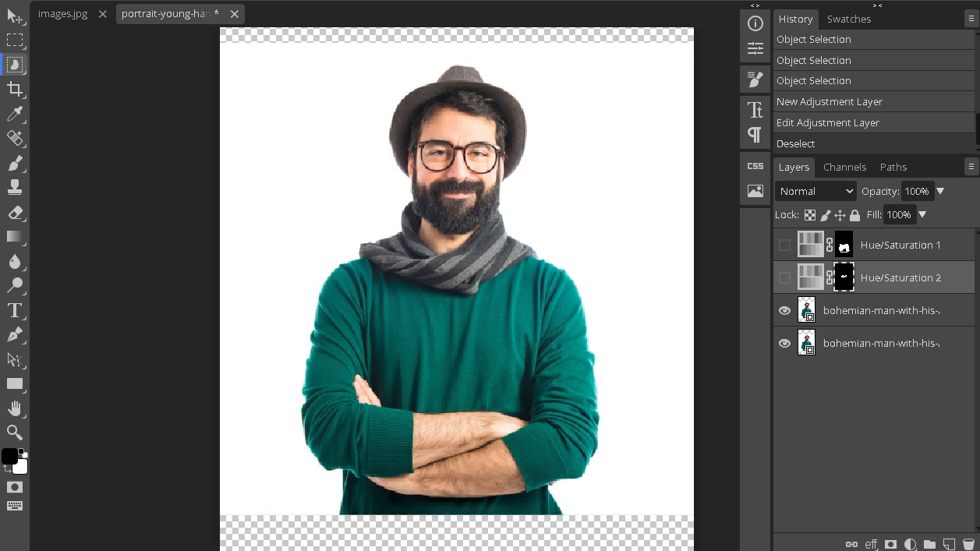

Task 2: Car Color Change
- Open an image of a car.
- Select the car body using the Quick Selection Tool.
- Create a Hue/Saturation Adjustment Layer.
- Change the car color using the Hue slider.
- Adjust Saturation and Lightness to achieve a realistic appearance.
- Refine the Layer Mask using the Brush Tool.
- Change the car to at least two different colors.
- Save the final image as Car_Color_Change.jpg.
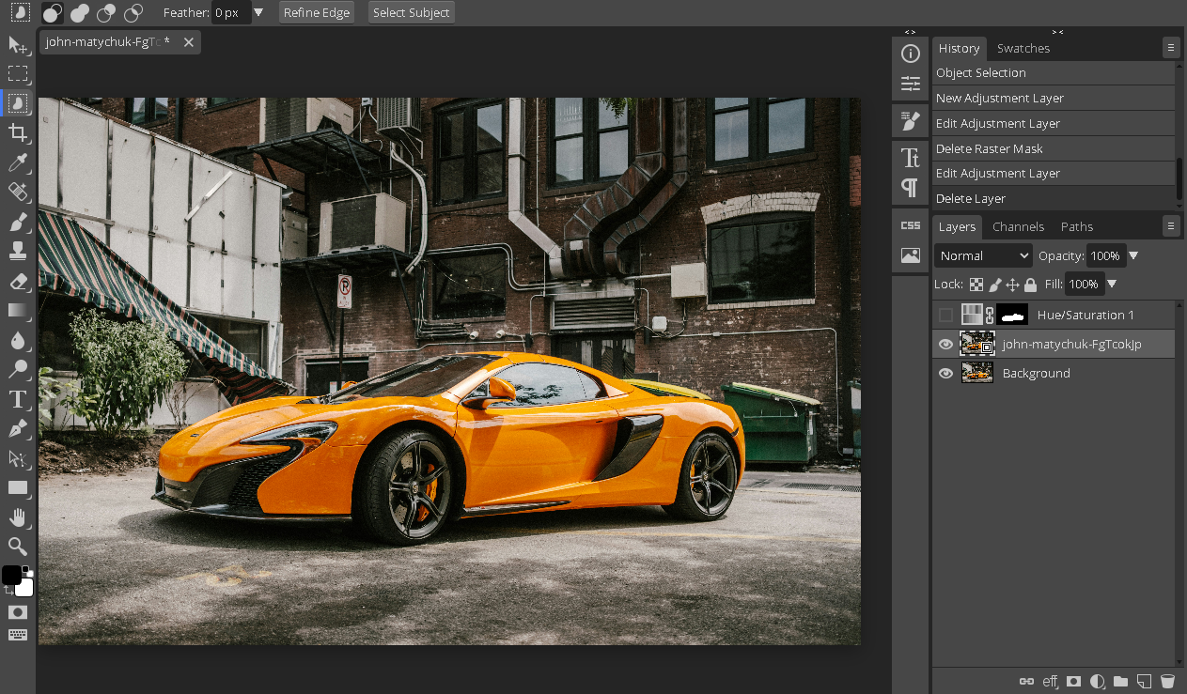
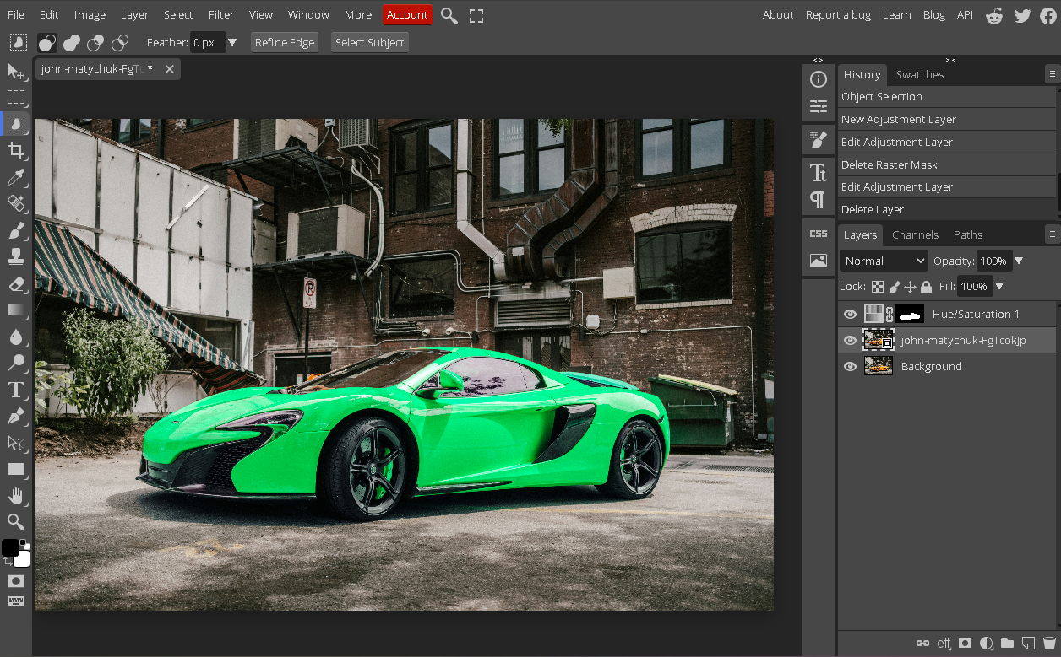

Theory Questions

1. What is the purpose of the Quick Selection Tool?
The Quick Selection Tool automatically selects areas of an image by detecting edges and color contrast as you click and drag. It is ideal for quickly selecting complex subjects like people or objects without manually tracing outlines.

2. What is a Hue/Saturation Adjustment Layer?
It is a non-destructive adjustment layer that lets you modify the hue, saturation, and lightness of an image without permanently altering the original pixels. It can be edited, masked, or deleted at any time.

3. What is the purpose of the Hue slider?
The Hue slider shifts all colors in an image around the color wheel, changing them to different colors. For example, it can turn a red object into blue, green, or any other hue.

4. What does the Saturation slider control?
The Saturation slider controls the intensity or purity of colors in an image. Moving it left makes colors duller and more gray, while moving it right makes them more vivid and vibrant.

5. What is the purpose of the Lightness slider?
The Lightness slider adjusts the overall brightness or darkness of the colors in an image. Moving it left darkens colors toward black, while moving it right brightens them toward white.

6. What is the Colorize option in Hue/Saturation?
The Colorize option applies a single uniform hue and saturation across the entire image, replacing all original colors. It is commonly used to create sepia, duotone, or monochrome tinted effects.

7. What is a Layer Mask?
A Layer Mask is a grayscale channel attached to a layer that controls which parts of that layer are visible or hidden. White areas are visible, black areas are hidden, and gray areas are partially transparent.

8. Why is a Layer Mask used when changing an object's color?
A Layer Mask confines the color change to only the selected object, preventing the adjustment from affecting the rest of the image. It also allows non-destructive editing, so the effect can be refined or removed later.

9. What happens when we paint with black on a Layer Mask?
Painting with black on a Layer Mask hides the corresponding parts of the layer, making them invisible. This effectively removes the effect or content in those areas.

10. What happens when we paint with white on a Layer Mask?
Painting with white on a Layer Mask reveals the corresponding parts of the layer, making them visible again. It restores the effect or content that was previously hidden.

Result
The colors of the shirt and car were successfully changed using the Hue/Saturation Adjustment Layer, Quick Selection Tool, and Layer Mask without significantly affecting the background.

Conclusion
In this lab, we learned how to change the color of specific objects in Adobe Photoshop. We used the Quick Selection Tool to select the object, the Hue/Saturation Adjustment Layer to modify its color, and the Layer Mask with Brush Tool to refine the selected area. This technique is useful for fashion editing, product visualization, automotive design, and creative photo editing.

