LAB NO. 03
Image Enhancement Using Filter Gallery and Filter Effects
Objective
To enhance and creatively modify images in Adobe Photoshop by using the Filter Gallery, Artistic Filters, Smart Filters, and other Filter Effects.
Theory
1. Filters in Adobe Photoshop
Filters are built-in effects in Adobe Photoshop that are used to change or enhance the appearance of an image. They can be used to create artistic effects, improve image quality, add texture, sharpen details, blur areas, or create special visual effects.
Purpose of Filters:
- Enhance the appearance of an image.
- Create artistic and creative effects.
- Sharpen image details.
- Blur unwanted areas.
- Add texture and special effects.
- Give photographs a painting-like appearance.
- Save editing time by applying predefined effects.
2. Filter Gallery
Filter Gallery is a feature in Adobe Photoshop that provides a collection of artistic and creative filters. It allows users to preview and apply different effects to an image.
Common Filter Gallery categories include:
- Artistic
- Brush Strokes
- Distort
- Sketch
- Texture
Filter Gallery is useful for:
- Creating artistic effects.
- Giving an image a painting-like appearance.
- Applying brush-stroke effects.
- Creating sketch and texture effects.
- Experimenting with different visual styles.
3. Smart Object
A Smart Object is a Photoshop layer that preserves the original properties of an image and allows editing to be performed non-destructively. When a filter is applied to a Smart Object, it becomes a Smart Filter.
Advantages of Smart Objects:
- Preserve the original image.
- Allow filters to be edited later.
- Allow filters to be removed.
- Provide non-destructive editing.
- Make it easier to experiment with different effects.
4. Smart Filter
A Smart Filter is a filter applied to a Smart Object. Unlike a normal filter, a Smart Filter can be edited or removed after it has been applied.
Basic workflow: Image → Convert to Smart Object → Apply Filter → Smart Filter
5. Artistic and Brush Stroke Effects
Photoshop provides different artistic and brush-stroke effects that can make an ordinary photograph look like a painting or traditional artwork.
- Dry Brush
- Accented Edges
- Angled Strokes
- Crosshatch
- Ink Outlines
- Spatter
- Sprayed Strokes
- Sumi-e
The available filters may vary depending on the Photoshop version.
Procedure
Part A: Convert the Image into a Smart Object
Step 1: Open Photoshop
- Launch Adobe Photoshop.
- Wait for Photoshop to open completely.
Step 2: Open an Image
- Go to File → Open.
- Select a suitable color image.
- Click Open.
- Use a landscape or nature photograph for this part.
Step 3: Convert the Layer into a Smart Object
- Go to the Layers panel.
- Right-click on the image layer.
- Select Convert to Smart Object.
- A small Smart Object icon will appear on the layer thumbnail.
Part B: Apply Filter Gallery
Step 4: Open Filter Gallery
From the menu bar, go to: Filter → Filter Gallery
Step 5: Select an Artistic Filter
- Select the Artistic category.
- Choose a suitable artistic filter.
- Preview the effect on the image.
- Depending on your Photoshop version, filters may include Dry Brush, Cutout, Poster Edges, Paint Daubs, or Sponge.
Step 6: Adjust Filter Settings
Adjust the available settings according to the desired result. Depending on the selected filter, settings may include Brush Size, Brush Detail, Texture, Light/Dark Balance, or Intensity. Observe the preview while changing the values.
Do not apply the filter until you are satisfied with the result.
Step 7: Apply the Filter
Click OK to apply the filter. If the image was converted into a Smart Object, the filter will appear below the layer as a Smart Filter.
Part C: Apply Additional Filter Effects
Step 8: Open a Second Image
- Go to File → Open.
- Select a portrait or another suitable image.
- Click Open.
Step 9: Convert the Image into a Smart Object
- Right-click the image layer.
- Select Convert to Smart Object.
Step 10: Apply the First Filter
Go to: Filter → Blur → Gaussian Blur
Adjust the Radius according to the image. Observe the preview and click OK.
Step 11: Apply the Second Filter
For example, go to: Filter → Sharpen → Smart Sharpen
Adjust the settings and click OK. You can also experiment with Oil Paint, Filter Gallery, Dry Brush, Cutout, or Unsharp Mask.
Part D: Compare the Result
- Compare the original image with the edited image.
- Observe changes in texture, sharpness, details, colors, and artistic appearance.
- If Smart Filters were used, try disabling the filter using the eye icon in the Layers panel.
- Enable it again to compare the before and after results.

Lab Tasks
Task 1: Artistic Filter
Open a suitable landscape or nature image and convert it into a Smart Object. Apply an artistic filter through Filter → Filter Gallery. Experiment with the available artistic/brush-stroke filters and adjust their settings.
Save the final image as: Print_Strokes.jpg
Before After
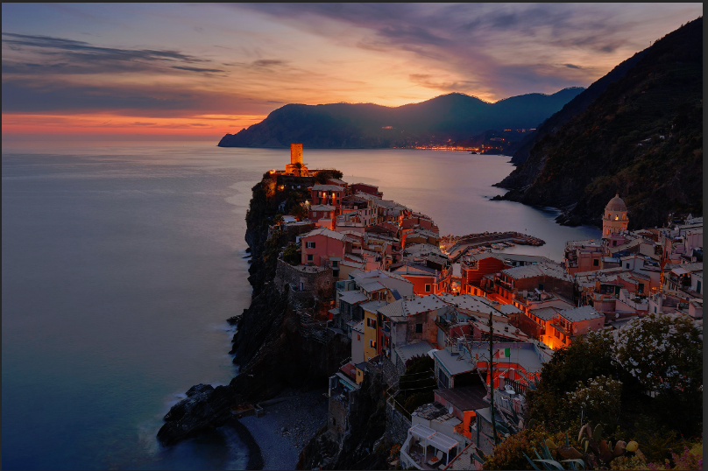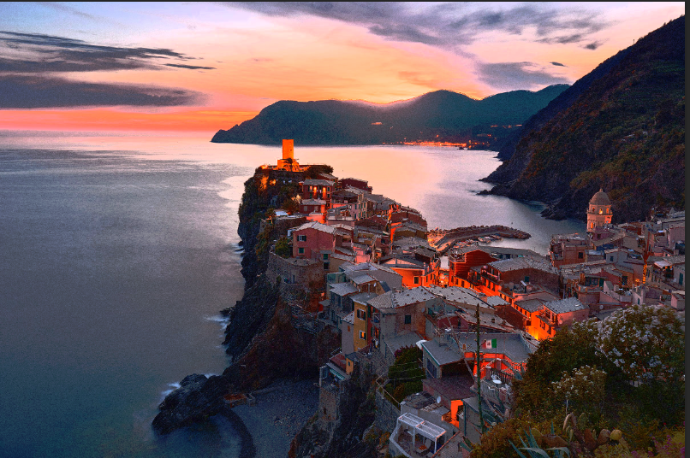

Task 2: Apply Two Filter Effects
Open a suitable portrait image. Convert the image into a Smart Object and apply any two different filters. For example: Gaussian Blur and Smart Sharpen. Adjust the settings of both filters to create a noticeable but suitable enhancement.
Save the final image as: Filter_Effects.jpg
Before After
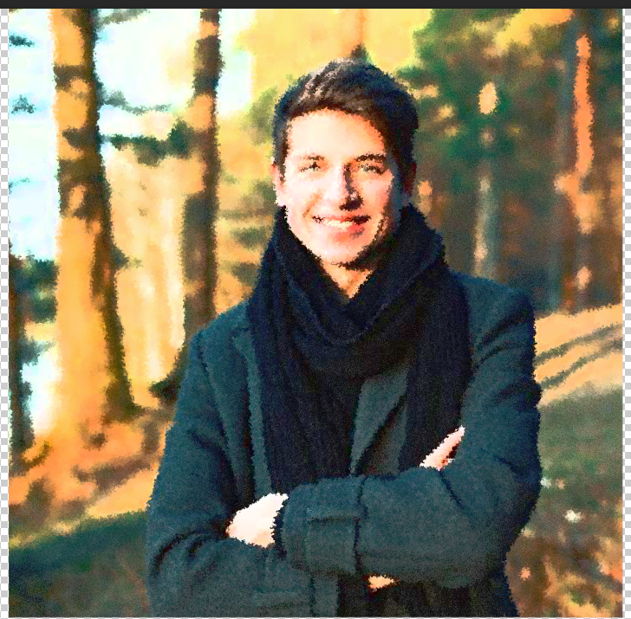
Result
The image was successfully enhanced using Filter Gallery, Artistic Filters, Smart Filters, and other Photoshop Filter Effects.
Conclusion
In this lab, we learned how to use Photoshop filters to enhance and creatively modify images. We also learned how to convert an image into a Smart Object and apply filters non-destructively using Smart Filters. Different artistic, blur, and sharpening effects were applied to understand how filters can change the appearance and visual quality of an image.

