Lab No. 04
Correcting Perspective and Wide-Angle Distortion Using Adaptive Wide Angle
Objective
To learn why Adaptive Wide Angle is used in Adobe Photoshop, where it is used, and how to apply it to correct perspective and lens distortion in an image.
Software Required
• Adobe Photoshop
• Any image captured with a wide-angle lens or an image containing curved/distorted lines
Theory
What is Adaptive Wide Angle?
Adaptive Wide Angle is a Photoshop filter used to correct lens distortion and perspective problems in photographs. Images taken with wide-angle lenses can sometimes make straight lines appear curved or distorted. Adaptive Wide Angle helps correct these distortions and makes the image look more natural.

Why Do We Use Adaptive Wide Angle?
• Correct curved or distorted lines.
• Fix perspective distortion.
• Straighten buildings and architectural structures.
• Correct distortion caused by wide-angle lenses.
• Improve the overall appearance of photographs.

Where Do We Use Adaptive Wide Angle?
It is commonly used for:
• Architecture photography
• Buildings and interior photography
• Landscape photography
• Wide-angle photographs
• Rooms and buildings where straight lines appear curved
• Photographs taken with action cameras or wide-angle lenses

Procedure
1. Open Adobe Photoshop.
2. Go to File → Open.
3. Select an image that contains wide-angle or perspective distortion.
4. The image will open in Photoshop.
5. Go to Filter → Adaptive Wide Angle.
6. The Adaptive Wide Angle dialog box will appear.
7. Select the appropriate Correction option according to the image.
8. Use the Constraint Tool to draw a line along a distorted or curved edge that should be straight.
9. Photoshop will adjust the image according to the constraint.
10. Add more constraints to other distorted lines if required.
11. Adjust the Scale value if necessary to improve the composition.
12. Preview the corrected image.
13. Click OK to apply the effect.
14. Compare the image before and after applying Adaptive Wide Angle.
15. Save the final image using File → Save As.

Practical Task
Task: Open a photograph of a building or any wide-angle photograph in Adobe Photoshop and correct its perspective and lens distortion using the Adaptive Wide Angle filter.

Students must:
1. Open the original image.
2. Apply Filter → Adaptive Wide Angle.
3. Identify at least two distorted/curved lines.
4. Use the Constraint Tool to correct these lines.
5. Adjust the image until the perspective looks natural.
6. Save the corrected image.

Before After

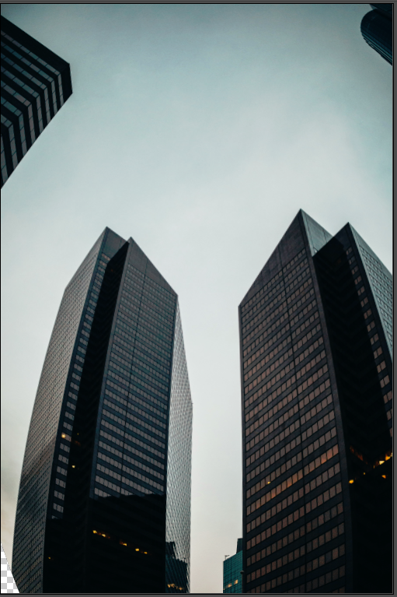

Result:
Conclusion:

