Lab No. 05:
Working with Blend, Merge and Flatten Layers

Objective
Understand the difference between Merge Layers and Flatten Image.

Theory Blend Layers

Definition
Layer Blending is the process of combining two or more layers using Blend Modes. Blend Modes determine how the pixels of one layer interact with the pixels of another layer.

Common Blend Modes
Blend Mode | Function
Normal | Displays the original layer without blending.
Multiply | Makes the image darker.
Screen | Makes the image brighter.
Overlay | Increases contrast.
Soft Light | Creates soft lighting effects.

Purpose
- Combine images.
- Create lighting effects.
- Improve contrast.
- Produce photo manipulations.

Merge Layers

Definition
Merge Layers combines selected visible layers into one layer while leaving other layers unchanged.

Purpose
- Reduce the number of layers.
- Organize projects. ● Simplify editing.

Flatten Image

Definition
Flatten Image merges all visible layers, including text and adjustment layers, into a single Background layer.

Purpose
- Reduce file size.
- Prepare the image for export.
- Finalize a project.

Difference
Merge Layers | Flatten Image
Merges selected layers | Merges all visible layers
Other layers remain separate | Only one Background layer remains
Editing is still partially possible | Layer editing is no longer possible

Steps

Blend Layers
- Open Photoshop.
- Open two images.
- Place one image over the other.
- Select the top layer.
- Change the Blend Mode to:
o Multiply o Screen o Overlay 6. Observe the results.
7. Save the file.

Merge Layers
- Select two or more layers.
- Right-click.
- Choose Merge Layers .
- Save the file.

Flatten Image
- Go to Layer → Flatten Image .
- Save the image in JPEG format.

Lab Tasks
Task 1: Create a poster using at least two images and apply any two Blend Modes .
Before After.
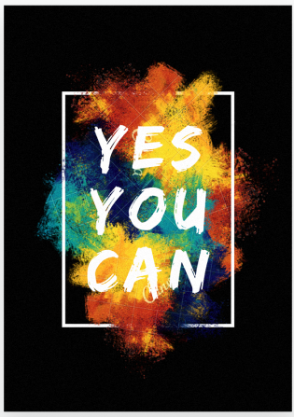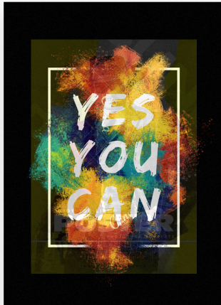
Task 2: Merge the design layers and then flatten the image.
Before (Multiple Layers) After ( Flatten Image )
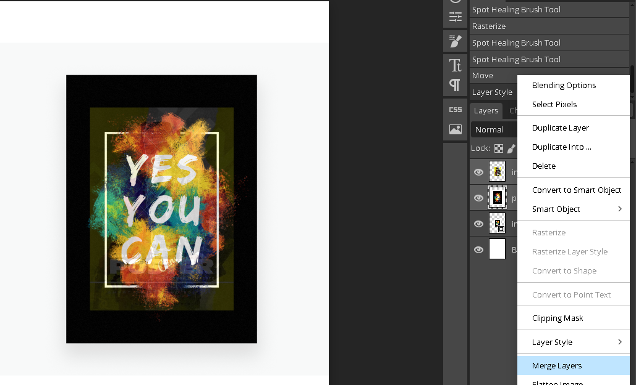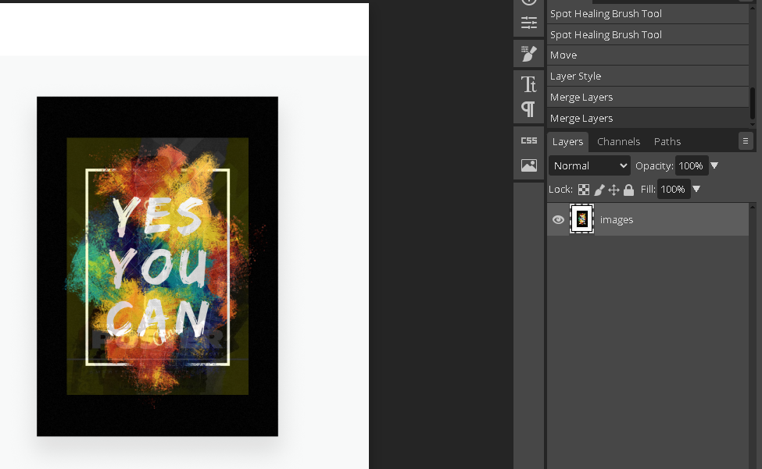
Result :
Conclusion:

