LAB 06
SKIN RETOUCHING IN ADOBE PHOTOSHOP
Objective
To learn and perform professional skin retouching in Adobe Photoshop by removing unwanted spots, pimples, blemishes, and other skin imperfections while maintaining a natural skin appearance.
Software Required
- Adobe Photoshop 2020 or later
- A portrait/face photograph
Theory
Skin Retouching is the process of improving the appearance of a person's skin in a photograph while keeping the face natural. Photoshop provides several tools for this purpose, including the Spot Healing Brush Tool, Healing Brush Tool, Clone Stamp Tool, Brush Tool, and layer techniques.
Practical Procedure
Step 1 – Open the Image
- Open Adobe Photoshop.
- Go to File → Open.
- Select the portrait/face image and click Open.
- Make sure the image is clearly visible.
Step 2 – Duplicate the Background Layer
- Select the Background layer in the Layers Panel.
- Right-click the layer and select Duplicate Layer.
- Rename the new layer: Skin Retouching.
- This keeps the original image safe.
Step 3 – Zoom into the Face
- Select the Zoom Tool (Z).
- Zoom to approximately 100%–200%.
- Inspect the face and identify pimples, acne marks, spots, dark marks, and other minor blemishes.
Step 4 – Remove Small Blemishes
- Select the Spot Healing Brush Tool.
- Adjust the brush size according to the blemish.
- Keep the brush slightly larger than the spot.
- Click or paint over the unwanted blemish.
- Repeat for pimples, small marks, and minor imperfections.
Step 5 – Use the Healing Brush for Detailed Retouching
- Select the Healing Brush Tool.
- Choose a soft round brush and adjust its size.
- Hold Alt and click on a clean area of skin to sample it.
- Release Alt and paint over the unwanted area.
- Repeat where necessary.
Step 6 – Retouch Larger Areas
- Select the Clone Stamp Tool (S).
- Choose a soft brush.
- Hold Alt and click on a suitable clean skin area.
- Carefully paint over the unwanted portion.
- Sample different nearby areas when necessary.
Step 7 – Smooth the Skin Carefully
- Create a duplicate of the retouched layer if required.
- Use an appropriate softening/blur technique lightly.
- Avoid excessive smoothing.
- Preserve important facial details such as eyes, eyebrows, lips, nose details, and natural facial structure.
Step 8 – Check the Skin
- Zoom out to approximately 50%–100%.
- Check that pimples and spots are reduced and the skin still looks natural.
- Make sure there are no obvious repeated textures or excessive blur.
Step 9 – Compare Before and After
- Turn the edited layer OFF using the eye icon.
- Observe the original image.
- Turn the edited layer ON again.
- Compare both versions and check that the improvement remains realistic.
Step 10 – Save the Photoshop File
- Go to File → Save As.
- Save the project as Skin_Retouching_YourName.psd.
- Example: Skin_Retouching_Ayesha.psd
Step 11 – Export the Final Image
- Go to File → Export → Export As.
- Select JPG.
- Set the appropriate image quality and click Export.
- Save as Skin_Retouching_YourName.jpg.

Lab Task
- Select one portrait photograph.
- Open it in Adobe Photoshop.
- Duplicate the original layer.
- Remove pimples and unwanted spots.
- Retouch visible skin imperfections.
- Smooth the skin carefully while maintaining natural facial features.
- Compare the Before and After results.
- Save the editable Photoshop file.
- Export the final JPG image.
Required Screenshots
- Original portrait opened in Photoshop.

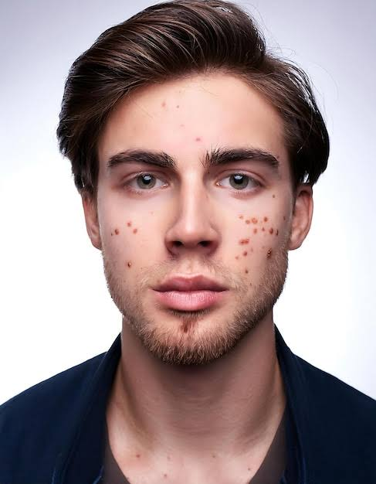

- Layers Panel showing the duplicated/retouching layer.

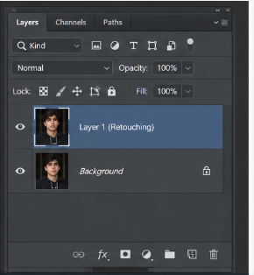

- Image while performing skin retouching.

Before After
- 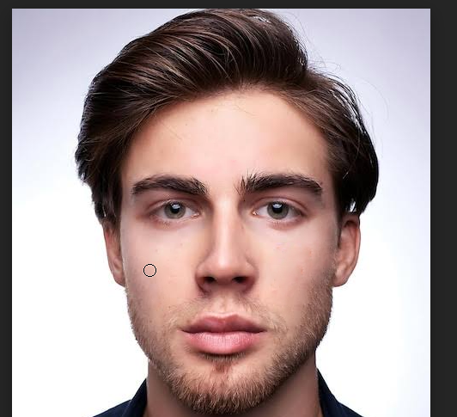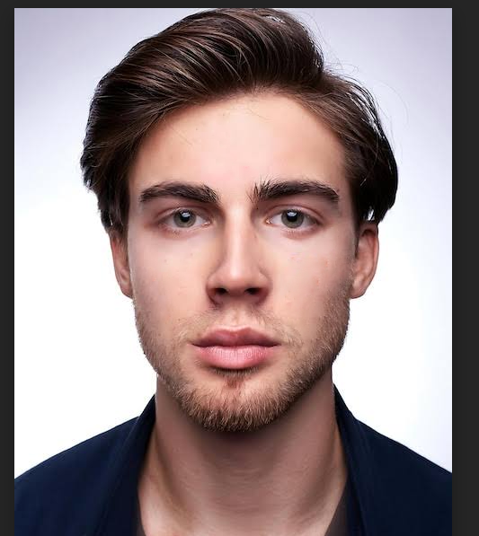

- Final retouched image.

Expected Output
- Reduced pimples and blemishes
- Cleaner-looking skin
- Improved overall appearance
- Natural skin texture
- Clearly visible facial details
- No excessive blur or artificial skin effect
Result
Successfully performed skin retouching in Adobe Photoshop by removing unwanted skin imperfections and improving the appearance of the portrait while maintaining a natural look.

