Lab No. 07:

Using Shapes & Text Tools to Create Post

Objective:

To learn how to use Shape Tools and Text Tool in Adobe Photoshop and create a simple promotional post.

Required Software
- Adobe Photoshop

Canvas Size
- Width: 1080 px
- Height: 1350 px
- Resolution: 72 PPI
- Color Mode: RGB

Tools
- Rectangle Tool
- Ellipse Tool
- Rounded Rectangle Tool
- Text Tool
- Move Tool

Task: Design a Graphic Design Workshop Post
Create a 1080 × 1350 px social media post for a Graphic Design Workshop using different shapes, text, and images.

Your post must contain:
GRAPHIC DESIGN
WORKSHOP
Learn • Create • Design
Photoshop | Illustrator | Branding
20 October 2026
11:00 AM | Computer Lab
REGISTER NOW

Design Requirements
Students must:
- Create a suitable background.
- Use at least 3 different shapes.
- Use shapes as decorative elements and/or text backgrounds.
- Place a relevant picture inside one of the shapes and adjust it properly so the picture fits within the shape.
- Add the given text using the Text Tool.
- Use different font sizes for heading, subtitle, and details.
- Create a REGISTER NOW button using a rounded rectangle.
- Properly align and arrange all elements.
- Keep the design clean and professional.
- Rename the layers properly.

Required Submission
Submit:
- Final post screenshot
- Layers Panel screenshot
Result:
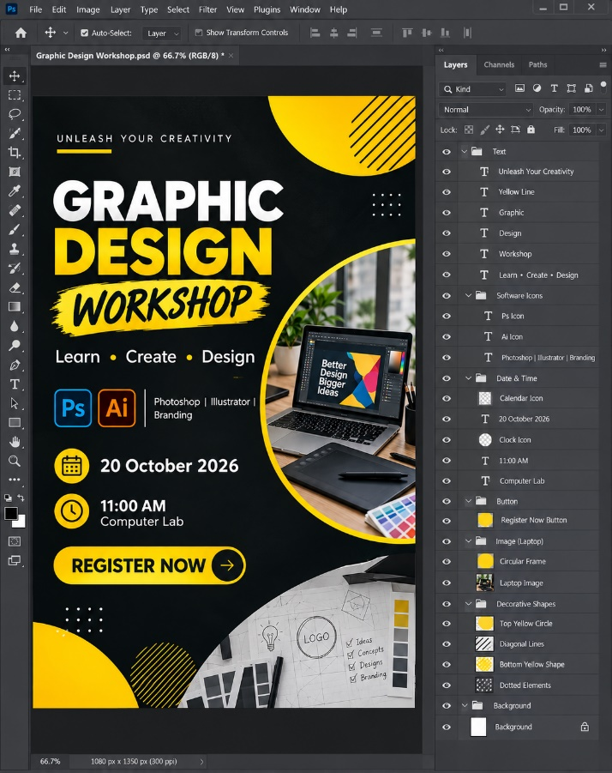
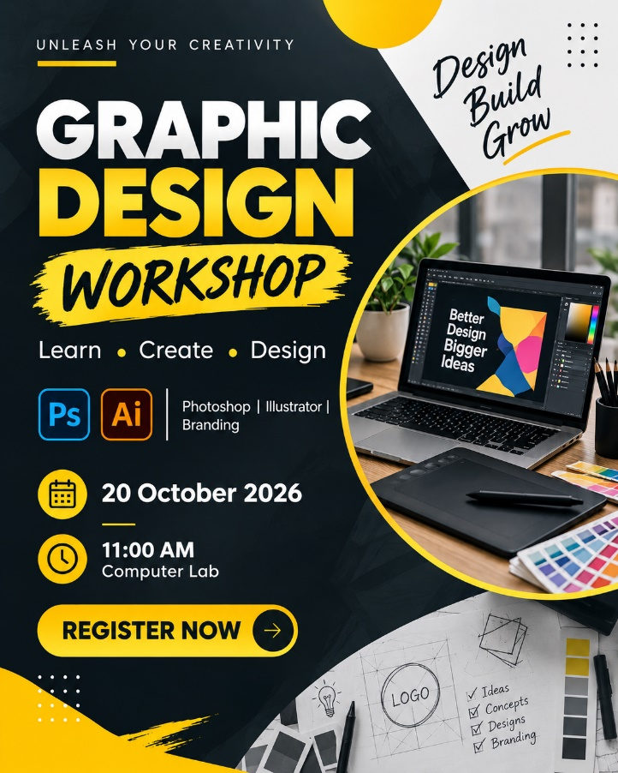
Final post screenshot Layers Panel screenshot

