Cloud Resource Monitoring & Intelligence Platform
Master Requirements, Architecture & Design Document
Resource Monitoring · AI Anomaly Detection & Prediction · Cost Optimization · Cloud Intrusion Detection · AI Incident Narrator
Version 3.0 | Prepared: September 2026

Table of Contents
Executive Summary 3
1. Introduction 3
2. Stakeholders 4
3. System Architecture 4
4. Data Flow 5
5. Database Design 6
6. Requirements Analysis 8
7. API Design 9
8. Unique Differentiating Features 10
9. Technology Stack 11
10. Implementation Plan 12
11. Feasibility & Risk Analysis 13
12. Testing Strategy 14
13. Deployment Plan 14
14. Conclusion 14
15. References 14

Executive Summary
This document is the single reference for the Cloud Resource Monitoring & Intelligence Platform: what it does, why each part exists, how the pieces connect, and how it can be built. It consolidates the requirements analysis, system architecture, database design, unique differentiating features, technology stack, and implementation plan produced across the project's design phase into one document, with all supporting diagrams included in place.
The platform is organized into five modules: (1) Resource Monitoring — the telemetry foundation; (2) AI Anomaly Detection & Prediction — statistical/ML scoring and forecasting; (3) Resource Cost Optimization — usage-to-spend analysis and rightsizing; (4) Cloud-based Intrusion Detection — behavioral and signature-based security monitoring; and (5) the AI Incident Narrator — a cross-module reasoning layer that explains incidents in plain language by correlating signals across the other four.

1. Introduction

1.1 Problem Statement
Cloud environments host large numbers of virtual machines, containers, and microservices whose resource demand, cost, and security exposure all change continuously. Teams typically monitor performance, cost, and security through separate, disconnected tools, which delays incident detection, obscures the relationship between a security event and a cost spike, and leaves cost optimization as a manual, reactive exercise. This project builds a single integrated platform that collects resource telemetry and security events, applies AI-based anomaly detection and forecasting, recommends cost optimizations, detects intrusions, and explains what is happening across all of this through one conversational interface.

1.2 Objectives
- Continuously monitor CPU, memory, storage, and network usage across cloud resources with real-time and historical dashboards.
- Detect abnormal resource behavior using both configurable thresholds and machine-learning-based anomaly detection, and forecast future usage.
- Identify idle, underutilized, or misallocated resources and recommend concrete cost-saving actions.
- Detect potential security intrusions from network and access-layer signals, using both known-signature and behavioral detection.
- Correlate signals across performance, cost, and security domains and explain incidents in plain language through an AI agent.

1.3 Scope

In Scope
- Resource-level metric collection, storage, and visualization for VMs/containers/hosts.
- Threshold-based and ML-based anomaly detection and short-horizon forecasting.
- Cost estimation, idle-resource detection, and rightsizing recommendations.
- Behavioral and signature-based intrusion detection on network/auth/firewall events.
- A cross-module AI agent that answers natural-language questions using the platform's own data.

Out of Scope (for this version)
- Automatic remediation without human approval (auto-scaling, auto-blocking) — the platform recommends, it does not act unilaterally.
- Full production-grade network intrusion detection (deep packet inspection at line rate) — behavioral detection on log/flow data is the target, not a Suricata-equivalent NIDS.
- Multi-tenant SaaS billing/subscription management.

2. Stakeholders
Stakeholder | Primary Interest
Cloud/Infrastructure Administrator | Resource monitoring, threshold/alert configuration, incident response.
DevOps / SRE Engineer | Dashboards, forecasts, anomaly alerts for troubleshooting and capacity planning.
Security Analyst / SOC | Intrusion detection alerts, security event audit trail, SIEM integration.
Finance / IT Manager | Cost optimization recommendations, spend trends, realized savings.
Data/ML Engineer | Model training, retraining schedule, model quality monitoring.
System (automated) | Collection agents, AI scoring service, cost engine, IDS engine, narrator service.

3. System Architecture
The architecture is a layered pipeline: telemetry is collected, ingested, and stored once, then read by four analytical engines (AI, Cost, Intrusion Detection, and the cross-module Narrator), with all alerts flowing through one router into a single dashboard.
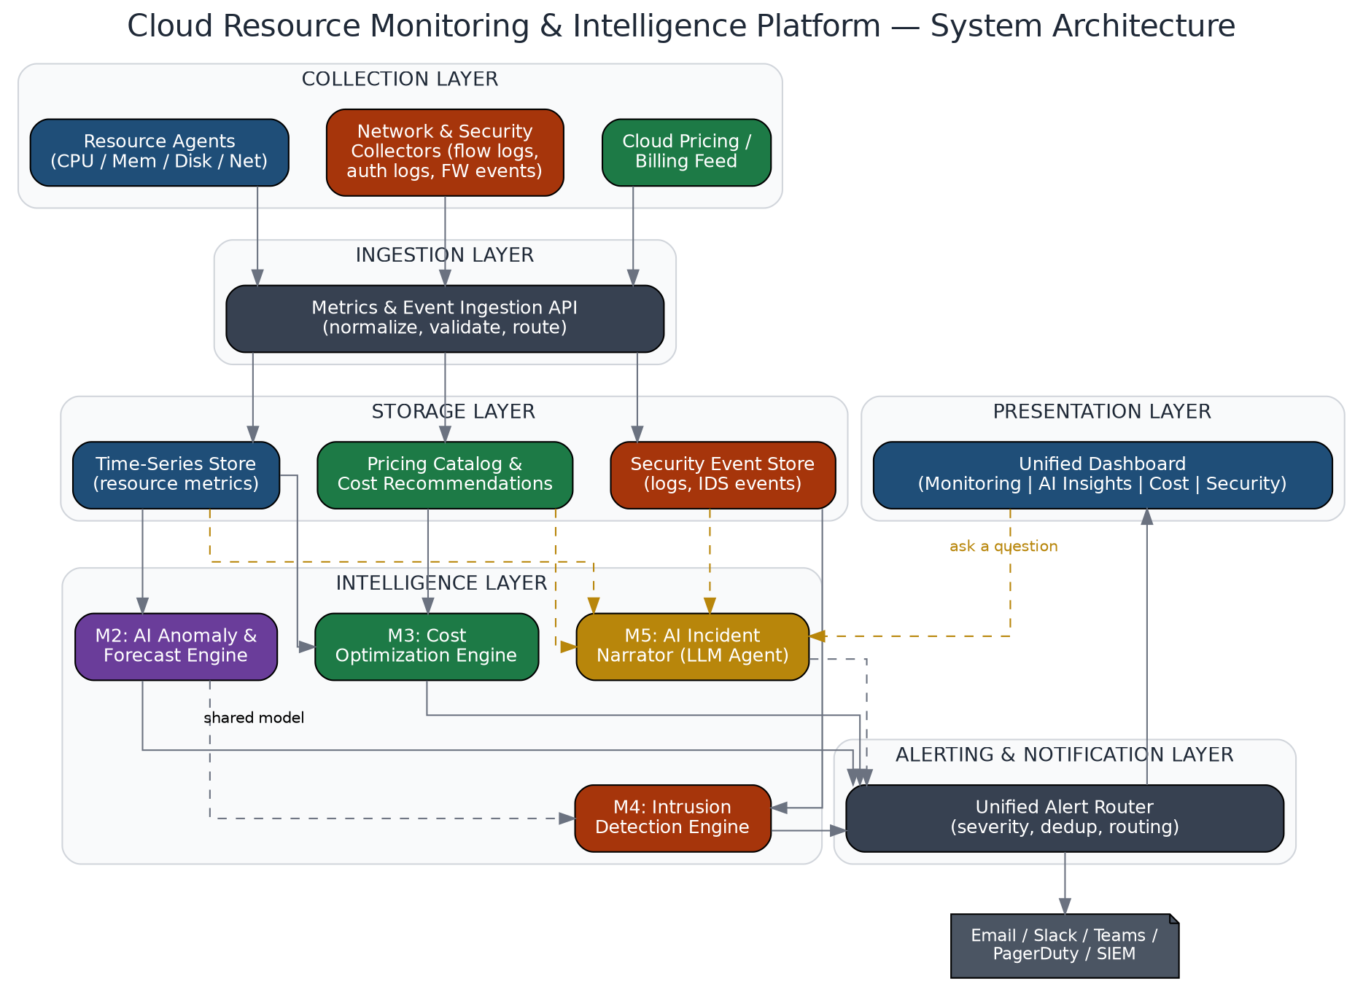
Figure 1 — Layered system architecture across all five modules.

3.1 Layer Descriptions
- Collection Layer: resource agents (CPU/mem/disk/network), network/security collectors (flow logs, auth logs, firewall events), and a cloud pricing/billing feed.
- Ingestion Layer: a single API normalizes and validates all incoming metrics and events before routing them to storage.
- Storage Layer: a time-series store for metrics, a security event store, and a pricing/cost-recommendation store.
- Intelligence Layer: the AI anomaly/forecast engine (M2), cost optimization engine (M3), and intrusion detection engine (M4, which reuses M2's model on security features) all read from storage; the AI Incident Narrator (M5) reads from all three plus storage directly.
- Alerting Layer: a unified router applies severity, deduplication, and routing rules before alerts reach notification channels or the dashboard.
- Presentation Layer: one dashboard with Monitoring, AI Insights, Cost, and Security views, plus the Narrator's conversational interface.

4. Data Flow
The Level-0 data flow diagram below shows the platform as a single process exchanging data with its external actors (cloud resources supplying telemetry, and the three human stakeholder roles) and its four internal data stores.
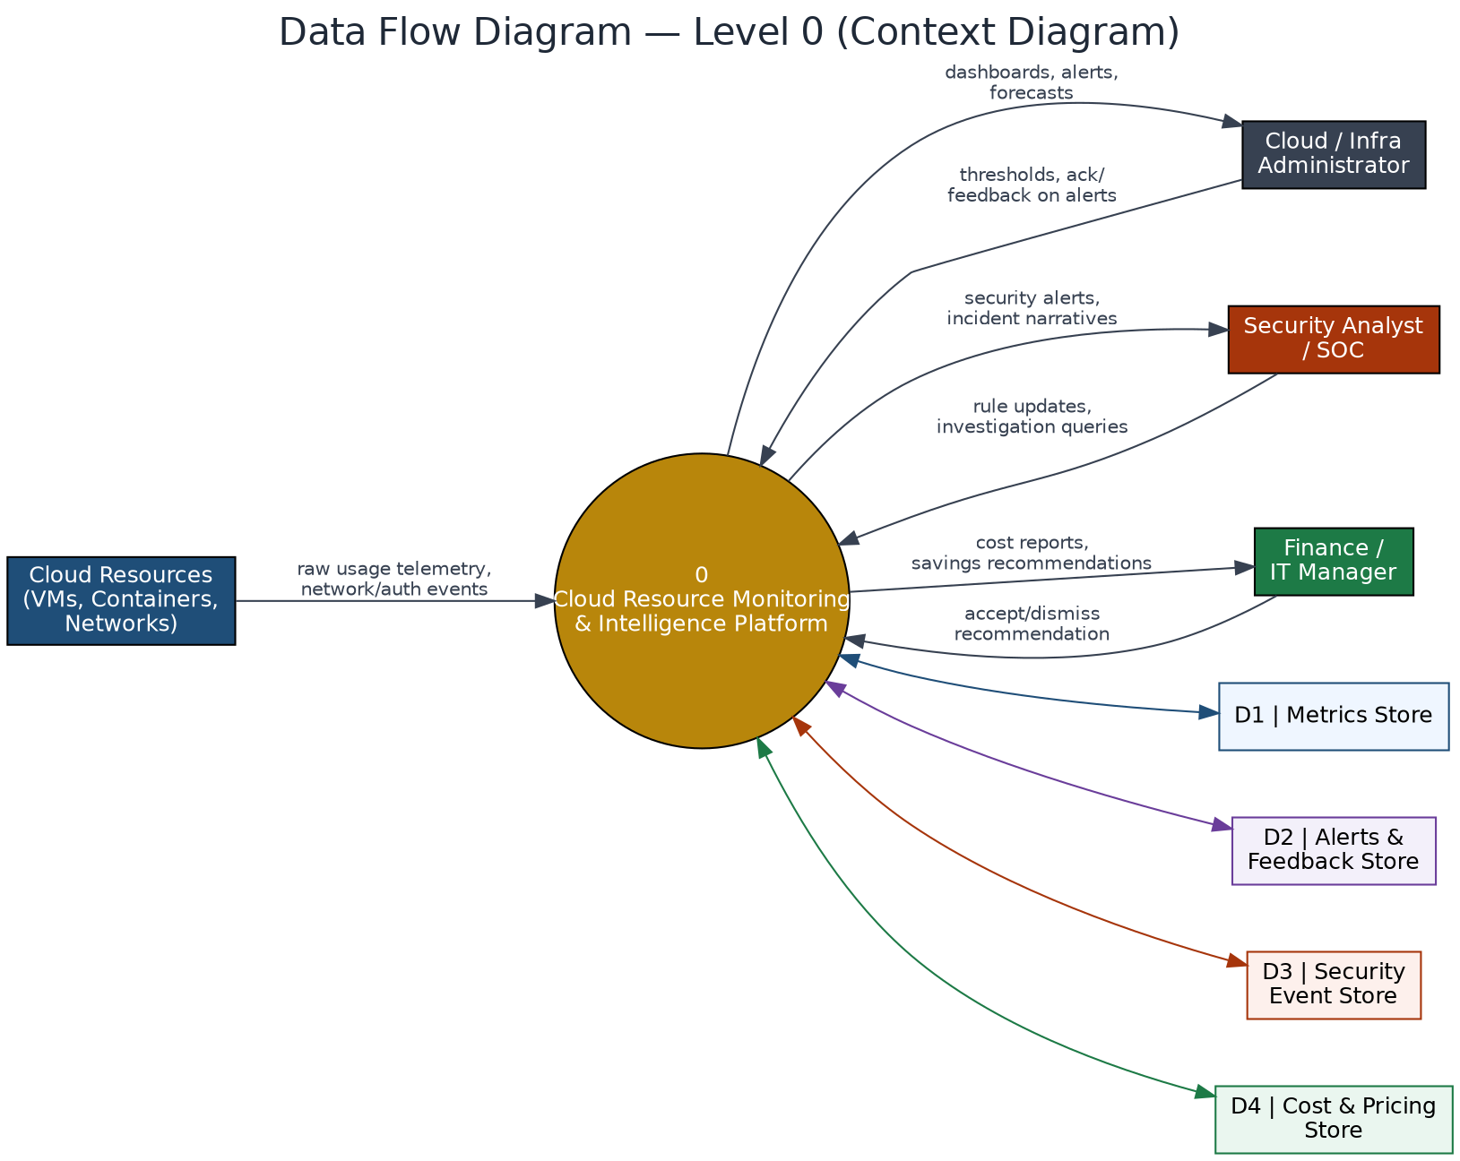
Figure 2 — Level 0 (context) data flow diagram.
Cloud resources push raw telemetry and security-relevant events into the system continuously. Administrators configure thresholds and receive dashboards/alerts; security analysts receive security alerts and can query for investigation; finance/IT managers receive cost reports and act on recommendations. All four data stores (metrics, alerts/feedback, security events, cost/pricing) are read and written by the central process, never directly by the external actors.

5. Database Design
The schema is deliberately host-centric: every metric, alert, security event, and cost recommendation references a single HOSTS table, which keeps cross-module correlation (the basis of Module 5) a simple join on host_id and a time window rather than a cross-system lookup.
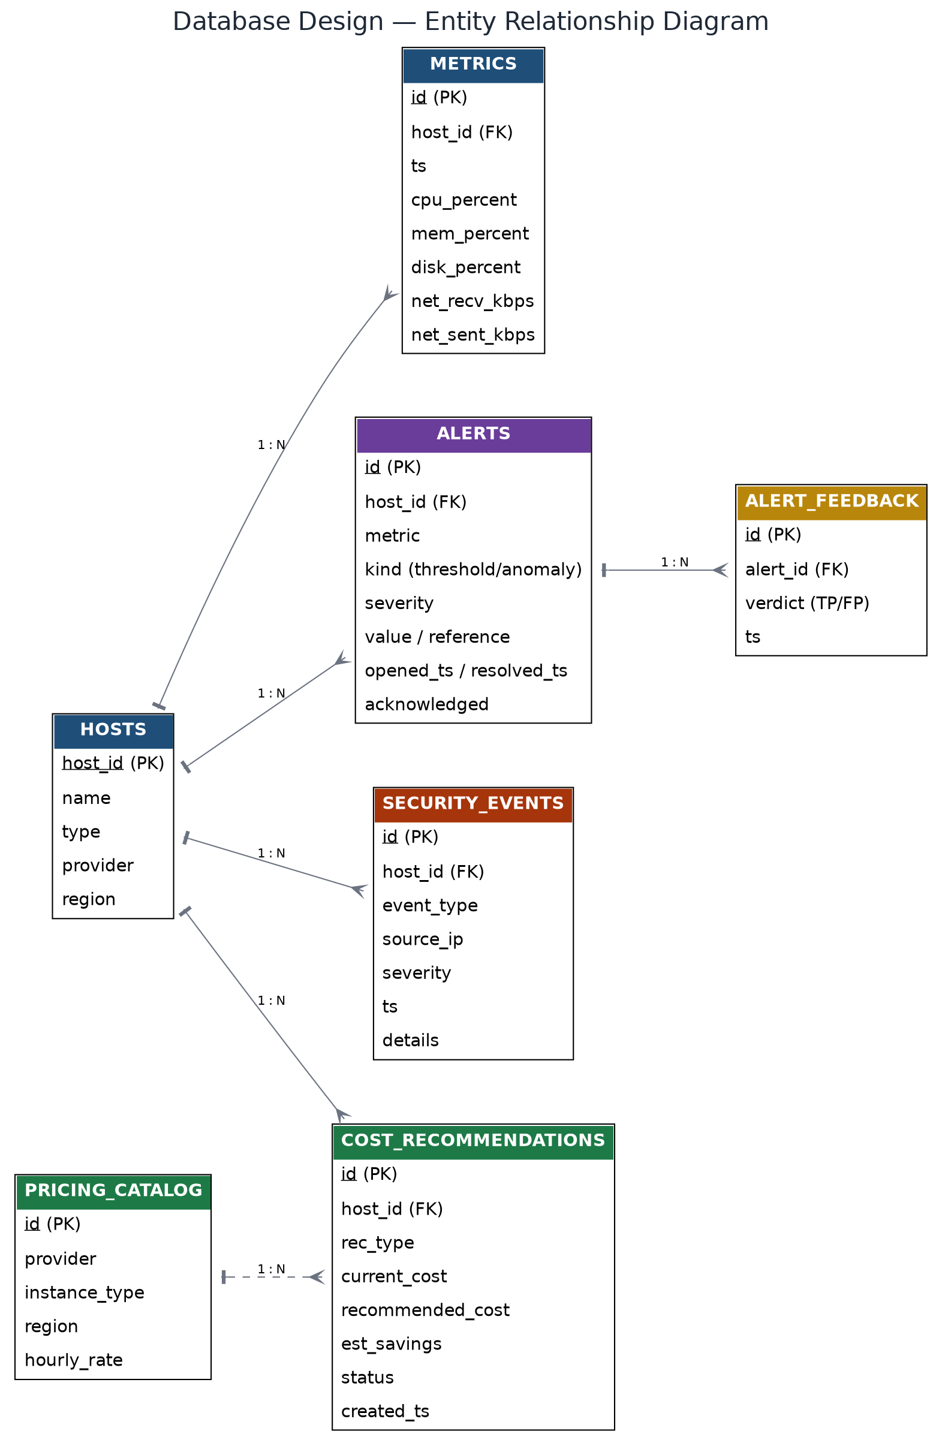
Figure 3 — Entity relationship diagram.

5.1 Table Notes
- METRICS is the highest-volume table and is the only one written on every polling interval; it should be indexed on (host_id, ts) and periodically downsampled for long-term retention.
- ALERTS deduplicates by (host_id, metric, kind) — only one open alert per combination at a time, consistent with the alert engine already implemented for Module 1.
- ALERT_FEEDBACK is new in this version and supports M5-FR6/FR7 — a human verdict per alert that the alert engine reads back to adjust future sensitivity.
- COST_RECOMMENDATIONS references PRICING_CATALOG loosely (by provider + instance_type) rather than a hard foreign key, since pricing data is refreshed independently.

6. Requirements Analysis
Functional and non-functional requirements for all five modules, consolidated. IDs are prefixed by module (M1–M5) for traceability.
MODULE 1 — RESOURCE MONITORING
ID | Requirement
M1-FR1 | Collect CPU, memory, storage, and network metrics from all registered resources at a configurable interval.
M1-FR2 | Auto-discover and register new cloud resources as they are provisioned.
M1-FR3 | Store metrics in a time-series datastore with configurable retention.
M1-FR4 | Provide real-time and historical dashboards per resource, group, and account/region.
M1-FR5 | Support configurable static threshold alert rules per metric.
M1-FR6 | Expose an API for programmatic access to metrics and alerts.
- NFR: scale horizontally to thousands of resources; dashboard refresh ≤2s; alert evaluation latency ≤30s; agents buffer/retry on network failure.
MODULE 2 — AI ANOMALY DETECTION & PREDICTION
ID | Requirement
M2-FR1 | Train an anomaly-detection model (Isolation Forest / autoencoder) on multi-metric historical data per resource.
M2-FR2 | Score incoming samples in near-real-time and flag multivariate anomalies single thresholds would miss.
M2-FR3 | Forecast CPU/memory/disk/network over a configurable horizon (e.g., 24–72h).
M2-FR4 | Raise predictive alerts when a forecast crosses a critical threshold before it occurs.
M2-FR5 | Support periodic retraining with a versioned model registry.
M2-FR6 | Report model confidence/quality metrics so operators can gauge trust.
M2-FR7 | Accept human feedback (true/false positive) to tune future sensitivity.
- NFR: scoring completes within seconds of ingestion; anomaly alerts indicate contributing metrics (explainability); falls back to threshold-only alerting until enough history exists.
MODULE 3 — RESOURCE COST OPTIMIZATION
ID | Requirement
M3-FR1 | Maintain/import a pricing catalog (on-demand, reserved, spot) per provider/region.
M3-FR2 | Estimate current spend per resource/group from usage history and pricing.
M3-FR3 | Identify idle/underutilized resources over a sustained period and flag for rightsizing.
M3-FR4 | Recommend an appropriately sized instance/tier from observed peak/average usage.
M3-FR5 | Identify resources suitable for reserved-instance/savings-plan commitments.
M3-FR6 | Provide a cost dashboard: spend trends, top-cost resources, open recommendations.
M3-FR7 | Track recommendation status (accepted/dismissed) and realized savings.
- NFR: cost estimates track actual billing within ±5% where reconcilable; recommendations recomputed at least daily; the module only recommends, never resizes/terminates automatically.
MODULE 4 — CLOUD-BASED INTRUSION DETECTION
ID | Requirement
M4-FR1 | Ingest network flow logs, auth logs, and firewall/security-group change events.
M4-FR2 | Detect known attack signatures/patterns (port scanning, brute-force logins, exfiltration to known-bad ranges).
M4-FR3 | Detect behavioral anomalies using the shared M2 engine trained on security features.
M4-FR4 | Classify events by severity and generate security alerts distinct from performance alerts.
M4-FR5 | Maintain an audit trail of security events and alert resolutions.
M4-FR6 | Support SIEM/ticketing integration for escalation.
M4-FR7 | Allow security rules/signatures to be updated without a full redeploy.
- NFR: high-severity alerts surface within seconds-to-minutes; detection sensitivity is tunable to control false positives; security event logs are append-only/tamper-resistant.
MODULE 5 — AI INCIDENT NARRATOR (CROSS-MODULE INTELLIGENCE)
ID | Requirement
M5-FR1 | Provide a natural-language query interface for operator questions about resource, cost, or security state.
M5-FR2 | Give the narrator agent tool access to Metrics, Alerts, Cost, and Security APIs, querying only what's needed per question.
M5-FR3 | Automatically correlate open security alerts with cost anomalies on the same resource within a time window into one combined incident.
M5-FR4 | Convert M2 forecasts into a plain-language time-to-threshold estimate per resource/metric.
M5-FR5 | Annotate every AI anomaly alert with its top contributing metric(s).
M5-FR6 | Let operators mark alerts true/false positive and persist the feedback.
M5-FR7 | Adjust per-resource/metric anomaly sensitivity from feedback without a full retrain.
M5-FR8 | Support a what-if query projecting cost/headroom for a hypothetical resource change.
M5-FR9 | Ground every narrator response in cited platform data (metric, alert ID, time range).
- NFR: query responses return within a few seconds for typical tool-call volumes; the narrator never autonomously executes changes; LLM tool-call count is bounded per query for predictable cost.

7. API Design
A single REST API surface serves all five modules, grouped by resource path. This is also the tool interface the Module 5 narrator agent calls.
Endpoint | Method | Purpose
/api/metrics | POST | Agent submits a metric sample for a host.
/api/metrics?host=&limit= | GET | Recent time-series for one host (charts).
/api/summary | GET | Latest sample + worst active alert status per host.
/api/alerts?active= | GET | List open (or all) alerts.
/api/alerts/{id}/ack | POST | Acknowledge an alert.
/api/alerts/{id}/feedback | POST | Record true/false-positive verdict (M5-FR6).
/api/forecast?host=&metric= | GET | Forecast series + time-to-threshold (M2/M5).
/api/cost/summary | GET | Spend trend and top-cost resources.
/api/cost/recommendations | GET/POST | List recommendations; update accepted/dismissed status.
/api/security/events?host= | GET | Security events for a host/time range.
/api/security/alerts | GET | Open security alerts (distinct stream from performance alerts).
/api/narrator/query | POST | Natural-language question in, grounded explanation out.

8. Unique Differentiating Features
These features specifically require the other modules to already exist and cooperate, which is what gives the platform an identity beyond a generic monitoring dashboard.
★ AI Incident Narrator — the flagship feature
An LLM-based agent with tool access to all module APIs. Given a question or a triggered alert, it queries the relevant APIs, correlates timestamps and signals across modules, and returns a plain-language, evidence-cited explanation.
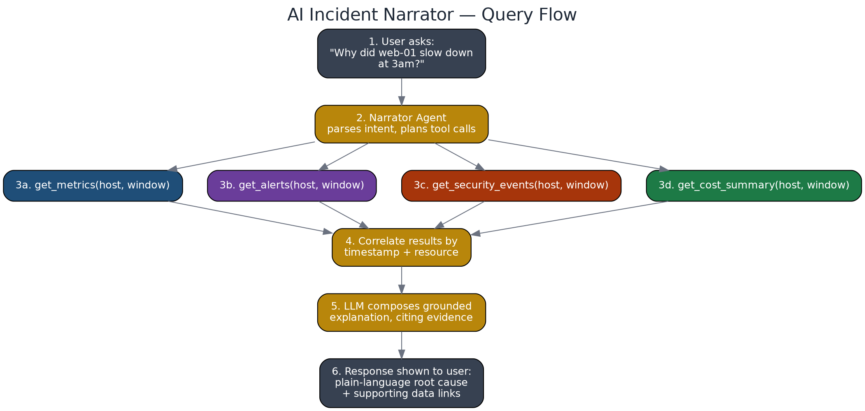
Figure 4 — AI Incident Narrator query flow.
★ Security ↔ Cost Correlation
Detects when an open security alert coincides with a cost anomaly on the same resource (e.g., a cryptojacking intrusion simultaneously driving up CPU and spend) and raises one combined incident instead of two unrelated alerts.
★ Predictive Failure Timeline
Converts forecasts into a plain countdown ("disk-full in 14 hours at current growth rate") rather than a chart the user has to interpret.
★ Explainable Anomaly Attribution
Every AI-flagged anomaly names its top contributing metric(s), so operators can trust or dispute a flagged event instead of treating the model as a black box.
★ Feedback-Tuned Sensitivity
Marking an alert true/false-positive adjusts that resource's sensitivity going forward — lightweight continuous learning without full retraining infrastructure.
★ What-If Simulation
Projects cost and utilization headroom for a hypothetical resource change from historical data, before anything is changed in production.

9. Technology Stack
MODULE 1 — RESOURCE MONITORING
Layer | Technology
Collection agents | psutil-based agent (prototype) → Prometheus Node Exporter / cAdvisor / cloud-native agents for production
Ingestion | REST/HTTP push (prototype) → Prometheus remote-write or Kafka at scale
Storage | SQLite (prototype) → Prometheus + Thanos/Mimir or InfluxDB/TimescaleDB
Dashboard | Custom HTML/CSS/JS canvas charts (prototype) → Grafana for production panels
MODULE 2 — AI ANOMALY DETECTION & PREDICTION
Layer | Technology
Anomaly detection | scikit-learn Isolation Forest, or a PyTorch autoencoder for richer multivariate patterns
Forecasting | Prophet / statsmodels ARIMA; LSTM as a stretch goal
Model serving | FastAPI microservice exposing /score and /forecast
Model registry | File-based versioning (prototype) → MLflow for production
Explainability | SHAP values for tree-based models
MODULE 3 — RESOURCE COST OPTIMIZATION
Layer | Technology
Pricing data | Cloud pricing/billing APIs (AWS Price List API, Azure Retail Prices API) or a maintained rate table
Analysis engine | Python batch job (pandas) joining usage with pricing on a schedule
Storage | Same store as Module 1, dedicated recommendations table
Dashboard | Cost tab on the unified dashboard
MODULE 4 — CLOUD-BASED INTRUSION DETECTION
Layer | Technology
Network telemetry | VPC/flow logs, audit logs; Suricata/Zeek for packet-level analysis where feasible
Signature detection | Suricata ruleset or a simplified custom rules engine for the prototype
Behavioral detection | Reuses the Module 2 model, trained on security-specific features
Event store | Elasticsearch/OpenSearch, or the same relational store at prototype scale
Escalation | Webhook integration to a SIEM/ticketing system
MODULE 5 — AI INCIDENT NARRATOR
Layer | Technology
LLM | Claude (Anthropic API) or an open-source model via tool-calling
Agent orchestration | Custom Python orchestrator wrapping REST APIs as tools (simplest) or LangChain/CrewAI for more structure
Tool interface | get_metrics / get_alerts / get_cost_summary / get_security_events as callable JSON-schema tools
Correlation logic | Python service joining Module 3 and Module 4 alerts by resource + time window
Feedback store | alert_feedback table read by the alert engine
SHARED PLATFORM SERVICES
Layer | Technology
Backend framework | Flask (prototype) → FastAPI recommended when scaling the API surface
Auth / RBAC | JWT-based auth with role claims — required before multi-user use
Notifications | SMTP email, Slack/Teams webhooks, PagerDuty/Opsgenie
Deployment | Docker per service, docker-compose at project scale, Kubernetes for production
Testing | pytest for backend logic; a labeled-incident dataset for validating anomaly/RCA accuracy

10. Implementation Plan
A 16-week phased plan, sequencing modules so each phase builds on data or services the previous phase already produced. Module 1 must ship first since every other module reads its data; Module 5 is scheduled last since it depends on all four others being queryable.
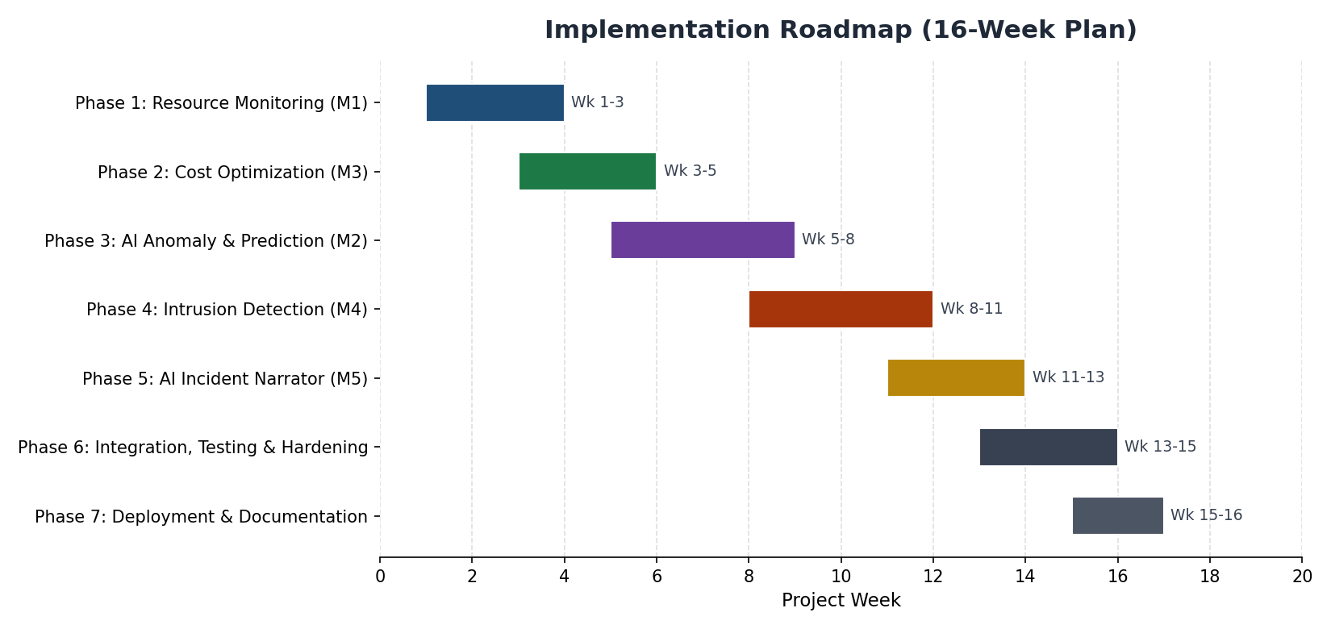
Figure 5 — Implementation roadmap.
Phase | Weeks | Key Deliverables
1. Resource Monitoring | 1–3 | Agents, ingestion API, time-series storage, dashboard, threshold alerts (already prototyped).
2. Cost Optimization | 3–5 | Pricing catalog, spend estimation, idle-resource detection, cost dashboard tab.
3. AI Anomaly & Prediction | 5–8 | Isolation Forest scoring, Prophet/ARIMA forecasting, predictive alerts, explainability.
4. Intrusion Detection | 8–11 | Event ingestion, signature rules, behavioral detection reusing Module 2, security dashboard tab.
5. AI Incident Narrator | 11–13 | Tool-calling agent, cross-module correlation, what-if simulation, feedback loop.
6. Integration, Testing & Hardening | 13–15 | End-to-end tests, auth/RBAC, load testing, bug fixing.
7. Deployment & Documentation | 15–16 | Containerization, deployment guide, final documentation, demo preparation.

11. Feasibility & Risk Analysis
Module | Feasibility | Key Risk | Mitigation
1. Monitoring | High — done | Agent data loss on network failure | Local buffering + retry on agents
2. AI Anomaly/Prediction | High (statistical) / Medium (deep learning) | Insufficient history for reliable baseline | Fall back to threshold-only alerting until enough data accumulates
3. Cost Optimization | High | Estimated cost drifts from actual billing | Reconcile against real billing data when available; state tolerance explicitly
4. Intrusion Detection | Medium — behavioral only | False positives from noisy behavioral detection | Tunable sensitivity; start with signature rules for known patterns, add behavioral gradually
5. AI Narrator | Medium-High | Ungrounded/hallucinated explanations | Force tool-call grounding (M5-FR9); cap tool-call count; require citations in every response

12. Testing Strategy
- Unit tests: alert engine threshold/anomaly logic, cost calculation functions, API request/response contracts (pytest).
- Integration tests: end-to-end flow from agent → ingestion → storage → alert → dashboard, using the simulated multi-host fleet.
- Model evaluation: precision/recall of the anomaly detector against a labeled set of known incidents; forecast error (MAE/RMSE) against held-out history.
- Narrator evaluation: a fixed set of test questions with known correct answers, checking both accuracy and that citations match real data (no hallucination).
- Load testing: ingestion and dashboard performance under a growing number of simulated hosts, to validate the scalability NFRs.

13. Deployment Plan
- Containerize each service (monitoring API, AI service, cost engine, IDS engine, narrator service) with its own Dockerfile.
- Compose all services with docker-compose for local/project-scale deployment, including the database and reverse proxy.
- Configure environment-based secrets (LLM API key, DB credentials) — never hard-coded.
- Deploy agents to target hosts (or use the simulator for demonstration) pointing at the deployed ingestion endpoint.
- For production scale, migrate storage to a managed time-series/search backend and move orchestration to Kubernetes.

14. Conclusion
This document consolidates the platform's requirements, architecture, database design, API surface, unique differentiators, technology stack, and implementation plan into a single reference. The design keeps every module reading from one shared data model (Section 5), which is what makes Module 5's cross-module reasoning possible without duplicated infrastructure. The phased roadmap (Section 10) sequences delivery so a working, demonstrable system exists at the end of every phase, not only at the very end of the project.

15. References
Meera, A., & Swamynathan, S. (2013). Agent based Resource Monitoring System in IaaS Cloud Environment. Procedia Technology, 10, 200–207.
RCACOPILOT: Automatic Root Cause Analysis via Large Language Models for Cloud Incidents. arXiv:2305.15778.
RCAgent: Cloud Root Cause Analysis by Autonomous Agents with Tool-Augmented Large Language Models. ACM CIKM 2024.
Barrett et al. Observability and Monitoring Using Prometheus and Grafana in Cloud Setups. ResearchGate (2023).
An Overview of the Commercial Cloud Monitoring Tools. arXiv:1312.6170.
CNAPP: Cloud-Native Application Protection Platform — vendor documentation (Wiz, Orca, CrowdStrike, Palo Alto Networks).
Datadog Cloud Cost Management and Cloud Security Management — product documentation, datadoghq.com.

