STORE SALES PREDICTION

Wireframe Documentation

Home Page

It is divided into two sections –

* The first section on the top of with 10 input data to predict inputs given by user.
* The second section below it to predict data in bulk on database.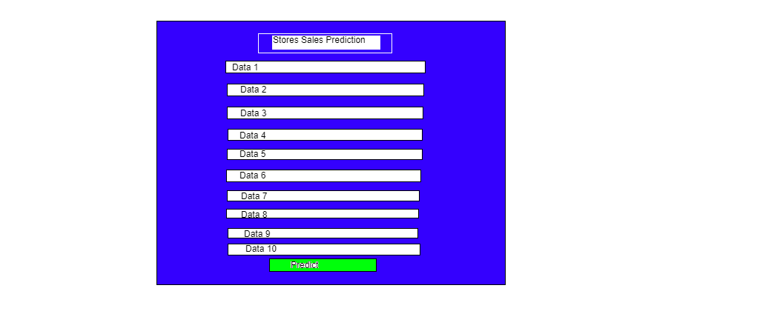

For Bulk Prediction

