Software Testing Principles

* Software testing is a procedure of implementing software or the application to identify the defects or bugs.
* For testing an application or software, we need to follow some principles to make our product defects free.
* It also helps the tester to test the software with their effort and time.

**There are Seven Types of Principles of Software Testing:**

1. Testing shows the presence of defects
2. Exhaustive Testing is not possible
3. Early Testing
4. Defect Clustering
5. Pesticide Paradox
6. Testing is context-dependent
7. Absence of errors fallacy

**4) Defect Clustering:**

* While testing any software, the testers mostly come across a situation wherein most of the defects are found related to some specific functionality and the rest of the functionalities will have a lower number of defects.
* **Defect clustering** means a small number of modules containing most of the defects.
* Basically, the defects are not distributed uniformly across the entire application, rather defects are concentrated or centralized across two or three functionalities.
* Defect Clustering is based on “**Pareto Principle**” which is also known as **80-20 rule**.
* It means that 80% of the defects are found due to 20% of the modules in the application.
* The concept of Pareto Principle was initially defined by an Italian economist*–* **Vilfrodo Pareto.**

**For Example**:

Let’s consider the below image which is tested for one of the banking application and it shows that most of the defects are related to the “Overdraft” functionality. Rest of the functionalities like Account Summary, Funds Transfer, Standing Instruction etc., have limited number of defects.

[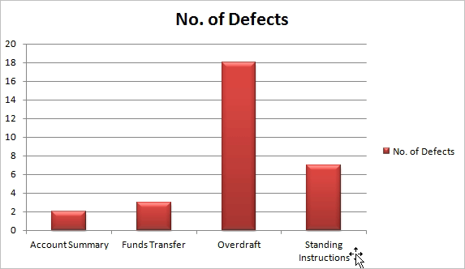](https://www.softwaretestinghelp.com/wp-content/qa/uploads/2018/11/Defect-Clustering.png)

* The above picture states that there are **18 defects** around the Overdraft functionality out of the total **20 defects**, which means that **80%** of the defects are found in the “Overdraft” module.
* Hence, testers mostly concentrate on this area during execution to find more and more defects.
* It is recommended that the testers should have a similar focus on the other modules as well during testing.
* **Defect clustering** indicates that the defect-prone area is to be tested thoroughly during regression testing.