1)Launch one EC2 using Amazon Linux 2 image and add a script in user data to install Apache.

STEP A — Go to EC2 Console
- Login to AWS
- Services → EC2
- Click Launch instance

STEP B — Name your instance
Name: AmazonLinux-Apache
This is just a tag. Helps in identifying.

STEP C — Choose AMI
Select:
Amazon Linux 2 AMI (HVM), SSD
Why?
- Best support in AWS
- Yum package manager is fast
- Integrated with AWS tools

STEP D — Choose instance type
For labs:
t2.micro (Free tier eligible)

STEP E — Key Pair
This is required to SSH into the instance.
You can:
- Create new key → choose .pem
- Or use existing
Why?
SSH needs a private key to authenticate securely.

STEP F — Security Group
Create New Security Group:
Allow:
- SSH (22) → Your IP
- HTTP (80) → Anywhere (0.0.0.0/0)
Why port 80?
Apache serves websites on port 80, so browser should reach it.

🧠 STEP G — Add User Data (MOST IMPORTANT PART)
Scroll to “Advanced Details”
Find User Data section
Paste this script:

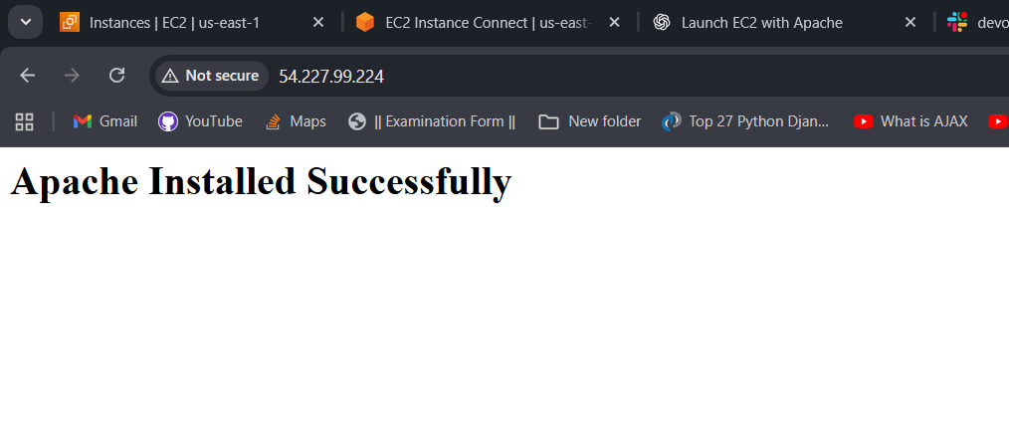
2)Launch one EC2 using Ubuntu image and add a script in user data to install Nginx.
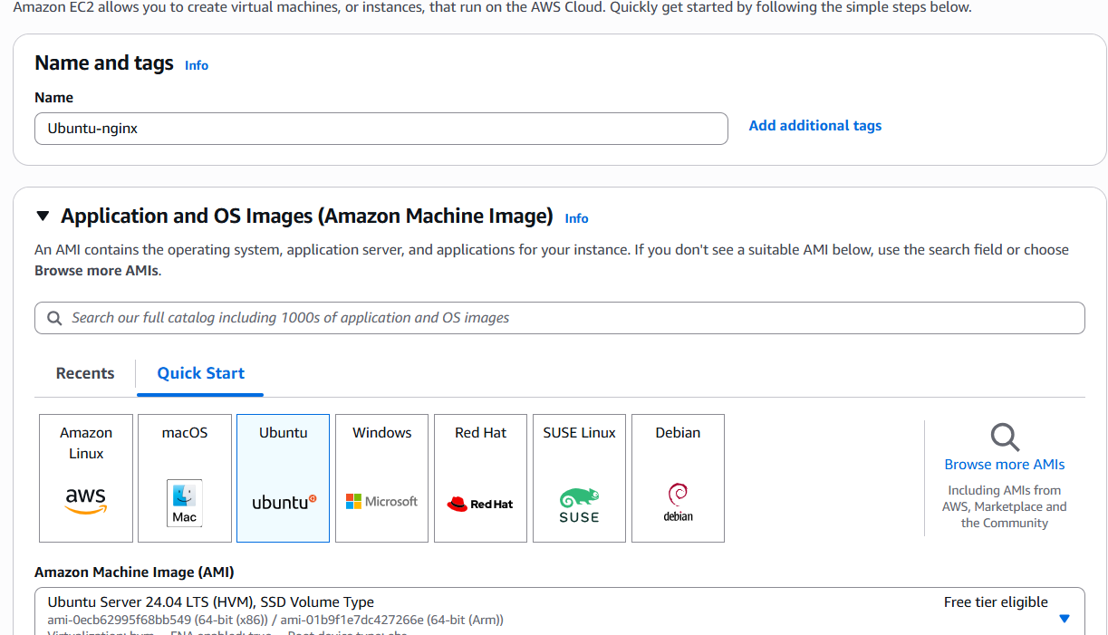
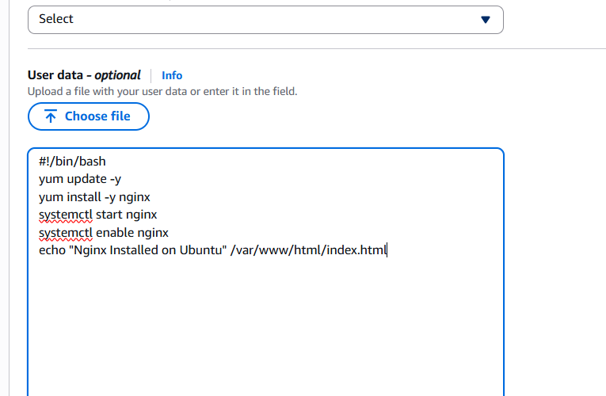
3)Launch one Windows server and install Tomcat on Windows.

✅ Step 1 — Go to EC2 → Launch Instance
Name:
Windows-Tomcat-Server

✅ Step 2 — Choose AMI (Windows OS)
Under “Microsoft Windows” choose:
Windows Server 2019 Base
(or 2022 — both work)
Why?
- Stable
- Supports Tomcat
- Java can be installed easily

✅ Step 3 — Choose Instance Type
Minimum recommended:
t3.medium (2 vCPU, 4GB RAM)
But for learning, even t2.micro works.

Step 4 — Key Pair
Select your existing key or create a new one.
This key is needed to decrypt the Windows password later.

✅ Step 5 — Security Group
Allow:
- RDP (3389) → Your IP
- HTTP (80) → Anywhere
- HTTPS (443) → Anywhere (optional)
Why?
- RDP is needed to access Windows GUI
- Tomcat works on port 8080, but Tomcat binds to ANY port by default, so 80/443 is fine for access
- We will manually open 8080 too

✅ Step 6 — Launch Instance
Done.
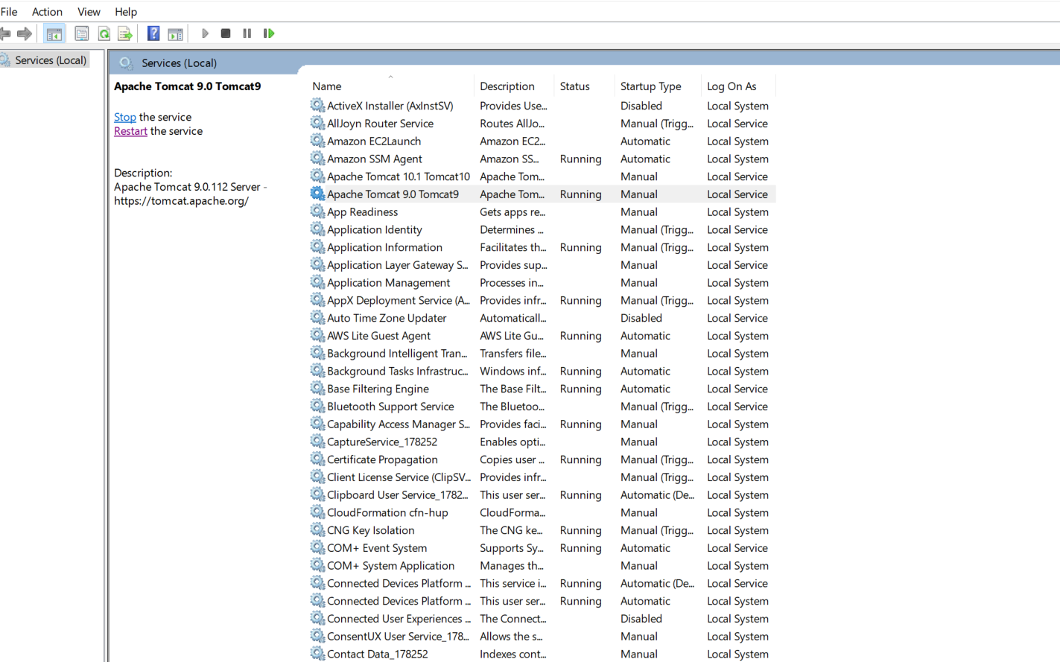
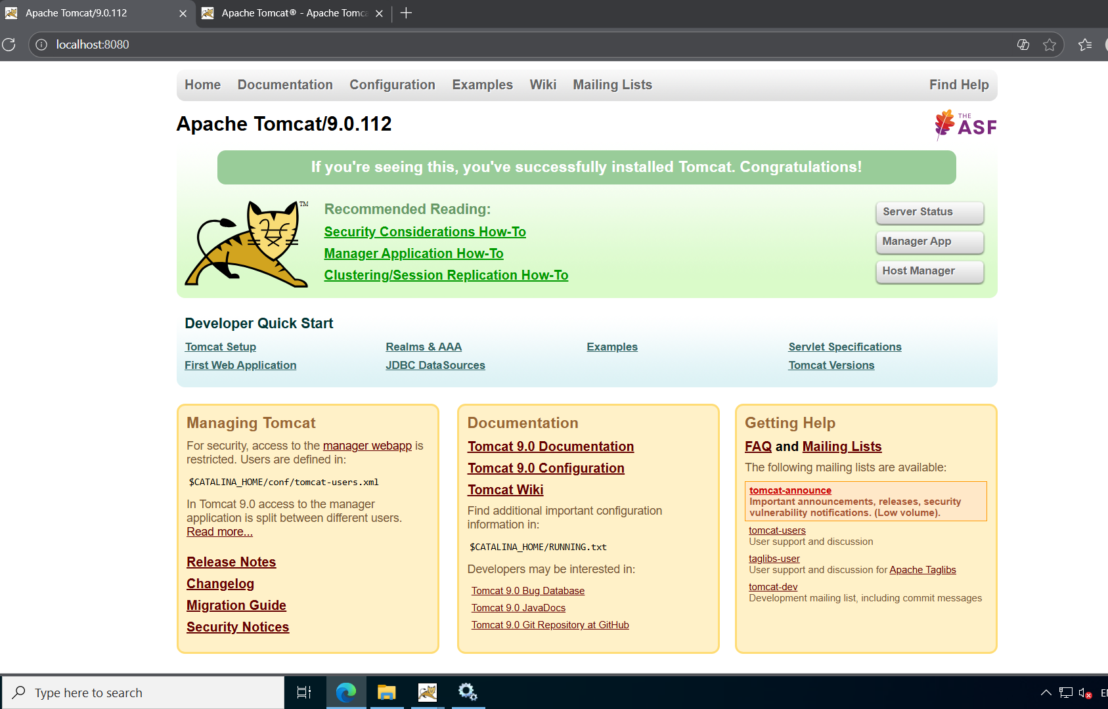

4)Take a snapshot of the instance created in Task 1.
A snapshot is a backup of your EC2’s root EBS volume. It lets you restore the server anytime or create new volumes/AMIs from it.
1. Go to:
EC2 Console → Instances
2. Select the Task-1 instance (Amazon Linux).
3. Scroll down to the “Storage” section.
4. Click the Volume ID (example: vol-xxxxxxxx).
5. On the volume page click:
Actions → Create snapshot
6. Fill details:
Name: Task1-EC2-Snapshot
Description: Snapshot of root volume of Task 1 instance
7. Click Create snapshot.
8. Verify:
EC2 → Snapshots → Status: completed.
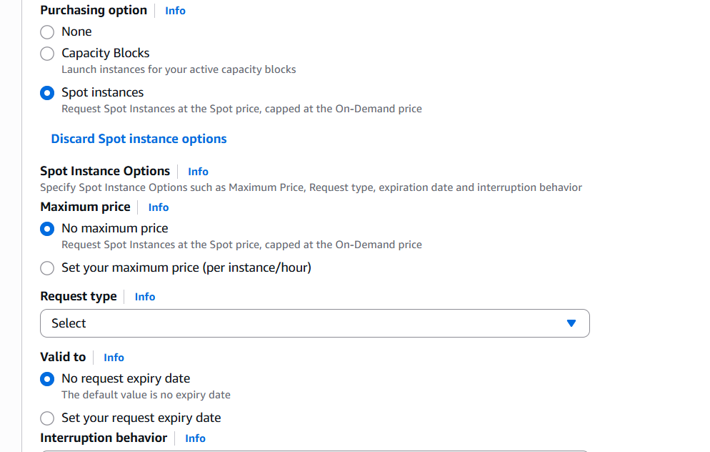
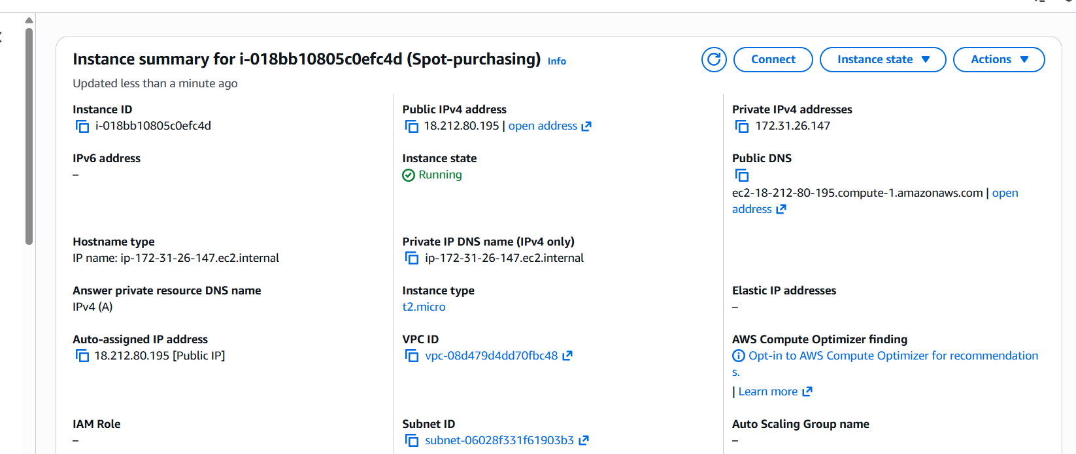

5)Assign passwordless authentication for the EC2 created in Task 2.
# 1) Go to folder where key is stored
cd ~/Downloads
# 2) Fix key permissions
chmod 400 webapp.pem
# 3) SSH into the Ubuntu EC2 (passwordless using key pair)
ssh -i "webapp.pem" ubuntu@<Public-IP>
# 4) (Optional: Add your own custom SSH key)
# Generate new SSH key on your laptop
ssh-keygen -t rsa -b 2048 -f myubuntu
# Copy the public key
cat myubuntu.pub
# Add this public key to EC2
mkdir -p ~/.ssh
chmod 700 ~/.ssh
echo "ssh-rsa AAAA.....your_public_key_here....." >> ~/.ssh/authorized_keys
chmod 600 ~/.ssh/authorized_keys
# 5) Logout
exit
# 6) Login using your custom private key (passwordless)
ssh -i "myubuntu" ubuntu@<Public-IP>
# RESULT:
# Passwordless login enabled using SSH keys.
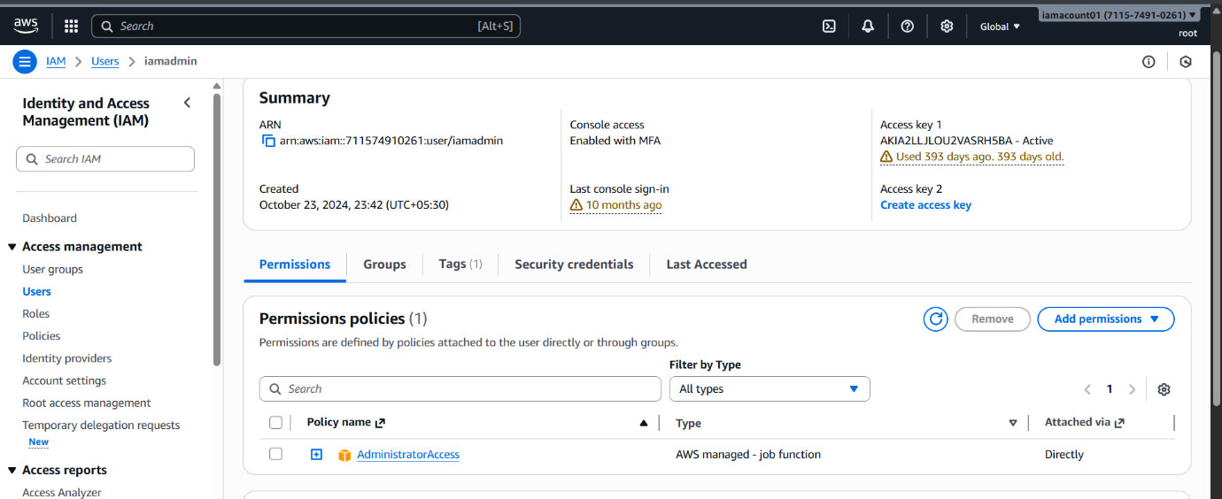

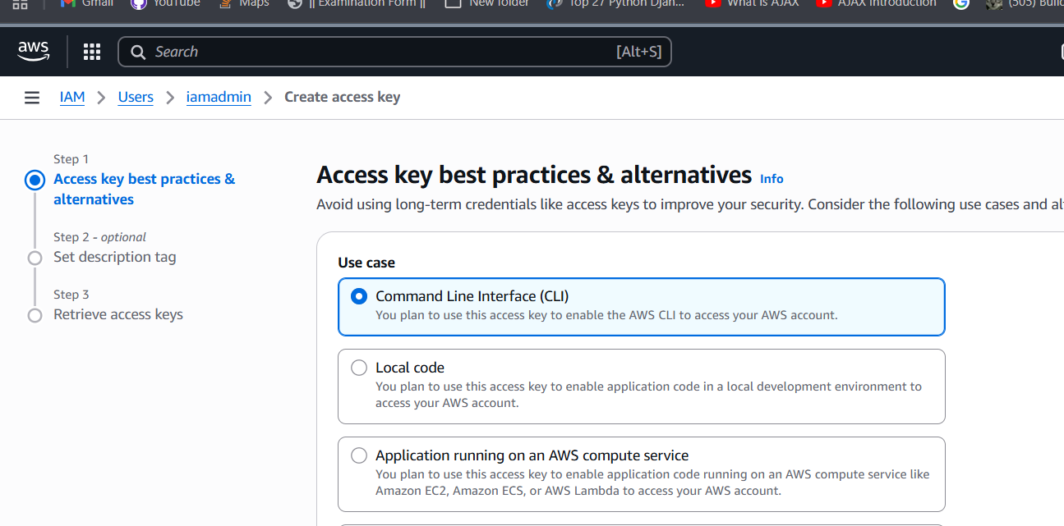

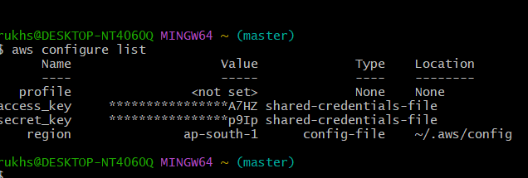
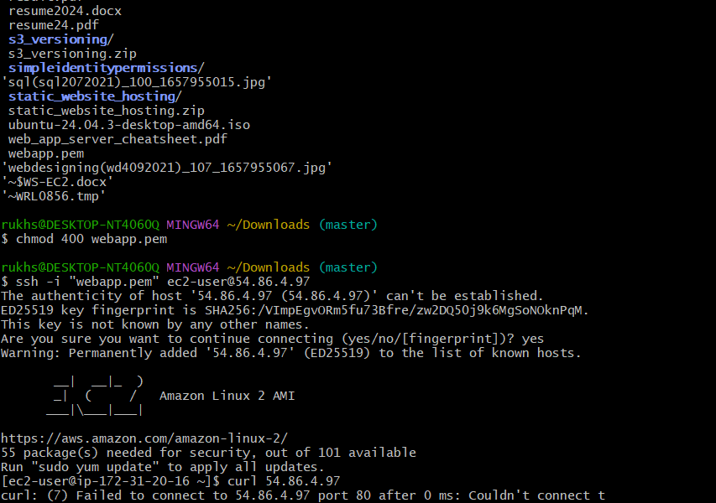

6)Launch any EC2 using the spot purchasing option.
Spot Instances are up to 90% cheaper than On-Demand instances. Good for testing, automation, and non-critical workloads.
1. Go to:
EC2 Console → Launch Instance
2. Name:
Spot-Instance-Server
3. Choose AMI:
Amazon Linux 2 AMI
4. Instance type:
t3.micro (or any)
5. Enable Spot:
In “Instance type” section → Tick:
✓ Request Spot Instances
Leave Max price empty (default).
Interruption behavior: Terminate.
6. Choose Key Pair.
7. Configure Security Group:
SSH (22) → Your IP
HTTP (80) → Anywhere (optional)
8. Click Launch Instance.
9. Instance moves through:
pending → spot request fulfilled → running.

7)Enable termination policy on the EC2 created in Task 2.
1. Go to:EC2 Console → Instances
2. Select the Task-2 EC2 instance (Ubuntu with Nginx).
3. Click:
Actions → Instance settings → Modify termination protection
4. Select:
Enable
5. Click Save.
Result:
Termination protection is ON — prevents accidental termination of the server.
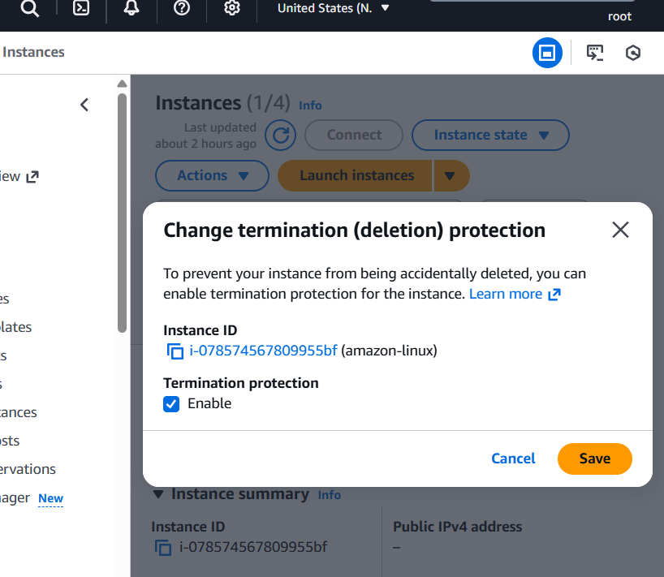

8)Launch one EC2 using AWS CLI.
AWS CLI allows automated, repeatable, script-based EC2 creation — essential for DevOps, CI/CD, and infrastructure automation.
# TASK 8 — Launch EC2 Using AWS CLI (us-east-1)
# 1) Configure AWS CLI (only once)
aws configure
# Access Key ID: <your-key>
# Secret Access Key: <your-secret>
# Default region: us-east-1
# Output format: json
# 2) Launch EC2 using CLI
aws ec2 run-instances \
--image-id ami-0c02fb55956c7d316 \
--instance-type t2.micro \
--count 1 \
--key-name webapp \
--security-group-ids sg-000fd428787496815 \
--subnet-id subnet-06028f331f61903b3 \
--associate-public-ip-address
# 3) Verify instance status
aws ec2 describe-instances --filters Name=instance-state-name,Values=running
# 4) Copy Public IP from output, then SSH into it
ssh -i "webapp.pem" ec2-user@<Public-IP>
# RESULT:
# New EC2 instance successfully launched using AWS CLI.
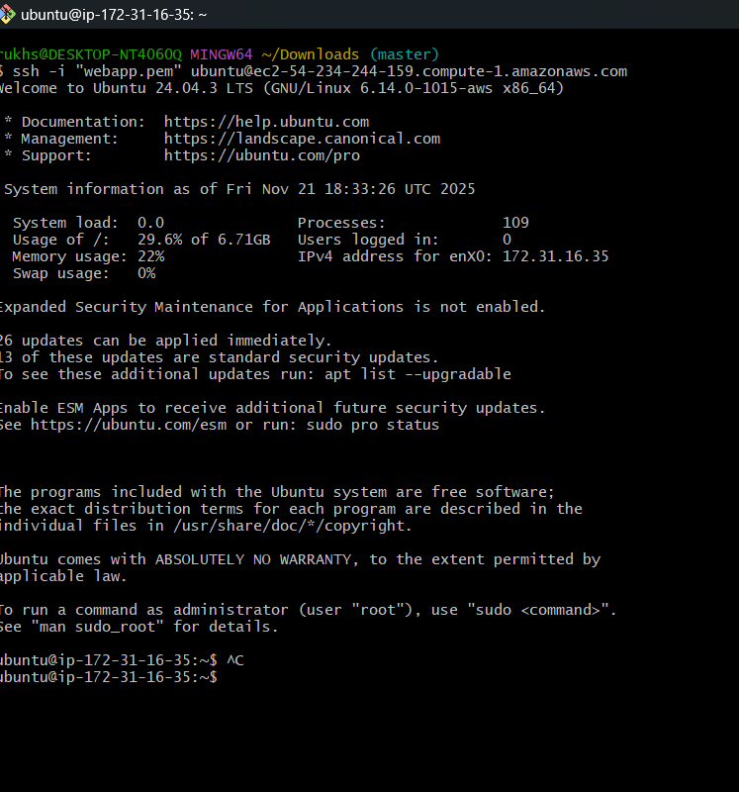
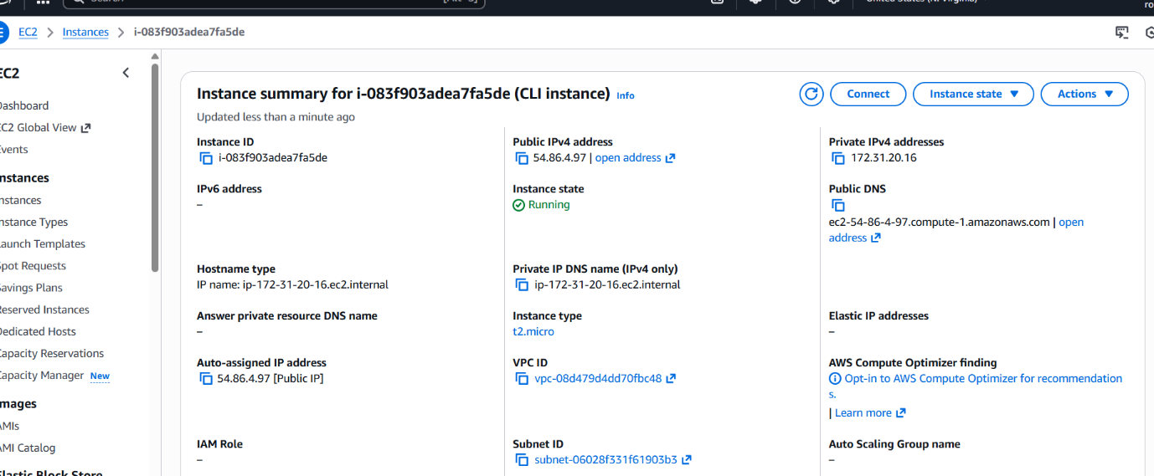

--image-id Amazon Linux 2 for ap-south-1 (Mumbai)
--instance-type EC2 type (free-tier eligible)
--key-name Your key pair
--security-group-ids Firewall rules SG
--subnet-id Subnet inside Mumbai VPC
--associate-public-ip-address Gives Public IP automatically

