1.Create one IAM user and assign EC2 and S3 Full Access roles
- Go to IAM → Users → Create User.
- Enter username (example: admin-user).
- Skip access key if not required.
- After creation, go to the Permissions tab.
- Click Add Permissions → Attach Policies Directly.
- Search and attach:
  - AmazonEC2FullAccess
  - AmazonS3FullAccess
- Save.
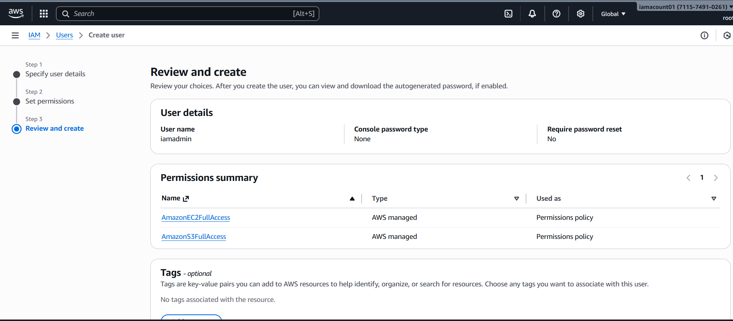

2.Create one group in IAM and assign read access for EC2

Steps
- Go to IAM → User Groups → Create Group.
- Enter group name (example: EC2-ReadOnly-Group).
- Under permissions, search for:
  - AmazonEC2ReadOnlyAccess
- Select and create the group.
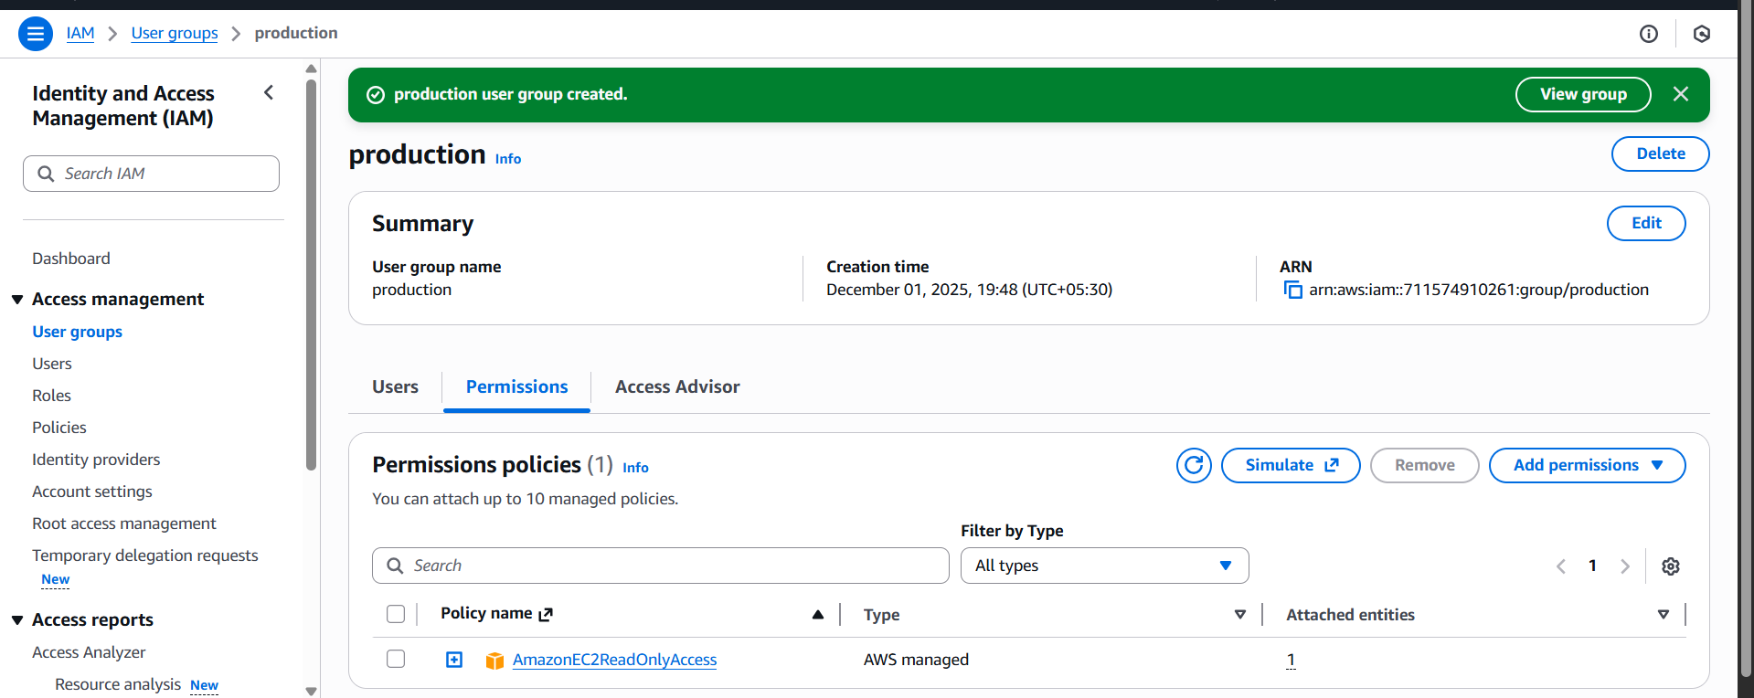

3.Create a new user named "Devops" and add to the group created in Task

Steps
- Go to IAM → Users → Create User.
- Enter username: Devops.
- Create user.
- Open user → Groups → Add User to Group.
- Select EC2-ReadOnly-Group.
- Save.

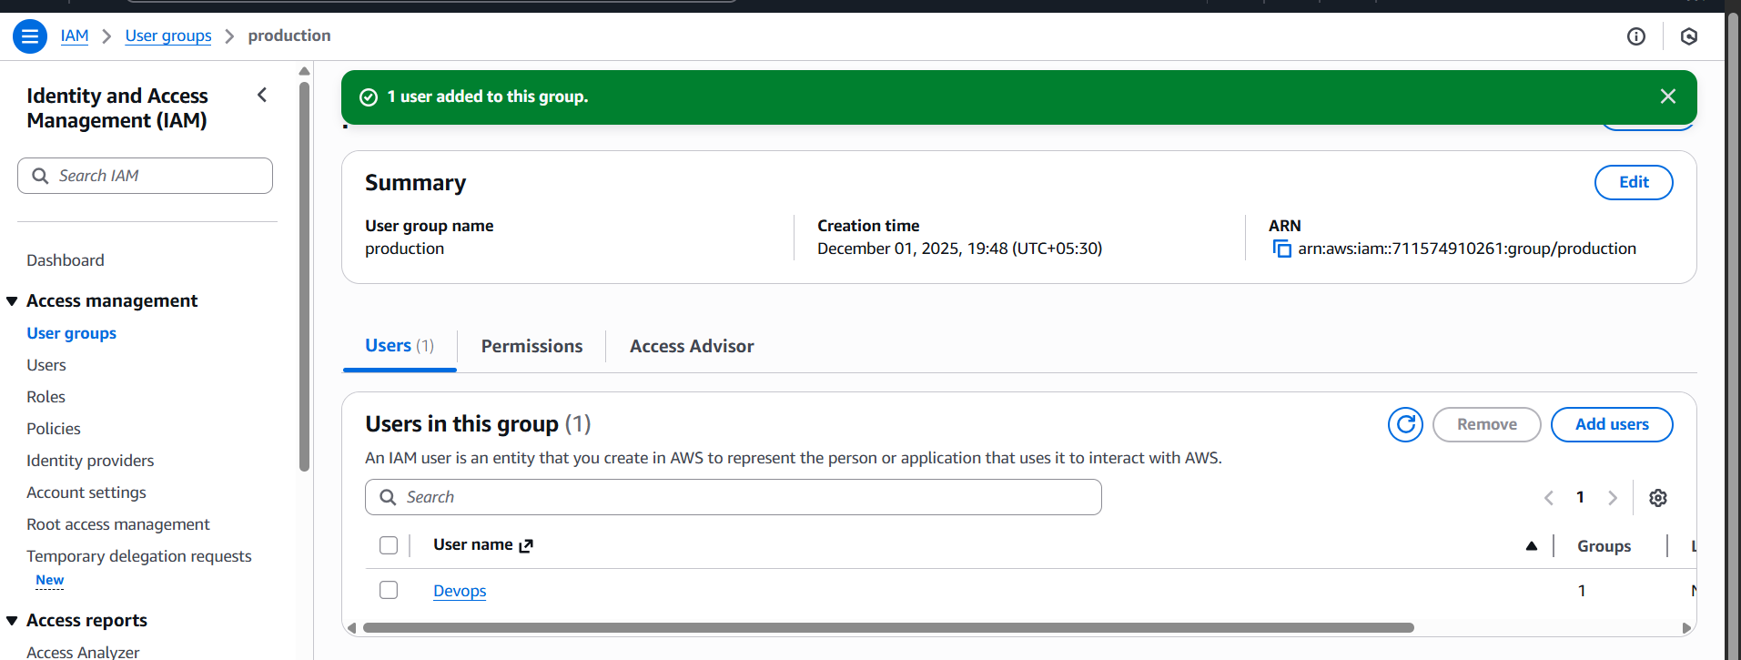

4.Write a bash script to create an IAM user with VPC full access
#!/bin/bash

USER_NAME="vpc-user"

# Create IAM user
aws iam create-user --user-name $USER_NAME
# Attach VPC Full Access Policy
aws iam attach-user-policy \
--user-name $USER_NAME \
--policy-arn arn:aws:iam::aws:policy/AmazonVPCFullAccess
echo "User $USER_NAME created with VPC Full Access."
Note:
Before running script you must configure AWS CLI:
aws configure
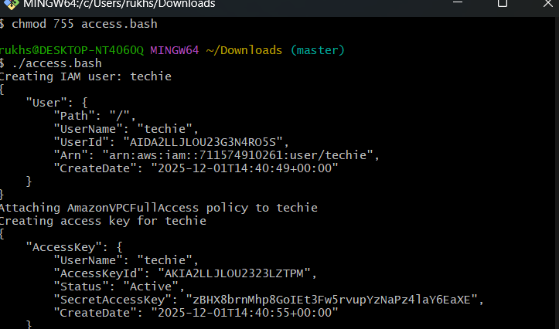
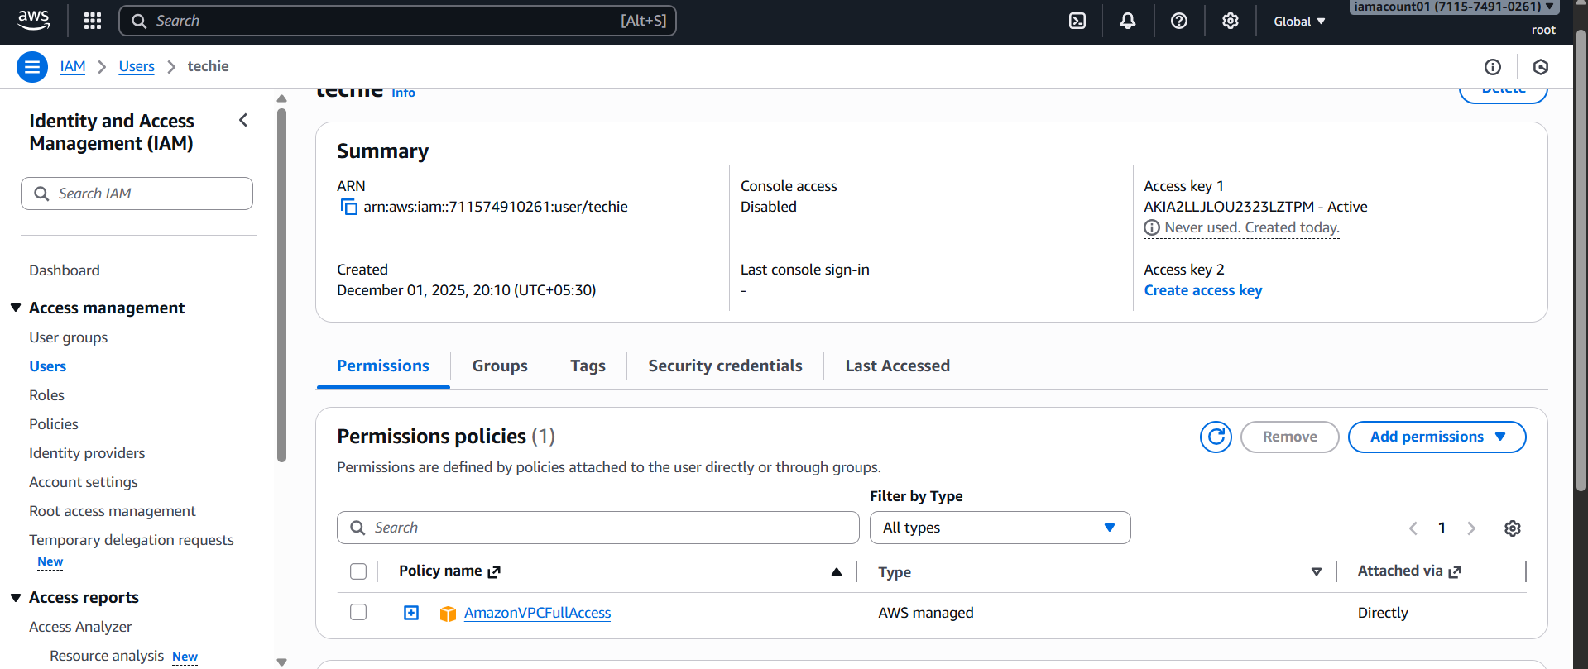

5.IAM policy to allow EC2 access only in specific regions
Script

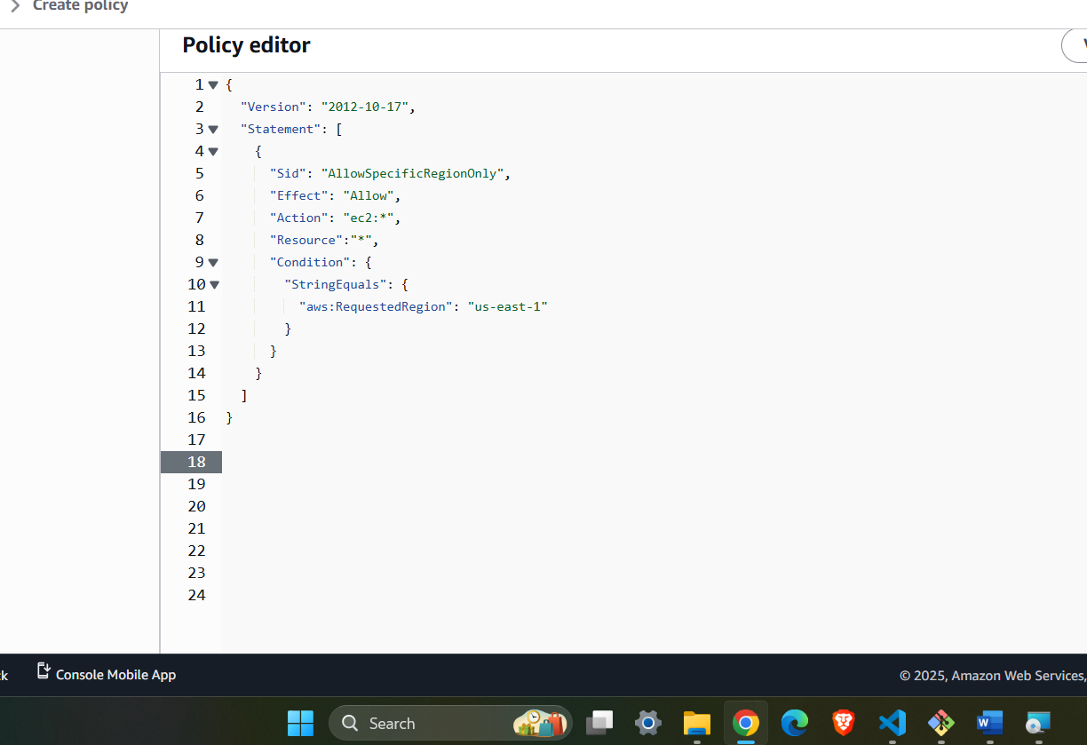
Steps
- Go to IAM → Policies → Create Policy.
- Choose JSON tab.
- Paste the above JSON.
- Name it (example: EC2-Region-Lock-Policy).
- Attach it to the specific user.

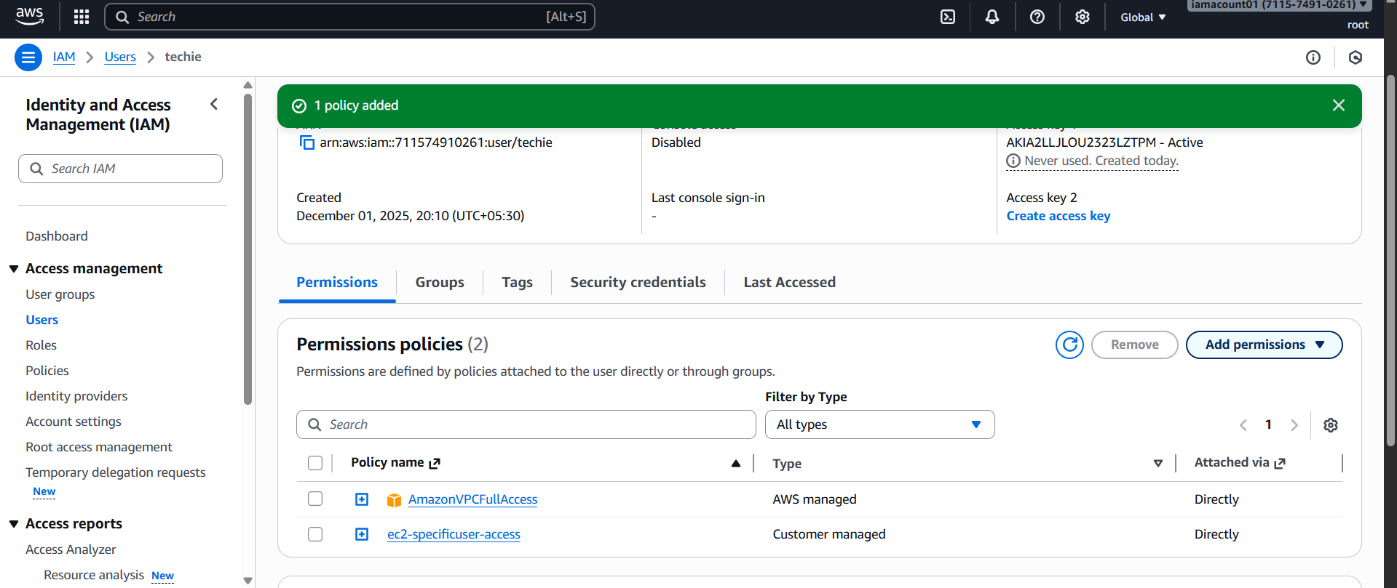

- Cross-Account S3 Access (Account A → Account B)We want:
User in Account A should access S3 bucket in Account B.

Step-by-Step (Simple Explanation)

1. In Account B — Edit S3 Bucket Policy
Add Account A user or role ARN.
Example bucket policy:
{
"Version": "2012-10-17",
"Statement": [
{
"Effect": "Allow",
"Principal": {
"AWS": "arn:aws:iam::<ACCOUNT-A-ID>:user/DevUser"
},
"Action": "s3:*",
"Resource": [
"arn:aws:s3:::my-cross-bucket",
"arn:aws:s3:::my-cross-bucket/*"
]
}
]
}

2. In Account A — Give the user S3 permissions
Attach policy:
{
"Version": "2012-10-17",
"Statement": [
{
"Effect": "Allow",
"Action": "s3:*",
"Resource": "*"
}
]
}

3. Test from Account A
Run:
aws s3 ls s3://my-cross-bucket
If bucket policy + user policy are correct → access works.

