VPC-Virtual Private Cloud
1)Create VPC with 2 private and 2 public subnets.
- Create VPC: Navigate to VPC > Your VPCs. Click Create VPC, name it vpc-01,vpc-02.., and set the IPv4 CIDR Block to 10.0.0.0/16.
- Create Subnets: Navigate to Subnets. Click Create Subnet and create the four subnets listed above, ensuring you select vpc-01 and place Public 1/Private 1 in one AZ, and Public 2/Private 2 in a different AZ.

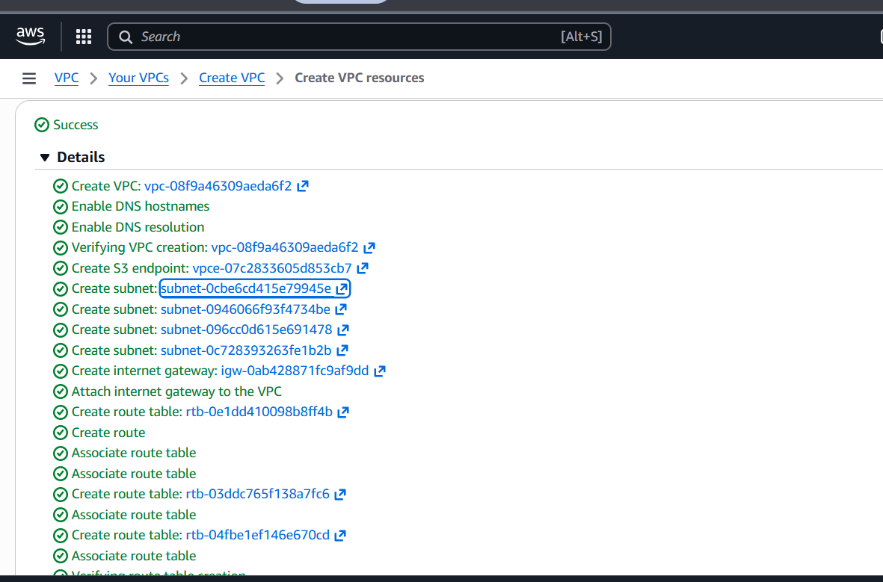
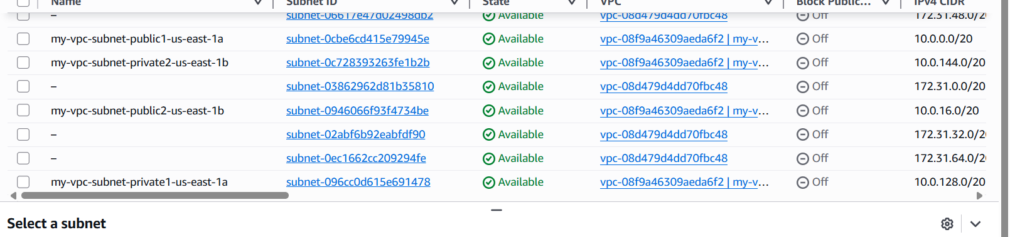

2)Enable DNS Hostname in VPC.
- Create VPC: Navigate to VPC > Your VPCs. Click Create VPC, name it MultiTier-VPC, and set the IPv4 CIDR Block to 10.0.0.0/16.
- Create Subnets: Navigate to Subnets. Click Create Subnet and create the four subnets listed above, ensuring you select MultiTier-VPC and place Public 1/Private 1 in one AZ, and Public 2/Private 2 in a different AZ.

3)Enable Auto Assign Public IP in 2 public subnets.
Ensure that any new EC2 instance launched in the public subnets automatically receives a public IP address, allowing direct access from the internet (e.g., for a web server or bastion host).

Steps
- Navigate to Subnets: Go to VPC > Subnets.
- Select Public Subnet 1: Select the Public Subnet 1 (e.g., 10.0.1.0/24).
- Edit Subnet Settings: In the Actions dropdown menu, select Edit subnet settings.
- Enable Auto-Assign: Check the box for Enable auto-assign public IPv4 address.
- Save: Click Save changes.
- Repeat: Repeat steps 2-5 for the Public Subnet 2 (e.g., 10.0.2.0/24).

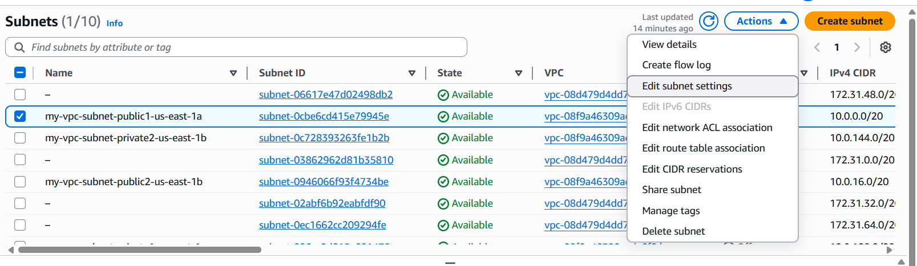
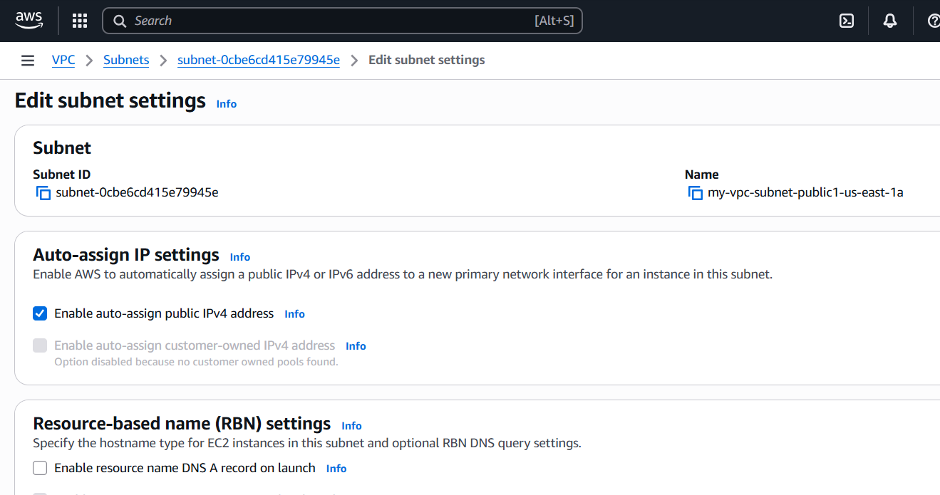

4)Add 2 private subnets in private route table.

steps to attach Private Subnets to Private Route Tables

✔ For subnet-1 (private1-us-east-1a)
- Go to VPC → Route Tables
- Click on:
rtb-03ddc765f138a7fc6 | my-vpc-rtb-private1-us-east-1a
- Select the Subnet associations tab
- Click Edit subnet associations
- Checkbox:
✔ subnet-096cc0d615e691478
- Save
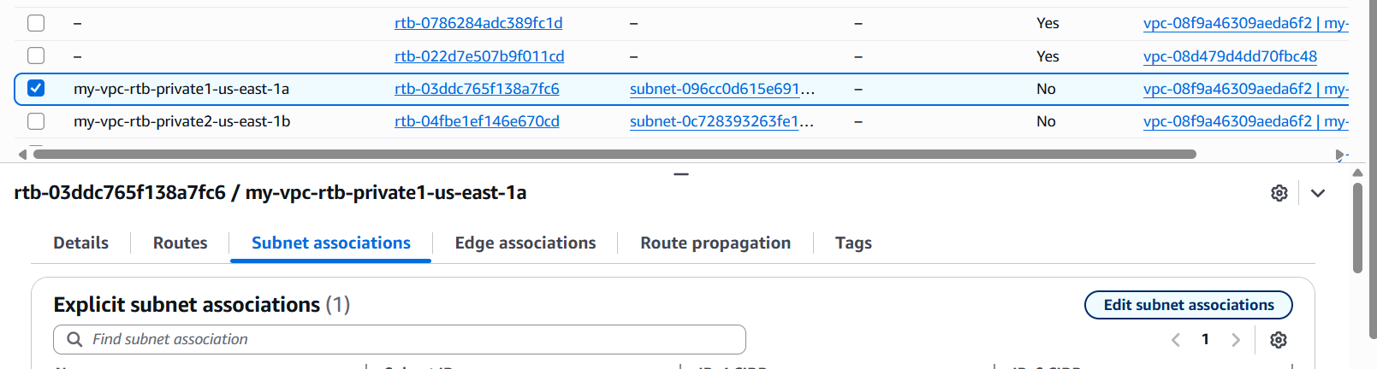
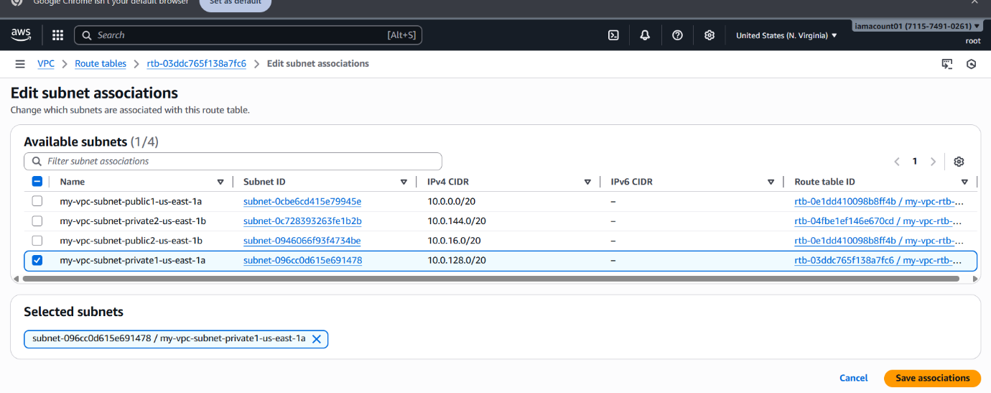

5)Add 2 public subnets in public route table.
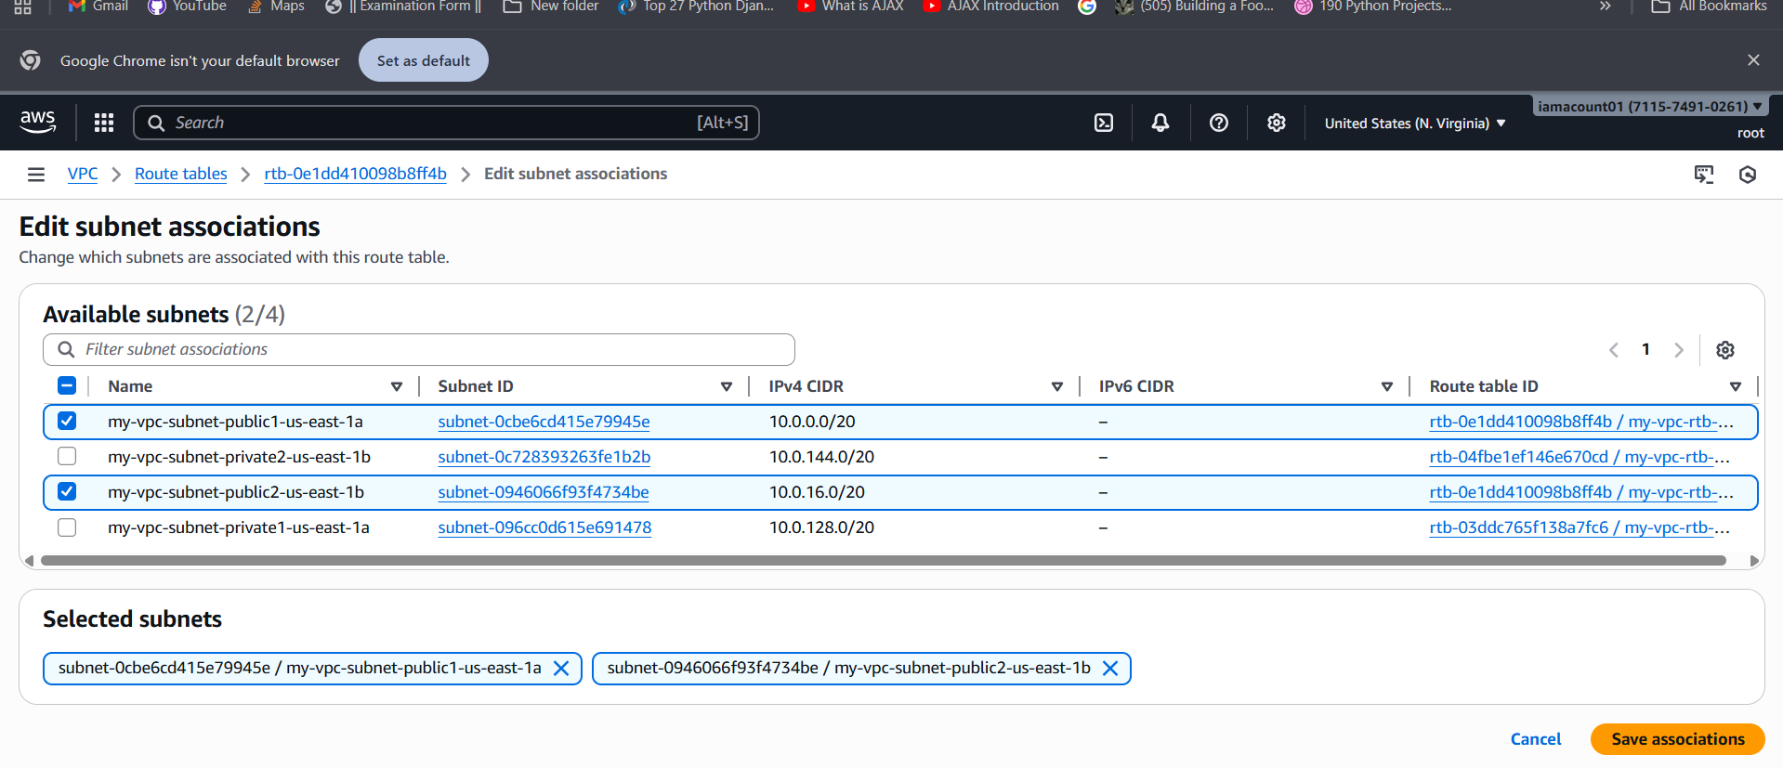

6)Public route table will have the routes to internet and local.

7)Create EC2 in public subnet with t2.micro and install PHP.

Steps
- Launch Instance: Navigate to EC2 > Instances. Click Launch instances.
- Configuration:
- Name: Public-PHP-Server.
- AMI: Choose Amazon Linux (2 or 2023).
- Instance Type: t2.micro.
- Key Pair: Select or create a key pair (required for SSH).
- Network Settings:
VPC: MultiTier-VPC.
Subnet: Public Subnet 1.
Auto-assign Public IP: Enabled (if Task 3 was completed).
Security Group (Public-SG): Allow inbound SSH (22) and HTTP (80) from 0.0.0.0/0.
- Install PHP (User Data): In Advanced details, paste this script into the User data field:
- #!/bin/bash
- # Install and start Apache HTTPD and PHP
- yum update -y
- yum install -y httpd php php-cli
- systemctl enable httpd
- systemctl start httpd
- # Create a simple test file
- echo "<?php phpinfo(); ?>" > /var/www/html/index.php
- Launch: Click Launch instance.

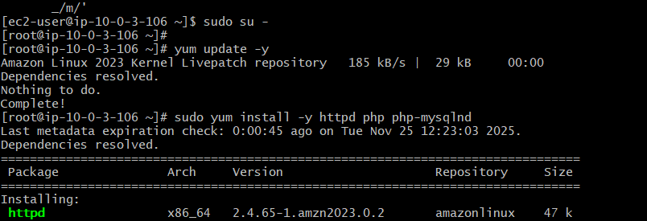
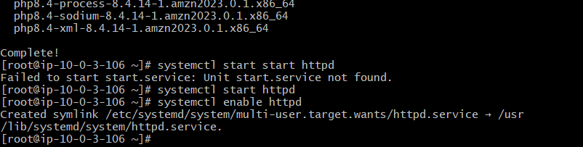
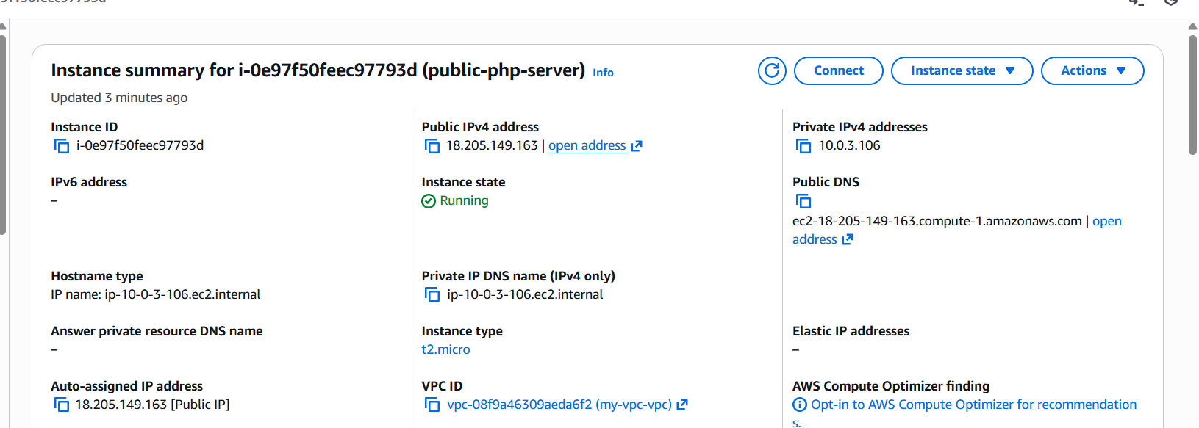
8)Configure NAT gateway in public subnet and connect to private instance.
- Allocate Elastic IP (EIP): Navigate to EC2 > Elastic IPs and allocate a new EIP.
- Create NAT Gateway (NAT-GW): Navigate to VPC > NAT Gateways. Click Create NAT gateway.
  - Subnet: Choose Public Subnet 1.
  - Elastic IP: Select the EIP you just allocated.
- Update Private Route Table: Navigate to Route Tables and select Private-RT.
  - Go to Routes > Edit routes.
  - Add a route: Destination 0.0.0.0/0, Target MultiTier-NAT-GW.
- Connect to Private Instance:
  - Launch Private EC2: Launch a Private-Tomcat-Server in Private Subnet 1 (ensure its security group allows SSH from the Public EC2's IP/SG).
  - SSH Tunnel: SSH from your local machine to the Public EC2, and then from the Public EC2, SSH to the Private EC2's private IP. This verifies the connection path is working through the bastion.

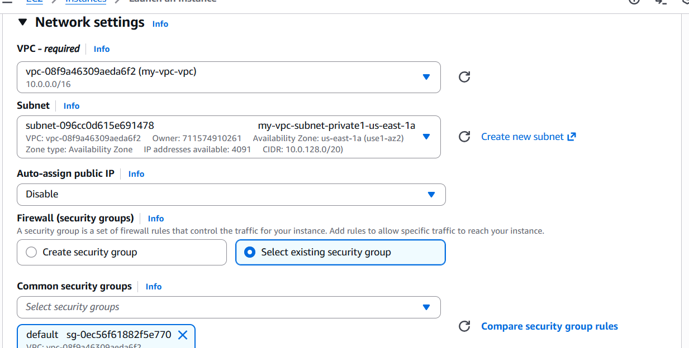
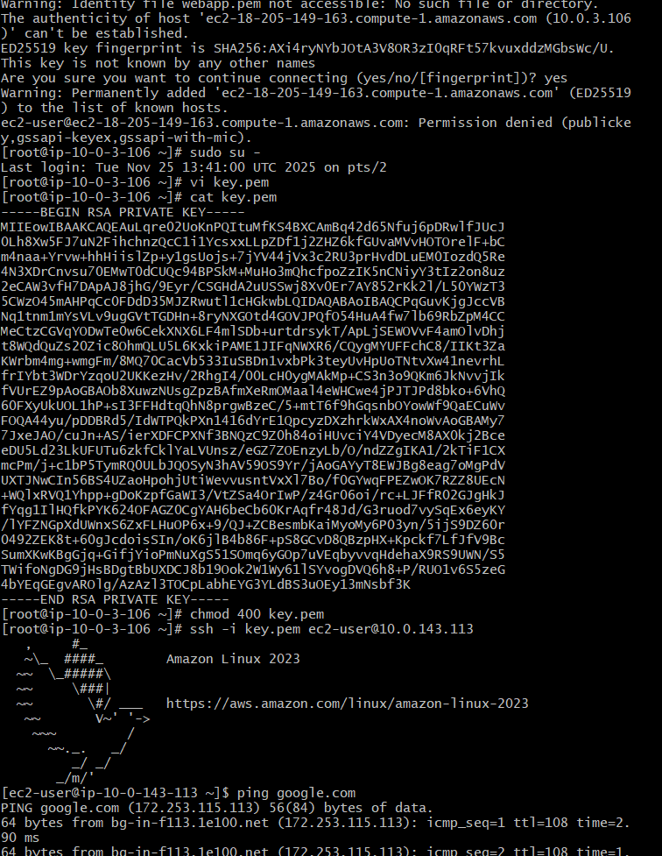
9)Install Apache Tomcat in private EC2 and deploy a sample app.

Steps (Executed while SSH'd into the Private EC2)
- Install Java:
- sudo yum update -y
- sudo yum install java-1.8.0-openjdk-devel -y
- Install Tomcat: (Using Tomcat 9 as an example)
- # Download, extract, and move Tomcat
- wget [https://dlcdn.apache.org/tomcat/tomcat-9/v9.0.86/bin/apache-tomcat-9.0.86.tar.gz](https://dlcdn.apache.org/tomcat/tomcat-9/v9.0.86/bin/apache-tomcat-9.0.86.tar.gz) -P /tmp
- sudo tar xzvf /tmp/apache-tomcat-9.0.86.tar.gz -C /opt/
- sudo mv /opt/apache-tomcat-9.0.86 /opt/tomcat
- # Set permissions
- sudo groupadd tomcat; sudo useradd -s /bin/false -g tomcat -d /opt/tomcat tomcat
- sudo chown -R tomcat:tomcat /opt/tomcat
- sudo sh -c 'chmod +x /opt/tomcat/bin/*.sh'
- Deploy Sample App & Start:
- # Create simple index.html in the default webapps root
- echo "<h1>Private Tomcat Server is Running!</h1>" | sudo tee /opt/tomcat/webapps/ROOT/index.html
- # Start the service
- /opt/tomcat/bin/startup.sh
- Verification (from Public EC2): Use curl from the Public EC2 to test the private server:
curl http://<Private_IP_of_Tomcat_Server>:8080

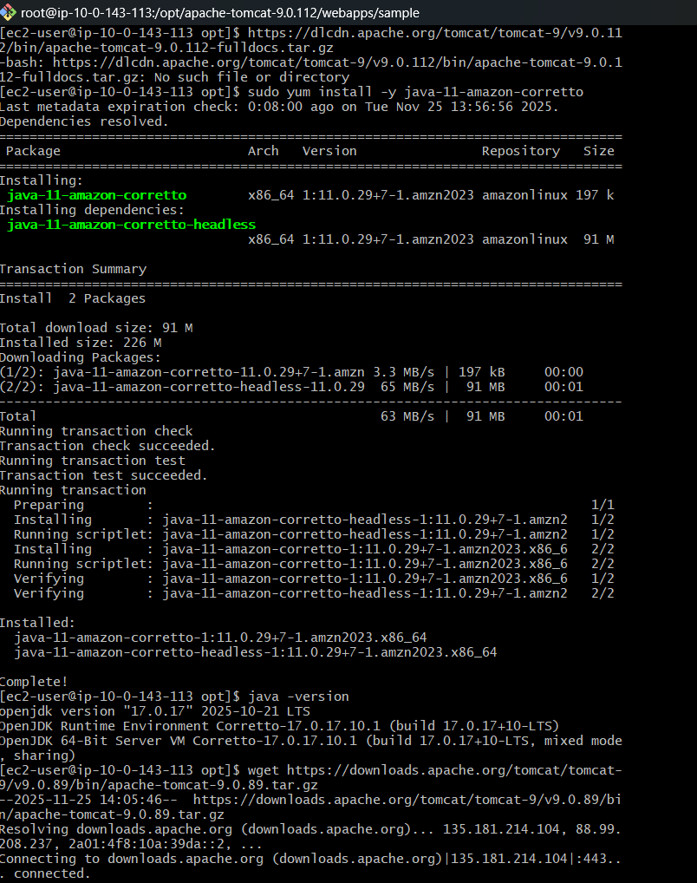
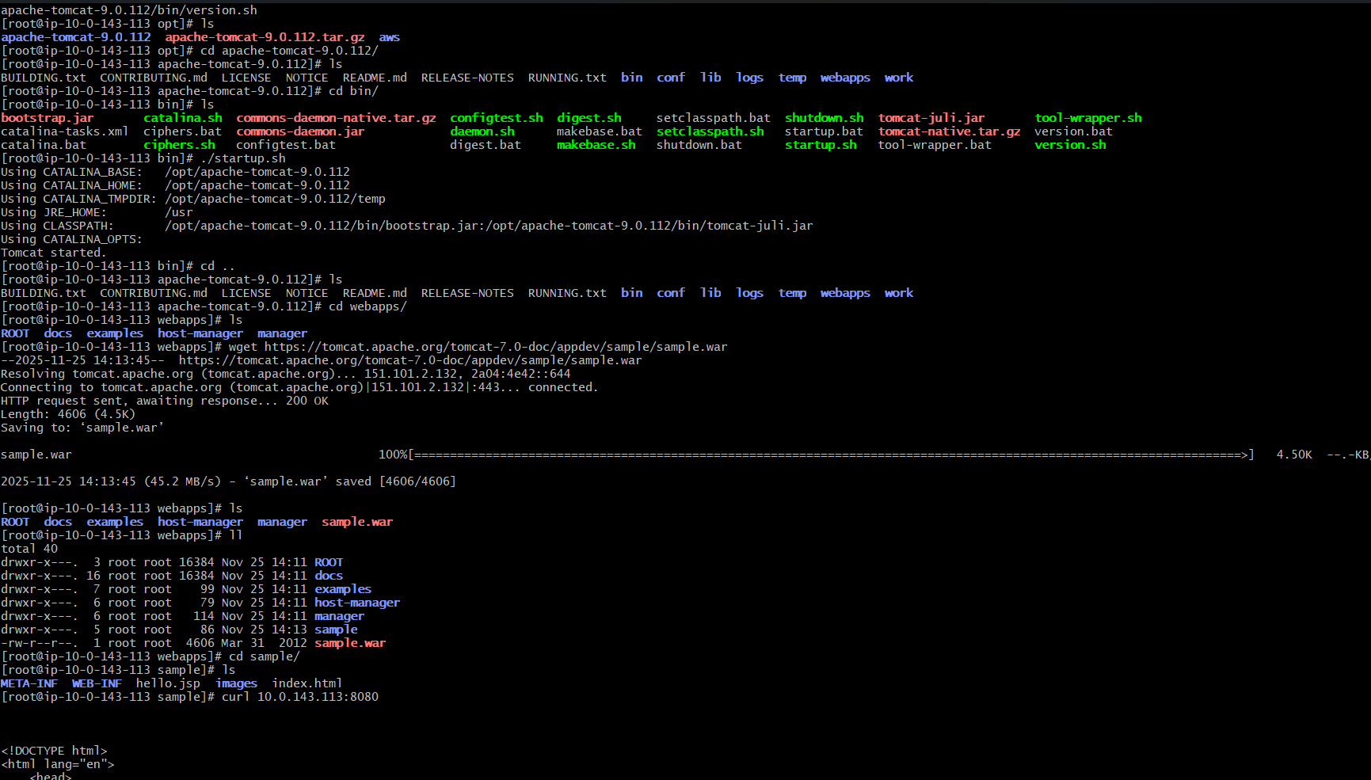
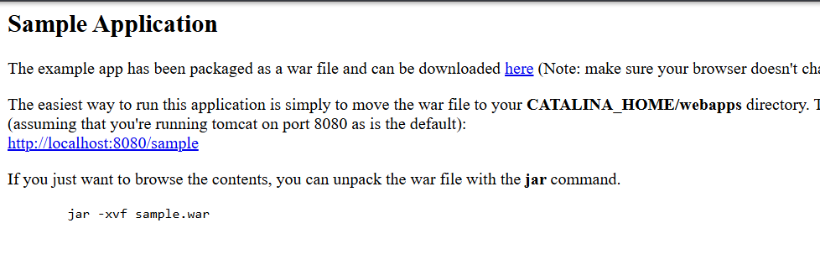
10)Configure VPC flow logs and store the logs in S3 and CloudWatch.

Steps
- Create S3 Bucket: Navigate to S3 and create a new bucket (e.g., vpc-flow-logs-storage-xyz).
- Create IAM Role: Navigate to IAM > Roles. Click Create role.
  - Trusted entity: Custom trust policy to allow vpc-flow-logs.amazonaws.com as the service principal.
  - Policy: Attach the managed policy AWSVPCFlowLogsServiceRole.
  - Name: FlowLogs-Role-VPC.
- Create Flow Log: Navigate to VPC > Your VPCs and select MultiTier-VPC. Go to the Flow Logs tab. Click Create flow log.
- Configuration:
  - Filter: All (to capture accepted and rejected traffic).
  - Destination 1 (CloudWatch): Specify a log group (e.g., /aws/vpc/flow-logs/MultiTier-VPC) and select the FlowLogs-Role-VPC.
  - Destination 2 (S3): Enter the ARN of the S3 bucket created in step 1.
- Create flow log.

