VPC-2 TASKS
Create one VPC, with 1 public subnet and 1 private subnet.
VPC → Create VPC → VPC Only
Name: vpc-main
CIDR: 10.0.0.0/16
Create.

✔ Step 2: Create Public Subnet
Name: vpc-main-public
CIDR: 10.0.1.0/24
AZ: us-east-1a
Tick (Enable Auto-assign public IPv4): YES

✔ Step 3: Create Private Subnet
Name: vpc-main-private
CIDR: 10.0.2.0/24
AZ: us-east-1b
Auto-assign public IP: NO

✔ Step 4: Create Internet Gateway
VPC → Internet Gateway → Create
Name: igw-main
Attach → vpc-main

✔ Step 5: Create Route Tables

Public RT
Name: rt-public
Routes:
0.0.0.0/0 → igw-main
Subnet associations → attach vpc-main-public

Private RT
Name: rt-private
No IGW route.
Attach vpc-main-private

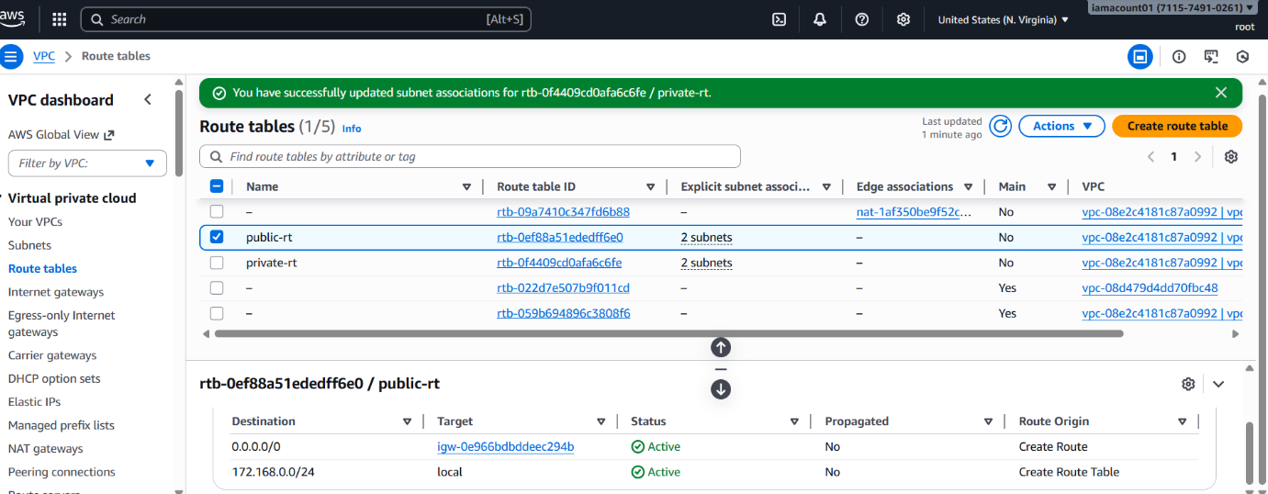

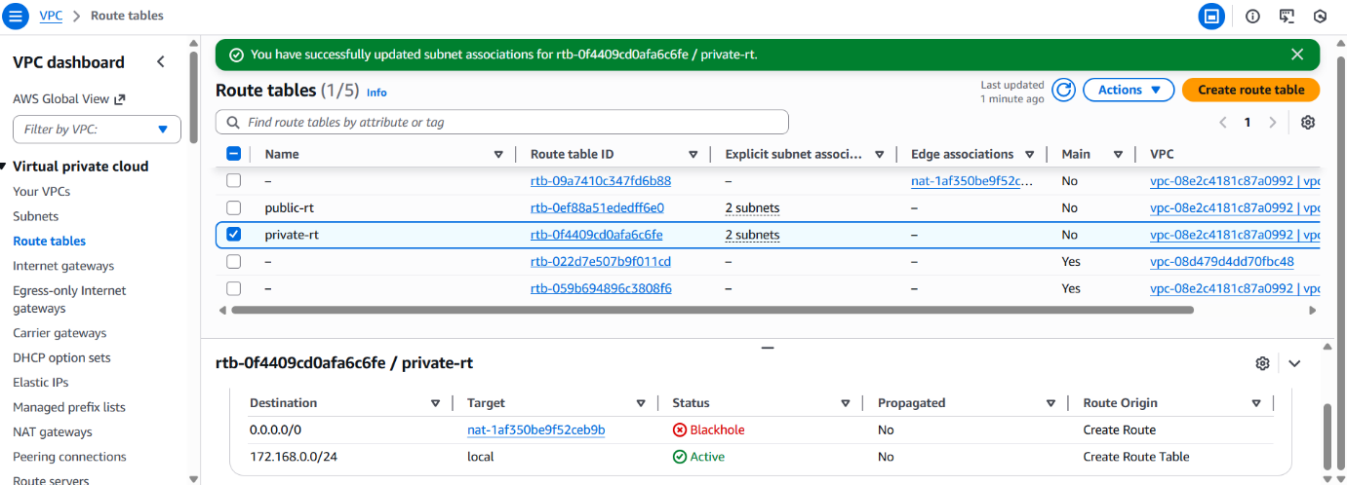
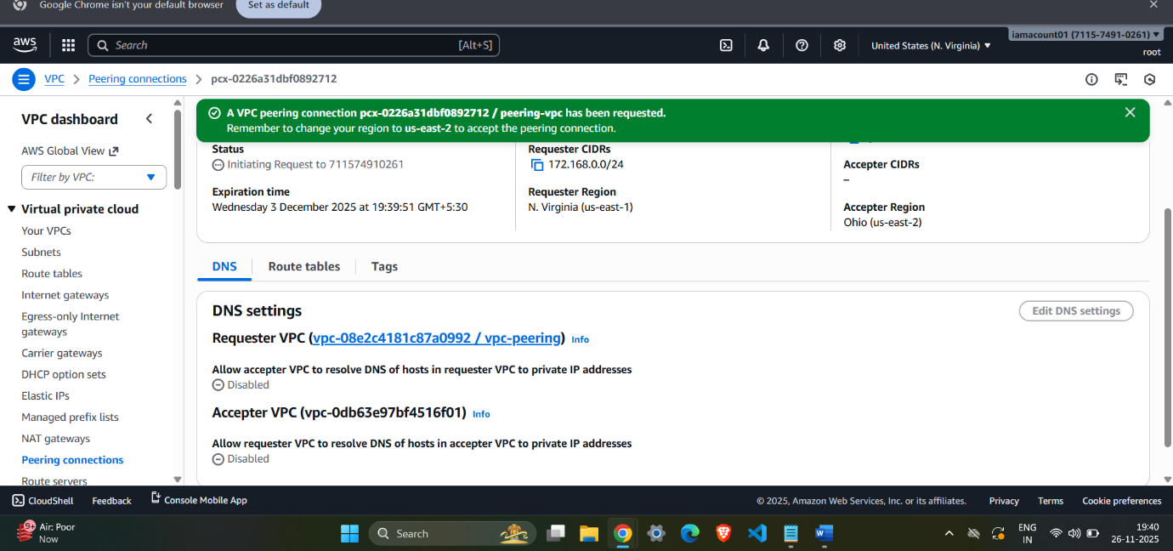

2.Enable VPC peering for cross-region. You need two VPCs in two regions, example:
VPC-A (us-east-1)
VPC-B (us-west-2)

✔ Step 1: Open region us-east-1
VPC → Peering → Create Peering Connection
Peering name: peer-east-west
VPC requester: vpc-main (us-east-1)
VPC accepter: Another region
Region: us-west-2
VPC ID: vpc-b
Click Create.

✔ Step 2: Switch to Region us-west-2
VPC → Peering → Accept

✔ Step 3: Update Route Tables (IMPORTANT)

In VPC-A route table:
Destination: CIDR of VPC-B
Target: PCX (peering-id)

In VPC-B route table:
Destination: 10.0.0.0/16
Target: same PCX
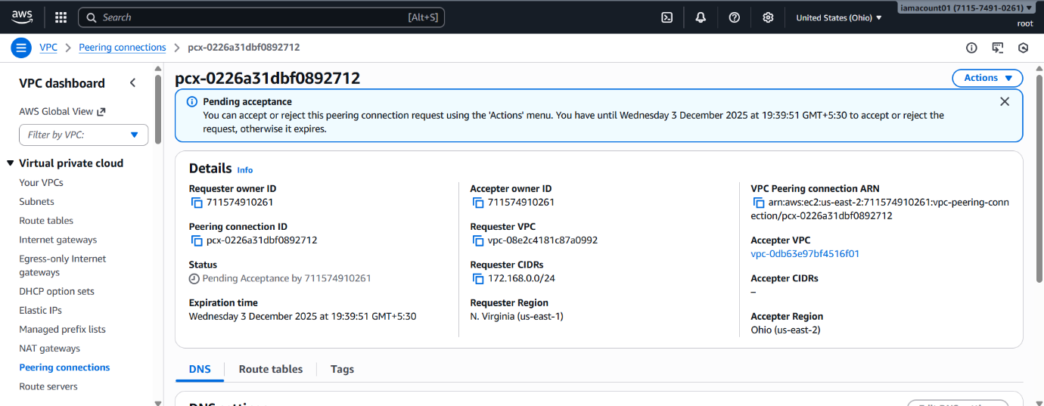
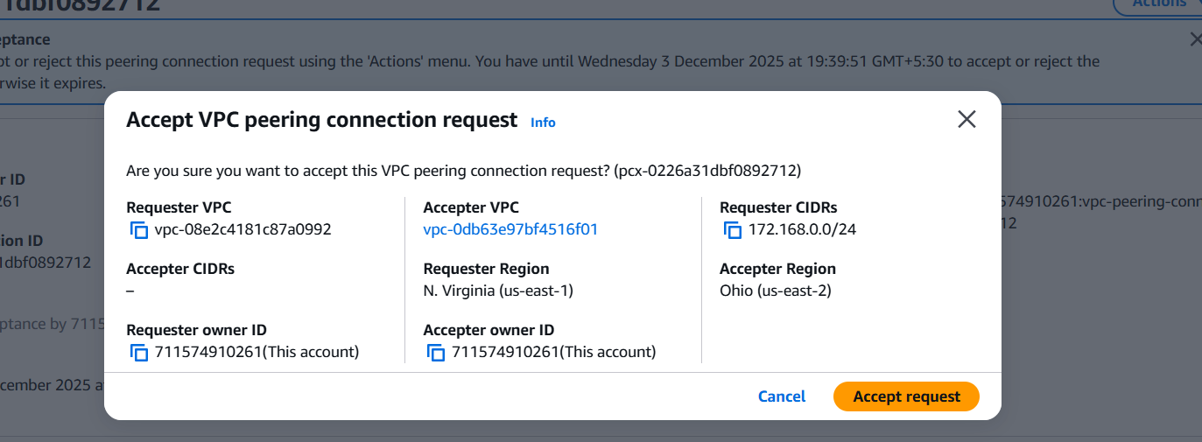
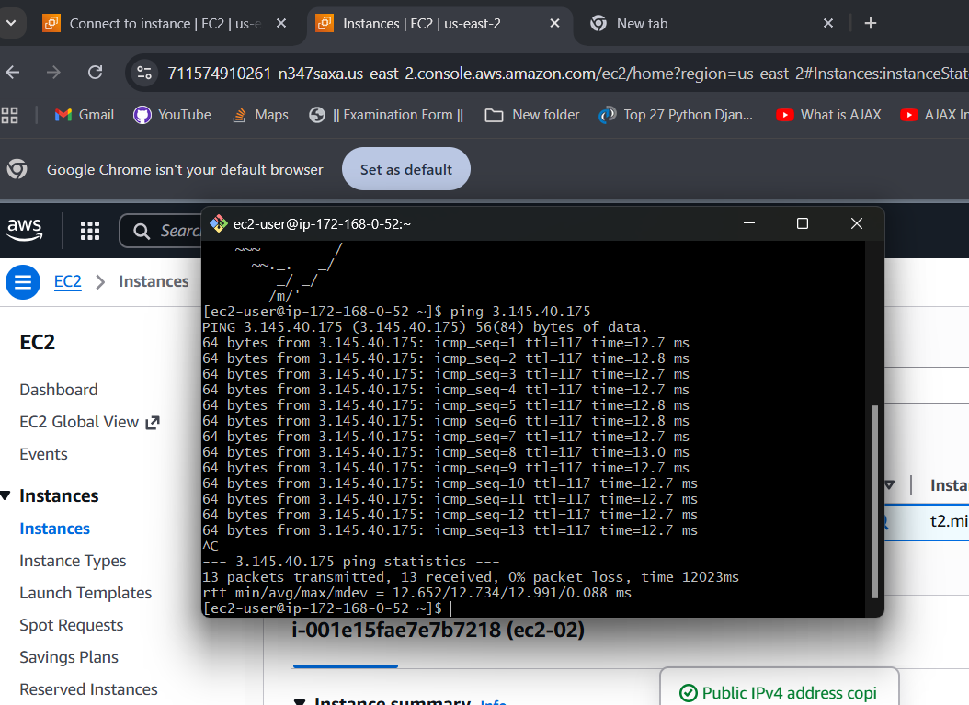

3.Enable VPC peering for cross-account (you can collaborate with your friend to do this task).

Step 1: You create request
In your account → Peering → Create:
Requester VPC: your-vpc
Accepter VPC: Account ID (friend’s)
VPC ID: friend's VPC

✔ Step 2: Friend accepts the peering
Friend → VPC → Peering → Accept

✔ Step 3: BOTH update Route tables
Yours:
Dest: friend's VPC CIDR → PCX
Friend:
Dest: your VPC CIDR → PCX

✔ Step 4: Allow SG inbound rules
Both add:
Allow traffic from other VPC CIDR
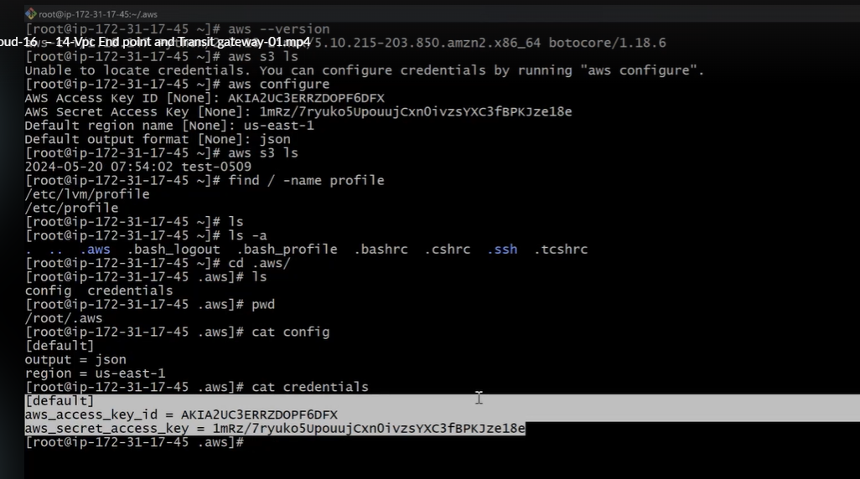
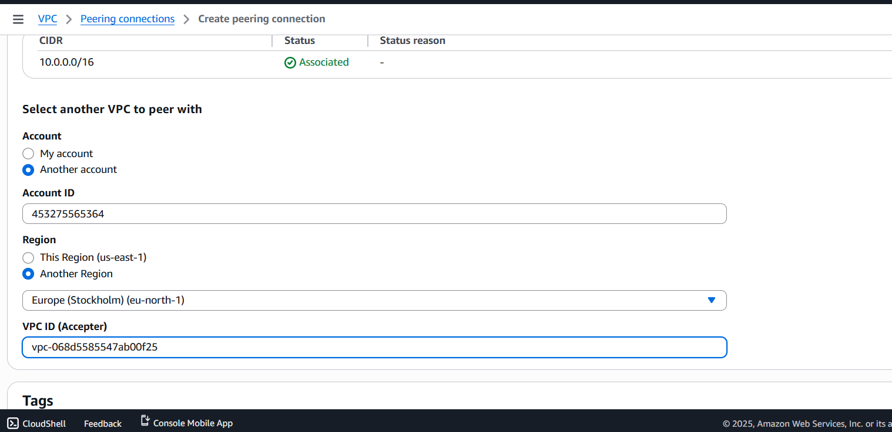
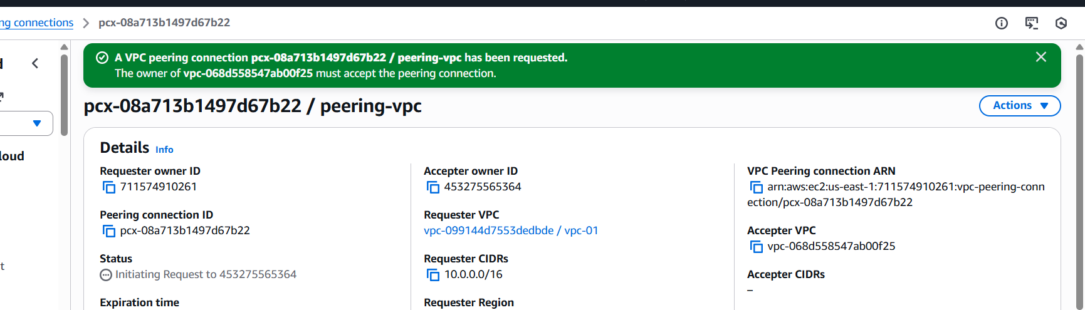
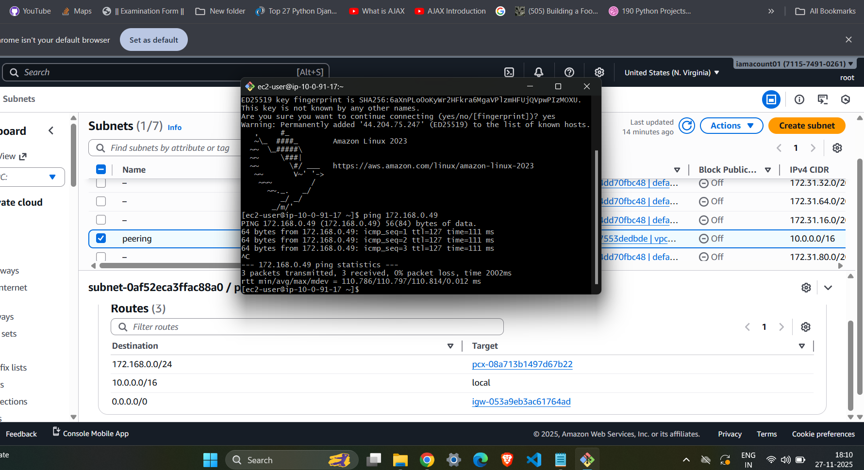

4.Set up a VPC Transit Gateway.
For VPC-1:
Create attachment → VPC → Select VPC → Select 1 subnet (NOT us-east-1e)
For VPC-2 (other region/account):
Create attachment → VPC → Select VPC → Select 1 subnet

✔ Step 3: Update TGW Route Table
TGW → Route Tables → Edit
Add:
Dest: VPC1 CIDR → attachment-1
Dest: VPC2 CIDR → attachment-2

✔ Step 4: Update each VPC’s Route Table
In VPC-1 route table:
Dest: VPC2 CIDR → tgw-id
In VPC-2 route table:
Dest: VPC1 CIDR → tgw-id
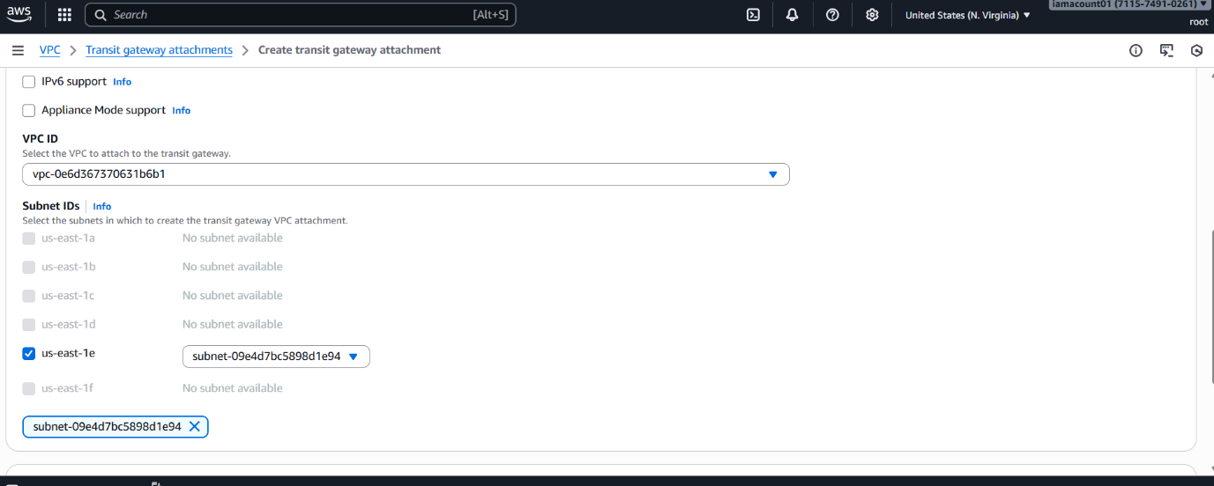

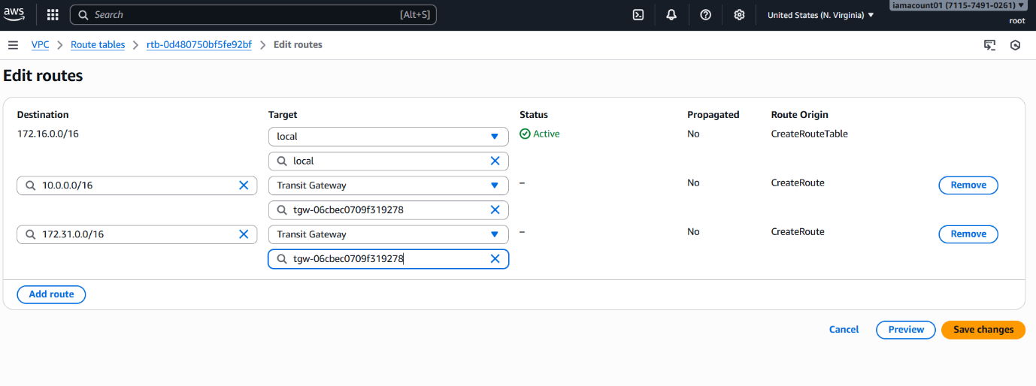
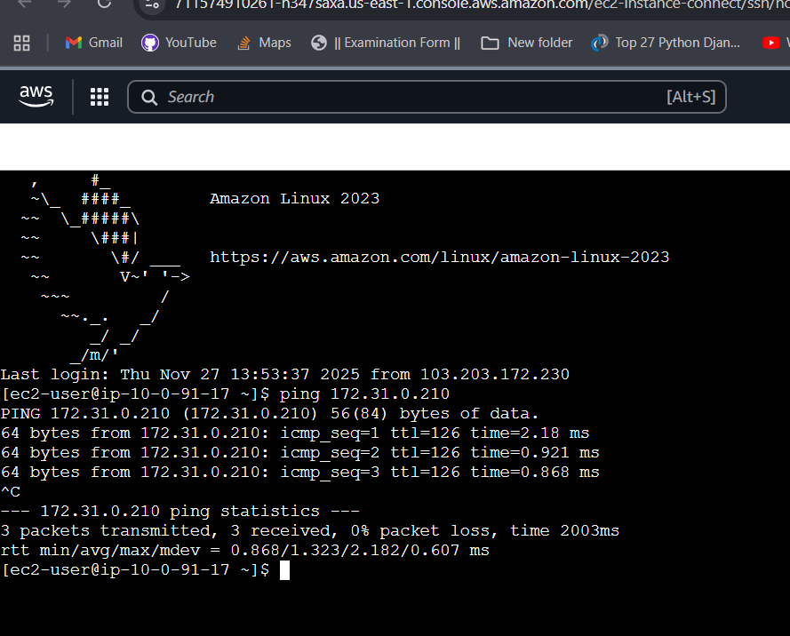

5.Set up a VPC Endpoint.
You need S3 Gateway Endpoint.

✔ Step 1: Go to VPC → Endpoints → Create

✔ Step 2: Search “s3”
Select:
com.amazonaws.us-east-1.s3
Type: Gateway

✔ Step 3: Select VPC
Select your private VPC (vpc-main)

✔ Step 4: Select PRIVATE Route Table
Choose rt-private (NOT public)

✔ Step 5: Create

✔ Step 6: Test (mandatory)
From private EC2:
ping google.com
❌ Should fail (no internet)
aws s3 ls
