1.Design and deploy a scalable network architecture using AWS Transit Gateway to simplify network connectivity between multiple VPCs.

For VPC-1:
Create attachment → VPC → Select VPC → Select 1 subnet (NOT us-east-1e)
For VPC-2 (other region/account):
Create attachment → VPC → Select VPC → Select 1 subnet

Step 3: Update TGW Route Table
TGW → Route Tables → Edit
Add:
Dest: VPC1 CIDR → attachment-1
Dest: VPC2 CIDR → attachment-2

Step 4: Update each VPC’s Route Table
In VPC-1 route table:
Dest: VPC2 CIDR → tgw-id
In VPC-2 route table:
Dest: VPC1 CIDR → tgw-id
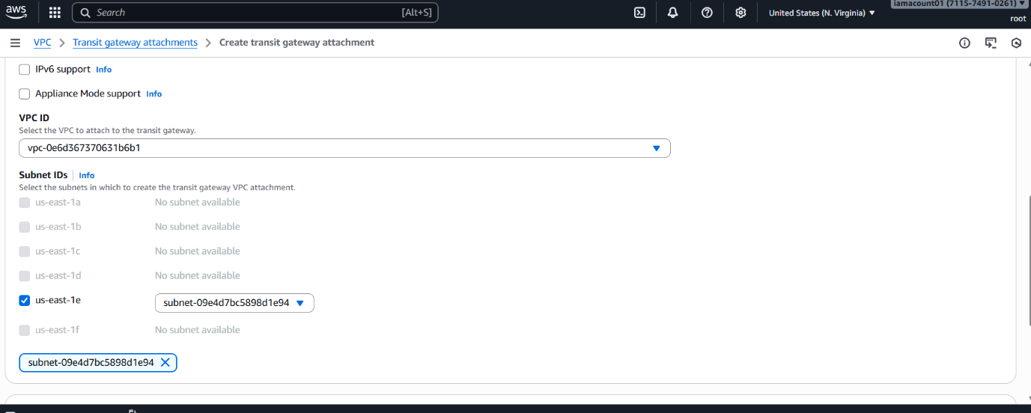

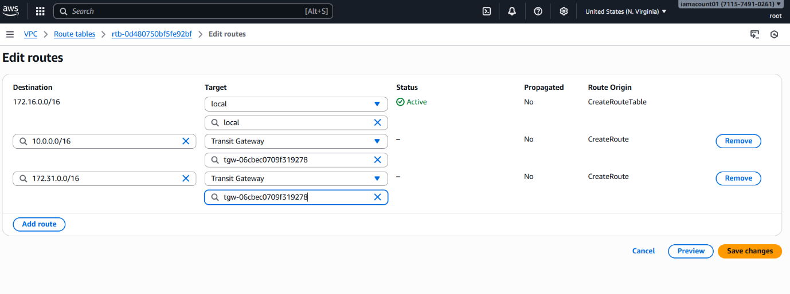
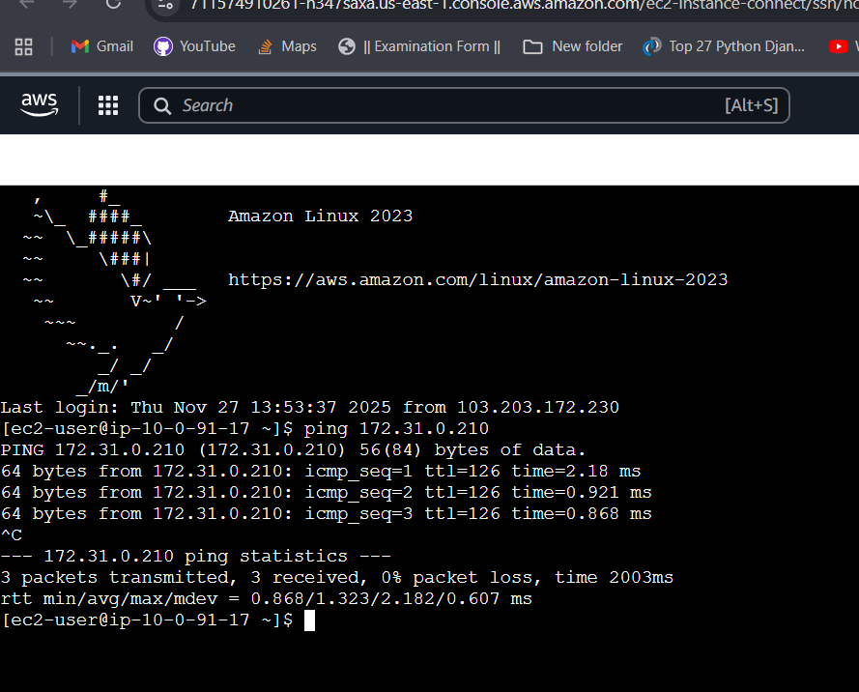

2. Configure VPC endpoints to securely access AWS services without internet gateways or NAT gateways, ensuring data privacy and minimizing exposure to external threats.

You need S3 Gateway Endpoint.

Step 1: Go to VPC → Endpoints → Create

Step 2: Search “s3”
Select:
com.amazonaws.us-east-1.s3
Type: Gateway

Step 3: Select VPC
Select your private VPC (vpc-main)

Step 4: Select PRIVATE Route Table
Choose rt-private (NOT public)

Step 5: Create

Step 6: Test (mandatory)
From private EC2:
ping google.com
Should fail (no internet)
aws s3 ls
