Linux Practical Tasks
1) Create user with name Techie and provide sudo access to user.
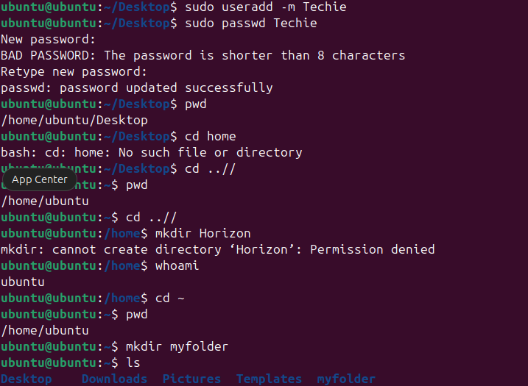

2) Navigate to the home directory.
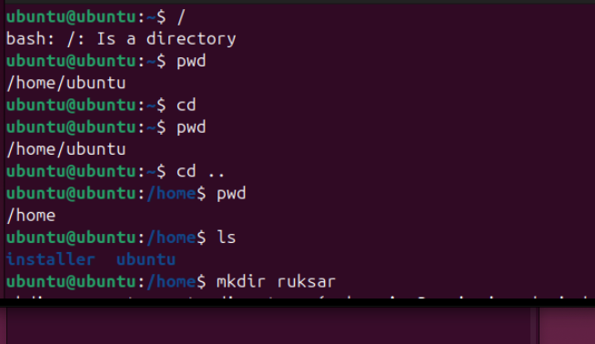
3) Create a new directory.
4) List the contents of a directory.
5) Change the current directory.

6) Create a new empty file.

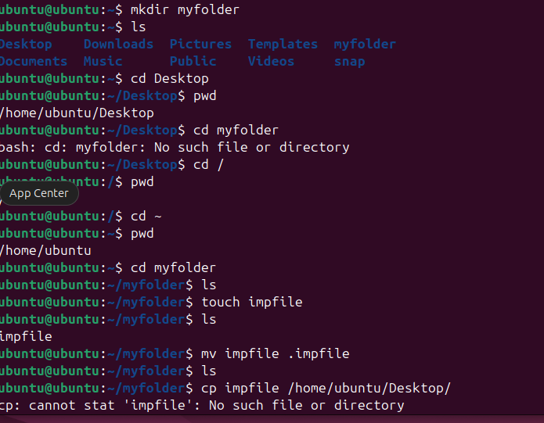

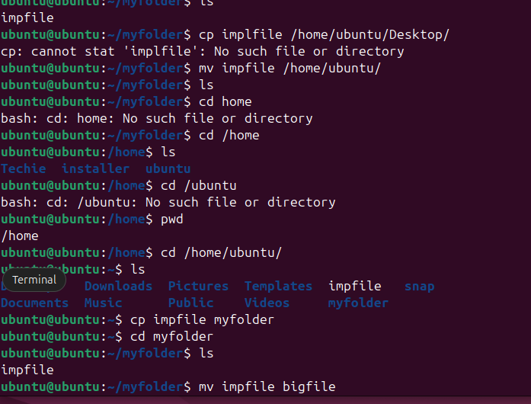
7) View the contents of a file.
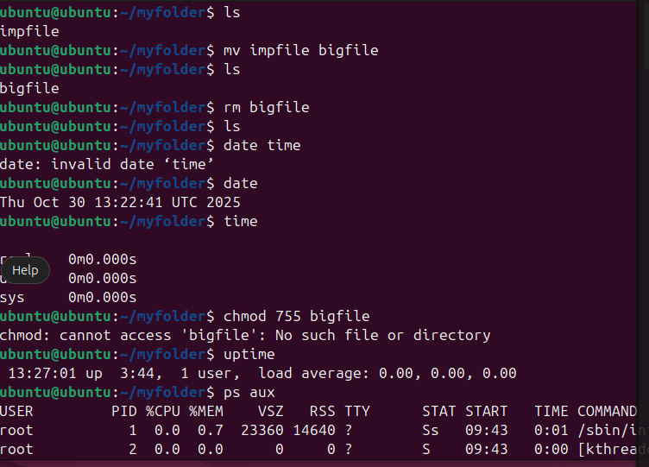
8) Copy a file to another location.

9) Move a file to another location.

10) Rename a file.

11) Delete a file.
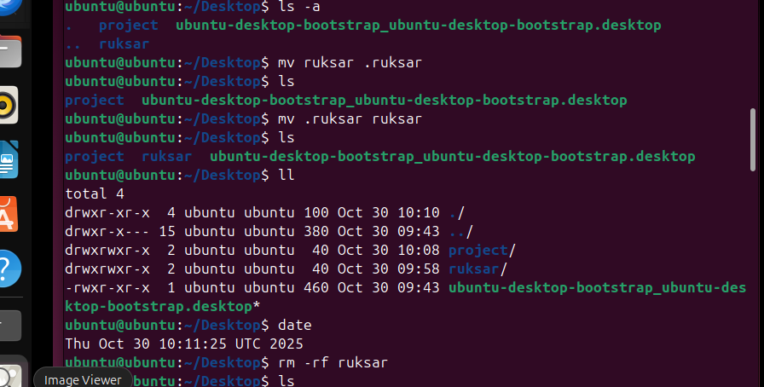

12) Grant or revoke permissions on a file or directory.
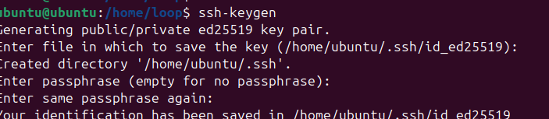
13) View the current date and time.
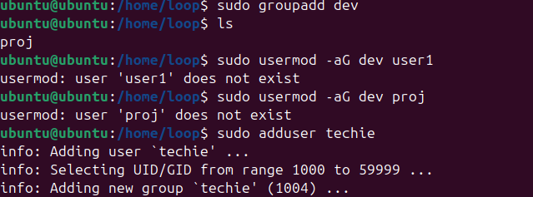
14) Check the system uptime.
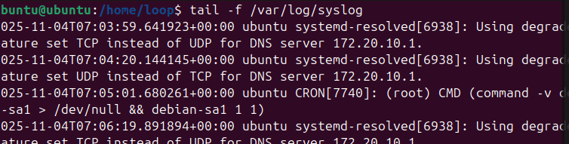
15) View the running processes.

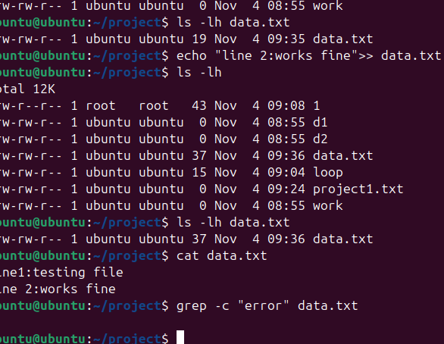
16) Kill a running process.
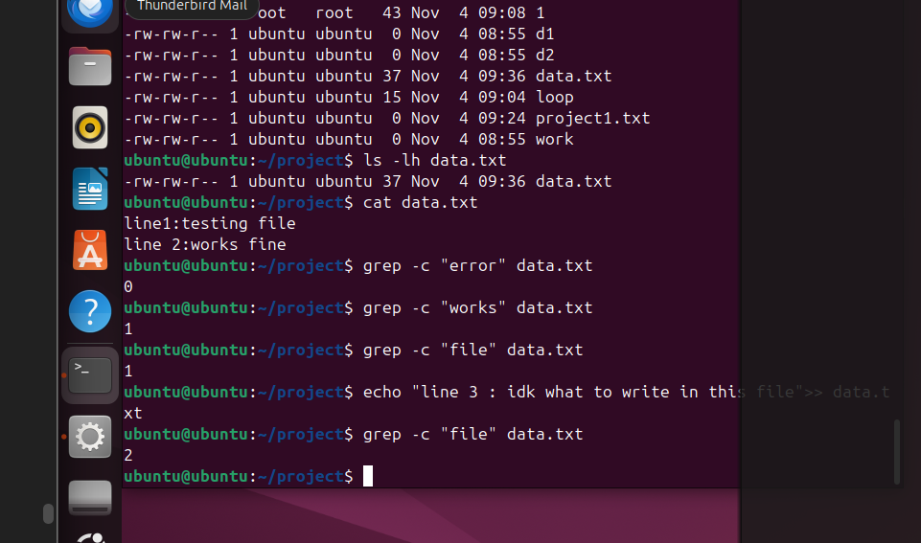
17) Install a package using the package manager (e.g., apt or yum).
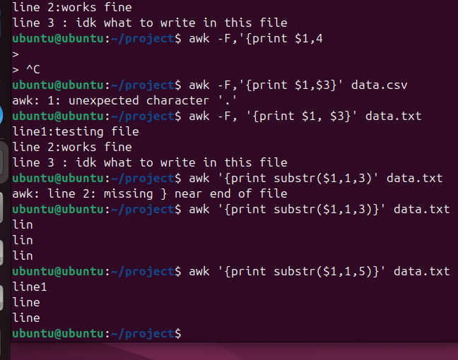
18) Update the system packages.
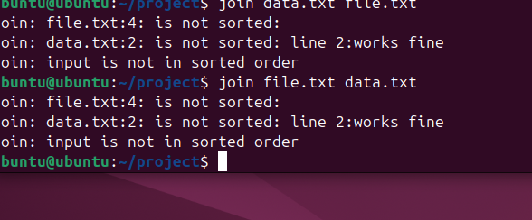
19) Create a symbolic link.
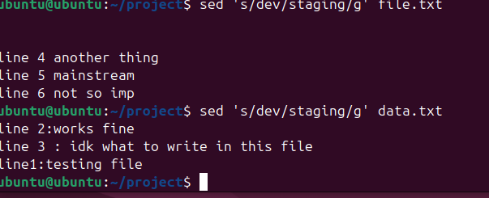
20) Search for files using the find command.

21) Compress and decompress files using tar.

22) Monitor system resources with top or htop.

23) Create and manage user groups.
24) Set up SSH password less authentication.

25) Monitor log files using tail or grep.

26) Set up a web server (e.g., Apache or Nginx).
(Screenshot to be added later)
27) Configure and secure a MySQL Database.
(Screenshot to be added later)
28) Set up a Application Server (e.g.,Apache Tomcat).
(Screenshot to be added later)
29) Create a service file for Apache Tomcat.(Should execute by using systemctl command).
(Screenshot to be added later)
30) Print specific columns from a delimited file.

(

31) Filter and print lines based on a specific pattern or condition.

32) Calculate and print the average, sum, or other statistics of a column.
33) Perform string manipulation, such as extracting substrings or changing case.
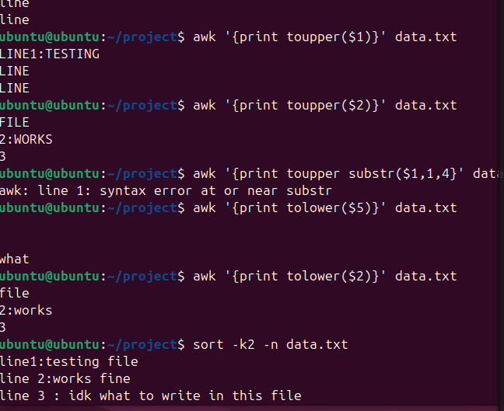

34) Count the occurrences of a specific pattern in a file.

35) Sort lines based on a specific field or column.
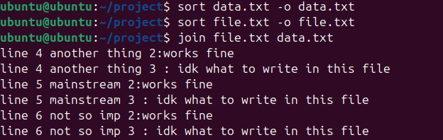

36) Merge multiple files based on a common field or column.

37) Substitute text in a file using search and replace.
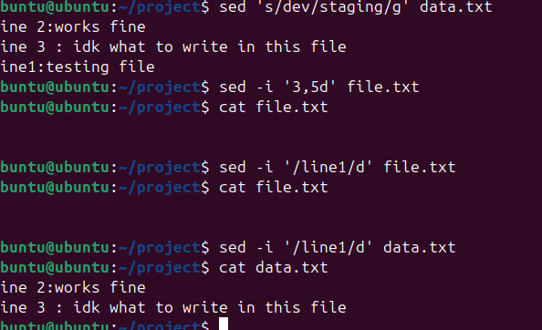

38) Delete specific lines based on a pattern or line number.
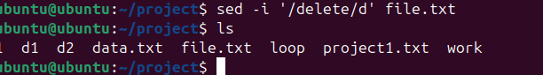

39) Append or insert text before or after a specific pattern or line.

40) Print only specific lines from a file.

41) Copy file from linux to windows machine.

42) 5 use cases for AWK and 5 use cases for sed.

AWK Use Cases:
- Print specific columns from CSV or log files.
- Calculate sum/average of numeric columns.
- Filter rows based on pattern (e.g., errors).
- Format and align output text neatly.
- Perform field-based text replacement.

SED Use Cases:
- Search and replace words in a file.
- Delete lines matching a pattern.
- Insert or append text after a specific line.
- Replace text only on certain lines (like 2nd or last).
- Remove blank lines or extra spaces.

