1. Task Title
Deploy Static Website Using S3, CloudFront CDN, SSL Certificate, and Route 53 Domain Mapping

2. Objective
To host a static website on S3, accelerate it using CloudFront CDN, secure it using HTTPS, and make it accessible using a purchased custom domain configured through Route 53.

3. Prerequisites
Before starting, the following must be available:
• A purchased domain (from GoDaddy)
• AWS account
• S3 bucket for website hosting
• CloudFront distribution
• ACM SSL certificate (us-east-1)
• Route 53 hosted zone
• Basic understanding of static site files (index.html)

4. Step-by-Step Implementation (With Evidence Placeholder)
Note: Insert screenshots where the word “(screenshot)” appears.

Task 1: Configure VPC Peering in Cross Regions
- Go to VPC console → Peering Connections → Create Peering Connection.
- Select Requester VPC in Region A and Accepter VPC in Region B.
- Enter Accepter VPC ID from the second region.
- Create peering request.
- Switch to the second region → Accept the peering request.
- Update route tables in both VPCs to forward traffic through the peering connection.
- Test connectivity using ping or curl between instances in both VPCs.
Evidence:
• Screenshot of peering connection (screenshot)
• Screenshot of route table entries (screenshot)
• Ping/curl output from EC2 to EC2 (screenshot)

Task 2: Purchase One Domain from GoDaddy
- Login into GoDaddy.
- Search for the domain name and complete the purchase.
- Keep the domain ready for AWS Route 53 DNS configuration.
Evidence:
• Screenshot of purchased domain in GoDaddy dashboard (screenshot)

Task 3: Deploy Static Website in S3
- Create an S3 bucket with the same name as the domain:
Example: techwithrukhsar.site
- Enable “Static website hosting” under Properties.
- Upload index.html and any other website files to the bucket.
- Make the bucket public using a bucket policy.
Evidence:
• Screenshot of S3 bucket
• Screenshot of static website hosting enabled
• Screenshot of uploaded index.html
• Screenshot of website opening via S3 endpoint URL

Task 4: Create a CDN (CloudFront) and Attach SSL Certificate
- Go to CloudFront → Create Distribution.
- Set Origin Type = S3 Website Endpoint.
- Leave default settings unless required otherwise.
- Create distribution.
- Go to ACM (us-east-1) → Request Certificate.
- Add domain names:
  - techwithrukhsar.site
  - www.techwithrukhsar.site
- Choose DNS validation → Create validation records in Route 53.
- After validation, return to CloudFront.
- Open the distribution → Edit → Add Alternate Domain Names:
  - techwithrukhsar.site
  - www.techwithrukhsar.site
- Select the ACM SSL certificate.
- Save and wait for deployment.
Evidence:
• CloudFront distribution screenshot
• CNAMEs added screenshot
• SSL certificate validated screenshot
• CloudFront status deployed screenshot

Task 5: Create a Route 53 Hosted Zone and Map the Domain to the CDN
- Open Route 53 → Hosted zones → Create Hosted Zone.
- Enter domain name purchased from GoDaddy.
- Two name servers (NS records) are generated.
- Go to GoDaddy → DNS settings → Replace GoDaddy nameservers with the Route 53 nameservers.
- Back in Route 53, create two A-records:
Record 1: Root domain
Name: techwithrukhsar.site
Type: A
Alias: Yes
Value: CloudFront distribution domain
Record 2: www
Name: www.techwithrukhsar.site
Type: A
Alias: Yes
Value: CloudFront distribution domain
Evidence:
• Hosted zone screenshot
• NS records screenshot
• A-record for root domain screenshot
• A-record for www screenshot
• GoDaddy name server update screenshot

Task 6: Update index.html in the S3 Bucket and Validate
- Upload a new version of index.html into the S3 bucket.
- Invalidate old cache in CloudFront (optional but recommended):
CloudFront → Invalidations → Create Invalidation → /*
- Test domain in browser:
  - techwithrukhsar.site
  - www.techwithrukhsar.site
Evidence:
• Screenshot of updated index.html in S3
• Screenshot of CloudFront invalidation
• Screenshot of updated website visible on both domains

Task 7: Share the Domain Name for Testing
- Copy the domain name:
https://techwithrukhsar.site
- Share in Slack or communication channel for validation by others.
Evidence:
• Screenshot of Slack message (screenshot)

5. Validation Steps
Validation 1: Check S3 Website Hosting
• Confirm S3 website URL works (screenshot)
Validation 2: Check CloudFront Distribution
• Confirm CloudFront URL works (screenshot)
Validation 3: HTTPS Validation
• Confirm browser shows https and padlock (screenshot)
Validation 4: DNS Validation
• Confirm that both:
– techwithrukhsar.site
– www.techwithrukhsar.site
open correctly (screenshot)
Validation 5: Updated Content
• Confirm that after updating index.html, new content is visible from the domain (screenshot)

6. Issues Faced
- AccessDenied 403 error from CloudFront
Cause: Domain not added under “Alternate domain names (CNAMEs)” in CloudFront.
Fix: Added domain → Attached SSL → Redeployed.
- www subdomain not working
Cause: A-record for www missing in Route 53.
Fix: Created A-record alias to CloudFront.
- XML-style error
Cause: CloudFront received a request for a domain it did not recognize.
Fix: Added domain and certificate properly in CloudFront.

7. Conclusion
All tasks were completed successfully.
The static website was deployed in S3, served globally using CloudFront, secured with ACM SSL, and mapped to the custom domain using Route 53. Both root and www domains correctly display the website, and updated files reflect instantly across the CDN.
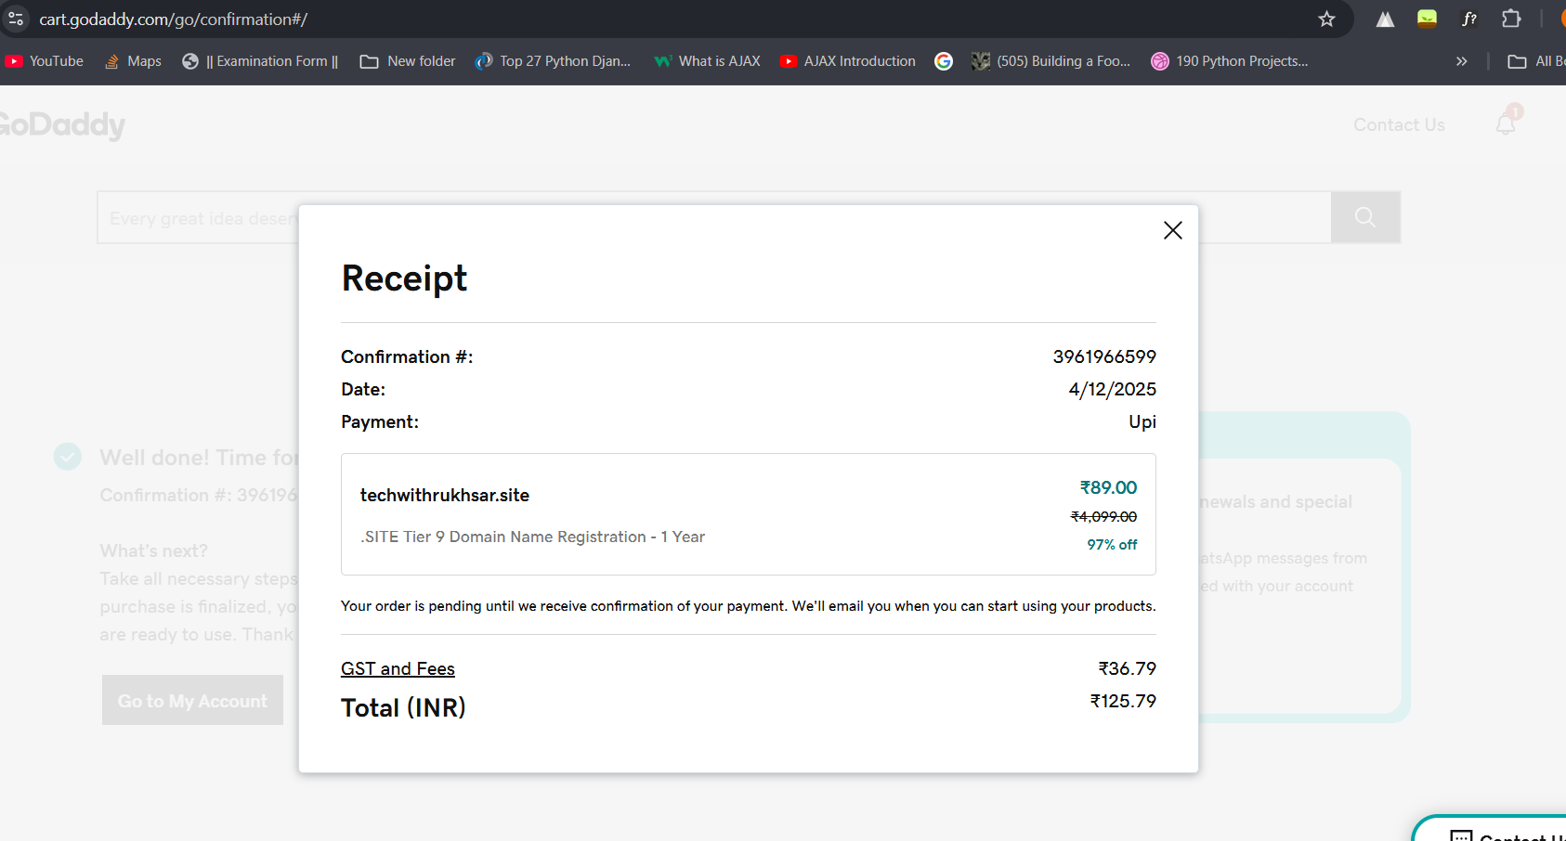
https://site-nnyz3h64q.godaddysites.com/