- Install git.
- We use git --version to check if Git is already installed because it shows whether the system recognizes Git.
- We install Git using the package manager (apt install git or yum install git) because that downloads Git + its dependencies.
- We run git config --global user.name and git config --global user.email because Git needs your identity for every commit.
- We verify again with git --version to confirm Git is installed correctly and available in the system PATH.

2)Create a repo in github with README.md and .ignore file.
• We create a GitHub repo because Git needs a central remote location where we can push and store our code online.
• We add a README.md because GitHub uses it to display project information on the repo’s main page.
• We add a .gitignore file because it tells Git not to track sensitive or unnecessary files like logs, passwords, or system files.
• After creating the repo, GitHub gives us a clone URL which we use to connect our local machine to the central repository.

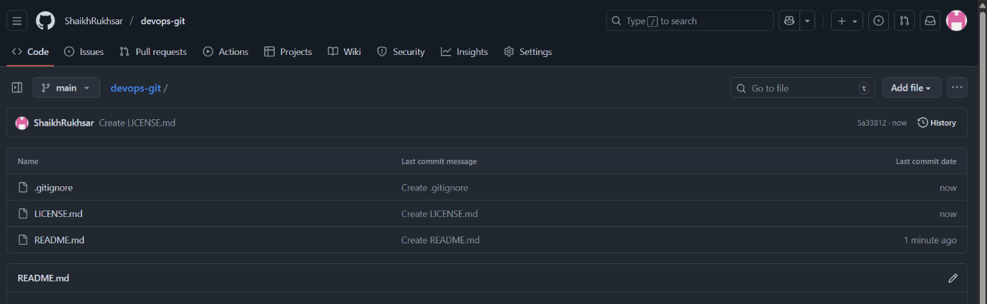

3) )Clone the created repo to local.
• We use git clone <repo-link> because cloning copies the entire GitHub repository to our local system.
• Cloning automatically creates the .git folder, which contains all version history and Git metadata.
• Moving into the folder using cd <repo-name> is necessary because Git commands only work inside the cloned repository.
• Cloning also sets the default remote name as origin, allowing us to push and pull from GitHub easily.

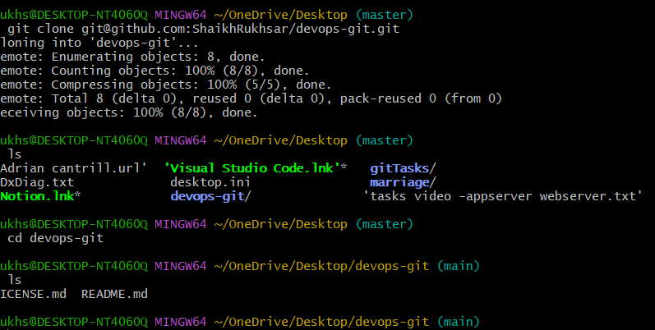
4)Create two files in local repo.
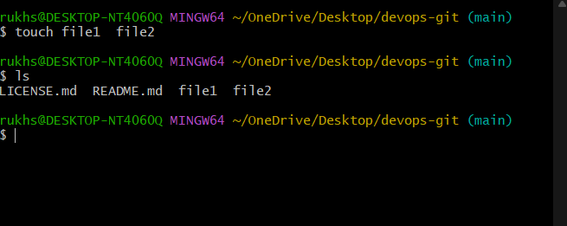
5)Commit two files and push to central Repository.
- We use git add . because Git needs files moved from the working area to the staging area before they can be committed.
- We run git commit -m "message" because commit creates a permanent save point in the repository history with a message explaining the change.
- We push using git push -u origin main because this sends our local commits to the central GitHub repository.
- The -u flag sets a permanent link between local main and remote main, so future pushes only need git push.

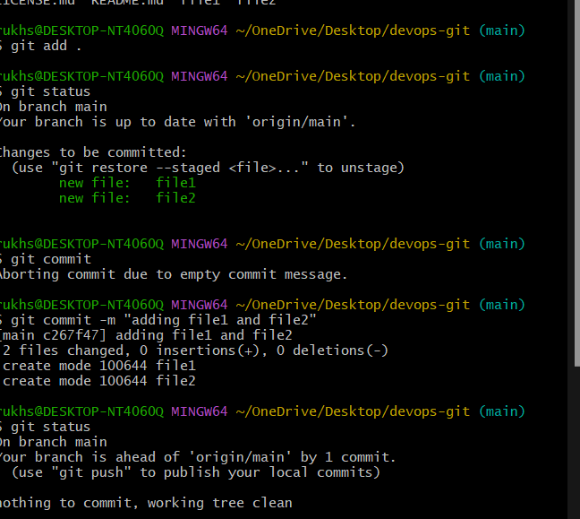
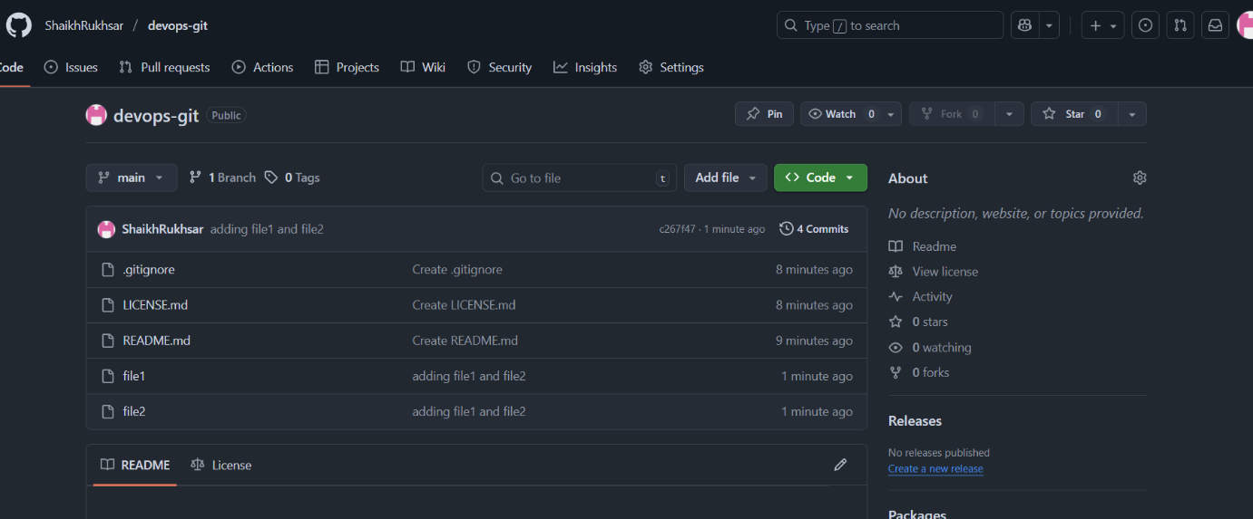
6)Create a branch in local and create a sample file and push to central.
• We create a branch using git checkout -b feature because branches let us work on new changes without disturbing the main branch.
• We create a sample file because Git needs some actual change in the branch to commit and push.
• We run git add and git commit because every branch needs its own commit history before pushing to GitHub.
• We push using git push -u origin feature so the new branch gets created on GitHub and links to our local branch for future work.

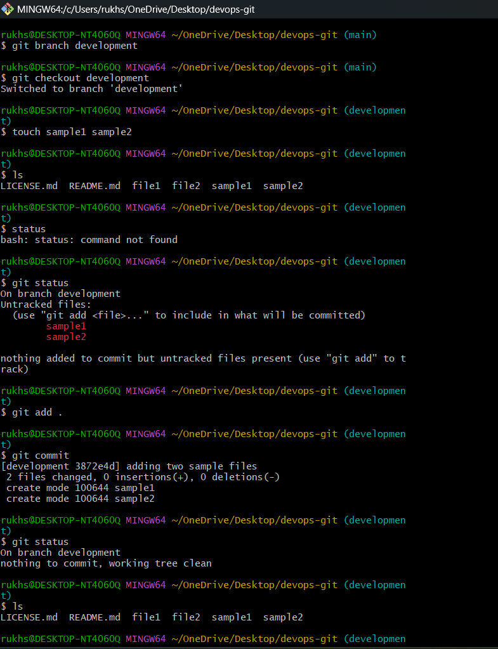
7)Create a branch in github and clone that to local.
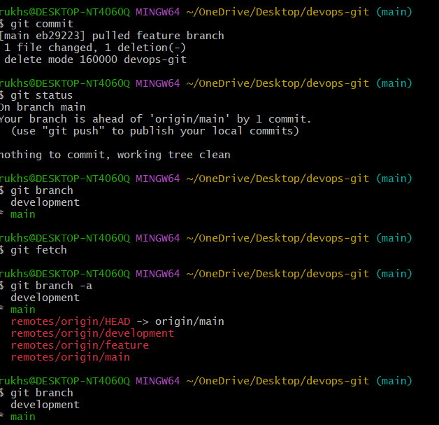
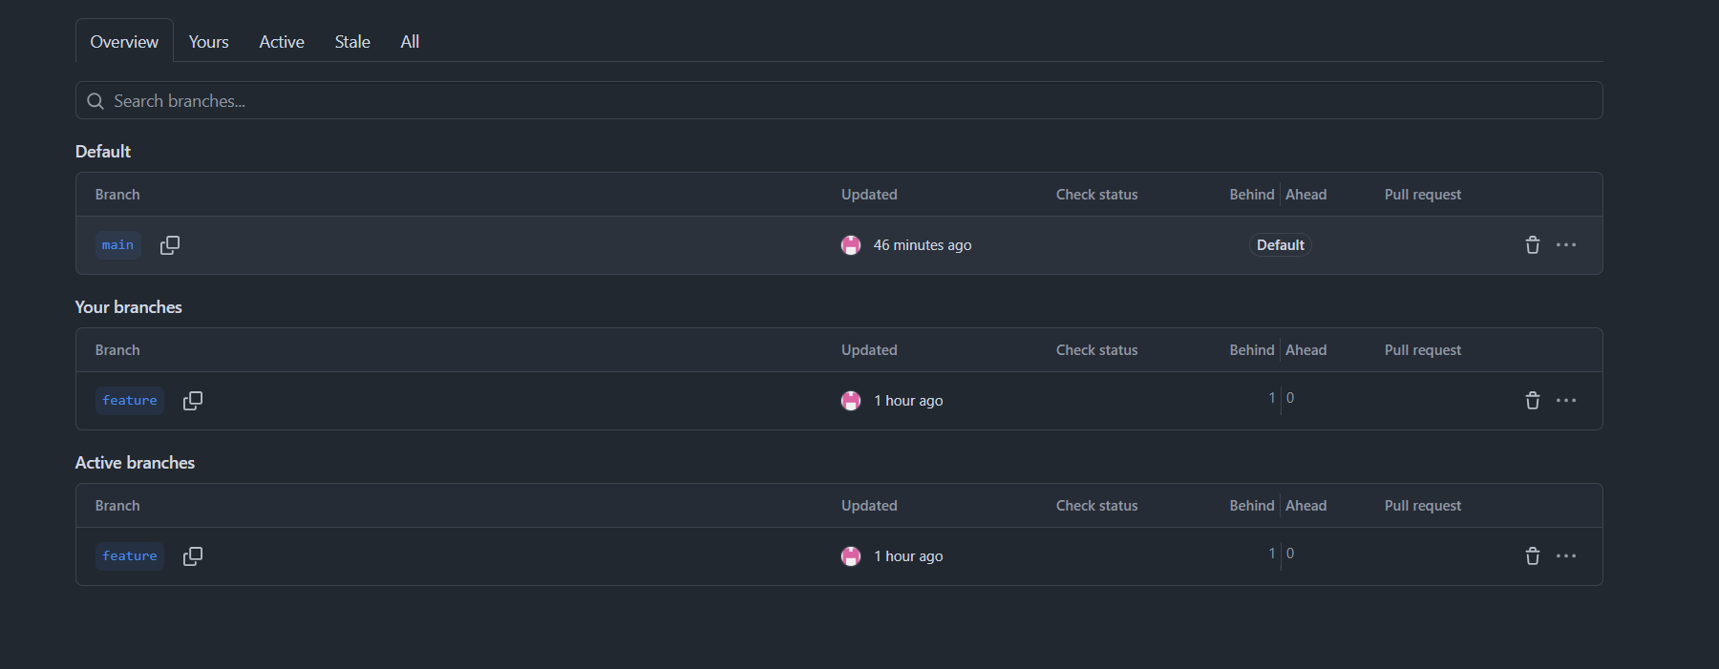
8)Merge the created branch with master in git local.
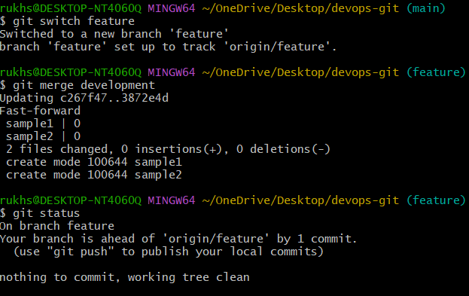
9)Merge the created branch with master in github by sending a pull request.
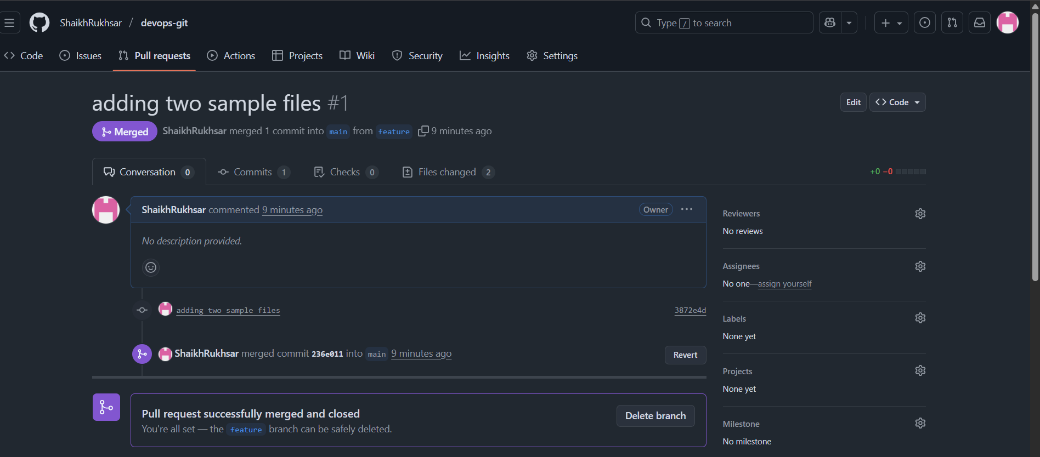

10)Create a file in local a STEP 1: Go inside your local repository folder
You must be inside the project before doing anything.
cd ~/OneDrive/Desktop/devops-git

STEP 2: Switch to the branch where you want your file
You have to be on the correct branch before adding files.
git switch feature
STEP 3: Create a new file in your local repo
This actually creates the file you want to send.
touch file3

STEP 4: Add the new file to the staging area
This tells Git: “I want this file included in my next commit.”
git add .

STEP 5: Commit the file locally
This saves your changes in your local Git history.
git commit -m "added file3"

STEP 6: Push the commit to GitHub
This sends your local changes → to the GitHub branch.
git push

STEP 7: Check if everything is clean
This confirms that all changes are committed and pushed.
git status
nd send that to branch in github.
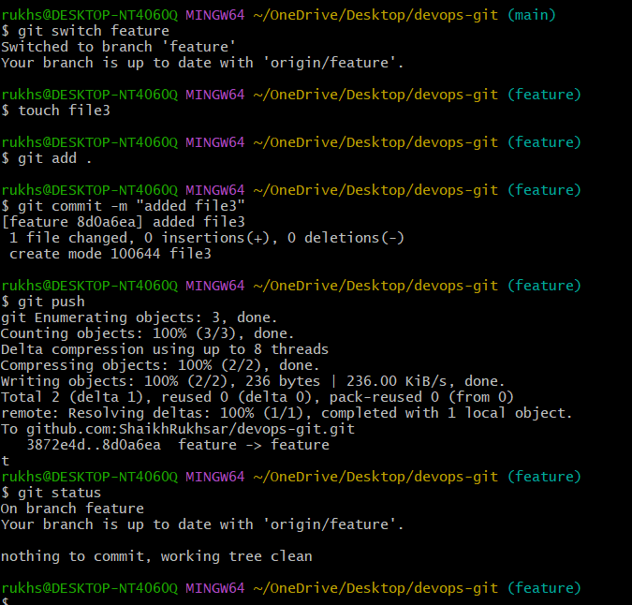

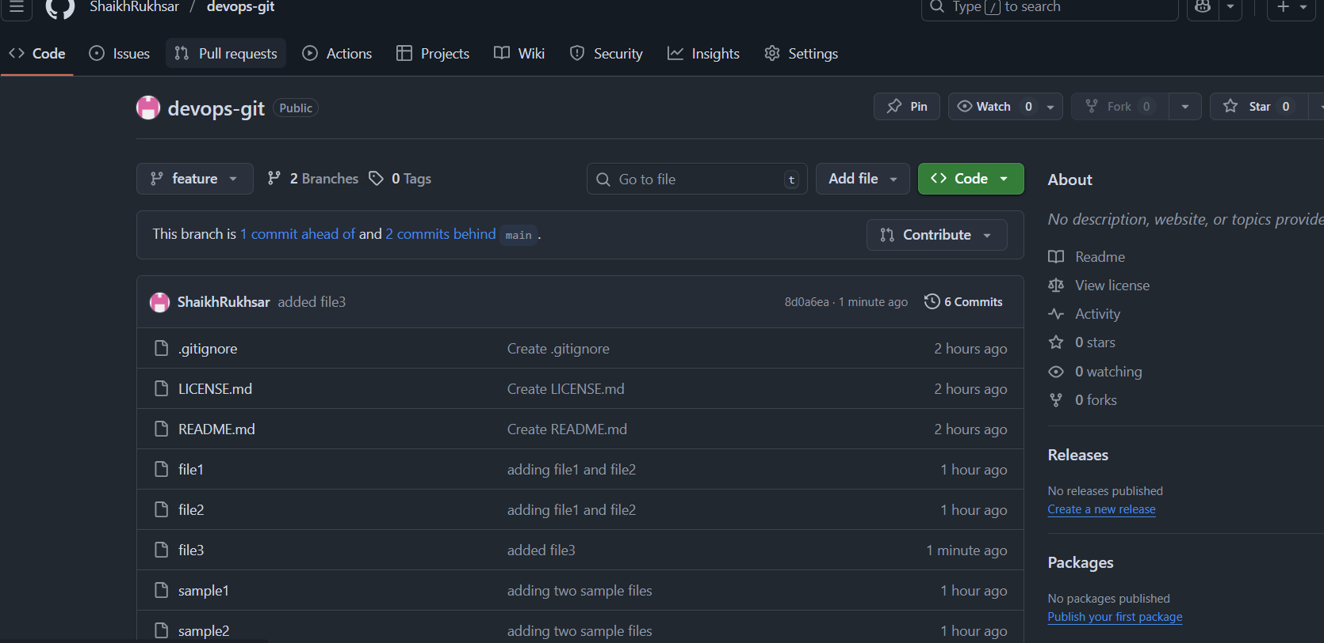11)Clone only a branch from github to local.

STEP 2: Use git clone with the -b option
-b tells Git which branch you want to clone.
This will clone the repo AND directly switch you into that branch.
git clone -b feature https://github.com/ShaikhRukhsar/devops-git.git
(Replace feature with your actual branch name.

STEP 3: Go inside the newly created folder
Git creates a folder with the repo name.
cd devops-git

STEP 4: Confirm that you are on the correct branch
This checks if the clone opened the branch you asked for.
git branch
You should see:
* feature
main

STEP 5: Check files inside the branch
Just to verify you pulled the correct version.
ls

Done — you cloned only that branch into your local system.
imp :- Cloning a branch does NOT mean:
- you only get that branch’s files
- you only get part of the repo
- you only get that branch folder
You get the full repository folder — just checked out on the feature branch.

12)Create a file with all passwords and make that untrackable with git.
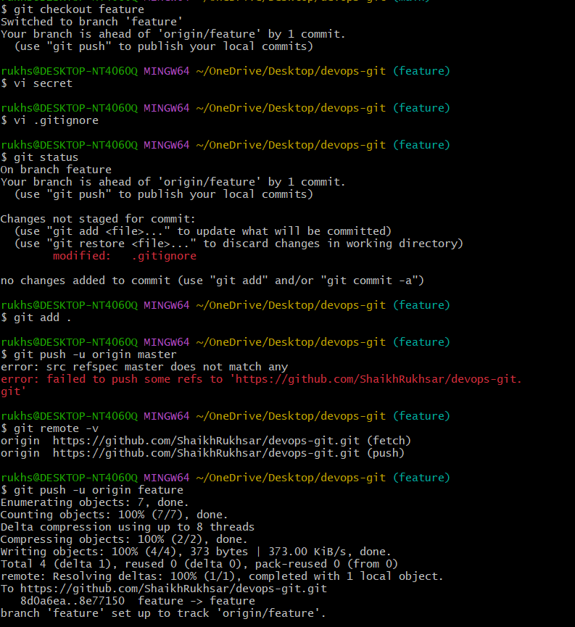
13)Make a commit and make that commit reset without savings changes.
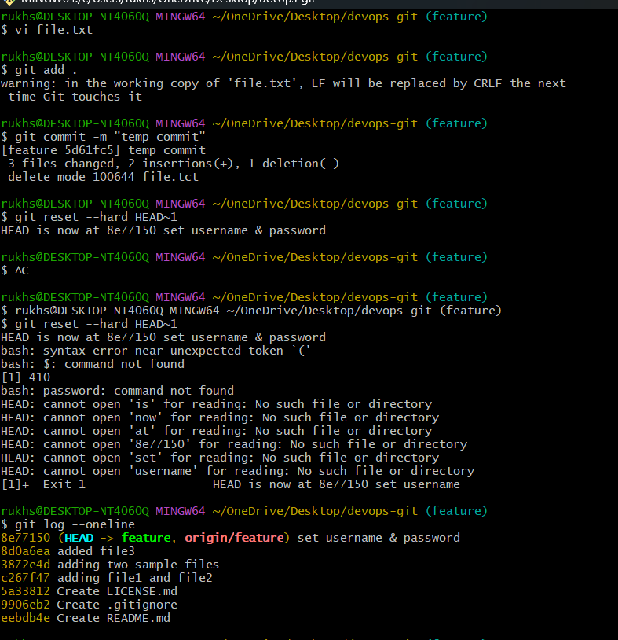
14)Revert a commited commit to the older version.

15)Push a file to stash without savings the changes and work on another file.
1) First we edit the file normally in working directory
Because Git only stashes files that have modifications.
2) Then we stash only that specific file using git stash push filename
This saves that file’s changes into stash memory without creating a commit.
3) Git cleans the working directory for that file after stashing
So the file looks fresh and unmodified, allowing you to switch tasks.
4) We confirm the stash entry using git stash list
To ensure the file’s changes are safely stored as a stash entry.

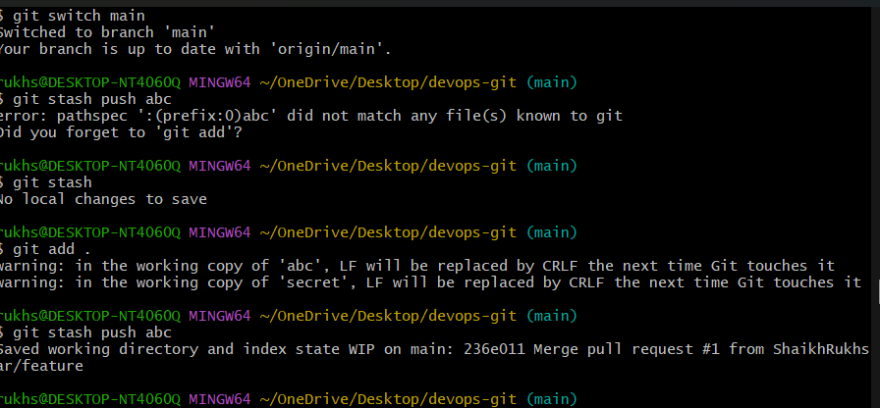
16)Undo the stash file and start working on that again.
We use git stash pop to restore the file’s hidden changes
Pop takes the file out of stash and applies it to the working directory.
2) Pop also deletes the stash entry after applying
Because pop = restore + remove from stash memory.
3) If we want to keep the stash entry, we use git stash apply instead
Apply restores the changes but keeps the stash stored.

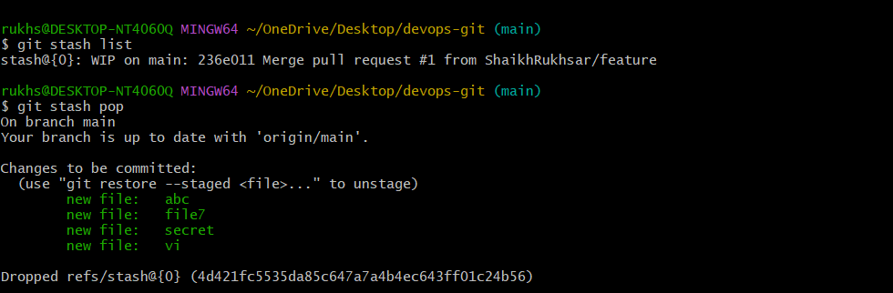
17)Generate a ssh-keygen and configure into github.
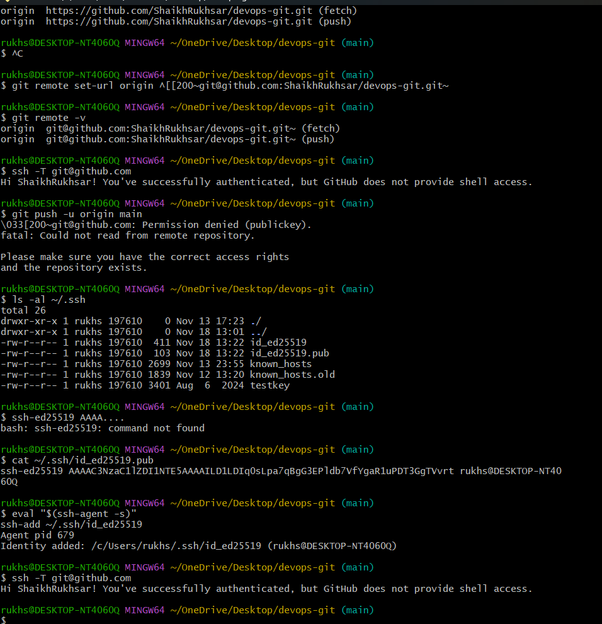

18)Configure webhooks to github.
19)Basic understanding of .git file.
20)Check all the logs of git.
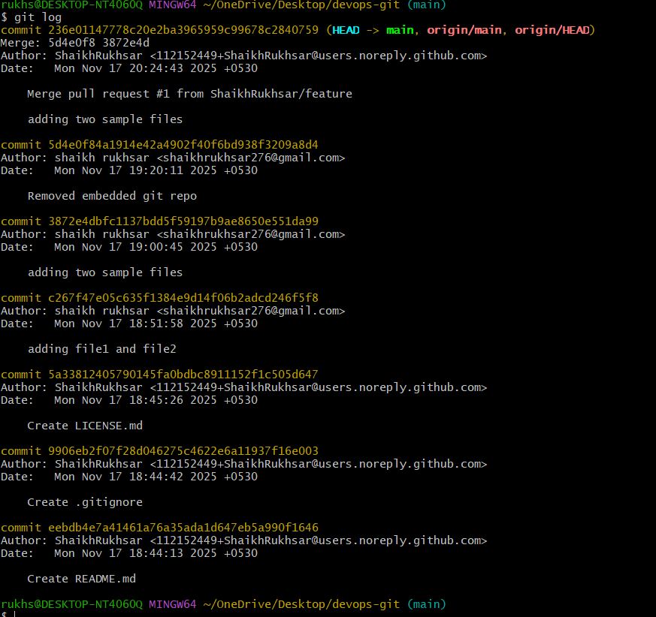
21)Rename the commit message.
Use this when you just committed something:
Step 1:
git commit --amend -m "new message"
Step 2:
If already pushed → you MUST force push
git push --force
Why:
Amending changes commit hash → rewrite history.
One-line summary:
“amend edits the last commit message.”

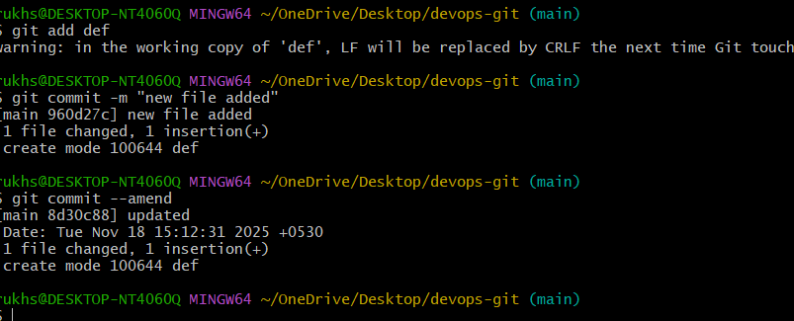
22)Merge multiple commits into single commit. 