HTMLS:Learn important things

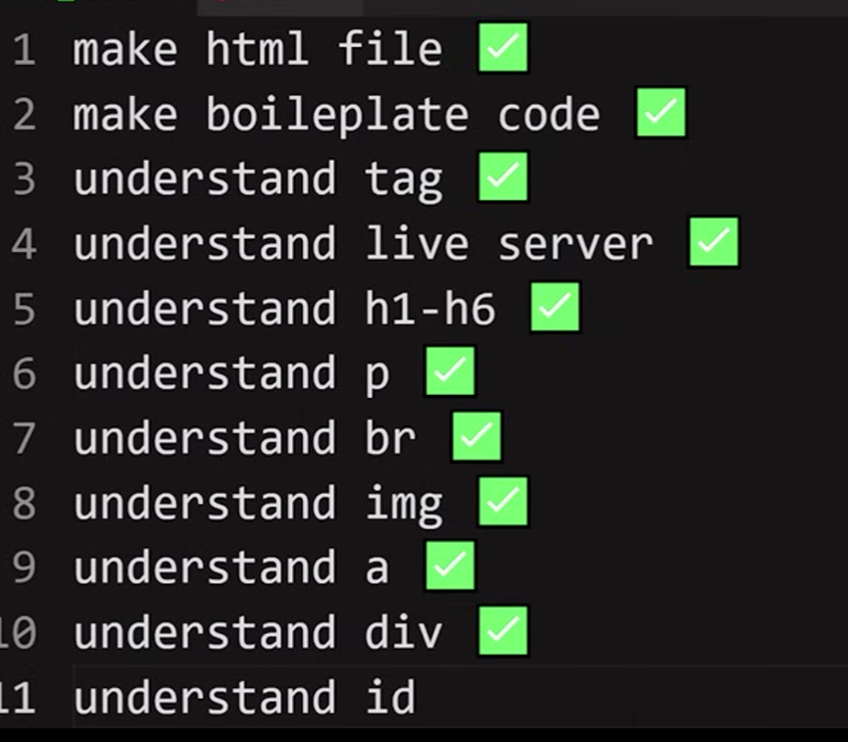

12:understand class.

What is div?

Div is rectangle with full width and zero height.

**🌐 Personal Portfolio Webpage (HTML-Only Project)**

**💡 Description:**

Create a single-page website that introduces yourself. You’ll use headings, paragraphs, images, links, and structure it using div, id, and class.

**🧱 Sections to Include:**

**1. Header**

* Use <h1> for your name.
* Use <p> for a short tagline or role.
* Use a <div> with an id="header".

**2. About Me**

* Use <h2> and <p> to describe yourself.
* Add a <br> tag between lines for formatting.
* Wrap in a <div class="about-section">.

**3. My Picture**

* Use the <img> tag to add a profile picture.
* Make sure to set alt="My photo".

**4. My Projects**

* Use <h2> and then list projects using <p> or <ul><li>.

**5. Contact Me**

* Use <h2>, <p> for your email or links.
* Add an <a> tag that links to your email (using mailto:) or your GitHub/LinkedIn.

**6. Footer**

* Add a simple footer using <p> and maybe a copyright.