* Java Information.
* new keyword.
* Object
* Constructor
* Methods
* Packages
* import
* returntypes
* setter getter
* Object classes
* Blocks
* static keywords /non-static

***Always Remember:***

* Always remember everything in java is executed line by line and in order
* Create object of that class which is need to be called
* Always save the method on the basis of returntype of method
* Default Constructor global var ko intialize karta hai
* Whenever an object is created naya location create hota hai or usma default values aati hai agar usko intialize nhi kiya toh
* Intialize : To set the values
* static blocks are called first even before main method
* static things are called in order
* Non -static depends on object of the class
* In main method main is not a keyword
* Compilation – javac running java
* We can write class name and file name different because humlog file name ko compile ke liye “**javac**” use karte hai or run karneko “**Java** ” command use karte hai. (Only in notepad)
* We can compile a code without creating the main method.
  + As main method is only for running the java program.
* **To access anything from the class in main method we need to create object.(eg:global var,classes,methods,default constructor)**
* Java always gives class file like eg:System,Object which are final and we cant change it. Only some part can be change via method ovveriding
* Classes ka name Pascal(Starting word alphabet captial ) standard mai rehta hai. Eg class HelloSumi (H,S captial)
* There are 5 kinds of blocks: Normal method,main method,static and non-static method, default constructor
* All the names other than class follows camelcase(Starting word ka alphabet small or baaki ke word ka starting alphabet capital) eg: hiEveryone (h , E)
* All the classes that are given by java present inside java -> jdk
  + - lib ->rt.jar folder
* r t stand for runtime. And jar is the collection of all class file
* to change the implementation/logic of any method present in the class given by java can be done by method overriding.
  + Eg : Object class ka toString method

1. What is java ?
   * Programming langugauge(to give Set of instruction) and a platform
   * High level(understand by human and computer) , Robust ,object -oriented ,secure ,case - sensitive

* **PLATFORM**: "A platform is like a playground where apps and games can run."
* **ROBUST**: Handle run-time errors as it checks the code during the compile and runtime.

1. Why use java ?

* Java works on different platforms (windows, mac, Linux etc.)
* It is easy to learn and simple to use
* It is open –source and free
* It is secure, fast and powerful
* It has huge community support (tens of millions of developers)
* Java is an object oriented language which gives a clear structure to program and allow code to be reused, lowering development cost

1. History of java ?

* Java was developed by james gosling.(Father of java)
* Established in 1995,by Sun microsystem.
* Intially called OAK changed to java inspired by java coffee because already trademark of some company
* Jdk 1.0 was released in jan 23,1996.
* 1.0to 1.6 -> Developed under sun microsystem.
* In 2009,sun microsystem was took over by oracle
* From 1.7 onwards oracle is developing java
* James gosling develop java in 18 months

1. Features of java ?

* Simple
* Object oriented
* Portable
* platform independent
* secured
* robust
* High performance

There are 21 languages supportd by java i.e we can code in english,japaneese etc.

* **new KEYWORD :**
* Allocates memory(ram) to the object during runtime.
* Invokes specified constructors of the class to create the objects.
* Returns reference to allocated memory.
* The refernce is nothing but memory location
* **Object: (Instance of the class)**
* ***Test t = new Test();***
* ***Test t // declaration***
* ***Test :class, t=ref var***
* ***, new = Test class ka sabka data t ke andar store karta hai i.e:int rollno;.***
* ***Test() = default constructor hota hai global var ko intialize karta hai.i.e rollno = 10; //if intialize if not than default.***
* ***Objects are made at runtime.***
* ***NOTE: jab bhi object create hota hai tab tab usma pehla default values aate hai variables ka.***

NOTE:

Varname

A a1 🡪 if maina esko directly print kiya a1 ko toh null value

print hoga or any non primitive data

Agar humne yeh null value ko aage jaake kisi or ko intialize kiya ya phir koi or object ko refer kiya toh runtime mai null pointer exception hoga(example of array)

**Type (of class)**

class

memory

new A()

Yeh constructor ke andar saare class ke varibales aata hai toh esliye hum agar new A().i , kiya toh hume i ke value print hoga

NOTE: every data is present in a1 variable.

Student s = new Student() 🡪 use when we wont to perform some operation.

new Student() -> If muje usma koi operation nhi karna hai

new student() 🡪 its the actual object

* A a is used when you want to declare a variable to hold an object reference for later use.
* new A().m1() is used when you want to create an object and immediately perform an action (like calling a method) without storing the object reference.
* **Constructor:**

**Q.Why to use Constructor.**

* + - A constructor in Java is a special method
    - (looks like method but it is not a method ) that is used to initialize objects.
    - The constructor is called when an object of a class is created.
    - It can be used to set initial values for object attributes
    - It doesn’t return any value
    - Every class as default constructor . or java tab tak uss default ko hi consider karta hai until and unless hum declare kare constructor
    - We can’t make constructor final static or any other thing
    - Only access modifier are used.

**1.Default Constructor: One type of block**

* Invokes automatically even we don’t create it.
* Used to initialize(setting the value) global variable.

i.e int rollno = 10; is divided into

int rollno; // declaration

rollno = 10; // intialize(Meaning putting value in variable) intilize in constructor

* Default mai intialize hota hai automatically can be seen in cavaj software.
* It is always public with no parameters if we don’t create ours and java adds it

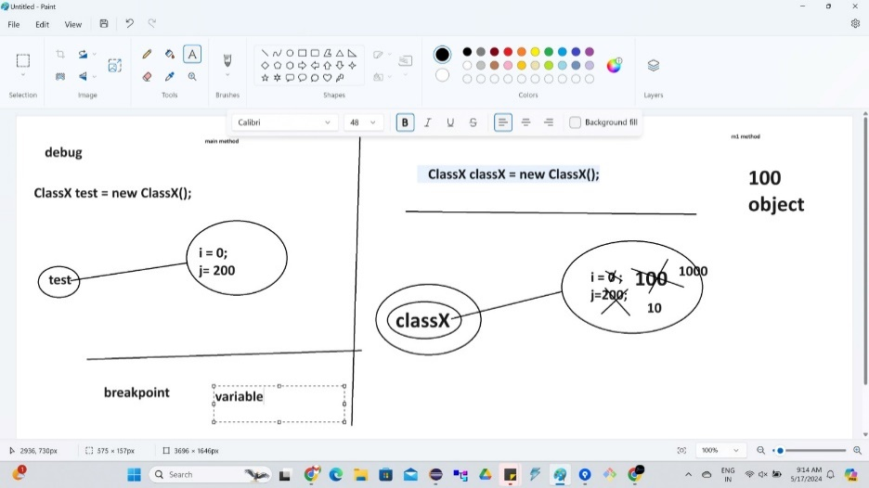

**2.Parameterized Constructor**

* Use to give inputs.
* Can be primitive non -primitive
* Replacement of intializing the object via the refernce variables i.e s.id = 1,s.rollno = 21; etc
* Can add validation for eg i > 10

**Disadvantage:**

1. It is tightly coupled (Saare Parameters ko value dena hi padega ). Esliye hum setter getter ke pass jaate hai value ko

Intialize karne.

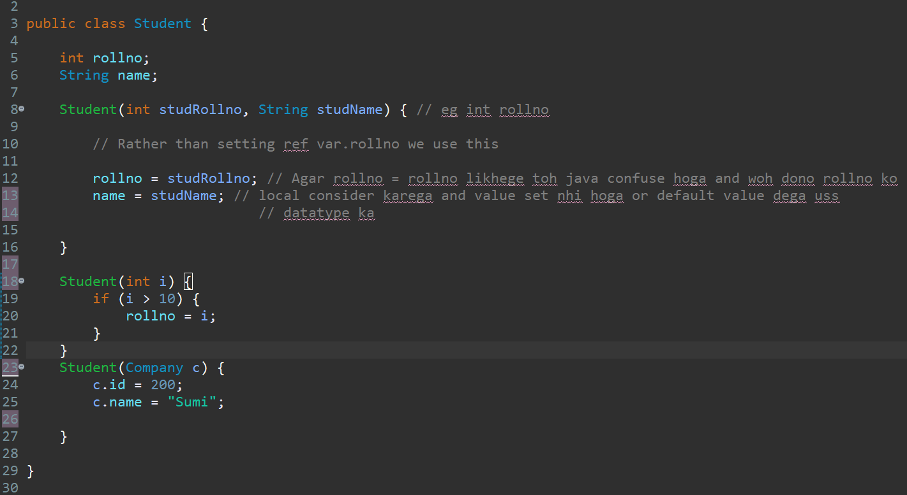

**3. Constructor Chaining : (Example in this and super keyword)**

* Achieved via this() or super().
* Every constructor in java irrepective we write it or not has super() present matlab inheritance ho ya khuch bhi ho super() keyword hoga hi .
* We can only write either super() or this() . i.e dono saathme nhi ho sakta.
* this() or super() is present at the first line of the constructor.i.e agar beech mai kedar likha toh error

NOTE:

Constructors are divided in 3:

1st line for -> this() or super()

2nd line for -> intialization

3rd line for -> statements

Rules for defining constructor. (see concept of the day)

* It is legal to have method name same as constructor name or same as class name but it is not recommended.
* Recursive constructor calling is not allowed.
* Only access modifier are allowed

|  |  |
| --- | --- |
| 1  2  3  4  5  6  7  8 | **class** A  {       A()       {  **this**();            // It gives compile time error       }  } |

* No Cylic calling of constructors.

|  |  |
| --- | --- |
| 1  2  3  4  5  6  7  8  9  10  11  12  13 | **class** A  {       A()       {  **this**(10);            // It gives compile time error       }       A(**int** i)       {  **this**();            // It gives compile time error       }  } |

Methods: one type of block

Use to add functionality

Eg: Animal class : Has function of walk,sleep etc.

1.No args /no argument/non parameterized method.

* Does not contain parameter

2. Parameterized method. **(Scenirios in java notes folder)**

* Contains parameters i.e inputs
* Parametrs can be primitive ,non-primitive

Q:Why it is suggested to not have more than 6 -7 parameters in parameterized methods/constructor

* Because parameters manage karna hard hai .
* Parameters ka order maintain karna padta hai.
* Jaisa order mai parameters diya hai waise hi order mai calling ki time value dena hoga.
* **Packages(Folder):**
* Organize related or similar classes,interface,enum in one group.
* Always declared at the first statement .
* If written somewhere else than compile time error.
* Ek package com hai uske andar com banaya tha acceptable hai
* Ek package ke andar ek hi similar class hota hai.
* Same classes name in other package is possible.
* Eg package com;

**Eg: 1:** Package 1 Package 2

class A class A

2: Package1 Package1

class A Package 1

class A

* **import Statement:**
* Import use for using the member/ methods of the package in another package.
* Access always by the **class name or “*:for all classes import”;**
* NOTE:

1.According to Industry Standard more than 3 classes import karna hai toh “*” daalneka.

2.To access anything from any package that package methods,variables, constructor anything should be writtern public

* Eg:import packagname.classname or *
* 🡪 import com.student.StudentInfo or *;

**Steps for Running main class in cmd for package:**

**Step1: Always remember that compile the imported package file via**

**javac -d . filename**

**-🡪 javac - d . Test.java //here d is directory “.” current**

**Step2: Compile the main class file via same command**

**Step3: Run the file having main class via 🡪 java com.Demo**

**java packagename.classname**

**-🡪 java com.stud.Student**

Q.Ek package ka specific method ya variable access kar sakte hai kya

For eg: import com. Student.m1; //m1 here is method

🡪 No,Because every method/var ko object chaiye class ka

Import com.Student;

* **Returntypes:**
* We use it in method.
* Return types can be primitives and non primitives
* In short Output
* It is has a fixed place i.e before method name sat

Q:Why to use Custom class as an Returntype?

* Agar hume bohot saara data chaiye toh custom class important hai

**RULES:**

1.Can only return one value

2.Need to create object if returntype is class.

3.Can’t execute anything after return keyword.

NOTE:

1: Always save the method based on the returntype.

2: Always create the object of the class that we need to call.

* **setter-getter (Pojo class – plan old java /Model class/Bean Entity)**
* Alternative of parameterized constructor
* Mostly used
* Zarruri nhi hai saare values ko set ya get karna hai i.e it does not follow tight coupling
* Always use with private
* Protect karta hai data
* Can add validation for eg i > 10
* 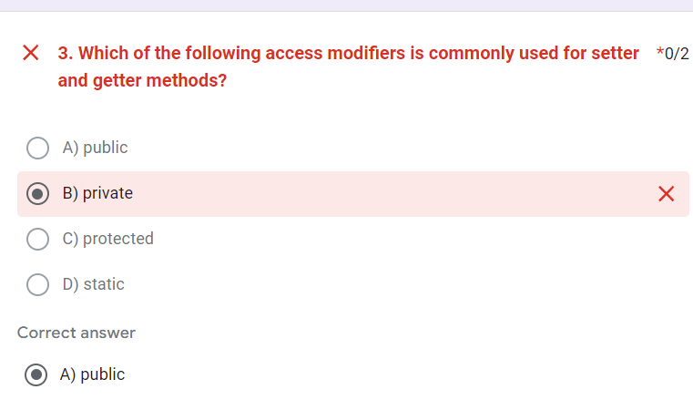
* **Object classes**
* Parent classes of all classes in java by default present
* Can be seen using ctrl + t (Show hirarchial of class)
* Part of java.lang package

1:toString() = public String toString() {

Return “Any string”;

}

* The toString() method returns the String representations of the object.
* sReplacement of normal printing. i.e Syso(s.id)
* With this method we can directly print the data memebers values using the object itself

Eg = Student s = new Student

Syso(s) //All the properties like rollno,name will be printed.

* If we don’t override the toString method and than if we try to print the object it will provide hashcode.
* The hashcode is generated by the toString method in the backend by default even if we don’t ovveride it or uss method ke andar yeh logic hai hashcode ka.
* But agar humne usko ovveride kiya toh values print karega. Nhi kiya toh object ka hashcode print hoga.

1. hashcode method :->

* It converts the internal address of the object to an integer by using an algorithm.
* And dont give the actual address because it is not possible in java

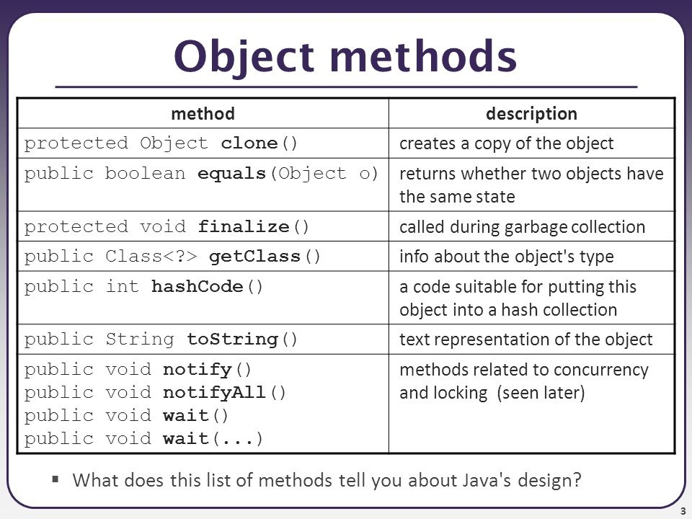

clone() 🡪

-whichever class we need to clone that class needs to implement cloneable interface else classNotFoundException.

-we need to override clone method

* **Blocks : 5 types : default constructor,static ,non static ,normal method, main method**

1: static block:

static {

//all the statement

}

* Executed at the time of class loading(bootstrap loding : when the classes are loaded by jvm.)
* Executed before the main method.
* Executed only once.
* Use static keyword (reserved keyword)
* Eg : jdbc connection

NOTE:

* Till the jdk version 1.6 (at the time of sunmicrosystem) we can run the java program without main method by using static block.
* But after 1.7 when oracle took over the java it make compulsory that the program wont run without main method .
* But the execution of static block will be done before the main method
* We use static block if we wont to do something or load something before main method i.e like datatbase name,url etc.
* Agar humne static block ko main method ke neeche bhi likh toh bhi static block hi execute hoga static should be inside the class outside main.

Q why we can only call static block once?

Because class ek hi baar load hota hai na

Q:Can we have more than one static block

Yes we can have but it is not suggested because static block ek hi baar load hota hai

Q: Why we cant refer any static block as this and super

Because it refers to class memory and this and super are for object

2:Non-static Block:

{

//Statements.

}

* Depends on object
* When the object is created non static block is called first even before calling the constructor
* We use non static block in the case where we have to perform something with the global var before it has been intialize by the constructor.
* Rarely used block.

Important example of nonstatic (Infinite runtime error will generate here)

Class Student {

{

Student s = new Student() // again object created//

After object creation it will again check

} wheter it has non static block .

so in this way it will go in infinite loop

Main method {

Student s = new Student() // Checks any nonstatic,yes go to non static

block

}

}

3:Main method

Public static void main(String[] args) {

}

Main method:

It is an entry point to execute java code. It is fixed only we can change args(variable name).

static :As main method is to be load only once hence static

the main method is the first thing that executed hence it doesn’t make sense to create it, object so static helps us to execute t without creating the object of the class

void : It is an return type which dosnt return anything only print things as it is .

main : it is an method name

name of the method

* **static keyword:**
* static keyword is use for memory management i.e we create memory only once.
* we can use static keyword before varibales,blocks ,nested classes,method
* static is present in class memory. Refers to class

RULES FOR static:

1. static are executed in order and before main method

Eg :

static int i = m1() 🡺🡺 1

public static int m1() {

Syso (“Hi”) 🡺🡺 2

return i

static {

Syso(“Welcome”) 🡺🡺 3

}

Main method{

Syso(i) 🡺🡺 4

}

}

1. static variables cannot be overriden

Class A Class B extends A

static int i = 100; static int i = 10;

main method {

Syso(A.i) --🡪 We will get 100 because there are two different i created.

}

1. We cant call non static in static
2. There will be one single memory for static

Q.Why it is of type class?

Because it is only loaded once at the time of class loading.Does not depend on object

Q.When to use?

When we wont that an object must share a common properties eg:classname.

Q.How we can access it

We can acces it by refernce var(object) or directly by class name(prefered)

If in same class than directly by name(prefered) or by classname or object creation

If we wont to call in another class than by classname(Prefered) or object creation

Q.Why we can’t access non-static things in static

Because non -static depends on object

Agar object nhi create kiya toh who exist hi nhi karta

Q:Why we cant make constructor as static

Because static refer to class whereas constructor is refer to obejct or use for creating object

Q:can we make classes as static?

Yes only inner classes

the static keyword is meant for things inside a class to say, "I don't need an object of the class to exist." Since an outer class is already at the top level and independent, there's no need for it to be static.

* **Non-static:**

All methods,blocks,variables,classes which donot have static written are nonstatic

NOTE:

1. Static value declare toh ek hi baar memory banage but agar usko ek object se change kiya ya phir static varibales se change kiya ya phir non-static block se change kiya toh the change will reflect in all.
2. Non static har baar naya obj toh change done by one object or non -static block for that object wont reflect in another object.