CUSTOMER CHURN BUSINESS ANALYIS

Technical Report
Project Introduction
Customer churn refers to customers who stop using a company's products or services. High customer churn can negatively affect business growth and revenue.
This project performs an end-to-end analysis of customer churn data to identify important patterns and factors associated with customers leaving the company.
The project includes data validation, data cleaning, exploratory data analysis, statistical analysis, hypothesis testing, confidence interval analysis, and business recommendations.
The purpose of this analysis is to transform raw customer data into meaningful insights that can support better business decision-making and customer retention strategies.

Business Problem
Customer retention is an important challenge for many businesses. When customers leave a company, the business may lose revenue and incur additional costs to acquire new customers.
The main business problem addressed in this project is to understand which customer characteristics are associated with customer churn.
The project attempts to answer the following question:
What factors are associated with customer churn, and how can the business use these insights to improve customer retention?
Project Objectives
The main objectives of this project are:
- Validate and prepare the customer dataset for analysis.
- Identify patterns associated with customer churn.
- Perform exploratory data analysis using professional visualizations.
- Compare customer characteristics between churned and non-churned customers.
- Perform statistical hypothesis testing.
- Calculate confidence intervals for important business metrics.
- Translate analytical findings into actionable business recommendations.
- Develop a practical customer retention implementation plan.

Dataset Description
The project uses a customer churn dataset containing 500 customer records and 9 variables.
The dataset contains the following features:
- CustomerID – Unique customer identification number.
- Tenure – Duration of the customer's relationship with the company.
- MonthlyCharges – Monthly amount charged to the customer.
- TotalCharges – Total amount charged to the customer.
- Contract – Customer contract type.
- PaymentMethod – Method used by the customer for payment.
- PaperlessBilling – Whether the customer uses paperless billing.
- SeniorCitizen – Indicates whether the customer is a senior citizen.
- Churn – Indicates whether the customer left the company.
The dataset was used to analyze relationships between customer characteristics and churn behavior.

Data Cleaning and Preparation
Before performing the analysis, the customer churn dataset was examined to ensure that the data was suitable for analysis.
The following data quality checks were performed:
- Dataset shape was examined.
- Column names and data types were checked.
- Missing values were identified.
- Duplicate records were checked.
- Numerical and categorical variables were reviewed.
Data Quality Results
The dataset contained 500 rows and 9 columns.
The analysis found:
- No missing values
- No duplicate rows
- Numerical columns were correctly identified.
- Categorical variables were reviewed for consistency.
Therefore, the dataset was considered suitable for further analysis.
The cleaned dataset was saved as:
cleaned_data.csv
This cleaned dataset was then used for Exploratory Data Analysis and Advanced Statistical Analysis.

Data Preparation Process
The dataset preparation process ensured that the data was organized and ready for analysis.
The main variables used during the analysis included:
- Tenure
- MonthlyCharges
- TotalCharges
- Contract
- PaymentMethod
- Churn
The cleaned dataset was used consistently across all analysis notebooks to maintain reproducibility and ensure reliable results.

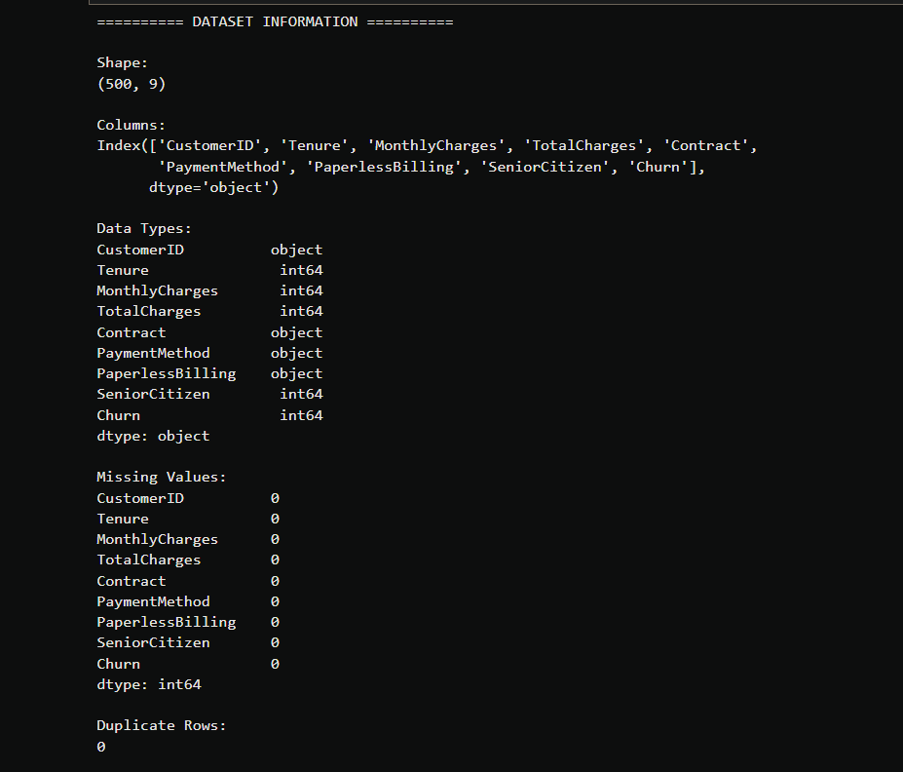

Exploratory Data Analysis
Exploratory Data Analysis (EDA) was performed to understand customer behavior, identify churn patterns, and examine relationships between important variables.
The analysis included customer churn distribution, contract type analysis, payment method analysis, numerical data distributions, scatter plot analysis, and correlation analysis.
A total of seven visualizations were created.

7.1 Customer Churn Distribution
The customer churn distribution was analyzed to understand the overall proportion of customers who left the company.
Out of 500 customers:
- 447 customers did not churn
- 53 customers churned
- Overall churn rate was 10.6%
This shows that although most customers remained with the company, customer churn still represents an important business concern.
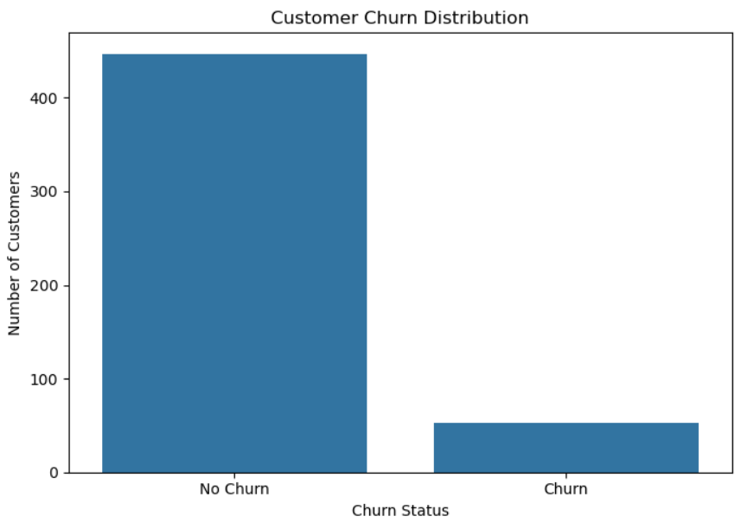

7.2 Churn Rate by Contract Type
Customer churn was compared across different contract types.
- Month-to-month: 20.59%
- One-year: 4.30%
- Two-year: 6.94%
Month-to-month customers had the highest observed churn rate.
This suggests that customers without longer-term contracts may have a higher risk of leaving the company.
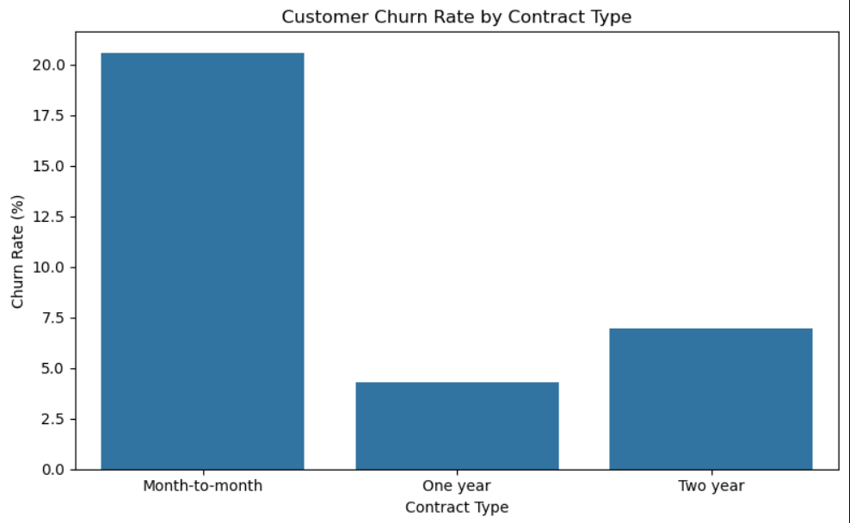

7.3 Churn Rate by Payment Method
The churn rate was also analyzed according to customer payment methods.
- Bank Transfer: 6.92%
- Credit Card: 13.48%
- Electronic Check: 11.04%
Customers using Credit Card had the highest observed churn rate, while Bank Transfer customers had the lowest.
This suggests that payment method may be associated with differences in customer churn behavior.
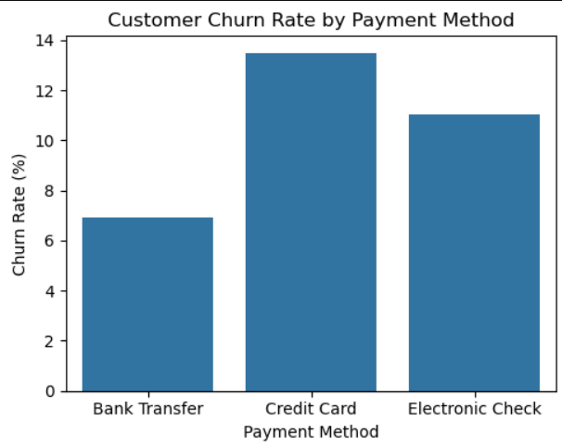

7.4 Monthly Charges Distribution
The distribution of Monthly Charges was analyzed using a histogram.
This visualization helped identify how customer charges were distributed across different price ranges.
Further analysis compared Monthly Charges between churned and non-churned customers.
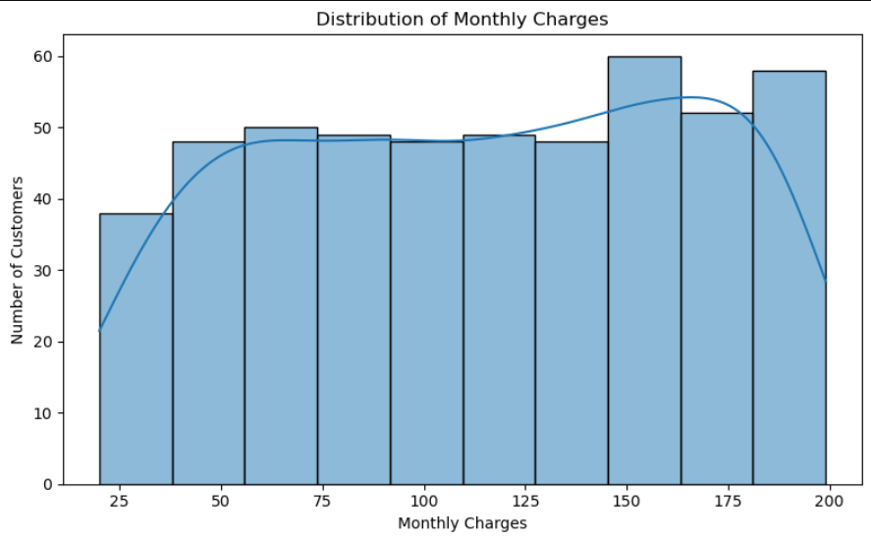

7.5 Customer Tenure Distribution
Customer tenure was analyzed to understand how long customers had been associated with the company.
The tenure distribution provided insight into the duration of customer relationships.
Further statistical analysis showed that customer tenure had an important association with churn.
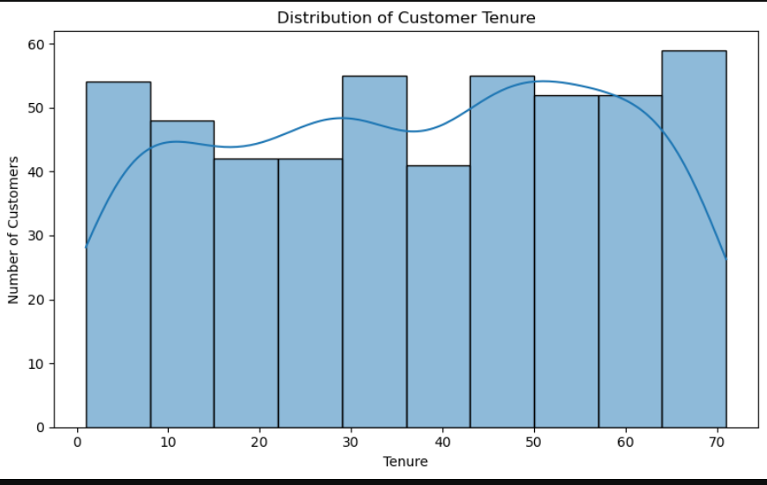

7.6 Tenure vs Monthly Charges
A scatter plot was created to examine the relationship between customer tenure and Monthly Charges based on churn status.
This visualization helped compare patterns between churned and non-churned customers.
The results suggested that churn behavior may differ depending on customer tenure and Monthly Charges.
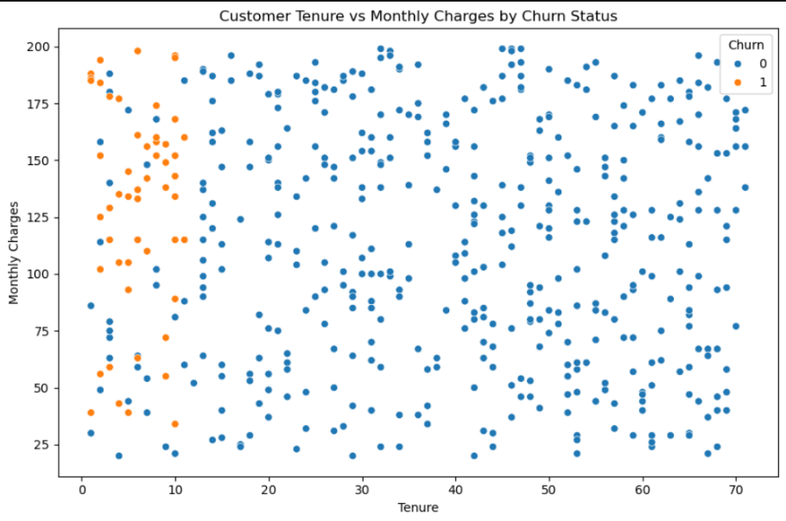
7.7 Correlation Analysis
A correlation heatmap was created to examine linear relationships between numerical variables.
The numerical variables included:
- Tenure
- MonthlyCharges
- TotalCharges
- SeniorCitizen
- Churn
Correlation analysis helps identify associations between variables but does not prove causation.
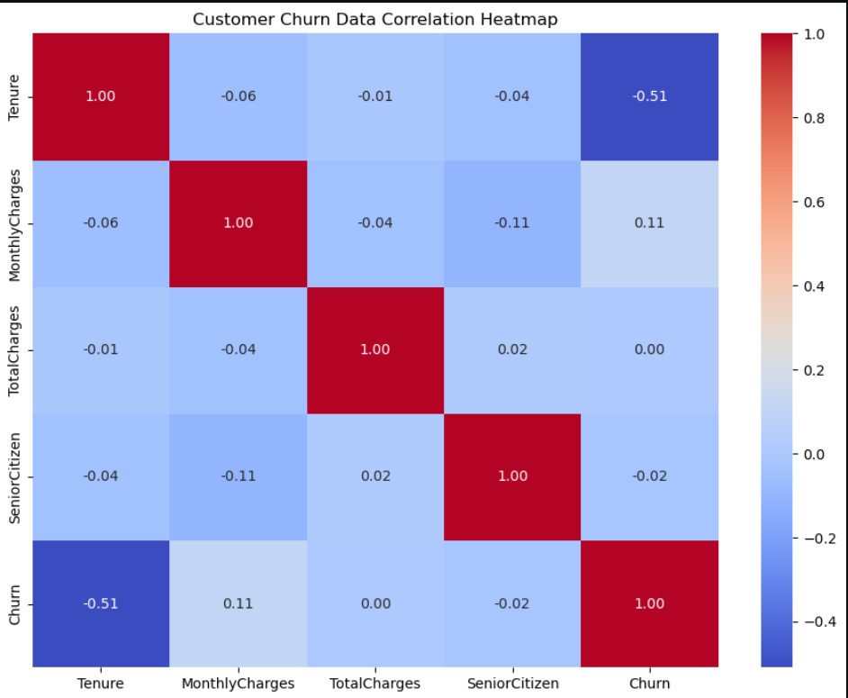

Statistical Analysis and Hypothesis Testing
Statistical Analysis
Statistical analysis was performed to determine whether the differences observed between churned and non-churned customers were statistically significant.
The analysis included:
- Descriptive statistics by churn group
- Independent sample t-tests
- Confidence interval analysis
A significance level of 0.05 was used for hypothesis testing.
If the p-value was less than 0.05, the result was considered statistically significant.

8.1 Descriptive Statistics by Churn Status
The numerical characteristics of churned and non-churned customers were compared.
Customer Tenure
- Average tenure of non-churned customers: 40.15
- Average tenure of churned customers: 6.00
This shows a major difference between the two groups.
Monthly Charges
- Average Monthly Charges of non-churned customers: 111.72
- Average Monthly Charges of churned customers: 129.77
Churned customers had higher average Monthly Charges.
Total Charges
- Average Total Charges of non-churned customers: 4234.58
- Average Total Charges of churned customers: 4265.75
The average Total Charges were relatively similar between the two groups.
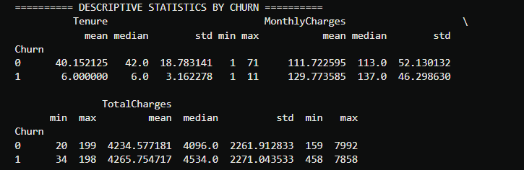

8.2 Hypothesis Test 1: Tenure vs Customer Churn
Null Hypothesis (H₀)
There is no significant difference in average customer tenure between churned and non-churned customers.
Alternative Hypothesis (H₁)
There is a significant difference in average customer tenure between churned and non-churned customers.
Results
- T-statistic: -34.53
- P-value: 8.98 × 10⁻¹³⁰
- Result: Statistically Significant
Since the p-value is much smaller than 0.05, the null hypothesis was rejected.
There is a statistically significant difference in customer tenure between churned and non-churned customers.
This indicates that customer tenure is strongly associated with churn in this dataset.
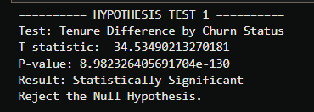

8.3 Hypothesis Test 2: Monthly Charges vs Customer Churn
Null Hypothesis (H₀)
There is no significant difference in average Monthly Charges between churned and non-churned customers.
Alternative Hypothesis (H₁)
There is a significant difference in average Monthly Charges between churned and non-churned customers.
Results
- T-statistic: 2.65
- P-value: 0.0101
- Result: Statistically Significant
Since the p-value is less than 0.05, the null hypothesis was rejected.
There is a statistically significant difference in Monthly Charges between churned and non-churned customers.
This suggests that Monthly Charges are associated with customer churn in this dataset.
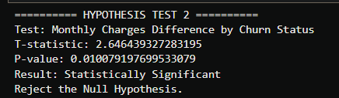

8.4 Hypothesis Test 3: Total Charges vs Customer Churn
Null Hypothesis (H₀)
There is no significant difference in average Total Charges between churned and non-churned customers.
Alternative Hypothesis (H₁)
There is a significant difference in average Total Charges between churned and non-churned customers.
Results
- T-statistic: 0.09
- P-value: 0.9250
- Result: Not Statistically Significant
Since the p-value is greater than 0.05, we fail to reject the null hypothesis.
There is no statistically significant difference in Total Charges between churned and non-churned customers.
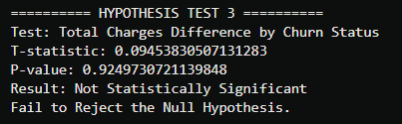

8.5 Confidence Interval Analysis
A 95% confidence interval was calculated for the average Monthly Charges.
Results
- Mean Monthly Charges: 113.64
- Margin of Error: ±4.55
- 95% Confidence Interval: 109.08 to 118.19
Based on the sample data, the underlying population mean Monthly Charges is estimated to fall within this range with 95% confidence.
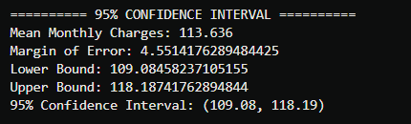

Key Findings
Key Findings
The analysis produced several important findings related to customer churn.
1. Customer Churn Rate
Out of 500 customers, 53 customers churned, resulting in an overall churn rate of 10.6%.
2. Customer Tenure
Customer tenure showed the strongest relationship with churn.
Churned customers had an average tenure of 6.00, while non-churned customers had an average tenure of 40.15.
The difference was statistically significant.
3. Contract Type
Month-to-month customers had the highest churn rate at 20.59%.
One-year contract customers had the lowest observed churn rate at 4.30%.
4. Monthly Charges
Churned customers had higher average Monthly Charges (129.77) compared to non-churned customers (111.72).
This difference was statistically significant.
5. Payment Method
Churn rates varied across payment methods.
- Bank Transfer: 6.92%
- Credit Card: 13.48%
- Electronic Check: 11.04%
6. Total Charges
Total Charges did not show a statistically significant difference between churned and non-churned customers.

10. Business Recommendations
Recommendation 1: Focus on Early Customer Retention
The analysis showed that customers with low tenure have a higher association with churn.
The business should develop strong onboarding programs and engagement strategies during the first few months of the customer relationship.

Recommendation 2: Encourage Longer-Term Contracts
Month-to-month customers showed the highest churn rate.
The company can encourage customers to choose longer-term contracts by offering:
- Discounts
- Loyalty benefits
- Special offers
- Contract upgrade incentives

Recommendation 3: Review Pricing Strategies
Churned customers had higher average Monthly Charges.
The company should review whether customers receiving higher charges are receiving sufficient value from the service.
Possible strategies include personalized pricing plans and targeted discounts.

Recommendation 4: Improve Payment Experience
Different payment methods showed different churn rates.
The company should investigate customer payment experiences and identify possible areas of improvement.

Recommendation 5: Develop a Churn Monitoring System
The company should regularly monitor important customer characteristics such as:
- Customer tenure
- Monthly Charges
- Contract type
- Payment method
- Churn trends
Customers identified as high-risk could receive proactive retention offers.

11. Business Implementation Plan
Phase 1: Identify High-Risk Customers
Identify customers who show important churn-risk indicators, particularly:
- Low tenure
- Month-to-month contracts
- Higher Monthly Charges

Phase 2: Retention Campaigns
Develop targeted retention campaigns such as:
- Welcome programs
- Personalized offers
- Loyalty rewards
- Contract upgrade incentives

Phase 3: Monitor Performance
The company should regularly track:
- Customer churn rate
- Customer retention rate
- Contract conversion rate
- Campaign performance

Phase 4: Continuous Improvement
The retention strategy should be regularly evaluated using new customer data.
Business decisions should be updated based on customer behavior and future analytical findings.

12. Conclusion
Conclusion
This project conducted an end-to-end business analysis of customer churn using a dataset containing 500 customer records.
The project included data validation, data cleaning, exploratory data analysis, statistical hypothesis testing, confidence interval analysis, and business recommendations.
The analysis identified customer tenure, contract type, and Monthly Charges as important factors associated with customer churn.
The strongest finding was the substantial difference in customer tenure between churned and non-churned customers. Customers who churned had significantly lower average tenure.
The findings suggest that businesses should prioritize early customer engagement, encourage longer-term contracts, review pricing strategies, and monitor customer churn risk proactively.
This project demonstrates how data analysis can transform raw customer data into meaningful business insights and actionable recommendations.

