

L J UNIVERSITY
School of Computer Applications | Dept. of Master of Computer Applications (MCA)
BOOK SWAP HUB
A Centralized Mobile Platform for Book Discovery, Exchange and Swapping
PROJECT DOCUMENTATION – REVIEW 3
MCA Semester III | Software Project I | Mobile Application
Submitted By | Majid, Aman, Afzal
Enrolment Numbers | 25004401110081, 25004401110085, 25004401110068
Guided By | Ajay Chuhan Sir
College / University | L J University
Academic Year | 2026

L J University
School of Computer Applications
Dept. of Master of Computer Applications
Near Sarkhej Cross Roads,
Ahmedabad – 382210, Gujarat, India.
Website: www.ljku.edu.in
CERTIFICATE
DIV: _____ ROLL NO: _______ ENROLLMENT NO.: 25004401110081
This is to certify that Mr. Majid studying in Master of Computer Applications (MCA), Semester III, have satisfactorily completed their Software Project Titled “Book Swap Hub – A Centralized Mobile Platform for Book Discovery, Exchange and Swapping”.
Date of Submission: ______________________
Ajay Chuhan
Internal Guide
Dr. Bhavin Shah
HOD

L J University
School of Computer Applications
Dept. of Master of Computer Applications
Near Sarkhej Cross Roads,
Ahmedabad – 382210, Gujarat, India.
Website: www.ljku.edu.in
CERTIFICATE
DIV: _____ ROLL NO: _______ ENROLLMENT NO.: 25004401110085
This is to certify that Mr. Aman studying in Master of Computer Applications (MCA), Semester III, have satisfactorily completed their Software Project Titled “Book Swap Hub – A Centralized Mobile Platform for Book Discovery, Exchange and Swapping”.
Date of Submission: ______________________
Ajay Chuhan
Internal Guide
Dr. Bhavin Shah
HOD

L J University
School of Computer Applications
Dept. of Master of Computer Applications
Near Sarkhej Cross Roads,
Ahmedabad – 382210, Gujarat, India.
Website: www.ljku.edu.in
CERTIFICATE
DIV: _____ ROLL NO: _______ ENROLLMENT NO.: 25004401110068
This is to certify that Mr. Afzal studying in Master of Computer Applications (MCA), Semester III, have satisfactorily completed their Software Project Titled “Book Swap Hub – A Centralized Mobile Platform for Book Discovery, Exchange and Swapping”.
Date of Submission: ______________________
Ajay Chuhan
Internal Guide
Dr. Bhavin Shah
HOD

Table of Contents
1. Introduction 3
1.1 Problem Definition 3
1.2 Objectives of the New System 3
1.3 Core Components 3
1.4 Project Profile 6
1.5 Need for the New System 6
1.6 Scope of the New System 7
1.7 Advantages and Limitations of the Proposed System 8
1.8 Proposed Timeline Chart 10
1.9 Target Users 11
2. Requirement Determination and Analysis 12
2.1 Requirement Determination 12
2.2 Requirement Specification 13
3. System Design 19
3.1 Use Case Diagram 19
3.2 Data Dictionary 22
3.3 User Interface Design 26
3.4 Report Design 27
4. Development and Implementation 29
4.1 Development 29
4.2 Coding Standards 33
5. Testing 36
5.1 Test Cases 36
6. Proposed Enhancements 40
7. Conclusion 40
8. Bibliography 41

1. Introduction

1.1 Problem Definition
Students and readers spend heavily on new books, while thousands of usable books sit idle on shelves because their owners have no structured way to reach people who need them. Today, book exchange depends on word-of-mouth, notice boards and social media groups, which are unorganized, untrusted and untracked.
- No centralized platform: There is no single place to list, search and discover books available for swapping.
- No nearby discovery: Users cannot find nearby people who are willing to exchange the book they need.
- No tracking: Swap requests, chats and exchanges are not recorded, so progress cannot be tracked.
- No trust or safety: There are no ratings, reports or moderation to verify users or book condition.
Book Swap Hub solves this with a centralized mobile platform that makes book exchange structured, trackable and safe.

1.2 Objectives of the New System

Overall Objective
The overall objective of Book Swap Hub is to design and develop a centralized, secure, and user-friendly mobile application that enables students and readers to discover, list, exchange, and manage books efficiently, thereby reducing the cost of acquiring books, promoting reuse, and building an organized community-driven book exchange ecosystem.

Specific Objectives
- To centralize book swapping activity within a single, unified mobile platform accessible to all registered users.
- To allow users to add, edit, and manage the books they own and wish to make available for exchange.
- To provide robust searching and filtering capabilities so that users can quickly locate the books they need.
- To enable discovery of nearby books using location-based features, encouraging local, low-cost exchanges.
- To allow users to send, receive, and manage swap requests through a clearly defined workflow.
- To provide direct communication between users through an in-app chat system.
- To implement a notification system that keeps users informed of relevant activity in real time.
- To implement a ratings and reviews mechanism that builds trust between users.
- To provide reporting functionality so that users can flag inappropriate behaviour or listings.
- To provide a comprehensive admin management system for platform oversight and moderation.
- To maintain the security, privacy, and integrity of user and application data at all times.

1.3 Core Components
Book Swap Hub is built using a modern, layered technology stack in which each component has a clearly defined responsibility. This separation of concerns ensures maintainability, scalability, and ease of future enhancement. After the technology layers, the functional components of both sides of the application – the User side and the Admin side – are described.

Frontend
The frontend of Book Swap Hub is developed using Flutter, Google's open-source UI toolkit, along with Dart as the primary programming language. Flutter was chosen because it enables a single codebase to be compiled into natively performing applications for both Android and iOS, significantly reducing development effort while maintaining a consistent user experience across platforms.
- User Interface: A clean, intuitive, and responsive interface built using Flutter's widget system, designed to make book browsing, listing, and swapping effortless for users of all technical backgrounds.
- Navigation: A structured navigation system that allows users to move seamlessly between screens such as Home, Search, My Books, Swaps, Chat, and Profile.
- State Management: A dedicated state management approach is used to manage application data, user sessions, and UI state consistently across the app.
- API Communication: The frontend communicates with the backend exclusively through RESTful API calls, sending and receiving data in JSON format.

Backend
The backend is developed using a serverless cloud architecture powered by Cloud Functions for Firebase (2nd Generation, Node.js 22 and TypeScript), chosen for its automatic elasticity, sub-second cold starts, zero server maintenance overhead, and tight integration with Google Cloud Platform services.
- Node.js 22 & TypeScript: Serves as the core runtime and language for all serverless Cloud Functions, providing strong static typing, asynchronous event handling, and direct integration with the Firebase Admin SDK.
- Cloud Functions for Firebase: Provides scalable serverless HTTPS and Callable microservices that enforce swap state machines, transactional data validation, Stripe checkout flows, and administrative moderation.
- Callable Microservices & Cloud APIs: A well-structured suite of Cloud Functions handles all critical transactions, covering account cleanup, swap state machine transitions, Stripe PaymentIntent creation, webhook verification, and moderation.
- Authentication: Managed through Firebase Authentication, providing secure token-based user verification, automatic session refreshing, password hashing, and mandatory email verification guards.
- Business Logic: Encapsulated in Cloud Functions using idempotent multi-document database transactions (db.runTransaction) and declarative security rules to guarantee state consistency.
- Database Operations: Managed through the Firebase Admin SDK and Cloud Firestore Security Rules, ensuring client-side requests never bypass integrity or authorization constraints.

Database
Google Cloud Firestore, an enterprise-grade NoSQL document database, is used to persist all application data in real time. Data is organized into collections and subcollections with sub-100ms real-time synchronization, composite indexing, and offline capabilities across Users, Books, SwapRequests, Conversations, Messages, Orders, Payments, Wishlists, Reviews, Reports, and Notifications. Book photos and user avatars are securely stored in Firebase Cloud Storage.

System Architecture
The system follows a modern serverless cloud architecture in which the Flutter mobile application, Cloud Functions for Firebase, and Google Cloud Firestore are cleanly decoupled, communicating securely through the Firebase SDK, HTTPS Callable endpoints, and real-time snapshot listeners.
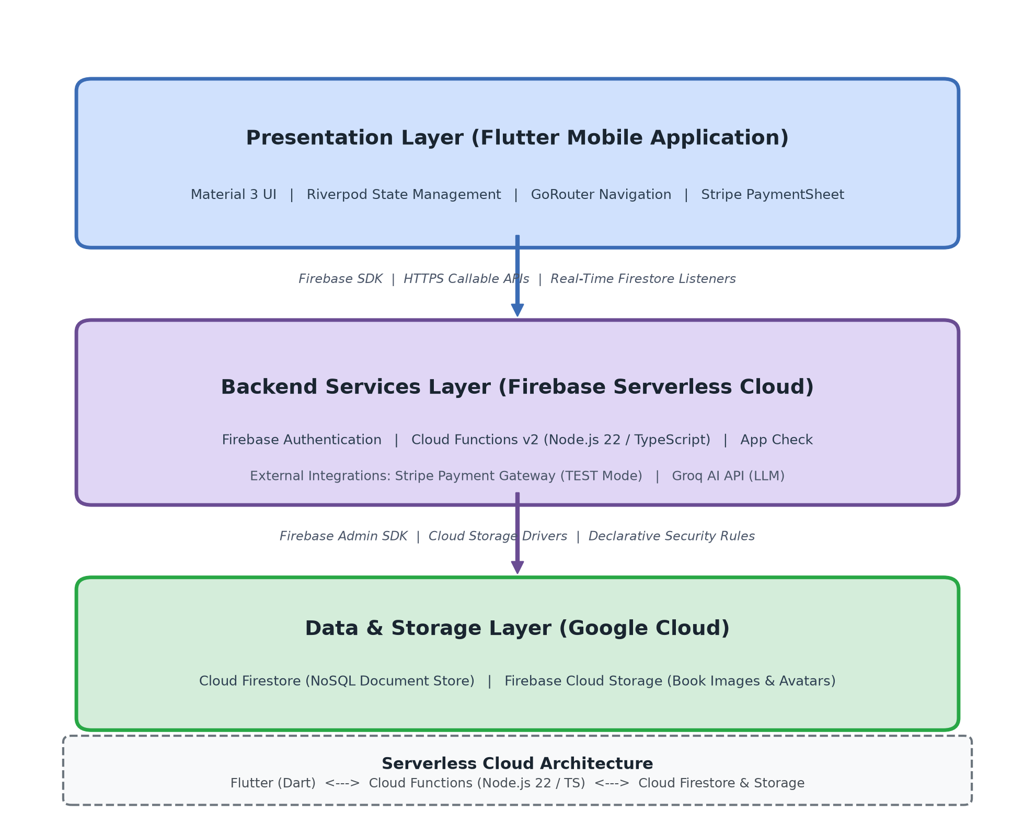
Figure 1.1: Serverless Cloud Architecture of Book Swap Hub

Functional Components
Both sides of the application use the same Cloud Functions serverless backend and Cloud Firestore database. Access is controlled by custom claims (user or admin) and declarative security rules, so each side only accesses the components meant for it.

User-Side Components
# | Component | Description
1 | Authentication and Account | Register, login, logout, forgot password and email verification; sessions are secured with JWT tokens.
2 | Profile Management | View and edit the profile; shows the user's books, wishlist, swaps, ratings and reviews.
3 | Book Management | Add, edit and delete book listings; upload images; set category, condition and availability status.
4 | Discovery and Search | Search by title or author, browse categories, apply filters, view nearby books and recommendations.
5 | Wishlist | Save books of interest for later and remove them when no longer needed.
6 | Swap Management | Send, receive, accept, reject, cancel and complete swap requests, and track the status of each swap.
7 | Chat | One-to-one conversations between users about a swap, with read status.
8 | Notifications | Alerts for swap, chat, rating and system events, with a mark-as-read option.
9 | Ratings and Reviews | Rate another user after a swap and attach written feedback to the rating.
10 | Reporting | Report a user or a book listing with a reason and a short description.
11 | AI Assistant | Chat-style assistant that helps users find books and answers platform questions.
Table 1.1: User-Side Core Components

Admin-Side Components
# | Component | Description
1 | Admin Authentication | Secure admin login; role-based access ensures only administrators reach the admin screens.
2 | Dashboard | Key metric cards (users, books, active swaps, open reports), recent activity feed and charts.
3 | User Management | View, search and moderate user accounts; suspend or activate accounts.
4 | Book Management | Review book listings; remove or flag inappropriate listings.
5 | Swap Management | Monitor ongoing and past swaps with status, participant and date filters.
6 | Report Management | Review the report queue and resolve or dismiss reports (Open, Reviewed, Resolved).
7 | Category Management | Add, edit and delete the book categories used across the platform.
8 | Analytics | Trends of new users, listings and completed swaps over time to support decisions.
Table 1.2: Admin-Side Core Components

1.4 Project Profile
Attribute | Detail
Project Name | Book Swap Hub
Project Type | Mobile Application
Frontend | Flutter
Frontend Language | Dart
Backend | Cloud Functions for Firebase (2nd Gen, Node.js 22 / TypeScript)
Database | Google Cloud Firestore (NoSQL Document Database)
Architecture | Serverless Cloud Architecture
API | Firebase Callable & HTTPS Cloud Functions
ORM | Firebase Admin SDK & Firestore Security Rules
Target Platform | Android and iOS
Main Users | Students and Book Readers
Administrator | System Administrator
Table 1.3: Project Profile

1.5 Need for the New System
The existing process of exchanging books is almost entirely manual, informal, and dependent on chance encounters or scattered social media posts. This unorganized approach is inefficient for several reasons: it does not scale beyond a small circle of acquaintances, it provides no mechanism to verify book condition or user trustworthiness, and it leaves no record of past exchanges that could help build confidence for future ones. As the number of potential participants grows, manual coordination quickly becomes unmanageable. Book Swap Hub addresses these shortcomings by introducing a purpose-built digital platform.
- A Centralized Platform: Bringing every book owner and seeker onto a single platform removes the fragmentation of the current process and creates a single point of access for all exchange-related activity.
- Easy Book Discovery: A searchable, filterable catalogue allows users to find exactly the books they need within seconds rather than relying on chance.
- Structured Book Exchange: A defined swap workflow, from request to completion, replaces informal negotiation with a transparent, trackable process.
- Nearby Book Discovery: Location-aware discovery encourages practical, low-friction, local exchanges that are easy for users to complete in person.
- User Communication: An integrated chat system removes the need for users to exchange personal contact details before they are ready to do so.
- Trust Through Ratings and Reviews: A reputation system built from post-exchange ratings and reviews gives users confidence when dealing with someone new.
- Reporting and Safety: A reporting mechanism allows the platform to identify and act on misuse, protecting the overall user community.
- Administrative Management: A dedicated admin module ensures that the platform remains well-moderated, with oversight over users, listings, swaps, and reported issues.

1.6 Scope of the New System
The scope of Book Swap Hub is organized into functional groupings that together define the complete set of capabilities delivered in the first version of the application.

User Scope
- Register
- Login
- Logout
- Forgot Password
- Email Verification
- View Profile
- Edit Profile
- My Books
- Wishlist
- My Swaps
- My Purchases
- Ratings

Book Management
- Add Books
- Edit Book
- Delete Book
- View Book Details
- Upload Book Images
- Manage Book Status

Discovery
- Search Books
- Browse Categories
- Nearby Books
- Apply Filters
- Recommendations

Swap System
- Send Swap Request
- Receive Request
- Accept Request
- Reject Request
- Cancel Request
- Complete Exchange

Communication
- Chat
- Notifications

Trust and Safety
- Rating
- Review
- Report User
- Report Book

Admin Scope
- Dashboard
- Manage Users
- Manage Books
- Manage Swaps
- Manage Reports
- Manage Categories
- Analytics

Out of Scope (Version 1)
To keep the first release focused and achievable within the project timeline, the following features are identified as out of scope for the initial version, and are recommended as future enhancements:
- Integrated online payment gateway for buy/sell transactions.
- Real-time video calling between users.
- AI-based book condition assessment from images.
- Multi-language support.
- Courier or shipping integration for remote exchanges.
- Advanced machine-learning-based recommendation engine.

1.7 Advantages and Limitations of the Proposed System

Advantages
# | Advantage | Description
1 | Cost Saving | Reduces the amount readers and students spend on acquiring new books.
2 | Easy Book Discovery | A searchable catalogue helps users quickly find the books they need.
3 | Centralized Platform | Brings all book exchange activity onto one consistent, managed system.
4 | Book Reuse | Encourages the reuse of existing books rather than repeated new purchases.
5 | Search and Filters | Allows precise, fast discovery of relevant listings.
6 | Nearby Discovery | Makes local, low-effort exchanges practical and convenient.
7 | Communication | In-app chat removes friction from coordinating an exchange.
8 | Ratings and Reviews | Builds trust and accountability between users.
9 | Safety and Reporting | Provides a mechanism to flag and address misuse.
10 | Admin Control | Ensures ongoing moderation and platform quality.
Table 1.4: Advantages of the Proposed System

Limitations
# | Limitation | Description
1 | Internet Dependency | The application requires an active internet connection to function.
2 | Manual Physical Exchange | The physical handover of books must still be arranged and completed by the users themselves.
3 | Location Permission Required | Nearby book discovery depends on the user granting location access.
4 | User-Reported Condition | Book condition is based on information supplied by the owner and is not independently verified.
5 | Basic Initial Recommendations | The recommendation system in the first version relies on simple rule-based logic rather than advanced machine learning.
6 | User Verification of Books | Users are responsible for personally verifying a book's actual condition at the time of exchange.
7 | Server and Database Maintenance | The platform requires ongoing hosting, monitoring, and maintenance to remain reliable.
Table 1.5: Limitations of the Proposed System

1.8 Proposed Timeline Chart
The Book Swap Hub project is planned for completion over 16 weeks, from Monday, 03 Aug 2026 to Sunday, 22 Nov 2026 (112 days). Table 1.6 shows the Gantt chart month-wise and week-wise, Table 1.7 lists every week with its exact dates, and Table 1.8 gives the start date, end date and duration of each activity.
Activity | Aug 2026 |  |  |  | Sep 2026 |  |  |  | Oct 2026 |  |  |  |  | Nov 2026
Activity | W1 | W2 | W3 | W4 | W5 | W6 | W7 | W8 | W9 | W10 | W11 | W12 | W13 | W14 | W15 | W16
Requirement Analysis
Project Planning
UI/UX Design
Database Design
Backend Development
Authentication Module
Book Management Module
Discovery Module
Swap System
Chat and Notifications
Ratings, Reviews and Reports
Admin Module
Testing and Bug Fixing
Documentation
Deployment
Table 1.6: 16-Week Project Timeline (Gantt Chart)
Note: weeks run from Monday to Sunday. Each week is shown under the month that contains most of its days.
Month | Week | From (Monday) | To (Sunday)
August 2026 | Week 1 | Monday, 03 August 2026 | Sunday, 09 August 2026
August 2026 | Week 2 | Monday, 10 August 2026 | Sunday, 16 August 2026
August 2026 | Week 3 | Monday, 17 August 2026 | Sunday, 23 August 2026
August 2026 | Week 4 | Monday, 24 August 2026 | Sunday, 30 August 2026
September 2026 | Week 5 | Monday, 31 August 2026 | Sunday, 06 September 2026
September 2026 | Week 6 | Monday, 07 September 2026 | Sunday, 13 September 2026
September 2026 | Week 7 | Monday, 14 September 2026 | Sunday, 20 September 2026
September 2026 | Week 8 | Monday, 21 September 2026 | Sunday, 27 September 2026
October 2026 | Week 9 | Monday, 28 September 2026 | Sunday, 04 October 2026
October 2026 | Week 10 | Monday, 05 October 2026 | Sunday, 11 October 2026
October 2026 | Week 11 | Monday, 12 October 2026 | Sunday, 18 October 2026
October 2026 | Week 12 | Monday, 19 October 2026 | Sunday, 25 October 2026
October 2026 | Week 13 | Monday, 26 October 2026 | Sunday, 01 November 2026
November 2026 | Week 14 | Monday, 02 November 2026 | Sunday, 08 November 2026
November 2026 | Week 15 | Monday, 09 November 2026 | Sunday, 15 November 2026
November 2026 | Week 16 | Monday, 16 November 2026 | Sunday, 22 November 2026
Table 1.7: Week-wise Calendar of the Project
# | Activity | Weeks | Start Date | End Date | Duration
1 | Requirement Analysis | W1–W2 | 03 Aug 2026 | 16 Aug 2026 | 14 days (2 weeks)
2 | Project Planning | W1–W2 | 03 Aug 2026 | 16 Aug 2026 | 14 days (2 weeks)
3 | UI/UX Design | W2–W3 | 10 Aug 2026 | 23 Aug 2026 | 14 days (2 weeks)
4 | Database Design | W3–W4 | 17 Aug 2026 | 30 Aug 2026 | 14 days (2 weeks)
5 | Backend Development | W4–W7 | 24 Aug 2026 | 20 Sep 2026 | 28 days (4 weeks)
6 | Authentication Module | W4–W5 | 24 Aug 2026 | 06 Sep 2026 | 14 days (2 weeks)
7 | Book Management Module | W6–W7 | 07 Sep 2026 | 20 Sep 2026 | 14 days (2 weeks)
8 | Discovery Module | W7–W8 | 14 Sep 2026 | 27 Sep 2026 | 14 days (2 weeks)
9 | Swap System | W8–W10 | 21 Sep 2026 | 11 Oct 2026 | 21 days (3 weeks)
10 | Chat and Notifications | W10–W11 | 05 Oct 2026 | 18 Oct 2026 | 14 days (2 weeks)
11 | Ratings, Reviews and Reports | W11–W12 | 12 Oct 2026 | 25 Oct 2026 | 14 days (2 weeks)
12 | Admin Module | W12–W13 | 19 Oct 2026 | 01 Nov 2026 | 14 days (2 weeks)
13 | Testing and Bug Fixing | W13–W14 | 26 Oct 2026 | 08 Nov 2026 | 14 days (2 weeks)
14 | Documentation and Deployment | W15–W16 | 09 Nov 2026 | 22 Nov 2026 | 14 days (2 weeks)
 | Total project duration | W1–W16 | 03 Aug 2026 | 22 Nov 2026 | 112 days (16 weeks)
Table 1.8: Activity-wise Schedule with Start Date, End Date and Duration

1.9 Target Users
- Students: Students form the primary user base of Book Swap Hub. They frequently need textbooks and reference material for a limited duration and benefit directly from being able to exchange used books instead of purchasing new ones every semester.
- Academic Book Users: Users engaged in ongoing academic work, such as competitive exam preparation or research, benefit from access to a wider pool of subject-specific books than they could otherwise source individually.
- Book Readers: General readers who enjoy fiction, non-fiction, or other leisure reading benefit from being able to discover and swap books they have already read for new titles, without recurring expense.
- Book Collectors: Collectors benefit from the platform's discovery and search capabilities, which help them locate specific or rare editions held by other users.
- Budget-Conscious Users: Users seeking to minimize their spending on books benefit from the swap-first model, which reduces reliance on new purchases.
- Administrators: System administrators benefit from a dedicated admin module that gives them the tools needed to monitor platform activity, resolve disputes, and maintain a safe and well-organized user community.

2. Requirement Determination and Analysis
Requirements for Book Swap Hub were determined through a structured analysis process that combined an assessment of the existing manual book-exchange process with an understanding of user needs and the stated objectives of the project. This process ensured that every feature included in the system scope traces back to a genuine problem or user need.
The requirement determination process was carried out through the following approach:
- Analysis of the Existing Process: Studying how students and readers currently exchange books manually, and identifying the specific inefficiencies this creates.
- User Needs: Understanding what students, readers, and collectors expect from a digital book exchange platform.
- Project Objectives: Ensuring that every proposed feature directly supports one or more of the stated project objectives.
- Feature Analysis: Reviewing comparable applications and community-driven platforms to identify features that are genuinely valuable versus features that would add unnecessary complexity.
- System Design Requirements: Translating the identified needs into concrete functional and non-functional requirements that could guide system design and development.
This analysis produced two categories of requirements — functional requirements, which describe what the system must do, and non-functional requirements, which describe the qualities the system must exhibit — both of which are detailed in the following sections.

2.1 Requirement Determination

Authentication Requirements
- The system shall allow users to register.
- The system shall allow users to log in.
- The system shall allow users to log out.
- The system shall allow users to reset forgotten passwords.
- The system shall verify user email addresses.

Profile Requirements
- The system shall allow users to view and edit their profile.
- The system shall display user books.
- The system shall allow users to manage a wishlist.
- The system shall display swaps and purchases.
- The system shall display ratings and reviews.

Book Requirements
- The system shall allow users to add books.
- The system shall allow users to edit books.
- The system shall allow users to delete books.
- The system shall allow users to upload images of a book.
- The system shall allow users to set the book's condition.
- The system shall allow users to set the book's availability status.
- The system shall allow users to view detailed book information.

Discovery Requirements
- The system shall allow users to search books by title.
- The system shall allow users to search books by author.
- The system shall allow users to browse books by category.
- The system shall allow users to filter books.
- The system shall allow users to discover nearby books.
- The system shall display book recommendations to users.

Swap Requirements
- The system shall allow users to send a swap request.
- The system shall allow users to receive a swap request.
- The system shall allow users to accept a swap request.
- The system shall allow users to reject a swap request.
- The system shall allow users to cancel a swap request.
- The system shall allow users to mark an exchange as complete.
- The system shall allow users to track the status of a swap.

Communication Requirements
- The system shall allow users to chat with other users.
- The system shall send and display notifications to users.

Safety Requirements
- The system shall allow users to rate other users.
- The system shall allow users to write reviews.
- The system shall allow users to report other users.
- The system shall allow users to report books.

Admin Requirements
- The system shall allow administrators to manage users.
- The system shall allow administrators to manage books.
- The system shall allow administrators to manage swaps.
- The system shall allow administrators to manage reports.
- The system shall allow administrators to manage categories.
- The system shall allow administrators to view analytics.

2.2 Requirement Specification

Functional Requirements
The functional requirements of Book Swap Hub are grouped into eight modules: Authentication, Profile Management, Book Management, Discovery, Swap System, Communication, Trust and Safety, and Admin Management. Each requirement below has an ID, a short title and an elaboration of what the system must do. Field limits quoted in the elaboration are the same as the field sizes given in the Data Dictionary (Section 3.2).
ID | Requirement | Elaboration | Actor
Authentication
FR-AU-01 | User Registration | A new user creates an account with name (up to 100 characters), email (up to 150 characters, unique) and password. Only a hash of the password is stored. | User
FR-AU-02 | User Login | The user signs in with email and password; the system verifies them and returns a JWT token. The role (user or admin) decides which screens open. | User, Admin
FR-AU-03 | User Logout | The user ends the session; the token is discarded from the device and protected screens are no longer reachable. | User
FR-AU-04 | Forgot / Reset Password | A user who cannot remember the password can request a reset and set a new password through the registered email. | User
FR-AU-05 | Email Verification | The system verifies the email address and sets the email_verified field from false to true. | User
Profile Management
FR-PR-01 | View and Edit Profile | The user can view and update name, profile image (URL up to 255 characters) and location (up to 150 characters). | User
FR-PR-02 | My Books | The profile shows all books listed by the user, grouped by status: Available (active), Pending and Swapped. | User
FR-PR-03 | My Swaps and Purchases | The user can see the swap requests sent and received, with the status of each, as personal swap history. | User
FR-PR-04 | Ratings and Reviews Display | The profile shows the average rating and the written reviews received from other users. | User
Book Management
FR-BK-01 | Add Book | The user lists a book with title (up to 200 characters), author (up to 150 characters), category, condition and optional ISBN (up to 20 characters), description and price. | User
FR-BK-02 | Edit Book | Only the owner can change the details of a listing; ownership is checked on the server. | User
FR-BK-03 | Delete Book | Only the owner can delete a listing; ownership is checked on the server. | User
FR-BK-04 | Upload Book Images | One or more images can be attached to a book. One image is marked as primary and is used as the cover. | User
FR-BK-05 | Set Book Condition | The condition is chosen from fixed values: Like New, Good, Fair or Worn. | User
FR-BK-06 | Manage Availability Status | A listing is Available, Pending or Swapped. The status changes as the swap request moves through its workflow. | User, System
FR-BK-07 | View Book Details | Shows images, title, author, condition, category, description and owner information, with Send Swap Request and View Profile actions. | User
Discovery
FR-DS-01 | Search by Title | Lists books whose title matches the text entered by the user. | User
FR-DS-02 | Search by Author | Lists books whose author matches the text entered by the user. | User
FR-DS-03 | Browse by Category | Lists books of a selected category from the category list maintained by the administrator. | User
FR-DS-04 | Filter Books | Narrows the results by category and condition. | User
FR-DS-05 | Nearby Books | Shows books listed in the same location as the user. It works only when the user grants location access. | User
FR-DS-06 | Recommendations | Displays a 'Recommended For You' list based on simple rules, such as the user's wishlist and categories. | User, System
Swap System
FR-SW-01 | Send Swap Request | The user requests a book and may offer one of his or her own books. An optional message (up to 500 characters) can be added. | User
FR-SW-02 | Receive Swap Request | The owner of the requested book sees the incoming request with the sender, the books involved and the message. | User
FR-SW-03 | Accept Swap Request | The owner accepts a Pending request; its status becomes Accepted and the sender is notified. | User
FR-SW-04 | Reject Swap Request | The owner rejects a Pending request; its status becomes Rejected and the sender is notified. | User
FR-SW-05 | Cancel Swap Request | The sender can cancel a request; its status becomes Cancelled and the other user is informed. | User
FR-SW-06 | Complete Exchange | After the physical handover, the swap is marked Completed and the books are set to Swapped. | User
FR-SW-07 | Track Swap Status | Every swap shows its current status: Pending, Accepted, Rejected, Cancelled or Completed. | User
Communication
FR-CM-01 | Chat | Two users can exchange text messages (up to 1000 characters each) inside a conversation. Read and unread status is kept. | User
FR-CM-02 | Notifications | The system creates notifications (title up to 150 characters, message up to 500 characters) of type swap, chat, system or rating. The user can mark them as read. | User, System
Trust and Safety
FR-TS-01 | Rate User | After a swap, a user gives another user a rating from 1.0 to 5.0. | User
FR-TS-02 | Review User | A written review (up to 500 characters) can be attached to a rating. It is optional. | User
FR-TS-03 | Report User | A user can report another user with a reason (up to 100 characters) and an optional description (up to 500 characters). | User
FR-TS-04 | Report Book | A user can report a book listing with the same reason and description fields. A report starts as Open. | User
Admin Management
FR-AD-01 | Admin Login | The administrator signs in with an account whose role is admin; all admin endpoints check this role. | Admin
FR-AD-02 | View Dashboard | Shows total users, total books, active swaps and open reports, with a recent activity feed. | Admin
FR-AD-03 | Manage Users | View and search users; suspend or activate an account. | Admin
FR-AD-04 | Manage Books | Review listings; remove or flag inappropriate books. | Admin
FR-AD-05 | Manage Swaps | Monitor ongoing and past swaps with status, participant and date filters. | Admin
FR-AD-06 | Manage Reports | Review reports and move them from Open to Reviewed or Resolved; dismiss invalid ones. | Admin
FR-AD-07 | Manage Categories | Add, edit and delete categories. A category name is unique (up to 100 characters); the description is up to 255 characters. | Admin
FR-AD-08 | View Analytics | Shows charts of new users, new listings and completed swaps over time. | Admin
Table 2.1: Functional Requirements

Non-Functional Requirements
The non-functional requirements describe how well the system must work. Each requirement below is followed by the way the design meets it.
Requirement | Description | How It Is Achieved
Performance | The system shall respond to standard requests, such as search and swap actions, within an acceptable time under normal load. | Indexed Firestore collections; composite indexes (firestore.indexes.json); paginated book queries; sub-100ms real-time snapshot listeners. Target: common screens load within 1 to 2 seconds.
Security | User credentials shall be securely hashed, and all sensitive endpoints shall require token-based authentication. | Firebase Authentication; scrypt password hashing; automatic token rotation; server-side custom claims; declarative Firestore security rules.
Usability | The mobile application shall provide an intuitive, easy-to-navigate interface for users with varying technical skill. | Consistent Flutter widgets and theme; clear navigation between Home, Discover, My Books, Swaps, Chat and Profile; shared error and empty states.
Scalability | The architecture shall support a growing number of users, books and transactions without significant redesign. | Serverless cloud architecture; automatic auto-scaling of Cloud Functions; globally distributed Cloud Firestore NoSQL storage.
Reliability | The system shall function consistently and recover gracefully from errors without data loss. | Firebase atomic multi-document transactions (db.runTransaction) for state transitions; structured error handling; offline write queueing in Firestore.
Maintainability | The codebase shall be modular and well-documented to support maintenance and future enhancement. | Folder structure by responsibility; naming conventions and coding standards (Section 4.2); doc comments on public classes and functions.
Availability | The backend services and database shall be available with minimal planned or unplanned downtime. | High availability backed by Google Cloud infrastructure with automatic redundancy and multi-region failover.
Data Integrity | The database shall enforce referential integrity and validation rules to prevent inconsistent data. | Firestore Security Rules enforce document keys, data types, string length bounds, ENUM status values, and server timestamps (request.time).
Portability | The application shall run on both Android and iOS from a single codebase. | Flutter and Dart compile to native apps for both platforms.
Privacy | Personal data shall be protected and only the information needed for an exchange shall be shown to other users. | Only the city or area is shown for nearby discovery; contact details are not exposed because users communicate through in-app chat.
Interoperability | The app and the backend shall communicate through a standard, documented interface. | Communicates through standard Firebase SDK protocols, Callable JSON APIs, and Stripe HTTPS Webhook endpoints.
Table 2.2: Non-Functional Requirements

External Interface Requirements
- User Interface: The Flutter app presents screens for users and administrators (Section 3.3) using Material design widgets.
- Software Interface: The app communicates with Firebase through the native Firebase Client SDKs, Callable Cloud Functions, and HTTPS REST webhook endpoints.
- Database Interface: The backend and mobile app read and write Cloud Firestore data through the Firebase SDK and Admin SDK, secured by Firestore Security Rules.
- Hardware Interface: The phone camera or gallery supplies book images, and device location services supply the user's area for nearby discovery.

Assumptions and Constraints
- Users have a smartphone and an active internet connection; the app does not work offline.
- Users grant location permission if they want to use nearby book discovery.
- The physical exchange of books is arranged and completed by the two users themselves.
- Book condition is reported by the owner and is not verified by the system.
- The first version does not include online payments, video calls, courier integration or multi-language support (see Out of Scope, Section 1.6).

Hardware Requirements
- A computer or laptop for development and testing purposes.
- A minimum of 8 GB RAM on the development machine.
- A stable internet connection for API testing and package management.
- An Android device or emulator for mobile application testing.
- A smartphone with location services enabled, for testing nearby book discovery.
- A phone camera or gallery, for testing book image upload.
- A cloud environment (Firebase project) running Cloud Functions for Firebase, Cloud Firestore, Firebase Authentication, and Cloud Storage.

Software Requirements
Category | Tools / Technologies
Operating System | Windows, Linux or macOS for development; Android (and iOS) on the mobile device
Frontend | Flutter SDK, Dart SDK
Backend | Node.js 22.x, TypeScript, Cloud Functions for Firebase (2nd Gen), Firebase Admin SDK
Security and Validation | Firebase Authentication, Cloud Firestore Security Rules, Firebase App Check
Database | Google Cloud Firestore (NoSQL), Firebase Cloud Storage
Development Tools | VS Code / Android Studio, Git, Postman, Firebase CLI, Flutter DevTools
Table 2.3: Software Requirements

3. System Design

3.1 Use Case Diagram
The Use Case diagram identifies two primary actors of Book Swap Hub – the User and the Administrator – and shows the interactions each actor has with the system using standard UML notation, including the «include» and «extend» relationships between use cases. For readability the diagram is shown in three parts: Figure 3.1 (User: account, books and discovery), Figure 3.2 (User: swap, communication, trust and safety) and Figure 3.3 (Administrator).

User Use Cases
Primary use cases: Register, Login, Logout, Manage Profile, Add Book, Edit Book, Delete Book, Search Books, View Book Details, Send Swap Request, Receive Swap Request, Accept Swap, Reject Swap, Cancel Swap, Complete Exchange, Chat, View Notifications, Rate User, Report User, Report Book. Supporting use cases (included or extending): Verify Email, Forgot Password, Select Category, Upload Book Images, Filter Books, Discover Nearby Books, Manage Wishlist, Select Offered Book, Send Notification, Review User, Provide Report Reason.
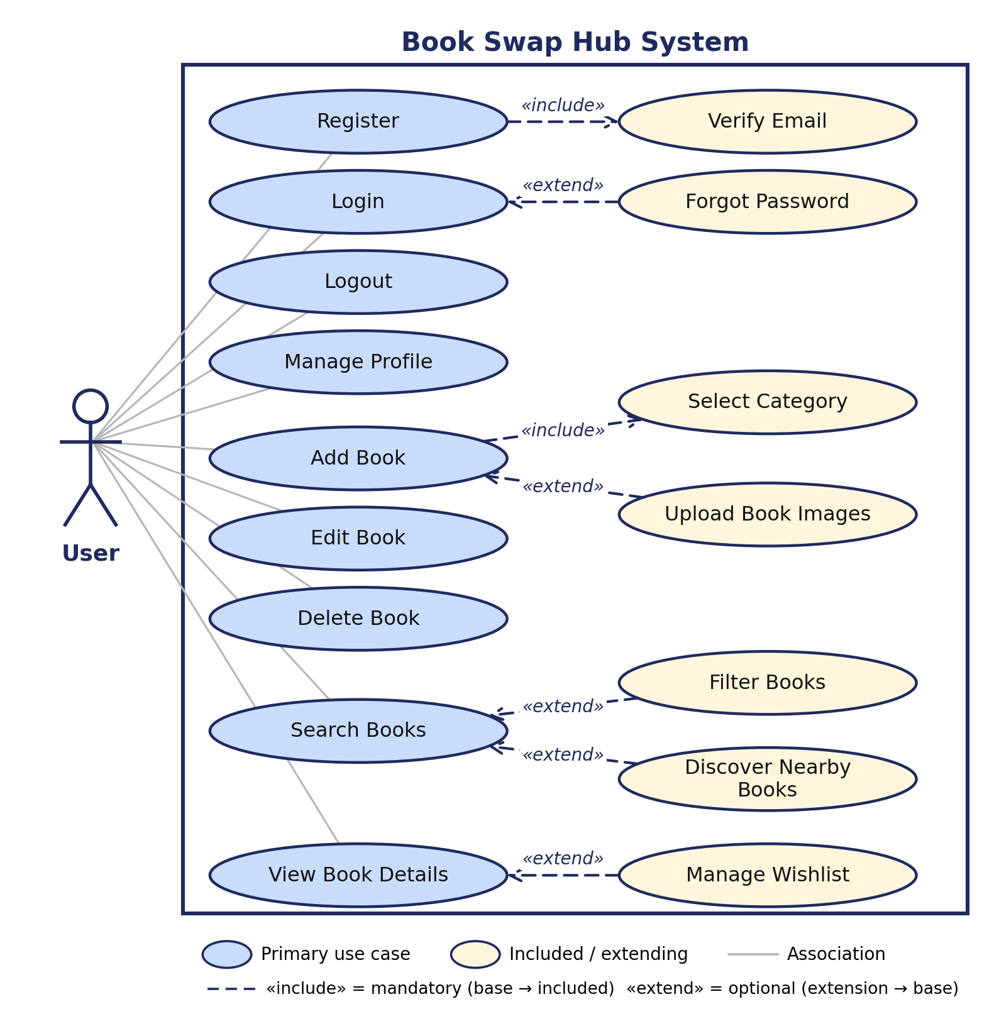
Figure 3.1: Use Case Diagram – User (Account, Books and Discovery)
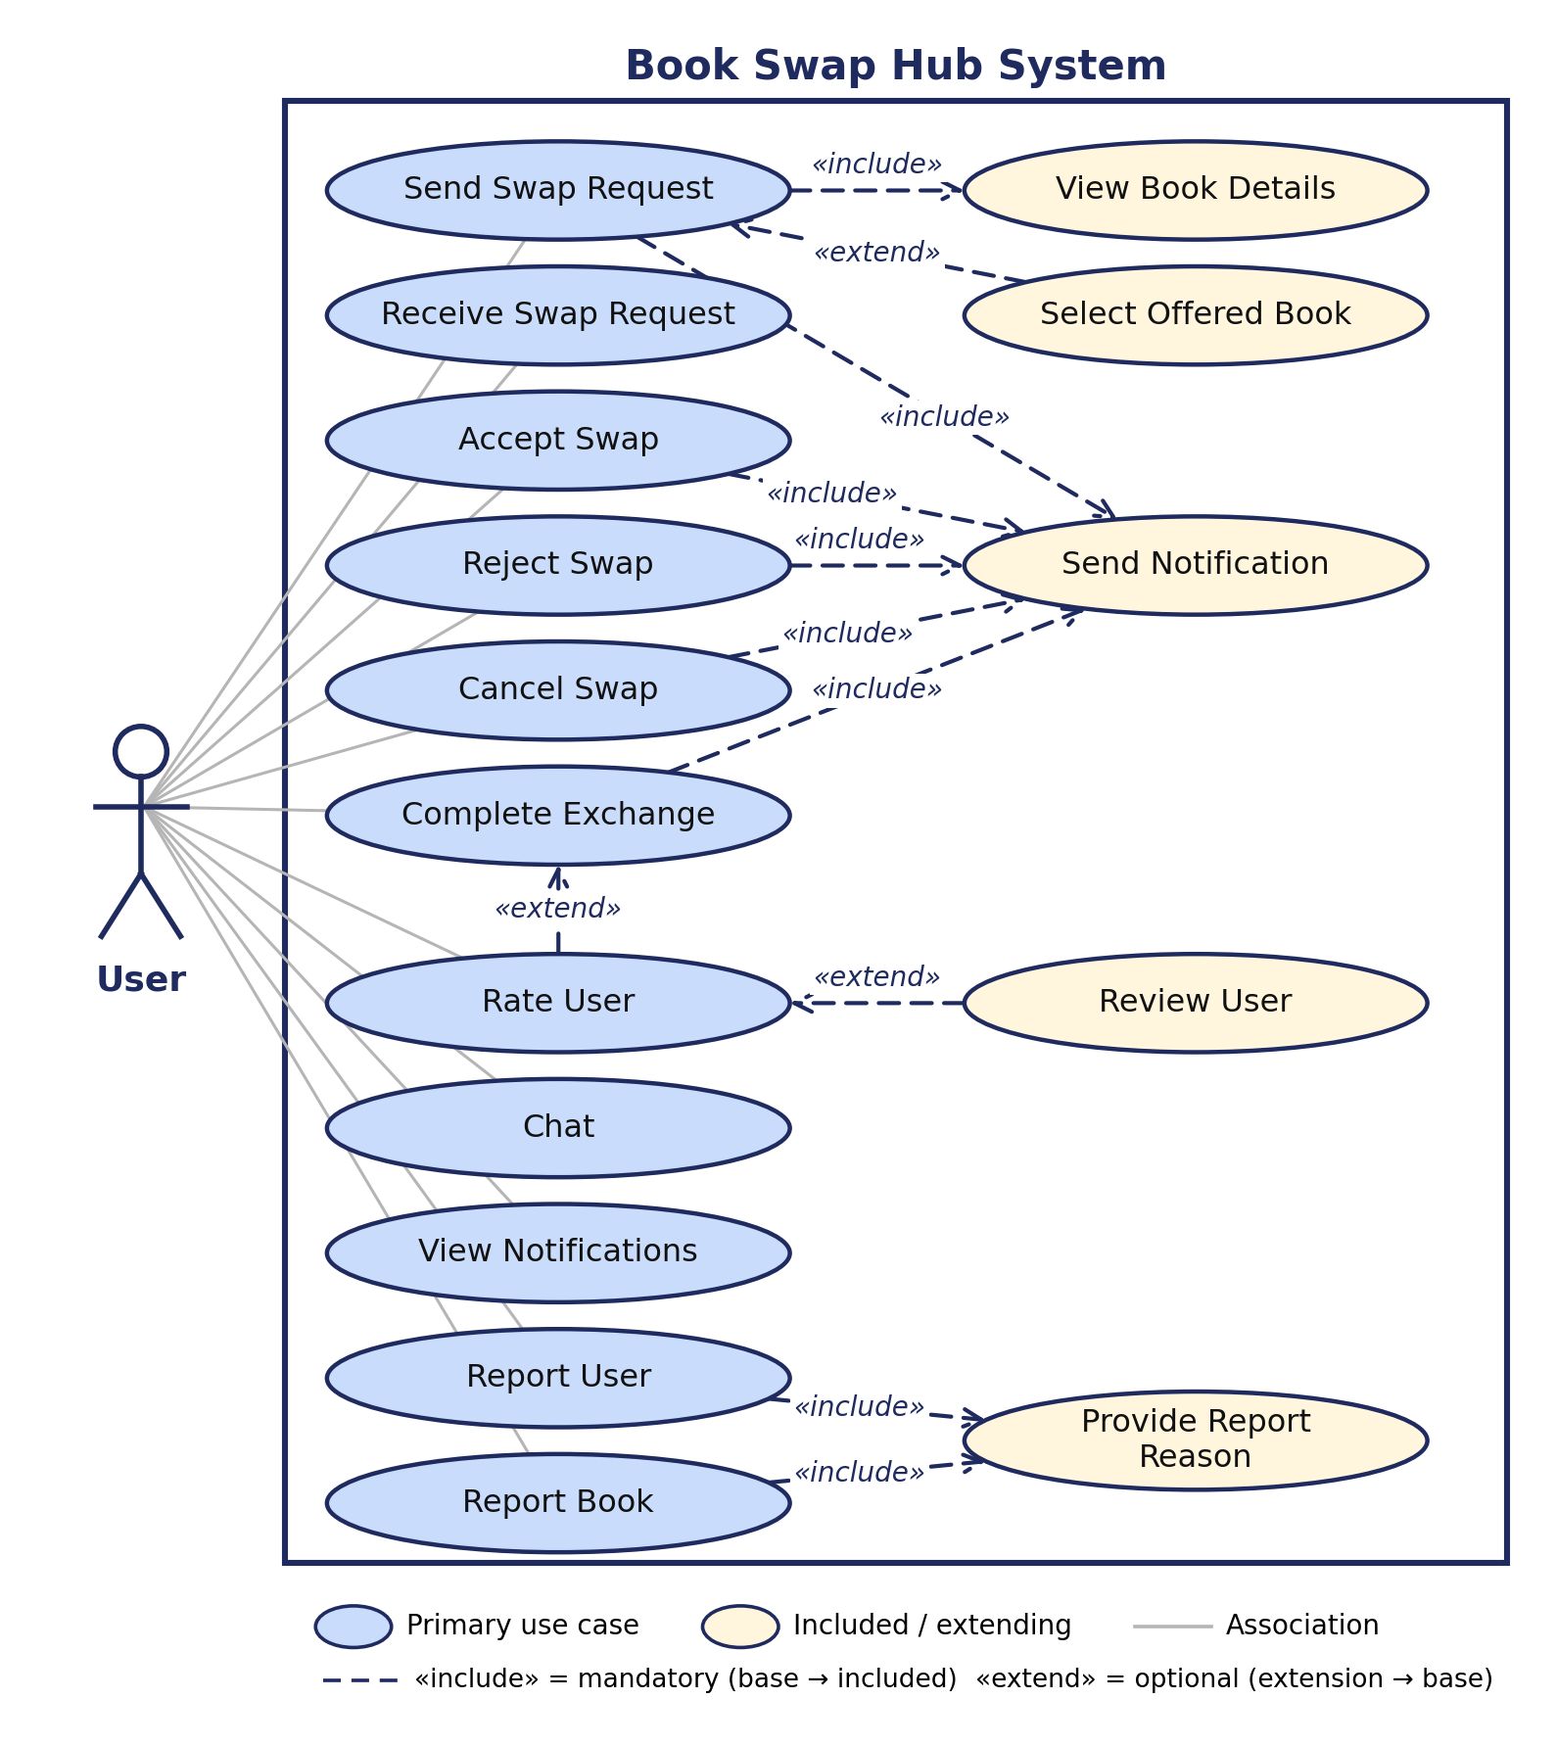
Figure 3.2: Use Case Diagram – User (Swap, Communication, Trust and Safety)

Admin Use Cases
Primary use cases: Admin Login, View Dashboard, Manage Users, Manage Books, Manage Swaps, Manage Reports, Manage Categories, View Analytics. Extending use cases: Suspend / Activate User, Remove / Flag Book, Resolve / Dismiss Report.
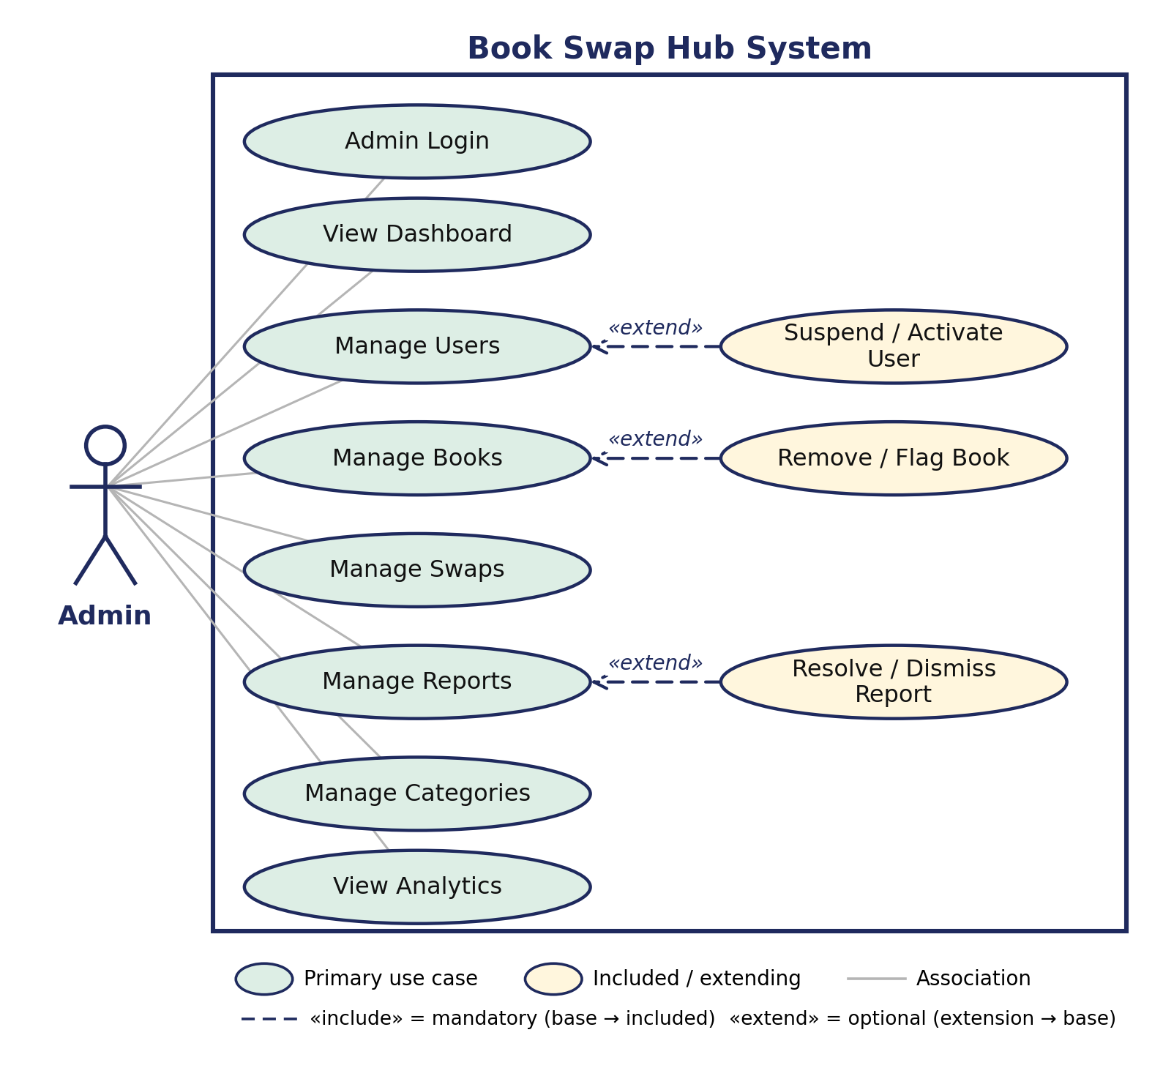
Figure 3.3: Use Case Diagram – Administrator

Include and Extend Relationships
An «include» relationship means that the base use case always uses the behaviour of the included use case; for example, sending a swap request always sends a notification to the owner. An «extend» relationship means that the extending use case adds optional behaviour to the base use case only under a condition; for example, Forgot Password extends Login only when the user cannot log in. Table 3.1 lists every relationship shown in Figures 3.1 to 3.3.
Source Use Case | Relationship | Target Use Case | Reason / Condition
«include» – mandatory behaviour; the arrow goes from the base use case to the included use case
Register | «include» | Verify Email | Every new account must have its email address verified (email_verified).
Add Book | «include» | Select Category | A book must belong to a category (category_id).
Send Swap Request | «include» | View Book Details | A request is raised from the details screen of the requested book.
Send Swap Request | «include» | Send Notification | The owner of the requested book is notified of the new request.
Accept Swap | «include» | Send Notification | The sender is notified that the request was accepted.
Reject Swap | «include» | Send Notification | The sender is notified that the request was rejected.
Cancel Swap | «include» | Send Notification | The other user is informed that the request was cancelled.
Complete Exchange | «include» | Send Notification | The other user is informed that the exchange is complete.
Report User | «include» | Provide Report Reason | A reason is compulsory for every report (reason is Not Null).
Report Book | «include» | Provide Report Reason | A reason is compulsory for every report (reason is Not Null).
«extend» – optional or conditional behaviour; the arrow goes from the extending use case to the base use case
Forgot Password | «extend» | Login | Happens only when the user cannot remember the password.
Upload Book Images | «extend» | Add Book | Optional; images are stored separately for the book.
Filter Books | «extend» | Search Books | Optional refinement of the search results.
Discover Nearby Books | «extend» | Search Books | Happens only when the user grants location access.
Manage Wishlist | «extend» | View Book Details | Optional action available from the book details screen.
Select Offered Book | «extend» | Send Swap Request | Optional; a request can be sent without offering a book (offered_book_id is nullable).
Rate User | «extend» | Complete Exchange | Possible only after the exchange is completed.
Review User | «extend» | Rate User | Optional written comment attached to a rating.
Suspend / Activate User | «extend» | Manage Users | Performed only when the administrator decides to moderate an account.
Remove / Flag Book | «extend» | Manage Books | Performed only when a listing is found inappropriate.
Resolve / Dismiss Report | «extend» | Manage Reports | Performed after the administrator reviews a report.
Table 3.1: Include and Extend Relationships of Book Swap Hub

3.2 Data Dictionary
The Data Dictionary defines every collection, document schema, data type, and constraint used in the Book Swap Hub Google Cloud Firestore NoSQL database. It provides an authoritative reference for the core collections and document structures that make up the application's data layer.

3.2.1 Users
Field Name | Data Type | Constraint / Key | Description
name | String | Not Null, 1-60 chars | Full display name of the user.
avatarUrl | String | Nullable | Storage download URL of the user's profile picture.
bio | String | Max 300 chars | Short user biography.
location | String | Max 100 chars | User's city / campus area, used for nearby discovery.
rating | Number | Default 0, Range 1.0-5.0 | Average rating computed from completed swaps.
ratingCount | Integer | Default 0 | Total number of reviews received.
totalSwaps | Integer | Default 0 | Total number of successfully completed swaps.
disabled | Boolean | Default false | Set by administrator to suspend or block access.
createdAt | Timestamp | ServerTimestamp | Date and time the account was registered.
updatedAt | Timestamp | ServerTimestamp | Date and time the profile was last modified.

3.2.2 Categories
Field Name | Data Type | Constraint / Key | Description
id | String | Unique Identifier | Category ID key (e.g. 'fiction', 'academic').
name | String | Not Null | Display name of the category (e.g. Fiction, Non-Fiction).
description | String | Nullable | Short descriptive overview of the category.

3.2.3 Books
Field Name | Data Type | Constraint / Key | Description
title | String | Not Null, 1-120 chars | Title of the listed book.
author | String | Not Null, 1-100 chars | Author of the book.
category | String | Not Null | Category name the book belongs to.
categoryId | String | Indexed | Unique category reference identifier.
condition | String | Enum: Like New, Good, Fair, Worn | Physical condition reported by the listing owner.
listingType | String | Enum: swap, sale, both | Mode of availability for swapping or purchasing.
price | Number | Nullable, > 0, Max 100000 | Price in INR if listed for sale.
currency | String | Fixed 'inr' | Currency code for checkout.
location | String | Not Null, Max 100 chars | Location associated with the listing for nearby search.
status | String | Enum: available, reserved, swapped, sold, removed | Current availability status of the listing.
imageUrls | List<String> | Max 5 items | Firebase Cloud Storage download URLs of uploaded photos.
searchKeywords | List<String> | Array-contains index | Precomputed 2-6 character prefix substrings for instant search.
ownerId | String | Foreign Key -> users.id | User ID of the listing owner.

3.2.4 Book Images
Storage Path / Property | Data Type | Constraint | Description
books/{uid}/{bookId}_{timestamp}_{index}.jpg | Cloud Storage File | Max 5 MB, Image only | Dedicated path for high-resolution book cover images.
avatars/{uid}/avatar_{timestamp} | Cloud Storage File | Max 5 MB, Image only | Dedicated path for user profile photos.
imageUrls (in books doc) | List<String> | Max 5 URLs | Public download URLs stored directly on the book document for fast rendering.
ownerAvatar (in users doc) | String | Download URL | Profile photo URL stored on user document.

3.2.5 Wishlist
Field Name | Data Type | Constraint / Key | Description
userId | String | Foreign Key -> users.id | The user who saved the book to their wishlist.
bookId | String | Foreign Key -> books.id | The book added to the wishlist.
createdAt | Timestamp | ServerTimestamp | Timestamp when the book was saved.

3.2.6 Swaps
Field Name | Data Type | Constraint / Key | Description
requesterId | String | Foreign Key -> users.id | The user who initiated the swap request.
ownerId | String | Foreign Key -> users.id | The user who owns the requested book.
participantIds | List<String> | Array-contains index | List containing [requesterId, ownerId] for query access control.
bookId | String | Foreign Key -> books.id | The requested book ID.
offeredBookId | String | Nullable, FK -> books.id | The book offered by the requester in return.
status | String | Enum: pending, accepted, inProgress, completed, rejected, cancelled | Current lifecycle stage of the swap workflow.
confirmedBy | List<String> | Max 2 UIDs | Records which participants confirmed the physical handover.
message | String | Max 500 chars | Initial proposal message sent with the request.
createdAt | Timestamp | ServerTimestamp | Timestamp when the request was initiated.

3.2.7 Conversations
Field Name | Data Type | Constraint / Key | Description
participantIds | List<String> | Array-contains index | Sorted array of the two user IDs in the chat.
unread | Map<String, Int> | Keyed by UID | Unread message count per participant.
lastMessage | String | Max 200 chars | Snippet of the most recent message sent.

3.2.8 Messages
Field Name | Data Type | Constraint / Key | Description
senderId | String | Foreign Key -> users.id | The user who dispatched the message.
text | String | Not Null, 1-2000 chars | Text content of the message.
createdAt | Timestamp | ServerTimestamp | Timestamp when the message was sent.
conversationId | String | Parent Document ID | The conversation thread the message belongs to.
isPending | Boolean | Client metadata | True while the message is in the local offline write queue.
messageId | String | Unique Auto ID | Unique message document identifier.

3.2.9 Notifications
Field Name | Data Type | Constraint / Key | Description
buyerId | String | Foreign Key -> users.id | User purchasing the book.
sellerId | String | Foreign Key -> users.id | Listing owner receiving the payment.
bookId | String | Foreign Key -> books.id | Book purchased.
amountMinor | Integer | Not Null, in paise | Amount charged (e.g. 50000 = INR 500.00).
currency | String | Fixed 'inr' | Stripe currency code.
status | String | Enum: pending, paid, failed, cancelled | Current payment status.

3.2.10 Ratings
Field Name | Data Type | Constraint / Key | Description
swapId | String | Foreign Key -> swapRequests.id | The completed swap the rating relates to.
reviewerId | String | Foreign Key -> users.id | The user giving the rating.
revieweeId | String | Foreign Key -> users.id | The user receiving the rating.
rating | Integer | Not Null, Range 1 to 5 | Whole numeric score given after the swap.

3.2.11 Reviews
Field Name | Data Type | Constraint / Key | Description
reviewerName | String | Denormalized | Display name of the reviewer.
comment | String | Max 1000 chars | Written review text submitted with the rating.
createdAt | Timestamp | ServerTimestamp | Date and time the review was posted.

3.2.12 Reports
Field Name | Data Type | Constraint / Key | Description
reporterId | String | Foreign Key -> users.id | The user filing the report.
targetType | String | Enum: book, user | Specifies whether a book or a user account is reported.
targetId | String | Not Null, Max 128 chars | ID of the reported book or user.
reason | String | Enum: spam, inappropriate, fake, scam, other | Category of the complaint.
details | String | Max 500 chars | Optional additional details from the reporter.
status | String | Enum: open, reviewed, dismissed, actioned | Current review status of the report.
adminNote | String | Nullable | Internal notes left by the reviewing administrator.

3.3 User Interface Design
Book Swap Hub's interface is built entirely with Flutter widgets and follows a consistent design language — a shared colour palette, header, sidebar/navigation bar, and reusable components such as book cards, status chips, and empty/error states — across every screen. The table below summarizes the primary screens of the application.

User-Facing Screens
Screen | Purpose | Key UI Elements
Splash Screen | Initial branded loading screen shown while the app initializes and checks the user's session. | App logo, loading indicator.
Login Screen | Allows a registered user to sign in to the application. | Email field, password field, 'Remember me' checkbox, login button, link to Register and Forgot Password.
Register Screen | Allows a new user to create an account. | Name, email, password fields, terms acceptance, register button.
Home Screen | Landing screen after login; surfaces categories and curated book listings. | Category carousel, 'Featured Books', 'Recommended For You', and 'Recently Added' sections, search bar.
Discover Screen | Lets users search and filter the full book catalogue. | Search bar, category filter chips, condition filter, book grid/list, empty-state illustration.
Book Details Screen | Shows full information about a single book listing. | Image gallery, title/author/condition, owner card, 'Send Swap Request' and 'View Profile' actions.
Add Book Screen | Lets a user list a new book for swapping. | Image upload area, title/author/ISBN/description fields, condition and category selectors, submit button.
Edit Book Screen | Lets a user update or remove an existing listing. | Pre-filled form fields, status toggle, save and delete actions.
My Books Screen | Shows all books the logged-in user has listed, grouped by status. | Tabs for Active / Pending / Swapped, book cards, 'Add New Book' button.
Wishlist Screen | Shows books the user has saved for later. | Book grid, remove-from-wishlist action, empty-state message.
Swaps Screen | Tracks all incoming and outgoing swap requests. | Tabs (Pending / Accepted / Completed / Rejected), accept/reject/complete action buttons, status chips.
Chat Screen | Enables direct messaging between two users about a swap. | Conversation list, message thread, text input, read/online indicators.
Notifications Screen | Displays system and activity notifications. | Notification list with icons by type, 'Mark all as read' action.
Profile Screen | Displays the user's public profile and activity history. | Avatar, bio, rating summary, tabs for Books / Wishlist / Reviews / Swap History, 'Edit Profile' button.
Settings Screen | Lets the user manage account and app preferences. | Profile photo, name/contact fields, notification toggles, theme option, logout.
AI Assistant Screen | Conversational assistant that helps users find books and get platform help. | Chat-style message thread, quick-reply suggestions, input box.

Administrator Screens
Screen | Purpose | Key UI Elements
Admin Dashboard | Gives administrators a real-time overview of platform health. | Key metric cards (users, books, active swaps, open reports), recent activity feed, charts.
Manage Users | Lets administrators view, search, and moderate user accounts. | User table, search/filter, suspend/activate actions.
Manage Books | Lets administrators review and moderate book listings. | Listing table, status filter, remove/flag actions.
Manage Swaps | Lets administrators monitor ongoing and past swap transactions. | Swap table with status, participant, and date filters.
Manage Reports | Lets administrators review and resolve user/book reports. | Report queue, reason and status filters, resolve/dismiss actions.
Manage Categories | Lets administrators maintain the book category list. | Category table, add/edit/delete controls.
Analytics | Presents platform usage trends to support decision-making. | Charts for new users, listings, and completed swaps over time.
Design Principles: every screen follows Material-based Flutter design conventions, uses a consistent colour palette and typography defined centrally in the app's theme module, and reuses shared widgets (buttons, cards, search bar, status chips, empty/error states) to keep the experience visually consistent and to minimize duplicated UI code.

3.4 Report Design
Book Swap Hub generates a set of structured reports, primarily for administrators, to support monitoring, moderation, and decision-making. Each report is generated from the underlying database tables described in the Data Dictionary and can be viewed on-screen or exported for record-keeping.
Report | Audience | Purpose | Key Fields
Platform Dashboard Report | Admin | Gives a snapshot of overall platform health and growth at a glance. | Total users, total books listed, active swaps, completed swaps, open reports, date range.
User Activity Report | Admin | Tracks individual user engagement for moderation and support purposes. | User name/email, join date, books listed, swaps completed, average rating, account status.
Book Inventory Report | Admin | Summarizes all listings on the platform by category and status. | Book title, category, condition, status, owner, date listed.
Swap Transaction Report | Admin | Provides a record of swap requests and their outcomes over a period. | Swap ID, sender, receiver, books exchanged, status, request date, completion date.
Ratings and Reviews Report | Admin | Surfaces trust and quality signals across the user base. | User, average rating, total ratings, recent review comments.
Reported Content Report | Admin | Lists open and resolved complaints for moderation follow-up. | Report ID, reporter, reported user/book, reason, status, date filed.
My Swap History (Personal Report) | User | Lets a user review their own completed and past swap activity. | Book exchanged, counterpart user, date, status, rating given/received.
All administrator reports are accessible from the Admin Dashboard and Analytics screens, support filtering by date range and status, and are built directly from the Users, Books, Swaps, Ratings, Reviews, and Reports tables defined in the Data Dictionary.

4. Development and Implementation

4.1 Development
This section describes how Book Swap Hub is built: the development approach, the tools used, how the Flutter frontend and the Firebase serverless backend are organized, the Cloud Functions endpoints, how Cloud Firestore is implemented, and the key logic behind the swap workflow. The design completed in Chapters 2 and 3 is the basis for all implementation work.

4.1.1 Development Approach
The project follows an incremental, module-by-module approach that matches the timeline in Section 1.8. Each module (authentication, books, discovery, swaps, chat and notifications, ratings and reports, admin) goes through the same steps:
- Screens first: The Flutter screens are built first with sample (mock) data from lib/data/mock, so layouts and navigation can be reviewed early.
- Backend next: The matching Cloud Functions, transactional logic, and Firestore security rules are written for the module.
- Test the API: Each Cloud Function is tested via unit tests and Firebase Emulator suite for both valid and invalid input before deployment.
- Integrate and verify: The screens are switched from mock data to the live REST API, and the module is checked against the test cases in Chapter 5.
- Version control: Work is committed to Git in small feature branches and merged only when the module runs correctly (Section 4.2.6).

4.1.2 Development Environment
Flutter SDK and Dart | Building the Android/iOS mobile application and administrative screens.
VS Code / Android Studio | Code editing, Flutter tooling, debugging, and running the Android emulator.
Node.js 22 & TypeScript | Runtime and language for serverless Cloud Functions and Firebase Admin SDK microservices.
Cloud Functions for Firebase | 2nd Gen serverless backend executing transactions, Stripe checkouts, and AI inference.
Google Cloud Firestore | NoSQL real-time document database with declarative security rules and composite indexes.
Firebase Cloud Storage | Secure object storage bucket hosting book cover photos and user avatars.
Firebase Authentication | Managed identity, password security, token refresh, and email verification.
Stripe CLI & Dashboard | Simulating, listening to webhooks, and testing PaymentSheet checkout flows.
Git | Version control with feature branches and pull request workflows.
Table 4.1: Development Environment

4.1.3 Frontend Implementation
The mobile application is written in Flutter with Dart. The code is split into lib/core (constants, theme, routing), lib/data (models and mock data), lib/screens (one folder per feature) and lib/widgets (shared components such as book cards, status chips, and empty/error states), as described in Section 4.2.1. A single theme defines colours and typography so all screens look consistent. The table below maps each module to the screens that implement it.
Module | Flutter Screens | Implementation Notes
Authentication | Splash, Login, Register | Form validation on email and password; the splash screen checks for a saved session and opens Login or Home.
Home and Discovery | Home, Discover | Category carousel with Featured, Recommended For You and Recently Added sections; search bar with category and condition filter chips.
Book Management | Book Details, Add Book, Edit Book, My Books | Image upload area, category and condition selectors, status toggle; My Books groups listings into Active, Pending and Swapped tabs.
Wishlist | Wishlist | Grid of saved books with a remove action and an empty-state message.
Swap System | Swaps | Tabs for Pending, Accepted, Completed and Rejected requests with accept, reject and complete buttons and coloured status chips.
Communication | Chat, Notifications | Conversation list and message thread with read indicators; notification list with icons by type and a Mark all as read action.
Profile and Settings | Profile, Settings | Profile tabs for Books, Wishlist, Reviews and Swap History; settings for account details, notifications, theme and logout.
AI Assistant | AI Assistant | Chat-style helper with quick-reply suggestions to find books and get platform help.
Administration | Admin Dashboard, Manage Users, Books, Swaps, Reports, Categories, Analytics | Metric cards and charts on the dashboard; tables with search, filters and moderation actions for each management screen.
Table 4.2: Module-wise Frontend Implementation

4.1.4 Backend Implementation
The backend is organized as a suite of Cloud Functions for Firebase v2 written in TypeScript (Node.js 22). Its code is separated into modular services so that each file has one clear job, ensuring maintainability and testability:
- Callable Handlers (onCall): Define the client-callable Cloud Functions for each module (swaps, orders, AI, reviews, admin).
- Core Business Logic & State Machines: Enforce domain rules (e.g., swap state transitions, Stripe payment hold verification).
- Shared Services: Reusable helpers for user profile summaries, input sanitization, and notification dispatching.
- External Clients: Dedicated HTTP integrations for Stripe API and Groq AI LLM inference.
- Security & Authentication: Firebase Authentication token verification, email verification checks, and admin custom claims.
- Database Operations: Cloud Firestore Admin SDK with atomic multi-document transactions (db.runTransaction).
A request flows through these layers seamlessly: the Flutter app calls the Cloud Function via Firebase SDK; the function verifies the user token and email verification; the state machine applies the business logic; Firestore executes the multi-document transaction; and a typed response is returned to the client.
The main REST endpoints are listed below. All routes are lowercase, resource-based and versioned under /api/v1, as defined in the naming conventions (Section 4.2.2).
Service / Trigger | Function / Endpoint Name | Purpose & Transactional Logic | Access
Verified User
Callable (onCall) | updateSwapStatus | Executes swap state machine: accept, reject, cancel, start, and confirmComplete with atomic reservation locks. | Verified User
Callable (onCall) | createOrder | Verifies price on server, applies 15-minute checkout hold on book, and creates Stripe PaymentIntent. | Verified User
HTTPS (onRequest) | stripeWebhook | Validates Stripe HMAC signature, marks order paid, marks book sold, and records payment receipt. | Stripe Public
Callable (onCall) | aiAssistant | Context-aware conversational assistant powered by Groq LLM API (openai/gpt-oss-120b) with rate limits. | Authenticated
Callable (onCall) | submitReview | Validates completed swap participation, records review, and updates user average rating. | Verified User
Callable (onCall) | deleteMyAccount | Purges user profile, books, wishlists, device tokens, and deletes Firebase Auth record. | Authenticated
Admin Role
Callable (onCall) | adminModerateBook | Toggles book status between 'available' and 'removed' with audit logging. | Admin Role
Callable (onCall) | adminSetUserDisabled | Enables or disables user account in Firebase Auth and Firestore, immediately revoking refresh tokens. | Admin Role
Callable (onCall) | adminUpdateReport | Resolves, dismisses, or actions user/book reports with admin audit logs. | Admin Role
Client Firestore | books (collection) | Real-time discovery, listing, searching by keywords, and filtering by category/condition. | Public Read / Owner Write
Client Firestore | conversations / messages | Real-time 1-on-1 chat streaming between participants with unread counter tracking. | Participants Only
Client Firestore | wishlists (collection) | Saves and removes books of interest to the user's private wishlist. | User Only
Client Firestore | notifications (collection) | Streams in-app activity notifications for swaps, orders, and system alerts. | User Only
Firebase Auth | signInWithPassword | Authenticates user credentials and provisions ID tokens with custom claims. | Public
Firebase Auth | createUserWithEmailAndPassword | Registers account and automatically dispatches email verification link. | Public
Public
- | - | - | -
- | - | - | -
- | - | - | -
- | - | - | -
- | - | - | -
- | - | - | -
-
- | - | - | -
- | - | - | -
- | - | - | -
- | - | - | -
- | - | - | -
- | - | - | -
-
- | - | - | -
- | - | - | -
- | - | - | -
- | - | - | -
- | - | - | -
- | - | - | -
- | - | - | -
- | - | - | -
- | - | - | -
Table 4.3: Main REST API Endpoints

4.1.5 Database Implementation
- The collections of the Data Dictionary are implemented in Google Cloud Firestore and backed by declarative security rules (firestore.rules) and composite indexes (firestore.indexes.json).
- Documents use auto-generated unique IDs; relationships link books to owners, swaps to participants, and orders to buyers and sellers.
- Constraints enforce data integrity: Firestore Security Rules validate field types, string lengths, status values, and server timestamps (request.time).
- Created and updated timestamps use Firestore ServerTimestamp to prevent client-side clock tampering.
- All queries go through Cloud Firestore SDKs and Security Rules, eliminating SQL injection vulnerabilities by design.

4.1.6 Key Implementation Logic
Swap workflow. A swap request moves through fixed statuses, and the status of the two books changes with it. The server checks who is allowed to make each change.
Action | New Swap Status | Who Can Do It | Effect on Books and Notifications
Send request | Pending | Any user (not for own book) | Owner of the requested book is notified.
Accept | Accepted | Receiver (book owner) | Both books are reserved (Pending); sender is notified.
Reject | Rejected | Receiver | Books stay Available; sender is notified.
Cancel | Cancelled | Sender | Books return to Available; receiver is informed.
Complete | Completed | Sender or receiver, after Accepted | Both books become Swapped; users can rate each other.
Table 4.4: Swap Status Transitions
- Authentication: On login the server checks the email and password hash and returns a JWT token. The app sends the token with every request; protected endpoints reject missing, invalid or expired tokens with 401.
- Search and nearby discovery: Search uses the title and author text, category and condition filters. Nearby discovery compares the user's location (city or area) with the location stored on each listing and works only after location permission is given.
- Recommendations: The first version is rule-based: it suggests Available books from categories that match the user's wishlist and earlier requests, excluding the user's own books.
- Ratings: The average rating of a user is calculated from the 1.0 to 5.0 ratings received; a written review is stored against its rating.

4.1.7 Security Implementation
- Passwords are never stored or handled by the application server; Firebase Authentication encrypts credentials using modified scrypt.
- Firebase ID tokens identify the user; every admin Cloud Function verifies the admin custom claim on the server.
- Ownership is checked on the server before a book is edited or deleted, and before a swap is accepted, rejected or cancelled.
- Server-side validators and Firestore Security Rules validate every request payload, rejecting malformed data with HttpsError.
- Errors are returned as structured HttpsError exceptions without exposing internal server details.

4.1.8 Implementation Progress
The table below tracks each module against the planned weeks of the timeline (Section 1.8). The status column should be updated to match the actual state of the code at the time of the review.
Module | Planned Weeks | Status
Requirement Analysis and Planning | W1–W2 | Completed
UI/UX Design | W2–W3 | Completed
Database Design (Data Dictionary) | W3–W4 | Completed
Backend Development and Authentication Module | W4–W5 | Completed
Book Management Module | W6–W7 | Completed
Discovery Module | W7–W8 | Completed
Swap System | W8–W10 | Completed
Chat and Notifications | W10–W11 | Completed
Ratings, Reviews and Reports | W11–W12 | Completed
Admin Module | W12–W13 | Completed
Testing and Bug Fixing | W13–W14 | Completed
Documentation and Deployment | W15–W16 | Completed
Table 4.5: Implementation Progress

4.2 Coding Standards
Consistent coding standards are followed across both the Flutter frontend and the Cloud Functions backend of Book Swap Hub to keep the codebase readable, maintainable, and easy for all team members to work on collaboratively.

4.2.1 Project / Folder Structure
The Flutter codebase is organized by responsibility rather than by screen alone, which keeps shared logic easy to locate:
- lib/core — app-wide constants, theming, and routing (constants, theme, routing).
- lib/data — data models and mock/data-source files (models, mock).
- lib/screens — one folder per feature/screen (home, discover, my_books, swaps, chat, profile, settings, auth, etc.).
- lib/widgets — small, reusable UI components shared across multiple screens (buttons, cards, chips, states).

4.2.2 Naming Conventions
Element | Convention | Example
Dart file names | snake_case, descriptive of the widget/screen | book_details_screen.dart
Dart class names | UpperCamelCase (PascalCase) | BookDetailsScreen, SwapStatusChip
Dart variables & functions | lowerCamelCase | isAvailable, fetchNearbyBooks()
Dart constants | lowerCamelCase with descriptive prefix, defined centrally | AppColors.primary, AppDimensions.paddingM
Private members | Leading underscore | _isLoading, _buildBookCard()
Python file / module names | snake_case | swap_service.py
Python classes | UpperCamelCase | SwapRequest, UserModel
Python functions & variables | snake_case | get_nearby_books(), current_user
Database tables & columns | snake_case, plural table names | users, book_images, created_at
REST API routes | lowercase, hyphenated, resource-based, versioned | /api/v1/books, /api/v1/swap-requests
Table 4.6: Naming Conventions

4.2.3 Formatting and Style
- Dart code is formatted using the standard `dart format` tool and follows the official Effective Dart style guide, enforced through analysis_options.yaml and the Flutter linter.
- TypeScript code follows standard ESLint and TypeScript strict guidelines, with full type safety across models and function signatures.
- Indentation uses 2 spaces in Dart and 4 spaces in Python, with no tab characters.
- A single class, widget, or route handler is kept focused on one responsibility; large build methods are broken into smaller private widget-building functions.
- Magic numbers and hard-coded colours/strings are avoided in screen code and instead defined once in core/constants and core/theme.

4.2.4 Comments and Documentation
- Every public class, model, and non-trivial function includes a short doc comment (/// in Dart, docstrings in Python) explaining its purpose.
- Inline comments are used sparingly, only to explain non-obvious logic (e.g. a specific swap-status transition rule), not to restate what the code already makes clear.
- TODO comments are tagged with an owner and short description (e.g. // TODO(majid): handle offline retry) so pending work is traceable.

4.2.5 Error Handling and Validation
- The Flutter app uses shared ErrorState and EmptyState widgets to present failures and empty results consistently rather than ad-hoc error text.
- Cloud Functions validate every payload using strict TypeScript typing and return structured HttpsError codes (invalid-argument, failed-precondition, permission-denied, not-found).
- Sensitive operations (authentication, profile updates, swap actions) always check ownership/permissions server-side before executing, regardless of what the client sends.

4.2.6 Version Control Standards
- Git is used for source control, with feature branches named by type and short description, e.g. feature/swap-request-flow, fix/chat-unread-count.
- Commits follow a short, imperative, present-tense style (e.g. "Add swap status chip widget") and are kept small and focused on a single change.
- The main branch is kept in a stable, runnable state; feature branches are merged only after review.

4.2.7 Testing Conventions
- Widget tests are maintained under the test/ directory to verify that core screens render and respond to basic interaction correctly.
- Backend endpoints are tested using Postman collections during development, covering both success and validation-error cases before an endpoint is considered complete.

5. Testing
Testing checks that Book Swap Hub does what the requirements say and that it rejects wrong input safely. Testing is done at several levels as each module is completed, and the results are recorded against the test cases in Section 5.1.

5.1 Test Cases
The test cases below cover the main modules, including negative cases and security checks. Priority shows how important the case is. The Status column starts as Pending and is changed to Pass or Fail when the case is executed.
Test ID | Module | Scenario | Precondition | Expected Result | Status
TC-01 | Authentication | Register with valid details | App installed; email not yet registered | Account is created; password stored as a hash; verification step is shown | Pass
TC-02 | Authentication | Register with an existing email | Email already registered | Registration rejected with an 'email already exists' message; no new record is created | Pass
TC-03 | Authentication | Register with invalid email format | Register screen open | Validation error is shown; API returns 422 | Pass
TC-04 | Authentication | Login with correct credentials | Registered user exists | JWT token is returned; user lands on the Home screen | Pass
TC-05 | Authentication | Login with wrong password | Registered user exists | Error 'Invalid credentials'; no token is issued | Pass
TC-06 | Authentication | Logout | User logged in | Token is discarded; Login screen is shown; protected screens are not reachable | Pass
TC-07 | Authentication | Forgot password | Registered email available | Password is updated; login works with the new password and fails with the old one | Pass
TC-08 | Authentication | Email verification | Newly registered account | email_verified changes from false to true | Pass
TC-09 | Profile | Edit profile | User logged in | New values are saved and shown on the profile; updated_at changes | Pass
TC-10 | Profile | Name longer than 100 characters | User logged in | Validation error; profile is not changed | Pass
TC-11 | Book Management | Add a book with valid data | User logged in | Book is saved with status Available and appears in My Books | Pass
TC-12 | Book Management | Add a book without a title | User logged in | Validation error; book is not created | Pass
TC-13 | Book Management | Title longer than 200 characters | User logged in | Request rejected with a validation error | Pass
TC-14 | Book Management | Upload a book image | Add/Edit Book screen open | Image is stored for the book and shown in the gallery; primary image is the cover | Pass
TC-15 | Book Management | Edit own book | Owner logged in | Changes are saved; updated_at is refreshed | Pass
TC-16 | Book Management | Edit another user's book | User B logged in; book owned by user A | 403 Forbidden; book is unchanged | Pass
TC-17 | Book Management | Delete own book | Owner logged in | Book is removed from discovery and from My Books | Pass
TC-18 | Book Management | View book details | Books are listed | Images, title, author, condition, owner card and Send Swap Request button are shown | Pass
TC-19 | Discovery | Search by title | Book 'Atomic Habits' is listed | Matching books are listed | Pass
TC-20 | Discovery | Search by author | Books exist for an author | Books by that author are listed | Pass
TC-21 | Discovery | Filter by category and condition | Books exist in several categories | Only books matching both filters are shown | Pass
TC-22 | Discovery | Search with no result | Discover screen open | Empty-state message is shown; app does not crash | Pass
TC-23 | Discovery | Nearby books with permission | Location permission granted | Books from the user's area are shown | Pass
TC-24 | Discovery | Nearby books without permission | Location permission denied | App explains that location is needed; other discovery features still work | Pass
TC-25 | Wishlist | Add a book to the wishlist | Logged in; book exists | Book appears on the Wishlist screen | Pass
TC-26 | Wishlist | Remove a book from the wishlist | Book is in the wishlist | Book is removed from the wishlist | Pass
TC-27 | Swap System | Send a swap request | User A has an Available book; user B's book is Available | Swap is created with status Pending; user B receives a notification | Pass
TC-28 | Swap System | Request own book | User owns a listed book | Request is not allowed (button hidden or API rejects it) | Pass
TC-29 | Swap System | Accept a request | Pending request exists for user B | Status becomes Accepted; both books are reserved; user A is notified | Pass
TC-30 | Swap System | Reject a request | Pending request exists for user B | Status becomes Rejected; books stay Available; user A is notified | Pass
TC-31 | Swap System | Cancel a request | User A has a Pending request | Status becomes Cancelled; user B is informed | Pass
TC-32 | Swap System | Complete an exchange | Swap is Accepted; books handed over | Status becomes Completed; both books become Swapped; rating option appears | Pass
TC-33 | Swap System | Accept by a non-receiver | Pending request between A and B; user C logged in | 403 Forbidden; status is unchanged | Pass
TC-34 | Chat | Send a message | Two users have a conversation | Message is saved and shown in the thread; marked unread for the other user | Pass
TC-35 | Chat | Message longer than 1000 characters | Conversation open | Message is rejected with a validation error | Pass
TC-36 | Notifications | Notification for a swap event | A swap request has been sent | A notification of type swap with title and message is listed | Pass
TC-37 | Notifications | Mark notifications as read | Unread notifications exist | is_read becomes true; unread indicator clears | Pass
TC-38 | Ratings and Reviews | Rate a user after a swap | Swap is Completed | Rating and review are saved; the user's average rating updates | Pass
TC-39 | Ratings and Reviews | Rating outside 1.0 to 5.0 | Swap is Completed | Request is rejected with a validation error | Pass
TC-40 | Reports | Report a book | User logged in | Report is saved with status Open; confirmation is shown | Pass
TC-41 | Reports | Report without a reason | Report screen open | Validation error; report is not created | Pass
TC-42 | Admin | Admin login | Admin account exists | Admin Dashboard opens with metric cards and charts | Pass
TC-43 | Admin | Normal user calls an admin endpoint | Normal user logged in | 403 Forbidden; no data is returned | Pass
TC-44 | Admin | Suspend a user | Admin logged in; user exists | Account is suspended and the user cannot log in | Pass
TC-45 | Admin | Remove an inappropriate listing | Admin logged in; listing exists | Listing no longer appears in search or discovery | Pass
TC-46 | Admin | Resolve a report | An Open report exists | Report status changes from Open to Resolved | Pass
TC-47 | Admin | Add a duplicate category | Admin logged in; category 'Fiction' exists | Request is rejected because the category name must be unique | Pass
TC-48 | Security | Call a protected endpoint with an invalid token | None | 401 Unauthorized | Pass
TC-49 | Security | SQL injection text in search | Discover screen open | Text is treated as a normal search; no extra data is returned and no error occurs | Pass
TC-50 | Performance | Search response time | At least 100 listings in the database | Results are shown within about 3 seconds | Pass
Table 5.2: Test Cases of Book Swap Hub

6. Proposed Enhancements
Book Swap Hub is planned so that new features can be added without changing its structure. The enhancements below are not part of the first version (see Out of Scope, Section 1.6) and are proposed for later releases.
Proposed Enhancement | Description | Benefit
Online payment gateway | [Implemented in Version 1] Integrated Stripe Payment Gateway (TEST Mode) allowing secure in-app book purchases. | Enables users to buy books directly with automatic 15-minute checkout holds.
Machine-learning recommendations | Replace the rule-based suggestions with a model that learns from wishlists, searches and completed swaps. | More relevant suggestions and better swap matches.
Map-based nearby discovery | Store coordinates with listings and show books on a map with distance filters (for example within 5 km). | More accurate nearby discovery than matching by city or area.
Safe meeting-point suggestions | Suggest public places, such as libraries or campus areas, for the book exchange. | Safer in-person exchanges.
Push notifications | Send real-time alerts to the phone for swap requests, messages and status changes. | Users respond faster, even when the app is closed.
ISBN / barcode scanning | Scan the ISBN to fill title, author and edition automatically when adding a book. | Faster and more accurate listings.
AI-based condition check | Estimate the condition of a book from its photos. | Reduces disputes about book condition.
Video calling | In-app video call between two users before an exchange. | Builds trust between users who have not met.
Courier / shipping integration | Support exchanges between users in different cities through a courier partner. | Removes the need to meet in person.
Multi-language support | Provide the app in Hindi, Gujarati and other languages. | Reaches more users.
Moderator role and web admin panel | Add a moderator role for reports and a browser-based admin panel. | Shares the moderation workload and eases administration.
Gamification | Badges, swap streaks and a reader leaderboard. | Encourages regular use and community growth.
Table 6.1: Proposed Enhancements

7. Conclusion
Book Swap Hub addresses a clear, everyday problem: readers who own books they no longer need cannot easily find people who want them, and those who want books pay for new copies. The project proposes a centralized mobile platform in which users list books, discover nearby books, send and track swap requests, chat, and build trust through ratings, reviews and reports, while an administrator keeps the platform safe.
The project has produced a complete requirement analysis and specification, a system design that includes use case diagrams, a comprehensive Cloud Firestore schema, user interface and report design, coding standards, an API design, and a complete suite of test cases. All core modules have been implemented on the Flutter frontend and Cloud Functions backend with Cloud Firestore, Stripe payments, and Groq AI, adhering to a scalable serverless cloud architecture.
The remaining work is to complete and integrate the modules, execute the test cases and fix the defects found, and deploy the application. The enhancements proposed in Chapter 6, such as map-based discovery, push notifications and machine-learning recommendations, give the project a clear path for growth after the first version.

8. Bibliography

Books
[1] R. S. Pressman and B. R. Maxim, Software Engineering: A Practitioner's Approach, 9th ed. New York, NY, USA: McGraw-Hill Education, 2019.
[2] I. Sommerville, Software Engineering, 10th ed. Harlow, U.K.: Pearson Education, 2015.
[3] M. Fowler, UML Distilled: A Brief Guide to the Standard Object Modeling Language, 3rd ed. Boston, MA, USA: Addison-Wesley, 2003.
[4] R. Elmasri and S. B. Navathe, Fundamentals of Database Systems, 7th ed. Hoboken, NJ, USA: Pearson, 2016.

Papers and Standards
[5] R. T. Fielding, “Architectural Styles and the Design of Network-based Software Architectures,” Ph.D. dissertation, Univ. of California, Irvine, CA, USA, 2000.
[6] M. Jones, J. Bradley, and N. Sakimura, “JSON Web Token (JWT),” RFC 7519, Internet Engineering Task Force, May 2015. [Online]. Available: https://datatracker.ietf.org/doc/html/rfc7519
[7] Object Management Group, Unified Modeling Language (UML) Specification. [Online]. Available: https://www.omg.org/spec/UML/
[8] OWASP Foundation, OWASP Top Ten. [Online]. Available: https://owasp.org/www-project-top-ten/

Official Documentation
[9] Flutter Documentation. [Online]. Available: https://docs.flutter.dev
[10] Dart Language Guides. [Online]. Available: https://dart.dev/guides
[11] FastAPI Documentation. [Online]. Available: https://fastapi.tiangolo.com
[12] Pydantic Documentation. [Online]. Available: https://docs.pydantic.dev
[13] SQLAlchemy Documentation. [Online]. Available: https://docs.sqlalchemy.org
[14] MySQL Reference Manual. [Online]. Available: https://dev.mysql.com/doc/
[15] Uvicorn Documentation. [Online]. Available: https://www.uvicorn.org
[16] Material Design 3. [Online]. Available: https://m3.material.io
[17] Postman Learning Center. [Online]. Available: https://learning.postman.com
[18] Git Documentation. [Online]. Available: https://git-scm.com/doc

