MINI PROJECT – I
BOOKLOOP
A Second-Hand Book Marketplace Web Application

FINAL PROJECT SUBMISSION REPORT

Course: Mini Project – I (Real-World Application Development)
Submitted By: ______________________________________________
Roll No.: ____________________ Class / Division: __________
Department: ________________________________________________
College / Institute: ________________________________________
Academic Year: 2026–2027
Project Repository: GitHub – Shaikhsaquib7276/Booklooop

CERTIFICATE
This is to certify that the project entitled “BookLoop – A Second-Hand Book Marketplace Web Application” has been developed and documented as a Mini Project-I in accordance with the prescribed course requirements for Real-World Application Development.
Project Guide: ____________________________ Signature: __________________
Head of Department: _______________________ Signature: __________________
Date: ____________________ Place: __________________

DECLARATION
I/We hereby declare that the BookLoop project and this report have been prepared for academic submission. The project demonstrates the application of software engineering concepts including problem identification, requirements engineering, UML modeling, system architecture, implementation, testing, deployment and documentation.
Student Signature: __________________________

ACKNOWLEDGEMENT
We express our sincere gratitude to our project guide, faculty members and institution for their guidance and support during the development of BookLoop. We also acknowledge the open-source technologies and services used to implement the application, including Node.js, Express.js, EJS, MongoDB, Mongoose, Passport, Cloudinary, Git and GitHub.

ABSTRACT
BookLoop is a web-based second-hand book marketplace designed primarily for students. It provides a structured alternative to informal channels such as messaging groups, personal contacts and notice boards. Sellers can create book listings with title, author, description, price, condition, category and a cover image. Buyers can browse the catalogue, search and filter books, sort and paginate results, view book details and seller information, save books to a wishlist and submit reservation requests. Sellers can manage their listings and accept or reject reservation requests.
The application is implemented using Node.js and Express.js on the server side, EJS for server-rendered pages, MongoDB with Mongoose for persistent data, Passport Local for authentication and Cloudinary for book-cover storage. The project follows a modular architecture in which routes receive requests, middleware performs authentication/validation/ownership checks, controllers implement application logic, models communicate with MongoDB and EJS views render the result.
The report covers the complete Mini Project-I lifecycle: problem identification and feasibility, stakeholder analysis, functional and non-functional requirements, SDLC planning, WBS, Gantt chart, resource planning, the complete UML set, architecture design, implementation, testing, deployment, security/performance validation, documentation and future enhancements.

Keywords
BookLoop, second-hand books, student marketplace, Node.js, Express.js, EJS, MongoDB, Mongoose, Passport, Cloudinary, reservation system, web application.

TABLE OF CONTENTS
- 1. Project Introduction and Overview
- 2. Problem Identification and Feasibility Study
- 3. Stakeholders, Scope and Objectives
- 4. Requirement Engineering and SRS
- 5. SDLC Planning and Project Management
- 6. UML System Modeling
- 7. System Architecture Design
- 8. Database and Data Design
- 9. Application Implementation
- 10. Detailed User Workflows
- 11. Testing Strategy and Test Cases
- 12. Performance and Security Testing
- 13. Deployment and Version Control
- 14. Technical Documentation
- 15. User Manual
- 16. Screenshots / UI Evidence
- 17. Course Outcomes Mapping
- 18. Module Deliverables Checklist
- 19. Limitations and Future Enhancements
- 20. Conclusion
- 21. References

1. PROJECT INTRODUCTION AND OVERVIEW

1.1 What is BookLoop?
BookLoop is a student-focused marketplace where students can publish and discover second-hand books. The core idea is simple: a student who owns a book they no longer need can list it, and another student who needs that book can discover the listing and request a reservation.

1.2 Why was BookLoop Developed?
Students often need textbooks for a semester or examination period but may not want to purchase expensive new copies. At the same time, other students may have usable books that are no longer required. Informal exchanges can work for small groups, but they become difficult to search, organize and track. BookLoop turns this informal exchange into a structured web application.

1.3 Current Feature Set
- Local signup, login and logout using Passport authentication.
- Create, edit, delete and view book listings.
- Book-cover image uploads using Cloudinary.
- Search, category/condition/price filtering, sorting and pagination.
- Seller profiles and listing status management.
- Personal dashboard with listing and wishlist statistics.
- Wishlist functionality for saving interesting books.
- Reservation requests where a buyer requests a listing and the seller accepts or rejects it.
- Responsive user interface for desktop and mobile layouts.
- Default BookLoop image when a seller does not upload a cover.

1.4 Technology Stack
Layer | Technology | Purpose
Runtime | Node.js | JavaScript server runtime
Web Framework | Express.js | HTTP server, routing and middleware
View Layer | EJS + EJS-Mate | Server-side HTML rendering and layouts
Database | MongoDB | Persistent application data
ODM | Mongoose | Schemas, relationships and database queries
Authentication | Passport + Passport Local Mongoose | User authentication and sessions
Images | Cloudinary + Multer storage | Book-cover image upload/storage
Validation | Joi / express-validator | Input validation
Session / Messages | express-session + connect-flash | Login session and user feedback
Version Control | Git + GitHub | Source control and collaboration
UI | CSS + Bootstrap support + JavaScript | Responsive interface

2. PROBLEM IDENTIFICATION AND FEASIBILITY STUDY

2.1 Problem Statement
There is no centralized and structured mechanism in the target student environment for publishing, finding and reserving second-hand academic books. Students may have to search multiple chat groups or ask individuals, while sellers have no consistent listing format. The absence of search, filtering, seller information and reservation tracking makes the process inefficient.

2.2 Problem Justification
- Reduces the effort required to find affordable academic books.
- Creates a searchable catalogue instead of scattered messages.
- Allows sellers to provide standardized information about a book.
- Provides a clear buyer-to-seller reservation workflow.
- Encourages reuse of books and can reduce unnecessary expenditure.
- Provides an academic demonstration of a real-world marketplace system.

2.3 Scope Definition
In Scope | Out of Current Scope / Future
User accounts and sessions | Online payment processing
Book listing CRUD | Private buyer-seller messaging
Search/filter/sort/pagination | Server-side phone verification
Wishlist | Native mobile APK
Seller profiles | Advanced recommendation engine
Reservation requests | Automated delivery/logistics
Cloudinary image storage | Full e-commerce order settlement

2.4 Feasibility Analysis
Feasibility | Assessment
Technical | High. Required technologies are mature, widely used and suitable for a student web project.
Economic | High. The application can be developed with open-source software and appropriate free/low-cost cloud tiers.
Operational | High. Students can use the system from a browser without installing special desktop software.
Schedule | Feasible for an iterative Mini Project because features can be developed in modules.
Legal / Ethical | The application should respect privacy, secure credentials and avoid storing unnecessary sensitive information.

3. STAKEHOLDERS, SCOPE AND OBJECTIVES

3.1 Stakeholder Identification
Stakeholder | Needs / Responsibilities
Buyer / Student | Search books, view details, wishlist and request reservations.
Seller / Student | Create and manage listings, view requests and accept/reject them.
Project Team | Requirements, design, implementation, testing, deployment and documentation.
College / Institution | Academic evaluation and potential student benefit.
Database Service | Persistent storage for users, books and reservations.
Cloudinary | Storage and delivery of uploaded book-cover images.

3.2 Aim
To design and implement a practical student marketplace that simplifies the discovery and exchange of second-hand books while demonstrating a complete real-world software development lifecycle.

3.3 Objectives
- Identify and analyze a real institutional/social problem.
- Define functional and non-functional requirements.
- Model the system using UML and ER concepts.
- Build a modular Node.js/Express web application.
- Integrate MongoDB for persistent storage.
- Implement authentication, authorization and validation.
- Support book-cover image uploads.
- Implement search, filtering, wishlist and reservation workflows.
- Test the application using unit, black-box and integration approaches.
- Deploy and maintain the project using GitHub/version control.

3.4 Success Criteria
- A new user can register and log in.
- A seller can publish a valid book listing.
- A buyer can find a book using catalogue/search features.
- A buyer can request a reservation.
- A seller can accept/reject the request.
- Unauthorized users cannot perform protected owner actions.
- Uploaded images display correctly and a default image is shown when no image is uploaded.
- Core pages remain usable on mobile and desktop.

4. REQUIREMENT ENGINEERING AND SRS

4.1 Functional Requirements
ID | Requirement | Description
FR-01 | User Registration | The system shall allow a new student to create an account.
FR-02 | Authentication | The system shall authenticate users and maintain sessions.
FR-03 | Listing Creation | An authenticated seller shall create a book listing.
FR-04 | Listing Management | The owner shall edit or delete their listing.
FR-05 | Catalogue | Students shall browse available book listings.
FR-06 | Search | Students shall search using relevant listing text.
FR-07 | Filtering | Students shall filter by category, condition and price range.
FR-08 | Sorting/Pagination | The catalogue shall support sorting and paginated results.
FR-09 | Book Details | A user shall view complete book and seller information.
FR-10 | Wishlist | A logged-in user shall add/remove books from a wishlist.
FR-11 | Dashboard | A user shall view relevant listing/wishlist information.
FR-12 | Reservation | A buyer shall request a book reservation.
FR-13 | Reservation Decision | A seller shall accept or reject a reservation request.
FR-14 | Image Upload | A seller shall upload a book-cover image.
FR-15 | Feedback | The system shall provide success/error feedback and error pages.

4.2 Non-Functional Requirements
NFR | Requirement
Usability | Navigation and forms should be understandable to students.
Responsiveness | Core pages should adapt to desktop and mobile screens.
Performance | Queries should be reasonably efficient and pagination should limit large result sets.
Security | Authentication, authorization, validation and protected ownership operations are required.
Reliability | Invalid requests should fail safely and show useful feedback.
Maintainability | Routes, controllers, models, middleware and views should remain modular.
Scalability | MongoDB and external image storage allow the project to grow beyond a local-only design.
Availability | Cloud hosting should be configured to keep the application accessible during normal use.

4.3 Use-Case Analysis
Use Case | Primary Actor | Precondition | Result
Register | Student | No account/session | Account created
Login | Student | Valid account | Authenticated session
Create Listing | Seller | Logged in | Book stored
Search Books | Student | Catalogue available | Matching results
View Book | Student | Book exists | Details displayed
Wishlist | Student | Logged in | Book saved/removed
Request Reservation | Buyer | Logged in; listing available | Pending request
Accept/Reject | Seller | Owns listing | Reservation status updated
Edit/Delete Listing | Seller | Logged in and owner | Listing changed/removed

4.4 Requirement Prioritization
Priority | Items
Must Have | Authentication, listing CRUD, database, catalogue, search/filter, validation, reservation.
Should Have | Wishlist, profiles, dashboard, image upload, responsive UI.
Could Have | Payment, messaging, phone verification, advanced recommendations.
Future / Optional | Mobile APK, logistics and advanced analytics.

4.5 Constraints and Assumptions
- Users are students or members of the intended marketplace community.
- Users need a browser and network connection.
- MongoDB and Cloudinary credentials are configured through environment variables.
- Current reservation is a request/approval workflow rather than an online payment transaction.
- Cloudinary is responsible for persistent book-cover storage.
- Production security should be strengthened further before handling real financial transactions.

5. SDLC PLANNING AND PROJECT MANAGEMENT

5.1 Selected SDLC Model
An Agile/iterative development model is appropriate for BookLoop. The project can be delivered incrementally: first the core catalogue and authentication, then listing management, then wishlist/reservations, followed by responsive UI, testing and deployment. This allows defects and usability issues to be corrected without redesigning the entire project.

5.2 Development Phases
Phase | Main Work
1. Problem Analysis | Identify problem, users, scope and feasibility.
2. Requirements | Prepare functional/non-functional requirements and SRS.
3. Design | Create UML, ER model, architecture and route/database design.
4. Implementation | Develop frontend, routes, controllers, models and integrations.
5. Testing | Unit, black-box, integration, validation, security and performance checks.
6. Deployment | Configure hosting, environment variables and GitHub workflow.
7. Documentation | Prepare technical report, user manual, screenshots and source documentation.

5.3 Work Breakdown Structure (WBS)
WBS | Work Package
1.0 | Problem identification and feasibility
1.1 | Stakeholders, scope and objectives
2.0 | Requirement engineering and SRS
2.1 | Functional/non-functional requirements
2.2 | Use-case analysis and prioritization
3.0 | UML and system design
3.1 | Use Case, Class, Sequence, Activity, ER, Deployment
3.2 | Architecture and database schema
4.0 | Frontend implementation
5.0 | Backend implementation
5.1 | Authentication and authorization
5.2 | Book listing/search/filter
5.3 | Wishlist/profile/dashboard
5.4 | Reservation workflow
6.0 | Integration and testing
7.0 | Deployment and GitHub version control
8.0 | Final report, user manual, screenshots and demo

5.4 Gantt Chart
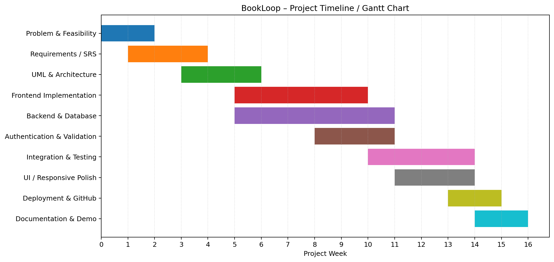
Figure 7: BookLoop Project Timeline / Gantt Chart

5.5 Resource Planning
Resource | Purpose
Student Developer(s) | Analysis, coding, testing and documentation.
Laptop/PC | Development and local testing.
Node.js | Server runtime.
VS Code / IDE | Source code development.
MongoDB / Atlas | Persistent database.
Cloudinary | Image storage.
Git + GitHub | Version control and repository.
Web Browser | Functional and UI testing.
Cloud Hosting | Production deployment.

6. UML SYSTEM MODELING

6.1 Use Case Diagram
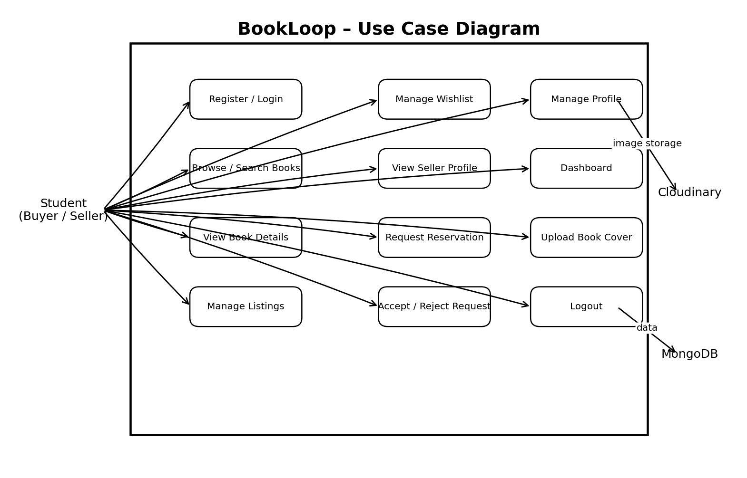
Figure 1: UML Use Case Diagram
The use case model identifies the Student as the main actor and shows the major interactions: registration/login, browsing, listing management, wishlist, profiles and reservation operations. Supporting services such as image storage and verification are shown where relevant.

6.2 Class Diagram
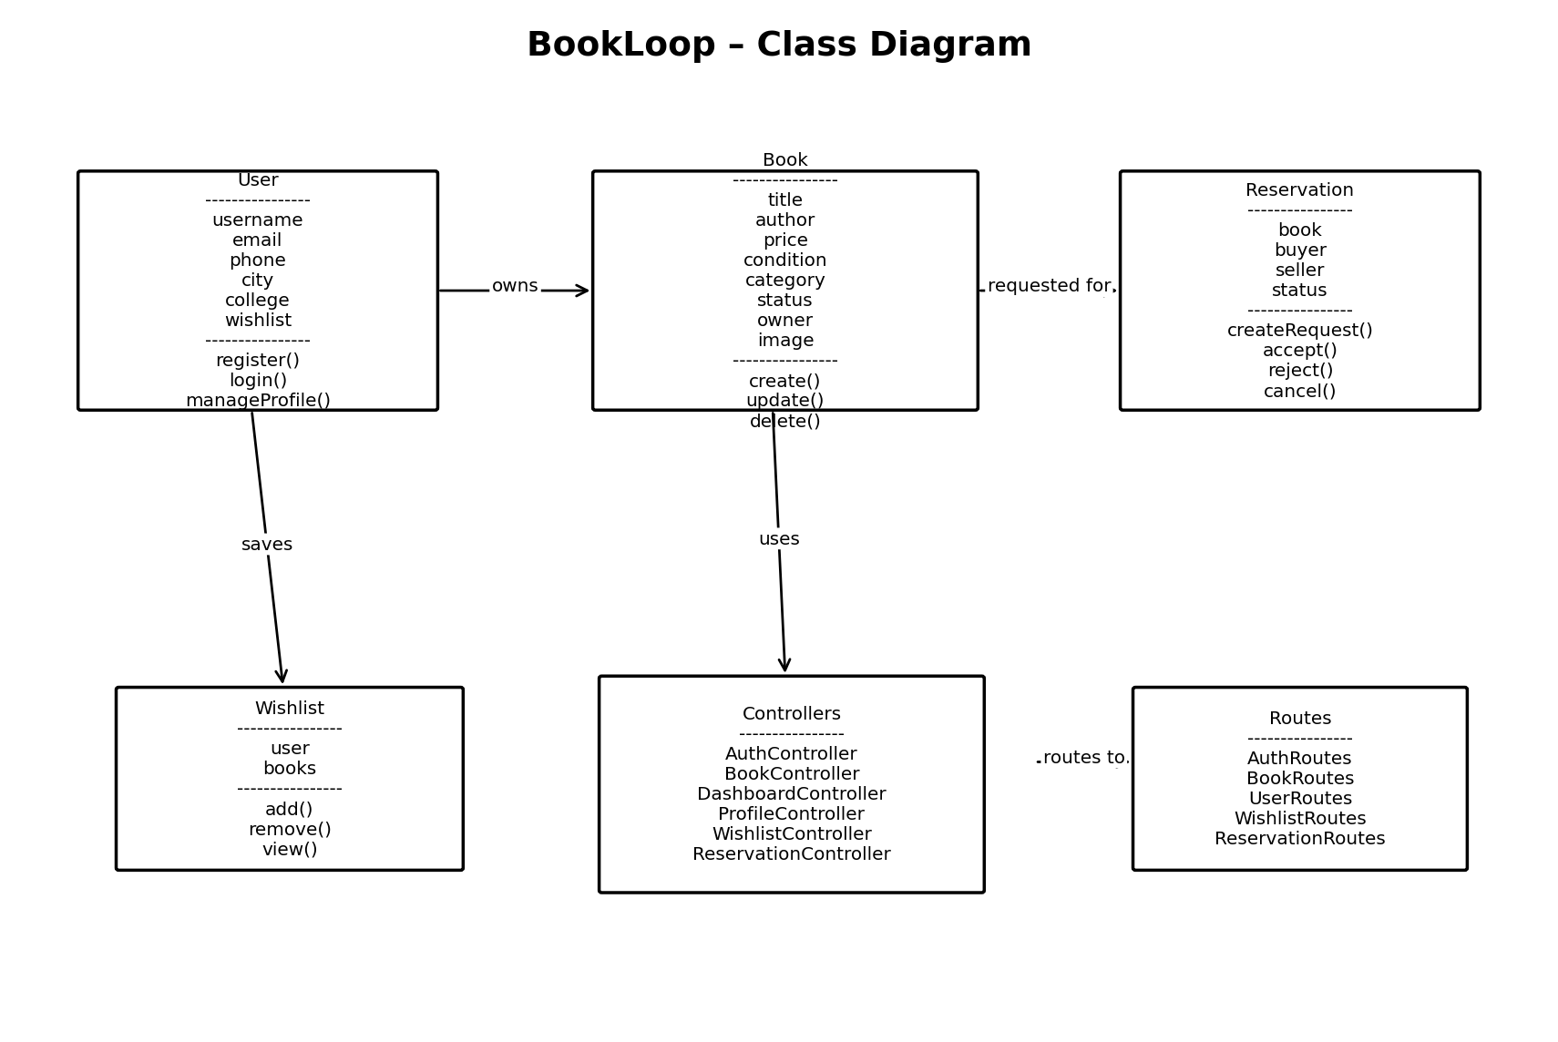
Figure 2: UML Class Diagram
The class model connects the main application concepts. User owns books, users can save books to a wishlist, and reservations connect a book with a buyer and seller. Routes, middleware and controllers are also represented as software components around the models.

6.3 Sequence Diagram – Reservation
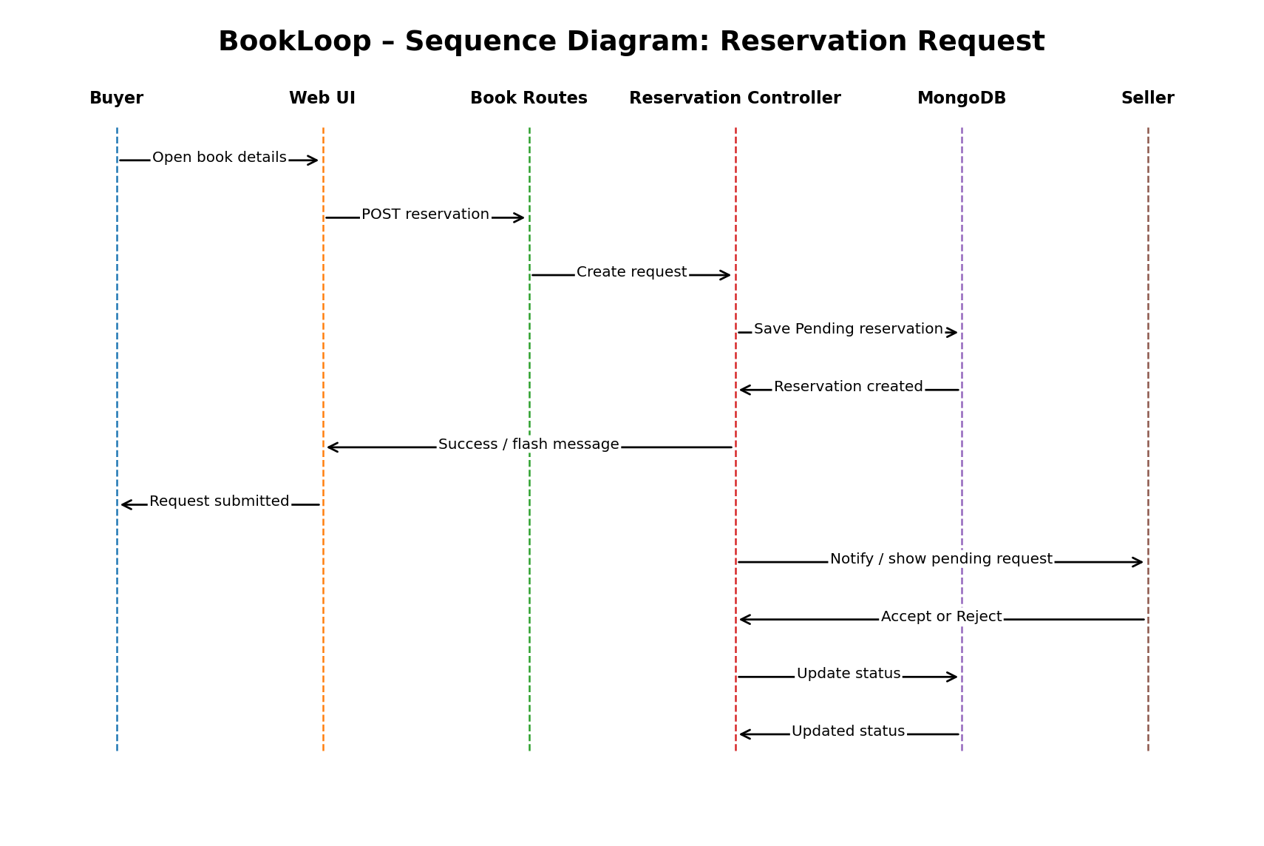
Figure 3: UML Sequence Diagram – Reservation Request
A buyer opens a book, submits a reservation request and the application validates the request before storing the reservation. The seller later processes the request. This diagram explains the time-ordered interaction among browser, routes/controllers, database and users.

6.4 Activity Diagram
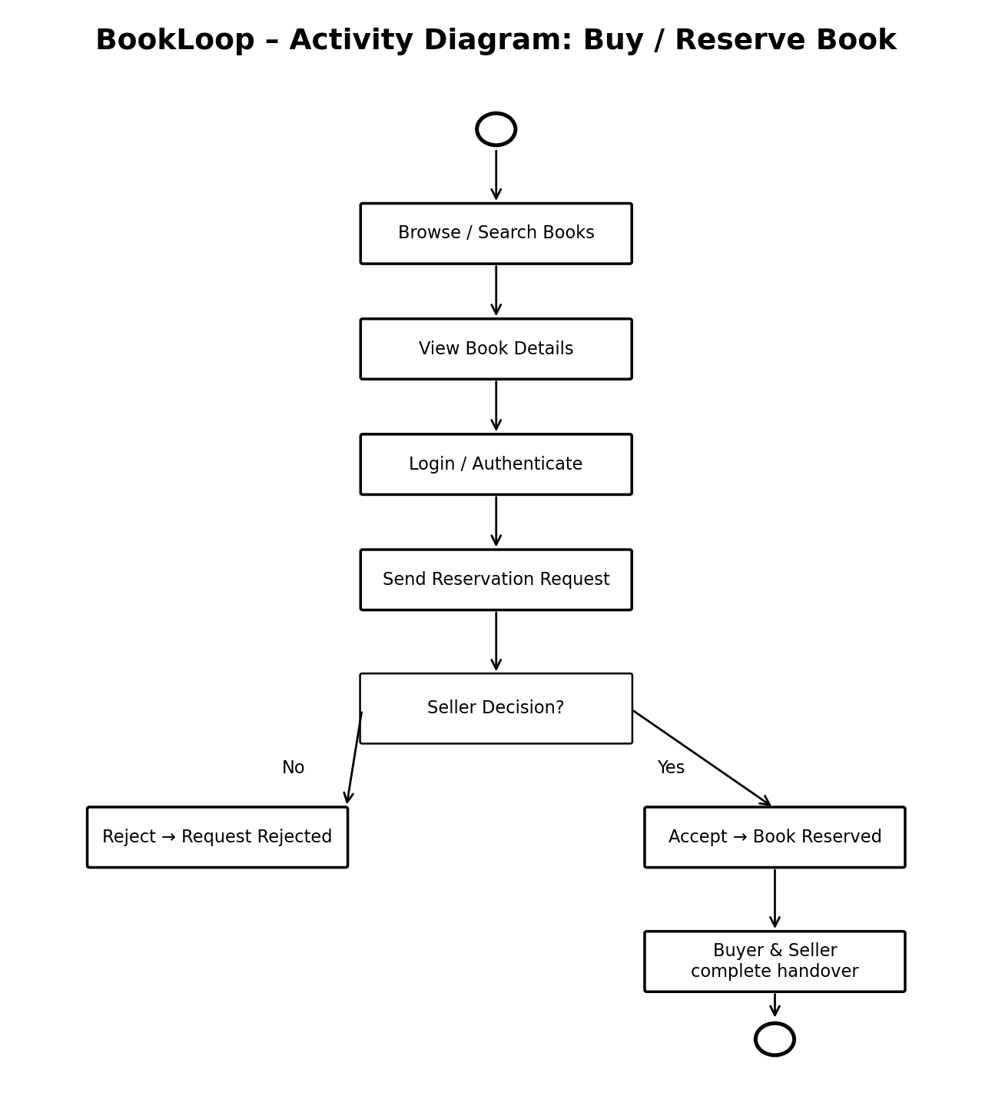
Figure 4: UML Activity Diagram – Buy/Reserve Book
The activity model starts with book discovery and continues through viewing details, authentication, reservation submission and the seller decision. It makes the business process understandable even to a reader who has not seen the source code.

6.5 ER Diagram
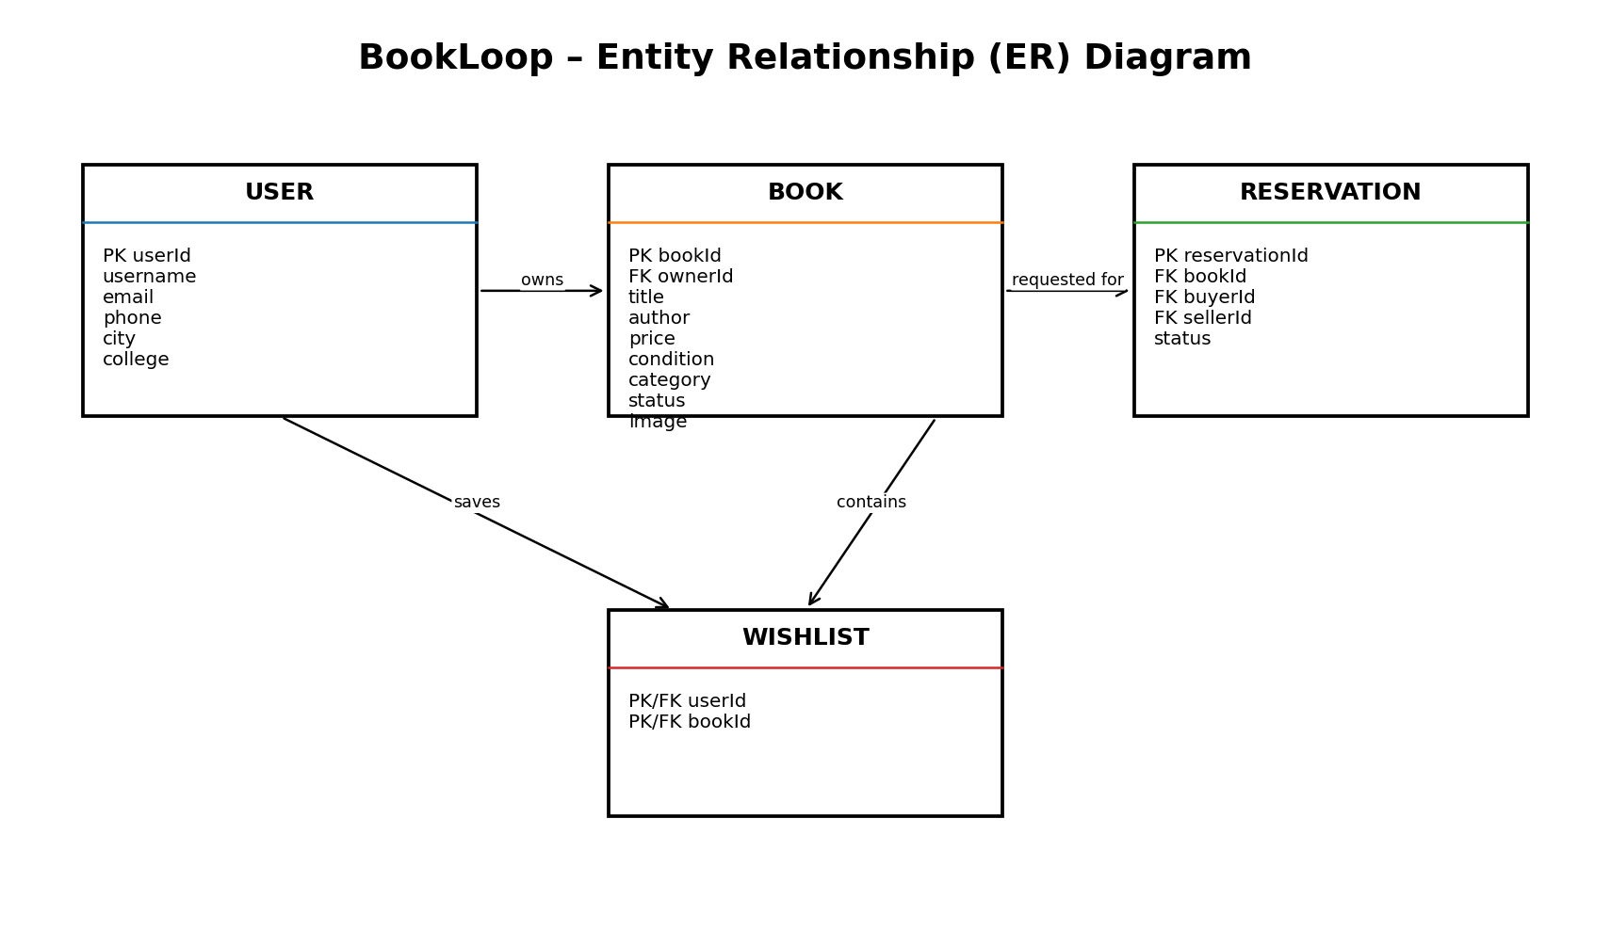
Figure 5: Entity Relationship Diagram
The ER model represents the persistent data: users, books, reservations and wishlist relationships. The User entity is related to owned books and reservation roles, while Book is connected to reservation and wishlist data.

6.6 Deployment Diagram
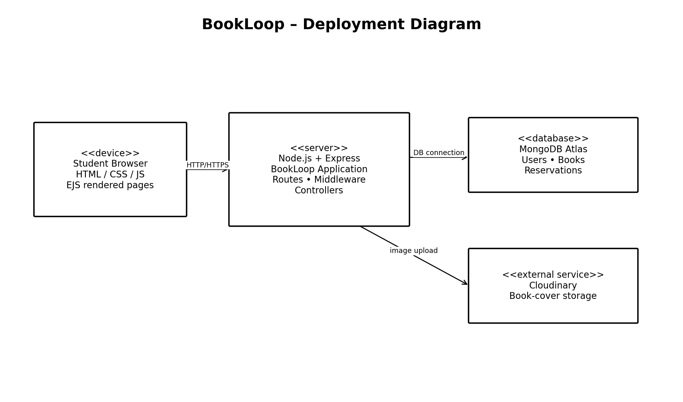
Figure 6: UML Deployment Diagram
The deployment diagram shows a student browser communicating with the Node.js/Express application. The application connects to MongoDB for persistent data and Cloudinary for book-cover images.

7. SYSTEM ARCHITECTURE DESIGN

7.1 High-Level Architecture
BookLoop follows a server-rendered MVC-style architecture. The browser sends HTTP requests to Express routes. Middleware performs cross-cutting tasks such as authentication, ownership checks and validation. Controllers implement application logic and call Mongoose models. Models communicate with MongoDB. EJS views generate the HTML response. Cloudinary is used when a book image is uploaded.
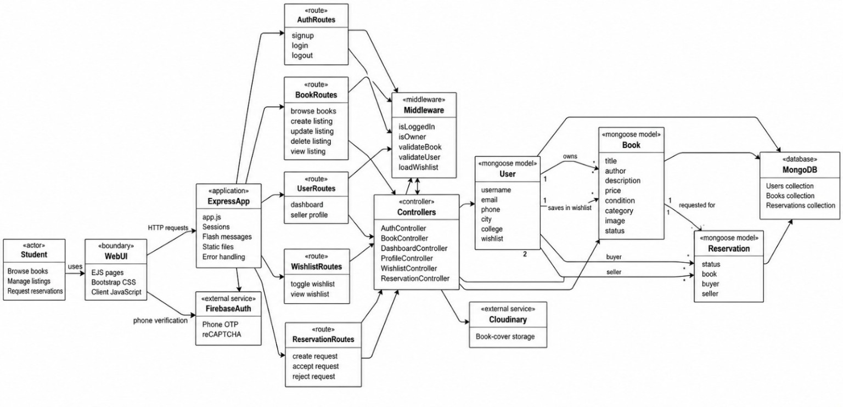
Figure 8: Supplied BookLoop Component/Software Architecture

7.2 Runtime Architecture
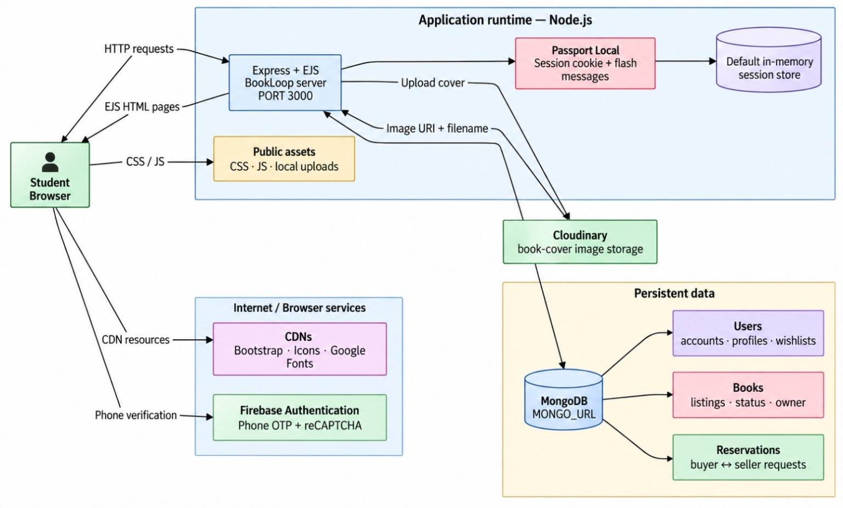
Figure 9: Supplied BookLoop Runtime Architecture
The runtime view shows the student browser, Node.js/Express/EJS application, Passport session handling, public assets, Cloudinary, MongoDB and external browser services. It provides a system-level view of where requests and data move during execution.

7.3 End-to-End Data Flow
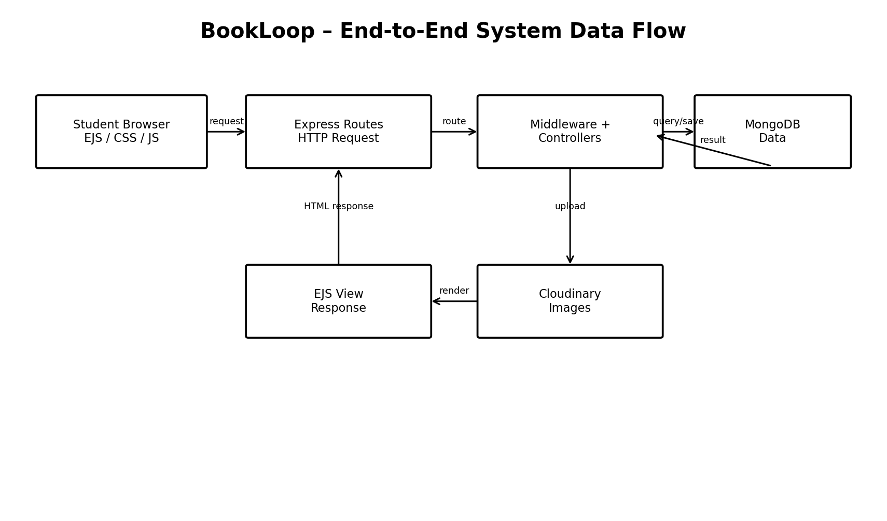
Figure 10: End-to-End Data Flow
The browser starts the interaction. Express routes select the correct workflow, middleware verifies access, controllers perform the operation, and models query or update MongoDB. For image uploads, the application communicates with Cloudinary and stores the returned image URI/filename with the book record. The controller then renders an EJS page for the browser.

7.4 Authentication and Authorization Flow
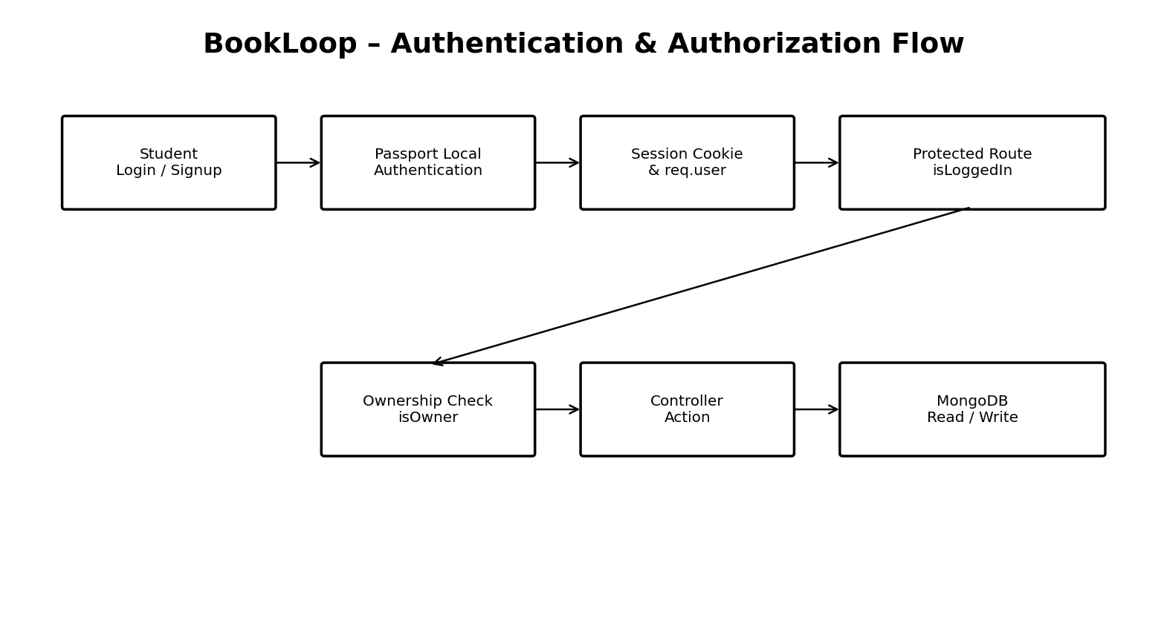
Figure 11: Authentication and Authorization Flow
Passport Local authenticates the user and a session identifies the authenticated request. Protected routes use login middleware. Owner-only operations additionally verify that the current user owns the requested book before allowing edits or deletion.

8. DATABASE AND DATA DESIGN

8.1 User Model
Field | Type / Meaning
username | Passport Local username / account identity
email | Unique required email
phone | User contact information
city | User location
college | College/institution
profileImage | Profile image reference
wishlist[] | References to Book documents
timestamps | Created/updated dates

8.2 Book Model
Field | Type / Meaning
title | Required string
author | Required string
description | Required string
price | Number, minimum 0
condition | New / Like New / Good / Fair / Poor
category | Book category
image.url | Cloudinary image URL or BookLoop default /book.jpg
image.filename | Uploaded file identifier
owner | Reference to User
status | Available / Reserved / Sold
timestamps | Created/updated dates
The current Book model explicitly uses /book.jpg as the default image and converts the known legacy external default image to the BookLoop default. This means a seller-uploaded Cloudinary image is preserved, while missing/legacy defaults render the BookLoop image. The application also exposes the root-level book.jpg through an explicit /book.jpg route. fileciteturn174file0 fileciteturn173file0

8.3 Reservation Model
Field | Meaning
book | Book being requested
buyer | User requesting the book
seller | Owner of the book
status | Pending / Accepted / Rejected / Cancelled
timestamps | Request creation/update dates

8.4 Relationships
- One User can own many Books.
- One User can have many wishlist references.
- One Book belongs to one owner User.
- One Book can be associated with reservation requests.
- A Reservation connects one Book, one buyer User and one seller User.
- MongoDB stores the collections while Mongoose manages references and schema rules.

8.5 Data Integrity
- Required fields prevent incomplete listings.
- Price has a non-negative constraint.
- Condition and status use controlled values.
- Ownership checks prevent another user from modifying a listing.
- Reservation status provides a controlled workflow.

9. APPLICATION IMPLEMENTATION

9.1 Project Structure
The repository is organized into application configuration, controllers, middleware, models, routes, views, public assets and supporting configuration. The major structure is:
Folder/File | Purpose
app.js | Main Express application, middleware, sessions, routes, error handling and server startup.
config/ | Database, Passport and Cloudinary-related configuration.
controller/ | Application/business logic for books, authentication, dashboard, profile, wishlist and reservations.
middleware/ | Authentication, ownership, validation and wishlist loading.
models/ | Mongoose schemas such as User, Book and Reservation.
routes/ | HTTP route definitions for auth, books, dashboard, profile, wishlist and reservations.
views/ | EJS pages, layouts and reusable view components.
public/ | CSS, JavaScript and public static assets.
schemas.js | Validation schema definitions.
package.json | Dependencies and npm scripts.

9.2 Main Application Bootstrap
The application loads environment variables, creates an Express app, configures EJS/EJS-Mate, connects to the database, enables URL-encoded and JSON parsing, serves public assets, configures sessions, Passport and flash messages, then mounts authentication, book, dashboard, profile, wishlist and reservation routes. It also contains 404/error handling and starts the server on the configured PORT. fileciteturn173file0

9.3 Dependencies
The current package configuration includes Express, EJS, EJS-Mate, Mongoose, MongoDB-related tooling, Passport, Passport Local, Passport Local Mongoose, Multer, Cloudinary storage, Joi, express-validator, sessions, flash messages, method-override, dotenv, bcrypt and Nodemon. fileciteturn172file0

9.4 Route Modules
Route Module | Main Responsibility
auth.js | Signup, login and logout.
books.js | Browse, create, edit, delete and view books.
dashboard.js | Dashboard information.
profile.js | Seller/public profile and profile management.
wishlist.js | Toggle and view wishlist.
reservations.js | Create, accept and reject reservation requests.
The repository currently contains these six route modules under routes/. fileciteturn175file0

9.5 Controller Layer
Controllers keep business logic separate from route definitions. Book controllers handle latest listings, search/filter/sort/pagination, book details, creation, editing and deletion. Other controllers handle authentication, dashboard, profiles, wishlist and reservations.

9.6 Middleware Layer
- isLoggedIn protects authenticated actions.
- isOwner protects seller-only listing operations.
- validateBook / validateUser enforce input rules.
- loadWishlist prepares wishlist information for the UI.
- Session and Passport middleware restore the authenticated user for each request.

9.7 Image Upload Implementation
A seller may upload a book cover. The book routes use Multer with Cloudinary-backed storage, and the controller stores the resulting URL/filename in the Book document. If no image is uploaded, the model's default image is used. This avoids the previous behavior where an external generic image could appear unexpectedly.

9.8 Default Image Logic
The Book model defines DEFAULT_BOOK_IMAGE as /book.jpg. Its getter returns that value when the stored image is missing or equals the known legacy external default URL. The schema enables getters in JSON/object conversion. The Express app explicitly serves the repository's root-level book.jpg at /book.jpg. fileciteturn174file0 fileciteturn173file0

10. DETAILED USER WORKFLOWS

10.1 Seller Workflow – Listing a Book
- Seller opens BookLoop and logs in.
- Seller navigates to the new-listing form.
- Seller enters title, author, description, price, condition and category.
- Seller optionally selects a cover image.
- Server validates the submitted fields.
- If an image is provided, it is uploaded to Cloudinary.
- The Book document is created with the authenticated user as owner.
- The listing is displayed in the catalogue.
- The seller can later edit or delete their own listing.

10.2 Buyer Workflow – Finding a Book
- Buyer opens the book catalogue.
- Buyer searches by keyword or applies filters.
- Server builds the query and returns paginated results.
- Buyer opens a book card to view details.
- Buyer checks price, condition, description and seller information.
- Buyer can add the book to the wishlist or request a reservation.

10.3 Reservation Workflow
- Buyer must be authenticated.
- Buyer opens an available book.
- Buyer submits a reservation request.
- Server validates that the request is allowed.
- A Reservation record is stored with Pending status.
- Seller sees the request in the reservation area.
- Seller accepts or rejects the request.
- The reservation status is updated accordingly.
- Further payment/handover can happen outside the current system because online payment is not yet implemented.

10.4 What Happens When Someone Wants a Book?
The current application is not yet a complete online payment marketplace. It implements the discovery and reservation stage. Therefore, the practical flow is: Buyer → Find Book → View Details → Request/Reserve → Seller Reviews → Accept or Reject → Arrange handover/payment. Online payment and private messaging are planned enhancements.

10.5 Status Lifecycle
Status | Meaning
Available | Book can be requested.
Pending Reservation | A buyer has submitted a request.
Reserved | The seller has accepted/held the book.
Sold | The transaction has been completed outside/after the current reservation workflow.
Rejected / Cancelled | Reservation request is no longer active.

11. TESTING STRATEGY AND TEST CASES

11.1 Testing Objectives
- Verify that every major feature behaves as specified.
- Detect invalid inputs and unauthorized actions.
- Verify route-controller-database integration.
- Check responsive UI behavior.
- Verify image upload and default-image behavior.
- Confirm reservation state transitions.

11.2 Unit Testing
Unit testing focuses on isolated units such as validation logic, model rules, helper functions and controller behaviors. The repository exposes an npm test command using Node's test runner. fileciteturn172file0

11.3 Black-Box Testing
Black-box testing checks the observable behavior of the application without requiring knowledge of its internal implementation. Examples include submitting a login form, searching for a book, creating a listing and requesting a reservation.

11.4 Integration Testing
Integration testing verifies that multiple modules work together: route → middleware → controller → model → MongoDB, and route/controller → Cloudinary for image uploads.

11.5 Test Case Matrix
ID | Scenario | Input | Expected Result | Result
TC-01 | Valid registration | Enter valid account data | Account created | Pass/Record
TC-02 | Invalid login | Wrong password | Login rejected | Pass/Record
TC-03 | Create listing | Valid book details | Book stored/displayed | Pass/Record
TC-04 | Invalid price | Negative price | Validation error | Pass/Record
TC-05 | Upload image | Valid jpg/png/webp within limit | Cloudinary image displayed | Pass/Record
TC-06 | No image | Create listing without cover | BookLoop default image displayed | Pass/Record
TC-07 | Search | Enter book keyword | Matching books shown | Pass/Record
TC-08 | Filter | Select condition/category/price | Filtered results shown | Pass/Record
TC-09 | Wishlist | Toggle wishlist | Book added/removed | Pass/Record
TC-10 | Reservation | Authenticated buyer requests available book | Pending request created | Pass/Record
TC-11 | Accept request | Seller accepts own request | Reservation updated | Pass/Record
TC-12 | Reject request | Seller rejects request | Reservation updated | Pass/Record
TC-13 | Unauthorized edit | Non-owner attempts edit | Access denied | Pass/Record
TC-14 | Delete listing | Owner deletes | Listing removed | Pass/Record
TC-15 | 404 | Open invalid route | Error page displayed | Pass/Record
TC-16 | Mobile layout | Use narrow screen | Core UI remains usable | Pass/Record

11.6 Bug Tracking
Bug / Issue | Cause / Area | Resolution
Random/default external image | Legacy image URL in Book model | Getter now maps missing/legacy value to /book.jpg.
Root default image not directly public | book.jpg located at repository root | Explicit /book.jpg route added in app.js.
Responsive layout issues | Different viewport sizes | Responsive CSS and mobile filter improvements.
Inconsistent page styling | Separate page styles | Shared theme, navbar, cards and page-specific CSS.
Online payment not present | Not implemented in current scope | Documented as future enhancement rather than pretending it exists.

12. PERFORMANCE AND SECURITY TESTING

12.1 Basic Load Testing Plan
For an academic project, load testing can begin with repeated concurrent requests against high-use endpoints such as the home page, book catalogue and book detail pages. Observe response time, error rate and database behavior as the number of records and concurrent users increases.
Test Area | What to Measure | Expected Goal
Home page | Response time under repeated requests | Stable response without server errors
Catalogue | Search/filter query time | Acceptable response as data grows
Book details | Database lookup time | Fast lookup using indexed identifiers
Reservation | Concurrent requests | No inconsistent duplicate state
Image upload | Upload success/error rate | Valid files handled reliably

12.2 Input Validation
- Required book fields must be supplied.
- Price must be zero or greater.
- Condition/status values must belong to allowed enumerations.
- Image uploads are restricted by configured file type and size rules.
- Object IDs should be validated before database operations.
- Authenticated user identity must be used for ownership-sensitive operations.

12.3 Security Validation
- Passport-based authentication protects account access.
- Session cookies are configured as HTTP-only.
- Protected operations require authentication.
- Owner checks prevent users from editing/deleting another user's listing.
- Environment variables are used for secrets/configuration.
- Server-side validation is required even when client-side validation exists.
- Future production hardening should include CSRF protection, rate limiting, secure headers, stronger session storage and secure cookie settings appropriate to HTTPS.

12.4 Reliability and Error Handling
The Express application has a 404 handler and centralized error-rendering middleware. Flash messages communicate success/error states. This prevents users from receiving unhandled raw errors during normal invalid navigation or validation failures. fileciteturn173file0

13. DEPLOYMENT AND VERSION CONTROL

13.1 Local Setup
- Install Node.js and MongoDB or configure MongoDB Atlas.
- Copy .env.example to .env.
- Configure database, session and Cloudinary variables.
- Install packages using npm install.
- Run npm run dev during development.
- Open the local application at http://localhost:3000.

13.2 Production Deployment
- Create the production service on the selected hosting platform.
- Connect the GitHub repository.
- Configure build/start commands and environment variables.
- Ensure MongoDB is reachable from the deployed service.
- Ensure Cloudinary credentials are present.
- Verify authentication, listing creation, image upload, search and reservation flows.
- Check the deployed logs for runtime errors.

13.3 GitHub Version Control
GitHub is a mandatory course requirement. The project repository is public and its default branch is main. Development work can be isolated on feature/fix branches, reviewed and then merged into main. The BookLoop UI improvements were developed on a separate ui-fix branch before being merged into main, preserving a controlled development workflow.

13.4 Current Repository Facts
Item | Value
Repository | Shaikhsaquib7276/Booklooop
Default branch | main
Application entry | app.js
Package scripts | start, dev, test
Main framework | Express.js
Database | MongoDB / Mongoose
Image storage | Cloudinary
Views | EJS / EJS-Mate

13.5 APK Build
The current BookLoop project is a browser-based web application, so an APK is not part of the current implementation. If the institution requires a mobile package in a later phase, the same backend could support a mobile client or a web-to-mobile wrapper.

14. TECHNICAL DOCUMENTATION

14.1 Request Lifecycle Example – Create Book
- Browser submits the new-book form.
- Express receives the HTTP POST request.
- Authentication middleware checks the user session.
- Upload middleware processes the optional image.
- Validation middleware checks book data.
- Book controller sets owner to the authenticated user.
- If an image exists, the Cloudinary URL/filename is stored.
- Mongoose saves the Book document in MongoDB.
- Controller redirects/renders the appropriate page and sends feedback.

14.2 Request Lifecycle Example – View Book
- Browser requests /books/:id.
- Book route receives the request.
- Controller finds the Book by ID and populates the owner.
- Related books and reservation information can be prepared.
- Controller renders the EJS book detail view.
- The view displays the stored image or BookLoop default image.

14.3 Request Lifecycle Example – Reservation
- Authenticated buyer opens an available listing.
- Reservation route receives the request.
- Middleware confirms the buyer is logged in.
- Controller checks the book and seller relationship.
- A Reservation document is created/updated.
- Seller later opens reservations.
- Seller accepts or rejects the request.
- Book/reservation status is reflected in the UI.

14.4 Important Configuration
Configuration | Purpose
MONGO_URL | MongoDB connection string.
SESSION_SECRET | Session signing secret.
Cloudinary credentials | Book-cover image upload/storage.
PORT | Server listening port; defaults to 3000 if not provided.

14.5 Source Code Quality Practices
- Separate route, controller, model and middleware responsibilities.
- Reusable EJS includes reduce repeated markup.
- Environment variables keep secrets out of source code.
- Git branches allow isolated changes.
- Validation and error handling reduce invalid states.
- Explicit image fallback prevents broken/undesired default images.

15. USER MANUAL

15.1 New User Registration
- Open BookLoop.
- Select Sign Up.
- Enter the requested account information.
- Submit the registration form.
- After successful registration, log in with the account.

15.2 Login
- Open Login.
- Enter username/email and password as configured by the application.
- Submit the form.
- A successful login creates a session and exposes authenticated features.

15.3 Add a Book
- Log in as a seller.
- Open the Add/New Book page.
- Enter book title and author.
- Enter description, price, condition and category.
- Select a cover image if available.
- Submit the form.
- Confirm the listing appears in the catalogue/dashboard.

15.4 Browse and Search
- Open Browse Books.
- Enter a search term if required.
- Apply category, condition and price filters.
- Choose a sorting option.
- Move through pages if there are many results.
- Open a book card to view complete details.

15.5 Wishlist
When logged in, a student can save an interesting book to the wishlist. The wishlist provides a personal collection of books the student may want to consider later.

15.6 Request a Book
- Open the desired book's detail page.
- Review price, condition, description and seller information.
- Use the reservation/request action.
- Wait for the seller to process the request.
- Check reservation status from the appropriate reservations/dashboard area.

15.7 Seller Reservation Management
- Open the reservations area while logged in as the seller.
- Review the buyer and requested book.
- Accept or reject the request.
- The reservation status is updated accordingly.

15.8 Edit/Delete Your Listing
A seller can edit or delete a listing only when the ownership check confirms that the authenticated user owns the book. This protects other users' listings from unauthorized modification.

16. SCREENSHOTS / UI EVIDENCE
The following UI images are included as visual evidence of the BookLoop interface design. They show the dark-themed book detail/listing presentation and seller information components. For final college submission, additional screenshots of the actual deployed application can be added for login, signup, homepage, catalogue, dashboard, wishlist and reservations if required.

Figure 12: Book Detail UI – Example View 1

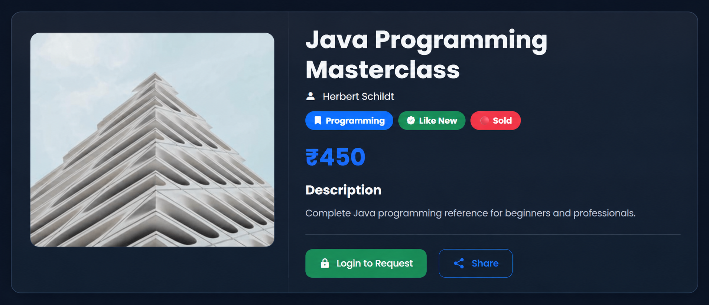
Figure 13: Book Detail UI – Example View 2


Figure 14: Book Detail UI – Example View 3


Figure 15: Book Detail UI – Example View 4

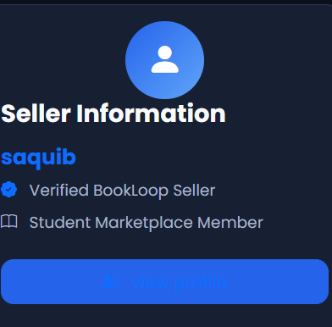
Figure 16: Seller Information UI

16.1 Recommended Evidence Set for Final Viva
- Homepage screenshot
- Signup page
- Login page
- Browse/search/filter page
- New Book form
- Book detail page with uploaded image
- Book detail page using default BookLoop image
- Seller profile
- Dashboard
- Wishlist
- Buyer reservation screen
- Seller reservation management screen
- MongoDB collections/data evidence
- Cloudinary uploaded image evidence
- GitHub repository and commit history
- Deployed website

17. COURSE OUTCOMES MAPPING
CO | Course Outcome Area | BookLoop Evidence
CO1 | Identify and analyze real-world problems | Second-hand student book marketplace problem, stakeholders, feasibility and scope.
CO2 | Develop skills in requirements, UML and architecture | SRS, functional/non-functional requirements, Use Case/Class/Sequence/Activity/ER/Deployment diagrams and architecture.
CO3 | Implement software using modern tools | Node.js, Express, EJS, MongoDB, Mongoose, Passport, Cloudinary, validation and GitHub.
CO4 | Integrate, test and evaluate | Unit/black-box/integration testing, test cases, bug tracking, performance and security validation.
CO5 | Document and present project | Technical report, user manual, screenshots, source-code explanation, UML and deployment evidence.

17.1 Module 1 Compliance
Syllabus Point | Included in Report
Problem Identification & Feasibility | Yes – Section 2
Requirement Engineering | Yes – Section 4
SDLC Planning | Yes – Section 5
WBS | Yes – Section 5.3
Gantt Chart | Yes – Section 5.4
Resource Planning | Yes – Section 5.5
Use Case Diagram | Yes – Section 6.1
Class Diagram | Yes – Section 6.2
Sequence Diagram | Yes – Section 6.3
Activity Diagram | Yes – Section 6.4
ER Diagram | Yes – Section 6.5
Deployment Diagram | Yes – Section 6.6
System Architecture | Yes – Section 7
Database Schema | Yes – Section 8
API/Route Structure | Yes – Section 9.4
Security Considerations | Yes – Section 12

17.2 Module 2 Compliance
Syllabus Point | Included in Report
Frontend Implementation | Yes – Section 9
Backend Implementation | Yes – Section 9
Database Integration | Yes – Section 8/9
Authentication & Validation | Yes – Sections 9/12
Error Handling | Yes – Section 12
Unit Testing | Yes – Section 11
Black-box Testing | Yes – Section 11
Integration Testing | Yes – Section 11
Test Case Preparation | Yes – Section 11.5
Bug Tracking | Yes – Section 11.6
Cloud Deployment / Local Hosting | Yes – Section 13
APK Build | Discussed as not applicable to current web implementation
Server Configuration | Yes – Section 13
GitHub Version Control | Yes – Section 13
Basic Load Testing | Yes – Section 12.1
Input Validation Checks | Yes – Section 12.2
Security Validation | Yes – Section 12.3
Technical Report / User Manual / Screenshots / Source Documentation | Yes – Sections 14–16

18. MODULE DELIVERABLES CHECKLIST

18.1 End of Module 1
- Project Proposal
- SRS Document
- Complete UML Set
- Architecture Design Document

18.2 End of Module 2
- Working Application
- Test Cases and Results
- Bug Tracking Record
- Deployment/Hosting Evidence
- Technical Report
- User Manual
- Screenshots
- Source Code Documentation

18.3 Final Submission Package
Item | Recommended Evidence
Report | This detailed document.
Source Code | GitHub repository.
UML | Figures 1–6.
Architecture | Figures 8–11.
Timeline | Figure 7.
UI Evidence | Figures 12–16 plus actual application screenshots.
Testing | Test-case matrix and recorded execution results.
Deployment | Live URL and deployment logs/screenshots.
Presentation | Short PPT covering problem → solution → architecture → demo → results.

19. LIMITATIONS AND FUTURE ENHANCEMENTS

19.1 Current Limitations
- Online payment is not implemented.
- Private buyer-to-seller messaging is not implemented.
- Phone verification is not fully implemented server-side.
- The current project is primarily a web application rather than a native mobile app.
- Advanced recommendation and analytics are not part of the current release.
- Production-scale security and load testing require further hardening.

19.2 Future Enhancements
- Integrate secure online payments.
- Add private buyer-seller chat.
- Implement verified phone numbers and OTP workflows.
- Add email/push notifications for reservation changes.
- Add advanced search and recommendation features.
- Introduce seller ratings and transaction feedback.
- Add admin moderation and reporting.
- Build a mobile application/APK using the same backend APIs.
- Add production-grade logging, monitoring, rate limiting and security headers.
- Add delivery/meeting-point coordination features.

20. CONCLUSION
BookLoop is a complete academic example of a real-world web application developed through the software engineering lifecycle. The project begins with a practical student problem and translates it into a defined scope, stakeholder model, requirements specification and feasibility study. It then uses UML and architecture diagrams to explain the system before implementation.
Technically, BookLoop demonstrates how a browser request travels through Express routes and middleware to controllers and Mongoose models, how MongoDB stores users/books/reservations, how Passport manages authentication, and how Cloudinary stores uploaded book-cover images. The reservation workflow provides a realistic marketplace interaction without incorrectly claiming that online payment is already implemented.
The project also addresses testing, error handling, security, responsive UI, deployment and GitHub version control. Therefore, a new developer or evaluator reading this report should be able to understand not only what BookLoop does, but also why it was built, how its modules interact, how its data is stored, how a user completes the main workflows and how the application can be extended in future.

21. REFERENCES
- Node.js documentation – server-side JavaScript runtime.
- Express.js documentation – web framework and middleware.
- MongoDB documentation – NoSQL database.
- Mongoose documentation – MongoDB object modeling.
- Passport.js documentation – authentication middleware.
- EJS documentation – server-side templating.
- Cloudinary documentation – media storage and delivery.
- Git documentation – distributed version control.
- GitHub documentation – repository and collaboration platform.
- BookLoop project source repository – Shaikhsaquib7276/Booklooop.

APPENDIX A – REPOSITORY IMPLEMENTATION NOTES
The current repository confirms the package scripts start, dev and test, with app.js as the main entry point. fileciteturn172file0
The current app.js configures Express, EJS/EJS-Mate, sessions, Passport, flash messages, static files, the explicit /book.jpg default-image route, application routes and centralized error handling. fileciteturn173file0
The current Book model contains the Book fields, owner/status relationships and the default-image getter logic described in this report. fileciteturn174file0
The current route directory contains authentication, books, dashboard, profile, reservations and wishlist modules. fileciteturn175file0

APPENDIX B – FINAL REVIEW CHECKLIST
- All required Module 1 topics included.
- All six required UML/ER/deployment diagrams included.
- Supplied component and runtime architecture diagrams included.
- WBS, Gantt chart and resource planning included.
- Functional and non-functional requirements included.
- Implementation architecture and repository structure explained.
- Database schema and relationships explained.
- Buyer/seller/reservation workflow explained.
- Testing categories, test cases and bug tracking included.
- Performance and security testing included.
- Deployment and GitHub workflow included.
- User manual and screenshot evidence sections included.
- Future enhancements and limitations documented.

