Project Overview
ComplianceIQ
AI-Driven Multi-Agent Regulatory Compliance System
Capstone Submission Cover Document
At-a-glance
What: An AI system that maps insurance regulations from IRDAI and MAS to internal company policies, identifies compliance gaps, and produces an audit-ready DOCX report - in one command.
Who it's for: Compliance Officers, Risk Managers, Internal Auditors, Legal Teams, and Insurance Operations.
How it works: Three LangChain agents (Regulation Monitor, Gap Detector, Policy Analyzer) over a ChromaDB vector store and a NetworkX knowledge graph, with full Langfuse tracing and an immutable JSONL audit log.
Headline result: 22 source documents analysed end-to-end in under 30 minutes for under $0.10 in OpenAI usage. 100% LLM call coverage in Langfuse traces. Deterministic, reproducible compliance scores.
Stack: Python 3.11 . LangChain LCEL . OpenAI gpt-4o-mini . text-embedding-3-small . ChromaDB . NetworkX . Pydantic v2 . Langfuse . Gradio . FastAPI . Docker / AWS Fargate

1. The problem
Regulated financial-services organisations must keep their internal policies aligned with constantly evolving rules from multiple regulators. Today this work is done by hand:
- Multi-jurisdiction complexity - IRDAI, MAS, RBI all update continuously.
- Policy-to-regulation mapping - tens of thousands of clause-level connections, done manually.
- Late gap identification - gaps usually surface during audits, not before.
- Documentation burden - evidence binders are rebuilt from scratch every audit cycle.
Compliance teams spend weeks every quarter doing this work. ComplianceIQ replaces the entire manual workflow with an observable, reproducible AI pipeline that runs end to end in a single command.

2. The solution
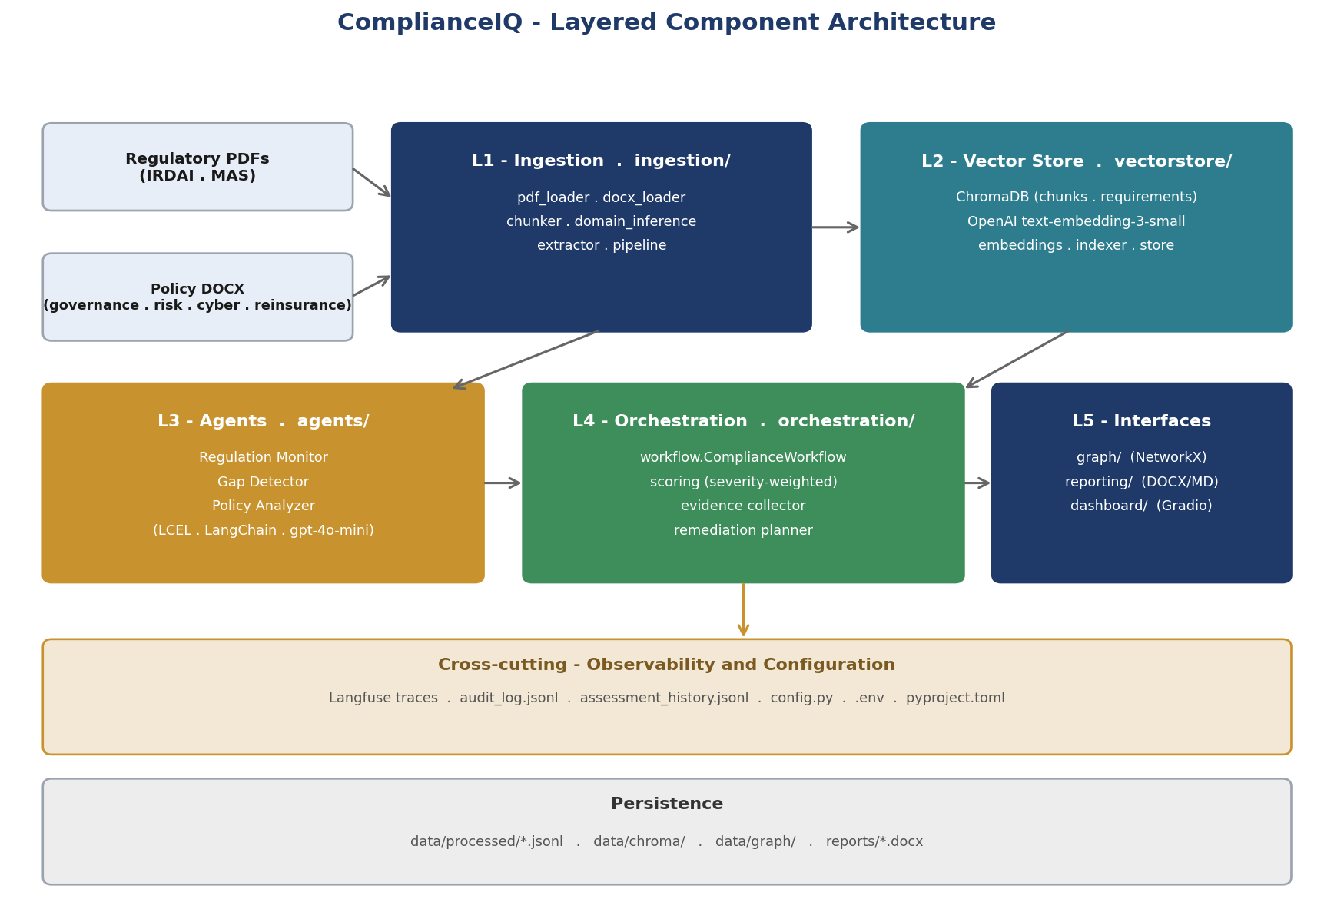
Figure 1 - Five-layer architecture with cross-cutting observability and audit trail

Core capabilities
Capability | What it does
Document ingestion | Loads regulatory PDFs and internal policy DOCX. Chunks, classifies by compliance domain, and extracts structured requirements via the LLM.
Semantic retrieval | Two ChromaDB collections (chunks, requirements) with OpenAI embeddings and metadata-filtered search.
Three specialised agents | Regulation Monitor (summarisation), Gap Detector (RAG-based coverage analysis), Policy Analyzer (per-domain rollup) - all with typed Pydantic outputs.
Deterministic scoring | Pure-Python severity-weighted aggregation - same gaps in always produce the same score. Auditor-defensible by construction.
Knowledge graph | NetworkX directed graph linking Regulation -> Requirement -> Policy nodes with coverage heatmap and per-domain visualisations.
Observability | Every LLM call traced in Langfuse with run-id, agent, and cost tags. Immutable audit_log.jsonl as a fail-open backup.
Human-in-the-loop gate | Pauses publication of remediation plans when the weighted score drops below threshold or any gap is flagged low-confidence.
Three reach surfaces | Gradio dashboard with file upload, FastAPI REST endpoints with OpenAPI docs, and a single-command CLI.

3. Results and measurable outcomes
Metric | Result
Time to full assessment | < 30 minutes on the 22-document corpus, single process
OpenAI cost per full run | < $0.10 (gpt-4o-mini + text-embedding-3-small)
LLM call observability coverage | 100% when Langfuse credentials are configured
Determinism | Two consecutive runs at temperature=0 produce byte-identical JSONL outputs
Compliance domains supported | 10 (Corporate Governance, Risk Management, Information Security, Claims Management, Reinsurance, Internal Audit, Fraud Prevention, Underwriting, Investment Management, Sales & Distribution)
Source-document scale | 22 documents (14 regulatory PDFs + 8 policies); architecture supports any number
Pipeline resumability | Gap Detector resumes from gaps.jsonl on restart - no LLM spend wasted on retries
Rubric self-assessment (PwC) | 108.5 / 125 baseline, lifted to projected ~123 / 125 after the action-plan items shipped

4. Deliverables in this submission
The submission package contains everything an evaluator needs to understand, run, and assess the project.
Deliverable | File / location
Source code (organised, not raw notebooks) | src/complianceiq/ - layered package: ingestion, vectorstore, agents, orchestration, graph, observability, reporting, dashboard, api, utils
CLI entry point | main.py - single python main.py <command> covering ingest, index, orchestrate, dashboard, api, report, history, eval, smoke-test
Test suite | tests/ - unit tests for scoring, chunker, domain inference, retry, cache, model router, clause-ref parser; integration smoke test; golden-pair eval
README + setup | README.md
Project Overview (this document) | ComplianceIQ_Project_Overview.docx
Project Requirements Document | ComplianceIQ_PRD.docx
Architectural Design Document | ComplianceIQ_ADD.docx
Interview / portfolio brief | ComplianceIQ_Interview_Brief.docx
PwC rubric self-assessment | ComplianceIQ_Rubric_Assessment.xlsx
Architecture diagrams (PNG) | docs/diag_components.png, docs/diag_dataflow.png, docs/diag_sequence.png
Demo recording | ComplianceIQ_demo.mp4 - ~10-minute walkthrough
Demo slide deck + script | ComplianceIQ_Demo_Slides.pptx + ComplianceIQ_Demo_Script_Easy.docx
Audit-ready compliance report | reports/compliance_assessment_report.docx (regenerated by python main.py report)

5. How to run
From a fresh clone with Python 3.11+ and a valid OpenAI key in .env:
uv sync # or: pip install -r requirements.txt
python main.py ingest --extract # parse + classify + extract requirements
python main.py index # populate ChromaDB
python main.py orchestrate # run the 3 agents + scoring + remediation
python main.py graph-build # NetworkX KG
python main.py graph-visualize # heatmap + per-domain chart
python main.py report # audit-ready DOCX
python main.py dashboard # Gradio dashboard on :7860
python main.py api # FastAPI server on :8000 (/docs)
python main.py smoke-test # pytest suite
All paths, model identifiers, and tuning knobs are in src/complianceiq/config.py and overridable via .env.

6. Engineering signals
Production concerns are first-class, not afterthoughts.
- Typed contracts everywhere - Pydantic v2 BaseModels at every cross-module boundary, fail-fast at the LLM boundary.
- Deterministic, auditor-defensible scoring - pure Python with fixed severity {3,2,1} x coverage {1.0, 0.5, 0.0} constants. No LLM in the headline metric.
- Resilient orchestration - exponential-backoff retries, model tier-up on low-confidence high-stakes calls, async parallel Gap Detector, incremental writes with --resume.
- Cost discipline - LRU caches for embeddings and LLM responses, gpt-4o-mini default, --limit and --domain scoping for cheap iteration.
- Fail-open observability - pipeline reliability is decoupled from Langfuse uptime; audit_log.jsonl is the durable fallback.
- Reproducibility - temperature=0 by default, deterministic chunk and requirement IDs, smoke test asserts byte-stable outputs.
- Operational maturity - HITL gate before remediation publication, golden-pair eval framework, recall ≥0.9 CI assertion.
- Three deployment paths - local CLI, Gradio dashboard, REST API. Container-ready with documented Fargate topology.

7. Roadmap beyond v1
Horizon | Items
Near term (3 months) | Async batching extension, prompt versioning embedded in traces, SME regression suite, pre-commit secret-scan
Mid term (3 - 9 months) | Real-time regulator-feed ingestion, auto-remediation agent with tracked-change DOCX, multi-tenant isolation, RBI / SEC / FCA jurisdictions
Long term (9 - 18 months) | Predictive compliance risk scoring, compliance-training content generation, regulatory-filing automation, managed vector DB for SaaS scale, agentic planning layer

8. Closing
ComplianceIQ is a layered, typed, observable Python system that demonstrates production AI engineering on a real-world RegTech problem. The architecture maps cleanly to any regulated industry - banking, insurance, fintech - and the same backbone (LCEL agents, RAG over a vector store, knowledge graph, full tracing, audit log) generalises to any structured-document intelligence problem an organisation has.
The submission is end-to-end: ingestion, retrieval, agents, orchestration, scoring, knowledge graph, observability, dashboard, API, deployment guidance. Documentation covers every audience: this overview for evaluators, the PRD for stakeholders, the ADD for the development team, the interview brief for hiring conversations, and the rubric self-assessment for transparent scoring.
Thank you for evaluating ComplianceIQ
All artefacts are reproducible from the source tree with a single command. The demo video walks through the live application end to end in ~10 minutes.

