Architectural Design Document
ComplianceIQ
AI-Driven Multi-Agent Regulatory Compliance System
Document Control
Field | Value
Document Title | ComplianceIQ - Architectural Design Document (ADD)
Version | 1.0
Status | For Development Team Review
Owner | AI Architecture team
Audience | Development team (AI Engineering, Data Engineering, MLOps, Backend, QA)
Companion documents | Project Requirements Document (PRD); README.md; Source code under src/complianceiq/
Last Updated | May 2026

1. Purpose, Audience, and Scope

1.1 Purpose
This document defines the target architecture of ComplianceIQ - the AI-driven multi-agent regulatory compliance system - in enough detail that engineers can implement, extend, and operate it without referring to external specifications. Where the PRD captures the what and the why, this ADD captures the how.

1.2 Audience
Primary readers are members of the development team:
- AI Engineering - implement and tune agents, prompts, retrieval, and orchestration.
- Data Engineering - own ingestion, schemas, vector store, knowledge graph persistence.
- MLOps - configuration, observability, deployment, environment management.
- Backend / Application Engineering - CLI, dashboard, reporting, integration points.
- QA & Reviewers - test strategy, acceptance, regression baselines.

1.3 Scope
In scope: the v1 architecture covering ingestion, embedding, three named agents, multi-agent orchestration, knowledge graph, observability, reporting, and the Gradio dashboard, deployable locally or as a containerized service.
Out of scope: real-time regulator feeds, automatic policy rewriting, multi-tenant SaaS isolation, native mobile clients, and direct integrations with external GRC platforms. These are roadmap items, listed in the PRD.

2. Architectural Goals and Constraints

2.1 Quality attributes (prioritized)
Quality attribute | Tactic
Auditability (top priority) | Every LLM call traced in Langfuse; immutable audit_log.jsonl; reproducible runs at temperature=0.
Reproducibility | Deterministic JSONL outputs; idempotent stages; ChromaDB upserts use stable IDs.
Cost efficiency | gpt-4o-mini + text-embedding-3-small; cost-control flags (--limit, --domain) for partial runs.
Extensibility | Pluggable agents behind agents/base.BaseAgent; data layout decouples regulators from code.
Operability | Single CLI entry point; structured logging; graceful degradation when observability is unavailable.
Portability | Pure-Python, file-based persistence; runs on Windows / macOS / Linux with Python 3.11+.
Maintainability | Layered package structure; Pydantic v2 at every boundary; small, testable modules.
Performance (lower priority) | Sequential pipeline acceptable; full run < 30 minutes on 22-document corpus.

2.2 Constraints
- LLM and embedding models are pinned to OpenAI gpt-4o-mini and text-embedding-3-small (configurable via env, defaults in src/complianceiq/config.py).
- LangChain v1.0+ with LCEL composition is mandated; agents are expressed as prompt | llm.with_structured_output(schema).
- All cross-module data exchange is Pydantic v2 BaseModels; no untyped dicts cross a module boundary.
- Vector database: ChromaDB embedded (file-backed). No standalone DB service in v1.
- Frontend: Gradio Blocks. The dashboard reads JSONL artefacts directly; no separate API tier in v1.
- Python 3.11+; no PyPy or alternative runtimes.

3. System Context

3.1 External actors and systems
Actor / System | Interaction
Compliance Officer / Reviewer | Operates the Gradio dashboard; consumes DOCX reports.
Developer / Operator | Runs the python main.py CLI; reads logs and audit trail.
OpenAI API | Synchronous calls for chat.completions (gpt-4o-mini) and embeddings (text-embedding-3-small).
Langfuse (cloud or self-hosted) | Receives traces via LangChain CallbackHandler.
Filesystem / Object Store | Sole persistence layer: data/ for inputs, processed artefacts, vector store, graph; reports/ for outputs.

3.2 Trust boundaries
- Local trust boundary: developer machine or container; .env never leaves this boundary.
- Egress: only OpenAI API and Langfuse endpoints over TLS.
- No inbound network exposure required for the CLI; the Gradio dashboard binds to localhost by default.

4. Logical Architecture
ComplianceIQ is organized into five logical layers, each implemented as a Python sub-package under src/complianceiq/, plus cross-cutting concerns for observability and configuration.
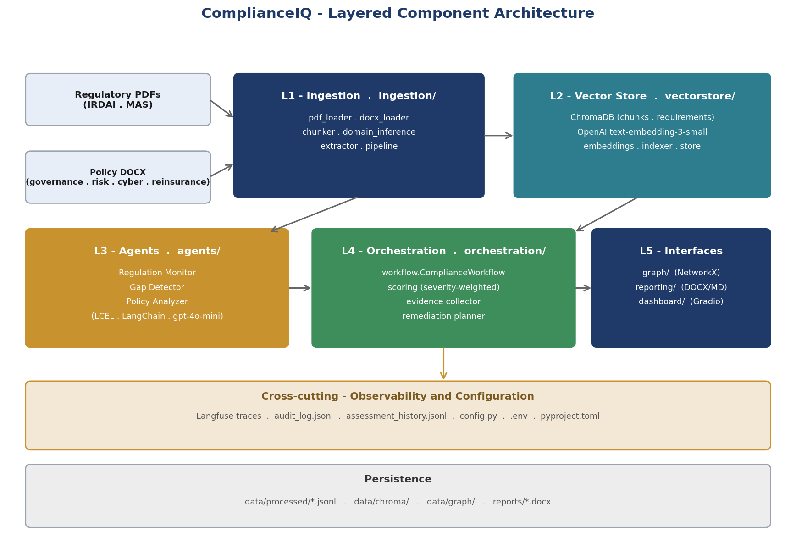
Figure 1 - Layered component architecture

4.1 Layer responsibilities
Layer | Package | Responsibility | Public surface
L1 Ingestion | ingestion/ | Load PDF/DOCX, chunk, classify, extract structured requirements. | ingest_pipeline(); extract_requirements()
L2 Vector store | vectorstore/ | Embed and persist chunks + requirements; serve semantic search. | ChromaStore.load(); .similarity_search()
L3 Agents | agents/ | Regulation Monitor, Gap Detector, Policy Analyzer. | RegulationMonitorAgent, GapDetectorAgent, PolicyAnalyzerAgent
L4 Orchestration | orchestration/ | Sequence agents, score, collect evidence, plan remediation. | ComplianceWorkflow.run(); run_workflow()
L5 Interfaces | graph/, reporting/, dashboard/ | Knowledge graph, DOCX/MD reports, Gradio dashboard. | build_graph(); render_report(); build_app()

4.2 Cross-cutting concerns
- Observability - src/complianceiq/observability/ wraps Langfuse, audit logging, and history snapshots. Every agent attaches the Langfuse CallbackHandler in BaseAgent.
- Configuration - src/complianceiq/config.py is the single source of paths, model names, and tunables. All code reads from this module rather than os.environ directly.
- Models - src/complianceiq/models.py defines every Pydantic v2 model used at module boundaries.

5. End-to-End Data Flow
Each pipeline stage consumes the artefact of the previous stage and emits its own JSONL artefact under data/processed/. Artefacts are append-only within a stage and overwrite-on-next-run across stages, so each run produces a complete, self-consistent set.
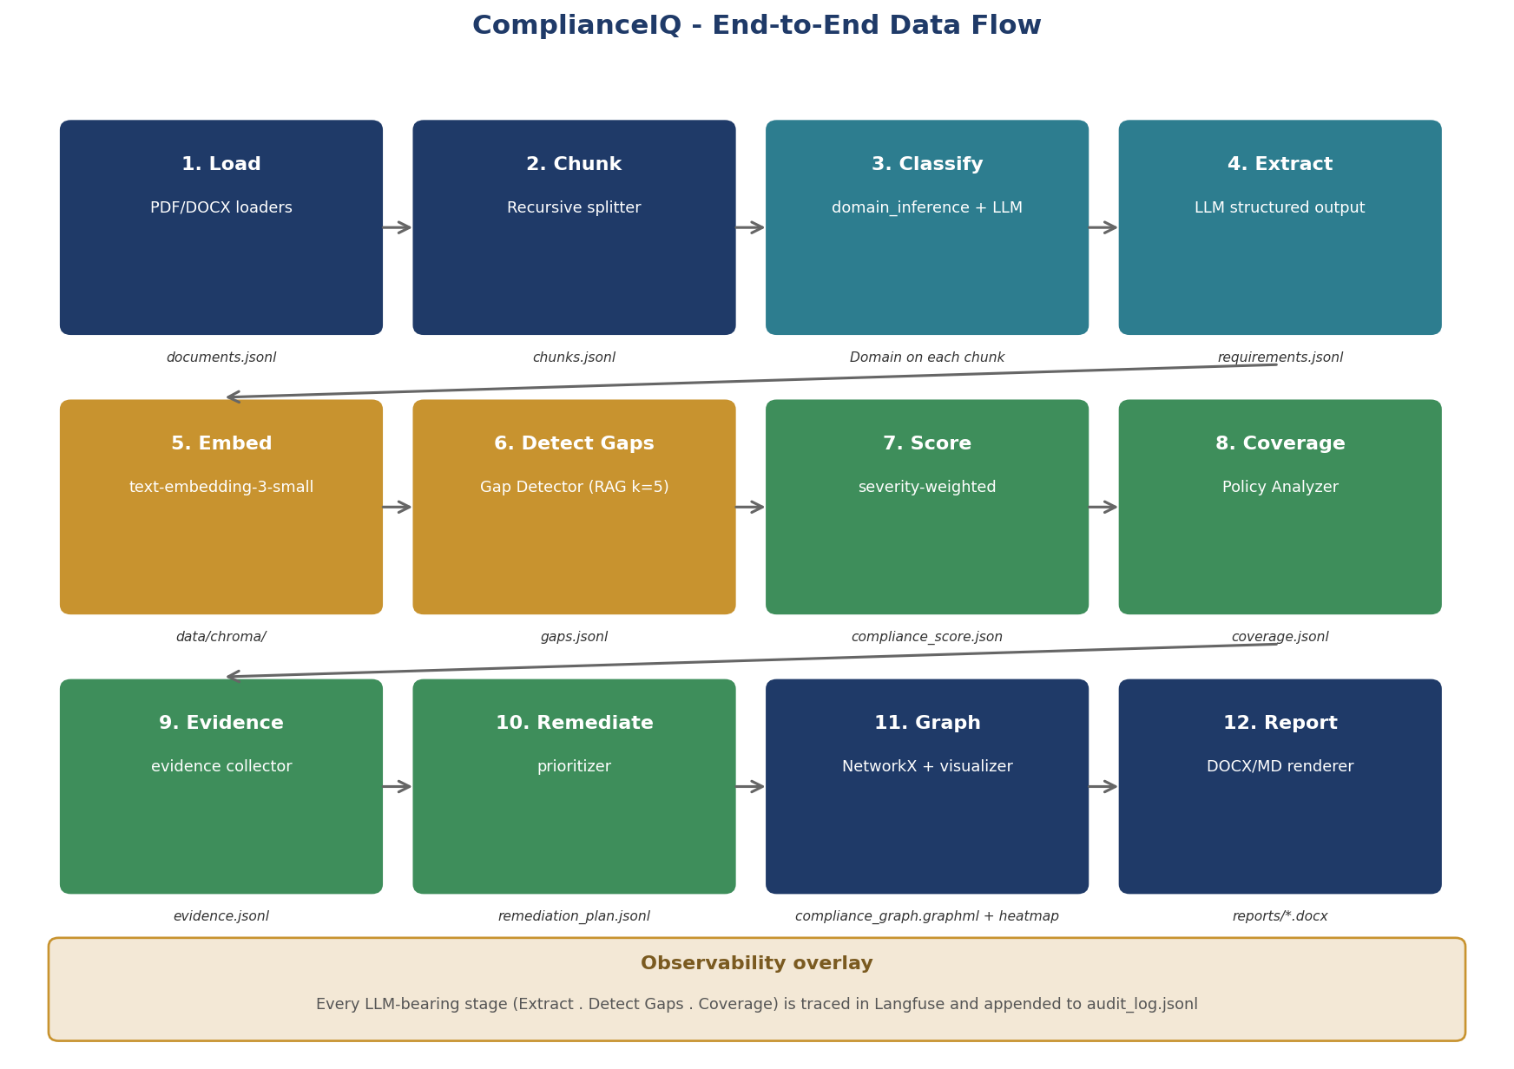
Figure 2 - Twelve-stage data flow from source documents to audit-ready report

5.1 Stage contracts
# | Stage | Reads | Writes
1 | Load | data/regulatory/**, data/policies/** | documents.jsonl
2 | Chunk | documents.jsonl | chunks.jsonl
3 | Classify | chunks.jsonl | chunks.jsonl (with Domain)
4 | Extract | chunks.jsonl | requirements.jsonl
5 | Embed | chunks.jsonl, requirements.jsonl | data/chroma/ (chunks, requirements collections)
6 | Detect Gaps | requirements.jsonl, ChromaDB | gaps.jsonl
7 | Score | gaps.jsonl | compliance_score.json
8 | Coverage | gaps.jsonl | coverage.jsonl
9 | Evidence | requirements.jsonl, ChromaDB | evidence.jsonl
10 | Remediate | gaps.jsonl, compliance_score.json | remediation_plan.jsonl
11 | Graph | requirements.jsonl, gaps.jsonl | data/graph/compliance_graph.graphml, .json, .png
12 | Report | all of the above | reports/compliance_assessment_report.docx, .md

6. Orchestration Sequence
The orchestrate command runs the full multi-agent pipeline. The sequence below captures one run from CLI invocation through to the WorkflowResult returned to the user.
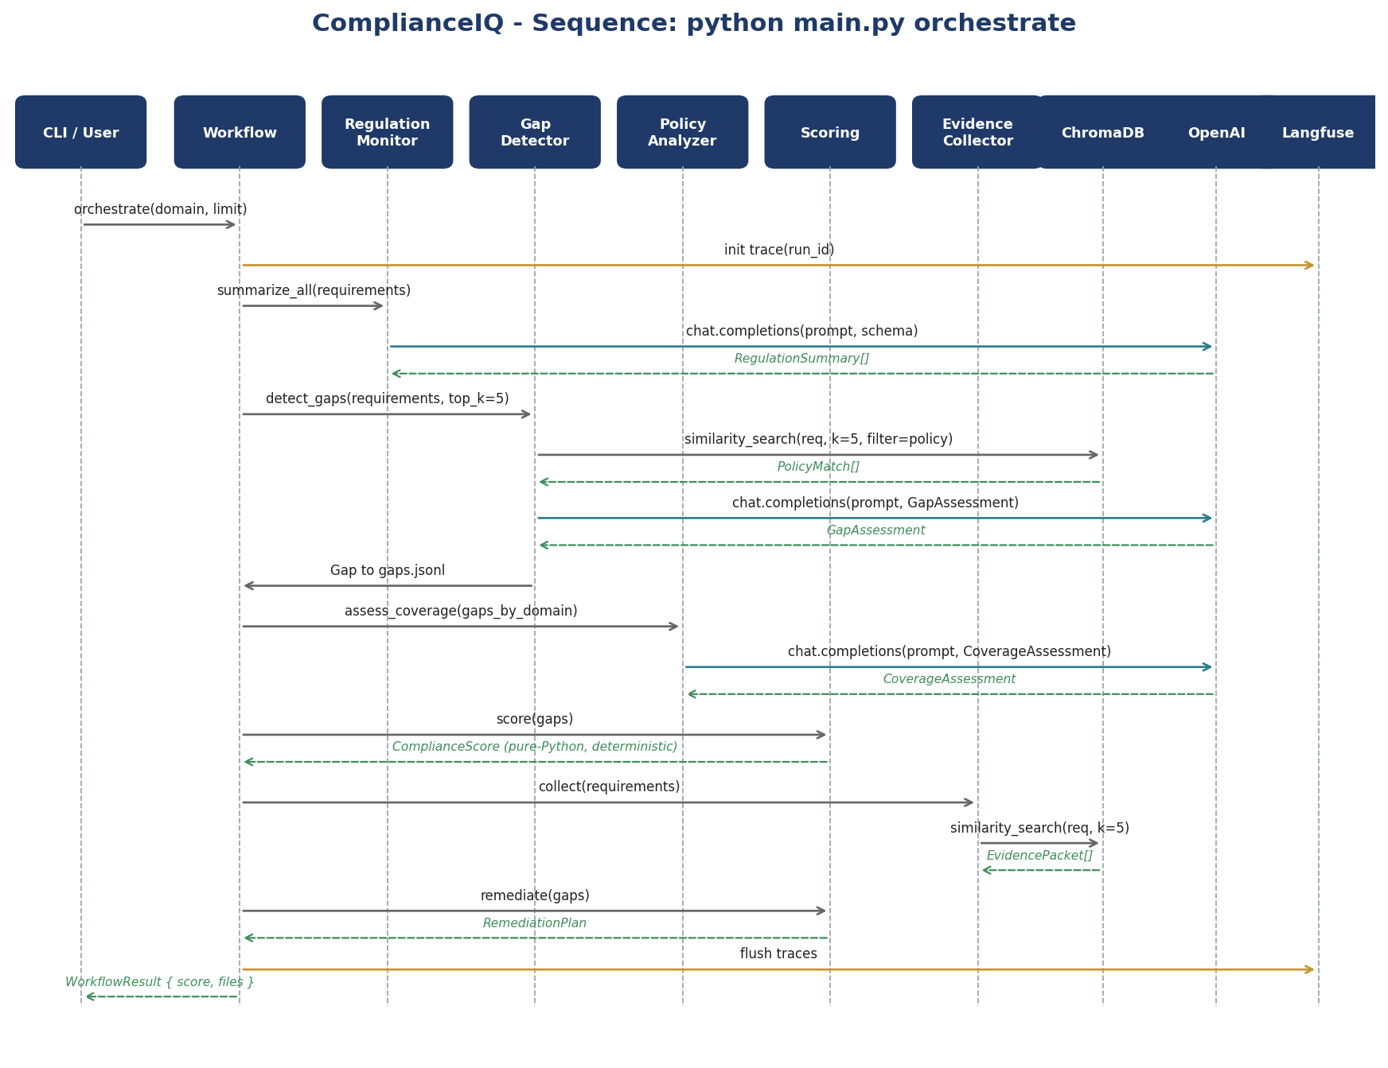
Figure 3 - Sequence diagram for python main.py orchestrate

6.1 Notes on the sequence
- The Workflow obtains a run_id (UUID4) and an AuditLogger at construction; both are propagated to every agent so traces and audit entries can be correlated.
- Gaps are written incrementally to gaps.jsonl by the Gap Detector so that a crash mid-run does not lose progress. detect_gaps(resume=True) is the default.
- Scoring and remediation are pure-Python, deterministic functions over the gap set. No LLM call is involved.
- Langfuse flush at the end ensures all spans are durably persisted.

7. Module-by-Module Design
Each layer is implemented as a Python sub-package with a small, focused public surface. The tables below list the modules, their primary classes / functions, and the contracts they expose to other layers.

7.1 ingestion/
Module | Responsibility | Key API
pdf_loader.py | Parse PDFs via pdfplumber/PyPDF2; produce Document objects. | load_pdf(path) -> Document
docx_loader.py | Parse DOCX via python-docx. | load_docx(path) -> Document
chunker.py | RecursiveCharacterTextSplitter; CHUNK_SIZE=1000, CHUNK_OVERLAP=200. | chunk_document(doc) -> list[Chunk]
domain_inference.py | Rule-based Domain classifier on filename, ordered by specificity. | infer_domain(path) -> Domain
extractor.py | LLM call with structured output to extract Requirement records from chunks. | extract_requirements(chunks) -> list[Requirement]
pipeline.py | Composes the four stages above; persists JSONL artefacts. | run_ingestion(extract=False, limit=None)

7.2 vectorstore/
Module | Responsibility | Key API
embeddings.py | Chroma-compatible wrapper around openai>=1.0 embedding API. Both legacy callable and modern __call__(input=list[str]) interfaces. | make_embedding_function() -> EmbeddingFunction
store.py | Wraps ChromaDB persistent client; exposes chunks and requirements collections. | ChromaStore.load(); .similarity_search(query, k, where)
indexer.py | Upserts chunks.jsonl and requirements.jsonl into ChromaDB. | index_all(rebuild=False)

7.3 agents/
Module | Responsibility | Key API
base.py | BaseAgent - shared LCEL chain construction, Langfuse callback wiring, run_id propagation. | BaseAgent.make_chain(system, user_template, schema, agent_name)
prompts.py | All prompt templates; version-controlled alongside code. | REGULATION_MONITOR_SYSTEM, GAP_DETECTOR_SYSTEM, POLICY_ANALYZER_SYSTEM
regulation_monitor.py | Summarize regulatory documents into RegulationSummary records. | RegulationMonitorAgent.summarize_all(reqs, domain=None)
gap_detector.py | For each Requirement, retrieve top-k policy chunks and emit a Gap. | GapDetectorAgent.detect_gaps(reqs, domain=None, limit=None, resume=True)
policy_analyzer.py | Aggregate gaps per domain into CoverageAssessment. | PolicyAnalyzerAgent.assess_coverage(gaps)

7.4 orchestration/
Module | Responsibility | Key API
workflow.py | ComplianceWorkflow - sequential runner over the three agents + scoring + evidence + remediation. | run_workflow(domain=None, limit=None, skip_summaries=False)
scoring.py | Pure-Python severity-weighted aggregation; deterministic. | score(gaps) -> ComplianceScore; remediate(gaps) -> RemediationPlan
evidence.py | EvidenceCollector - retrieves citable policy excerpts per Requirement. | EvidenceCollector.collect(reqs) -> list[EvidencePacket]

7.5 graph/
Module | Responsibility | Key API
builder.py | Build a directed NetworkX graph: Regulation -> Requirement -> Policy; persist GraphML + node-link JSON. | ComplianceGraphBuilder.build(); .save(); .load()
analytics.py | Node/edge counts, top-cited policies, orphan requirements, per-domain subgraph extraction. | graph_metrics(g); domain_subgraph(g, domain)
visualizer.py | Coverage heatmap (domain x severity) + per-domain bar chart. | render_heatmap(); render_domain_chart()

7.6 observability/
Module | Responsibility | Key API
tracing.py | Initializes Langfuse client; exposes CallbackHandler. Degrades gracefully on missing keys or auth failure. | get_handler(); flush(); is_enabled()
audit.py | Append-only AuditLogger writing AuditEvent records to audit_log.jsonl. | AuditLogger(run_id).log(event, actor, payload)
history.py | Snapshot ComplianceScore + counts per run. | record_snapshot(score); load_history(); compare()

7.7 reporting/, dashboard/
Module | Responsibility | Key API
reporting/docx_report.py | Render compliance_assessment_report.docx via python-docx with sections for summary, scoring, gaps, evidence, remediation. | render_docx_report() -> Path
reporting/loader.py | Reads JSONL artefacts and assembles a report-ready dict. | load_report_inputs()
dashboard/app.py | Gradio Blocks UI with six tabs (Overview, Gaps, Coverage, Remediation, Search, Reports). | build_app() -> gr.Blocks; launch()

8. Data Model (Pydantic v2)
All cross-module data structures are defined in src/complianceiq/models.py as Pydantic v2 BaseModels. The table below summarizes the key types and where they are produced and consumed.
Model | Produced by | Consumed by | Key fields
Domain (Enum) | ingestion.domain_inference | everywhere | CORPORATE_GOVERNANCE, RISK_MANAGEMENT, ... (10 + GENERAL)
Severity (Enum) | extractor | scoring, dashboard | HIGH, MEDIUM, LOW
CoverageQuality (Enum) | Gap Detector | scoring, policy analyzer | FULLY_COVERED, PARTIALLY_COVERED, NOT_COVERED
Document | loaders | chunker | id, source_file, doc_type, domain
Chunk | chunker | extractor, indexer | id, source_file, text, location, domain
Requirement | extractor | agents, indexer | id, source_file, regulation_text, mandatory_action, severity, domain
PolicyMatch | Gap Detector (retrieval) | Gap Detector (prompt) | policy_file, location, excerpt, distance
GapAssessment | Gap Detector (LLM) | Gap Detector (stitching) | coverage, severity, remediation_priority, remediation_steps
Gap | Gap Detector | scoring, policy analyzer, evidence | requirement_id, coverage, severity, remediation_priority, remediation_steps, matches[]
CoverageAssessment | Policy Analyzer | scoring, dashboard | domain, coverage_score, high_severity_count, ...
DomainScore / ComplianceScore | scoring | report, dashboard, history | overall, weighted_overall, per_domain[], open by severity
EvidenceItem / EvidencePacket | evidence collector | report, dashboard | requirement_id, items[]
RemediationItem / RemediationPlan | scoring | report, dashboard | priority_score, severity, domain, steps[]
AuditEvent | AuditLogger | audit_log.jsonl | run_id, ts, event, actor, payload
AssessmentSnapshot | history | history.jsonl | run_id, ts, ComplianceScore, counts

8.1 Scoring formulas (deterministic, no LLM)
Coverage and severity values are constants:
SEVERITY_WEIGHT = { HIGH: 3, MEDIUM: 2, LOW: 1 }
COVERAGE_VALUE = { FULLY_COVERED: 1.0, PARTIALLY_COVERED: 0.5, NOT_COVERED: 0.0 }

Per-domain coverage_score is the unweighted mean over gaps in that domain:
coverage_score = sum(COVERAGE_VALUE[g.coverage] for g in gaps) / len(gaps)
weighted_score is severity-weighted, so HIGH gaps dominate the metric:
num = sum(COVERAGE_VALUE[g.coverage] * SEVERITY_WEIGHT[g.severity] for g in gaps)
den = sum(SEVERITY_WEIGHT[g.severity] for g in gaps)
weighted_score = num / den
The overall ComplianceScore is the mean (or severity-weighted mean) over all DomainScore entries. Implementation: src/complianceiq/orchestration/scoring.py.

9. Persistence Layout
ComplianceIQ/
data/
regulatory/{irdai,mas}/ # source PDFs
policies/ # source DOCX
processed/ # JSONL artefacts (per run)
documents.jsonl chunks.jsonl requirements.jsonl
regulation_summaries.jsonl gaps.jsonl coverage.jsonl evidence.jsonl
compliance_score.json remediation_plan.jsonl
audit_log.jsonl assessment_history.jsonl
chroma/ # persistent ChromaDB (chunks, requirements)
graph/ # compliance_graph.graphml/json, heatmap.png
reports/ # compliance_assessment_report.docx/md

9.1 Idempotency and naming
- Every JSONL artefact has a single, fixed path under data/processed/.
- Re-running a stage overwrites its artefact; downstream stages read the latest.
- ChromaDB uses deterministic IDs: chunk_id = sha1(source_file + chunk_index); requirement_id = uuid5(NAMESPACE, source_file + clause_text).
- audit_log.jsonl and assessment_history.jsonl are append-only across runs.

10. Configuration
All configuration lives in src/complianceiq/config.py. The file loads .env via python-dotenv at import time and exposes typed module-level constants.
Variable | Default | Purpose
OPENAI_API_KEY | (required) | OpenAI access; absence raises at first LLM call.
LANGFUSE_PUBLIC_KEY / SECRET_KEY | (optional) | Enables tracing; absence disables silently.
LANGFUSE_BASE_URL | https://cloud.langfuse.com | Self-hosted endpoint override.
LLM_MODEL | gpt-4o-mini | Chat model identifier.
EMBEDDING_MODEL | text-embedding-3-small | Embedding model identifier.
LLM_TEMPERATURE | 0 | Determinism control.
CHUNK_SIZE / CHUNK_OVERLAP | 1000 / 200 | Recursive splitter tuning.
MIN_CHUNK_CHARS | 60 | Drop tiny chunks.
ANONYMIZED_TELEMETRY | False | Silences ChromaDB posthog telemetry.

10.1 Rules
- No module reads os.environ directly except config.py.
- Secrets are never logged or echoed; only their presence/absence is logged at INFO.
- All paths are absolute Path objects derived from PROJECT_ROOT for portability.

11. Concurrency and Resource Model
- v1 is single-process and sequential within an orchestration run. Stages run one after another; LLM calls within a stage may be parallelized (see below).
- Inside the extractor and Gap Detector, an asyncio semaphore (default size 4) caps concurrent OpenAI calls.
- OpenAI client retries with exponential backoff on 429 / 5xx. The semaphore is sized so steady-state throughput sits below the project's tier rate limit.
- ChromaDB is accessed via a single PersistentClient. No external locking is required for single-process use.
- The Gradio dashboard runs in its own process and reads JSONL artefacts only - no shared in-memory state with the pipeline.

12. Error Handling and Resilience
Failure | Detection | Strategy
OpenAI 429 / 5xx | HTTP error in client | Exponential backoff (built into openai SDK).
Pydantic validation error on LLM output | ValidationError from with_structured_output | Log with chunk_id, skip the item, continue the batch.
Empty retrieval (no policy chunks) | len(matches) == 0 | Emit Gap with coverage=NOT_COVERED and severity inherited from requirement.
Langfuse auth failure | auth_check returns False | Disable tracing for the process; log warning; do not block run.
Corrupt source PDF | Loader exception | Skip file; log source_file + reason; surface in audit_log.
Mid-run crash | Process exit | gaps.jsonl is incrementally written; restart with resume=True (default) to continue.
Disk full | OSError on write | Fail fast; surface in audit_log; no partial overwrite of prior run's artefact.

13. Security and Secrets
- Secrets live in .env (development) or the cloud provider's secret store (production); never committed.
- .env is gitignored; pre-commit hook (recommended) prevents accidental staging.
- No source-document content is logged. Only metadata (file path, chunk_id, sizes) appears in logs.
- Egress restricted to OpenAI and Langfuse endpoints; both under enterprise data-processing agreements.
- Dashboard runs on localhost by default. For shared deployment, front with an authenticated reverse proxy (Cognito / OIDC).
- PII redaction hook reserved in ingestion/pipeline.py - not active in v1 because the v1 corpus is policy/regulation text with no personal data.

14. Observability

14.1 Tracing
- Langfuse CallbackHandler is attached at agent construction inside agents/base.BaseAgent.
- Each orchestration run starts a parent trace tagged with run_id; per-agent calls become nested spans.
- Tags on spans: run_id, agent_name, domain, source_file. These keys support filter queries in the Langfuse UI.
- Token usage and cost are captured automatically and can be aggregated per run for budget tracking.

14.2 Audit log
audit_log.jsonl entries (Pydantic AuditEvent):
{
"run_id": "3a9a2b4c-...",
"ts": "2026-05-13T10:24:18Z",
"event": "gap_detection_completed",
"actor": "gap_detector",
"payload": { "requirements": 124, "gaps": 39, "high_severity": 7 }
}

14.3 Assessment history
- assessment_history.jsonl records a snapshot at the end of every orchestration run.
- CLI: python main.py history --compare shows delta vs. previous run for trend tracking.

14.4 Logging
- Python logging at INFO by default; DEBUG via LOG_LEVEL env var.
- ChromaDB telemetry is disabled at startup to avoid posthog noise (config.py sets ANONYMIZED_TELEMETRY).

15. Testing Strategy
Layer | Examples | Owner
Unit | tests/test_chunker.py, test_domain_inference.py, test_scoring.py | AI Engineering
Schema | Pydantic round-trip tests per JSONL contract (recommended addition) | Data Engineering
Integration / smoke | tests/test_smoke.py - end-to-end on a tiny fixture corpus | AI Eng + MLOps
Benchmark | SME-labelled gaps; report recall / precision after prompt changes | Compliance + AI Eng
UX / manual | Pre-release dashboard checklist | QA + Compliance reviewers

15.1 Determinism in tests
- LLM_TEMPERATURE=0 in test fixtures.
- Tests that depend on LLM output use recorded responses (vcrpy / cassette files) where feasible to keep CI fast and offline-safe.
- Pure-Python modules (scoring, chunker, domain_inference) have full coverage and assert exact numerical outputs.

16. Performance and Cost Budget
Indicative budget on the 22-document corpus, gpt-4o-mini + text-embedding-3-small, single-process developer machine:
Stage | Time (target) | OpenAI calls | Cost estimate
Load + Chunk + Classify | < 30 s | 0 (pure local) | $0.00
Extract requirements | 5 - 10 min | ~ 1 per chunk (~ 200-300) | < $0.05
Embed (chunks + requirements) | 1 - 2 min | ~ 400 embed calls | < $0.01
Gap Detector | 5 - 10 min | 1 per requirement (~ 120-150) | < $0.03
Policy Analyzer | 1 - 2 min | 1 per domain (~ 10) | < $0.01
Scoring + Evidence + Remediation + Graph + Report | < 1 min | 0 - few | $0.00
Total | < 30 min | ~ 700 | < $0.10

16.1 Cost levers
- --limit N caps the number of LLM calls in any stage; used heavily during prompt iteration.
- --domain X scopes the run to a single Domain.
- --skip-summaries skips the Regulation Monitor step entirely when iterating on Gap Detector alone.
- ChromaDB is persisted, so re-embedding is skipped unless --rebuild is passed.

17. Deployment Architecture

17.1 Environments
Environment | Purpose | Compute | Persistence
Local development | Day-to-day development; pilot runs. | Developer laptop, Python 3.11. | Local filesystem.
Staging | Pre-prod validation, SME review. | Single AWS EC2 / ECS task. | EBS-backed volume.
Production | Periodic assessments + reviewer dashboard. | ECS Fargate: 1 dashboard task + scheduled batch task for orchestrate. | EFS or S3-backed working set.

17.2 Container image
FROM python:3.11-slim
WORKDIR /app
COPY pyproject.toml uv.lock ./
RUN pip install uv && uv sync --frozen
COPY src/ src/
COPY main.py ./
COPY data/ /data
ENV PYTHONPATH=/app/src
# Two entrypoints; pick at run-time.
ENTRYPOINT ["python", "main.py"]
# Long-running dashboard: docker run ... image dashboard
# Scheduled batch run: docker run ... image orchestrate

17.3 Runtime topology (production)
- Dashboard task - 1x Fargate task, 512 CPU / 1 GB RAM, ALB-fronted (target: GET /), TLS via ACM.
- Orchestration task - scheduled via EventBridge cron (e.g., nightly). Reads/writes EFS or syncs from S3 prefix.
- Secrets - SSM Parameter Store, mounted as env vars on the task definition.
- Observability - CloudWatch for logs; Langfuse remains the primary trace store.

18. Extensibility Recipes

18.1 Add a new regulator (e.g., RBI)
- Drop PDFs under data/regulatory/rbi/.
- Add domain hints to ingestion/domain_inference.py if new domain keywords appear.
- Run python main.py ingest --extract && python main.py index && python main.py orchestrate.
No agent or prompt change is required - the schema is regulator-agnostic.

18.2 Add a new compliance domain
- Extend Domain enum in src/complianceiq/models.py.
- Add a keyword rule to ingestion/domain_inference._DOMAIN_RULES (priority-ordered).
- Add a fixture to tests/test_domain_inference.py asserting the new rule wins.

18.3 Add a new agent
- Subclass agents/base.BaseAgent; define a Pydantic schema for its output.
- Add the prompt to agents/prompts.py.
- Register the new agent and its step in orchestration/workflow.ComplianceWorkflow.
- Add an audit_log event name (e.g., "<agent>_started" / "<agent>_completed").
- Surface the new artefact in dashboard/app.py and reporting/docx_report.py if needed.

19. Architecture Decision Records (ADRs)

ADR-001 Use ChromaDB embedded (file-backed) for v1
Status: Accepted
Context: We need a vector store. Options considered: ChromaDB (embedded), Qdrant, Weaviate, PGVector.
Decision: Use ChromaDB embedded with a local persistent directory.
Consequences: Pros: zero infrastructure, no separate service to operate, simple to ship as a container. Cons: not suitable for multi-writer scenarios; revisit if we move to multi-tenant SaaS.

ADR-002 LCEL with Pydantic-validated structured output for all agents
Status: Accepted
Context: We need to expose typed outputs from LLM calls without brittle JSON parsing.
Decision: Every agent uses prompt | llm.with_structured_output(schema) where schema is a Pydantic v2 model from models.py.
Consequences: Schema violations fail fast at the agent boundary, before they pollute downstream artefacts. Tradeoff: prompts must be tuned to satisfy the schema; verbose-but-strict.

ADR-003 Deterministic scoring (no LLM) at the aggregation layer
Status: Accepted
Context: Compliance scoring must be reproducible and explainable to auditors.
Decision: Scoring is pure Python: severity-weighted aggregation over Gap records with fixed COVERAGE_VALUE and SEVERITY_WEIGHT tables.
Consequences: Audit-friendly: same gaps in always produce same score. Tradeoff: scoring cannot reflect nuanced LLM judgments beyond what is encoded in Severity / CoverageQuality.

ADR-004 JSONL artefacts as the inter-stage contract
Status: Accepted
Context: Stages need a portable, append-friendly, easy-to-inspect contract.
Decision: Each stage writes a single JSONL file under data/processed/. Each line is a single Pydantic model JSON-serialized.
Consequences: Tools like jq, pandas, and Excel can introspect outputs without bespoke loaders. Tradeoff: schema migrations require a small adapter script; we accept this.

ADR-005 Gradio dashboard reads JSONL directly; no separate API layer in v1
Status: Accepted
Context: We want minimum operational complexity for v1.
Decision: Dashboard loads JSONL files at request time and renders tables / charts inline.
Consequences: Pros: zero coupling between batch and UI; UI is read-only; trivial to deploy. Cons: large artefacts may pause UI; revisit by introducing a small FastAPI layer if response times exceed 2 s.

ADR-006 Langfuse for observability; tracing is fail-open
Status: Accepted
Context: We need LLM-aware tracing without making it a single point of failure.
Decision: Langfuse is the trace store. tracing.init() checks auth at startup and disables tracing on any failure mode, while keeping the pipeline running.
Consequences: Pros: pipeline reliability is not coupled to observability uptime. Cons: missed traces during outages must be reconciled from audit_log.jsonl.

ADR-007 Domain inference is rule-first, LLM-second
Status: Accepted
Context: We need stable, explainable domain classification. Pure LLM classification is non-deterministic and expensive at scale.
Decision: ingestion/domain_inference.py defines a priority-ordered keyword list applied to the filename. The LLM extractor may refine a chunk's domain when it is more specific.
Consequences: Pros: stable, explainable, free at runtime. Cons: rules must be maintained; covered by tests/test_domain_inference.py.

20. Open Questions and Architectural Risks
Item | Type | Owner | Resolution path
Does v2 need a relational backing store for assessment history? | Open question | AI Architect + Data Eng | Decide after first 30 days of production data volume.
Should Gap Detector parallelize requirements via async batching? | Optimization | AI Engineering | Profile after Gap Detector latency exceeds 10 min on extended corpora.
Multi-tenant isolation requirements | Future scope | AI Architect | Re-architect persistence and config before SaaS pivot.
Chroma 0.5+ migration | Tech-debt | Data Engineering | Pin chromadb<0.5 in pyproject.toml; track upstream changelog quarterly.
LangChain v1.x deprecations | Tech-debt | AI Engineering | Canary upgrade in staging; integration suite must pass before bumping main.
LLM cost overrun on extended corpora | Risk | MLOps | Tier-aware --limit caps wired into orchestrate by default in v1.1.

21. Glossary
Term | Definition
Agent | An LLM-backed component with a single, well-defined responsibility (e.g., Gap Detector).
Artefact | A persisted output of a pipeline stage (JSONL / JSON / GraphML / PNG / DOCX).
BaseAgent | Shared base class in agents/base.py that wires the LCEL chain, Langfuse callback, and run_id propagation.
ChromaDB | Embedded vector database used as the semantic search backend.
Coverage quality | FULLY_COVERED / PARTIALLY_COVERED / NOT_COVERED; the LLM's judgment per requirement.
Gap | A Requirement that is not fully covered by any policy, with severity and remediation priority.
LCEL | LangChain Expression Language - the pipe-composable runnable API.
Pydantic | Data validation library; all structured outputs are typed Pydantic v2 BaseModels.
RAG | Retrieval-augmented generation - pairing semantic search with an LLM call.
Run ID | UUID4 generated at the start of an orchestration run; used to correlate traces and audit entries.
Severity | HIGH / MEDIUM / LOW; attached to Requirements and inherited by Gaps.
Workflow | orchestration.ComplianceWorkflow - the sequential runner over the three agents + scoring / evidence / remediation.

